Network Project Verification & Testing Report

1. VLAN Configuration Verification
Description:
This section verifies that VLANs are correctly created on the distribution switches at both HQ and BR sites. The screenshots below show the VLAN IDs and names configured on each switch.
Screenshot:
This screenshot shows the VLAN configuration on HQ-DSW1. VLANs 10 (Engineers), 20 (Management), 30 (Finance), and 40 (IT) are successfully created as required.
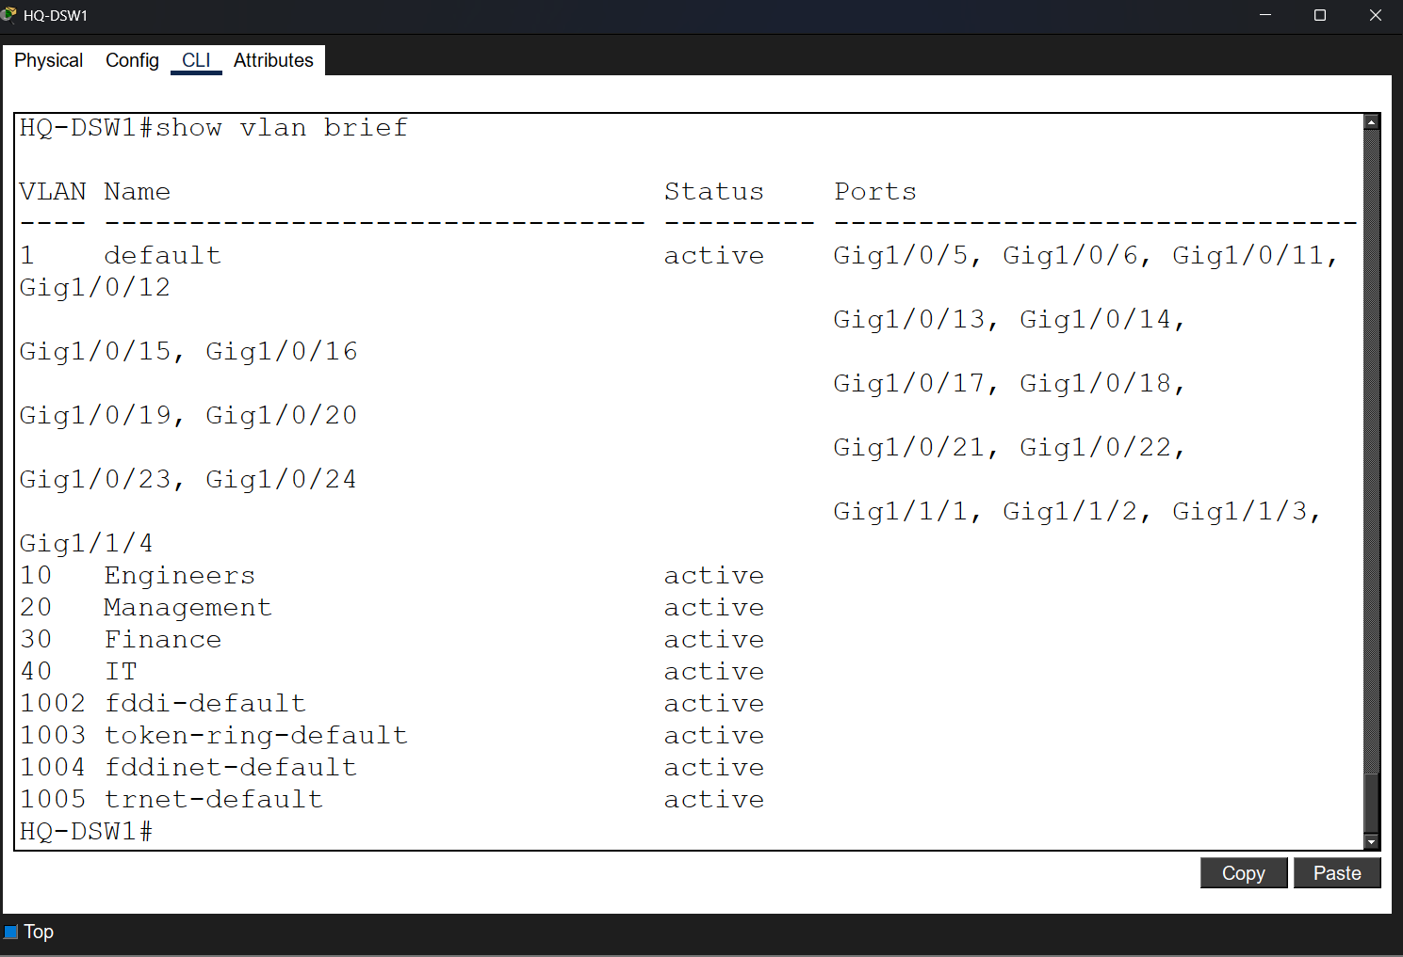

This screenshot shows the VLAN configuration on BR-DSW1. VLANs 60 (Maintenance), 70 (HR), and 80 (Sales) are successfully created according to the project requirements.
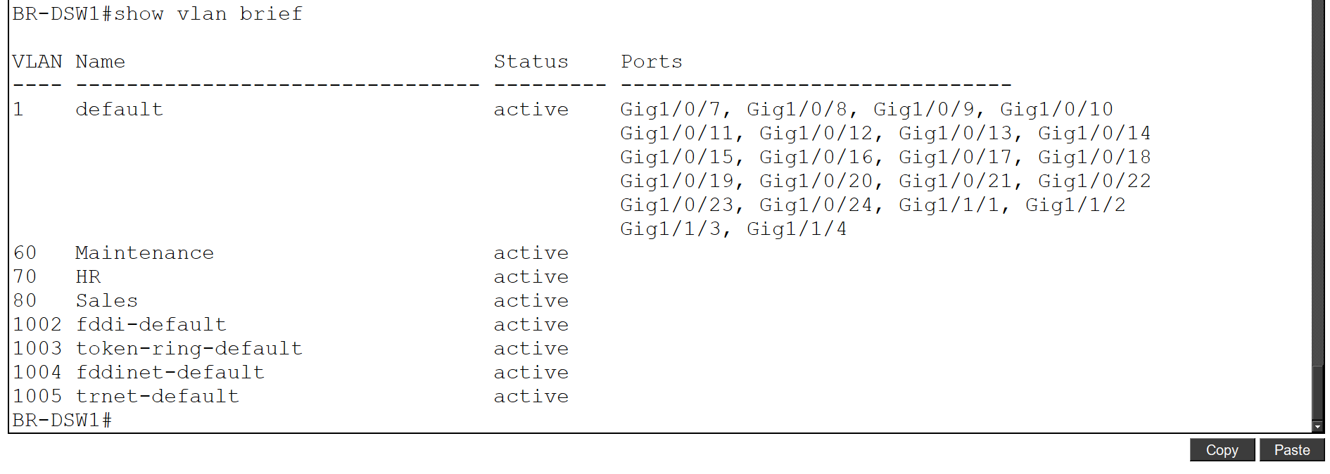

2. Trunk Links Verification
Description:
This section verifies that trunk links are properly configured between switches to allow VLAN traffic to pass across the network. Trunk ports ensure that multiple VLANs can communicate between distribution switches.
Screenshot:
This screenshot shows the trunk configuration on HQ-DSW1. The trunk ports are active and allow multiple VLANs to pass through the switch.
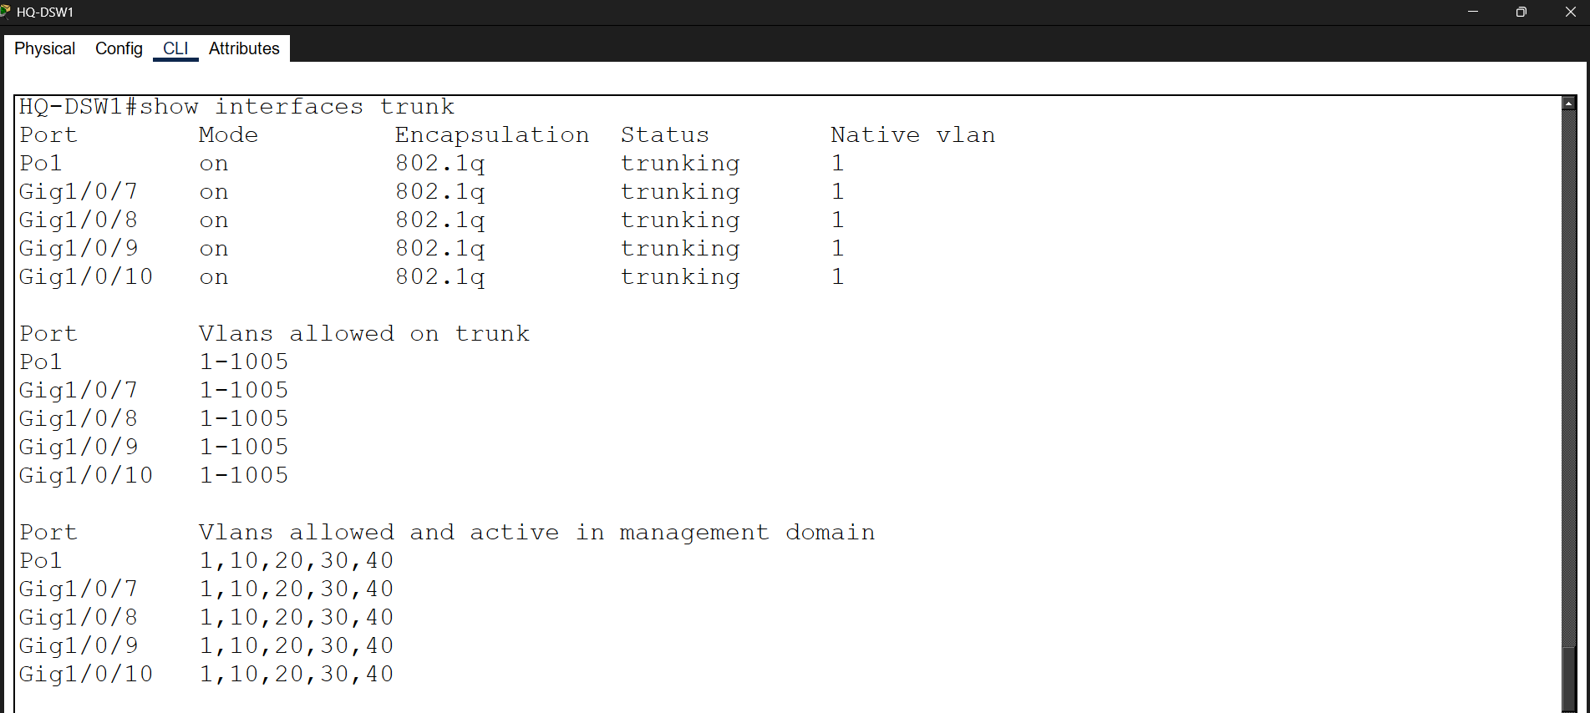

This screenshot shows the trunk configuration on HQ-DSW2. The trunk links are correctly established and operational.
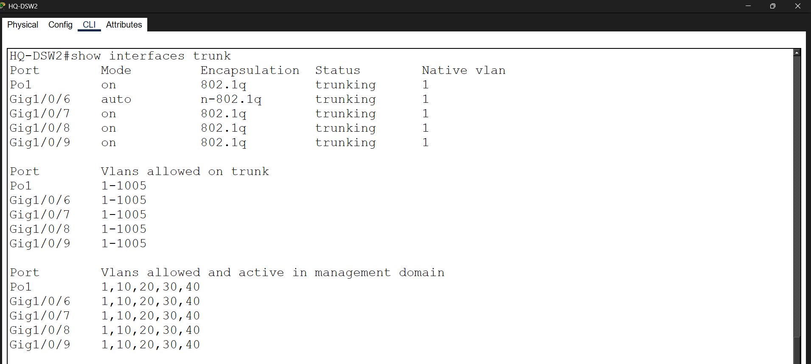
This screenshot shows the trunk configuration on BR-DSW1. The trunk ports are successfully configured to carry VLAN traffic.
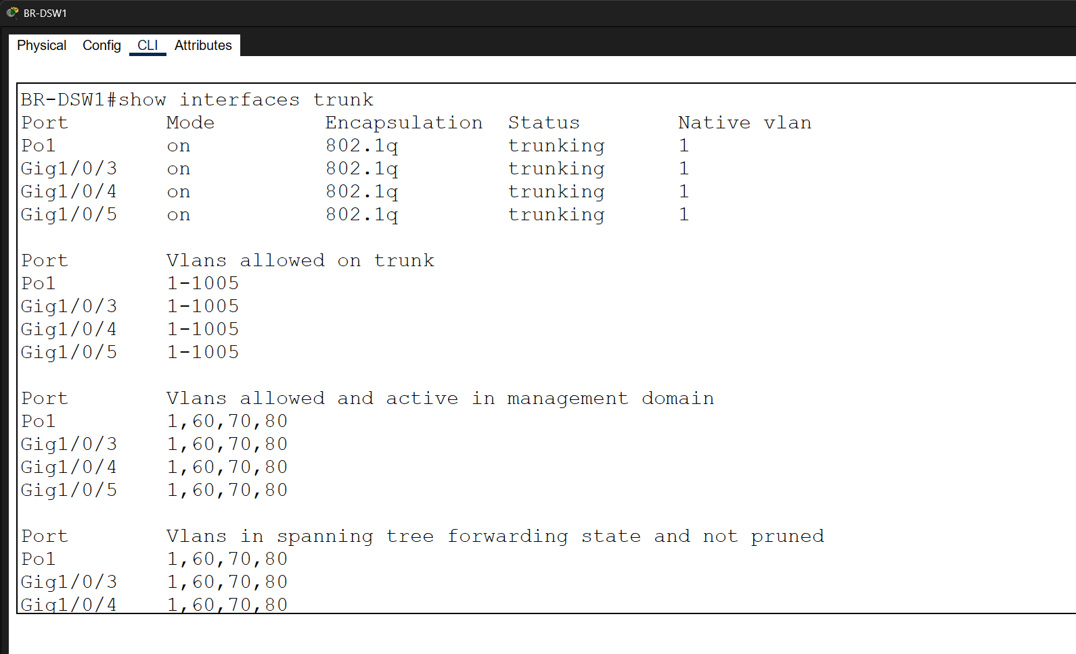

This screenshot shows the trunk configuration on BR-DSW2. The trunk links are active and functioning properly between switches.
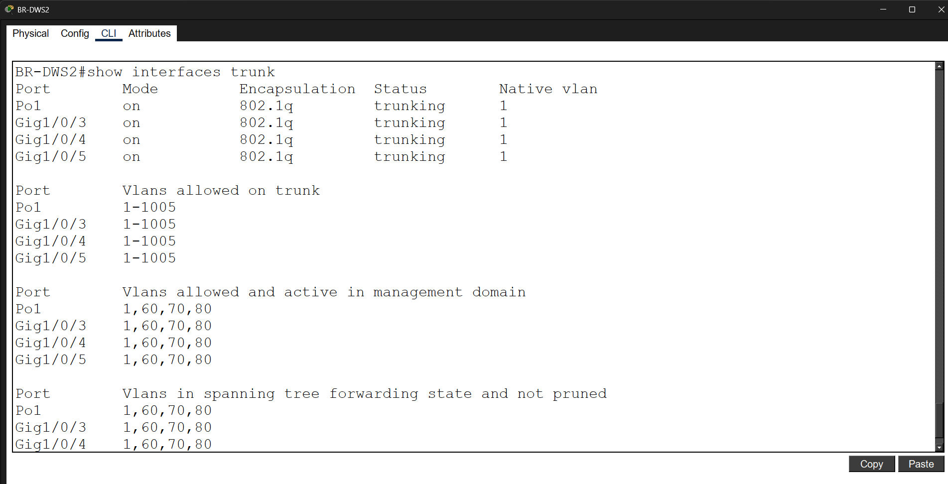

3. EtherChannel Verification
Description:
This section verifies that EtherChannel is correctly configured between distribution switches to provide higher bandwidth and redundancy. Multiple physical links are combined into a single logical Port-Channel using LACP in HQ and PAgP in BR.
Screenshot:
This screenshot shows the EtherChannel configuration on HQ-DSW1. The Port-Channel is successfully formed using LACP and is in an active state.
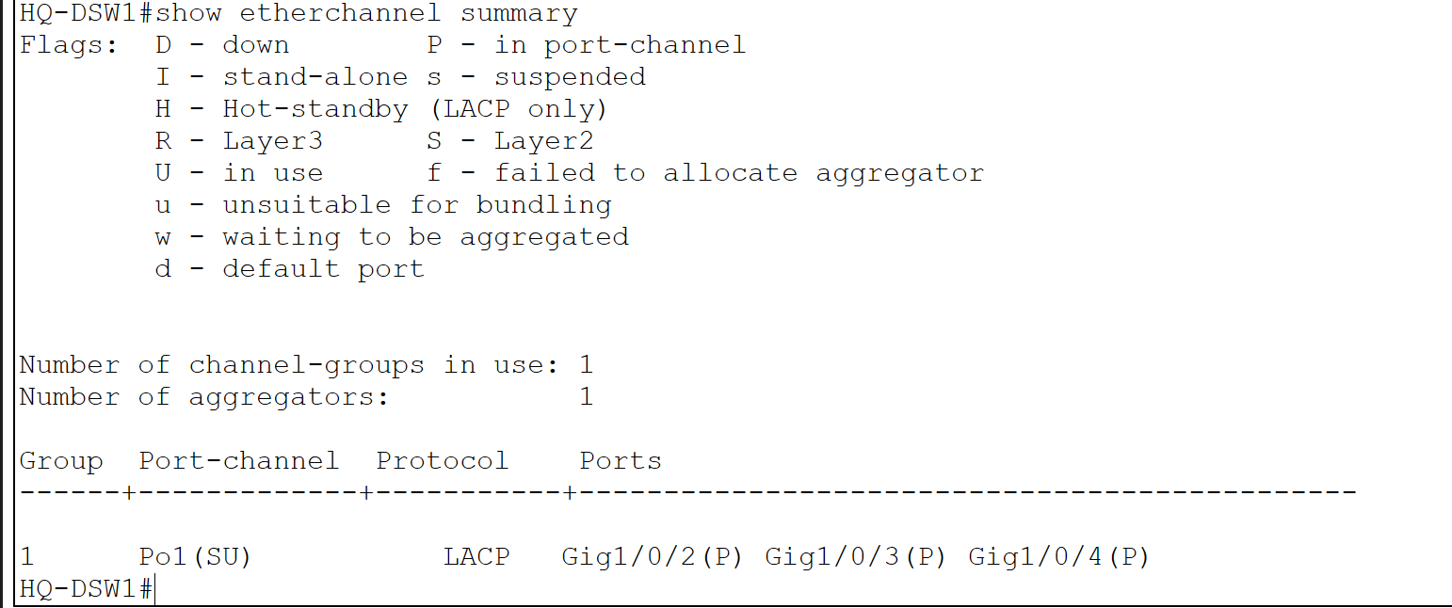
This screenshot shows the EtherChannel configuration on HQ-DSW2. The Port-Channel is correctly established and functioning using LACP.
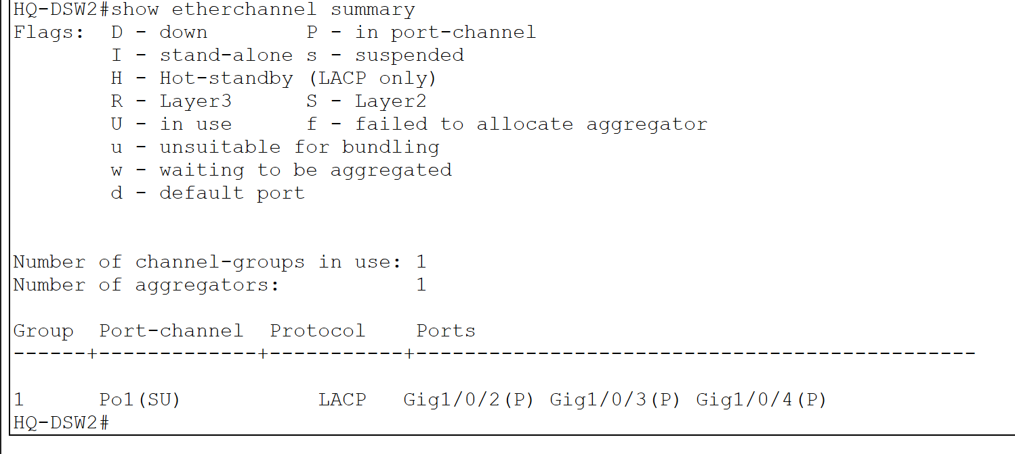
This screenshot shows the EtherChannel configuration on BR-DSW1. The Port-Channel is successfully configured using PAgP and is operational.
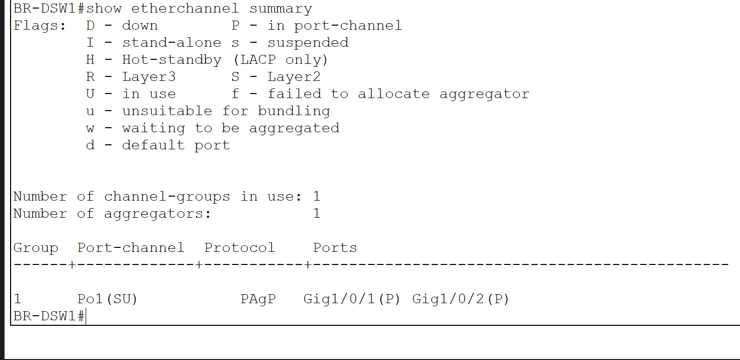

This screenshot shows the EtherChannel configuration on BR-DSW2. The Port-Channel is properly formed using PAgP and working as expected.
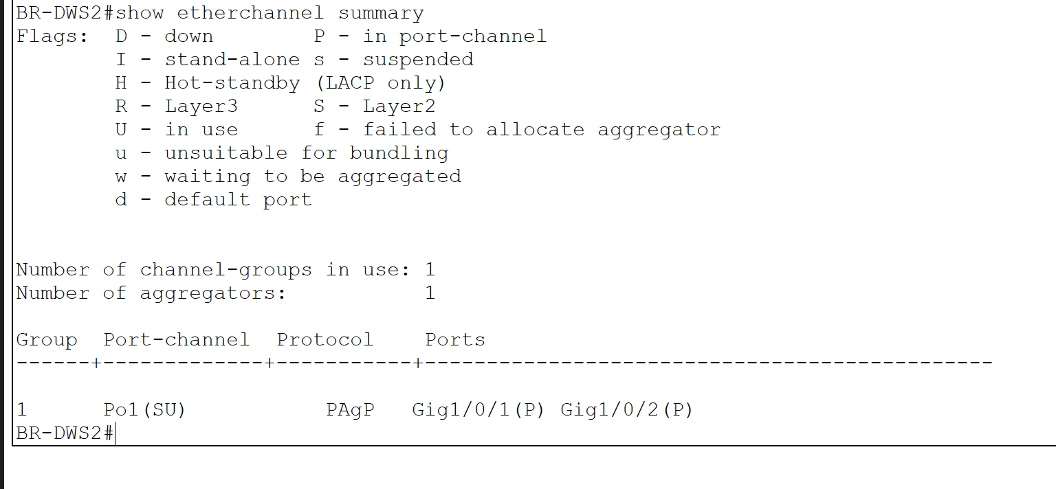

4. VTP Configuration Verification
Description:
This section verifies that VLAN Trunking Protocol (VTP) is correctly configured across all distribution switches. VTP ensures VLAN consistency by propagating VLAN information within the same domain. All switches are configured with the same VTP domain name, version, and password.
Screenshot:
This screenshot shows the VTP configuration on HQ-DSW1. The switch is configured in server mode with the correct domain name "Nass.com", version 2, and matching VTP password.
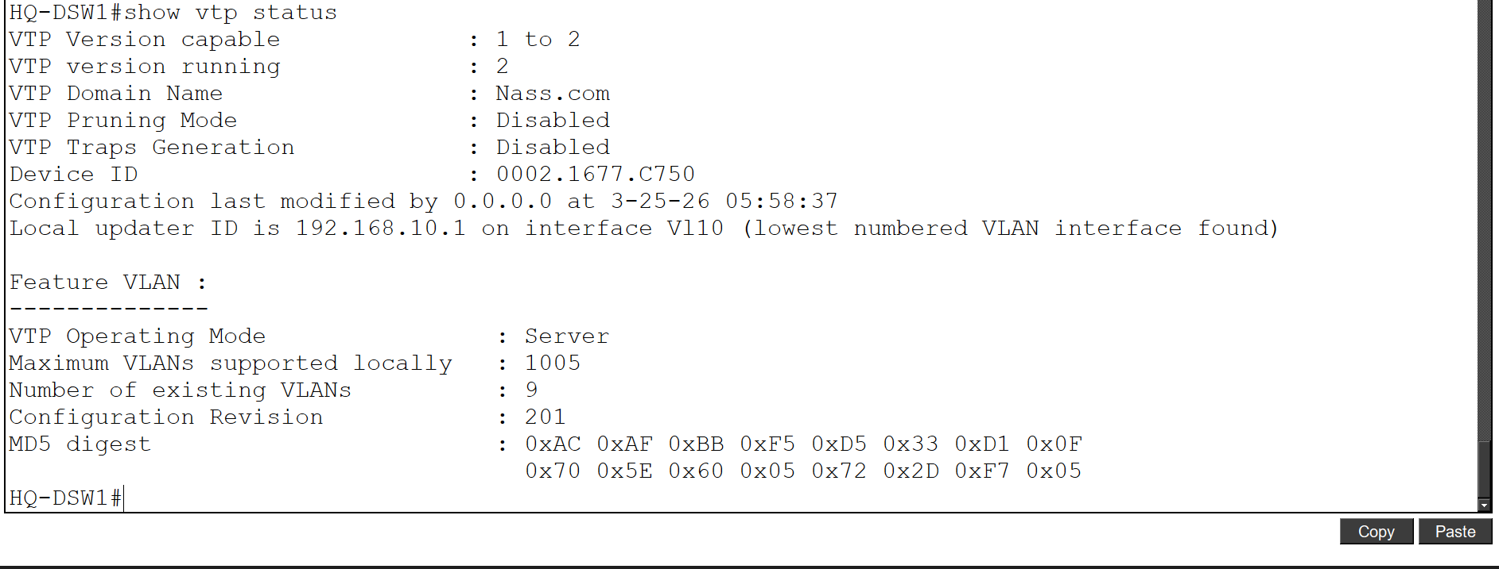
This screenshot shows the VTP configuration on HQ-DSW2. The switch is operating in client mode and successfully receives VLAN information from the VTP server.

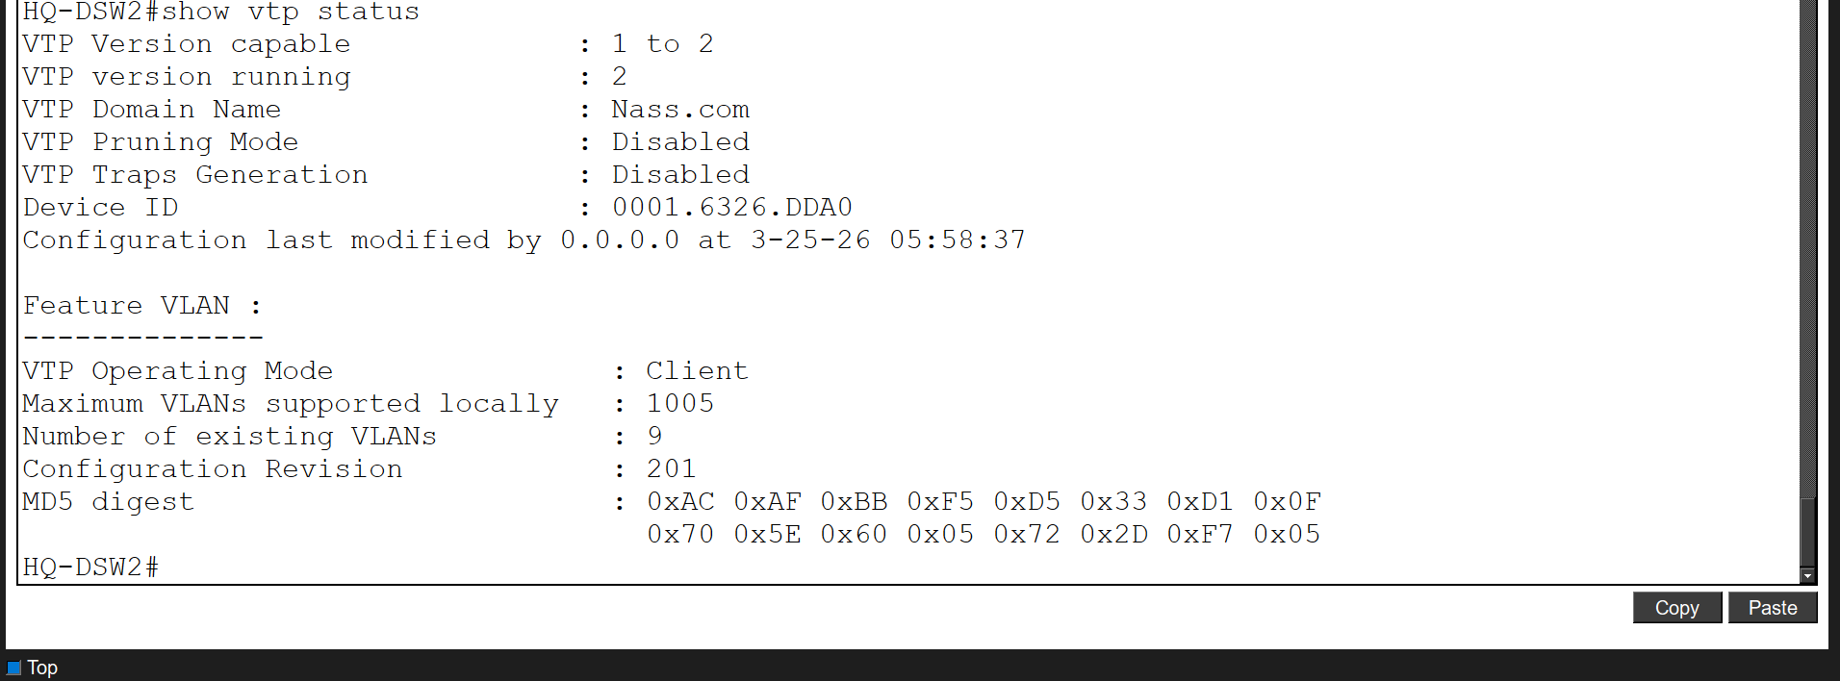
This screenshot shows the VTP configuration on BR-DSW1. The switch is configured in server mode with the correct VTP domain and settings.
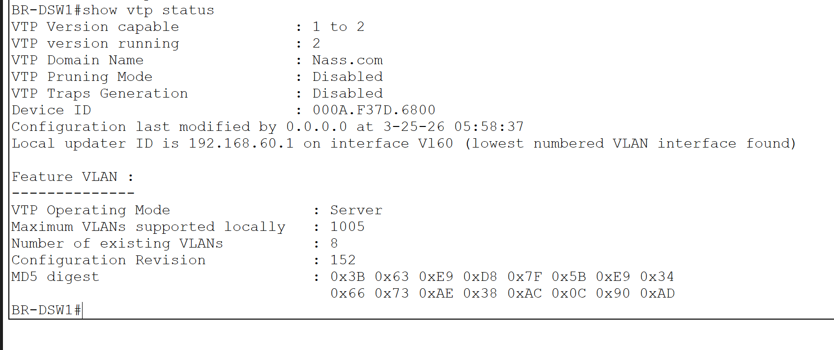

This screenshot shows the VTP configuration on BR-DSW2. The switch is in client mode and correctly synchronized with the VTP server.

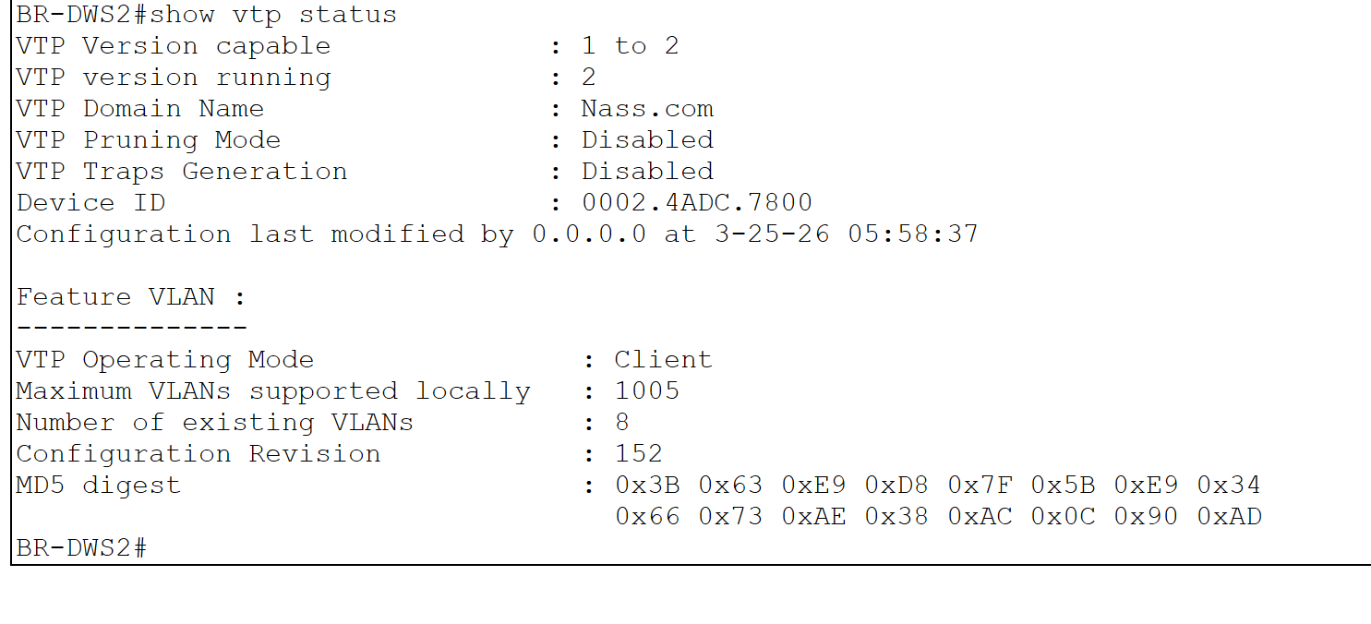

5. Inter-VLAN Connectivity (Ping Test)
Description:
This section verifies successful communication between different VLANs within the same site using Inter-VLAN routing. The ping results confirm that devices in separate VLANs can communicate through the Layer 3 distribution switches.
Screenshot:
This screenshot shows a successful ping from a PC in VLAN 10 to a device in VLAN 20 (192.168.20.55). The replies confirm proper inter-VLAN routing.

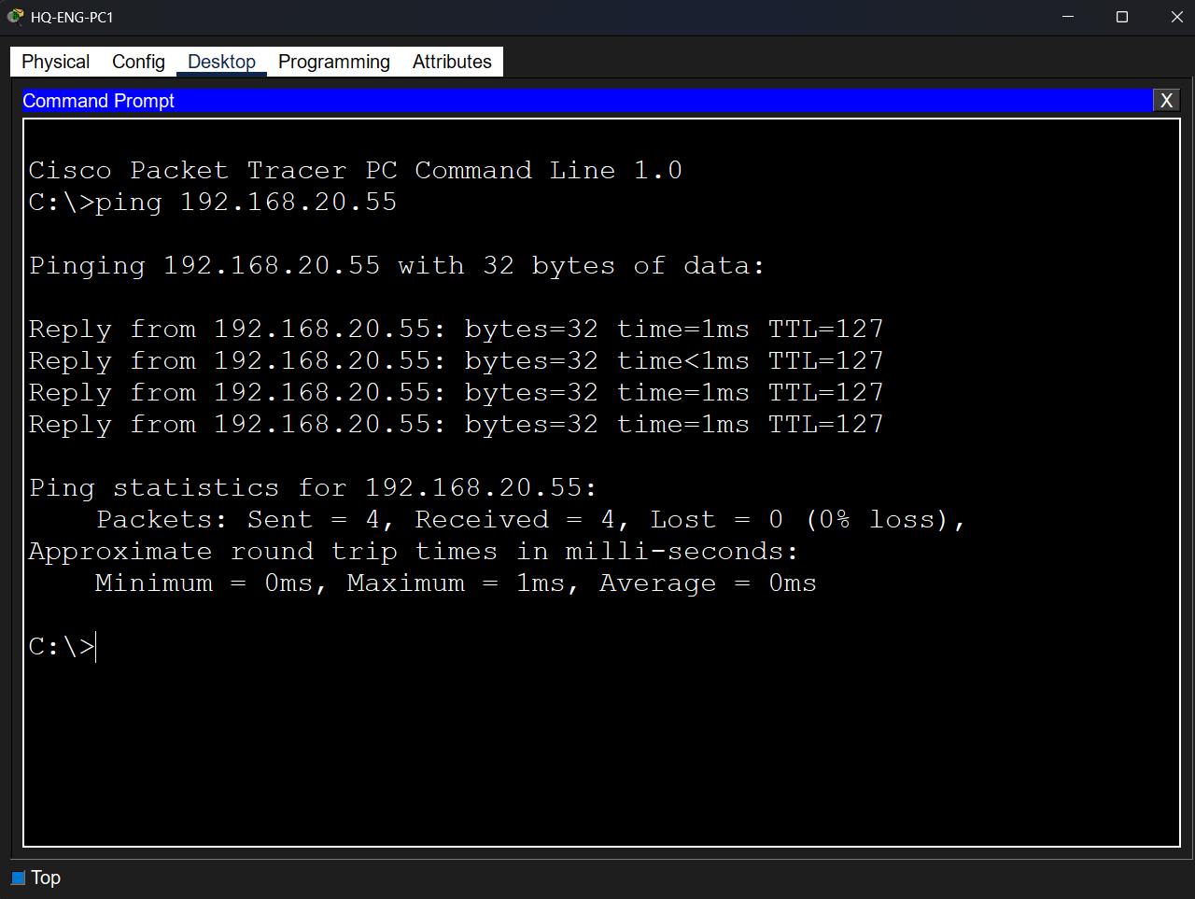

This screenshot shows a successful ping from a PC in VLAN 30 to a device in VLAN 40 (192.168.40.51). This verifies connectivity between these VLANs.
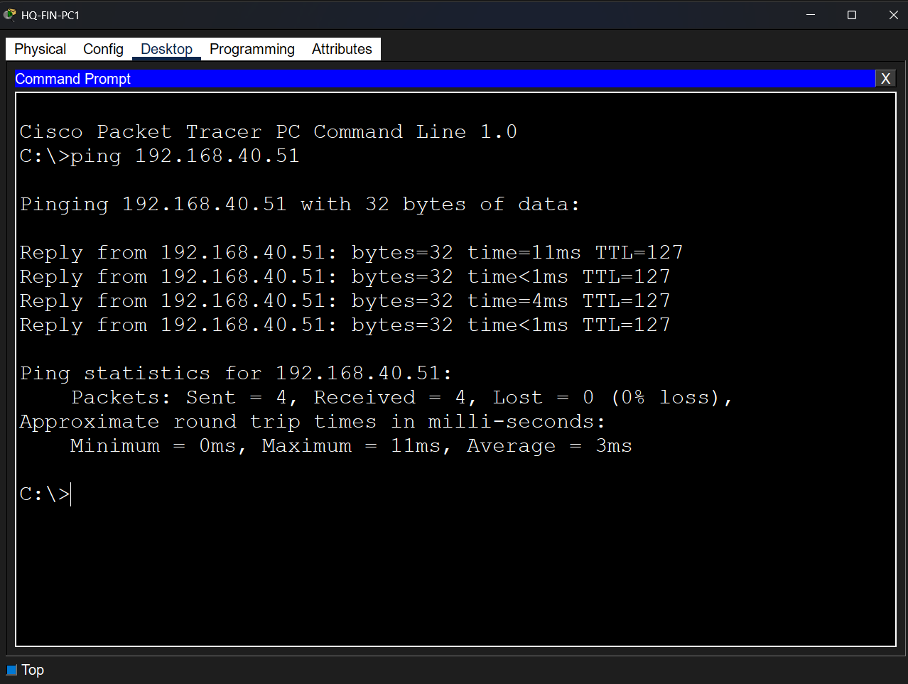

This screenshot shows a successful ping from a device in VLAN 60 to a PC in VLAN 70 (192.168.70.53). The communication is working correctly.
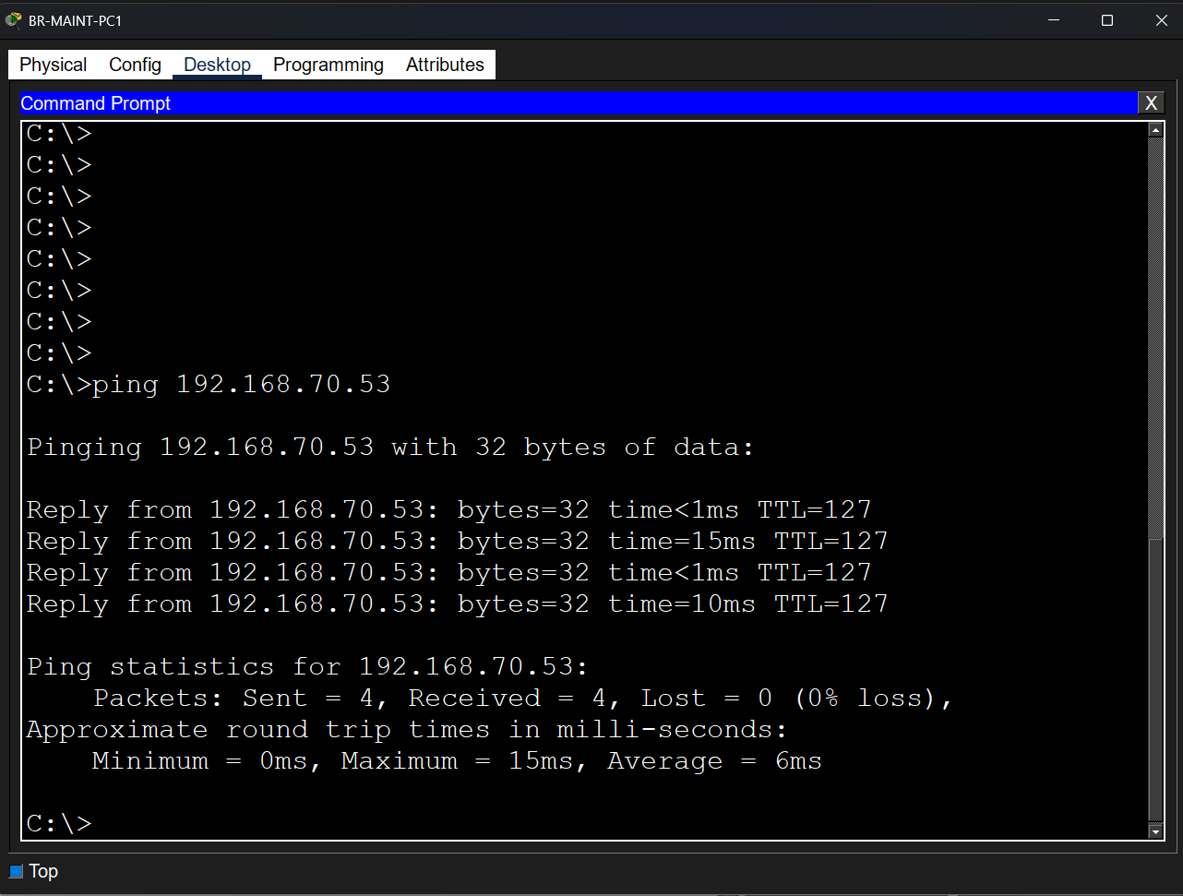

This screenshot shows a successful ping from a device in VLAN 70 to a device in VLAN 80 (192.168.80.51). This confirms inter-VLAN communication in the BR site.
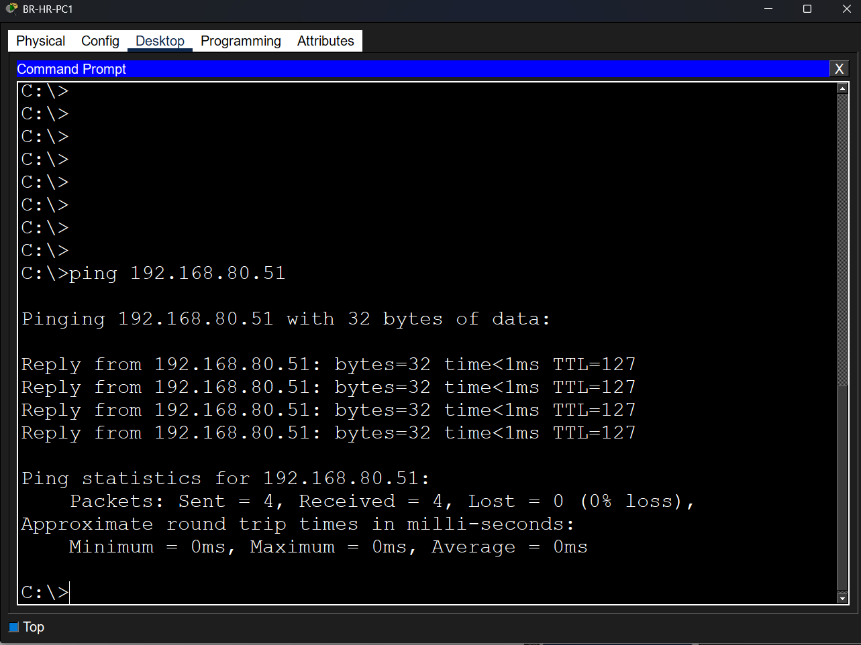

6. Inter-Site Connectivity (HQ ↔ BR)
Description:
This section verifies connectivity between the HQ and BR sites. The successful ping demonstrates that routing between the two sites is correctly configured using dynamic routing protocols.
Screenshot:
This screenshot shows a successful ping from a PC in VLAN 10 (HQ site) to a device in VLAN 60 (BR site) with IP address 192.168.60.53. This confirms end-to-end connectivity between both sites.
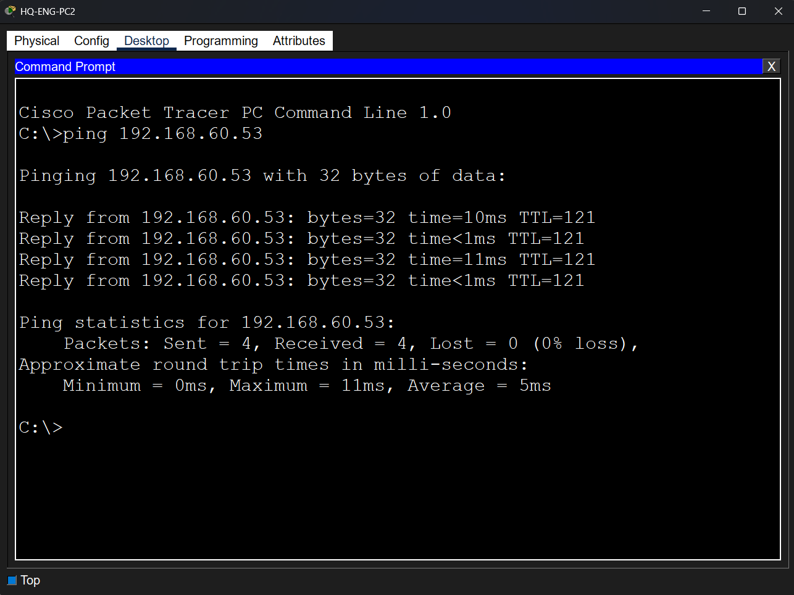

7. DHCP Configuration Verification
Description:
This section verifies that DHCP is correctly configured to automatically assign IP addresses to client devices in all VLANs. Each device receives a valid IP address, subnet mask, and default gateway.
Screenshot:
This screenshot shows a PC in VLAN 10 successfully receiving an IP address dynamically from the DHCP server.

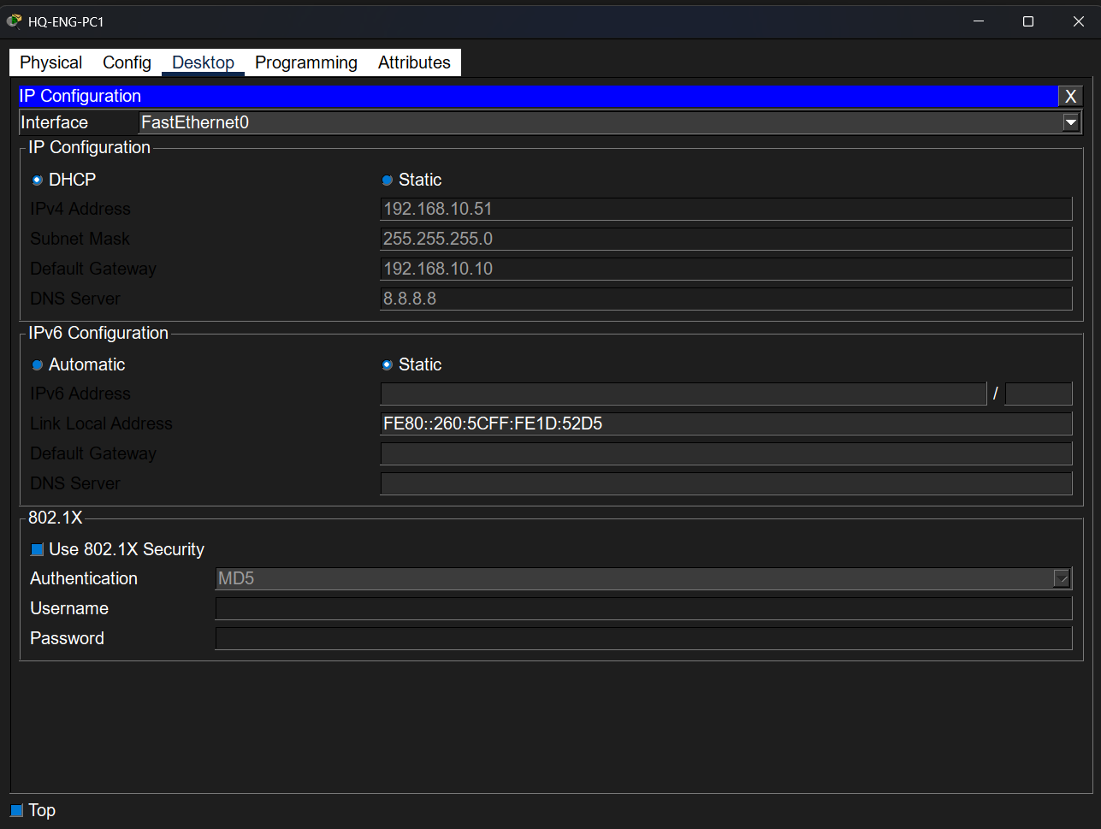

This screenshot shows a PC in VLAN 20 obtaining an IP address via DHCP.
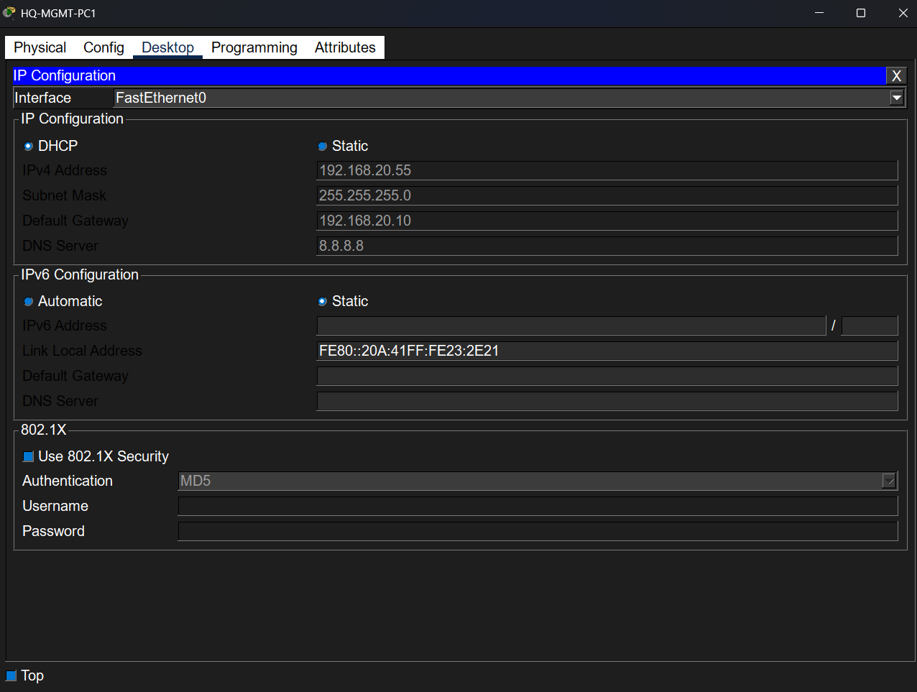

This screenshot shows a PC in VLAN 30 successfully receiving network configuration from DHCP.

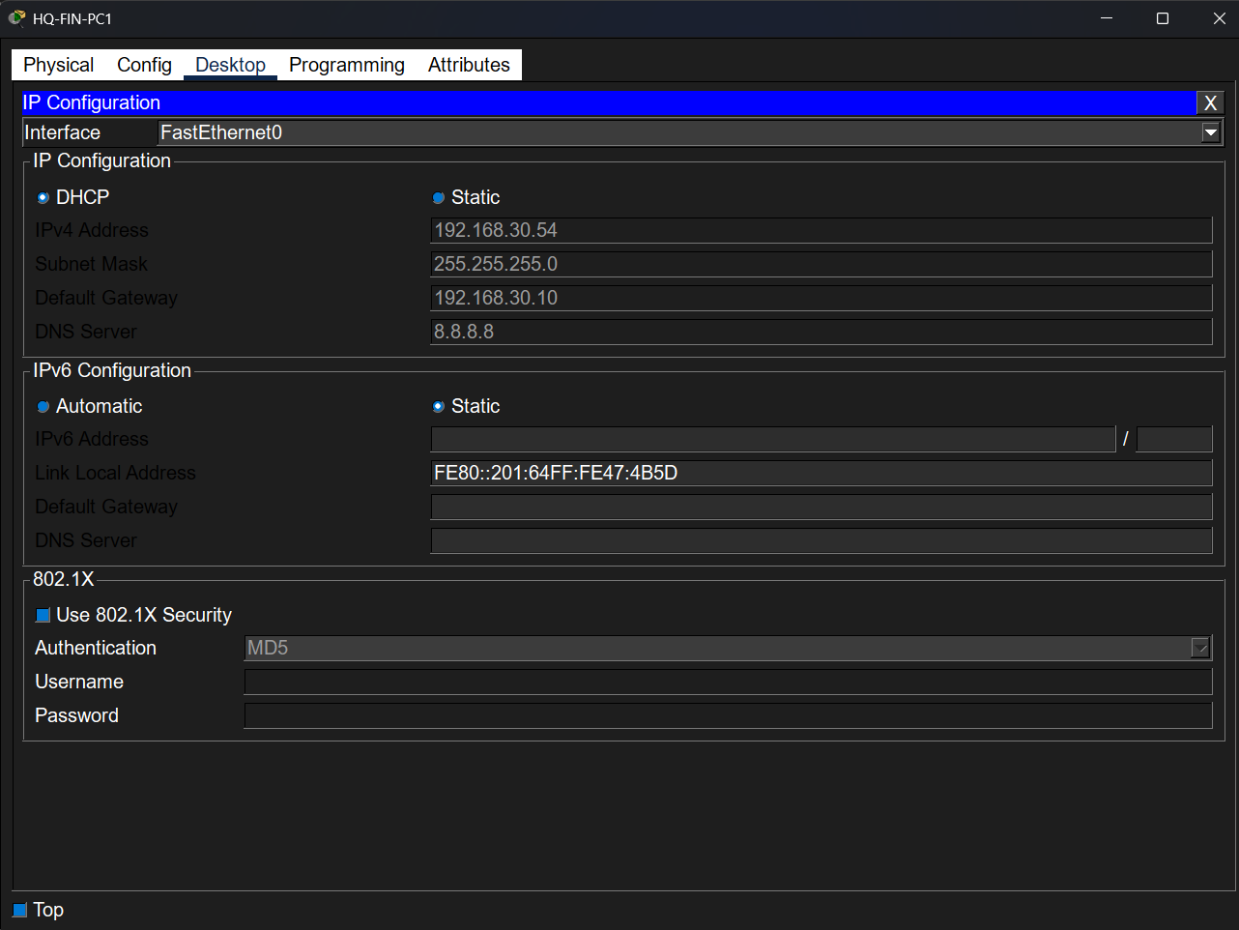

This screenshot shows a PC in VLAN 40 receiving an IP address dynamically.

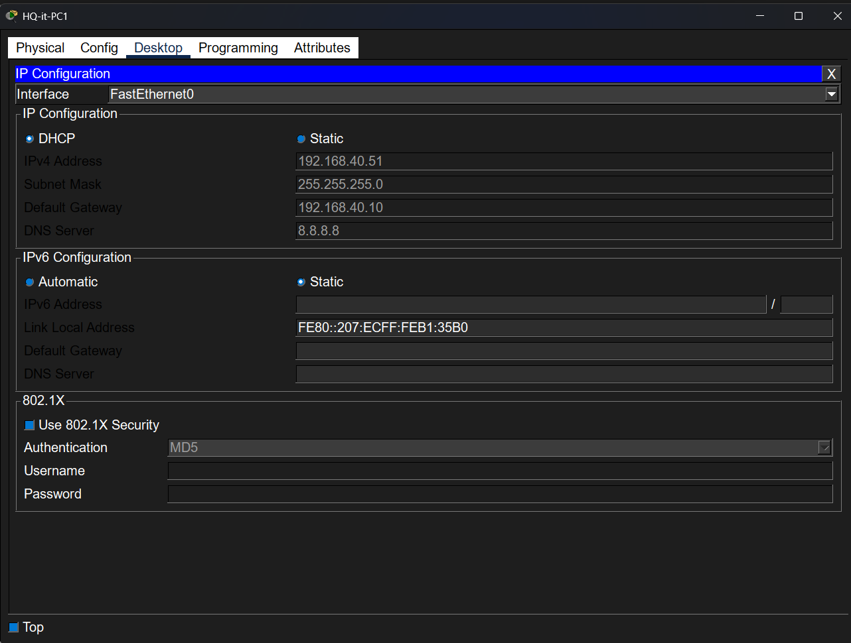

This screenshot shows a PC in VLAN 60 obtaining an IP address from DHCP at the BR site.

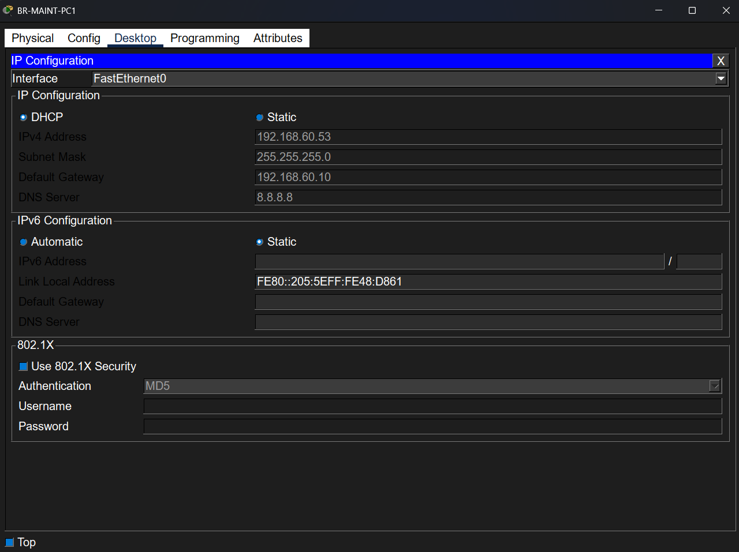

This screenshot shows a PC in VLAN 70 successfully receiving an IP address via DHCP.

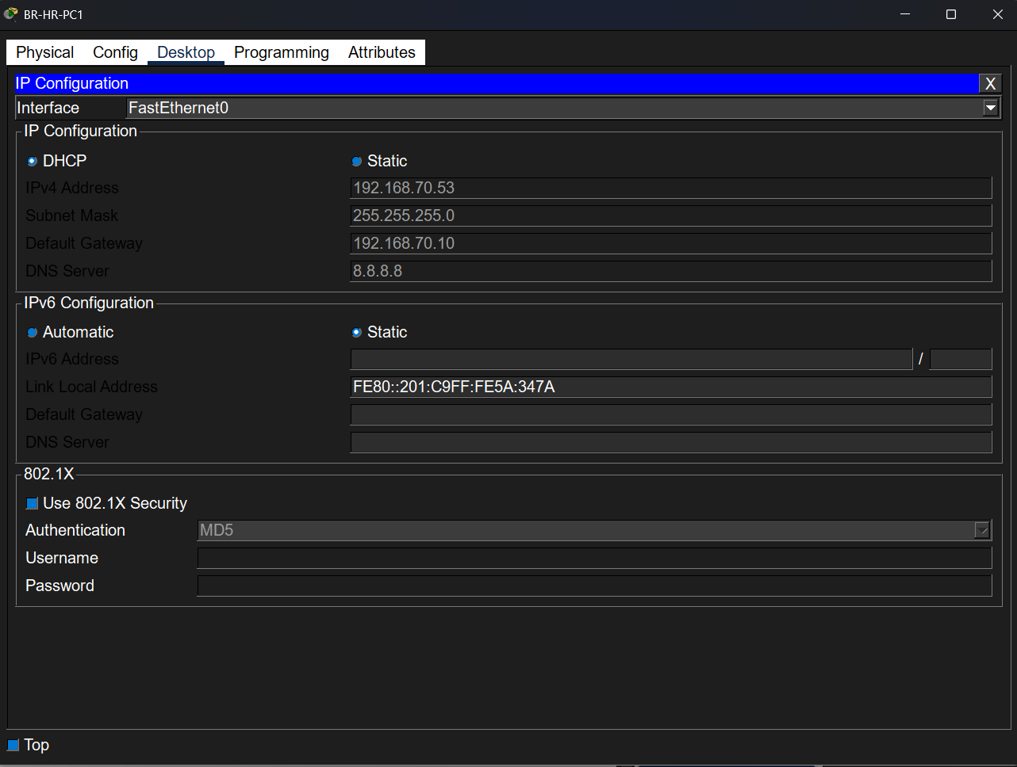

This screenshot shows a PC in VLAN 80 obtaining a valid IP configuration dynamically.

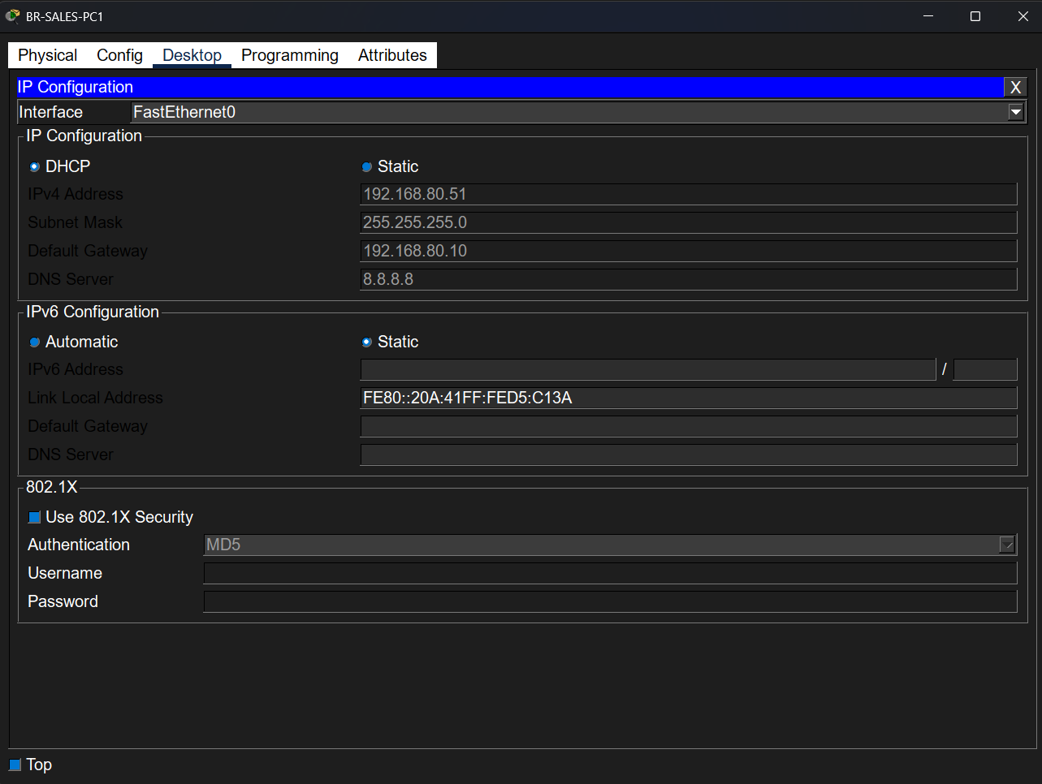

8. OSPF Neighbor Verification
Description:
This section verifies that OSPF is correctly configured between routers. OSPF neighbors are successfully formed, allowing dynamic routing between all networks.
Screenshot:
This section verifies that OSPF is correctly configured between routers. OSPF neighbors are successfully formed, allowing dynamic routing between all networks.
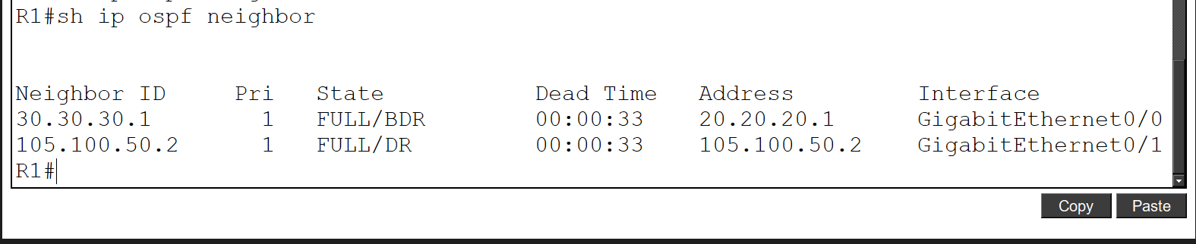

This screenshot shows OSPF neighbors on R2, indicating proper routing communication.
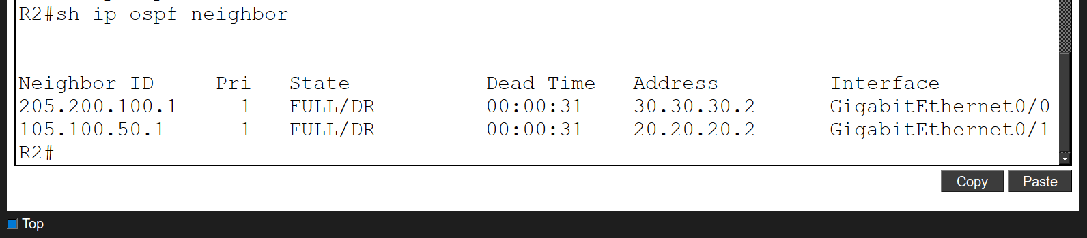

This screenshot shows OSPF neighbor status on R3, confirming that OSPF is functioning correctly.

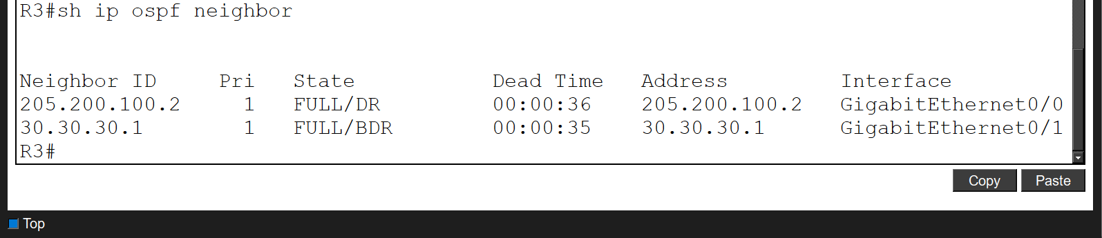

9. HSRP Redundancy Verification
Description:
This section verifies that HSRP is configured to provide gateway redundancy. One switch operates as active and the other as standby for each VLAN.
Screenshot:
This screenshot shows that HQ-DSW1 is operating as the active device for HSRP.
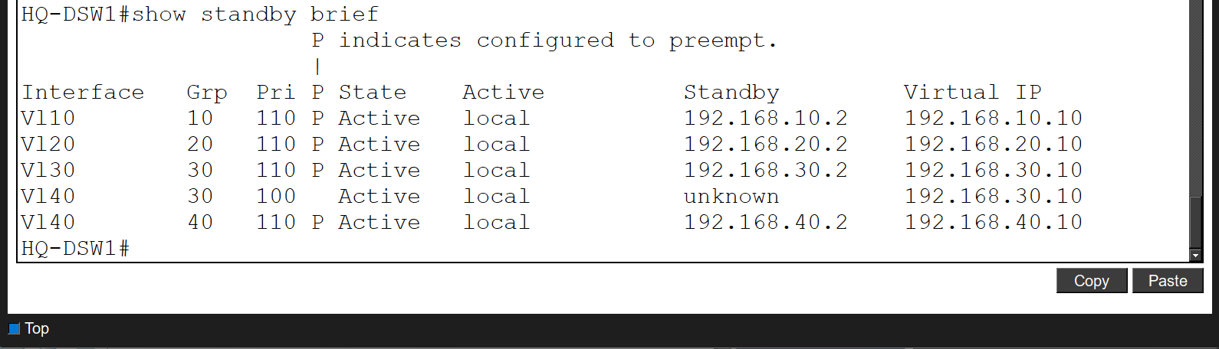

This screenshot shows BR-DSW2 operating as the standby device.
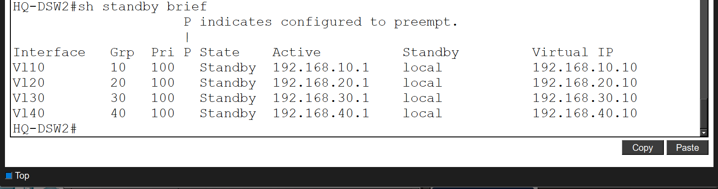

This screenshot shows BR-DSW1 acting as the active HSRP device.

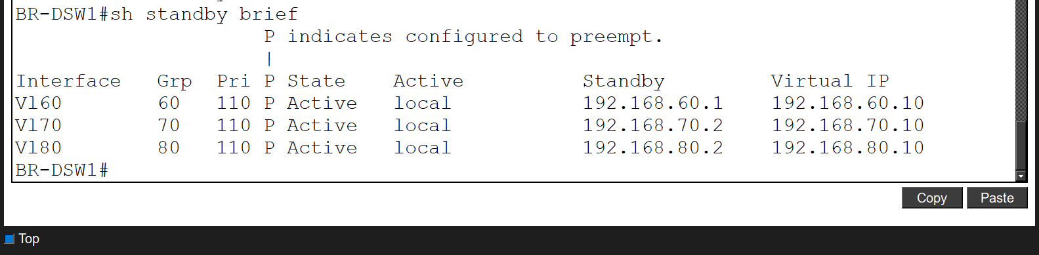

This screenshot shows BR-DSW2 operating as the standby device.

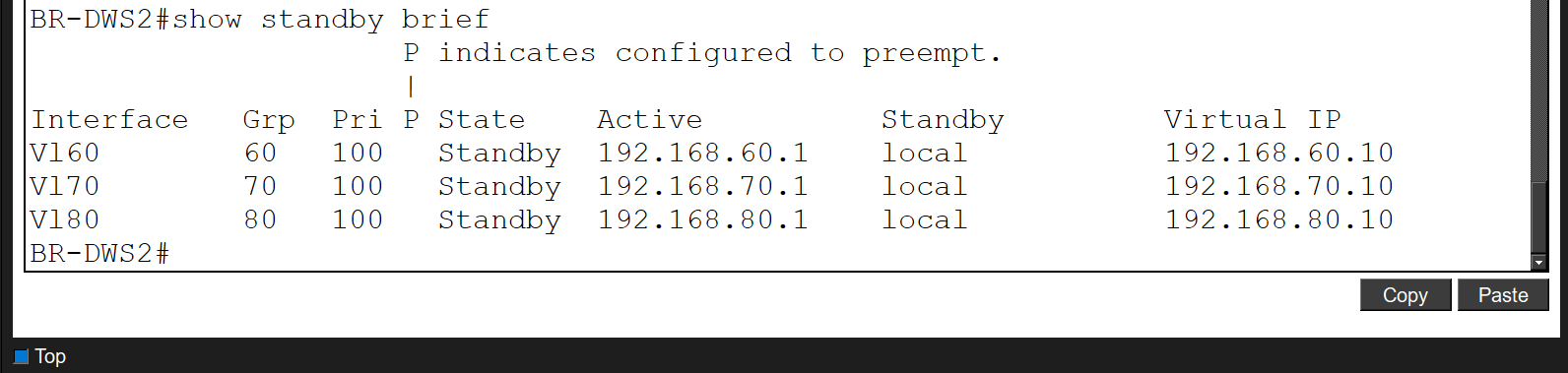

10. Port Security Verification
Description:
This section verifies that port security is enabled on access ports to restrict unauthorized devices and enhance Layer 2 security.
Screenshot:
This screenshot shows port security enabled on HQ-ASW1 with MAC address learning.
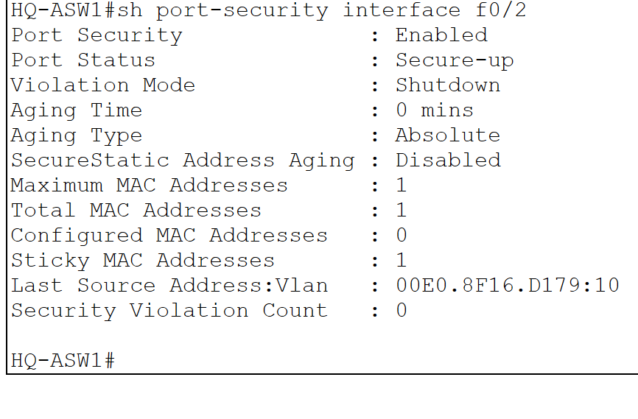
This screenshot shows port security configured on BR-ASW1 with appropriate violation mode.
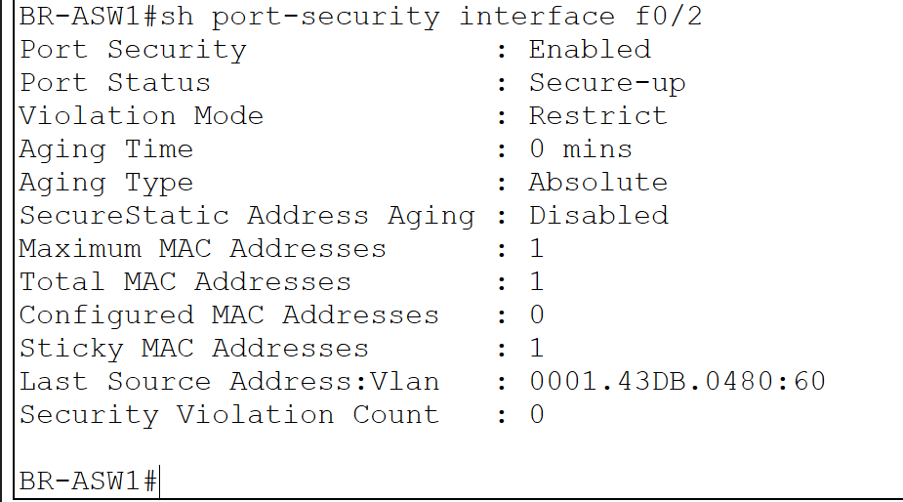

11. DHCP Snooping Verification
Description:
This section verifies that DHCP snooping is enabled to prevent unauthorized DHCP servers from assigning IP addresses.
Screenshot:
This screenshot shows DHCP snooping enabled on HQ-ASW1.
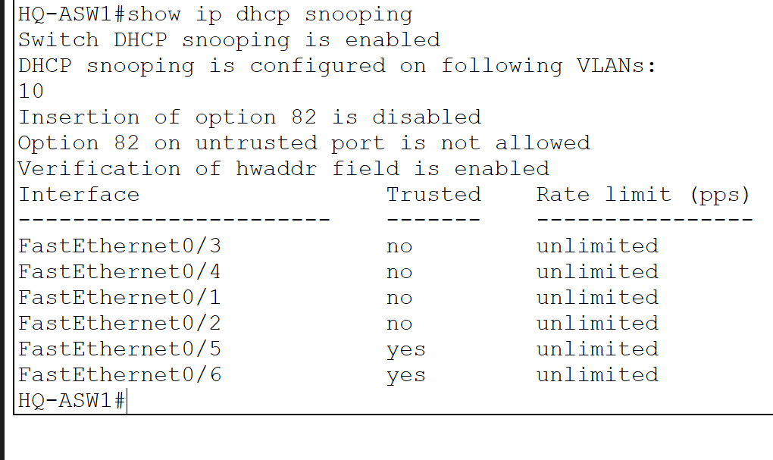
This screenshot shows DHCP snooping configuration on BR-ASW1.
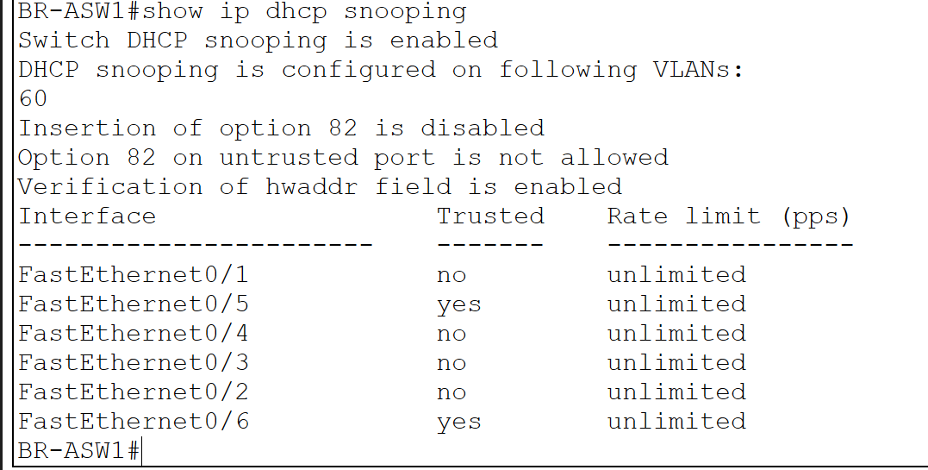

12. Dynamic ARP Inspection (DAI) Verification
Description:
This section verifies that Dynamic ARP Inspection is enabled to protect the network from ARP spoofing attacks.
Screenshot:
This screenshot shows DAI enabled on HQ-ASW1.
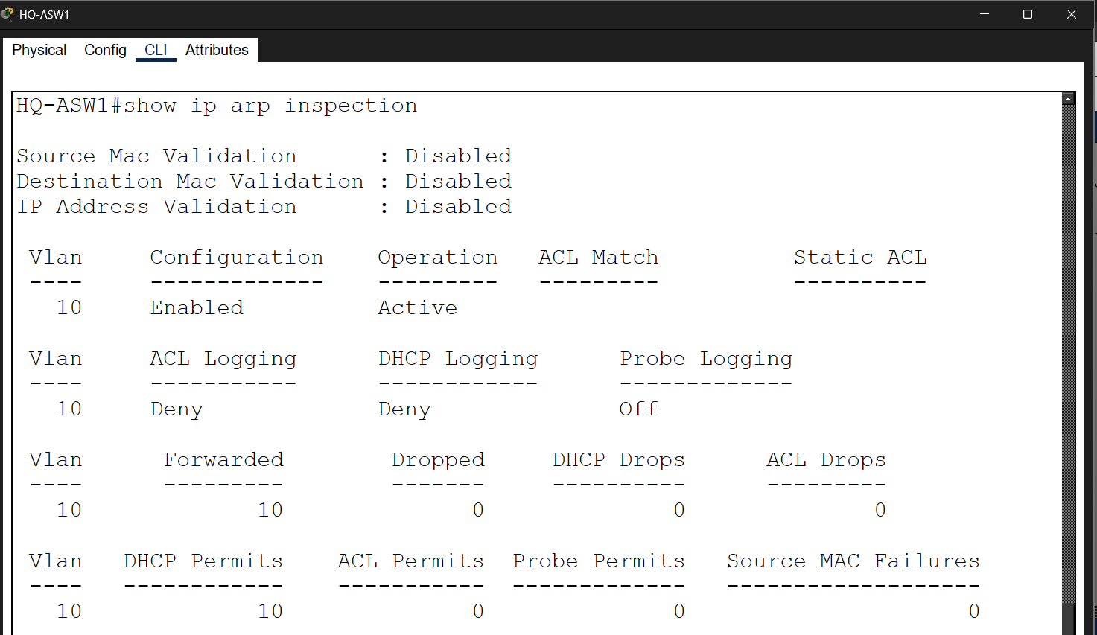

This screenshot shows DAI configured and operational on BR-ASW1.

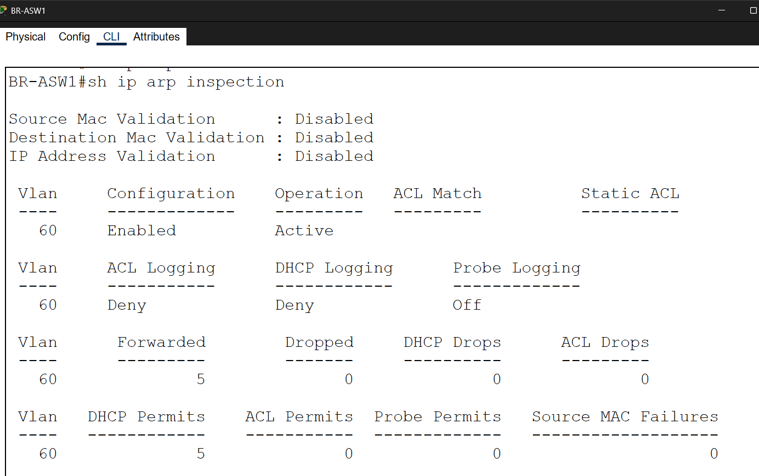

13. Access Control List (ACL) Verification
Description:
This section verifies that the ACL is correctly configured on the HQ-Core switch to restrict specific traffic and enhance security.
Screenshot:
This screenshot shows the configured ACL, including denied ICMP and HTTP traffic and permitted other traffic.

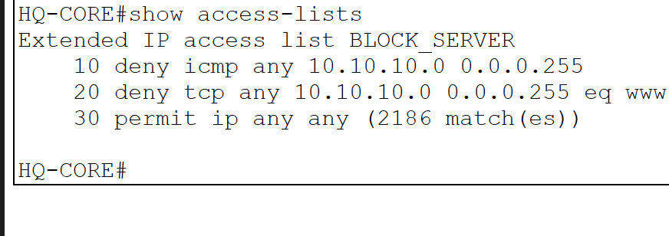

14. SSH Remote Access Verification
Description:
This section verifies that secure remote access using SSH is configured correctly.
Screenshot:
This screenshot shows a successful SSH connection from a PC in VLAN 30 to HQ-ASW1 using the configured username and password.
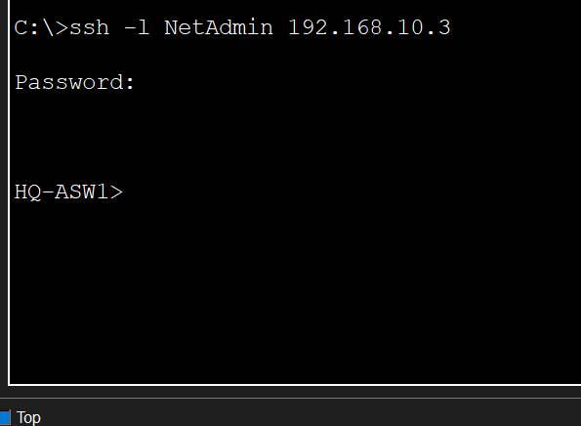

15. Syslog Server Verification
Description:
This screenshot shows log messages received on the Syslog server, confirming successful logging from network devices.
Screenshot:
This screenshot shows log messages received on the Syslog server, confirming successful logging from network devices.
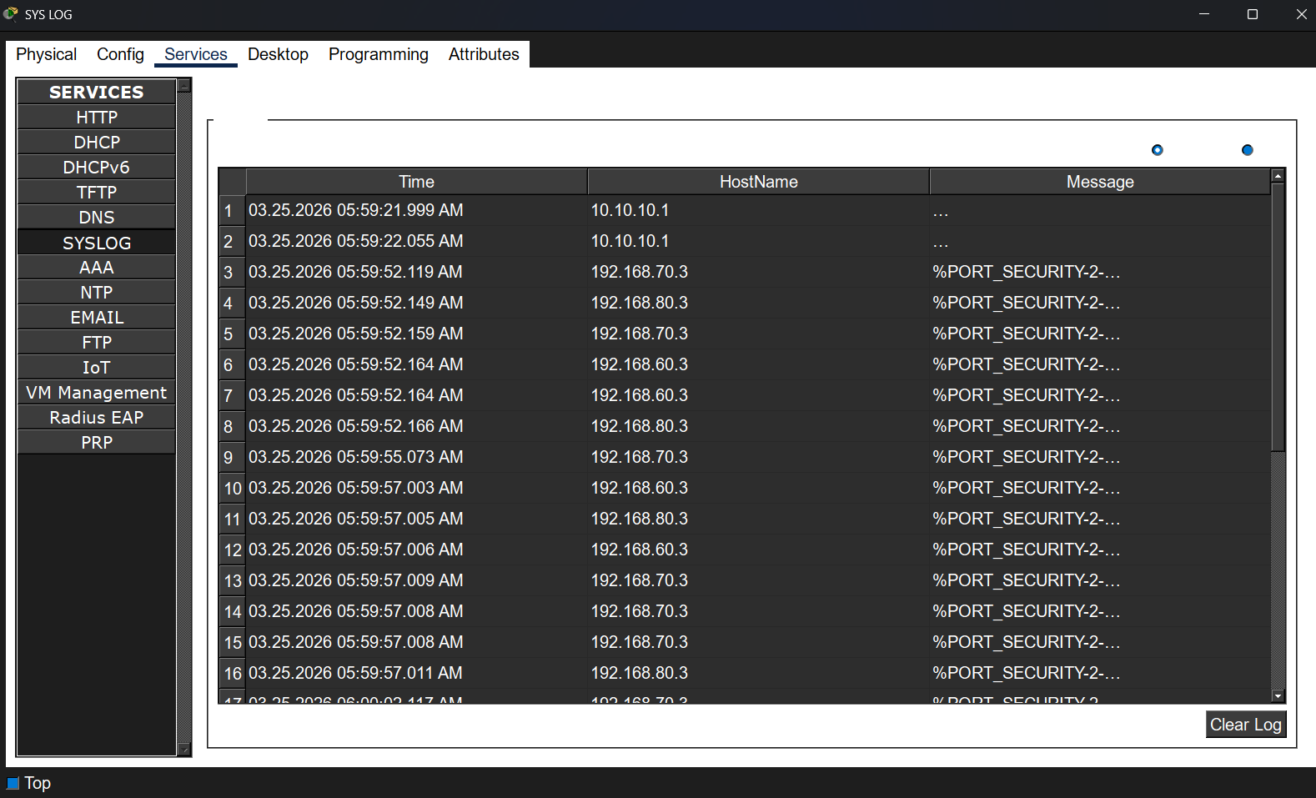

16. NTP Synchronization Verification
Description:
This section verifies that all devices are synchronized with the NTP server to maintain accurate time across the network.
Screenshot:
This screenshot shows that HQ-ASW1 is synchronized with the NTP server.

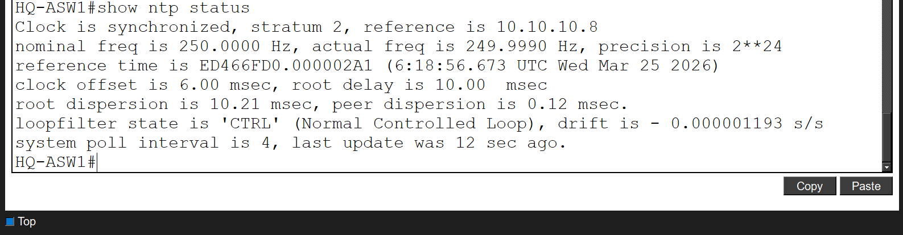
This screenshot shows that R1 is successfully synchronized.
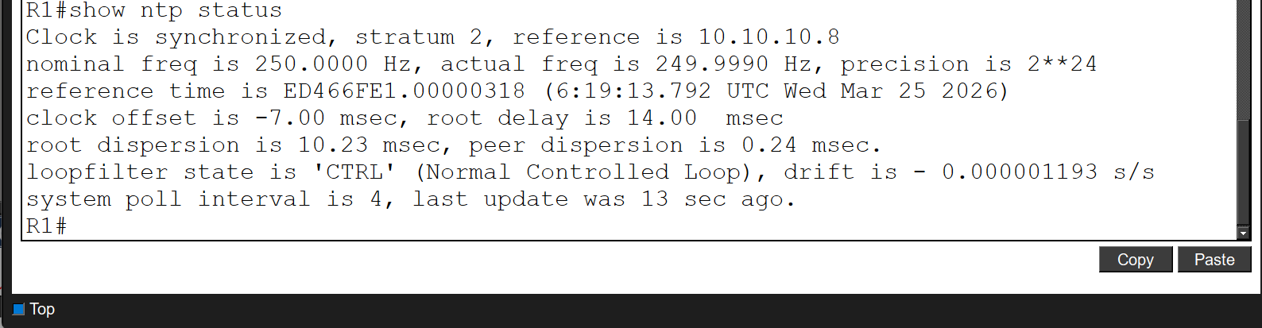

This screenshot shows NTP synchronization on BR-DSW1.

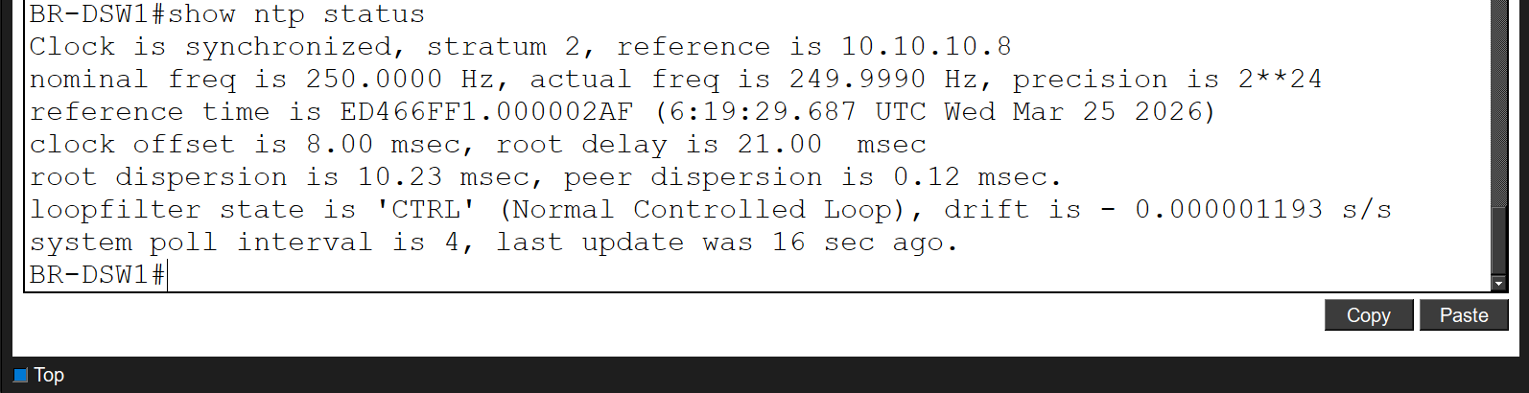

This screenshot shows that BR-ASW1 is correctly synchronized with the NTP server.
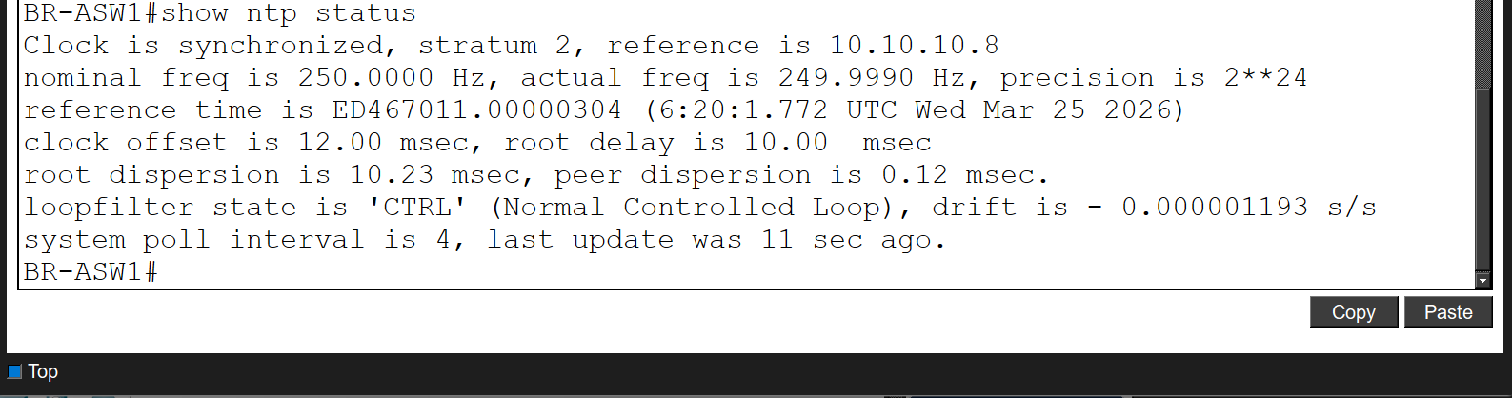

17. Wireless Connectivity Verification
Screenshot:
