After Executing database_SQL_INIT & Populating_Database:

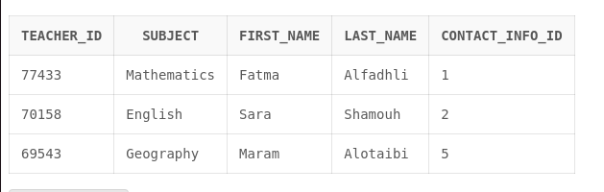
Teacher Table

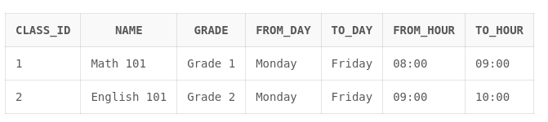
Class Table


Coordination


Email

Phone

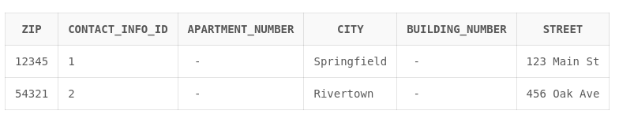
Address


Student_Contacts


Event


Organize


Location


Student

Queries Resutls:

First SELECT Query:
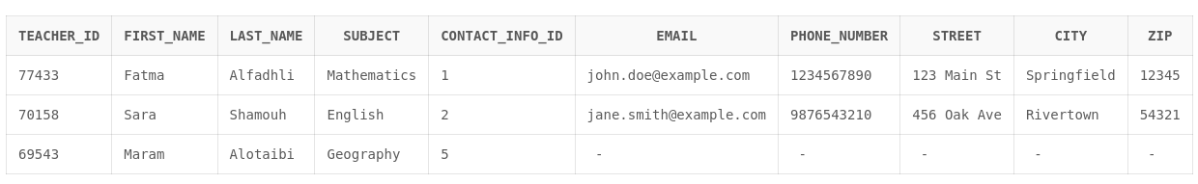
Note: There is no constraint enforcing that each contact_ID must have all details filled. However, there is a constraint enforcing the opposite: all contact details for any record must be indexed by a contact_ID. If we wish to ensure that contact information is provided for each person, it would be more effective to implement this requirement at the application layer by preventing users from submitting forms unless all required contact information is completed.

Second SELECT Query:


Third SELECT Query

