Name: Youssef Said Thabet Gad

ID: 2205064

First I get a log file that have a 5000 records and name it as access-log file and after that I created a file name log_analysis.sh and after that I created a file to generate a graphs for the output named generate_graphs.py as shown in the hierarchy like that
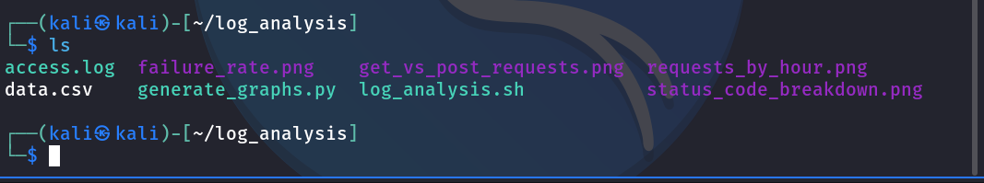
and after that to run the .sh file I want first to change the permissions to Execution mode to execute the file and run to run the file the output will appear like that

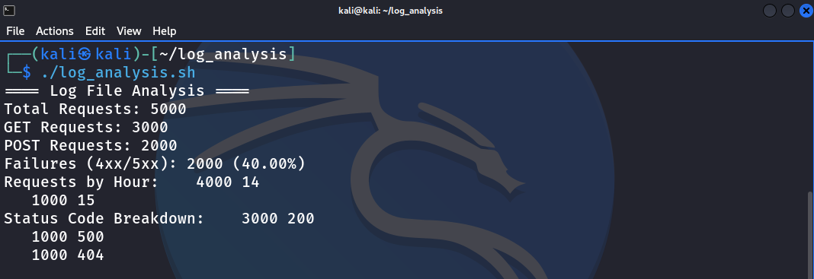
The output will be like that
- it tells me that the number of requests is 5000
- and the number for GET requests is 3000 from 5000
- and the number for POST requests is 2000 from 5000
- and the Failures is 2000 and the percentage 40%
- and there is a 1000 request the status code is 500
- and there is 1000 requests the status code is 404
- and there is 3000 request the status code is 200

but this is not the best way I take the output and send the output to the generate_graphs.py as in data.csv to give me a graphs for that like that

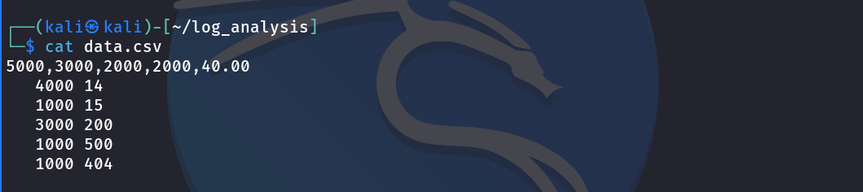
Okay to run the file generate_graphs.py this will generate the graphs for the output like that
we run the file by ./generate_graphs.py and the output will be like that the first image for the Failure Rate in the Requests

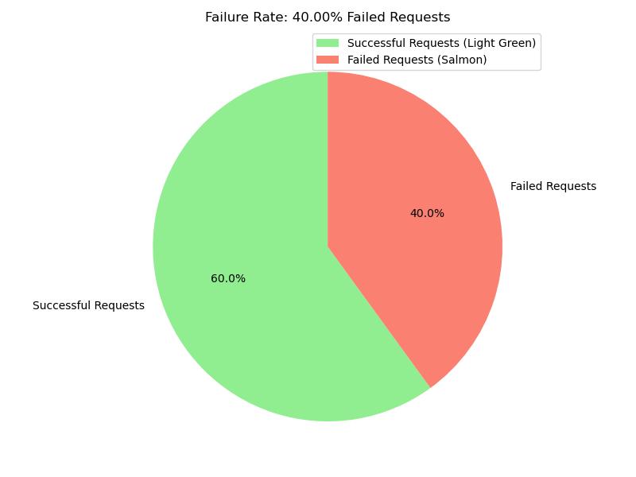
The Second One for the the number of GET and POST requests in the log file
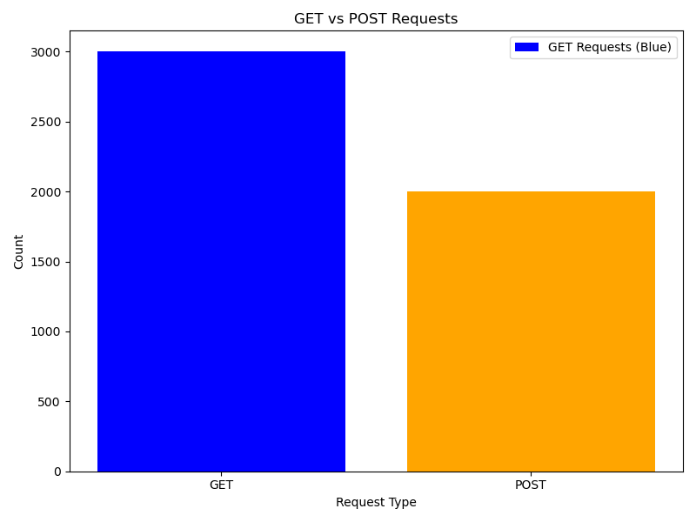
The Third one for request per hour in the day
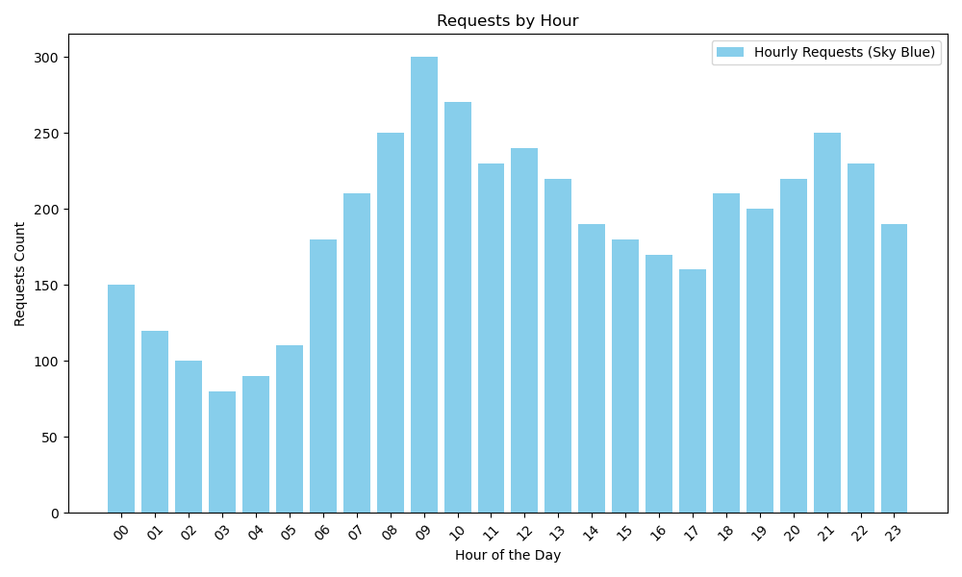
The Fourth one for the Status code for the requests how many status codes
