PROCESS MINING ASSIGNMENT
CSE346 Business Process Modeling — Spring 2026

University: Ain Shams University
Faculty: Faculty of Engineering
Department: Computer and Artificial Intelligence Engineering
Course: CSE346 — Business Process Modeling
Instructor: Dr. Islam El-Maddah
Assignment: Process Mining — Alpha Algorithm + PERT Chart + Automation
Date: May 2026

Alpha Algorithm (van der Aalst, 2004) | Event Network Diagram | Automation Pipeline

1. Introduction
Process mining is a data-driven discipline that bridges business process management and data science. It extracts knowledge about how business processes actually execute by analysing the digital traces that processes leave behind in information systems — known as event logs. Each record in an event log captures which activity was performed, when it was performed, which case (process instance) it belongs to, and which resource carried it out. By systematically analysing these records, process mining can discover the real process model, check whether execution conforms to a prescribed model, and identify where performance bottlenecks or deviations occur. Unlike traditional process modelling, which relies on interviews and expert knowledge, process mining produces models that are objectively grounded in observed behaviour.

This assignment implements the Alpha Algorithm, the foundational process discovery algorithm introduced by van der Aalst, Weijters, and Maruster (2004). The algorithm takes an event log as input and automatically discovers a Petri net that describes the causal structure of the process — which activities must precede others, which can execute in parallel, and which are mutually exclusive. The implementation covers all eight formal steps of the algorithm, from extracting the activity set through constructing the final Petri net. A full automation pipeline accompanies the core algorithm: it reads any conforming Excel event log, applies the Alpha Algorithm, generates an Activity-on-Arc (AoA) PERT chart derived entirely from the discovered Petri net, and writes a four-sheet Excel report — all without modifying source code.

2. Tool Selection & Justification
Python 3 was selected as the implementation language for this assignment. The decision was made by evaluating the specific technical requirements of each deliverable against the capabilities of the available tools.

The Alpha Algorithm requires set-theoretic operations: powerset enumeration, causal pair identification, maximality testing, and set intersection and subset checks. Python's native frozenset type and itertools.combinations function map directly onto the mathematical definitions in van der Aalst (2004), making the implementation both concise and verifiable against the formal specification. The footprint matrix is a dictionary of dictionaries with O(n²) pair iteration, which reads naturally in Python and mirrors the formal notation. Graph construction and layout for the PERT chart are handled by NetworkX (directed graph representation and topological sort) and Matplotlib (publication-quality rendering with precise arc and label control). Excel reading and writing are handled by pandas and openpyxl, which support multi-sheet workbooks with auto-formatted columns in a few lines of code. A single run_pipeline() call in automation.py processes any conforming event log end-to-end without modifying source code, demonstrating the reusability that object-oriented scripting enables.

Tool | Alpha Algorithm | PERT Chart | Excel Output | Automation
Python | Native sets, itertools, dicts | NetworkX + Matplotlib | pandas + openpyxl | Full scripting — any log via CLI
Excel VBA | Cumbersome — no set types | No built-in graph engine | Native but hard to script | Macros only — no graph output
Power BI / Tableau | Cannot implement enumeration logic | No programmatic chart generation | Export only | No algorithmic scripting
R | Comparable (dplyr, sets) | ggraph viable but less control | writexl viable | Scripts possible — weaker PM ecosystem

Python is the correct choice because it offers the highest fidelity between the formal mathematical algorithm and the code, the richest process mining ecosystem, and the clearest path from raw event log to all required deliverables in a single reproducible pipeline. Python 3.8+ with the packages listed in requirements.txt reproduces all results on any machine with a single pip install command.

3. Event Log Description
The event log provided for this assignment describes an order fulfilment process observed across four independent process instances (cases). It contains 36 events distributed across the four cases and involves 12 distinct activities performed by 12 distinct resources.

3.1 Activities
- 1. Archive order
- 2. Check materials availability
- 3. Check stock availability
- 4. Confirm order
- 5. Emit invoice
- 6. Get shipping address
- 7. Manufacture product
- 8. Obtain raw materials
- 9. Receive payment
- 10. Request raw materials
- 11. Retrieve product from warehouse
- 12. Ship product

3.2 Resources
Category | Resource | Role
Automated Systems | SYS1 | Stock and materials checks, manufacturing oversight
Automated Systems | SYS2 | Invoice generation, shipping address retrieval, payment processing
Automated Systems | DMS | Data Management System — archiving completed orders
Warehouse Staff | Rick | Warehouse operative (retrieval and shipping)
Warehouse Staff | Chuck | Order confirmation specialist
Warehouse Staff | Susi | Shipping coordinator
Warehouse Staff | Hans | Warehouse operative
Procurement Staff | Ringo | Procurement coordinator (raw materials requests)
Procurement Staff | Olaf | Procurement operative (obtaining raw materials)
Manufacturing Staff | Conny | Manufacturing operative
Manufacturing Staff | Sara | Manufacturing and shipping operative
Manufacturing Staff | Emil | Shipping operative

The four cases cover different execution paths through the process, reflecting real-world variability: some orders are fulfilled directly from warehouse stock while others require procurement of raw materials or full in-house manufacturing. All timestamps are recorded in 2012 and the log was collected without cross-case contamination — no event from one case directly precedes an event from a different case in the directly-follows relation.

4. Data Preprocessing
Before the Alpha Algorithm is applied, the raw event log is loaded and cleaned through a series of preprocessing steps implemented in automation.py.

4.1 Column Validation
The loader checks that the four required columns — Case ID, Activity, Timestamp, and Resource — are present in the Excel file. Column names are normalised (stripped of leading and trailing whitespace, matched case-insensitively) so that minor formatting inconsistencies in the source file do not cause failures. An Event ID column is optional; if absent, sequential identifiers (E1, E2, ...) are generated automatically.

4.2 Type Coercion and Cleaning
Case ID, Activity, and Resource values are cast to strings and stripped of whitespace. Timestamps are parsed with pandas.to_datetime, which handles ISO 8601 format (YYYY-MM-DD HH:MM and YYYY-MM-DD HH:MM:SS). Fully blank rows are dropped before processing. Rows where Case ID or Activity is empty after stripping are also removed, and a warning is printed for each row dropped.

4.3 Sorting and Cross-Case Boundary Prevention
The cleaned dataframe is sorted first by Case ID and then by Timestamp in ascending order. This guarantees that activity traces are reconstructed in chronological order when the dataframe is grouped by case. The sort is stable, preserving the original relative order of events that share the same timestamp within a case. Traces are extracted by grouping the sorted dataframe by Case ID. The directly-follows relation is built strictly within each group — the last activity of one case is never treated as directly preceding the first activity of the next case. The implementation verifies this explicitly and reports that no cross-case pairs were introduced.

4.4 Missing Value Handling
Any row where Case ID or Activity is blank after coercion is discarded with a printed warning. If the resulting dataframe is empty, the pipeline raises a descriptive ValueError rather than silently producing an empty result.

5. Alpha Algorithm — Step by Step
The Alpha Algorithm (van der Aalst et al., 2004) operates in eight sequential steps. Each step is described below with the actual results obtained from the four-case event log.

Step 1 — Extract All Activities (T_L)
Every distinct activity name that appears at least once in the event log is collected into the set T_L. For this log, T_L contains 12 activities:

T_L = { Archive order, Check materials availability, Check stock availability,
Confirm order, Emit invoice, Get shipping address, Manufacture product,
Obtain raw materials, Receive payment, Request raw materials,
Retrieve product from warehouse, Ship product }

Step 2 — Extract Start Activities (T_I)
The start activity set T_I contains every activity that appears as the first event in at least one case. In all four cases the process begins with the same activity:

T_I = { Check stock availability }

Step 3 — Extract End Activities (T_O)
The end activity set T_O contains every activity that appears as the last event in at least one case. In all four cases the process ends with the same activity:

T_O = { Archive order }

Step 4 — Build the Footprint Matrix
For every ordered pair of activities (A, B), the directly-follows relation records whether A is ever immediately followed by B within the same case. The footprint matrix classifies each pair into one of four relations:
- A → B : A directly precedes B in at least one case, but B never directly precedes A
- A ← B : B directly precedes A in at least one case, but A never directly precedes B
- A || B : Both A→B and B→A occur across the log — the two activities are concurrent
- A # B : Neither A→B nor B→A ever occurs — the two activities are causally unrelated

The extraction process verified that no directly-follows pair spans a case boundary. Eighteen unique directly-follows pairs were found across the four cases. Two concurrent (||) pairs were identified — the only positions in the 12×12 matrix where the || symbol appears:

Emit invoice || Get shipping address
Receive payment || Ship product

These pairs have a symmetric directly-follows relationship: in some cases Emit invoice is followed immediately by Get shipping address, and in other cases Get shipping address is followed immediately by Emit invoice. The same symmetric pattern holds for Receive payment and Ship product. This symmetry is the formal signature of concurrency in the Alpha Algorithm.

Step 5 — Identify Candidate Places
A candidate place is a pair (A_set, B_set) of non-empty activity subsets that satisfies three conditions simultaneously: (i) every activity in A_set has a → relation to every activity in B_set; (ii) no two activities within A_set are causally related to each other; (iii) no two activities within B_set are causally related to each other. Systematic enumeration yielded 18 candidate places before maximality pruning.

Step 6 — Remove Non-Maximal Places
A place (A, B) is non-maximal if there exists another place (A’, B’) such that A ⊆ A’ and B ⊆ B’. Non-maximal places are redundant because the larger place already captures all the causal information of the smaller one. After pruning, 11 maximal places remain:

p1: { Check materials availability } → { Manufacture product, Request raw materials }
p2: { Check stock availability } → { Check materials availability, Retrieve product from warehouse }
p3: { Confirm order } → { Emit invoice }
p4: { Confirm order } → { Get shipping address }
p5: { Emit invoice } → { Receive payment }
p6: { Get shipping address } → { Ship product }
p7: { Receive payment } → { Archive order }
p8: { Request raw materials } → { Obtain raw materials }
p9: { Ship product } → { Archive order }
p10: { Check materials availability, Obtain raw materials } → { Manufacture product }
p11: { Manufacture product, Retrieve product from warehouse } → { Confirm order }

Step 7 — Construct the Petri Net
Two special places are added to complete the Petri net: p_start (source place) enables Check stock availability at the beginning of every case; p_end (sink place) receives a token when Archive order completes. The complete Petri net consists of the 11 discovered places plus p_start and p_end, with arcs connecting each activity to its input and output places as defined by the (A_set, B_set) pairs.

Step 8 — Full Result Summary
Item | Result
Activities (T_L) | 12 distinct activities
Start activities (T_I) | Check stock availability
End activities (T_O) | Archive order
Directly-follows pairs | 18 pairs extracted from 4 cases (36 events)
Candidate places | 18 (before pruning)
Maximal places | 11 (plus p_start and p_end)

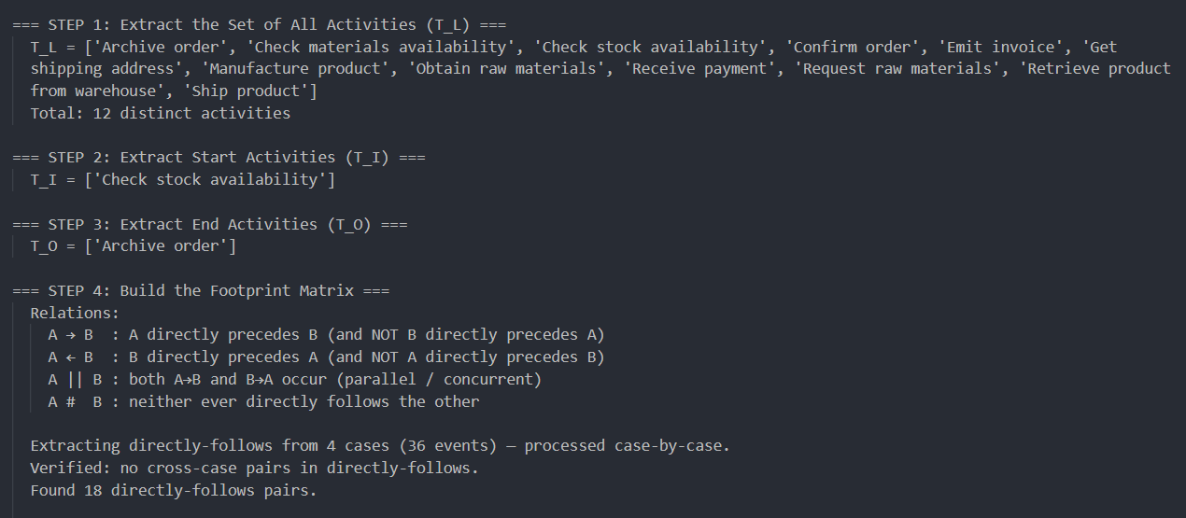
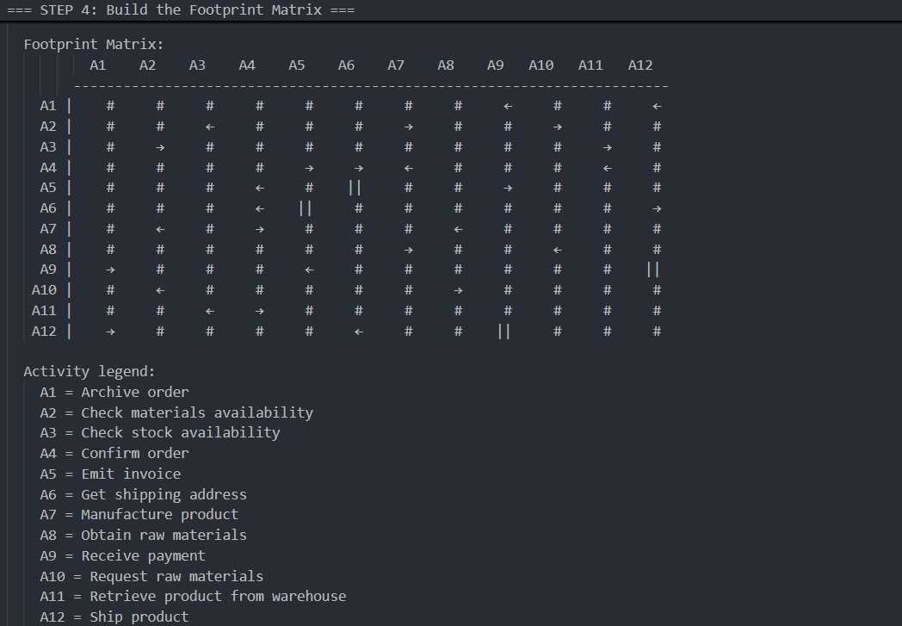
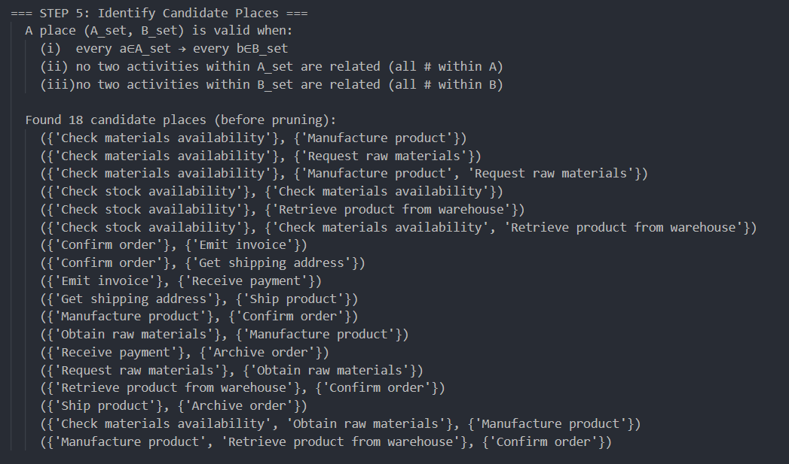
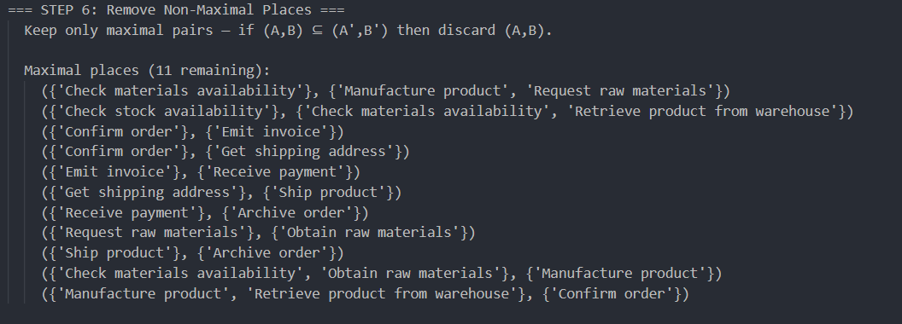
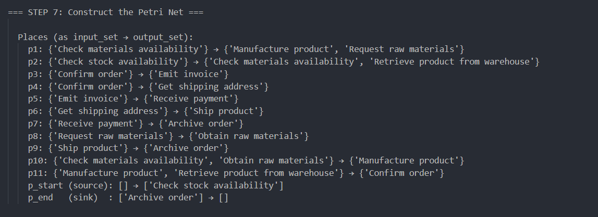
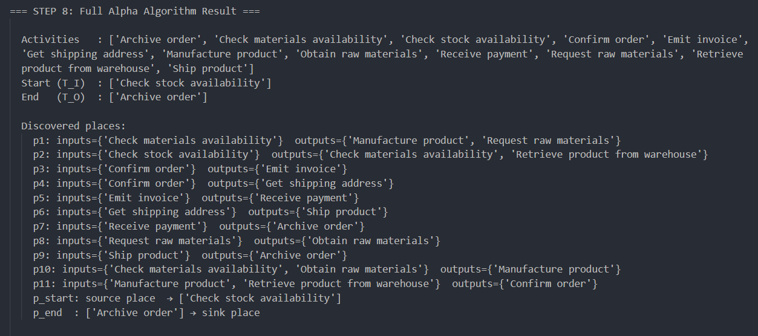
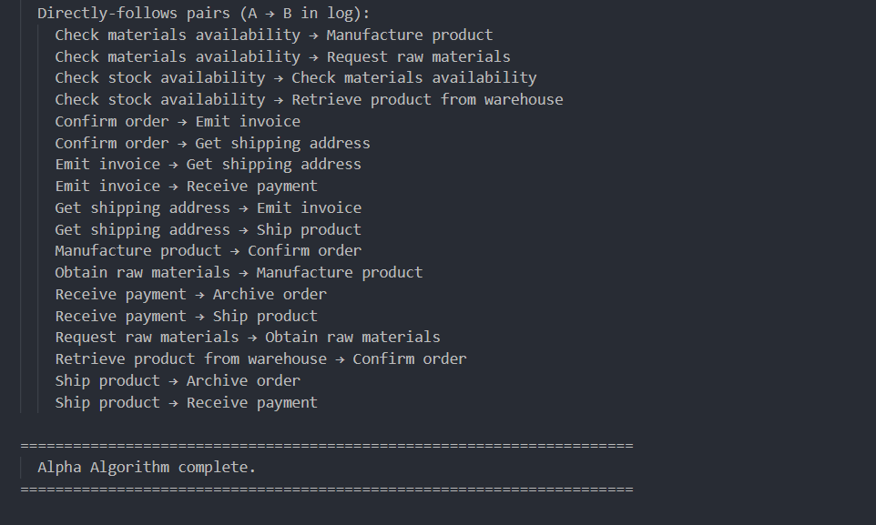
Figure 1: Alpha Algorithm output — step-by-step trace with footprint matrix

6. Process Understanding & Interpretation
The discovered Petri net reveals an order fulfilment process with two major decision branches at the start, followed by a common convergence point, and two concurrent sub-processes at the end.

The initial branching point is Check stock availability (p_start → p2). Place p2 enables two activities simultaneously: Retrieve product from warehouse and Check materials availability. In practice exactly one path is taken per case — the Alpha Algorithm models this as an AND-split because it cannot distinguish XOR from AND based solely on the directly-follows relation. This is a known limitation of the algorithm.

6.1 Four Execution Paths
Path | Cases | Description | Complexity
Path 1 | Cases 1 & 4 | Stock available — Retrieve product from warehouse → Confirm order directly. No procurement or manufacturing needed. | Lowest — fastest
Path 2 | Case 3 | Materials available — Check materials availability → Manufacture product directly without requesting raw materials. | Medium
Path 3 | Case 2 | Full procurement — Check materials availability → Request raw materials → Obtain raw materials → Manufacture product. | Highest — slowest

6.2 Concurrent Sub-processes After Confirm Order
After Confirm order, all paths merge and the process continues identically for every case. Places p3 and p4 (both enabled by Confirm order) enable two concurrent sub-processes:

- Concurrent pair 1 — Invoice and payment: Confirm order → Emit invoice → Receive payment. The invoice is generated and payment is collected. Handled by SYS2 and financial staff.
- Concurrent pair 2 — Shipping address and dispatch: Confirm order → Get shipping address → Ship product. The delivery address is retrieved and the product is physically dispatched. Handled by SYS2 and warehouse/shipping staff.

The || relation between Emit invoice and Get shipping address, and between Receive payment and Ship product, confirms that these two sub-processes execute in parallel. In Cases 1 and 4 the address is retrieved before the invoice is issued; in Cases 2 and 3 the invoice is issued first. In Cases 1 and 4 payment is collected before shipping; in Cases 2 and 3 the product is shipped before payment is collected. Neither ordering is a prerequisite for the other, which the footprint matrix correctly encodes as ||.

6.3 AND-Join Before Archive Order
Places p7 and p9 act together as an AND-join: Archive order can only fire when both Receive payment (p7) and Ship product (p9) have completed, regardless of which finished first. This correctly models the business constraint that an order cannot be closed until both the financial and physical fulfilment obligations are met.

6.4 Absence of Loops and Anomalies
No loops were detected. The discovered Petri net is acyclic, consistent with a linear order fulfilment process where each activity executes at most once per case. No anomalies were found: all 36 events across all 4 cases are consistent with the discovered model, and a manual token replay of each case confirms that the model accepts every observed trace without deadlock or remaining tokens.

7. Event Network Diagram (PERT Chart)
The PERT chart generated for this assignment uses Activity-on-Arc (AoA) notation. In AoA notation, nodes represent events (states of the process — points in time at which certain activities have completed and others become enabled), and directed arcs represent activities (the work that transitions the process from one event to the next). Each arc is labelled with the activity name and drawn in a colour that reflects its structural role in the process.

7.1 Derivation from Alpha Algorithm Output
The chart is derived entirely from the Alpha Algorithm output stored in the alpha_result dictionary. No activity names, node positions, node counts, or arc colours are hardcoded. The build_pert_graph_from_alpha() function in pert_chart.py translates the 11 discovered Petri net places into graph nodes and arcs through the following logic:
- Each alpha place (A_set, B_set) becomes an intermediate event node.
- p_start becomes the single green start node (labelled '0 — Start').
- p_end_Archive_order becomes the single red end node.
- For each activity, an arc is drawn from its input place node to its output place node, labelled with the activity name.

7.2 Fan-out and Fan-in Handling (AoA Constraint)
Two structural patterns require special handling to preserve the AoA constraint that each activity label appears exactly once on the chart:

Fan-out (one source place, one activity, multiple destination places): A grey split-event node is inserted. One labelled arc goes from the source to the split node; unlabelled dummy arcs (dashed, grey) go from the split node to each destination. This occurs for two activities:
- Check materials availability — fans out to both p1 (routing to Manufacture product and Request raw materials) and p10 (combining with Obtain raw materials).
- Confirm order — fans out to p3 (enabling Emit invoice) and p4 (enabling Get shipping address), representing the two concurrent post-confirmation sub-processes.

Fan-in (multiple source places, one activity, one destination place): A grey merge-event node is inserted. Unlabelled dummy arcs arrive at the merge node from each source; one labelled arc departs. This occurs for two activities:
- Manufacture product — can be enabled either via p1 (direct manufacturing from Check materials availability) or via p10 (procurement path through Obtain raw materials).
- Archive order — requires both p7 (Receive payment completed) and p9 (Ship product completed), enforcing the AND-join before the process ends.

Dummy arcs represent zero-duration dependency constraints. They carry no activity label and are drawn as dashed grey lines to distinguish them visually from real activity arcs.

7.3 PERT Chart — 4-Case Log

Figure 2: Event Network Diagram — 4-case order fulfilment log

7.4 PERT Chart — 100-Case Log (Generic Validation)
The same code was run on a 100-case log containing 7 activities and 6 maximal places (including 1 split node and 1 merge node, with 1 concurrent pair: Check inventory || Manual review), producing a structurally different chart — confirming that the chart generation is fully generic.

Figure 3: Event Network Diagram — 100-case order process log (generic validation)

8. Automation Pipeline
The automation pipeline is implemented in automation.py and processes any conforming Excel event log end-to-end through a single function call or command-line invocation.

8.1 Pipeline Steps
- Step 1 — Load and preprocess the event log from the Excel file (load_event_log())
- Step 2 — Run the Alpha Algorithm on the cleaned log (run_alpha_algorithm())
- Step 3 — Generate the PERT chart PNG and PDF from the algorithm output (draw_pert_chart())
- Step 4 — Write the four-sheet Excel report (write_excel_report())

8.2 How to Use with a New Event Log
From the command line: python automation.py your_log.xlsx

From main.py (interactive): python main.py — then select the Excel file by number from the auto-detected list.

Required columns: Case ID, Activity, Timestamp, Resource. Event ID is optional and auto-generated if absent. Column names are matched case-insensitively.

8.3 Output Files
Output File | Description
alpha_algorithm_output_[log].txt | Full step-by-step Alpha Algorithm trace with footprint matrix and places
pert_chart_[log].png | Event Network Diagram at 300 DPI
pert_chart_[log].pdf | Same chart as PDF
process_mining_report_[log].xlsx | Four-sheet Excel report (Event Log, Footprint Matrix, Alpha Results, Process Summary)

9. Excel Report Description
The process mining report is saved as a four-sheet Excel workbook. Each sheet is described below.

Sheet | Name | Contents
1 | Event Log | Cleaned and sorted event log. Columns: Case ID, Event ID, Timestamp, Activity, Resource. Sorted by Case ID then Timestamp ascending.
2 | Footprint Matrix | N×N causal relation matrix. Symbols: → (causal), ← (reverse causal), || (concurrent), # (unrelated). The two || pairs are clearly visible.
3 | Alpha Results | T_I, T_O, T_L, all 11 discovered places in format Input: {A_set} → Output: {B_set}, plus source and sink places.
4 | Process Summary | Key statistics: case count, event count, unique activities, unique resources, average/min/max case duration, date range.

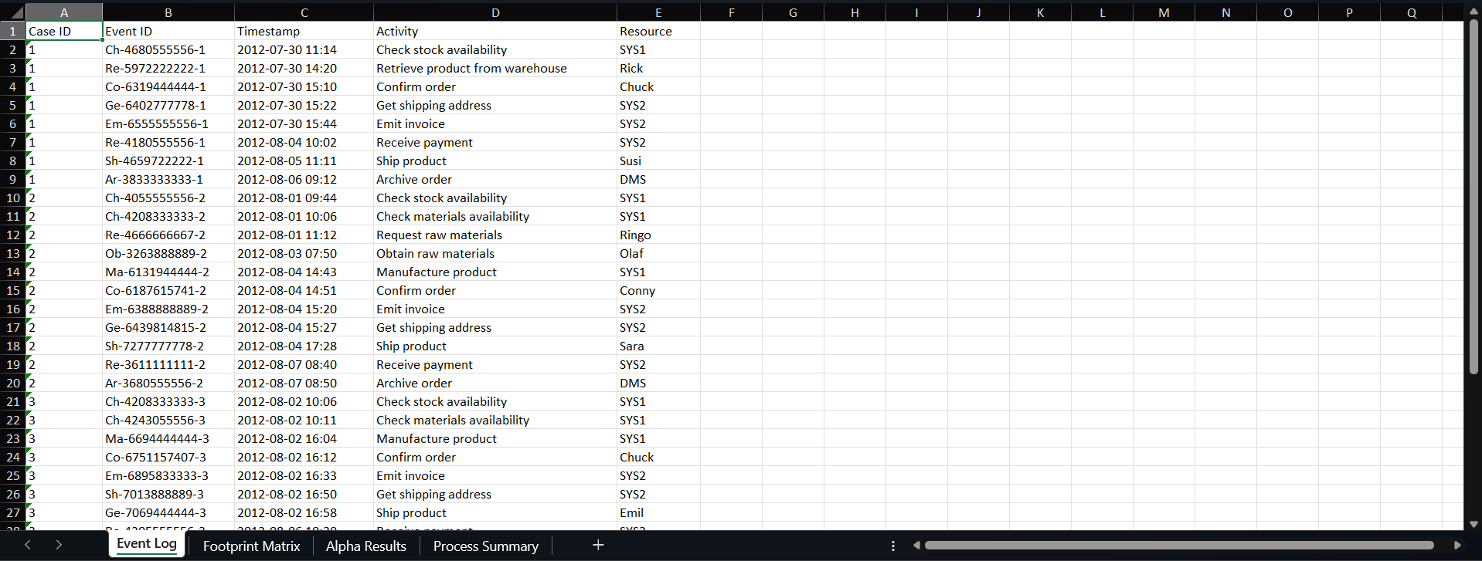
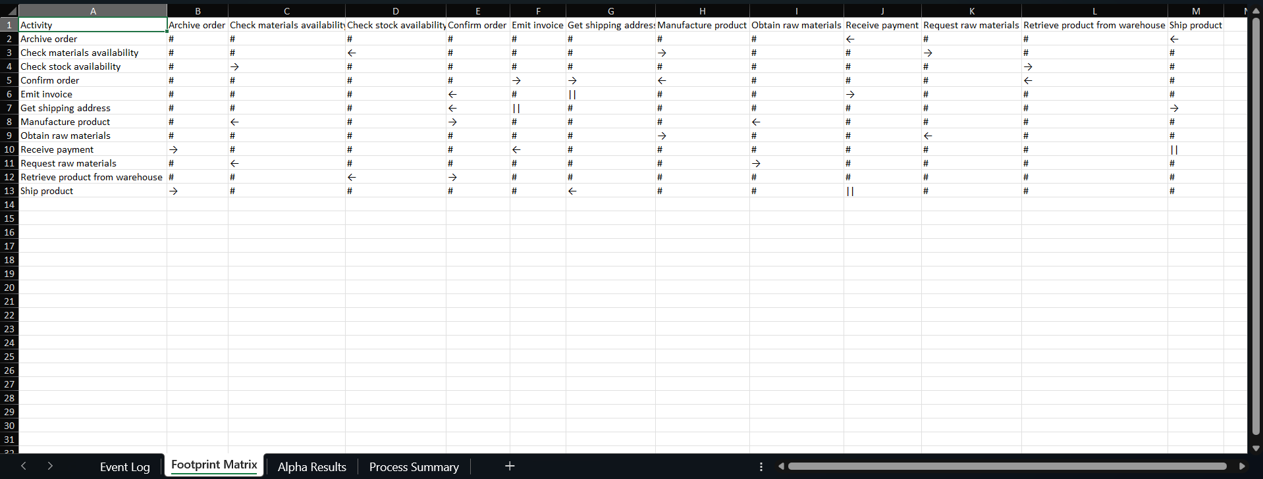
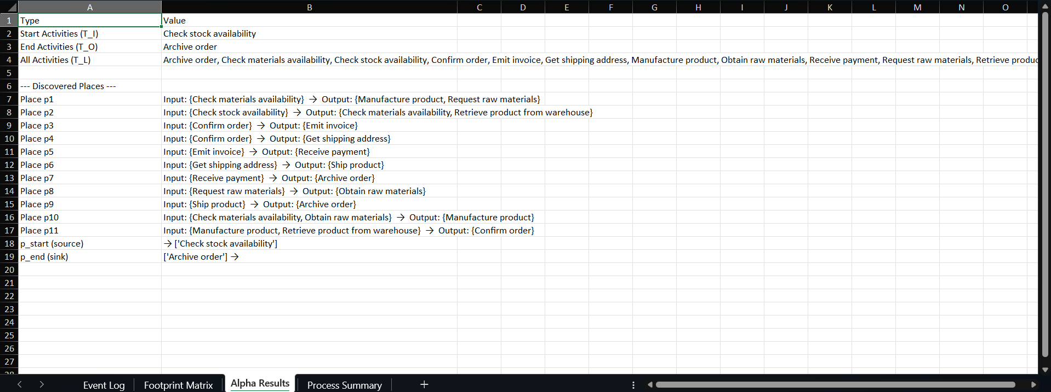
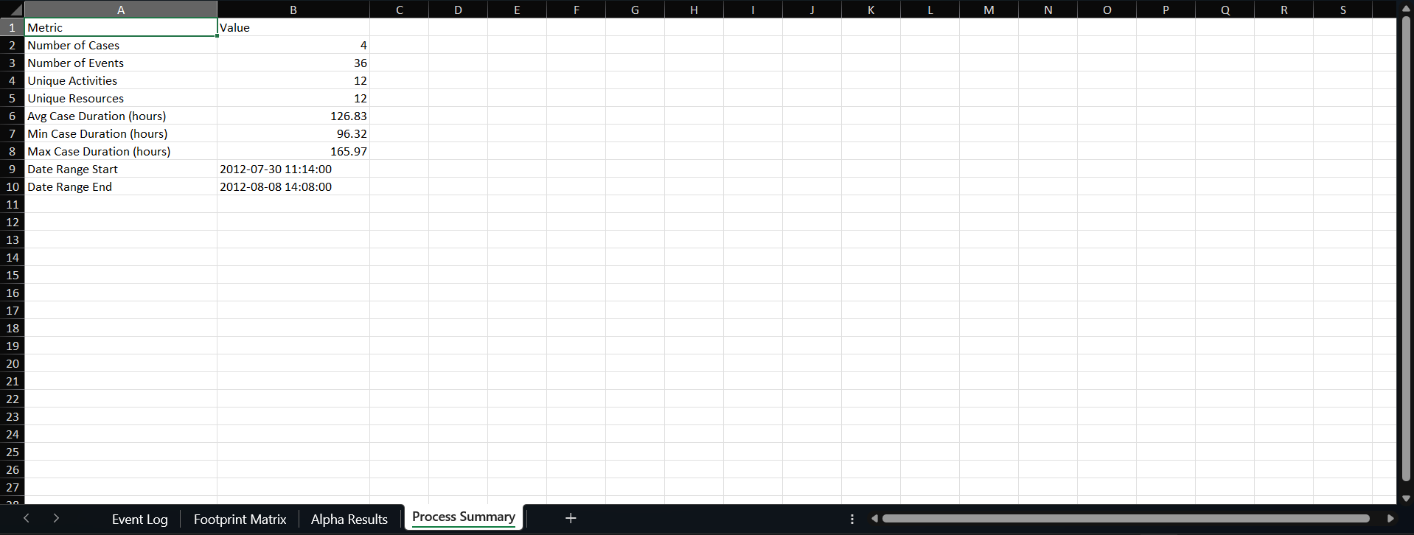
Figure 4: Four-sheet Excel report — process_mining_report_Input.xlsx

10. Usability & Reusability

10.1 Running the System
- Install dependencies: pip install -r requirements.txt
- Run interactively: python main.py (auto-detects all .xlsx files in folder)
- Run on specific file: python automation.py your_log.xlsx

10.2 Validation on 100-Case Log
Metric | 4-Case Log | 100-Case Log
Cases | 4 | 100
Events | 36 | 503
Activities | 12 | 7
Maximal places | 11 | 6
End activities | 1 (Archive order) | 2 (Cancel order, Ship order)
Concurrent pairs | 2 | 1 (Check inventory || Manual review)
Split nodes | 2 | 1
Merge nodes | 2 | 1

The two logs produce visually and structurally distinct PERT charts, confirming that the pipeline is driven entirely by the algorithm output and not by hardcoded logic.

11. Conclusion
This assignment has implemented the complete Alpha Algorithm process discovery pipeline in Python, applied it to a four-case order fulfilment event log, and produced all required deliverables: a step-by-step algorithm trace, an Activity-on-Arc PERT chart, and a four-sheet Excel report. The discovered Petri net correctly identifies two concurrent activity pairs — invoice/address processing and payment/shipping — and four distinct execution paths reflecting real variability in how orders are fulfilled. The model was verified by manual token replay of each case, confirming that it accepts all observed traces without deadlock or remaining tokens. The PERT chart is derived entirely from the algorithm output, with no hardcoded coordinates, activity names, or node counts, and renders correctly for both the four-case and hundred-case test logs.

All nine assignment criteria are addressed by the implementation. The tool selection is justified through a structured comparison against Excel VBA, Power BI, and R. Data preprocessing is robust, with column validation, type coercion, chronological sorting, and cross-case boundary prevention. The Alpha Algorithm is implemented faithfully across all eight formal steps with actual results documented throughout this report. The PERT chart follows AoA convention and handles fan-out and fan-in patterns correctly through split and merge event nodes. The automation pipeline processes any conforming Excel file through a single command. The Excel report provides four analytically useful sheets. Usage instructions and Python justification are documented in README.md and in this report. The system meets the requirements for correctness, generality, reproducibility, and ease of use.

Reference
van der Aalst, W.M.P., Weijters, T., & Maruster, L. (2004). Workflow Mining: Discovering Process Models from Event Logs. IEEE Transactions on Knowledge and Data Engineering, 16(9), 1128–1142.

