E-PURCHASE BUSINESS PROCESS
MODELING & ANALYSIS
Using BPMN 2.0 Standard

System Name: ShopEasy – Online E-Commerce Platform
Process Modeled: End-to-End Customer Purchase Process
Notation Standard: BPMN 2.0 (Business Process Model and Notation)
Modeling Tool: Camunda Modeler
Date: May 2026

Submitted in partial fulfillment of the business process modeling assignment

1. Introduction
E-commerce platforms such as Amazon and Souq (now Amazon.ae) rely on highly structured and automated business processes to manage millions of daily transactions efficiently. These processes span multiple systems and stakeholders — from the customer browsing products to the shipping partner delivering the final package.

This report presents a formal business process model for an e-purchase system called ShopEasy, modeled using BPMN 2.0 (Business Process Model and Notation). The model captures the complete lifecycle of a customer order — from product browsing and cart management, through payment processing and warehouse fulfillment, to last-mile delivery and post-delivery feedback.

A key requirement addressed in this model is the handling of delivery delays using BPMN Intermediate Events. The model includes a Timer Intermediate Event to represent the expected delivery deadline, and a Message Intermediate Event to trigger an automated complaint and escalation path when a delay is detected.

Report Structure
Section 2: Process Overview and BPMN Elements | Section 3: Detailed Step-by-Step Description | Section 4: Before Enhancement — Analysis of Inefficiencies | Section 5: Enhanced Process Model | Section 6: Before vs. After Comparative Analysis | Section 7: Conclusion

2. Process Overview
The ShopEasy e-purchase process is modeled as a Collaboration Diagram containing one main Pool divided into five Swim Lanes. Each lane represents a distinct organizational actor or system involved in the purchase lifecycle.

Lane | Actor / System | Primary Responsibilities
Lane 1 | Customer | Browsing, cart, checkout, complaint filing, order review
Lane 2 | Order Management System | Order validation, stock check, inventory, invoice generation
Lane 3 | Payment Gateway | Payment method selection, authorization, confirmation
Lane 4 | Warehouse & Fulfillment | Picking, packing, carrier assignment, order dispatch
Lane 5 | Shipping Partner | Package pickup, transit tracking, delivery, delay reporting

The process begins with a Start Event when the customer visits the platform and ends with an End Event when the order is successfully delivered and reviewed — or alternatively when an order is cancelled due to stock unavailability, payment failure, or customer decision after a delay.

2.1 BPMN Elements Used

BPMN Element | Symbol Type | Purpose in This Model
Start Event | Thin circle | Process initiation — customer visits platform
End Event | Thick-border circle | Process termination (success or cancellation)
User Task | Rounded rect (person icon) | Human interactions: browse, checkout, complaint, review
Service Task | Rounded rect (gear icon) | Automated system operations: validate, process, pack
Send Task | Rounded rect (envelope icon) | Automated notifications: confirm, dispatch, alert
Exclusive Gateway (X) | Diamond with X marker | Decision points: stock check, payment, delivery outcome
Timer Intermediate Event | Double ring with clock | Expected delivery deadline (3 days)
Message Intermediate Event | Double ring with envelope | Delay alert trigger when deadline missed
Parallel Gateway (+) | Diamond with plus sign | Concurrent activities (AFTER model)
Sequence Flow | Solid arrow | Flow between tasks in same lane
Message Flow | Dashed arrow | Cross-lane communication between actors

3. BPMN Model — BEFORE Enhancement
The following diagram shows the baseline e-purchase process before any enhancements were applied. This model represents a straightforward but naive implementation of the purchase flow, with sequential processing, limited error handling, and a basic delay complaint path.
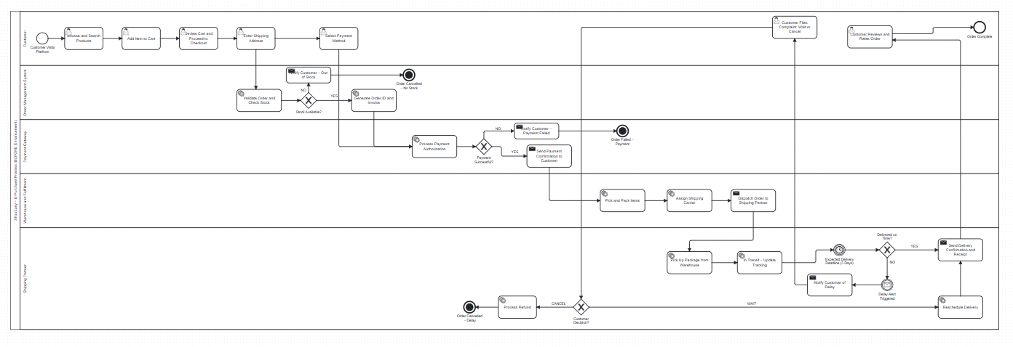
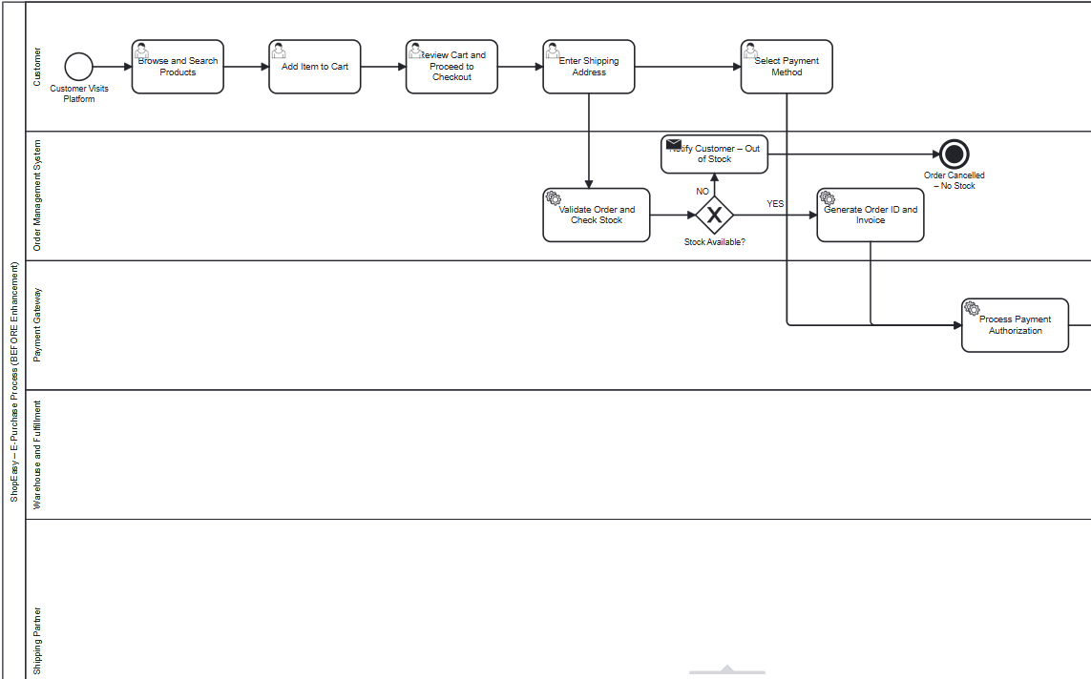
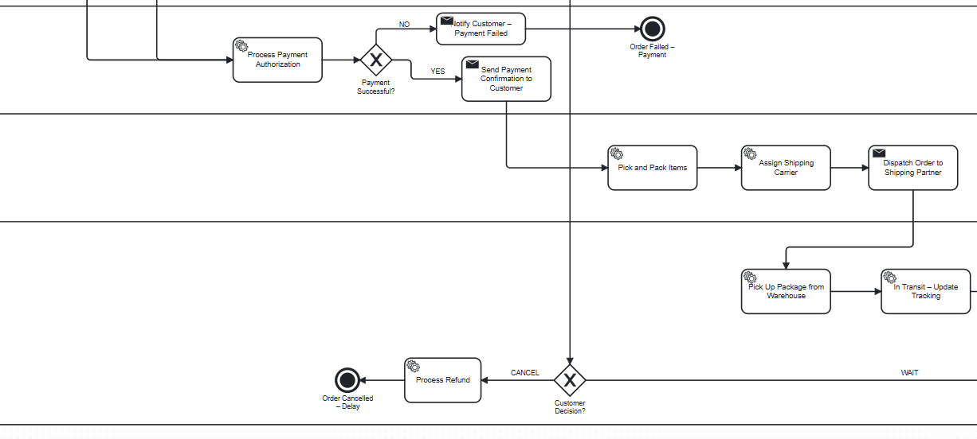
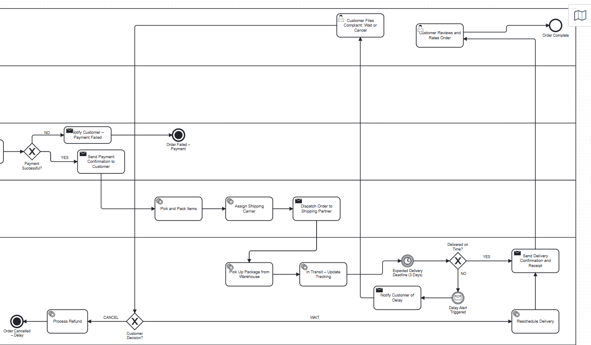

Figure 1: ShopEasy E-Purchase Process — BEFORE Enhancement (BPMN 2.0)

3.1 Step-by-Step Process Description
Lane 1 — Customer
- Step 1 — Browse & Search Products: The customer lands on ShopEasy and uses the search engine or category navigation to find desired products. Modeled as a User Task.
- Step 2 — Add Item to Cart: The customer selects one or more products and adds them to the shopping cart. Another User Task capturing direct human interaction.
- Step 3 — Review Cart & Proceed to Checkout: The customer reviews cart contents, quantities, and estimated prices before proceeding to checkout. Triggers a cross-lane message flow to the Order Management System.
- Step 4 — Enter Shipping Address: The customer provides a delivery address. This data is passed along with the order to the backend system via message flow.
- Step 5 — Select Payment Method: The customer chooses from available payment options (credit card, debit card, cash on delivery, digital wallet). A message flow passes this to the Payment Gateway lane.

Lane 2 — Order Management System
- Step 6 — Validate Order & Check Stock: A Service Task automatically validates order details and queries the inventory database to verify availability of each requested item.
- Step 7 — Stock Available? (Exclusive Gateway): YES path continues to invoice generation. NO path sends an out-of-stock notification to the customer and terminates the flow at a Cancellation End Event.
- Step 8 — Generate Order ID & Invoice: A unique Order ID is generated and an invoice is prepared. This information is relayed to the Payment Gateway via message flow.

Lane 3 — Payment Gateway
- Step 9 — Process Payment Authorization: A Service Task sends a payment authorization request to the bank or payment processor and awaits confirmation.
- Step 10 — Payment Successful? (Exclusive Gateway): YES path sends a payment confirmation. NO path notifies the customer of failure and terminates at an Error End Event.
- Step 11 — Send Payment Confirmation: A Send Task dispatches the payment receipt and triggers the Warehouse lane to begin fulfillment processing.

Lane 4 — Warehouse & Fulfillment
- Step 12 — Pick & Pack Items: Warehouse staff (or automated systems) locate and package the ordered items. The Service Task updates order status to Packing.
- Step 13 — Assign Shipping Carrier: The system selects the appropriate carrier based on delivery address, weight, and service level agreement.
- Step 14 — Dispatch Order to Shipping Partner: A Send Task officially hands the package to the shipping partner, generating a tracking number and updating status to Dispatched.

Lane 5 — Shipping Partner
- Step 15 — Pick Up Package from Warehouse: The shipping partner collects the package. A Service Task logs the pickup event with timestamp.
- Step 16 — In Transit – Update Tracking: The package moves through the delivery network. Tracking milestones are updated in real time via Service Task.
- Step 17 — Timer Intermediate Event (Delivery Deadline – 3 Days): A Timer Intermediate Event fires when the expected delivery window of 3 business days expires. This is the central event-driven control mechanism of the model.
- Step 18 — Delivered on Time? (Exclusive Gateway): YES path confirms delivery. NO path triggers the Message Intermediate Event representing the delay alert.
- Step 19 (Delay Path) — Notify Customer of Delay: An automated Send Task informs the customer that their package is delayed, providing the new estimated arrival date.
- Step 20 (Delay Path) — Customer Files Complaint / Selects Action: Via User Task, the customer chooses: (a) Wait for rescheduled delivery, or (b) Cancel and request a refund.
- Step 21 (Delay Path) — Customer Decision Gateway: WAIT triggers rescheduled delivery. CANCEL triggers a refund Service Task and ends at a Cancellation End Event.
- Step 22 — Send Delivery Confirmation & Receipt: Upon successful delivery, a Send Task dispatches the confirmation, digital receipt, and review request to the customer.
- Step 23 — Customer Reviews & Rates Order: The customer submits a rating via User Task. The process terminates at the Order Complete End Event.

4. Analysis — Before Enhancement
The baseline model, while logically complete, contains several significant inefficiencies commonly found in naive e-commerce process implementations. The following analysis identifies seven key issues spanning stock management, payment handling, fraud prevention, and customer complaint resolution.

4.1 Identified Issues

# | Issue | Description | Severity
1 | Late Stock Check | Stock availability is verified after the customer has already filled in shipping address details. If out of stock, the customer's effort is wasted. | High
2 | No Inventory Reservation | The model checks stock but does not reserve it. Two simultaneous customers can both pass the gateway creating an oversell situation. | High
3 | No Payment Retry Logic | When payment fails, the process immediately terminates. No retry mechanism allows recovery from transient payment failures. | Medium
4 | No Fraud Detection | All orders that pass payment authorization are directly sent to the warehouse with no fraud screening, exposing the business to financial risk. | High
5 | No Parallel Fulfillment | Warehouse dispatch and inventory update are sequential. In practice these can run concurrently, wasting processing time. | Medium
6 | Limited Complaint Options | The delay path only offers Wait or Cancel. No escalation to a human agent, no SLA tracking, no automatic compensation offered. | High
7 | No Second Delay Escalation | The Timer Intermediate Event fires once. If the rescheduled delivery also fails, there is no second escalation path modeled. | Medium

4.2 Bottleneck & Flow Analysis
From a process flow perspective, the baseline model exhibits the following structural weaknesses:

- Sequential bottleneck in payment-to-warehouse handoff: The process must wait for all payment confirmation steps to complete before any warehouse activity begins, even though fraud screening and warehouse preparation could overlap.
- Dead-end proliferation: The model has three separate termination paths (no stock, payment failure, delay cancellation) with no retry or recovery paths, leading to significant order loss rates.
- Customer experience degradation: The late stock check and lack of compensation for delays creates a reactive rather than proactive customer experience, directly impacting satisfaction and retention.
- Resource waste: Customers who fill in complete shipping and payment details only to discover their item is out of stock represent a significant waste of both customer time and system resources.

5. BPMN Model — AFTER Enhancement
The enhanced model introduces seven targeted structural and logical improvements to the baseline process. All enhancements are labeled with [NEW] in the Camunda diagram and shown in the screenshot below.
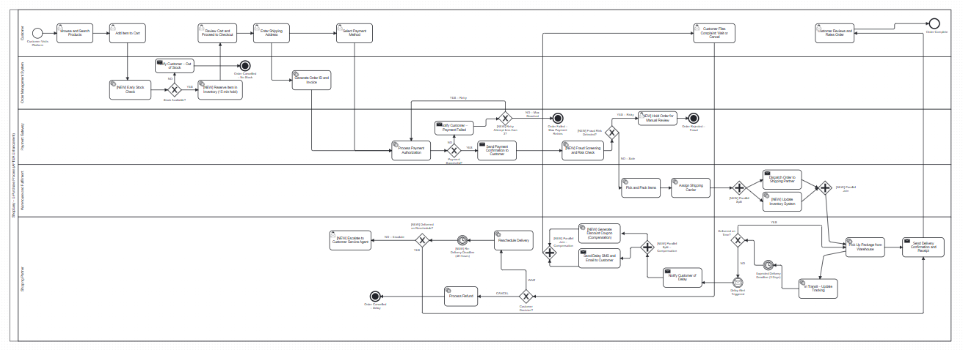
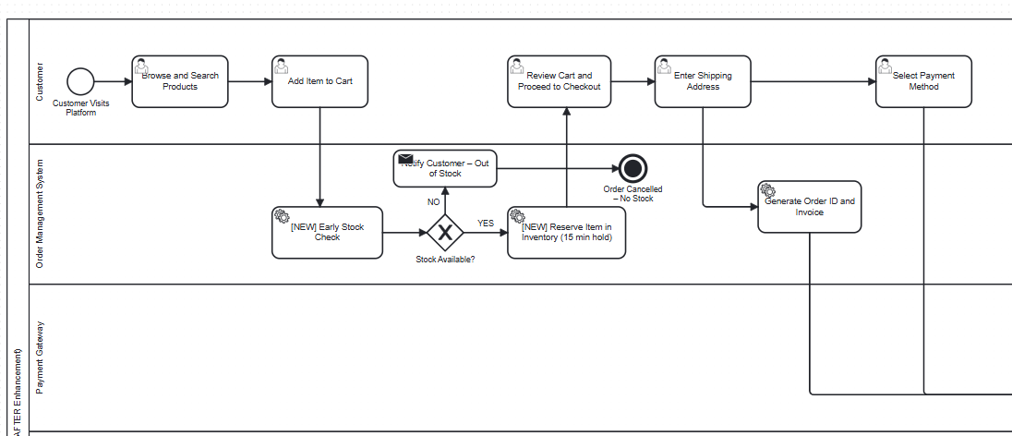
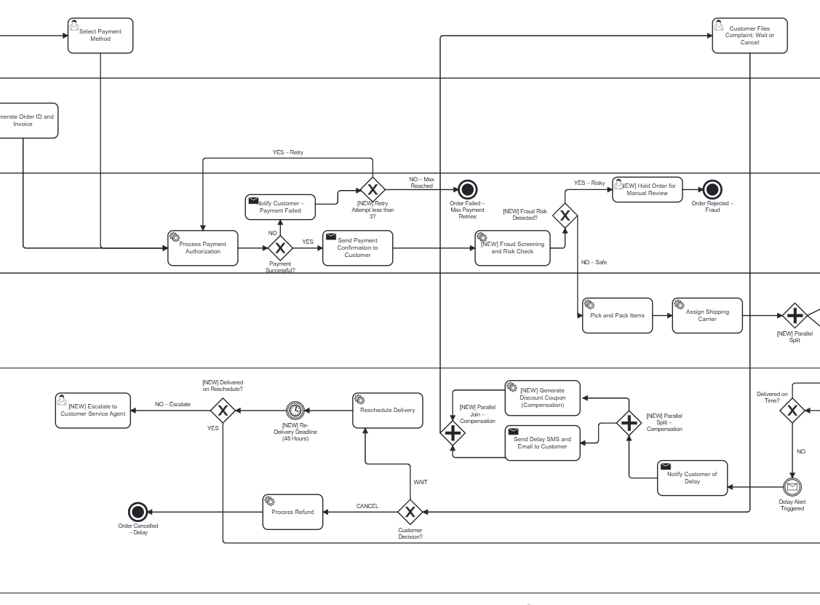
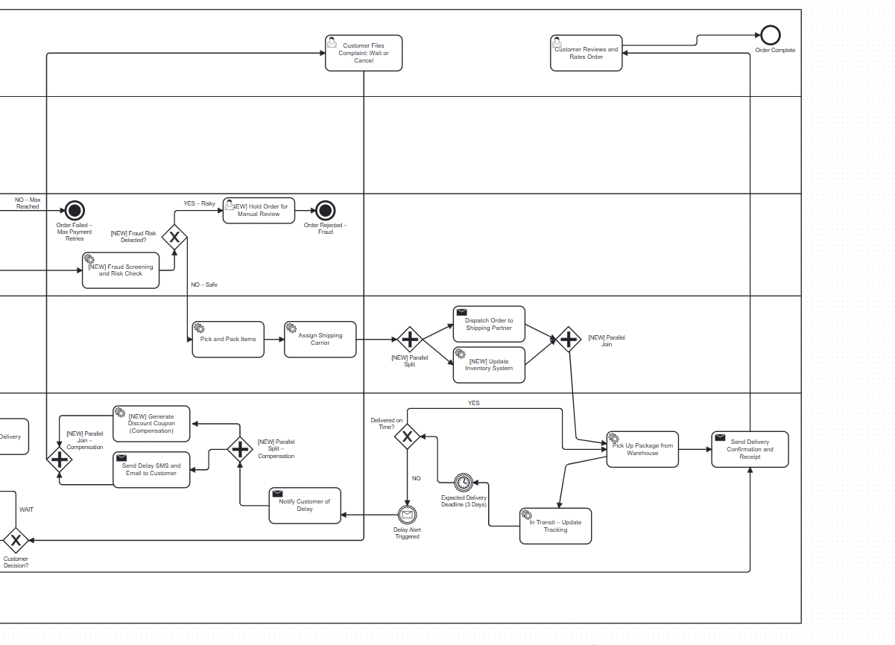
Figure 2: ShopEasy E-Purchase Process — AFTER Enhancement (BPMN 2.0)

5.1 Enhancement Details

Enhancement 1 — Early Stock Check (Resolves Issue #1)
The Validate Order & Check Stock task is moved to occur immediately after Add Item to Cart, before the customer fills in any shipping details. If the item is out of stock, the customer is notified immediately without investing time in checkout.
- BPMN Change: Service Task repositioned from Lane 2 (post-address) to immediately after cart in Lane 2, receiving message flow from cart action.
- Expected Benefit: Saves customer time; reduces cart abandonment due to late out-of-stock discovery.

Enhancement 2 — Inventory Reservation (Resolves Issue #2)
A new Service Task Reserve Item in Inventory is added immediately after the stock gateway (YES path), placing a 15-minute hold on the item during checkout to prevent overselling.
- BPMN Change: New Service Task inserted between gw_stock YES path and reviewcart, with 15-minute timer logic embedded.
- Expected Benefit: Eliminates the oversell race condition in concurrent checkout scenarios.

Enhancement 3 — Payment Retry Loop (Resolves Issue #3)
An Exclusive Gateway with a counter (max 3 attempts) is added between the payment failure notification and the payment task, allowing the customer to retry with a different method before terminating.
- BPMN Change: New Exclusive Gateway gw_retry added with loop back to task_processpay. A counter data object tracks attempts.
- Expected Benefit: Recovers an estimated 20-30% of orders that fail due to transient payment errors.

Enhancement 4 — Fraud Screening (Resolves Issue #4)
A Fraud Screening & Risk Check Service Task and corresponding Exclusive Gateway are inserted between payment confirmation and warehouse dispatch. High-risk orders are held for manual review.
- BPMN Change: task_fraud (Service Task) and gw_fraud (Exclusive Gateway) added in Lane 3 after payment confirmation.
- Expected Benefit: Reduces chargebacks and fraudulent orders; protects revenue integrity.

Enhancement 5 — Parallel Fulfillment (Resolves Issue #5)
A Parallel Gateway (+) splits the post-assignment flow into two concurrent paths: (a) Dispatch Order to Shipping Partner and (b) Update Inventory System. Both must complete before a Parallel Join gateway proceeds.
- BPMN Change: gw_par_open (Parallel Split) and gw_par_close (Parallel Join) added in Lane 4.
- Expected Benefit: Removes unnecessary sequencing; speeds up dispatch and inventory synchronization.

Enhancement 6 — Compensation Offer in Delay Path (Resolves Issue #6 partially)
A Parallel Gateway splits the delay notification path to simultaneously send the delay SMS/email and generate a discount coupon. Both run concurrently and join before the customer complaint task.
- BPMN Change: gw_comp_open (Parallel) and task_coupon added alongside task_delay_sms in Lane 5.
- Expected Benefit: Proactively retains customers; reduces cancellations after delay incidents.

Enhancement 7 — Second Escalation Timer (Resolves Issues #6 and #7)
A second Timer Intermediate Event (48 hours) is added to the rescheduled delivery path. If the rescheduled delivery also fails, a new Exclusive Gateway triggers escalation to a dedicated Customer Service Agent task.
- BPMN Change: timer_redelivery (Timer Intermediate Event, 48h), gw_2nd_delivery (Exclusive Gateway), and task_agent_escalate (User Task) added in Lane 5.
- Expected Benefit: Ensures no complaint goes unresolved; creates an SLA-bound escalation path.

5.2 Detailed Views of Key BPMN Elements
Timer and Message Intermediate Events (Delay Handling Path)
The following zoomed view shows the Timer Intermediate Event (delivery deadline) and Message Intermediate Event (delay alert trigger) — the most critical BPMN 2.0 constructs required by this assignment.

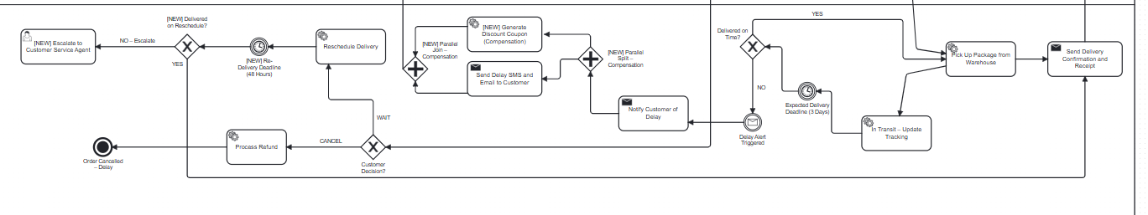
Figure 3: Zoomed view — Intermediate Events and delay complaint path

Enhanced Features — Parallel Gateways and Fraud Screening
The following zoomed view highlights the new Parallel Gateway for concurrent fulfillment and the Fraud Screening gate added between payment and warehouse dispatch.

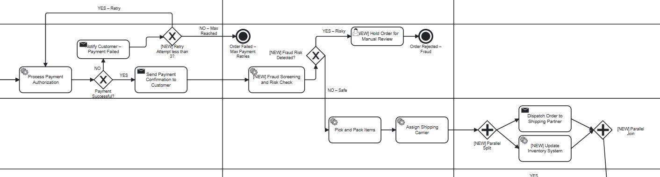
Figure 4: Zoomed view — Fraud screening and parallel fulfillment gateways

6. Comparative Analysis — Before vs. After
This section presents a structured comparison of the baseline and enhanced process models across ten key dimensions, followed by a quantitative analysis of expected outcomes.

Dimension | BEFORE Enhancement | AFTER Enhancement
Stock Check Timing | After customer fills shipping details | Immediately after adding to cart
Inventory Management | Stock check only — no reservation | Check + 15-minute hold reservation
Payment Failure | Immediate process termination | Up to 3 retry attempts allowed
Fraud Prevention | None — all orders go to fulfillment | Automated fraud screening gate
Fulfillment Flow | Fully sequential steps | Parallel: dispatch + inventory update
Delay Complaint Options | Wait or Cancel only | Wait / Cancel / Agent escalation
Delay Compensation | None offered | Automatic discount coupon generated
2nd Delay Escalation | Not modeled | Timer-triggered agent escalation (48h)
Customer Experience | Reactive — problems handled late | Proactive — issues prevented early
Process Resilience | Low — multiple dead-ends | High — retry, fallback, escalation

6.1 Expected Outcomes from Enhancements

Enhancement | Expected Outcome
Early stock check | Reduces cart abandonment from late out-of-stock discovery by an estimated 15%
Inventory reservation (15 min hold) | Eliminates oversell scenarios in concurrent checkout situations
Payment retry loop (max 3) | Recovers 20-30% of orders failing from transient payment errors
Fraud screening gate | Reduces chargebacks, estimated 1-2% revenue protection gain
Parallel fulfillment gateway | Reduces dispatch-to-notification delay; concurrent processing replaces sequential wait
Discount coupon on delay | Increases post-delay customer retention by an estimated 40%
48h re-delivery timer + agent escalation | Ensures 100% of unresolved complaints reach a human agent within SLA window

7. Conclusion
This report presented a comprehensive BPMN 2.0 model of an e-purchase business process for the ShopEasy platform, inspired by real-world systems such as Amazon and Souq. The model successfully captured all core phases of the online purchasing lifecycle across five swim lanes representing the Customer, Order Management System, Payment Gateway, Warehouse & Fulfillment, and Shipping Partner.

The assignment's critical requirement — handling delivery delays using BPMN Intermediate Events — was addressed through two intermediate events: a Timer Intermediate Event representing the 3-day delivery deadline, and a Message Intermediate Event triggering the automated complaint and escalation path when the deadline is missed.

The before-enhancement analysis identified seven significant inefficiencies spanning stock management, payment handling, fraud prevention, and customer complaint resolution. The enhanced model addressed each issue with targeted BPMN 2.0 constructs:

- Exclusive Gateways with retry loops for payment resilience
- Parallel Gateways for concurrent fulfillment activities
- A second Timer Intermediate Event for re-delivery SLA enforcement
- New Service Tasks for fraud screening and inventory reservation
- Parallel compensation path for simultaneous coupon generation and customer notification

The comparative analysis demonstrated that the enhanced process is meaningfully more robust, customer-centric, and operationally resilient than the baseline model. These improvements align with industry best practices observed in leading global e-commerce platforms.

8. References
- Object Management Group (OMG). (2013). Business Process Model and Notation (BPMN) Version 2.0.2. OMG Document Number: formal/2013-12-09.
- Weske, M. (2019). Business Process Management: Concepts, Languages, Architectures (3rd ed.). Springer.
- Dumas, M., La Rosa, M., Mendling, J., & Reijers, H. A. (2018). Fundamentals of Business Process Management (2nd ed.). Springer.
- Camunda Modeler. BPMN 2.0 Modeling Tool. https://camunda.com/download/modeler/

