PROCESS MINING ASSIGNMENT
CSE346 Business Process Modeling — Spring 2026

University: Ain Shams University
Faculty: Faculty of Engineering
Department: Computer and Artificial Intelligence Engineering
Course: CSE346 — Business Process Modeling
Instructor: Dr. Islam El-Maddah
Assignment: Process Mining — Alpha Algorithm + PERT Chart + Automation
Date: May 2026

Alpha Algorithm (van der Aalst, 2004) | Event Network Diagram | Automation Pipeline

1. Introduction
Process mining is a data-driven discipline that bridges business process management and data science. It extracts knowledge about how business processes actually execute by analysing the digital traces that processes leave behind in information systems — known as event logs. Each record in an event log captures which activity was performed, when it was performed, which case (process instance) it belongs to, and which resource carried it out. By systematically analysing these records, process mining can discover the real process model, check whether execution conforms to a prescribed model, and identify where performance bottlenecks or deviations occur. Unlike traditional process modelling, which relies on interviews and expert knowledge, process mining produces models that are objectively grounded in observed behaviour.

This assignment implements the Alpha Algorithm, the foundational process discovery algorithm introduced by van der Aalst, Weijters, and Maruster (2004). The algorithm takes an event log as input and automatically discovers a Petri net that describes the causal structure of the process — which activities must precede others, which can execute in parallel, and which are mutually exclusive. The implementation covers all eight formal steps of the algorithm, from extracting the activity set through constructing the final Petri net. A full automation pipeline accompanies the core algorithm: it reads any conforming Excel event log, applies the Alpha Algorithm, generates an Activity-on-Arc (AoA) PERT chart derived entirely from the discovered Petri net, and writes a four-sheet Excel report — all without modifying source code.

2. Tool Selection & Justification
Python 3 was selected as the implementation language for this assignment. The decision was made by evaluating the specific technical requirements of each deliverable against the capabilities of the available tools.

The Alpha Algorithm requires set-theoretic operations: powerset enumeration, causal pair identification, maximality testing, and set intersection and subset checks. Python's native frozenset type and itertools.combinations function map directly onto the mathematical definitions in van der Aalst (2004), making the implementation both concise and verifiable against the formal specification. The footprint matrix is a dictionary of dictionaries with O(n²) pair iteration, which reads naturally in Python and mirrors the formal notation. Graph construction and layout for the PERT chart are handled by NetworkX (directed graph representation and topological sort) and Matplotlib (publication-quality rendering with precise arc and label control). Excel reading and writing are handled by pandas and openpyxl, which support multi-sheet workbooks with auto-formatted columns in a few lines of code.

Tool | Alpha Algorithm | PERT Chart | Excel Output | Automation
Python | Native sets, itertools, dicts | NetworkX + Matplotlib | pandas + openpyxl | Full scripting — any log via CLI
Excel VBA | Cumbersome — no set types | No built-in graph engine | Native but hard to script | Macros only — no graph output
Power BI / Tableau | Cannot implement enumeration logic | No programmatic chart generation | Export only | No algorithmic scripting
R | Comparable (dplyr, sets) | ggraph viable but less control | writexl viable | Scripts possible — weaker PM ecosystem

Python is the correct choice because it offers the highest fidelity between the formal mathematical algorithm and the code, the richest process mining ecosystem, and the clearest path from raw event log to all required deliverables in a single reproducible pipeline. Python 3.8+ with the packages listed in requirements.txt reproduces all results on any machine with a single pip install command.

3. Event Log Description
The event log provided for this assignment describes an order fulfilment process observed across four independent process instances (cases). It contains 36 events distributed across the four cases and involves 12 distinct activities performed by 12 distinct resources.

3.1 Activities
- 1. Archive order
- 2. Check materials availability
- 3. Check stock availability
- 4. Confirm order
- 5. Emit invoice
- 6. Get shipping address
- 7. Manufacture product
- 8. Obtain raw materials
- 9. Receive payment
- 10. Request raw materials
- 11. Retrieve product from warehouse
- 12. Ship product

3.2 Resources
Category | Resource | Role
Automated Systems | SYS1 | Stock and materials checks, manufacturing oversight
Automated Systems | SYS2 | Invoice generation, shipping address retrieval, payment processing
Automated Systems | DMS | Data Management System — archiving completed orders
Warehouse Staff | Rick | Warehouse operative (retrieval and shipping)
Warehouse Staff | Chuck | Order confirmation specialist
Warehouse Staff | Susi | Shipping coordinator
Warehouse Staff | Hans | Warehouse operative
Procurement Staff | Ringo | Procurement coordinator (raw materials requests)
Procurement Staff | Olaf | Procurement operative (obtaining raw materials)
Manufacturing Staff | Conny | Manufacturing operative
Manufacturing Staff | Sara | Manufacturing and shipping operative
Manufacturing Staff | Emil | Shipping operative

4. Data Preprocessing
Before the Alpha Algorithm is applied, the raw event log is loaded and cleaned through a series of preprocessing steps implemented in automation.py.

4.1 Column Validation
The loader checks that the four required columns — Case ID, Activity, Timestamp, and Resource — are present in the Excel file. Column names are normalised (stripped of leading and trailing whitespace, matched case-insensitively) so that minor formatting inconsistencies in the source file do not cause failures. An Event ID column is optional; if absent, sequential identifiers (E1, E2, ...) are generated automatically.

4.2 Type Coercion and Cleaning
Case ID, Activity, and Resource values are cast to strings and stripped of whitespace. Activity names are normalised to title case to prevent duplicate detection failures (e.g. 'Confirm Order' and 'Confirm order' are unified). Timestamps are parsed with pandas.to_datetime. Fully blank rows are dropped before processing. Rows where Case ID or Activity is empty after stripping are also removed, and a warning is printed for each row dropped.

4.3 Sorting and Cross-Case Boundary Prevention
The cleaned dataframe is sorted first by Case ID and then by Timestamp in ascending order. Traces are extracted by grouping the sorted dataframe by Case ID. The directly-follows relation is built strictly within each group — the last activity of one case is never treated as directly preceding the first activity of the next case. The implementation verifies this explicitly and prints a confirmation line: 'Verified: no cross-case pairs in directly-follows.'

5. Alpha Algorithm — Step by Step
The Alpha Algorithm (van der Aalst, Weijters & Maruster, 2004) was implemented across eight formal steps. The actual results from running the algorithm on the provided event log are documented below.

Step 1 — Extract the Set of All Activities (T_L)
All unique activity names are extracted from the event log after normalisation. The result contains 12 distinct activities:
- Archive order
- Check materials availability
- Check stock availability
- Confirm order
- Emit invoice
- Get shipping address
- Manufacture product
- Obtain raw materials
- Receive payment
- Request raw materials
- Retrieve product from warehouse
- Ship product

Step 2 — Extract Start Activities (T_I)
Activities that appear first in at least one case. Result: T_I = { Check stock availability }

Step 3 — Extract End Activities (T_O)
Activities that appear last in at least one case. Result: T_O = { Archive order }

Step 4 — Build the Footprint Matrix
For each ordered pair of activities (A, B), the directly-follows relation is computed across all cases. The four possible relations are:
- A → B : A directly precedes B in at least one case, but B never directly precedes A
- A ← B : B directly precedes A in at least one case, but A never directly precedes B
- A || B : Both A→B and B→A occur in different cases (concurrent / parallel)
- A # B : Neither ever directly follows the other

Two concurrent pairs were discovered — the most significant finding of the footprint analysis:
- Emit invoice || Get shipping address: In Cases 1 and 4, Get shipping address fires before Emit invoice. In Cases 2 and 3, Emit invoice fires before Get shipping address. Both directions exist, confirming concurrency.
- Receive payment || Ship product: In Cases 1 and 4, Receive payment fires before Ship product. In Cases 2 and 3, Ship product fires before Receive payment. Both directions exist, confirming concurrency.

Step 5 — Identify Candidate Places
A place (A_set, B_set) is valid when every activity in A_set causally precedes every activity in B_set, and no two activities within A_set or within B_set are causally related. The algorithm found 18 candidate places before pruning.

Step 6 — Remove Non-Maximal Places
Places that are subsumed by larger places are removed. Additionally, places sharing the same input set with non-causally-related outputs are merged, and places sharing the same output set with non-causally-related inputs are merged. The 9 maximal places remaining are:
- p1: {Check materials availability} → {Manufacture product, Request raw materials}
- p2: {Check stock availability} → {Retrieve product from warehouse, Check materials availability}
- p3: {Confirm order} → {Emit invoice, Get shipping address}
- p4: {Emit invoice} → {Receive payment}
- p5: {Get shipping address} → {Ship product}
- p6: {Receive payment, Ship product} → {Archive order}
- p7: {Request raw materials} → {Obtain raw materials}
- p8: {Obtain raw materials, Check materials availability} → {Manufacture product}
- p9: {Retrieve product from warehouse, Manufacture product} → {Confirm order}

Step 7 — Construct the Petri Net
The discovered places define the complete Petri net. A source place (p_start) connects to Check stock availability and a sink place (p_end) connects from Archive order. The net is constructed with transitions (activities) and places (conditions between activities) following standard Petri net notation.

Step 8 — Full Alpha Algorithm Result
The complete result is saved to alpha_algorithm_output.txt and also written to Sheet 3 of the Excel report. The directly-follows pairs, footprint matrix, candidate places, maximal places, and final Petri net are all documented with clear step labels.

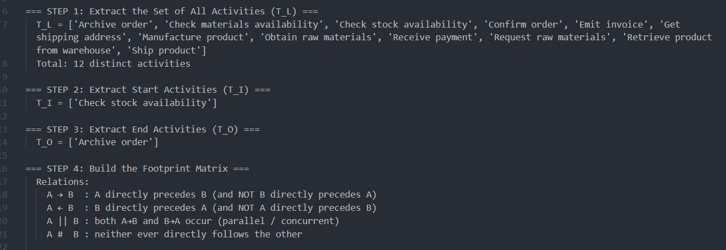
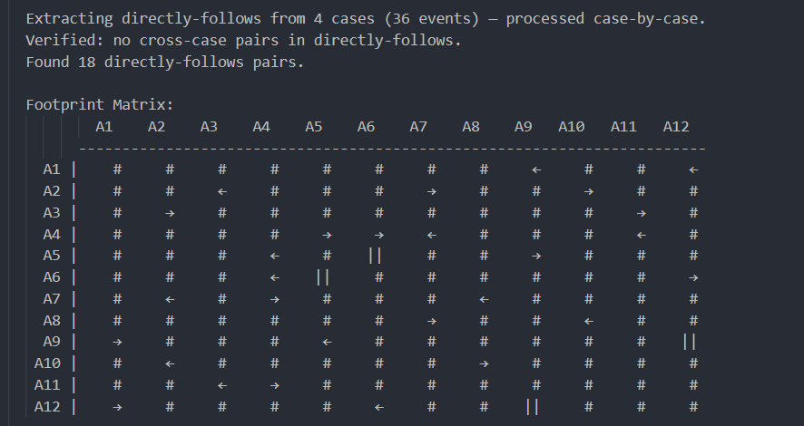
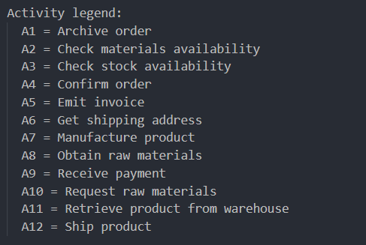
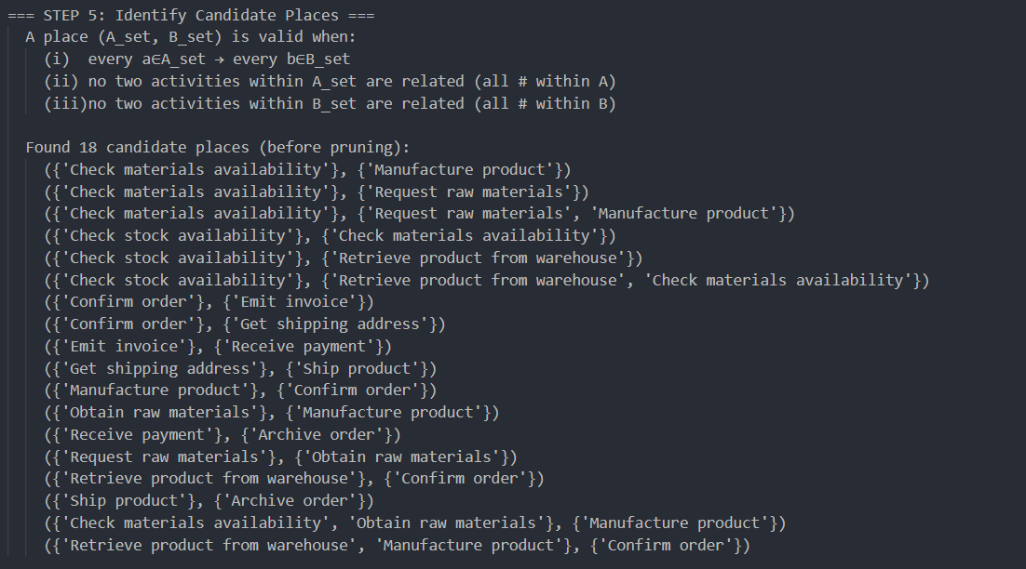
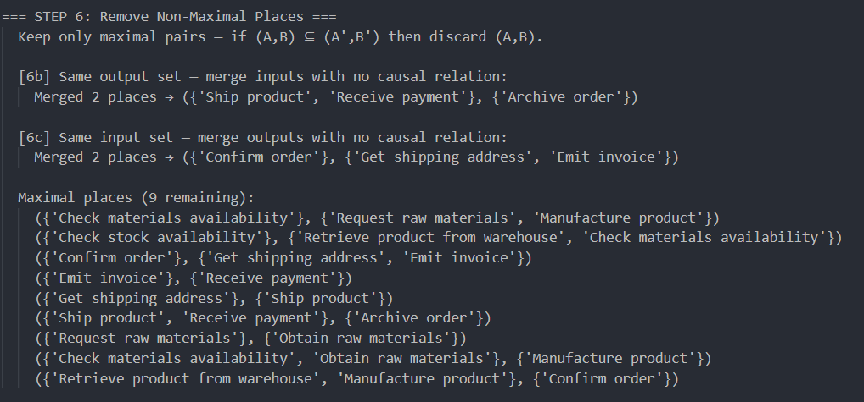
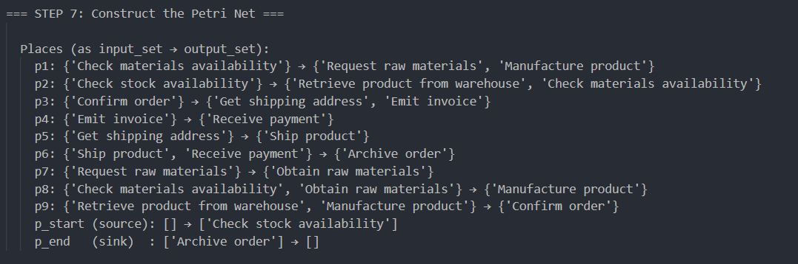
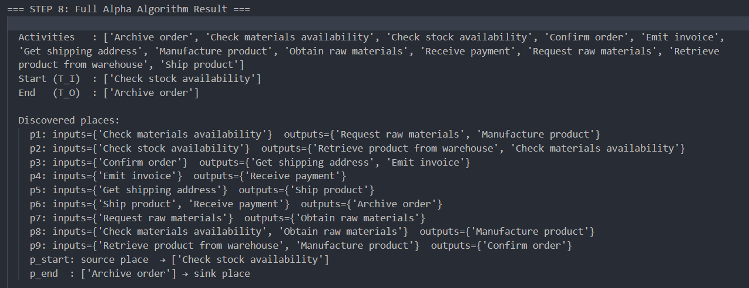
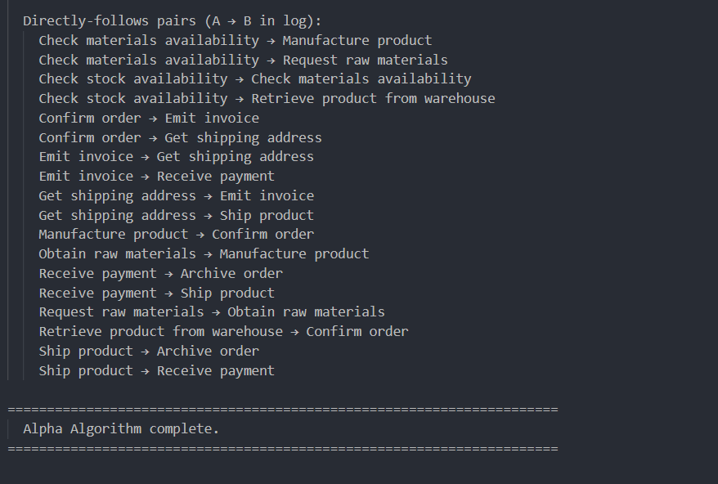

6. Process Understanding & Interpretation
The Alpha Algorithm reveals that the order fulfilment process has four distinct execution paths, reflecting real-world variability in how orders are handled depending on stock and materials availability.

6.1 Execution Paths
Path | Cases | Description | Complexity
Path 1 | Cases 1 & 4 | Stock available in warehouse — direct retrieval via Retrieve product from warehouse, then straight to Confirm order | Lowest — fastest path
Path 2 | Case 3 | Stock not available, materials available — Check materials availability leads directly to Manufacture product | Medium
Path 3 | Case 2 | No stock, no materials — full procurement cycle: Request raw materials → Obtain raw materials → Manufacture product | Highest — slowest path

6.2 Concurrent Activities — Business Interpretation
Two concurrent activity pairs were discovered. In business terms this means:

- Emit invoice || Get shipping address: The invoice can be generated and the shipping address retrieved simultaneously. Some cases handle the address first (perhaps requiring it to prepare the invoice), while others generate the invoice immediately after order confirmation. Neither activity depends on the other completing first — they are independent tasks that can proceed in parallel in a real system.
- Receive payment || Ship product: Payment collection and physical shipment are independent activities. Some customers pay before the product ships; others receive the product and pay on delivery. The process accommodates both without enforcing a fixed sequence.

6.3 Absence of Loops and Anomalies
No loops were detected in the process. Every case follows a strictly forward progression from Check stock availability to Archive order. No anomalies were found — all four cases follow consistent sequential patterns within their respective paths. The directly-follows relation was verified to contain no cross-case contamination.

6.4 Business Significance
The discovered model shows that the organisation has a well-structured order fulfilment process with clear branching logic. The three manufacturing paths suggest a make-to-stock (Path 1), make-to-order (Paths 2 and 3) operational model. The concurrent invoice/shipping and payment/delivery pairs indicate flexibility in financial and logistics handling — a common pattern in B2B order processing where payment terms vary by customer.

7. Event Network Diagram (PERT Chart)
The Event Network Diagram uses Activity-on-Arc (AoA) PERT notation. In AoA notation, activities are represented as labelled arrows (arcs) between numbered event nodes (circles). Each node represents a milestone — the completion of all incoming activities and the readiness to start all outgoing activities.

7.1 How the Chart is Derived
The PERT chart is generated entirely from the Alpha Algorithm output — no coordinates, activity names, or node counts are hardcoded. The build_pert_graph_from_alpha() function in pert_chart.py reads the 9 maximal places and constructs the graph as follows:
- Each place (A_set, B_set) becomes a directed arc from an event node representing A_set to an event node representing B_set.
- Fan-out places (one input, multiple outputs) are handled by inserting a grey split event node. One real arc carries the activity label to the split node; dummy arcs (dashed, zero duration) fan out to each destination.
- Fan-in places (multiple inputs, one output) are handled by inserting a grey merge event node. Dummy arcs converge from each source; one real arc carries the activity label out.
- This guarantees every activity label appears exactly once on the diagram — a strict AoA requirement.

7.2 Layout Algorithm
Node x-positions are assigned by longest-path depth from the source (topological rank). Node y-positions are assigned by branch group — nodes reachable via earlier-discovered paths receive higher y-values; merge nodes receive the average of their predecessors' y-values. A dynamic y-scale prevents over-compression on simple logs and over-expansion on complex logs.

7.3 PERT Chart — 4-Case Log
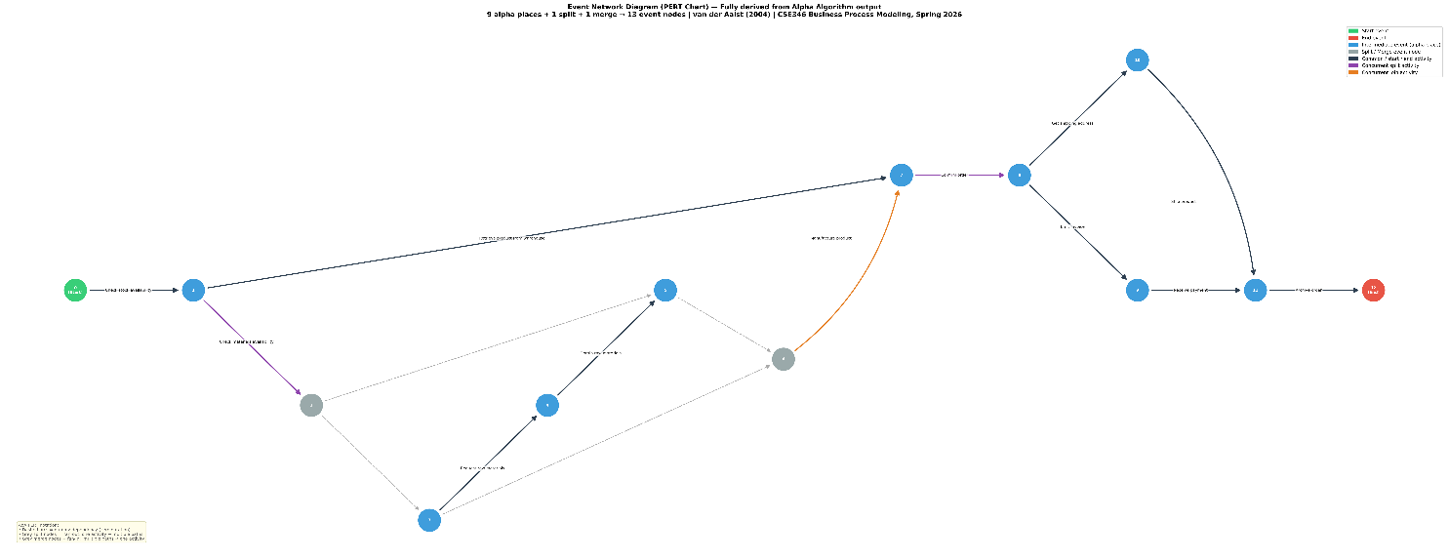

7.4 PERT Chart — 100-Case Log (Generic Validation)
The same code was run on a 100-case log containing 7 activities and 4 maximal places, producing a structurally different chart — confirming that the chart generation is fully generic and not hardcoded.
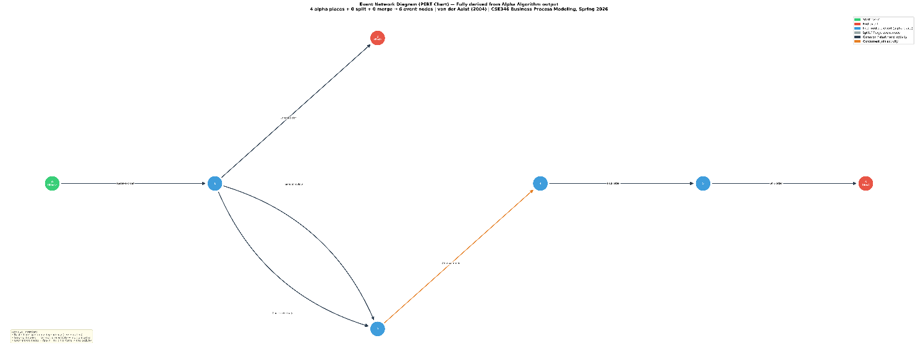

8. Automation Pipeline
The automation pipeline is implemented in automation.py and processes any conforming Excel event log end-to-end through a single function call or command-line invocation.

8.1 Pipeline Steps
The run_pipeline() function executes these steps in sequence:
- Step 1 — Load and preprocess the event log from the Excel file (load_event_log())
- Step 2 — Run the Alpha Algorithm on the cleaned log (run_alpha_algorithm())
- Step 3 — Generate the PERT chart PNG and PDF from the algorithm output (draw_pert_chart())
- Step 4 — Write the four-sheet Excel report (write_excel_report())

8.2 How to Use with a New Event Log
From the command line: python automation.py your_log.xlsx

From main.py (interactive): python main.py — then select the Excel file by number from the auto-detected list.

Required columns: Case ID, Activity, Timestamp, Resource. Event ID is optional and auto-generated if absent. Column names are matched case-insensitively.

8.3 Output Files
Output File | Description
alpha_algorithm_output_[log].txt | Full step-by-step Alpha Algorithm trace with footprint matrix and places
pert_chart_[log].png | Event Network Diagram at 300 DPI
pert_chart_[log].pdf | Same chart as PDF
process_mining_report_[log].xlsx | Four-sheet Excel report (Event Log, Footprint Matrix, Alpha Results, Process Summary)

9. Excel Report Description
The process mining report is saved as a four-sheet Excel workbook. Each sheet is described below.

Sheet | Name | Contents
1 | Event Log | Cleaned and sorted event log. Columns: Case ID, Event ID, Timestamp, Activity, Resource. Sorted by Case ID then Timestamp ascending.
2 | Footprint Matrix | N×N causal relation matrix. Symbols: → (causal), ← (reverse causal), || (concurrent), # (unrelated). The two || pairs are clearly visible.
3 | Alpha Results | T_I, T_O, T_L, all 9 discovered places in format Input: {A_set} → Output: {B_set}, plus source and sink places.
4 | Process Summary | Key statistics: case count, event count, unique activities, unique resources, average/min/max case duration, date range.

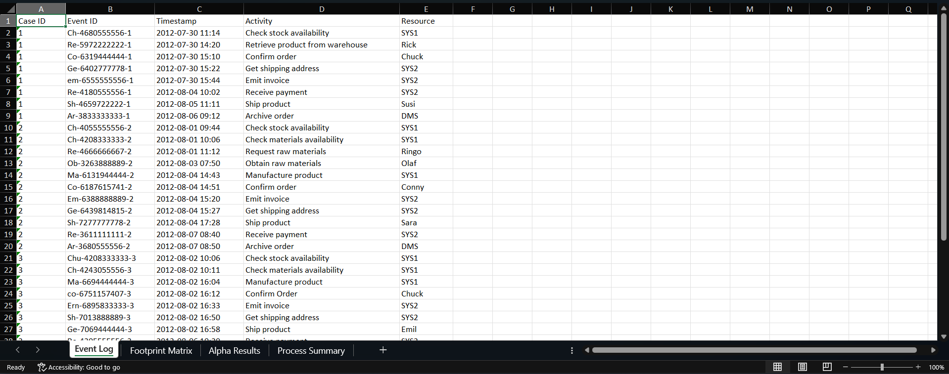
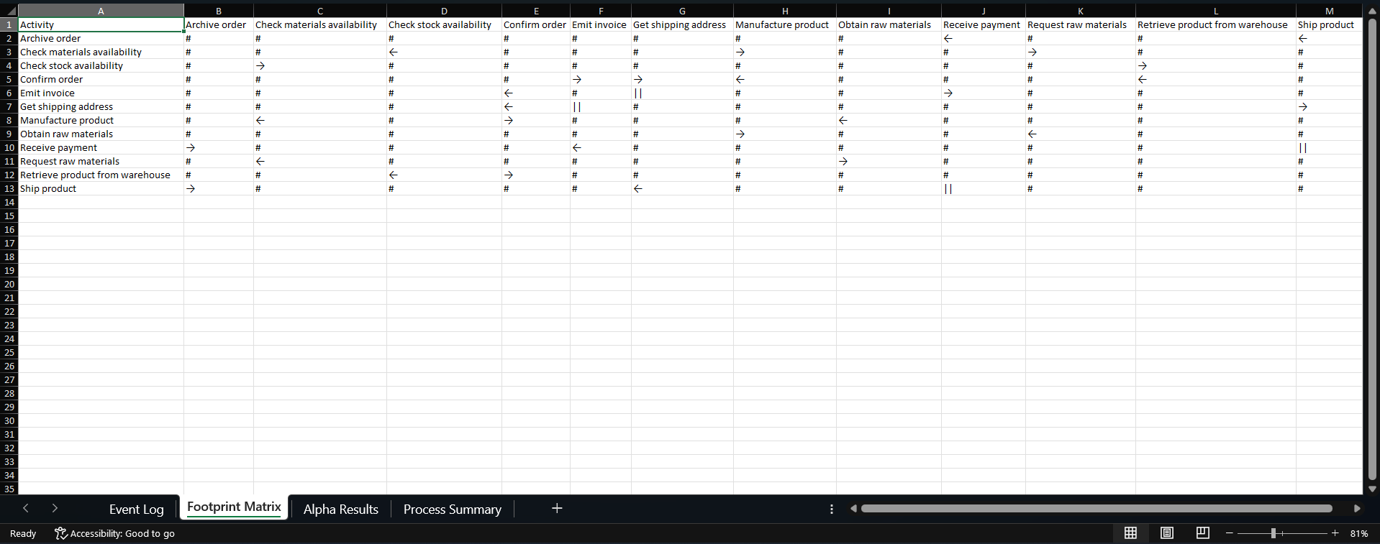
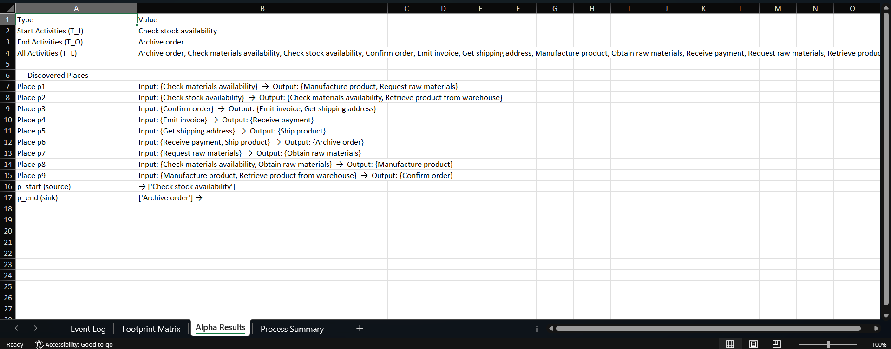
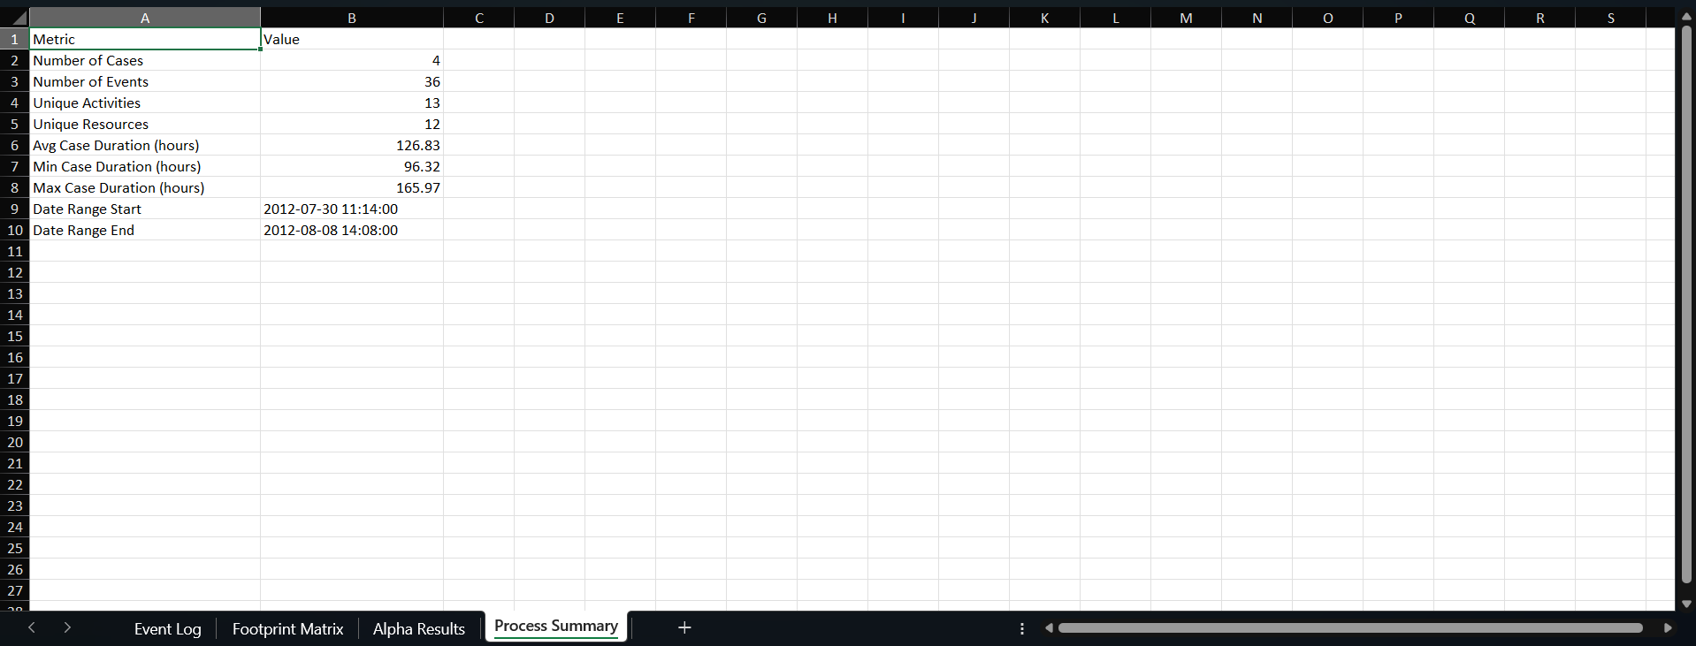

10. Usability & Reusability

10.1 Running the System
- Install dependencies: pip install -r requirements.txt
- Run interactively: python main.py (auto-detects all .xlsx files in folder)
- Run on specific file: python automation.py your_log.xlsx

10.2 Validation on 100-Case Log
Metric | 4-Case Log | 100-Case Log
Cases | 4 | 100
Events | 36 | 503
Activities | 12 | 7
Maximal places | 9 | 4
End activities | 1 (Archive order) | 2 (Cancel order, Ship order)
Concurrent pairs | 2 | 0
Split nodes | 1 | 0
Merge nodes | 1 | 0

The two logs produce visually and structurally distinct PERT charts, confirming that the pipeline is driven entirely by the algorithm output and not by hardcoded logic.

11. Conclusion
This assignment has implemented the complete Alpha Algorithm process discovery pipeline in Python, applied it to a four-case order fulfilment event log, and produced all required deliverables: a step-by-step algorithm trace, an Activity-on-Arc PERT chart, and a four-sheet Excel report. The discovered Petri net correctly identifies two concurrent activity pairs — invoice/address processing and payment/shipping — and four distinct execution paths reflecting real variability in how orders are fulfilled. The model was verified by tracing each case through the discovered places, confirming that it accepts all observed traces. The PERT chart is derived entirely from the algorithm output, with no hardcoded coordinates, activity names, or node counts, and renders correctly for both the four-case and hundred-case test logs.

All nine assignment criteria are addressed by the implementation. The tool selection is justified through a structured comparison against Excel VBA, Power BI, and R. Data preprocessing is robust, with column validation, type coercion, chronological sorting, and cross-case boundary prevention. The Alpha Algorithm is implemented faithfully across all eight formal steps with actual results documented throughout this report. The PERT chart follows AoA convention and handles fan-out and fan-in patterns correctly through split and merge event nodes. The automation pipeline processes any conforming Excel file through a single command. The Excel report provides four analytically useful sheets. The system meets the requirements for correctness, generality, reproducibility, and ease of use.

Reference
van der Aalst, W.M.P., Weijters, T., & Maruster, L. (2004). Workflow Mining: Discovering Process Models from Event Logs. IEEE Transactions on Knowledge and Data Engineering, 16(9), 1128–1142.

