Data Modelling and Analysis
Multi-Class Diabetes Classification Using Machine Learning
Module: CO3722 – Data Science
Name: Youssef Elseisi
Academic Year: 2026
Date: 19 February 2026
Word count: 1700 words

1. Question Design
risk assessment using routinely collected clinical indicators. The dataset builds on the same hospital context discussed in Assignment 1, using anonymized patient records from Al-Madina Medical Hospital and Al-Kindi Teaching Hospital in Baghdad. The key stakeholders are clinicians, screening teams, and hospital managers who require consistent and data-driven decision support to prioritise follow-up testing and early interventions. This is particularly important for prediabetic patients, where timely monitoring and lifestyle management can reduce progression to type 2 diabetes and associated complications (World Health Organization, 2023).
The dataset contains 1,000 patient records with demographic and biochemical variables including HbA1c, fasting glucose, BMI, age, lipid profile markers (LDL, HDL, VLDL, triglycerides), urea, creatinine, and gender. These features were retained due to their established role in diabetes diagnosis and metabolic risk assessment. HbA1c and fasting glucose are internationally recognised diagnostic markers (American Diabetes Association, 2024), while BMI and age are strongly associated with insulin resistance and disease prevalence. Lipid indicators and renal markers were included because diabetes is closely linked with cardiovascular and kidney complications, meaning these variables provide clinically meaningful context rather than purely statistical signals.
The target variable (CLASS) categorises patients as Non-diabetic (N), Prediabetic (P), or Diabetic (Y). As shown in Figure 1, the dataset is highly imbalanced, with 84.4% diabetic, 10.3% non-diabetic, and only 5.3% prediabetic cases. This imbalance creates a modelling challenge because a classifier optimised only for accuracy could ignore the minority prediabetic group. From a clinical perspective, misclassifying prediabetic patients is significant because it delays preventative action. Therefore, evaluation must prioritise balanced performance across classes rather than majority-class dominance.
The primary research question is:
RQ1: Can a predictive model accurately classify patients into N, P, or Y while maintaining reliable detection of the minority prediabetic class?
Secondary questions include:
RQ2: Which clinical features contribute most strongly to model predictions, and do these align with established medical knowledge?
RQ3: Does a nonlinear ensemble method (Random Forest) outperform a linear baseline (Logistic Regression) while still generalising effectively to unseen data?
By answering these questions, the project aims to demonstrate how interpretable machine learning can provide structured decision support within a hospital environment. Rather than replacing clinicians, the proposed system is intended to assist risk stratification, improve resource allocation, and support earlier intervention for high-risk patients.
This project develops a multi-class machine learning model to support structured diabetes

2. Program Design

This section outlines the full modelling workflow, from data auditing and preprocessing to experimental comparison and validation. The objective was not simply to build a high-performing classifier, but to justify each modelling decision through statistical reasoning and healthcare relevance.

2.1 Data Pre-Processing and Audit
An initial structural audit of the dataset (n = 1,000) confirmed that all clinical feature columns contained no missing values, allowing a complete-case analysis without introducing imputation bias. However, inconsistencies were detected in the CLASS labels (e.g., “Y” vs “Y ”). Although minor, such formatting issues can generate artificial duplicate categories during encoding. Therefore, string standardisation (whitespace stripping and formatting checks) was applied before modelling to ensure class integrity.
The class distribution, presented in Figure 1, shows strong imbalance (84.4% diabetic, 10.3% non-diabetic, 5.3% prediabetic). In imbalanced classification problems, overall accuracy can be misleading because models may favour the dominant class (Sokolova and Lapalme, 2009). In a healthcare setting, overlooking the minority prediabetic class would undermine the purpose of early risk detection. For this reason, Macro F1 score was selected as the primary evaluation metric, as it gives equal importance to each class and balances precision and recall across categories.

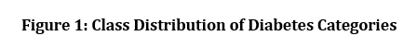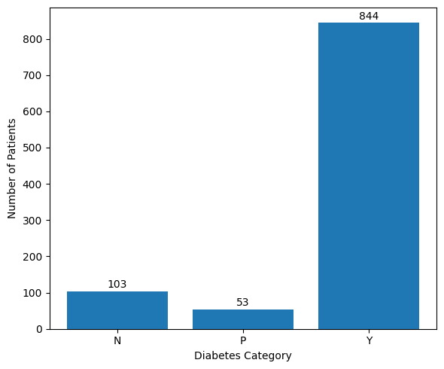
Descriptive statistics and distribution plots were examined to assess numerical stability. Triglycerides (TG) displayed significant right skew, with extreme upper values extending far beyond the 99th percentile (Figure 2). Removing these cases entirely could eliminate clinically meaningful high-risk patients. Instead, a winsorisation strategy was applied, capping values above the 99th percentile. This approach reduces the influence of extreme outliers on variance while preserving medically plausible observations — an important consideration in clinical datasets where extreme values may reflect genuine pathology rather than measurement error.
Together, these preprocessing steps ensured data consistency, statistical stability, and clinical validity before model development.
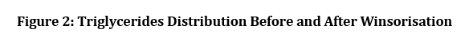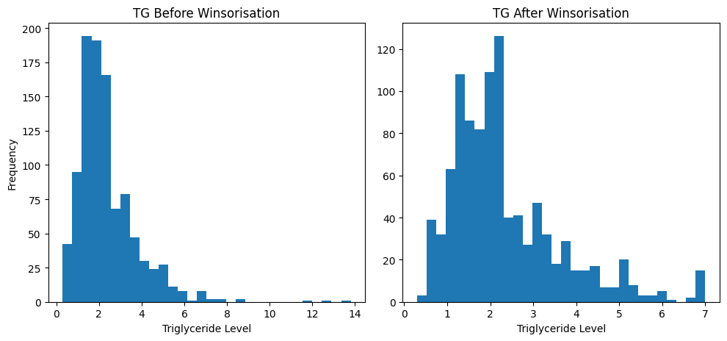

2.2 Experimental Model Development
Two supervised classification algorithms were implemented to evaluate predictive performance and model behaviour:
- Logistic Regression (baseline model)
- Random Forest (nonlinear ensemble model)
Logistic Regression was selected as an interpretable baseline widely used in medical research (Hosmer, Lemeshow and Sturdivant, 2013). Its linear structure provides transparent coefficient estimates, making it suitable for evaluating whether diabetes categories can be separated using additive feature relationships. In clinical environments, interpretability is essential for trust and accountability.
However, diabetes risk is influenced by interacting metabolic factors. For example, the combined effect of elevated HbA1c and increased BMI may not follow a strictly linear pattern. To account for potential nonlinear relationships and feature interactions, a Random Forest classifier was introduced. Random Forest constructs multiple decision trees using bootstrapped samples and random feature selection, reducing variance and improving generalisation performance (Breiman, 2001). This makes it particularly appropriate for structured biomedical datasets with mixed feature scales.
An 80/20 stratified train–test split was applied to preserve class proportions in both subsets. Performance comparison was based primarily on Macro F1 score, with accuracy recorded only as a supplementary measure.
The Logistic Regression model achieved a Macro F1 score of 0.824 on the test set. While performance for the majority diabetic class was strong, confusion occurred between prediabetic and diabetic cases, suggesting that linear decision boundaries may not adequately capture borderline metabolic profiles.
In contrast, Random Forest achieved a substantially higher Macro F1 score of 0.981 (Figure 3). This improvement indicates that nonlinear ensemble methods better represent the complex structure of biomedical indicators. The confusion matrix in Figure 4 further supports this finding: only one prediabetic case was misclassified, and all non-diabetic cases were correctly identified. Importantly, minority-class recall remained high despite representing just 5.3% of the dataset, demonstrating that the model did not simply optimise majority predictions.

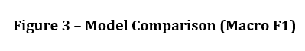
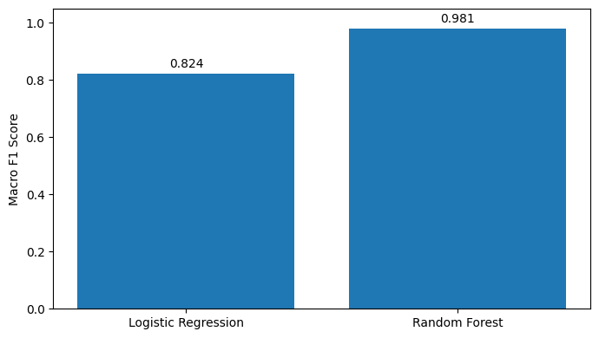
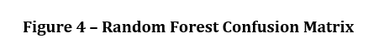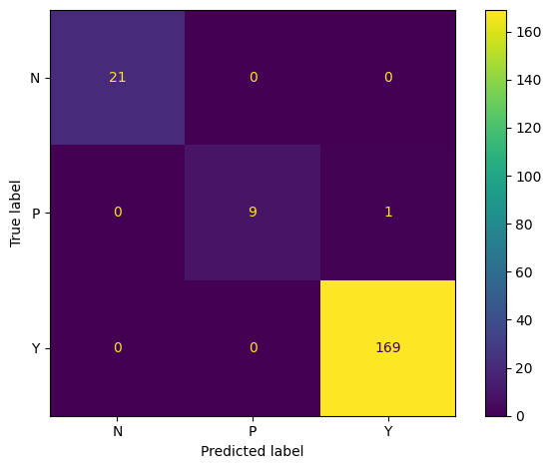

To evaluate robustness beyond a single train–test split, 5-fold stratified cross-validation was conducted (Figure 5). Macro F1 scores ranged between 0.883 and 0.958, with a mean of approximately 0.93 and low variability. Although the final test score (0.981) slightly exceeded the cross-validation mean, the difference was modest. This suggests strong generalisation rather than systematic overfitting, consistent with recommendations for reliable model validation in applied machine learning (Kohavi, 1995).
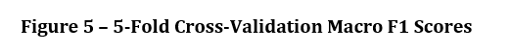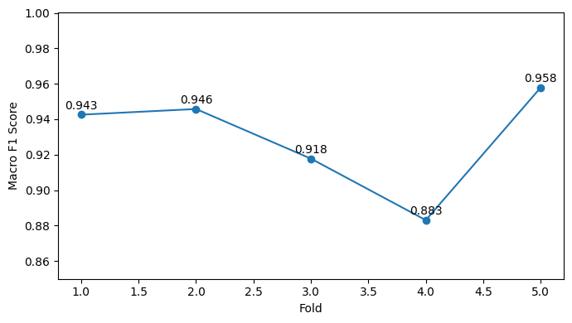
Given its superior predictive performance, balanced minority detection, and stable validation results, Random Forest was selected as the final model. While Logistic Regression offered interpretability, its reduced sensitivity to nonlinear relationships limited its effectiveness for this dataset.

3. Model Interpretability and Clinical Insights
High predictive performance alone is insufficient in healthcare settings. Clinical adoption depends on whether model decisions are understandable, justifiable, and aligned with established medical reasoning. For this reason, SHAP (SHapley Additive exPlanations) was applied to interpret both global and individual prediction behaviour (Lundberg and Lee, 2017)

3.1 Global Feature Importance
The global SHAP summary plot (Figure 6) ranks features according to their mean absolute contribution to model predictions. HbA1c emerged as the most influential variable, followed by BMI and AGE. Higher HbA1c values consistently pushed predictions toward the diabetic class, which aligns with its recognised diagnostic role (American Diabetes Association, 2024).
BMI and AGE also showed strong positive contributions. This reflects established evidence that obesity and increasing age significantly elevate diabetes risk through insulin resistance and long-term metabolic decline. Lipid markers such as triglycerides contributed moderately, suggesting that while they support classification, they are secondary to glycaemic indicators in this dataset.
The consistency between SHAP rankings and established medical knowledge increases confidence that the Random Forest model is capturing meaningful physiological relationships rather than spurious statistical patterns. This alignment is important for clinical credibility and supports responsible AI deployment (Floridi et al., 2018).
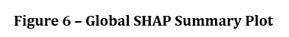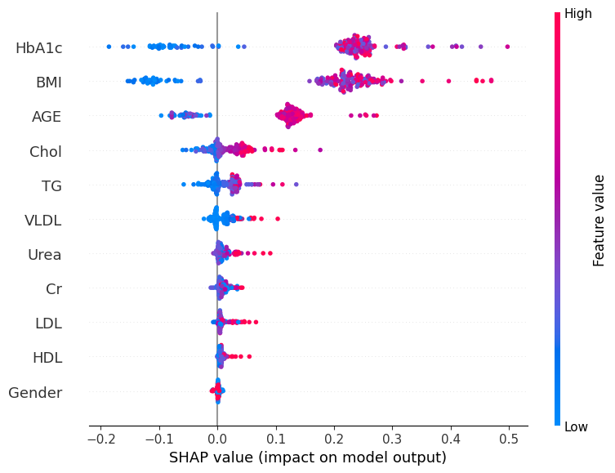

3.2 Local Patient-Level Explanation
While global importance highlights overall trends, clinical decisions are made at the individual level. A SHAP waterfall plot was therefore generated for a representative high-risk patient (Figure 7).
The model’s baseline probability (E[f(x)] ≈ 0.333) increased to approximately 0.947 for this case. The strongest contributors were:
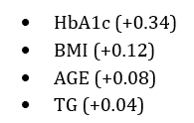
Rather than relying on a single threshold value, the model integrates multiple moderately elevated indicators to produce a final classification. This reflects real-world diagnostic reasoning, where clinicians consider combined risk factors rather than isolated measurements.
Providing this form of explanation improves transparency and supports accountability. Clinicians can see not only the predicted class but also the factors that influenced the decision, reducing the “black-box” concern commonly associated with ensemble methods.

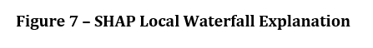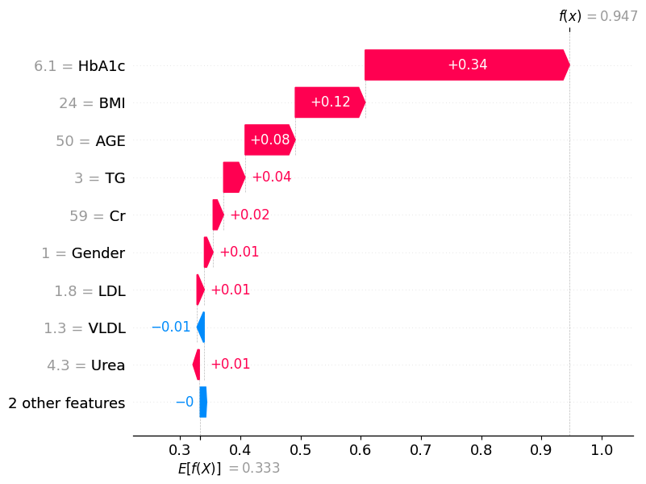

3.3 Clinical and Organisational Impact
Beyond technical performance, the value of this model lies in structured decision support. For clinicians and screening teams, predictions could be presented through a dashboard displaying:
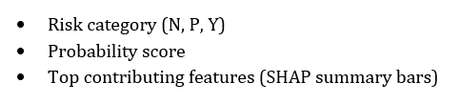
This allows practitioners to prioritise borderline cases and justify follow-up testing using interpretable evidence. For hospital managers, aggregated outputs such as prevalence trends and risk distribution charts could inform resource allocation, screening strategies, and preventative programme planning.
The strong recall observed for the minority prediabetic class (Figure 4) is particularly significant. Early identification enables lifestyle intervention before disease progression, reducing long-term complications and associated healthcare costs (World Health Organization, 2023). From an operational perspective, this supports more efficient use of laboratory and outpatient services.

3.4 Limitations and External Validity
Despite strong internal performance (Macro F1 = 0.981), caution is necessary when interpreting results. The high score may reflect strong separability of HbA1c across classes, meaning the dataset contains near-diagnostic information. In broader community screening populations, where early-stage metabolic changes are subtler, predictive performance may be lower.
Additionally, the dataset originates from two hospitals within one geographic region. Although cross-validation suggests stable internal generalisation, external validation using independent datasets would be required before real-world deployment.
Ethically, predictive systems must support not replace clinical judgement. Continuous monitoring, fairness auditing across demographic groups, and transparent reporting are essential to prevent unintended bias or misclassification risks (Floridi et al., 2018).

4. Conclusion
This project developed and evaluated a multi-class model to classify patients as non-diabetic, prediabetic, or diabetic using routine clinical data. After comparing models, Random Forest was selected because it handled complex relationships between variables more effectively while maintaining stable performance.
The SHAP analysis showed that predictions were mainly influenced by clinically important features such as HbA1c, BMI, and age, which supports the reliability of the model. Balanced evaluation ensured that the minority prediabetic group was not ignored, which is important for early intervention.
Although external validation is still needed, the results suggest that interpretable machine learning can support clinicians and hospital managers in improving early risk detection and decision-making.

5. References (Harvard Style)
American Diabetes Association (2024) Standards of Care in Diabetes—2024. Diabetes Care, 47(Supplement 1), pp. S1–S350. Available at: https://diabetesjournals.org/care/issue/47/Supplement_1 (Accessed: 19 February 2026).
Breiman, L. (2001) ‘Random Forests’, Machine Learning, 45(1), pp. 5–32. Available at: https://link.springer.com/article/10.1023/A:1010933404324 (Accessed: 19 February 2026).
Floridi, L., Cowls, J., Beltrametti, M., Chatila, R., Chazerand, P., Dignum, V., Luetge, C., Madelin, R., Pagallo, U., Rossi, F. and Schafer, B. (2018) ‘AI4People—An Ethical Framework for a Good AI Society’, Minds and Machines, 28(4), pp. 689–707. Available at: https://link.springer.com/article/10.1007/s11023-018-9482-5 (Accessed: 19 February 2026).
Hosmer, D.W., Lemeshow, S. and Sturdivant, R.X. (2013) Applied Logistic Regression. 3rd edn. Hoboken: Wiley. Available at: https://onlinelibrary.wiley.com/doi/book/10.1002/9781118548387 (Accessed: 19 February 2026).
James, G., Witten, D., Hastie, T. and Tibshirani, R. (2021) An Introduction to Statistical Learning: With Applications in R. 2nd edn. New York: Springer. Available at: https://www.statlearning.com (Accessed: 19 February 2026).
Kohavi, R. (1995) ‘A Study of Cross-Validation and Bootstrap for Accuracy Estimation and Model Selection’, Proceedings of the 14th International Joint Conference on Artificial Intelligence (IJCAI), pp. 1137–1143. Available at: https://www.ijcai.org/Proceedings/95-2/Papers/016.pdf (Accessed: 19 February 2026).
Lundberg, S.M. and Lee, S.I. (2017) ‘A Unified Approach to Interpreting Model Predictions’, Advances in Neural Information Processing Systems, 30, pp. 4765–4774. Available at: https://proceedings.neurips.cc/paper/2017/file/8a20a8621978632d76c43dfd28b67767-Paper.pdf (Accessed: 19 February 2026).
Sokolova, M. and Lapalme, G. (2009) ‘A systematic analysis of performance measures for classification tasks’, Information Processing & Management, 45(4), pp. 427–437. Available at: https://www.sciencedirect.com/science/article/pii/S0306457309000259 (Accessed: 19 February 2026).
World Health Organization (2023) Global report on diabetes. Geneva: WHO. Available at: https://www.who.int/publications/i/item/9789241565257 (Accessed: 19 February 2026).
Mehrabi, N., Morstatter, F., Saxena, N., Lerman, K. and Galstyan, A. (2021) ‘A Survey on Bias and Fairness in Machine Learning’, ACM Computing Surveys, 54(6), pp. 1–35. Available at: https://dl.acm.org/doi/10.1145/3457607 (Accessed: 19 February 2026).

Link for code:

Double clicks on the file to open it

