Facial Emotion Recognition using Deep Learning:
A ResNet18-Based Comparative Study on CK+ and FER-2013

Module: CO3519 Artificial Intelligence
University of Lancashire

Student Name: Youssef Elseisi
Student ID: G21152698

Table of Contents
Table of Contents 2
Table of Figures 3
1. Introduction 4
2. Literature Review 4
3. Datasets 5
4. Model Development 5
4.1 Model choice and overall design 5
4.2 CK+ pipeline 6
4.3 FER-2013 pipeline 6
5. Model Evaluation 7
5.1 Qualitative analysis 7
5.2 CK+ quantitative results 7
5.3 FER-2013 quantitative results 8
5.4 Comparative analysis 8
6. Conclusion 9
7. References 9
Supplementary Material 11
Source Code 11
Figures 11

Table of Figures
Figure 1. Sample Images per Emotion Class (CK+ and FER-2013)
Figure 2. Train and Test Set Class Distribution (CK+ and FER-2013)
Figure 3. Shared Processing Pipeline
Figure 4. Architecture Comparison: CK+ Model vs FER-2013 Model
Figure 5. CK+ ResNet18 Training Curves (Phase 1 and Phase 2)
Figure 6. FER-2013 ResNet18+CBAM Training Curves (Three Phases)
Figure 7. CK+ Correct and Incorrect Prediction Examples
Figure 8. FER-2013 Correct and Incorrect Prediction Examples
Figure 9. CK+ ResNet18 F1 Score per Emotion Class
Figure 10. CK+ ResNet18 Confusion Matrix
Figure 11. CK+ ResNet18 Ablation Study Comparison (Val Macro F1)
Figure 12. FER-2013 ResNet18+CBAM F1 Score per Emotion Class
Figure 13. FER-2013 ResNet18+CBAM Confusion Matrix

1. Introduction
Facial Emotion Recognition (FER) is an area of Artificial Intelligence that focuses on identifying human emotions from facial images. In this project, the task is to classify six expressions: Neutral, Angry, Happy, Surprise, Sad, and Fear. These expression categories are commonly used in emotion research because facial expressions are an important part of non-verbal communication and can indicate emotion (Ekman, 1992). Accordingly, FER has been explored in areas such as healthcare, security, and human–computer interaction (Sajjad et al., 2023).
In the previous assignment, this problem was approached using traditional machine learning with handcrafted Histogram of Oriented Gradients (HOG) features and classifiers such as KNN and SVM. Although that approach provided a useful baseline, the best result reached only 63% accuracy on CK+ using SVM, showing clear limitations when dealing with subtle expressions and wider variation in facial appearance. Traditional handcrafted features can struggle to capture complex facial patterns compared with deep learning methods (Happy and Routray, 2015).
To improve on this, the current project uses a deep learning approach based on convolutional neural networks (CNNs), specifically ResNet18. This project evaluates the model on CK+ and FER-2013, where the best result reached 89.69% accuracy on CK+, showing a clear improvement over the previous handcrafted-feature baseline.

2. Literature Review
Convolutional Neural Networks (CNNs) have become the dominant approach for facial emotion recognition (FER) in computer vision. He et al. (2016) introduced ResNet, which uses residual shortcut connections to allow deeper networks to train effectively without suffering from the vanishing gradient problem. This makes ResNet18 a well-suited architecture for FER, offering sufficient depth while remaining computationally manageable on smaller datasets like CK+.
Transfer learning has proven critical when labelled facial data is scarce. Ng et al. (2015) demonstrated that models pre-trained on large general datasets such as ImageNet can achieve strong FER performance even with limited domain-specific data, which directly motivated the use of ImageNet-pretrained weights in this project. Li and Deng (2020) further identified that in-the-wild datasets remain a key bottleneck, as noise and annotation inconsistency consistently reduce model performance compared to controlled laboratory settings.
Woo et al. (2018) proposed the Convolutional Block Attention Module (CBAM), which refines feature maps using channel and spatial attention. Unlike this project, their evaluation focused on general object recognition; here, CBAM is applied specifically to tackle FER-2013's noisy low-resolution images, extending their approach to an emotion-specific cross-dataset comparison not explored in the original work.

3. Datasets
This project used two facial expression datasets: Extended Cohn-Kanade (CK+) and FER-2013. Using both datasets allowed comparison between a controlled dataset and a more challenging real-world dataset. The six target emotion classes were Neutral, Angry, Happy, Surprise, Sad, and Fear. Sample images from both datasets are shown in Figure 1, and the train/test class distributions are presented in Figure 2.

CK+ is a laboratory-controlled dataset of posed facial expressions (Lucey et al., 2010). In this project, the selected six-class subset contained 245 training images and 97 test images, with part of the training data further split for validation. Because the images were already cropped around the face, no separate face-detection stage was required.

FER-2013 is a larger facial expression dataset collected through automated web scraping and is more challenging because of lower image quality, varied lighting, and pose differences (Goodfellow et al., 2013). After filtering the dataset to exclude the disgust class, the final six-class version contained approximately 25,273 training images and 7,067 test images. The original 48×48 images were resized to 224×224 for ResNet18, and data augmentation was applied to reduce the effect of class imbalance and improve generalisation.

4. Model Development

4.1 Model choice and overall design
A separate face-detection stage was unnecessary as CK+ and FER-2013 were provided as pre-cropped, labelled face datasets. This allowed the development effort to focus entirely on emotion classification. The shared pipeline, shown in Figure 3, illustrates how images pass through resizing, augmentation, the ResNet18 backbone, and the classification head. ResNet18 was selected as the base model (He et al., 2016); its residual shortcut connections facilitate gradient flow, preventing the vanishing gradient problem and stabilising fine-tuning. It also balances depth with overfitting risks, which is vital as CK+ contains only 342 images. ResNet50 was considered but not used, as its greater depth and larger number of parameters would likely increase the risk of overfitting on CK+ without giving a clear performance benefit for a small six-class problem. Both experiments employed transfer learning, initialising with ImageNet-pretrained weights rather than random values. This effective because features like edges and textures transfer well to facial imagery, allowing convergence with less labelled data (Oquab et al., 2014). The original ResNet18 output layer was replaced with a task-specific classification head in both pipelines, with architectural differences between the two shown in Figure 4.

4.2 CK+ pipeline
A two-phase training strategy was employed for CK+. Images were resized to 224 x 224 pixels, converted to RGB, and normalised using ImageNet statistics with an 85/15 stratified split. In Phase 1, the backbone was frozen while only the classification head comprising a Dropout layer (p = 0.5) to reduce overfitting and a fully connected layer for six emotion classes was trained for 10 epochs. AdamW was used as the optimiser (learning rate 0.001; weight decay 0.01), as its decoupled weight decay offers more consistent regularisation than standard Adam (Loshchilov and Hutter, 2019). In Phase 2, all layers were unfrozen for up to 50 epochs at a reduced learning rate of 0.0001 to avoid overwriting the pretrained features. Stability was maintained via a ReduceLROnPlateau scheduler, early stopping (patience 15), and gradient clipping at norm 1.0 (Pascanu et al., 2013).
To address class imbalance (e.g., 66 neutral vs. 20 sadness images), weighted cross-entropy loss and a WeightedRandomSampler were combined. Data augmentation, including horizontal flipping, rotation, translation, and colour jitter, improved generalisation. An ablation study comparing the full pipeline against no augmentation, label smoothing, and standard Adam confirmed these choices, yielding a peak validation macro F1 of 0.809. Finally, leave-one-subject-out (LOSO) cross-validation was used to ensure reliable generalisation to unseen individuals, accounting for repeated subjects in the dataset.

4.3 FER-2013 pipeline
For FER-2013, a Convolutional Block Attention Module (CBAM) was added after the final residual block (Figure 4; Woo et al., 2018). CBAM first applies channel attention using average and max pooling with a shared MLP to emphasise the most useful feature maps, then applies spatial attention with a convolutional layer to highlight important regions such as the eyes and mouth. Without attention, ResNet18’s global average pooling gives equal importance to all spatial locations, which can be a problem when emotion-related features appear only in small parts of a noisy 48×48-pixel image. CBAM was chosen over other attention methods because it adds few extra parameters while working across both channel and spatial dimensions, making it suitable for adapting a pretrained backbone without disrupting useful ImageNet features.
To provide additional capacity, the classification head was made deeper than the CK+ version, incorporating BatchNorm, Dropout (0.5), a 256-unit hidden layer, ReLU, a second BatchNorm, and Dropout (0.25) before the final six-class output. This additional depth was justified by the scale and noise level of FER-2013, where a single linear layer would lack the capacity to learn the more complex decision boundaries required.
Training followed a three-phase staged strategy. Phase 1 trained only the head and CBAM (backbone frozen) using AdamW at a learning rate of 0.0003 for 60 epochs. Phase 2 unfroze the final residual block for 30 epochs using differential learning rates and OneCycleLR scheduling. Differential learning rates assigned a smaller rate of 0.00001 to layer4 and a larger rate of 0.0001 to the CBAM and head, ensuring earlier layers changed slowly while newer layers adapted more quickly. Phase 3 unfroze the previous block at even smaller rates for 25 epochs. This progressive unfreezing preserves general pretrained features while allowing later layers to adapt to emotion-specific patterns (Howard and Ruder, 2018).
Regularisation included mix-up augmentation (alpha = 0.2; Zhang et al., 2018), 0.1 label smoothing, higher class weights for minority categories, and random erasing (p = 0.4) to make the model less sensitive to partial occlusion.

5. Model Evaluation

5.1 Qualitative analysis
Qualitatively, both models were expected to improve steadily during training. The CK+ training curves Figure 5 show fast, steady improvement during training, which reflects the clean and controlled nature of that dataset. The FER-2013 training curves (Figure 6) show a different pattern, with clear step-like improvement across the three training phases. Training accuracy rises to around 80% at the start of Phase 3 near epoch 66, while validation accuracy stabilises at 68.77%. This suggests that progressively unfreezing the backbone helped the model learn emotion-related features from noisier real-world data. The correct and incorrect prediction examples for CK+ (Figure 7) show robustness to changes in lighting and expression intensity, while the FER-2013 examples (Figure 8) show that the model can still classify some low-resolution faces with reasonable confidence.

5.2 CK+ quantitative results
The CK+ ResNet18 model achieved a test accuracy of 89.69% on 97 test images. This result was evaluated using test-time augmentation (TTA), where each image was passed through the model six times with different augmentations, and the most common prediction was taken as the final result. The macro-averaged precision, recall, and F1-score were 0.853, 0.868, and 0.852 respectively, with a weighted F1-score of 0.893. These results are shown in the per-class F1 chart Figure 9 and the confusion matrix Figure 10. Happy and surprise achieved perfect F1-scores of 1.000, and neutral reached 0.936, with 22 of 23 test instances correctly identified. Fear achieved a strong F1 of 0.933 despite having only 7 test samples, all of which were correctly recalled. The weakest classes were anger (F1 = 0.609) and sadness (F1 = 0.632). The confusion matrix shows that 5 of 14 anger instances were misclassified as sadness, which is expected given the shared downward brow and mouth position in both expressions (Li and Deng, 2020).
The ablation study Figure 11 confirmed that every design choice was necessary. The full pipeline achieved the highest validation macro F1 of 0.809, compared to 0.722 without augmentation, 0.637 with label smoothing only, and 0.629 with Adam without weight decay.
The LOSO evaluation across all 110 CK+ subjects produced a mean macro F1 of 0.945 and a mean accuracy of 0.953, confirming that the model generalises well across unseen identities rather than memorising subject-specific appearance.

5.3 FER-2013 quantitative results
The FER-2013 ResNet18+CBAM model achieved a test accuracy of 68.77% across 7,067 test images. The macro-averaged precision, recall, and F1-score were 0.683, 0.681, and 0.679 respectively, with a weighted F1-score of 0.692. Per-class F1 scores are shown in Figure 12. Happy was the strongest class with an F1 of 0.863, followed by surprise at 0.799. The three most challenging classes were fear (F1 = 0.564), sadness (F1 = 0.587), and angry (F1 = 0.620), consistent with the known difficulty of distinguishing these negative emotion categories in low-resolution, crowd-labelled data (Goodfellow et al., 2013).
The confusion matrix Figure 13 reveals that fear was most frequently confused with sadness (210 instances) and angry (104 instances), reflecting the shared muscular tension patterns in negative high-arousal expressions at 48-pixel resolution.

5.4 Comparative analysis
The performance gap between CK+ (89.69% accuracy) and FER-2013 (68.77% accuracy) is substantial and reflects fundamental differences in data quality rather than model limitations alone. Notably, the pattern of class difficulty is consistent across both datasets happy and surprise are the easiest classes in both cases, while fear and sadness are the hardest suggesting these are genuine perceptual overlaps rather than dataset-specific artefacts. This dual-dataset evaluation demonstrates that the ResNet18 + Convolutional Block Attention Module pipeline performs robustly across both controlled and in-the-wild conditions, while clearly showing that dataset quality remains the dominant factor in achievable performance.

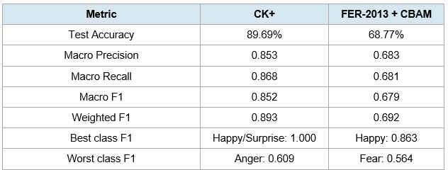

6. Conclusion
This project implemented and evaluated ResNet18-based facial emotion recognition systems across two datasets: CK+ and FER-2013. The CK+ model achieved 89.69% test accuracy (weighted F1 = 0.893) using a two-phase transfer learning strategy, weighted loss, and data augmentation. The FER-2013 model reached 68.77% accuracy (weighted F1 = 0.692), with CBAM attention and progressive layer unfreezing delivering meaningful improvements on a substantially harder dataset.
The most significant finding is that dataset quality influences performance more than architectural complexity. The twenty-percentage-point gap between datasets reflects differences in image resolution, label noise, and capture conditions rather than any failure of the model design. The consistent difficulty with fear and sadness across both datasets suggests these expressions share genuine perceptual overlap that architecture alone cannot resolve.
Future improvements could include applying Vision Transformer architectures to capture longer-range spatial dependencies (Dosovitskiy et al., 2021), pre-training on larger datasets such as AffectNet (Mollahosseini et al., 2019), and incorporating video-based temporal modelling to better differentiate ambiguous low-arousal emotions.
Through this project, I gained a better practical understanding of transfer learning, attention mechanisms, and the importance of adapting the training strategy to the characteristics of the dataset to achieve good generalisation.

7. References
Dosovitskiy, A., Beyer, L., Kolesnikov, A., Weissenborn, D., Zhai, X., Unterthiner, T., Dehghani, M., Minderer, M., Heigold, G., Gelly, S., Uszkoreit, J. and Houlsby, N. (2021) 'An image is worth 16×16 words: Transformers for image recognition at scale', in Proceedings of the International Conference on Learning Representations (ICLR). Available at: https://arxiv.org/abs/2010.11929 (Accessed: 22 March 2026).
Ekman, P. (1992) 'An argument for basic emotions', Cognition & Emotion, 6(3–4), pp. 169–200.
Goodfellow, I.J., Erhan, D., Carrier, P.L., Courville, A., Mirza, M., Hamner, B., Cukierbergk, W., Tang, Y., Thaler, D.H., Lee, D.-H. and Zhou, Y. (2013) 'Challenges in representation learning: A report on three machine learning contests', in Proceedings of the International Conference on Neural Information Processing, pp. 117–124. Available at: https://doi.org/10.1016/j.neunet.2014.09.005. (Accessed: 22 March 2026).

Happy, S.L. and Routray, A. (2015) 'Automatic facial expression recognition using features of salient facial patches', IEEE Transactions on Affective Computing, 6(1), pp. 1–12.
He, K., Zhang, X., Ren, S. and Sun, J. (2016) 'Deep residual learning for image recognition', in Proceedings of the IEEE Conference on Computer Vision and Pattern Recognition (CVPR), pp. 770–778. Available at: 10.1109/CVPR.2016.90. (Accessed: 21 March 2026).
Howard, J. and Ruder, S. (2018) 'Universal language model fine-tuning for text classification', in Proceedings of the 56th Annual Meeting of the Association for Computational Linguistics (ACL), pp. 328–339.
Li, S. and Deng, W. (2020) 'Deep facial expression recognition: A survey', IEEE Transactions on Affective Computing, 13(3), pp. 1195–1215. Available at: 10.1109/TAFFC.2020.2981446. (Accessed: 12 March 2026).
Loshchilov, I. and Hutter, F. (2019) 'Decoupled weight decay regularization', in Proceedings of the International Conference on Learning Representations (ICLR). Available at: https://arxiv.org/abs/1711.05101 (Accessed: 13 March 2026).
Lucey, P., Cohn, J.F., Kanade, T., Saragih, J., Ambadar, Z. and Matthews, I. (2010) 'The Extended Cohn-Kanade dataset (CK+): A complete dataset for action unit and emotion-specified expression', in Proceedings of the IEEE Computer Society Conference on Computer Vision and Pattern Recognition Workshops, pp. 94–101.
Mollahosseini, A., Hasani, B. and Mahoor, M.H. (2019) 'AffectNet: A database for facial expression, valence, and arousal computing in the wild', IEEE Transactions on Affective Computing, 10(1), pp. 18–31.
Ng, H.-W., Nguyen, V.D., Vonikakis, V. and Winkler, S. (2015) 'Deep learning for emotion recognition on small datasets using transfer learning', in Proceedings of the ACM International Conference on Multimodal Interaction, pp. 443–449.
Oquab, M., Bottou, L., Laptev, I. and Sivic, J. (2014) 'Learning and transferring mid-level image representations using convolutional neural networks', in Proceedings of the IEEE Conference on Computer Vision and Pattern Recognition (CVPR), pp. 1717–1724.
Pascanu, R., Mikolov, T. and Bengio, Y. (2013) 'On the difficulty of training recurrent neural networks', in Proceedings of the 30th International Conference on Machine Learning (ICML), pp. 1310–1318.
Woo, S., Park, J., Lee, J.-Y. and Kweon, I.S. (2018) 'CBAM: Convolutional block attention module', in Proceedings of the European Conference on Computer Vision (ECCV), pp. 3–19. Available at: [1807.06521] CBAM: Convolutional Block Attention Module. (Accessed: 16 March 2026).
Zhang, H., Cisse, M., Dauphin, Y.N. and Lopez-Paz, D. (2018) 'Mixup: Beyond empirical risk minimization', in Proceedings of the International Conference on Learning Representations (ICLR). Available at: https://arxiv.org/abs/1710.09412 (Accessed: 17 March 2026).

Supplementary Material

Source Code
Notebook 1 ----- CK+ ResNet18 model implementation and evaluation: https://colab.research.google.com/drive/14CLYTlhh4SI4Sp7LCiBGO-X_VGRwPb7p?usp=drive_link.
Notebook 2 ----- FER-2013 ResNet18+CBAM model implementation and evaluation: https://colab.research.google.com/drive/1ocHPDSP_OJnFvgs9lu9dEsbJ17x63U1q?usp=drive_link.

Figures
Figure 1 - Sample Images per Emotion Class for both datasets CK+ and FER-2013. CK+ on the right side and FER-2013 is on the left side.
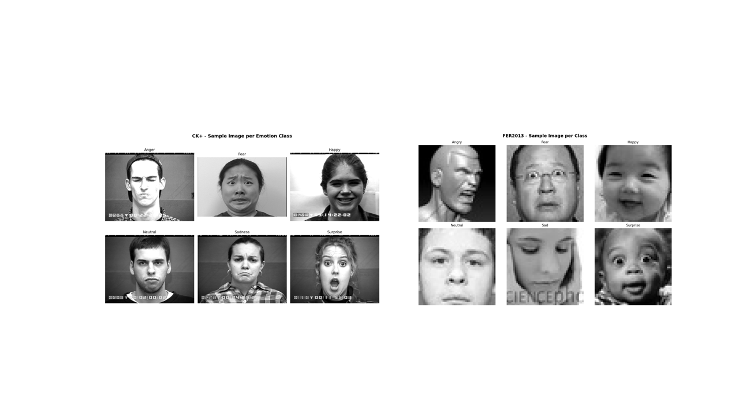

Figure 2 - Train and test class distributions for CK+ and FER-2013. CK+ shows visible imbalance, especially for fear and sadness, while happy is the dominant class in both FER-2013 splits.

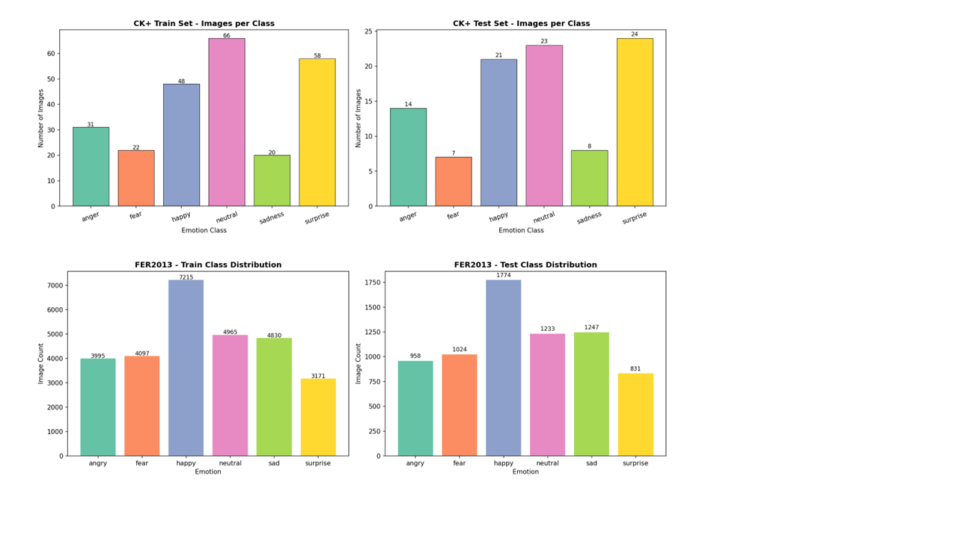

Figure 3 - Shared processing pipeline for both CK+ and FER-2013 experiments
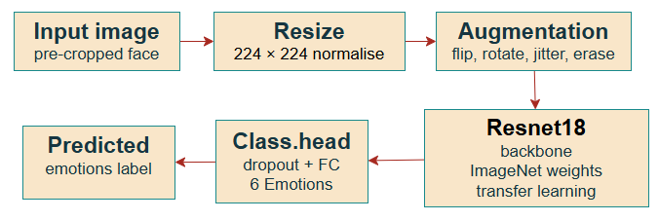
Figure 4 - Architecture comparison: CK+ model (left) vs FER-2013 model (right)
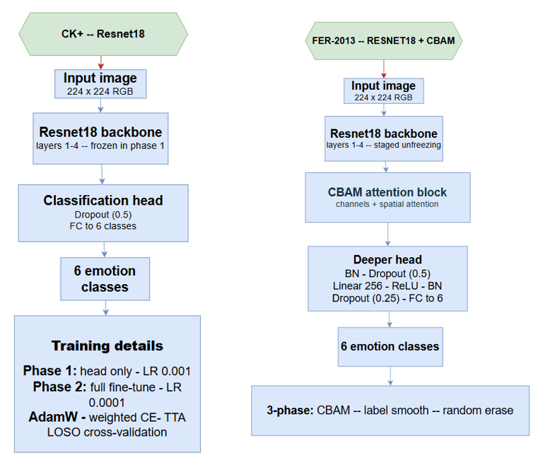

Figure 5 - Training accuracy and loss curves for the CK+ ResNet18 model across Phase 1 and Phase 2. The smooth and rapid convergence reflects the clean, controlled nature of the CK+ dataset, with validation accuracy stabilising quickly after Phase 2 unfreezing begins
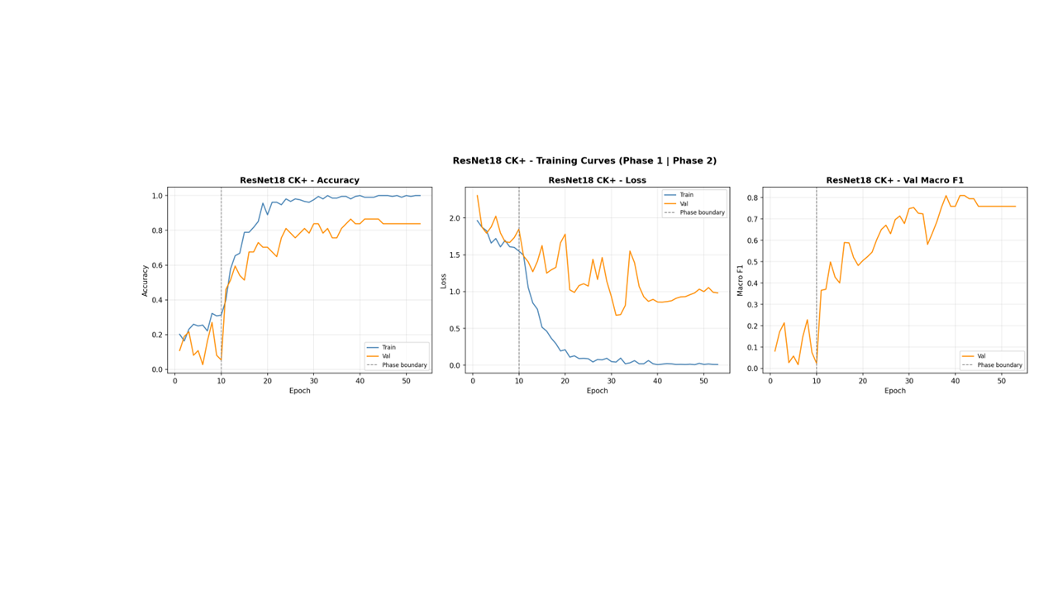

Figure 6 - Training accuracy and loss curves for the FER-2013 ResNet18+CBAM model across all three training phases (approximately 90 epochs total). Vertical dashed lines mark the start of Phase 2 (epoch ~37) and Phase 3 (epoch ~67). A clear step increase in validation accuracy is visible at the Phase 2 transition, confirming that progressive unfreezing of the backbone meaningfully improved the model’s ability to learn emotion-specific features.
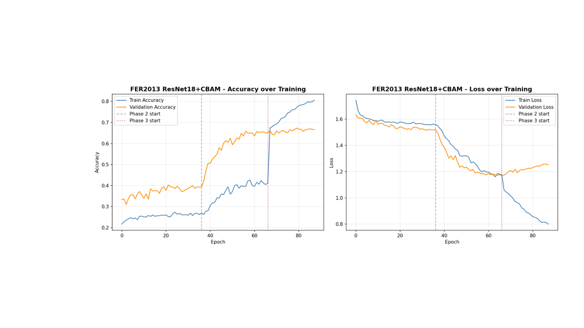

Figure 7 - Examples of correct and incorrect predictions from the CK+ test set. Green labels show correct classifications and red labels show misclassifications. The figure suggests that the model generally performs well under the controlled conditions of CK+, although some visually similar expressions are still confused.
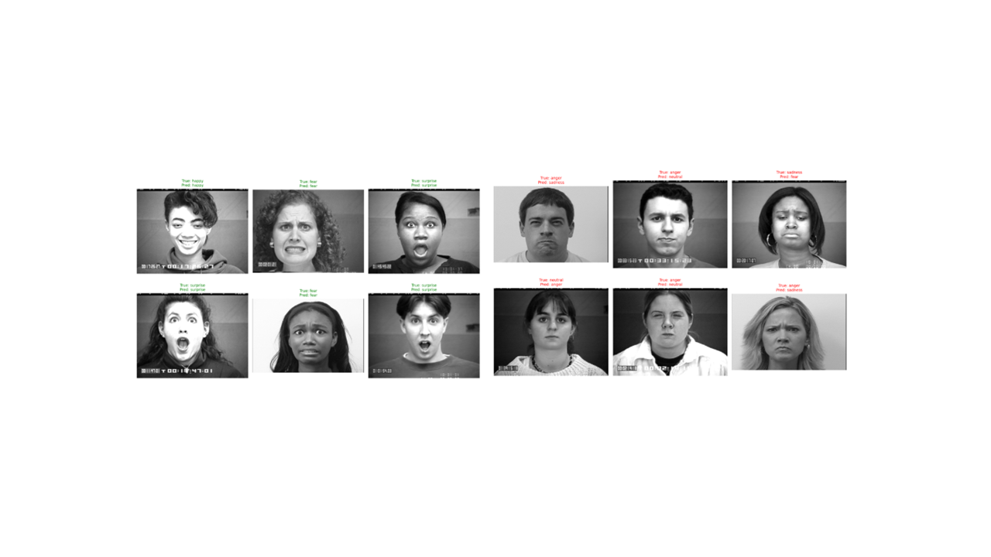

Figure 8 - Examples of correct and incorrect predictions from the FER-2013 test set. Green labels indicate correct classifications and red labels indicate misclassifications. The figure shows that the model can recognise some expressions well despite the low image resolution but still struggles with more ambiguous cases.
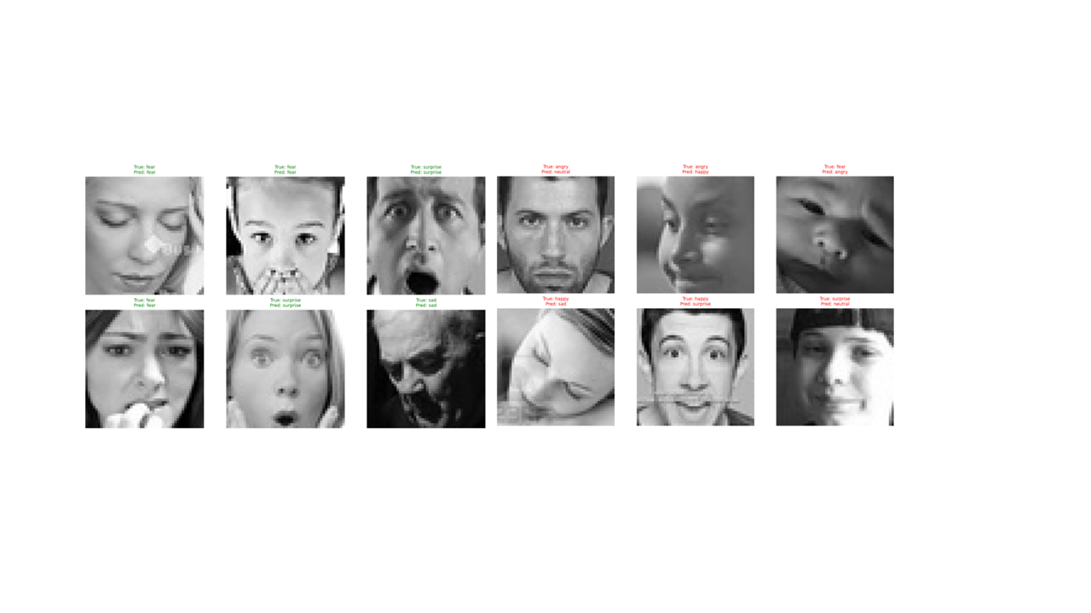

Figure 9 - Per-class F1 scores for the CK+ ResNet18 model. Happy and surprise both achieve a perfect F1 of 1.000, neutral reaches 0.936, and fear achieves 0.933 despite having only 7 test samples. Anger (0.609) and sadness (0.632) are the weakest classes, consistent with their known visual ambiguity.
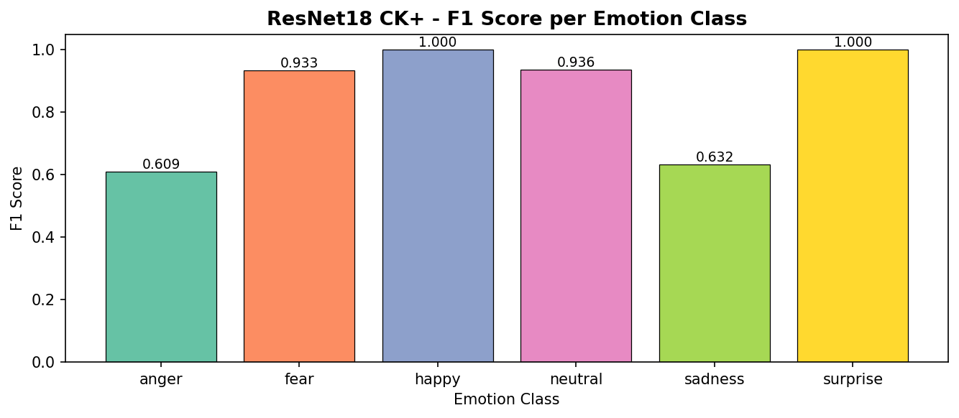

Figure 10 -Confusion matrix for the CK+ ResNet18 model on the 97-image test set. Happy and surprise achieve perfect diagonal entries with 21 and 24 correct predictions respectively. Anger shows the most off-diagonal activity, with 5 of 14 instances misclassified as sadness, reflecting the structural similarity between, these two expressions
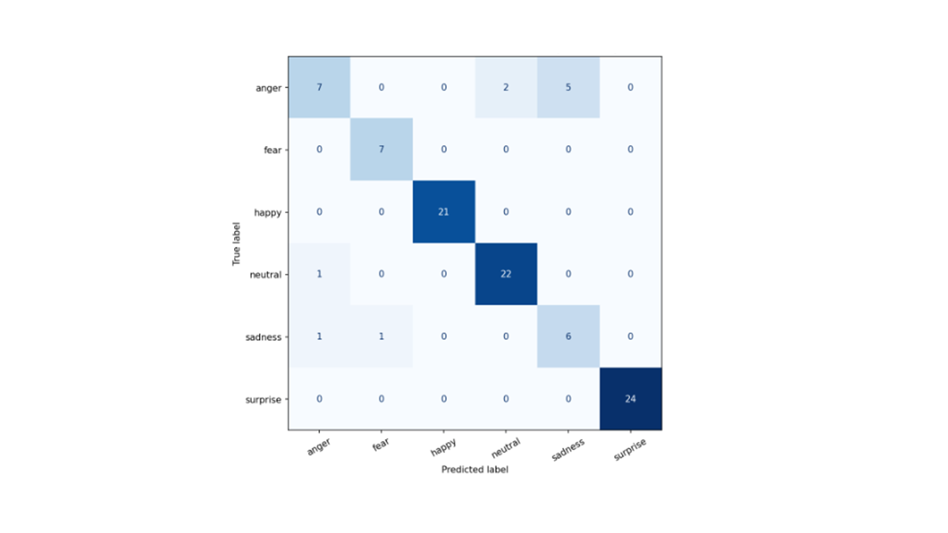

Figure 11 - CK+ experiment comparison bar chart. The one showing the four configurations and their validation macro F1 scores.
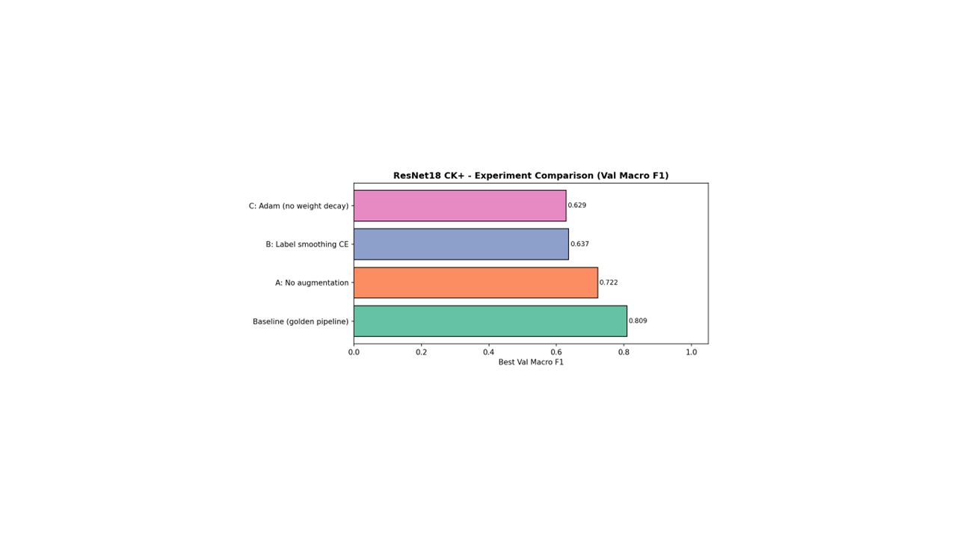
Figure 11 explanation. Bar chart comparing four configurations: Baseline golden pipeline (0.809), Experiment A - no augmentation (0.722), Experiment B - label smoothing CE (0.637), Experiment C - Adam without weight decay (0.629). Confirms the full pipeline is optimal.

Figure 12 - Per-class F1 scores for the FER-2013 ResNet18+CBAM model. Happy achieves the highest score of 0.863 and surprise reaches 0.799. Fear (0.564), sadness (0.587), and angry (0.620) are the weakest classes, consistent with the known difficulty of separating negative high-arousal and low arousal expressions in noisy crowd-labelled data.
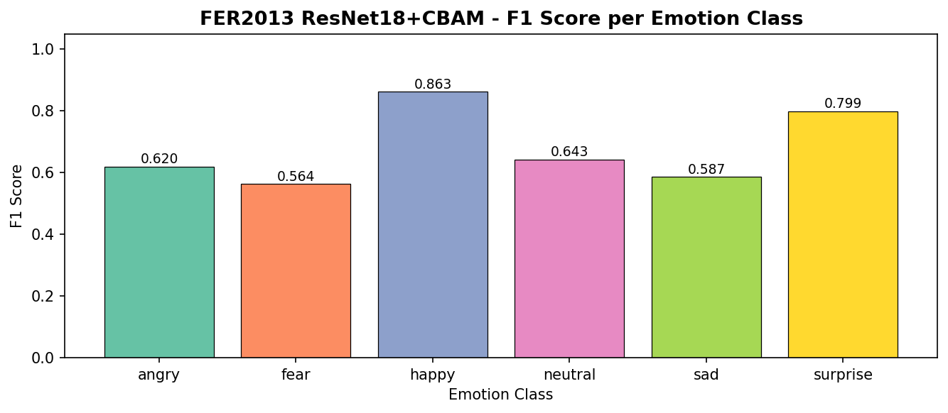

Figure 13 - Confusion matrix for the FER-2013 ResNet18+CBAM model on the 7,067-image test set. Happy is the strongest class with 1,415 correct predictions. Fear and neutral show the most confusion, with fear frequently misclassified as sadness (210 instances) and neutral confused with sadness (232 instances), reflecting the difficulty of separating low-arousal expressions in noisy low-resolution images.
