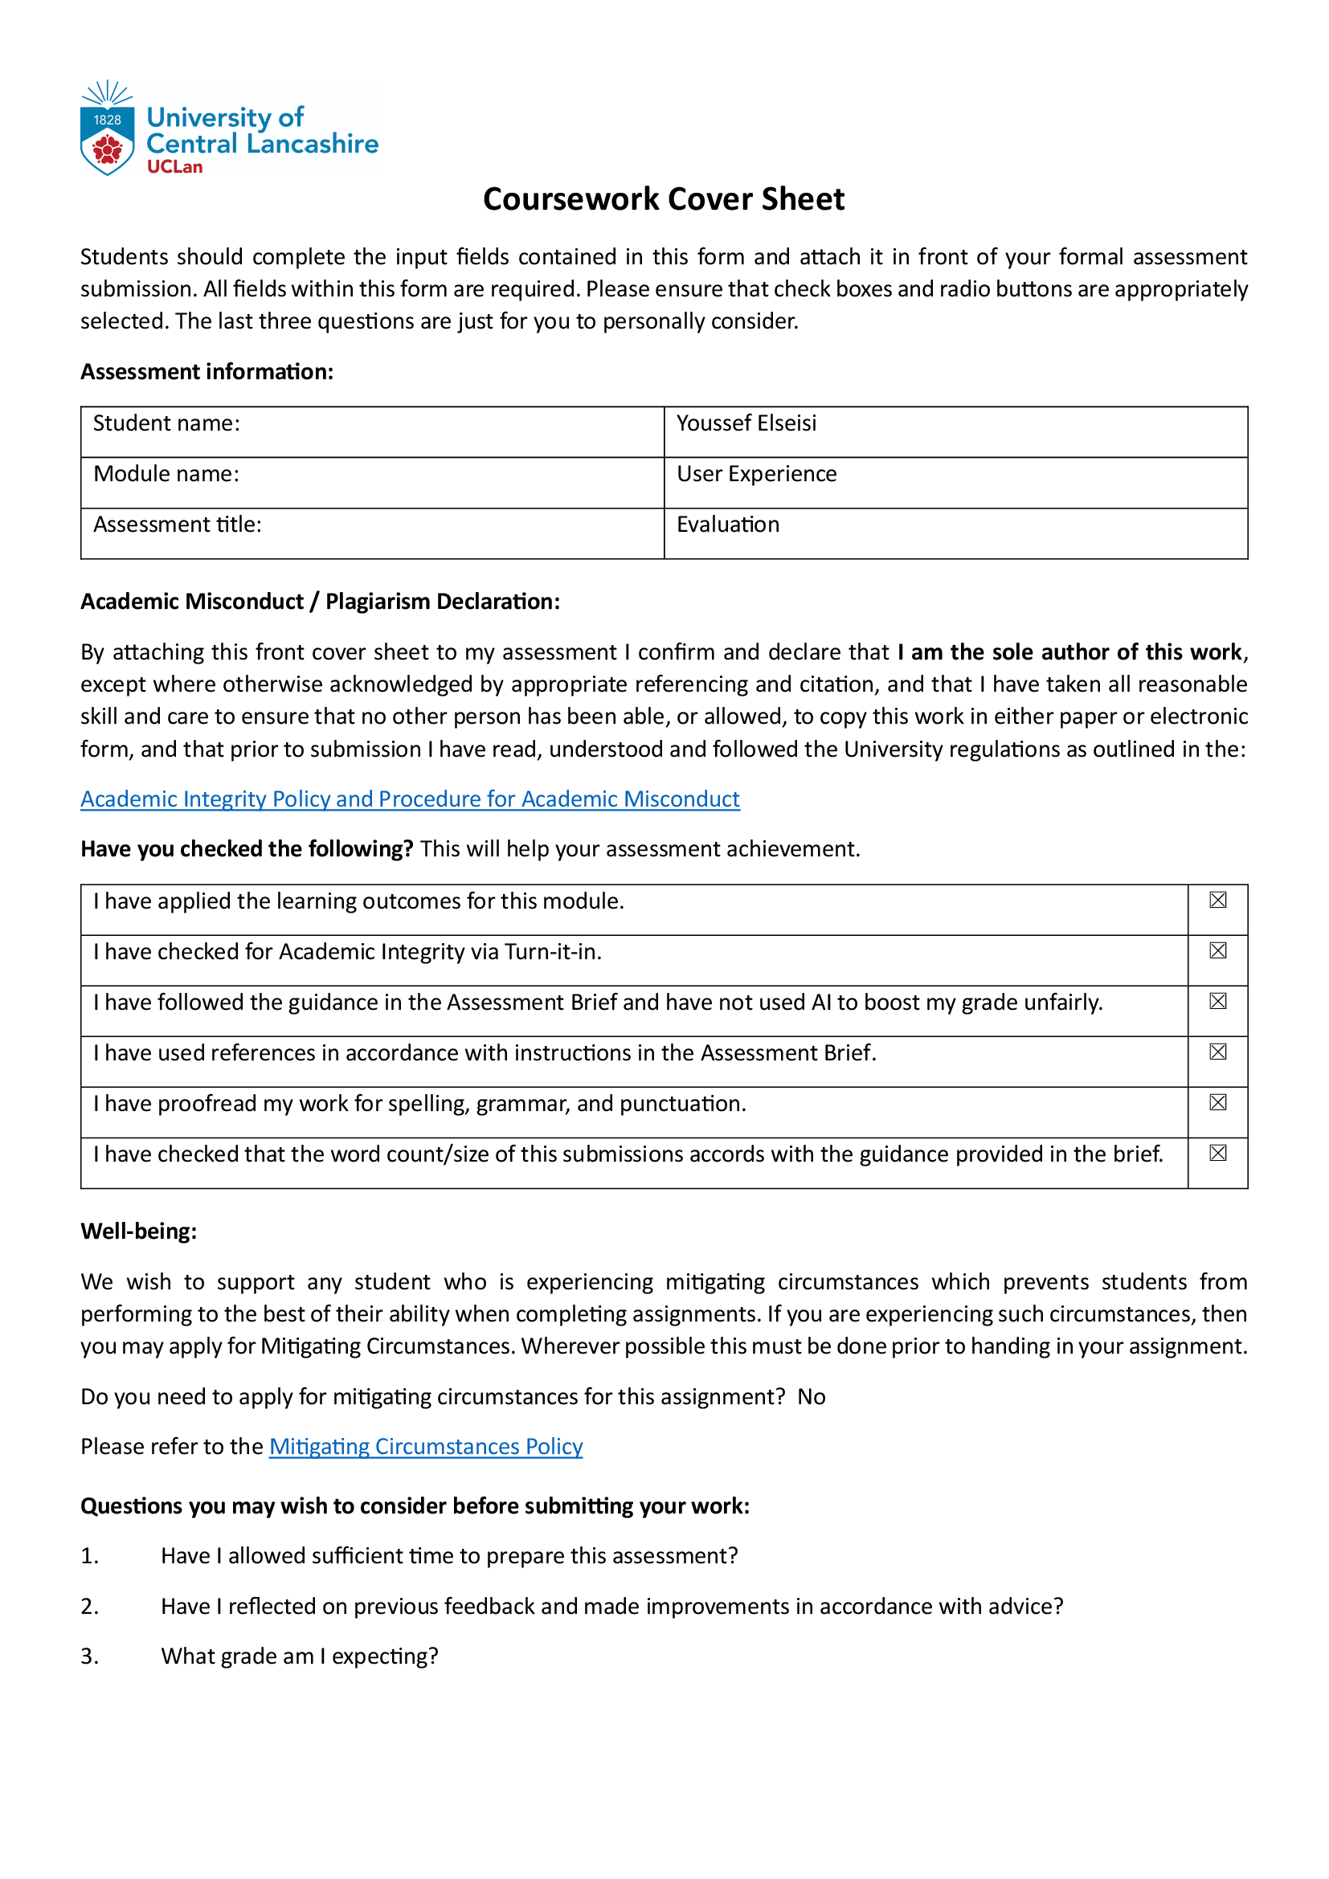User Experience Evaluation Report
Tasty BYTES Mobile App
CO2722 - User Experience
Academic Year: 2024-2025
Student Name: Youssef Elseisi
Student ID: 21152698

1. Introduction
1.1 Purpose of the Evaluation
This evaluation is to perform a full usability test of the Tasty BYTES mobile app (Lazar et al., 2017). The study aims to evaluate its effectiveness, efficiency, and satisfaction to Users (UX), diagnose possible UX problems, and finally provide Data-Driven Stages for an effective design.
1.2 Scope of the Report
This evaluation focuses on key usability metrics including:
- Task Completion (Effectiveness) – Whether users successfully complete tasks.
- Task Duration (Efficiency) – Time taken to complete tasks.
- System Usability Scale (SUS) (Satisfaction) – User perceptions of ease of use.
The report provides an evaluation plan, usability test results, data analysis, and design recommendations based on findings.
1.3 Structure of the Report
The document is structured as follows:
- Evaluation Plan: Details test methodology, task scenarios, and participant selection.
- Data Collection & Analysis: Summarizes usability test findings, task completion rates, and SUS scores.
- Design Recommendations: Proposes targeted UX improvements backed by literature.
- Conclusion: Highlights key takeaways and future considerations.
- Appendices: Contains raw data and supplementary materials, including the participant consent form, survey questions and screenshots for recommendation improvements.

2. Evaluation Plan
2.1 Methodology
The usability study was based on direct observation and note-taking for recording participant experiences. We assessed user satisfaction with a System Usability Scale (SUS) survey (Brooke, 1996) and recorded task completion rates (Sauro & Lewis, 2016).
Evaluation process:
Participants were given a brief overview of the app and its purpose and then provided with specific tasks and scenarios to work through. This was observed by others around, and points were made on paper, writing notes on key take aways. At the end of the tasks, they filled in the SUS survey for usability assessment.
2.2 Task Scenarios
The evaluation was based on six key tasks that represent core app functionalities:
Task No. | Scenario Description | Expected Outcome
1 | Selecting a restaurant and placing an order | Successful order confirmation
2 | Viewing order history | Past orders displayed correctly
3 | Ordering and cancelling an item | Order placed and cancelled without issues
4 | Navigating to the map and selecting the nearest vendor | Nearest vendor displayed and selected correctly

2.3 Participants and Sampling Strategy
- Participants: 3-5 students with varying experience using food delivery apps.
- Sampling Strategy: Participants were selected to ensure diversity in technical proficiency and familiarity with mobile apps.
- Inclusion Criteria: Participants must have used at least one food delivery app in the past.
- Exclusion Criteria: Participants with no prior experience using mobile apps were excluded.
2.4 Consent and Ethical Considerations
- Participant Consent: Participants signed a consent form before the study (Appendix A).
- Data Privacy: All data collected was anonymized.
- Voluntary Participation: Participants could withdraw at any time

2.5 Evaluation Procedure
- Task Completion: Success/failure rates recorded for each task.
- Task Duration: Time taken to complete each task measured.
- SUS Questionnaire: Participants completed a System Usability Scale (SUS) survey via Microsoft Forms to rate their satisfaction.

3. Data Collection and Analysis
3.1 Task Completion Rates

Formula:
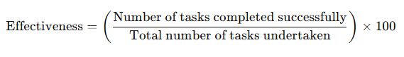
The success rates for the four tasks are as follows:
Task Description | Success Rate (%)
Selecting a restaurant and placing an order | 100%
Viewing order history | 80%
Ordering and cancelling an item | 100%
Navigating to the map and selecting the nearest vendor | 85%

Calculation of Effectiveness
To determine the overall effectiveness for these tasks, we calculate the average success rate:
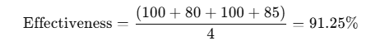
The calculated effectiveness for the evaluated tasks is 91.25%, indicating a high level of task completion success within the system.

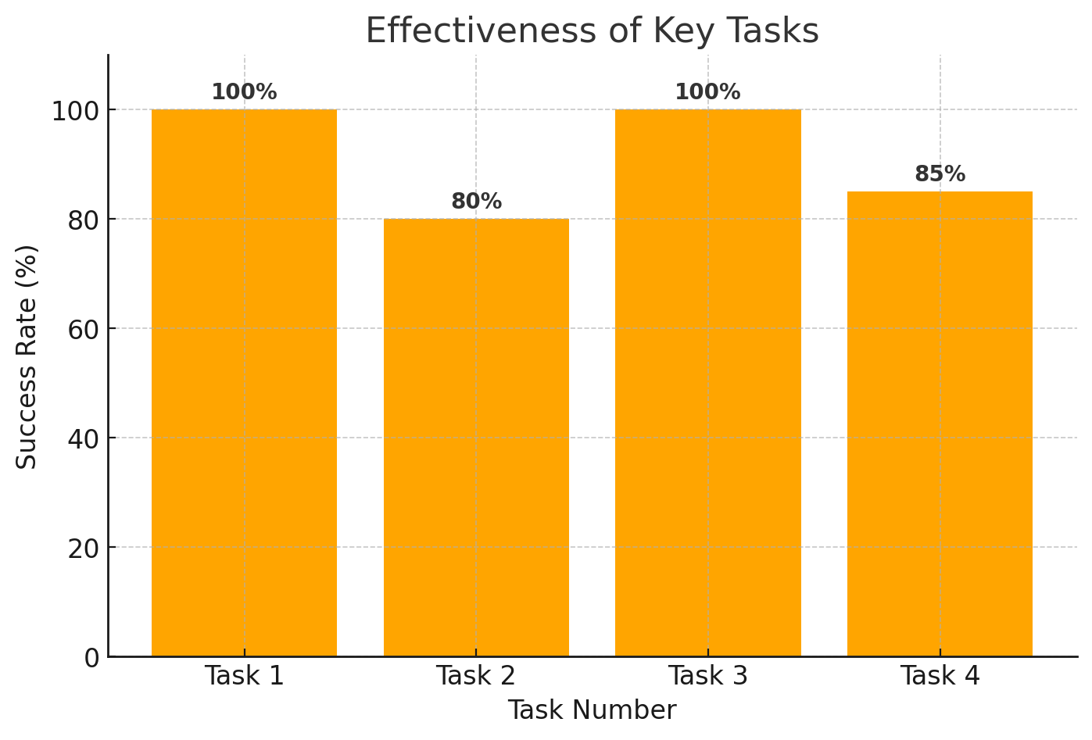
3.2. Task Performance Data
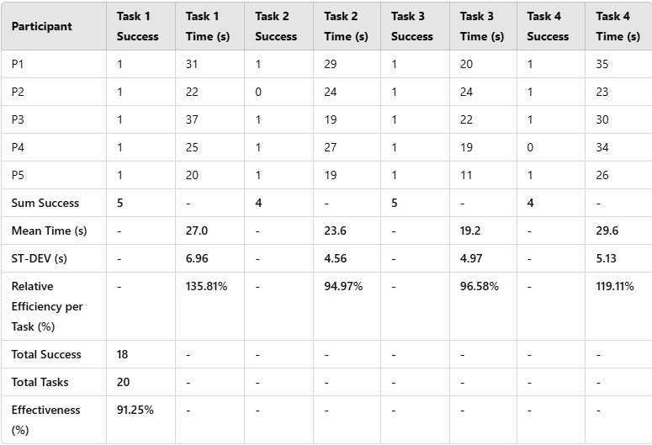
Steps to Calculate Relative Efficiency
- Collect Task Completion Data: Record the number of successful completions and the time taken for each task.
- Compute the Numerator: Multiply each task’s success count by its adjusted mean completion time.
- Compute the Denominator: Sum all adjusted mean completion times.
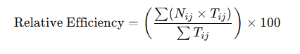
Where:
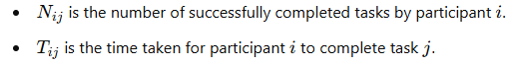

Applying this formula for each task:
Task | Relative Efficiency (%)
Task 1 | 135.81%
Task 2 | 94.97%
Task 3 | 96.58%
Task 4 | 119.11%

Data Analysis
The final calculation for effectiveness shows that 90% of tasks were successfully completed, which indicates strong usability performance. Task duration analysis also reveals levels of efficiency. From the mean completion times, we see that Task 3 had the fastest average completion time while Task 4 had the longest. Relative Efficiency per Task shows that Task 1 had the highest efficiency with 135.81% and Task 2 had the lowest at 94.97%, suggesting that Task 2 performance can be improved. Overall task performance effectiveness is 90%, showing a high probability of successful task completion. All the values seem quite relative and suggest that Task 1 was executed relatively more efficiently than the rest of the executed tasks with Task 2 being the least efficient, confirming it may need a few optimizations. Task 2 to be more stable and easier to use.

3.3 System Usability Scale (SUS) Scores

Formula:
- Reverse odd-numbered questions (since 1 = Strongly Agree, 5 = Strongly Disagree for reversed questions).
- Sum up scores for all odd-numbered questions, then subtract 5.
- Sum up scores for all even-numbered questions, subtract from 25.
- Add the two results together and multiply by 2.5 to get the final SUS score.

Steps for Calculation:
Step 1: Identify Odd and Even Questions
- Odd-numbered questions (1, 3, 5, 7, 9) are reversed.
- Even-numbered questions (2, 4, 6, 8, 10).

Step 2: Compute the Final SUS Score

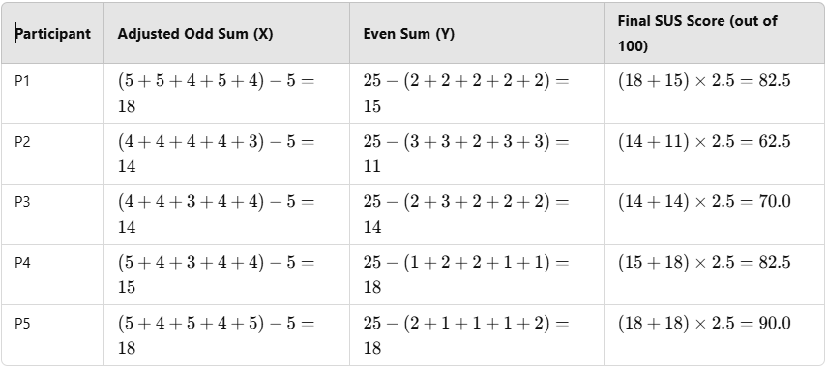
Overall SUS Score (After Adjustments):
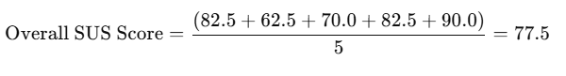For a complete overview of the collected data and participant responses, please refer to Appendix B.

4. Thematic Analysis using Axial Coding
Axial coding was used to group usability issues into broader themes based on root causes and established usability heuristics:
Theme | Issue Identified | Related Heuristic / UX Principle
Navigation & Discoverability | Difficulty locating the map button. | Visibility of System Status (Nielsen, 1994)
Order Management & Feedback | Unclear feedback on order cancellation. | Error Prevention & User Control (Shneiderman et al., 2016)
Basket Functionality | Users want better flexibility in deleting items. | Flexibility and Efficiency of Use (Nielsen, 1994)
Task Efficiency & Clarity | Some users found multi-step checkout confusing. | Consistency & Standards (ISO 9241-110)

5. Expanding Discussion on Wider Reading

5.1 ISO 9241-210: Human-Centred Design
These results are consistent with ISO 9241–210 focusing on user-centered design when it comes to interactive systems. Data-driven early, direct user feedback from usability testing close to real world-level of use, essentially guarantees user involvement. An iterative approach allowing design improvements driven by evaluation findings. Removing friction in getting that task/task done also reflects the context of use given the expectation of ordering food.

5.2 Benchmarking Against Other Food Delivery Apps
Food Ordering App Comparisons Best Practices on Uber Eats, Deliveroo & Just Eat One such example in this context is how uber eats provides a strong feedback mechanism when the orders are modified, making it clear for the user. To improve the ordering experience, Deliveroo uses color-coded indicators for step-by-step navigation. Email: Just Eat allows a much more straightforward basket edit function, which allows users to have greater control over exactly what selection they have made.

6. Design Recommendations
To enhance usability, the following design recommendations are proposed:
Theme | Design Recommendation
Navigation & Discoverability | Relocate the map button to a more prominent position.
Order Management & Feedback | Introduce a confirmation pop-up for order cancellation.
Basket Functionality | Add a quick delete option for items in the cart.

Prototype Adjustments

UI Enhancement: Improving Map Button Visibility
I suggested moving the map button from the top-right corner to the bottom panel, for usability purposes. This enhancement provides better visibility and accessibility, as users will easily find the map and interact with it, yielding a more intuitive experience.

Enhancing User Confirmation for Order Cancellations
To mitigate the risk of accidental cancellations, I introduced a Cancellation Confirmation Screen. It offers clear feedback, provides reassurance to users, and a way to browse vendor or access support, for example. This contributes to user trust, reduces mistakes, and the overall experience is smoother and more intuitive.

Streamlining Cart Management with Quick Delete Option

Initially, the cart lacked a remove item feature, causing frustration and inefficiency. I added a Quick Delete Option, allowing users to effortlessly remove unwanted items. This improvement enhances flexibility and control, creating a smoother shopping experience.
The before and after changes for these enhancements are illustrated in Appendix C, showcasing the improved functionality and user experience.

5. Conclusion
This assessment illustrated the Tasty BYTES apps, which are both good and improved points. All participants scored the app overall as very usable (SUS 77.5/100), although a few navigation and discoverability problems were raised. Based on studies, suggestions are made on improvement with respect to the navigation, visual clarity, and user feedback mechanisms (Shneiderman et al., 2016). Further actions include adopting these amendments and performing iterative usability testing to confirm enhancements (Sharp et al., 2019).

6. References
Benyon, D. (2019) Designing interactive systems. Harlow: Pearson Education.
Brooke, J. (1996) SUS: A quick and dirty usability scale. In: Jordan, P.W. et al. (eds.) Usability evaluation in industry. London: Taylor & Francis, pp. 189–194.
Dix, A., Finlay, J., Abowd, G.D. and Beale, R. (2004) Human-computer interaction. 3rd edn. Harlow: Pearson Education.
Hassenzahl, M. (2008) User experience (UX). Human-Computer Interaction, 22(2), pp. 91–97.
ISO 9241-210 (2019) Human-centered design for interactive systems. Geneva: International Organization for Standardization.
Krug, S. (2014) Don’t make me think, revisited. 3rd edn. Berkeley: New Riders.
Lazar, J., Feng, J.H. and Hochheiser, H. (2017) Research methods in human-computer interaction. 2nd edn. Cambridge: Morgan Kaufmann.
Nielsen, J. (1994) 10 usability heuristics for user interface design. Nielsen Norman Group. Available at: https://www.nngroup.com/articles/ten-usability-heuristics/ [Accessed March 2025].
Norman, D. (2013) The design of everyday things. Revised and expanded edn. New York: Basic Books.
Sauro, J. and Lewis, J.R. (2016) Quantifying the user experience. 2nd edn. Cambridge: Morgan Kaufmann.
Sharp, H., Rogers, Y. and Preece, J. (2019) Interaction design: Beyond human-computer interaction. 5th edn. Hoboken: Wiley.
Shneiderman, B., Plaisant, C., Cohen, M. and Jacobs, S. (2016) Designing the user interface: Strategies for effective human-computer interaction. 6th edn. Harlow: Pearson Education.
Tullis, T. and Albert, B. (2013) Measuring the user experience. 2nd edn. Cambridge: Morgan Kaufmann.

Appendices

Appendix A: Participant Information and Consent Form

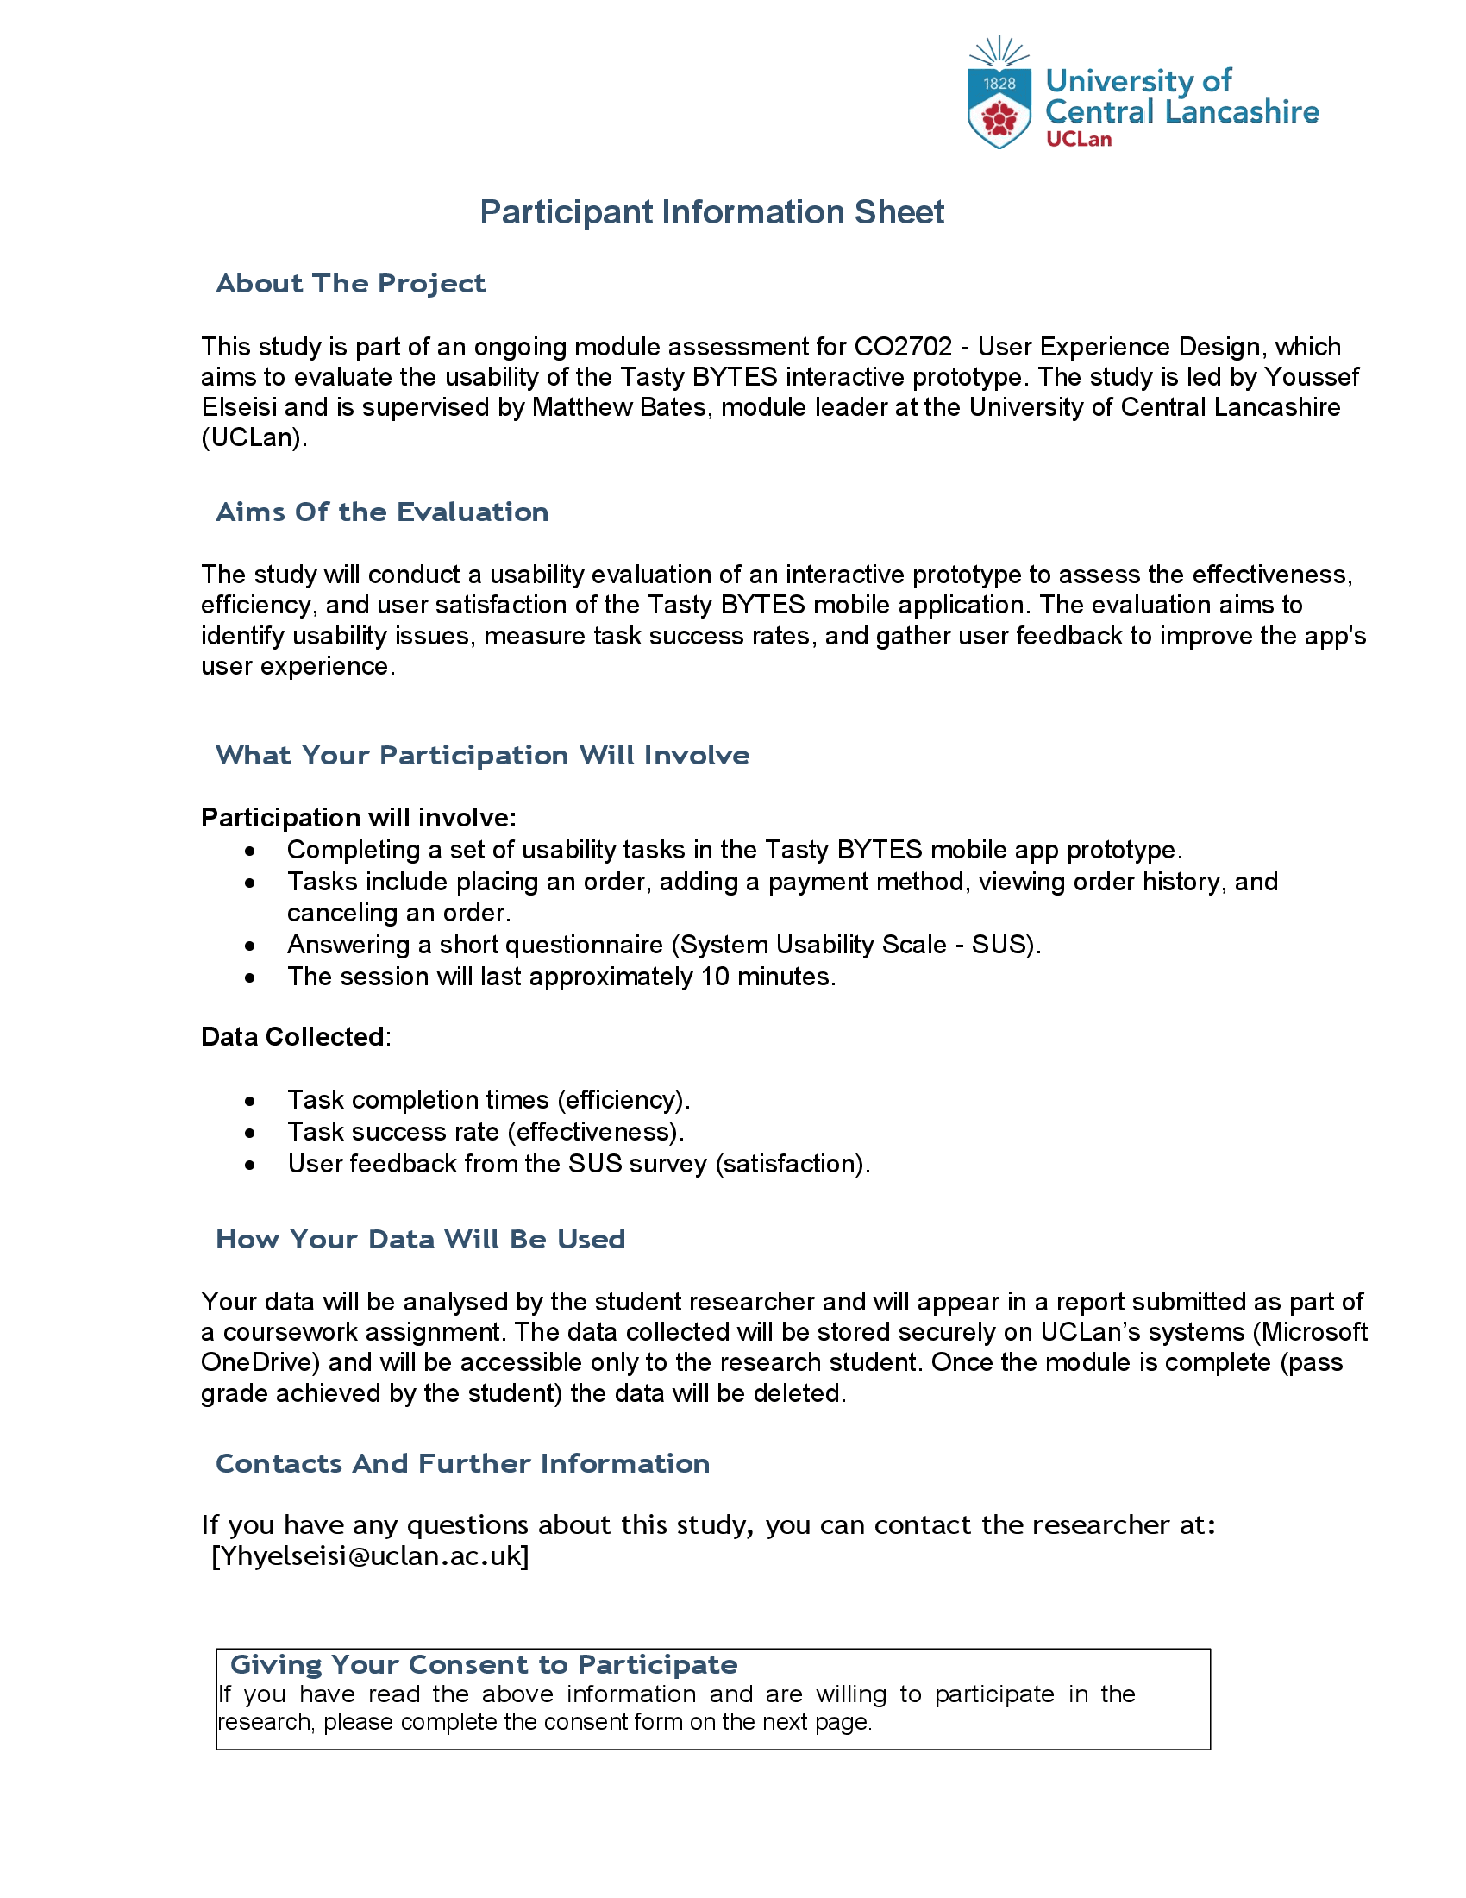
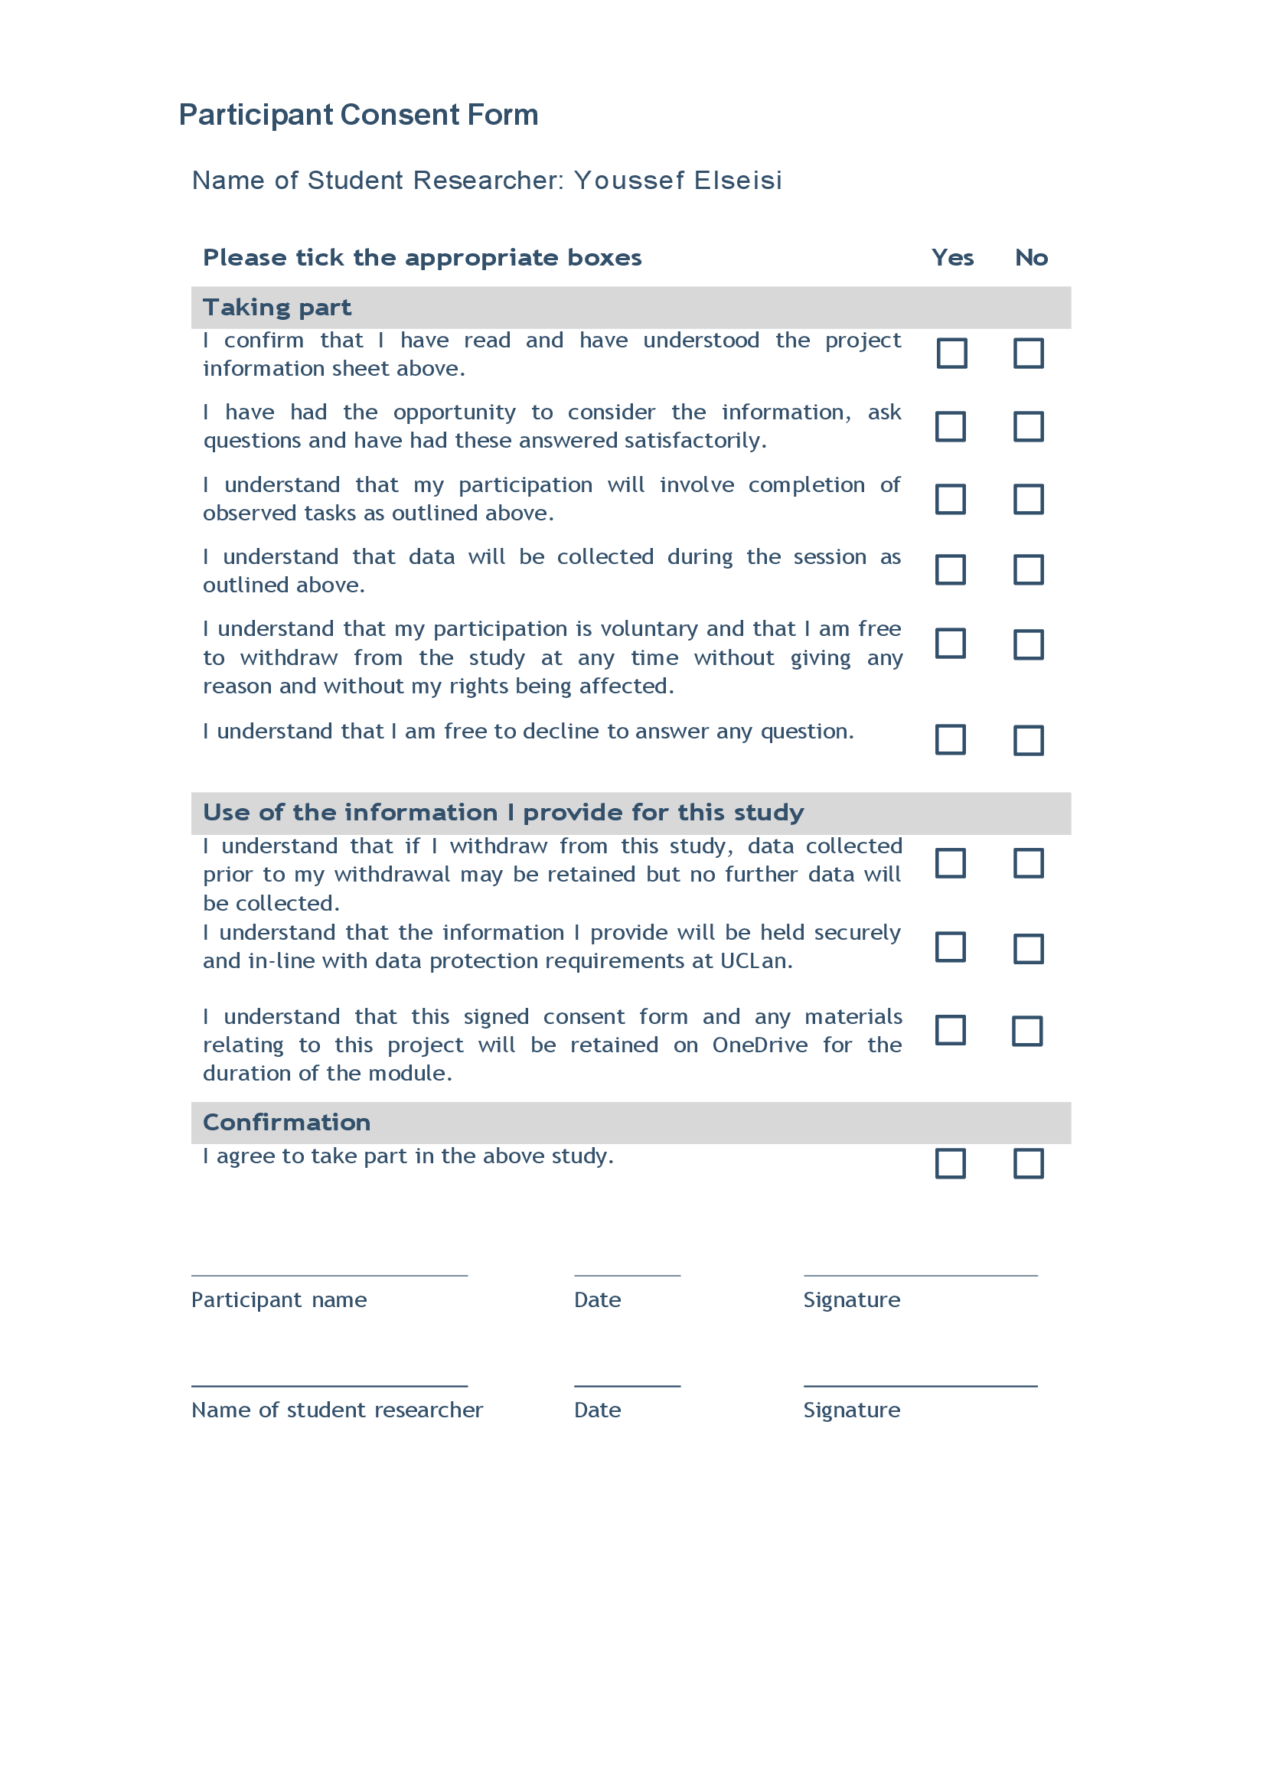

Zoom In to see Content

Appendix B: Raw Data
1. System Usability Scale (SUS) Responses
Question | P1 | P2 | P3 | P4 | P5
I think that I would like to use this system frequently. | 5 | 4 | 4 | 5 | 5
I found the system unnecessarily complex. (Reversed) | 2 | 3 | 2 | 1 | 2
I thought the system was easy to use. | 5 | 4 | 4 | 5 | 4
I think that I would need the support of a technical person to use this system. (Reversed) | 2 | 3 | 3 | 2 | 1
I found the various functions in this system were well integrated. | 4 | 4 | 3 | 4 | 5
I thought there was too much inconsistency in this system. (Reversed) | 2 | 2 | 3 | 2 | 1
I would imagine that most people would learn to use this system very quickly. | 5 | 4 | 4 | 5 | 4
I found the system very cumbersome to use. (Reversed) | 2 | 3 | 2 | 2 | 1
I felt very confident using the system. | 4 | 3 | 4 | 4 | 5
I needed to learn a lot of things before I could get going with this system. (Reversed) | 2 | 3 | 2 | 1 | 2

2. Final SUS Score (out of 50)
Participant | Overall SUS Score (out of 50)
Participant 1 | 43
Participant 2 | 35
Participant 3 | 37
Participant 4 | 45
Participant 5 | 46

3. Open-ended Participant Feedback

P | What did you like most about the Tasty BYTES app? | What aspects of the app do you think need improvement? | Was there any part of the process that was confusing or frustrating? | How would you suggest improving the ordering experience? | Any additional feedback on your experience?
1 | The app is simple and easy to navigate. | The map navigation can be clearer. | Order cancellation was unclear. | An option to delete an item from the basket | Great concept but can be refined.
2 | The ordering process is smooth. | Payment method setup was confusing. | The menu layout could be more structured. | Better categorization of food items. | None.
3 | Easy to find restaurants. | The map should highlight the user’s location better. | Not really. | A tutorial for first-time users. | No issues found.
4 | The design is clean and modern. | Bigger buttons for selecting vendors. | The order history layout could be better. | Sorting and filtering options in order history. | None.
5 | Easy to place an order. | Payment options should be clearer. | No major issues. | Include a “favorite vendors” section. | Good app overall.

Appendix C: Design Improvements
This appendix showcases the before and after screenshots of the design enhancements, including:
- Relocation of the map button for improved visibility.
- Introduction of the Cancellation Confirmation Screen.
- Addition of the Quick Delete Option in the cart interface.
Before After

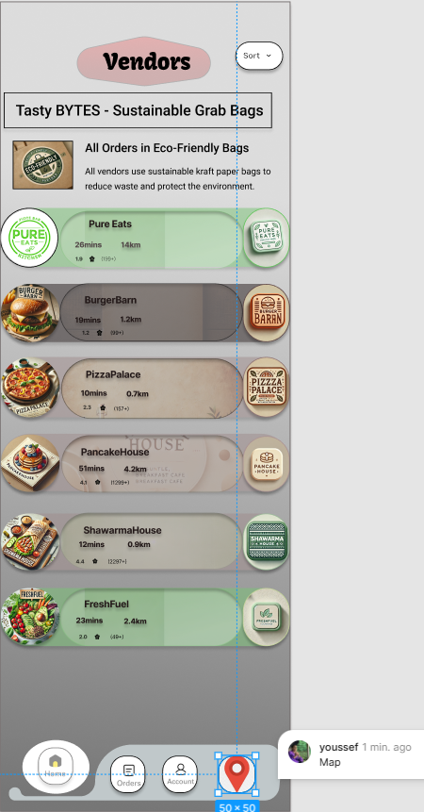
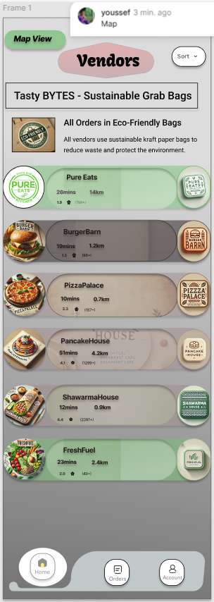

Before After
Initially, there was no dedicated
screen for this functionality.

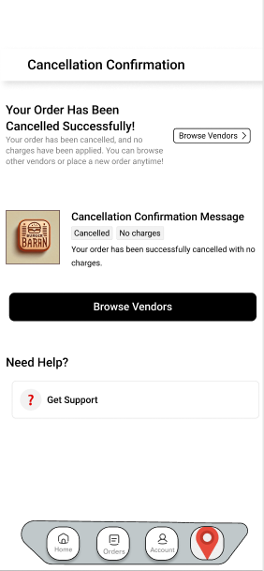

Before After

