CO2722 - User Experience

Assessment Report: Tasty BYTES Mobile App Design
Student Name: Youssef Hegazi Elseisi

1. Introduction
The Tasty BYTES mobile app is designed to streamline the process of ordering lunch for UCLan students and staff. By focusing on user needs, the app aims to deliver an intuitive and efficient experience that reduces wait times and ensures sustainability. This report documents the design process, covering personas, low-fidelity wireframes, and the high-fidelity prototypes. Usability principles and extensive wider reading underpin all design decisions.

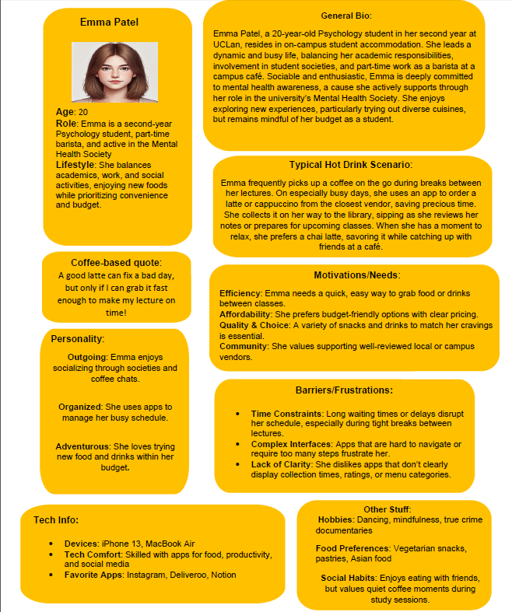
2. Personas
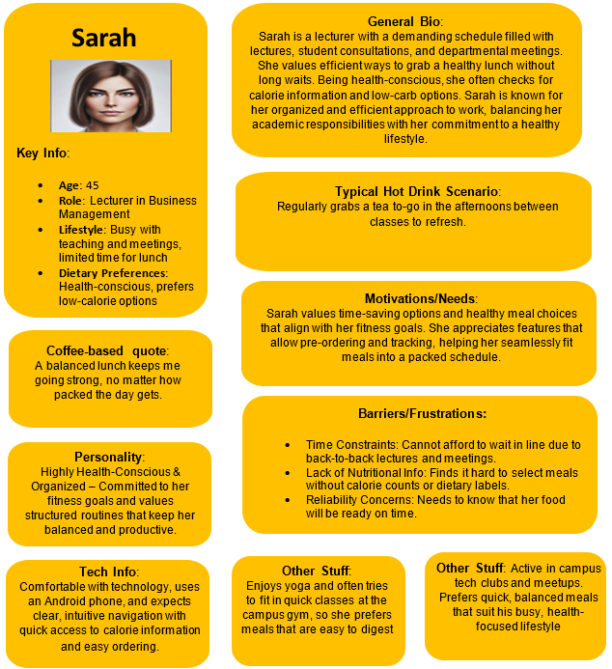

3. Low-Fidelity Wireframes
Overview
The wireframes illustrate the app's core functionality, ensuring that all user journeys are intuitive and align with Duke’s design requirements. Each screen has been annotated with explanations and justifications for design decisions, linking back to the personas and usability principles.
Key Screens
1. Home Screen:
- Displays a list of participating food vendors, sortable by collection time, distance, or rating.
- Includes a map feature to visualize vendor locations based on user proximity.
- Justification: Sorting options improve decision-making efficiency (Tullis & Albert, 2013). The map enhances spatial awareness (Nielsen, 2020).
2. Menu Screen:
- Categorises items into Nibbles, Bytes, Mega-Bytes, and Giga-Bytes.
- Includes filters for allergens, price range, and preparation time.
- Justification: Clear categorisation supports user goals by simplifying the selection process (Snyder, 2003).
3. Basket Screen:
- Allows users to review selected items, adjust quantities, or proceed to checkout.
- Justification: This provides control over the ordering process, aligning with Norman’s (2013) principles of user autonomy.
4. Order Status Screen:
- Tracks order progress with real-time updates on preparation and collection stages.
- Justification: Keeps users informed and reduces uncertainty (Tullis & Albert, 2013).
5. Account and Payment Screen:
- Enables management of personal information and payment methods.
- Justification: Simplifies the user’s interaction with the app (Shneiderman et al., 2017).

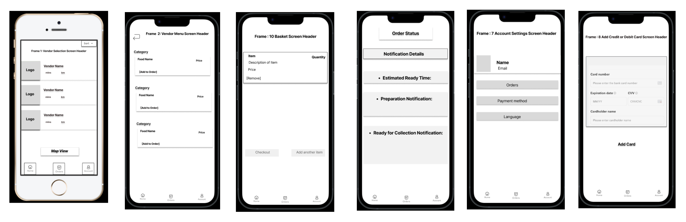

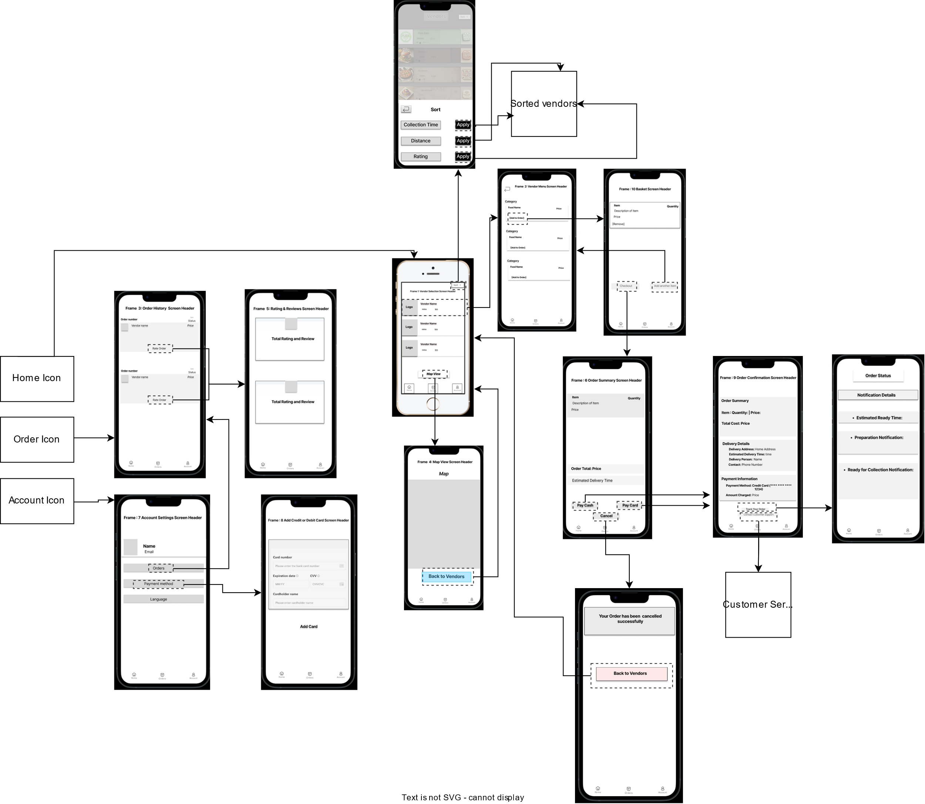

5. Wider Reading
The design decisions have been informed by the following sources:
- Tullis & Albert (2013): Metrics for measuring usability informed the sorting and filtering features.
- Nielsen (2020): Usability heuristics guided navigation and error prevention.
- Norman (2013): Principles of design thinking influenced the intuitive interface.
- Shneiderman et al. (2017): Best practices for interaction design were applied to the menu and order screens.
- Krug (2014): Insights on simplicity shaped the overall layout and navigation.
Significance: These sources provide a robust foundation for the app’s design, ensuring it meets modern UX standards.

6. Conclusion
The Tasty BYTES app has been designed to address the needs of UCLan students and staff, offering a user-friendly and efficient way to order lunch. The personas, wireframes, and prototype demonstrate how the app aligns with Duke’s requirements, supported by usability principles and wider reading. By focusing on both functionality and user experience, the app achieves a high standard of design.

References

Hassenzahl, M. (2003) 'The thing and I: understanding the relationship between user and product', Funology, 31, pp. 31-42.
Hassenzahl, M. (2010) Experience design: technology for all the right reasons. San Rafael, CA: Morgan & Claypool.
Krug, S. (2014) Don't make me think, revisited: a common sense approach to web usability. 3rd edn. Berkeley, CA: New Riders.
Law, E. L.-C., Roto, V., Hassenzahl, M., Vermeeren, A. P. and Kort, J. (2009) 'Understanding, scoping and defining user experience: a survey approach', Proceedings of the SIGCHI Conference on Human Factors in Computing Systems, pp. 719-728.
Nielsen, J. (2020) '10 usability heuristics for user interface design', Nielsen Norman Group, 1 April. Available at: https://www.nngroup.com/articles/ten-usability-heuristics/ (Accessed: 13 December 2024).
Norman, D. A. (2013) The design of everyday things. Revised and expanded edition. New York: Basic Books.
Shneiderman, B., Plaisant, C., Cohen, M., Jacobs, S., Elmqvist, N. and Diakopoulos, N. (2017) Designing the user interface: strategies for effective human-computer interaction. 6th edn. Boston: Pearson.
Snyder, C. (2003) Paper prototyping: the fast and easy way to design and refine user interfaces. San Francisco: Morgan Kaufmann.
Tullis, T. and Albert, B. (2013) Measuring the user experience: collecting, analyzing, and presenting usability metrics. 2nd edn. Waltham, MA: Morgan Kaufmann.
Usability.gov (n.d.-a) 'User interface design basics'. Available at: https://www.usability.gov/what-and-why/user-interface-design.html. (Accessed: 13 December 2024).
Usability.gov (n.d.-b) 'System status visibility'. Available at: https://www.usability.gov/how-to-and-tools/methods/system-status-visibility.html. (Accessed: 13 December 2024).
UX Collective (2023) 'The importance of user feedback in UX design', UX Collective, 15 March. Available at: https://uxdesign.cc/the-importance-of-user-feedback-in-ux-design-7bdf5e8f6c5e. (Accessed: 13 December 2024).
UX Planet (2021) 'Enhancing user experience with real-time updates', UX Planet, 22 July. Available at: https://uxplanet.org/enhancing-user-experience-with-real-time-updates-5d3b4f8e9f2b. (Accessed: 13 December 2024).

