F# STORE SIMULATOR
PROJECT DOCUMENTATION
Version: 1.0
Date: January 16, 2024
Authors: [Your Team Names]
Organization: [Your University/Organization]

TABLE OF CONTENTS
- Executive Summary
- Project Overview
- System Architecture
- Technical Specifications
- Module Documentation
- User Guide
- Developer Guide
- API Reference
- Deployment Guide
- Maintenance Guide

1. EXECUTIVE SUMMARY
Project Description
The F# Store Simulator is a modern desktop application built using F# and Avalonia UI framework. It demonstrates functional programming principles through a practical e-commerce simulation with product catalog management, shopping cart operations, discount calculations, and order persistence.
Key Features
- 15 pre-loaded products across 5 categories
- Real-time product search and filtering
- Immutable shopping cart operations
- Automatic and coupon-based discounts
- Stock management with validation
- JSON-based order persistence
- Modern, responsive user interface
Technology Stack
- Language: F# 8.0
- Framework: .NET 8.0
- UI Framework: Avalonia 11.3.8
- Architecture: MVVM (Model-View-ViewModel)
- Data Persistence: JSON (Newtonsoft.Json)
- Data Structures: Immutable Map and List
Project Goals
- Demonstrate functional programming concepts in F#
- Implement pure functions and immutable data structures
- Create a practical, real-world application
- Provide clean separation of concerns using MVVM
- Ensure type safety and error handling
Target Audience
- F# developers learning functional programming
- Students studying functional languages
- Developers exploring Avalonia UI
- Anyone interested in MVVM architecture with F#

2. PROJECT OVERVIEW
2.1 Problem Statement
Traditional imperative programming often leads to mutable state, side effects, and difficult-to-maintain code. This project demonstrates how functional programming principles in F# can create maintainable, testable, and reliable applications.
2.2 Solution Approach
The application uses:
- Immutable Data Structures: All data transformations create new instances
- Pure Functions: Functions without side effects for predictable behavior
- Type Safety: F#'s strong type system prevents runtime errors
- Pattern Matching: Elegant handling of optional values and errors
- Discriminated Unions: Clear representation of business logic states
2.3 Project Scope
In Scope
✅ Product catalog management
✅ Shopping cart operations
✅ Price calculations and discounts
✅ Search and filter functionality
✅ Order persistence to JSON
✅ Stock management
✅ User-friendly GUI
Out of Scope
❌ User authentication/authorization
❌ Multi-user support
❌ Database integration
❌ Payment processing
❌ Order history in UI
❌ Product images
❌ Multi-currency support

2.4 Project Timeline

Phase | Duration | Deliverables
Planning & Design | Week 1 | Architecture document, UI mockups
Core Module Development | Week 2-3 | Catalog, Cart, Price Calculator
UI Implementation | Week 4 | Avalonia XAML, ViewModel
Integration | Week 5 | Connect all modules
Testing | Week 6 | Test all features
Documentation | Week 7 | User guide, API docs
Deployment | Week 8 | Release version 1.0

3. SYSTEM ARCHITECTURE
3.1 Architecture Overview

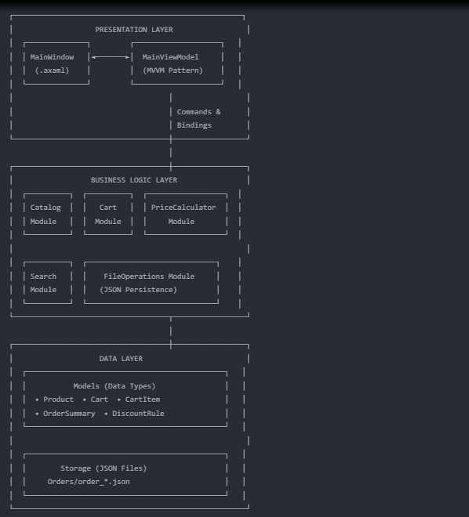
3.2 MVVM Pattern Implementation
Model
- Defines data structures (Product, Cart, CartItem)
- Contains business logic in modules (Catalog, Cart, PriceCalculator)
- No knowledge of UI
View
- XAML-based UI (MainWindow.axaml)
- Displays data through bindings
- Handles user input through commands
- No business logic
ViewModel
- MainViewModel.fs
- Exposes data as ObservableCollections
- Implements INotifyPropertyChanged
- Provides Commands for user actions
- Coordinates between View and Model
- 3.3 Data Flow
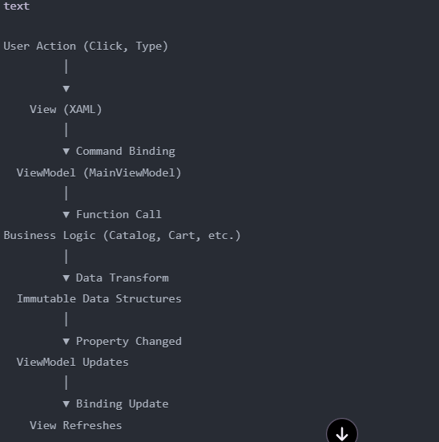

3.4 Module Dependencies
