📘 F# Store Simulator - Project Documentation

Complete Technical Documentation
Version: 1.0
Date: December 2025
Platform: .NET 8.0 / Avalonia UI
Language: F#

Table of Contents
- Project Overview
- Features
- Architecture
- Technology Stack
- Project Structure
- Installation & Setup
- Data Models
- Module Documentation
- UI Components
- Test Coverage
- Sample Data
- Team Contributions
- Usage Guide
- Known Coupons

- Project Overview

1.1 Objective
Build a virtual F# store with cart functionality and basic product management. The application is designed to help students learn:
- Data structures (List, Map)
- Pure functions
- Immutable state management
- MVVM architecture pattern

1.2 Description
Users can browse products, add/remove items from their cart, apply discount coupons, and complete checkout. The application demonstrates functional programming principles using F# with a modern GUI built on Avalonia UI framework.

1.3 Application Screenshot
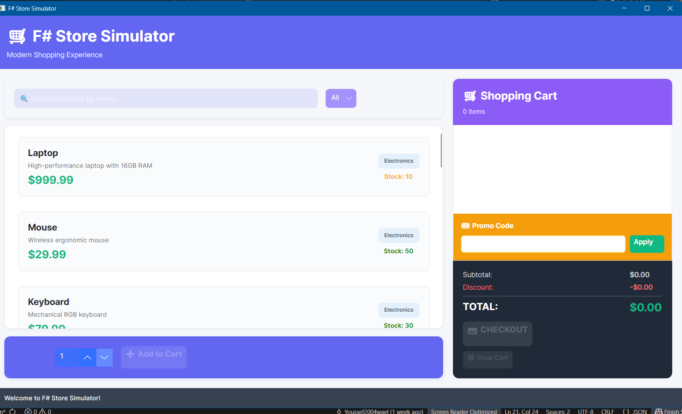
The application features a modern, clean interface with:
- Left panel: Product catalog with search and filtering
- Right panel: Shopping cart with promo code functionality
- Bottom bar: Status messages and notifications

- Features

  - Core Features
Feature | Description | Module
📦 Product Catalog | 15 products stored in immutable Map structure | Catalog.fs
🔍 Search & Filter | Search by name, filter by category/price | Search.fs
🛒 Shopping Cart | Add/remove products with immutable operations | Cart.fs
💰 Price Calculator | Subtotals, discounts, tax, and shipping | PriceCalculator.fs
🎟️ Coupon System | Apply promotional codes for discounts | PriceCalculator.fs
💾 Order Persistence | Save orders to JSON files | FileOperations.fs
🖥️ Modern GUI | Avalonia-based responsive interface | Views/

  - Discount System

Cart Value | Automatic Discount
$200+ | 5% off
$500+ | 10% off
$1000+ | 15% off

3. Architecture

3.1 Architecture Diagram

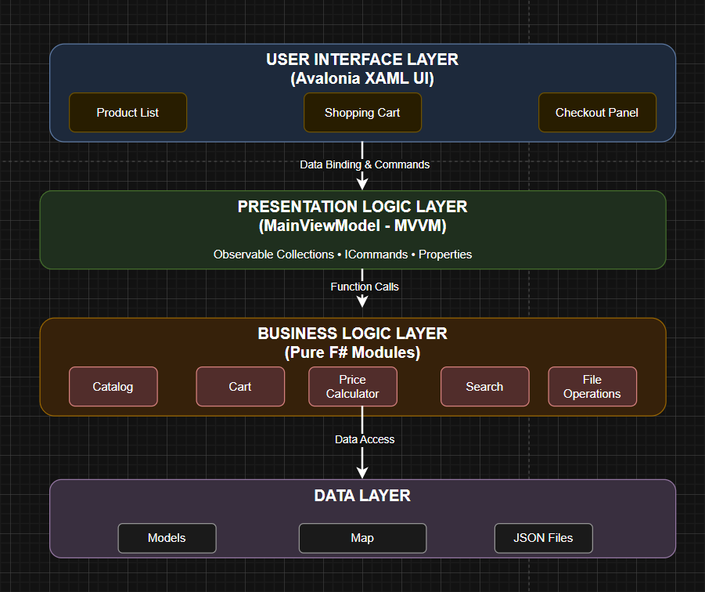

3.2 Data Flow

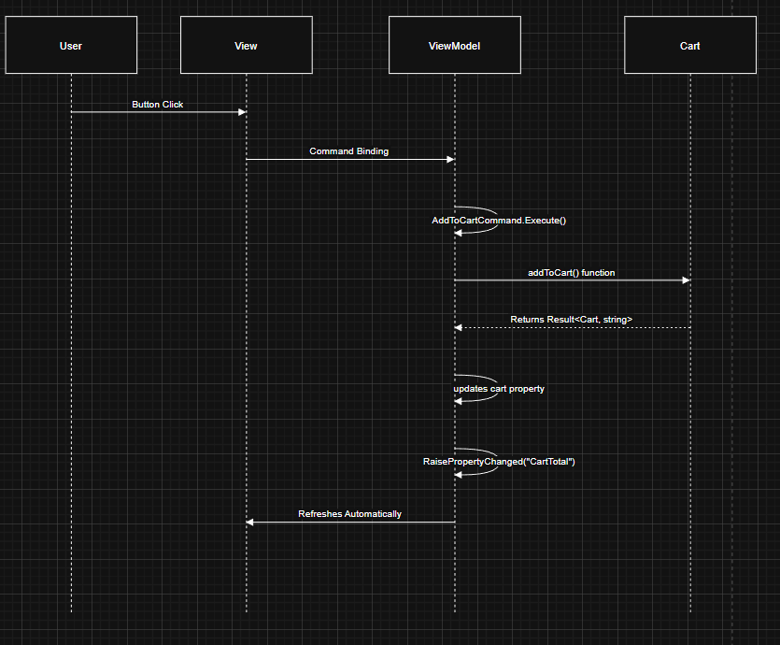

3.3 MVVM PATTERN FLOW

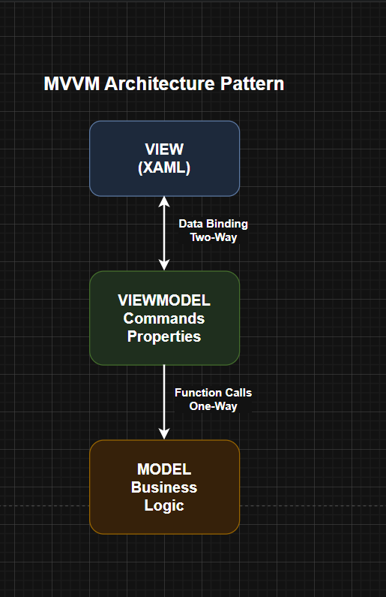

  - CART OPERATION FLOW
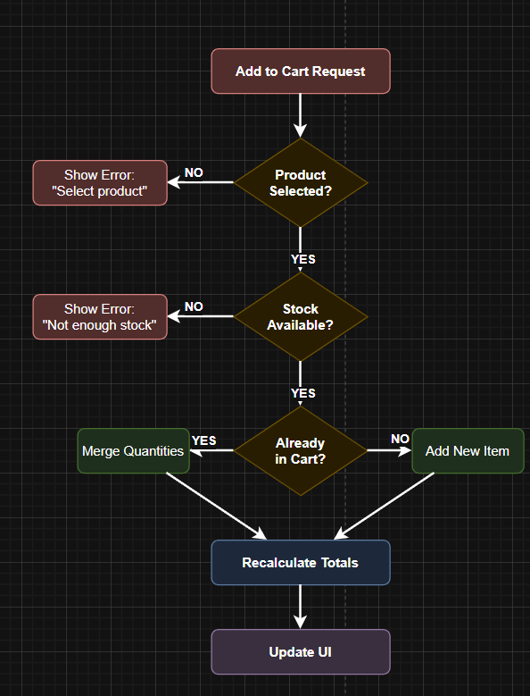
4. Technology Stack
4.1 Core Technologies

Technology | Version | Purpose
F# | .NET 8.0 | Primary programming language
Avalonia UI | 11.3.8 | Cross-platform UI framework
Newtonsoft.Json | 13.0.3 | JSON serialization

4.2 Testing Technologies

Technology | Version | Purpose
xUnit | 2.6.3 | Test framework
FsUnit.xUnit | 5.6.1 | F# assertions
Microsoft.NET.Test.Sdk | 17.8.0 | Test SDK
coverlet.collector | 6.0.0 | Code coverage

4.3 Dependencies (from .fsproj)

<PackageReference Include="Avalonia" Version="11.3.8" />
<PackageReference Include="Avalonia.Desktop" Version="11.3.8" />
<PackageReference Include="Avalonia.ReactiveUI" Version="11.3.8" />
<PackageReference Include="Avalonia.Themes.Fluent" Version="11.3.8" />
<PackageReference Include="Avalonia.Fonts.Inter" Version="11.3.8" />
<PackageReference Include="Avalonia.Diagnostics" Version="11.3.8" />
<PackageReference Include="Newtonsoft.Json" Version="13.0.3" />

5. Project Structure
StoreSimulatorGUI/
│
├── 📁 Assets/ # Application assets
├── 📁 Orders/ # Saved order JSON files
│ ├── order_20251203_022619.json
│ └── order_20251203_024202.json
│
├── 📁 ViewModels/
│ └── MainViewModel.fs # MVVM ViewModel
│
├── 📁 Views/
│ ├── MainWindow.axaml # Main UI layout
│ └── MainWindow.axaml.fs # Code-behind
│
├── 📁 Tests/ # Test project
│ ├── CartTests.fs # Cart module tests
│ ├── CatalogTests.fs # Catalog module tests
│ ├── PriceCalculatorTests.fs # Price calculator tests
│ ├── SearchTests.fs # Search module tests
│ ├── FileOperationsTests.fs # File operations tests
│ ├── IntegrationTests.fs # End-to-end tests
│ └── StoreSimulatorGUI.Tests.fsproj
│
├── Models.fs # Data types/records
├── Catalog.fs # Product catalog operations
├── Cart.fs # Shopping cart operations
├── PriceCalculator.fs # Pricing and discounts
├── Search.fs # Search and filter logic
├── FileOperations.fs # JSON/CSV file operations
├── App.axaml # Application resources
├── App.axaml.fs # Application initialization
├── ViewLocator.fs # View-ViewModel mapping
├── Program.fs # Entry point
└── StoreSimulatorGUI.fsproj # Project file

6. Installation & Setup

6.1 Prerequisites
- .NET 8.0 SDK
- IDE: Visual Studio 2022, VS Code, or JetBrains Rider

6.2 Build & Run
# Clone the repository
git clone <repository-url>
cd StoreSimulatorGUI

# Restore dependencies
dotnet restore

# Build the project
dotnet build

# Run the application
dotnet run

6.3 Run Tests

