School Finance Administration System (SDD)

1. Architecture Overview
The system follows a layered architecture consisting of Frontend, Backend API, Database, and Notification Service.
Users interact with the Frontend, which communicates with the Backend via REST APIs.

2. System Components
Frontend:
- Angular
Backend:
- Spring Boot
Database:
- PostgreSQL
Notification Service:
- Email + In-App

3. Database Design
Users:
- id
- name
- role
- email
- password
Bills:
- id
- title
- vendor
- amount
- date
- image
- tax
- description
- status
Request Funds:
- id
- title
- discerption
- amount of fund
- urgency level
- date
- image
Reports:
- id
- date
- title
- description
- type of report (email or in-App)

3.1 ERD
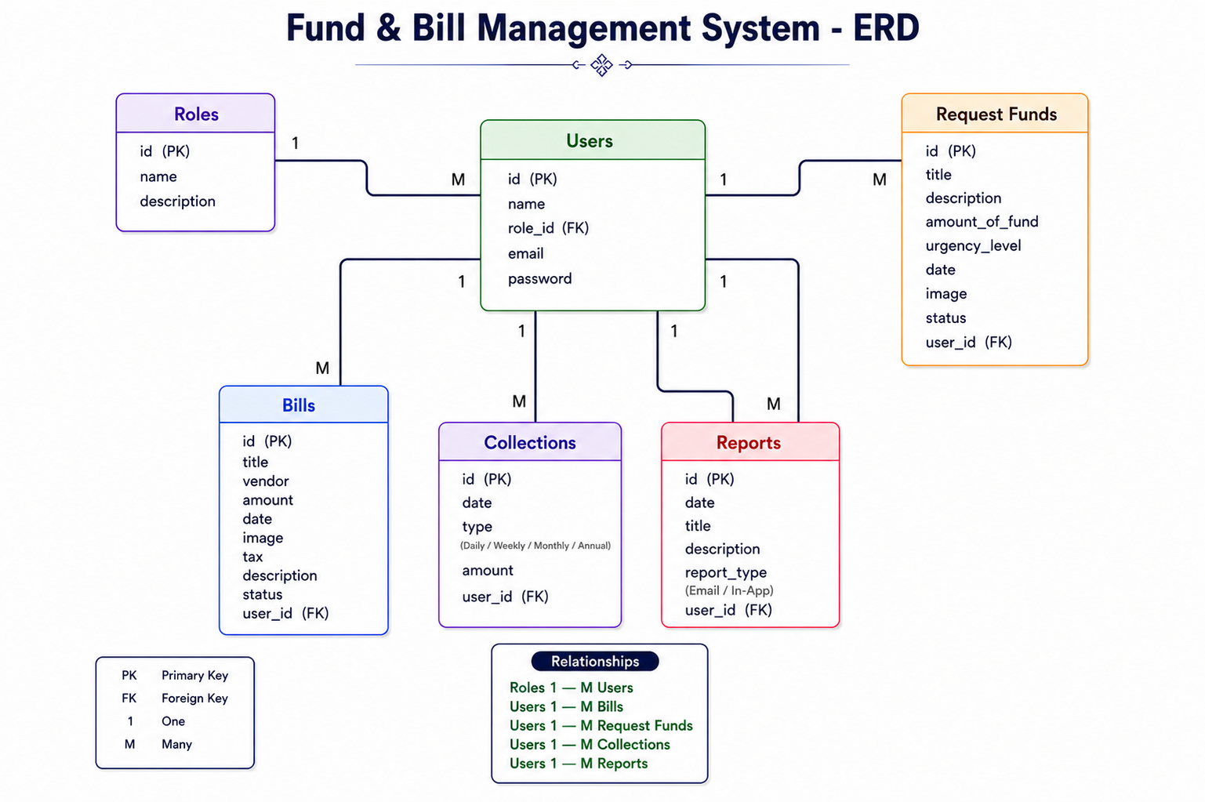

4. API Design
POST /auth/login
POST /bills
GET /bills
POST /collections
GET /reports
GET /notifications

5. Security Design
JWT Authentication
Role-Based Access
Password Hashing (BCrypt)

6. Data Flow
User → Frontend → Backend → Database → API → Notification Service → User

