Methodology
The project follows the Systems Development Life Cycle (SDLC) using the Waterfall methodology: each phase is finished and approved before the next phase starts.
Phases of the project
1- Planning (Project Plan): project identification, system request, feasibility study, and the project plan (PERT and Gantt charts).
2- Analysis (Project Proposal): interviews, questionnaires, data flow diagrams, data dictionary and process specification.
3- Design (Project Specification): ERD, normalization, UML diagrams, architecture, database, program and interface design.
4- Implementation (New System): coding the website, testing, deployment and user training.
Why Waterfall for this project?
1- The requirements of a booking system (search trips, choose seats, pay, e-ticket, cancel) are clear and stable from the beginning.
2- Every phase produces a document that matches the deliverables of the course template.
3- The work is easy to plan, divide between team members and track with PERT and Gantt charts.
4- Progress can be checked at the end of every phase before moving on.
Time Estimation

 | Planning | Analysis | Design | Implementation
Standard percentages | 15% | 20% | 35% | 30%
Estimated time based on planning time | Actual: 11 days | 15 days | 26 days | 22 days
Case Study
Background
A bus company runs daily trips between several cities. Passengers buy tickets at the station or by phone, and staff record bookings on paper.
Current problems
1- Passengers must travel to the station or call the office to check schedules, prices and free seats.
2- Seat availability is not updated in real time, so the same seat can be sold twice.
3- Paper tickets and manual records cause mistakes and lost tickets, and payments are hard to track.
4- Cancelling, changing or refunding a booking is slow, and management cannot easily get reports.
Proposed solution
A website where the passenger searches trips, sees free seats, selects seats, pays online and gets an e-ticket with a QR code, and can cancel or modify a booking. The admin manages routes, buses, schedules, prices and reports.
Expected results
No double booking, less paper and effort, booking 24/7, faster boarding by QR code, and accurate reports.
Pert Chart
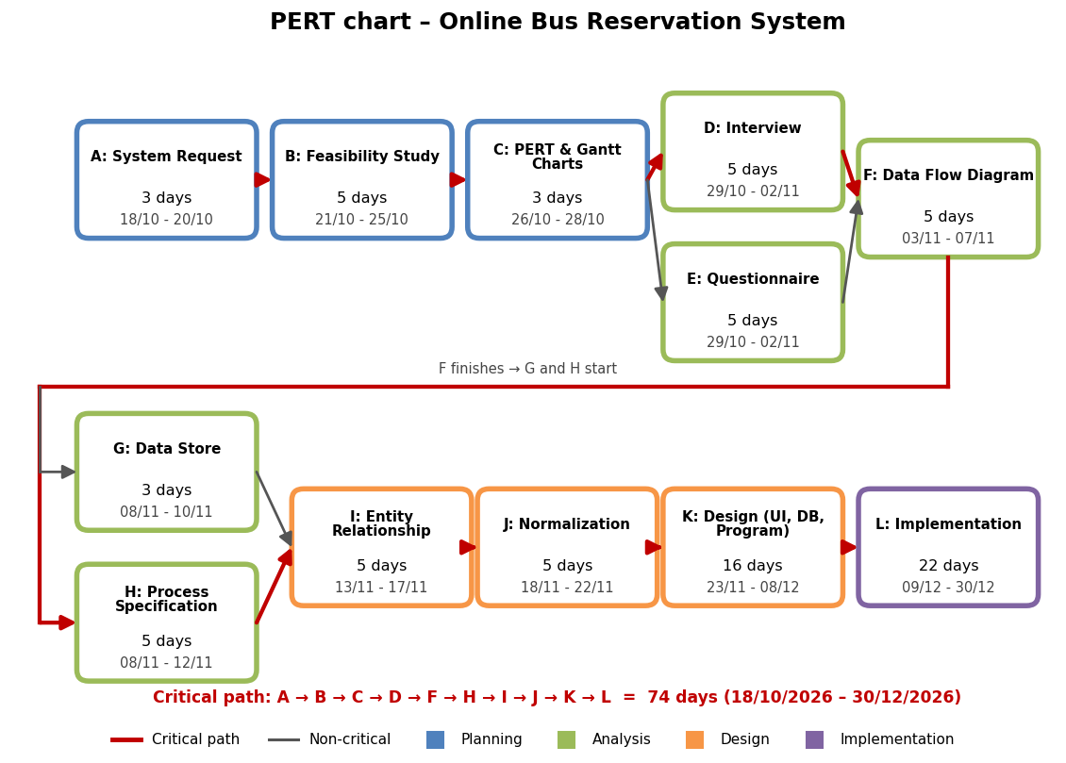
Gantt Chart
