Name: Youssef Hossam El-Sayed El-Sayed

ID: 1053

Section: 47

Group: 8

الاسم بالعربي: يوسف حسام السيد السيد

Github pages:

https://youssef907.github.io/ece001/

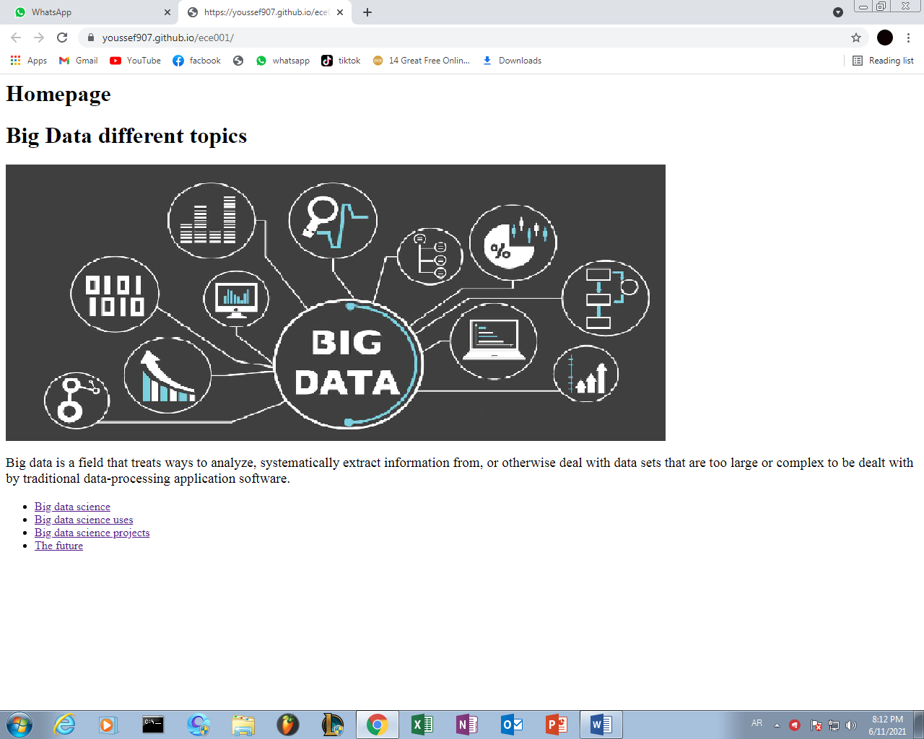

The project is about the big data and its topics and how it has improved the life of people and the prosperity of life.

Website project for ece001

big data