River crossing puzzle report:

Names: Mahmoud Mohamed 5560

Marwan Medhat Elnahas 5365

Youssef Ahmed 5491

Abdelrahman Elfeky 5421

When starting the application the user will be show the following window:

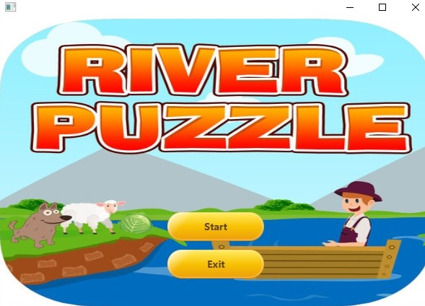

When pressing exit the application would close , when pressing start user would be show the following window:

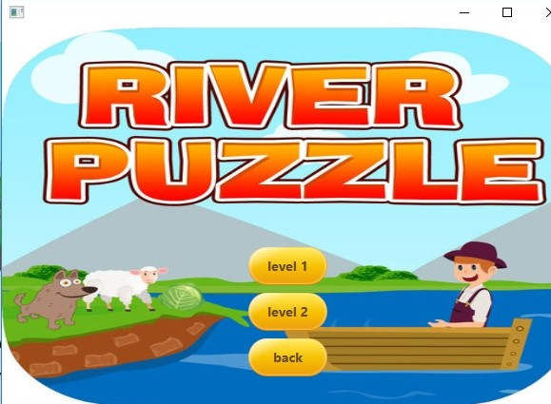

Where he chooses either level 1 or level 2, both lead to a new game/load game select screen:

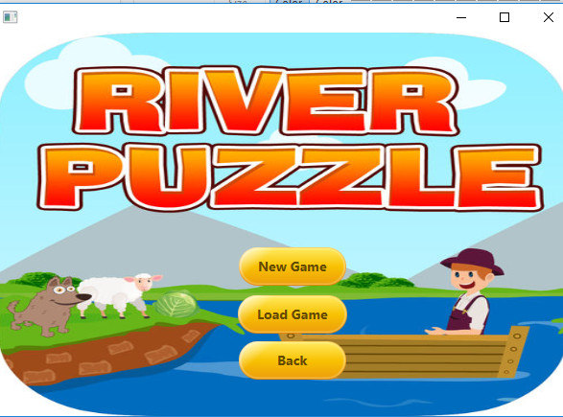

New game will reset all characters in either levels on the right, and resent score to zero and open the how to play for the level:

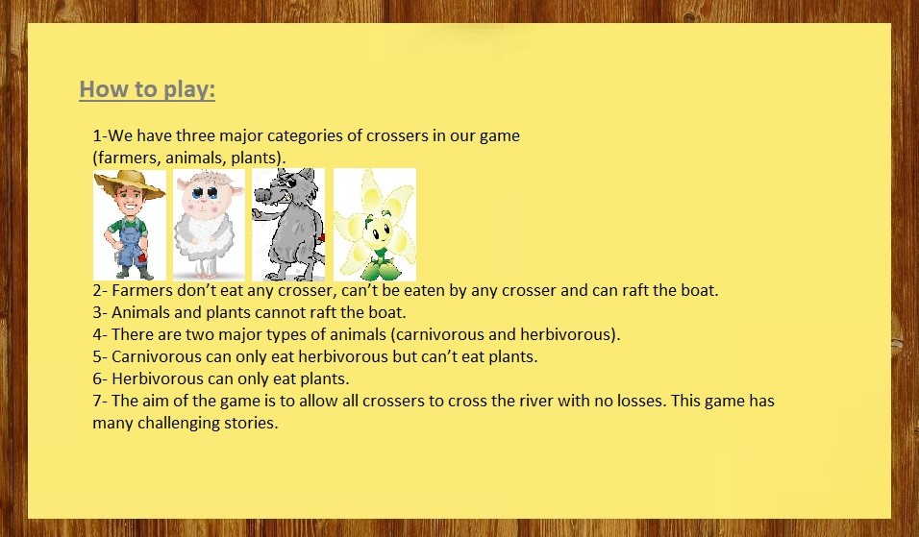

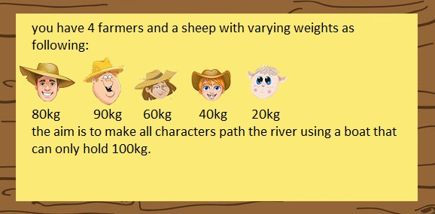

Continuing would lead to starting a new game of either levels:

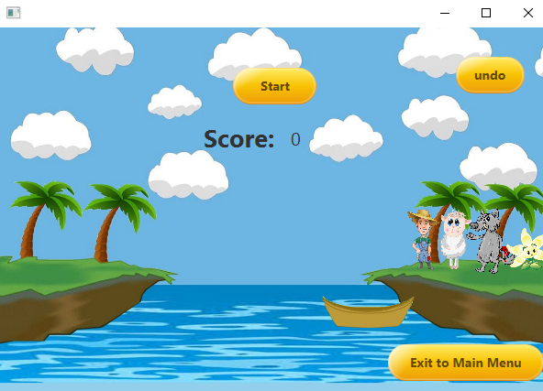

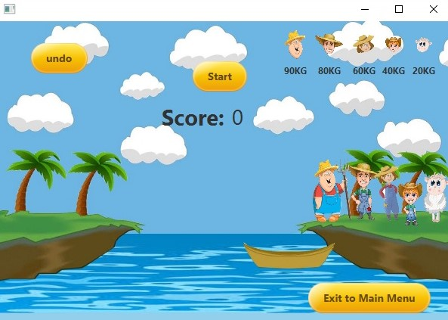

If load game is selected the user would start the game from the last point he left it in if and only if he left by selecting exit to main menu.

If user is able to win he would be shown the following scene:

