**Università degli Studi di Genova**

**CORSO DI LAUREA MAGISTRALE**

**Robotics Engineering**

**COOPERATIVE ROBOTICS**

Authors:

Giacomo Lugano

Youssef Attia

Hussein Fouad

Email:

[jek.lugano@yahoo.com](mailto:jek.lugano@yahoo.com)

[Youssef-attia@live.com](mailto:Youssef-attia@live.com)

[hussienfouad90@gmail.com](mailto:hussienfouad90@gmail.com)

Date: 02/02/2023

# Complete Mission Implementation

1. **Tasks unified hierarchy**

As shown from the table below the Task Priority Control hierarchy is composed of three actions. Firstly, the vehicle is spawned in:

$${\left[\begin{matrix}8.5 & 38.5 & -36 & 0 & -0.06 & 0.5\end{matrix}\right]}^{T}$$

and navigates to:

$${\left[\begin{matrix}10.5 & 37.5 & -38 & 0 & -0.06 & 0.5\end{matrix}\right]}^{T}$$

keeping into account a minimum altitude to the see bed “assuming it’s flat” of 1 meter and maintaining a proper pitch, roll and yaw presentenced in the so-called vehicle horizontal attitude control task.

Secondly, the landing action starts in which the vehicle lands to the sea bed and concurrently “with higher priority” aligned its self to the nodule to be inspected and keeping a desired distance from the nodule.

Lastly, the inspection actions starts maintaining the vehicle position in the so-called Vehicle null velocity task and guiding the end-effector to the nodule keeping into account “with higher priority” the arm joint limits and manipulability to avoid singularity. Furthermore, the vehicle null velocity task is crucial in this action to avoid the vehicle motion due to the forces and moments generated by the end effector motion.

|  |  |  |  |  |
| --- | --- | --- | --- | --- |
| Task | Type | Navigate to goal | Landing | Inspection |
| Arm Joints Limits | I |  |  | 1 |
| Arm Manipulability | I |  |  | 2 |
| Vehicle Null Velocity | E |  |  | 3 |
| End Effector Linear Position | E |  |  | 4 |
| End Effector Angular Position | E |  |  | 5 |
| Vehicle minimum altitude | I | 1 |  |  |
| Vehicle horizontal attitude | I | 2 | 1 |  |
| Vehicle heading control | I | 3 |  |  |
| Vehicle position control | E | 4 |  |  |
| Vehicle alignment to nodule | I |  | 2 |  |
| Vehicle distance to nodule | I |  | 3 |  |
| Vehicle altitude control | E |  | 4 |  |

1. **Robot’s behavior**

As per the discussion of the robot’s task priority control hierarchy in section I.1. This section will discuss the robot behavior proving it is following the proposed hierarchy.

Starting from the vehicle altitude and attitude throughout its mission which is composed of the three actions. It can be seen from the following graph [Fig.1] of the vehicle altitude that as the vehicle is spawned it has relatively high altitude and moving to the goal with the action *Navigate to waypoint* the altitude starts converging to the goal height. However, the *Vehicle minimum altitude* task should prevent the vehicle from going beneath 1 meter of altitude, but it is not the case here as the goal height is higher than task’s threshold. Moreover, as the vehicle have reached its goal and action *Landing* takes over the altitude starts converging to zero and stays there due to the task “Vehicle null velocity” in action *Inspection*.

Similar behavior can be seen in the graph of the vehicle attitude for the misalignment that is used for the *Horizontal attitude* task. However, a small change can be seen between the transition of action *Landing* to action *Inspection*. This is due to the relatively long period of transition between the two actions.

Figure :Vehicle Altitude and Attitude

Moreover, the following graphs in Fig.2 shows how the action *Navigate to waypoint* takes effect. In the beginning and as the simulation starts the vehicle is spawned away from the goal. And, as the action starts is can be seen that the distance vector starts to converge to zero and same goes to the misalignment vector of the vehicle to the goal. As the Vehicle reaches its goal, the action *Landing* two takes over and the vehicle goes further from the original goal. It can be noted here that the change is mainly on the Z-axis as the vehicle is Landing.

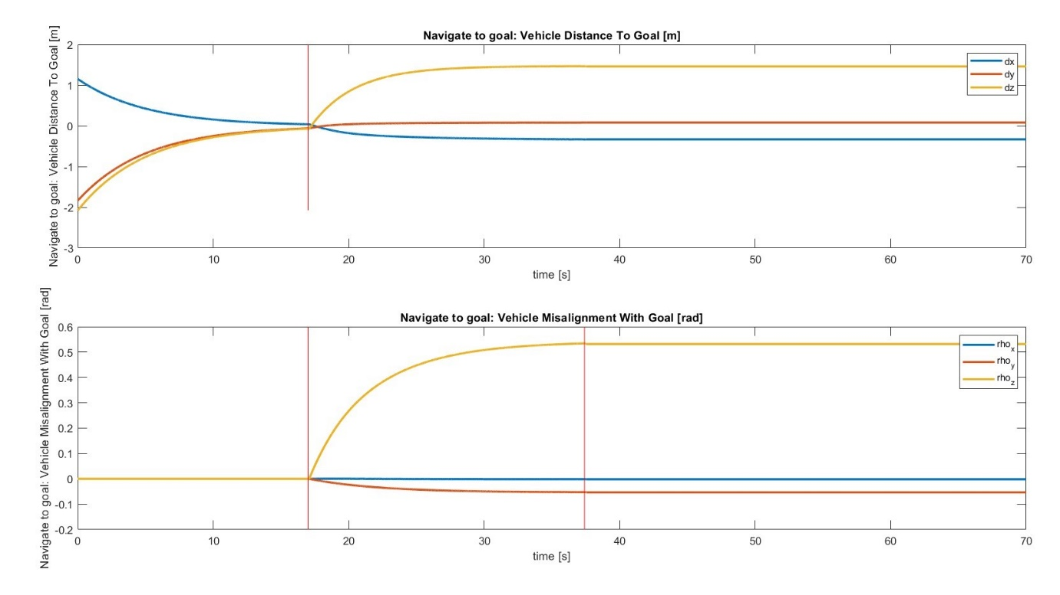

Figure : Vehicle distance and misalignment to goal

Moving to the action *Landing* the main goal here is to land making sure that the vehicle is aligned to the nodule and that nodule is in the manipulator’s workspace. Furthermore, the robot’s behavior in this case can be studied from the following graphs in Fig.3 showing the distance between the vehicle and the nodule and also the misalignment vector between the vehicle and the nodule. It can be noted here that after the action *Navigate to waypoint* has ended the vehicle is not aligned to the nodule and as the action *Landing* aligns the vehicle the misalignment vector converges to zero. Increasing the gain makes the vehicle align faster and vice versa. This is the task *Vehicle longitudinal alignment* *to nodule* is further discussed in section 3 and section 4.

Figure : Vehicle distance and misalignment to nodule

Lastly, from *Inspection* action point of view both the Arm distance and misalignment to the nodule should be studied, and it can be seen in Figure 4 that as soon as the *Inspection* action takes place both the distance and the misalignment start to converge to zero and they arrive to zero around t = 60 seconds and this can be considered the end of the mission.

Figure : Arm distance and misalignment to nodule

1. **Vehicle alignment to nodule task Jacobian**
2. **Alerting gain & observation**

In this section it is discussed how the gain of the task *Vehicle alignment to the nodule* takes effect on the robot’s behavior. For this case three different values of gain were chosen to observe the robot’s behavior difference. It was expected that having a lower gain makes the vehicle align to nodule in longer period and vise versa. However, there three gains value that were chosen are 0.01, 0.2 and 0.8. They were chosen like that as the first value is relatively very low and with this gain its expected that the vehicle should not finish it’s alignment even after touch the sea bed. While the second value is usually the same used for most tasks of the vehicle tasks. Lastly, the gain of 0.8 is relatively high value and it is expected that the vehicle will align with nodule even before the landing occurs.

Furthermore, the different values were tested, and the following graphs [Fig.5] was the result. And it can be seen here that the hypothesis of the experiment that was made can be considered as achieved. As for the first gain the vehicle was never able to finish the action *Landing* on the time of the simulation. While for the gain the vehicle was able to finish the action *Landing* and move to the action *Inspection* around t = 35 seconds. Finally for the gain of 0.8 the vehicle finished the action *Landing* around t = 25 seconds.

In conclusion, it can be reported that altering the gain has a directly proportional effect on the time needed for achieving the task and therefore the action. Keep in mind that this test is done on the simulation which has a max time of 70 seconds, this is relatively far from the real-life implementation and the gains must be tuned according to the vehicle specifications.

Figure : Different gains for Vehicle alignment to nodule task

On the other hand, this implementation can not be granted 100% to finish the action of *Landing* on time. A proper solution for this problem is to divide the action of *Landing* into two separate actions in which the vehicle first aligns to the nodule as one action and once done it moves to the second action which is *Landing.* A modification of the proposed hierarchy in section I.1 can be seen in the following table.

|  |  |  |  |  |  |
| --- | --- | --- | --- | --- | --- |
| Task | Type | Navigate to goal | Alignment | Landing | Inspection |
| Arm Joints Limits | I |  |  |  | 1 |
| Arm Manipulability | I |  |  |  | 2 |
| Vehicle Null Velocity | E |  |  |  | 3 |
| End Effector Linear Position | E |  |  |  | 4 |
| End Effector Angular Position | E |  |  |  | 5 |
| Vehicle minimum altitude | I | 1 |  |  |  |
| Vehicle horizontal attitude | I | 2 | 1 | 1 |  |
| Vehicle heading control | I | 3 |  |  |  |
| Vehicle position control | E | 4 |  |  |  |
| Vehicle alignment to nodule | I |  | 2 | 2 |  |
| Vehicle distance to nodule | I |  |  | 3 |  |
| Vehicle altitude control | E |  |  | 4 |  |

Having such a hierarchy insurers that the vehicle will never land without aligning to the nodules prior to the *Landing* action. This is also crucial in real life situation as it was observed in the test of gain 0.01 that the vehicle laned touching the nodule which can cause leakage in an AUV (Autonomous Underwater Vehicle) if there were no *obstacle avoidance* task with higher priority. Please find the proposed hierarchy solution as version 2 of the MATLAB scripts.

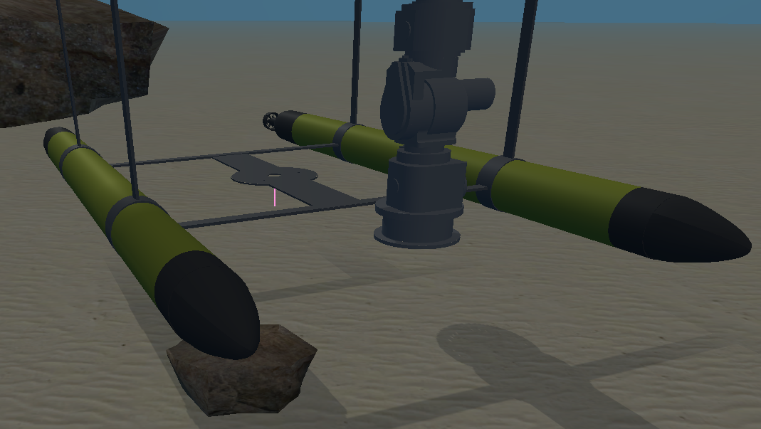

Figure : Vehicle landing while low gain of alignment to nodule task, hitting the rock.

1. **Landing action & End Effector motion**
2. **Proof that nodule is in manipulator’s workspace**