DevSecOps Project Report
  - student-management - Labs: Cybersecurity and Coding (5NIDS6)
Table of Contents

DevSecOps Project Report: student-management
Module: Labs: Cybersecurity and Coding (5NIDS6), Esprit Supervisor: Nawel Hammami Team: Youssef Bouaouina, (partner name) Validation: Thursday 12/11/2026 Repository: https://github.com/youssefbouaouina/devopsNIDS (branch devsecops/lab1-pre-commit)

1. Objective
Start from the CI/CD pipeline built in the 4th-year DevOps module and turn it into a full DevSecOps pipeline, adding security to each phase of the software lifecycle (Development, Acceptance, Production, Operations), as presented in the course material. The three course labs are part of the pipeline:
Course lab | Where it runs in our pipeline
Lab 1: Pre-commit security hooks | Developer git commit hook and first Jenkins stage Secrets Scan
Lab 2: Retire.js | Jenkins stage JS Dependency Scan (Retire.js)
Lab 3: Gauntlt | Jenkins stage Security Acceptance Tests (Gauntlt) against the deployed app
Following the course’s advice (“Do less, but do it better”), we picked one well-integrated tool per security activity. Every tool runs automatically in Jenkins, and every report is archived with the build.

2. Starting point: the DevOps pipeline (4th year)
GitHub ─▶ Jenkins ─▶ Maven ─▶ SonarQube ─▶ Docker Hub ─▶ Kubernetes (Minikube) ─▶ Prometheus/Grafana
Component | Role
Spring Boot 3 / Maven app (student-management) | REST API + MySQL
Jenkins (VM, Vagrant) | CI/CD orchestration (Jenkinsfile)
SonarQube | Code quality
Docker / Docker Hub | Image build and registry
Minikube | Deployment (namespace devops, MySQL + Spring app)
Prometheus + Grafana | Metrics and dashboards
Everything runs in one Ubuntu VM described as code (infra/vagrant). Jenkins polls GitHub every 2 minutes, so a git push starts the pipeline automatically.

3. The DevSecOps pipeline
─────────────────────────── DEVELOPMENT ─────────────────────────── ACCEPTANCE PRODUCTION OPERATIONS
Secrets ▶ Build ▶ SCA+IaC ▶ Retire.js ▶ SAST ▶ Build ▶ Image ▶ Push ▶ Deploy ▶ Gauntlt ▶ OWASP ZAP ▶ Monitoring
scan (Trivy) (Lab 2) (Sonar image scan (K8s) (Lab 3) baseline check +
(Lab 1) gate) (Trivy) attack demo
every stage writes to reports/ ──▶ archived by Jenkins with each build
Phase | Security activity (course) | Tool | Jenkins stage | Gate
Development (pre-commit) | Pre-commit security hooks | HMRC security-git-hooks via pre-commit | Secrets Scan (pre-commit) | Fails build
Development (commit) | Security Components Analysis (Java) | Trivy (rootfs on the jar) | SCA + IaC Scan (Trivy) | CRITICAL → UNSTABLE
Development (commit) | Infrastructure as Code analysis | Trivy (config) | SCA + IaC Scan (Trivy) | Report
Development (commit) | Security Components Analysis (JavaScript) | Retire.js | JS Dependency Scan (Retire.js) | HIGH → UNSTABLE
Development (commit) | Static code analysis (SAST) | SonarQube + Quality Gate | SonarQube Analysis (SAST) | Fails build
Development (commit) | Container security | Trivy (image) | Container Scan (Trivy) | CRITICAL → UNSTABLE
Acceptance | Security acceptance testing | Gauntlt (nmap + curl) | Security Acceptance Tests (Gauntlt) | Failure → UNSTABLE
Production | Security smoke tests | OWASP ZAP Baseline | Security Smoke Test (OWASP ZAP) | FAIL alerts → UNSTABLE
Production | Secrets management | Jenkins Credentials + Kubernetes Secret | Push / Deploy | n/a
Operations | Continuous monitoring | Prometheus alert rules + Grafana | Continuous Monitoring Check | Fails if not monitored
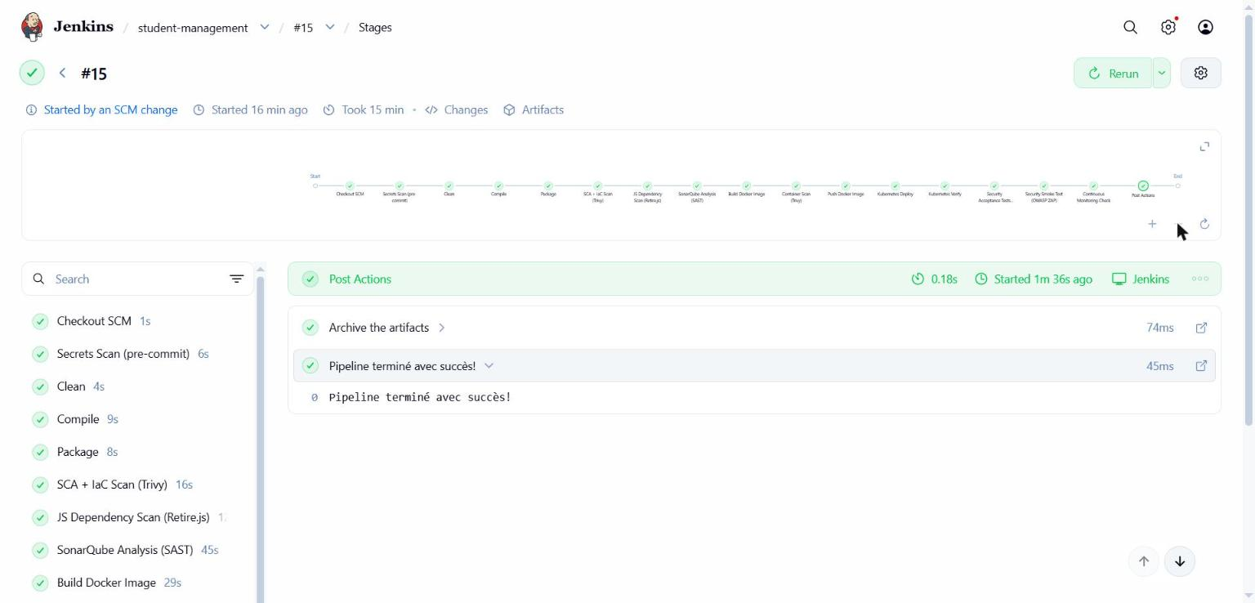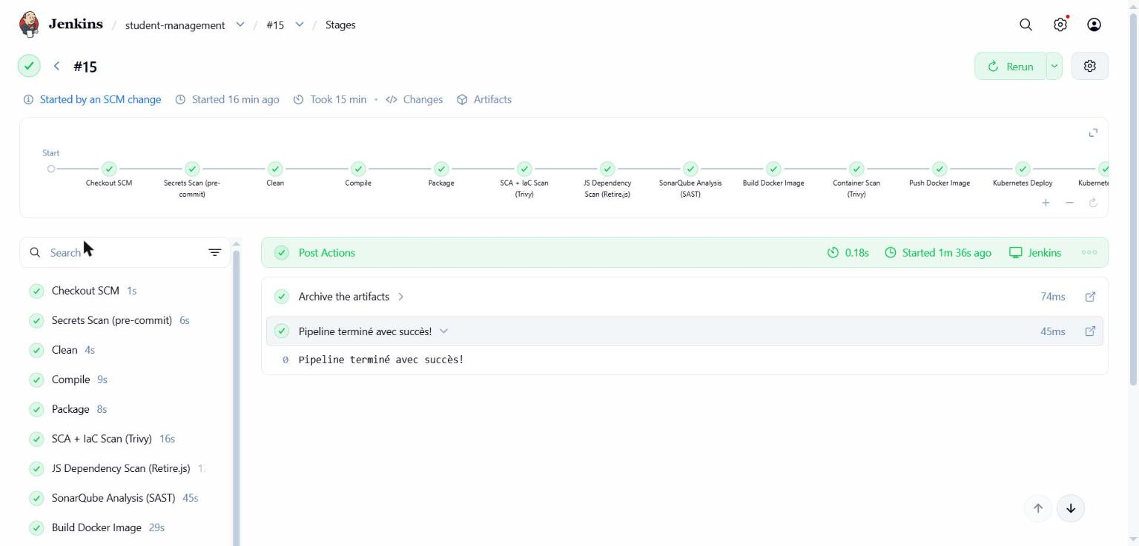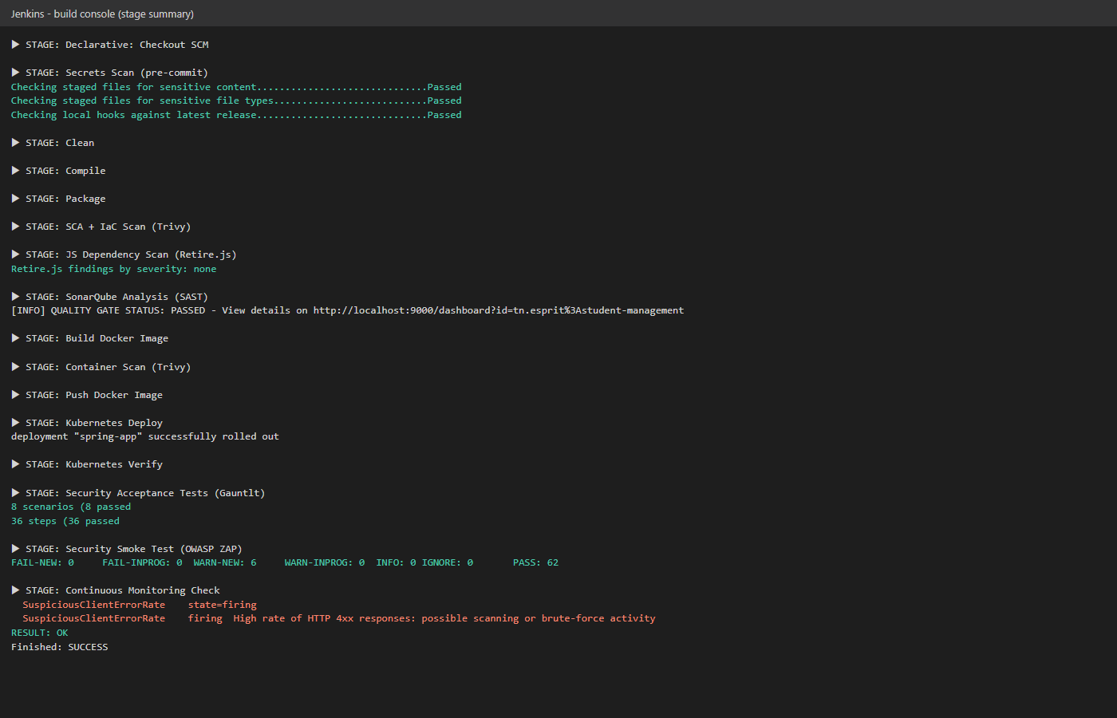

4. Phase 1: Development

4.1 Lab 1: Pre-commit security hooks
Goal: stop secrets (keys, passwords, tokens, key files) from ever reaching the repository.
Tool: the pre-commit framework with HMRC security-git-hooks (release 1.15.0): - secrets_filecontent: flags sensitive strings (AWS keys, certificates, application secrets…) - secrets_filename: flags sensitive file types (*.pem, *.key, …) - hooks_version_check: checks the hooks are up to date
Configuration: .pre-commit-config.yaml at the repository root (plus repository.yaml, which the HMRC hooks require). Lab evidence (lab1-evidence/) and course material are excluded, because they deliberately contain the fake AWS key used for the test.
Integration: 1. Developer side: pipx install pre-commit && pre-commit install. Every git commit runs the hooks. 2. Pipeline side: the first Jenkins stage runs pre-commit run --all-files in a python:3.12 container, so the rule also applies to commits made without the local hook.
Test (as in the lab): touch fake.key.pem and echo aws_secret_access_key = 1ye+Vark… > fake.aws.file, then git commit. Both hooks Failed and the commit was refused. The same files planted in the Jenkins workspace make the stage exit with code 1. On the real code base, all hooks Passed.
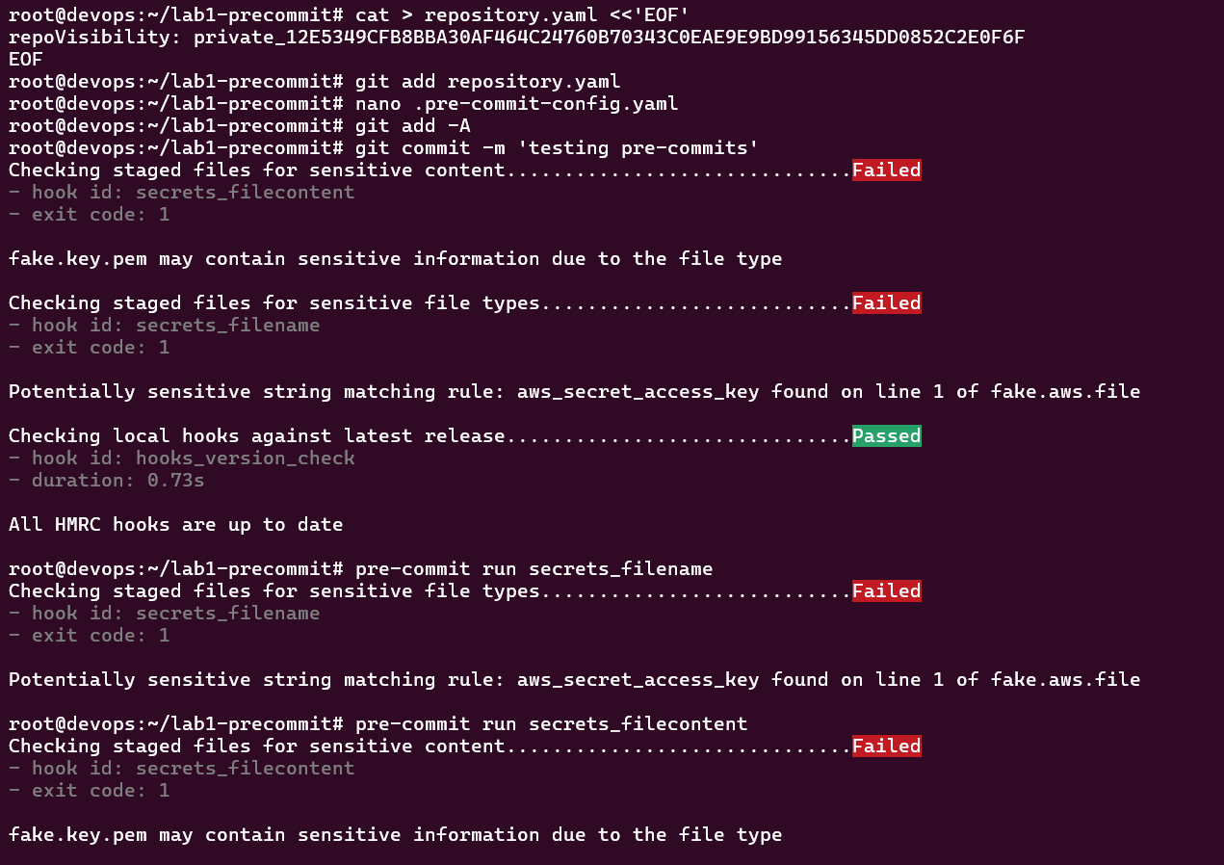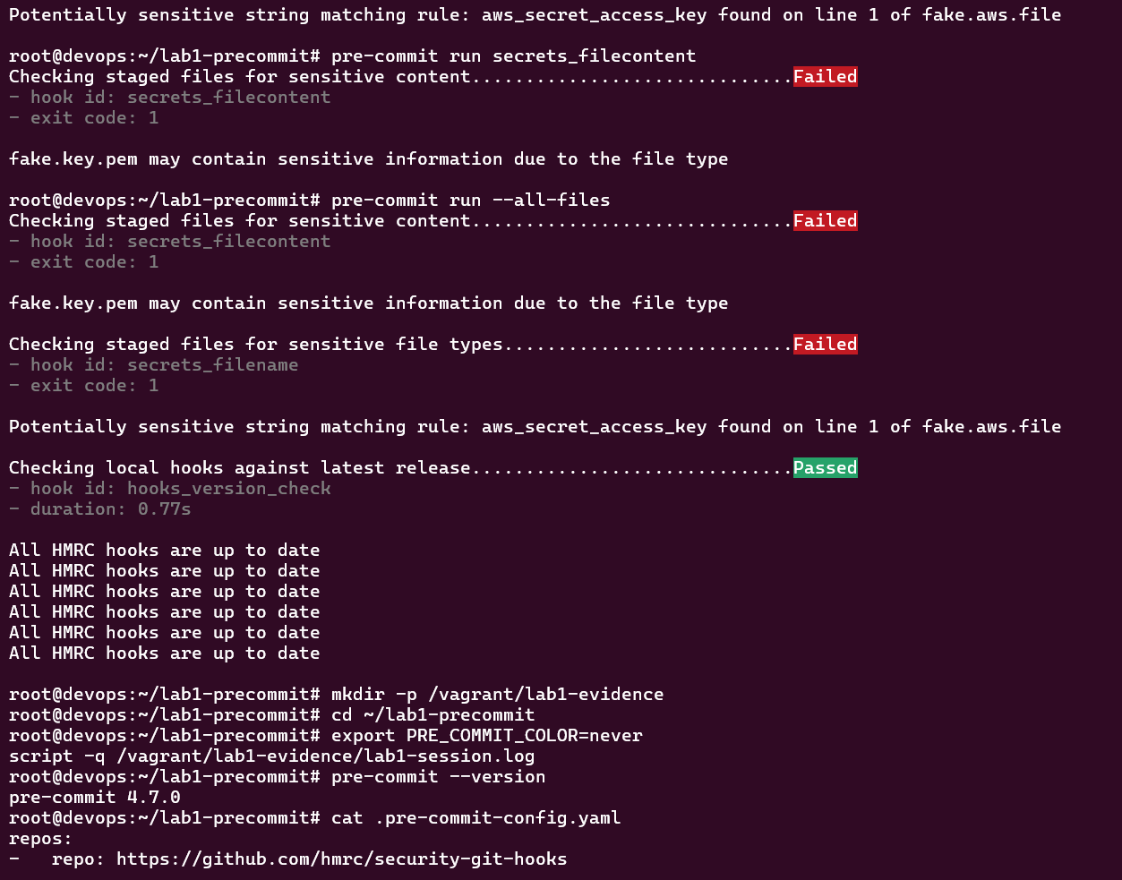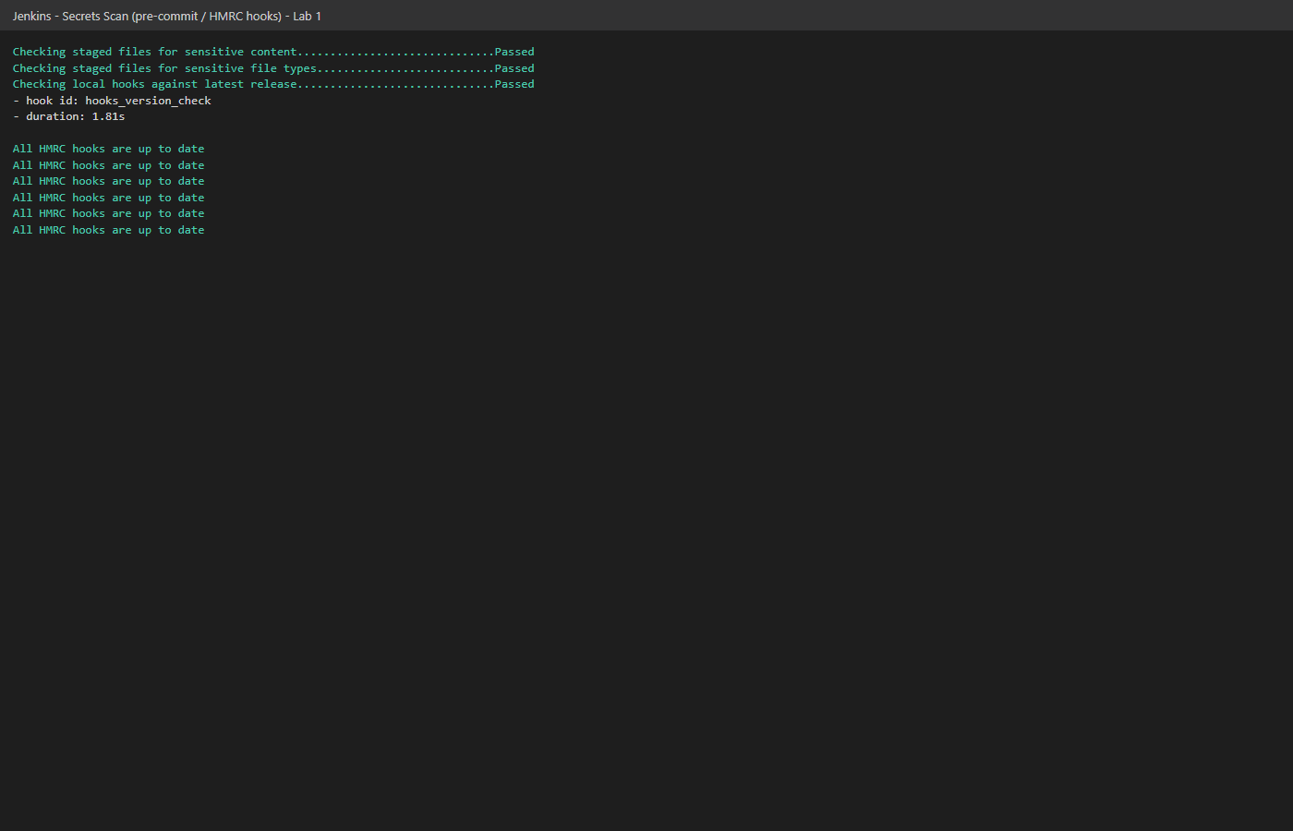

4.2 Security Components Analysis: Java dependencies (Trivy)
Retire.js (Lab 2) analyses JavaScript only, while the application is mainly Java/Maven. For the Java libraries we applied the same practice with Trivy, which reads every library packaged inside the Spring Boot fat jar. The same tool also covers IaC and container scanning.
Configuration: security/trivy.sh runs Trivy 0.65.0 in a container with a persistent vulnerability-DB cache. Reports: trivy-sca-report.html/.txt. A second run with --severity CRITICAL --exit-code 1 marks the build UNSTABLE if an unaccepted CRITICAL CVE exists.
Step | CVEs in the jar | CRITICAL | HIGH
Initial (Spring Boot 3.5.5) | 71 | 9 | 26
Spring Boot 3.5.15 | 22 | 7 | 6
+ patched Tomcat 10.1.59, Jackson 2.21.7, commons-lang3 3.18.0, log4j 2.25.5 | 0 unaccepted | 0 | 0
Two spring-webmvc CVEs (CVE-2026-47884, CVE-2026-47890) affect Server-Sent Events and are only fixed in Spring Framework 7 (a Spring Boot 4 major upgrade). The application has no SSE endpoint (checked in the source code), so the vulnerable code cannot be reached. They are recorded as accepted risks in .trivyignore, with a justification and an expiry date (2027-01-31).
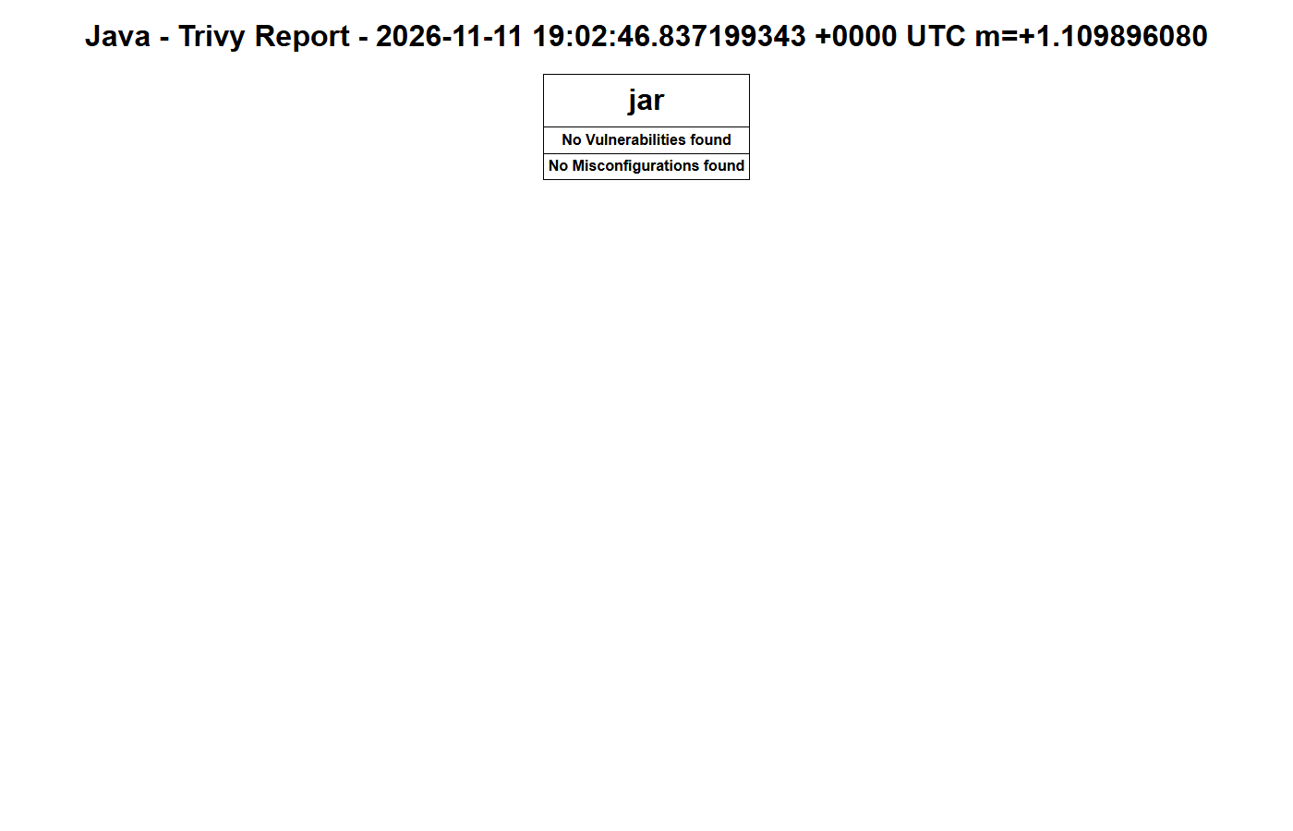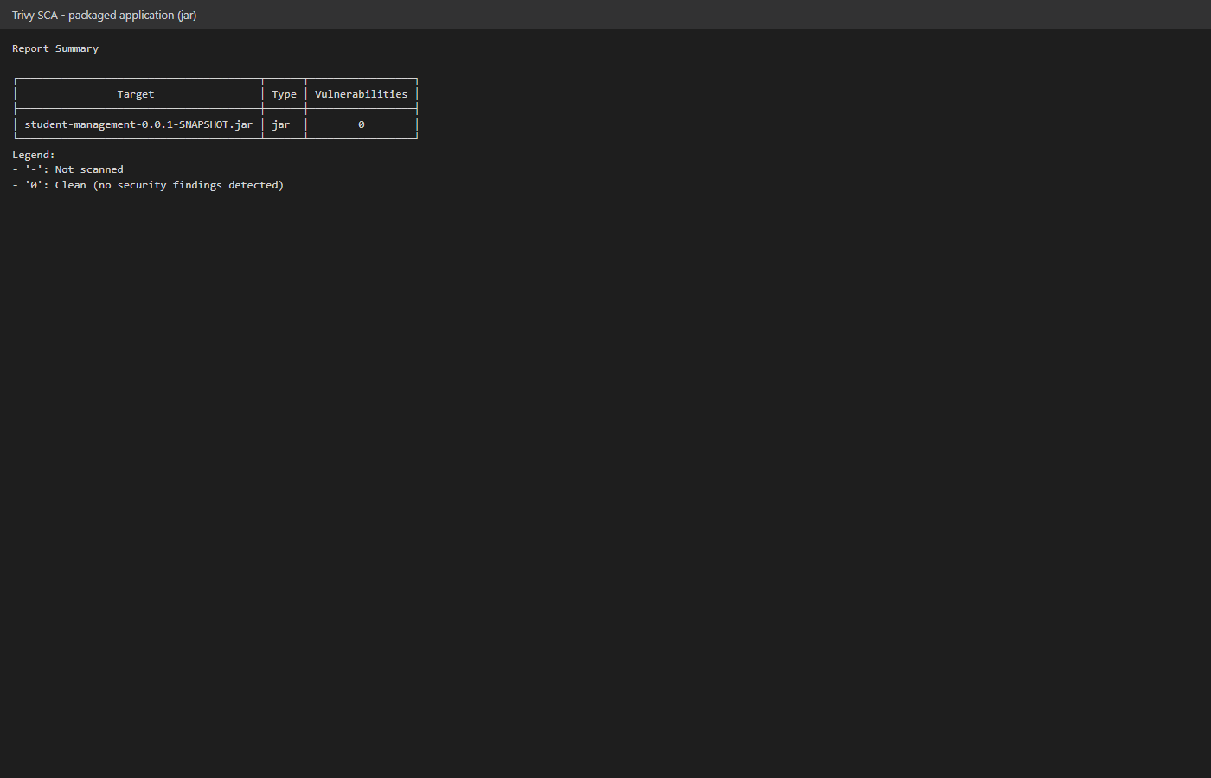

4.3 Lab 2: Retire.js (JavaScript libraries)
Where the JavaScript is: the application serves Swagger UI (API documentation), whose JavaScript is bundled inside a webjar in the Spring Boot jar. security/retire.sh extracts every .js file from the embedded libraries and runs Retire.js 5 on them (node:20 container). Reports: retire-report.json/.txt. HIGH or CRITICAL vulnerable libraries mark the build UNSTABLE.
Step | Library found | Retire.js result
Initial: springdoc 2.1.0 → Swagger UI 4.18.2 | DOMPurify 3.0.1 | HIGH, CVE-2024-47875 (mXSS), plus others
springdoc 2.8.17 → Swagger UI 5.32.2 | DOMPurify 3.3.2 | 2 HIGH, 20 MEDIUM, 12 LOW
Swagger UI webjar pinned to 5.34.1 | DOMPurify 3.4.17 | 0 findings
Trivy’s Java analysis did not see this issue: it is a JavaScript library hidden inside a Java dependency. OWASP ZAP (Phase 3) independently reported the same “Vulnerable JS Library” before the fix.
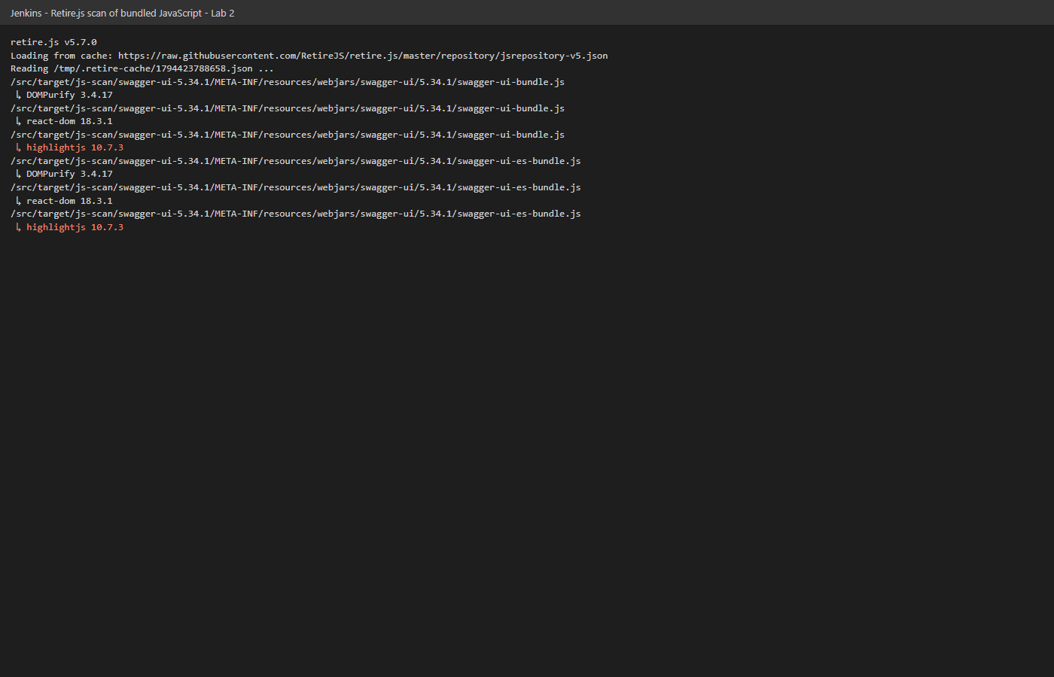
Retire.js scan

4.4 Infrastructure as Code analysis (Trivy config)
File | Before | After
Dockerfile | 2 (1 HIGH: runs as root) | 1 LOW (no HEALTHCHECK; Kubernetes probes cover it)
k8s/spring-app.yaml | 18 (3 HIGH) | 2 MEDIUM
k8s/mysql.yaml | 16 (3 HIGH) | 16, accepted for the lab (the official MySQL image needs root at start-up)
Remediation: - Dockerfile: eclipse-temurin:17-jre instead of the JDK (smaller attack surface); a dedicated user app (uid 10001) with USER 10001. - k8s/spring-app.yaml: runAsNonRoot, runAsUser/Group 10001, seccompProfile: RuntimeDefault, allowPrivilegeEscalation: false, readOnlyRootFilesystem: true (with an emptyDir for /tmp), capabilities.drop: [ALL], CPU/memory requests and limits, automountServiceAccountToken: false. The hardened pod deploys and runs correctly.
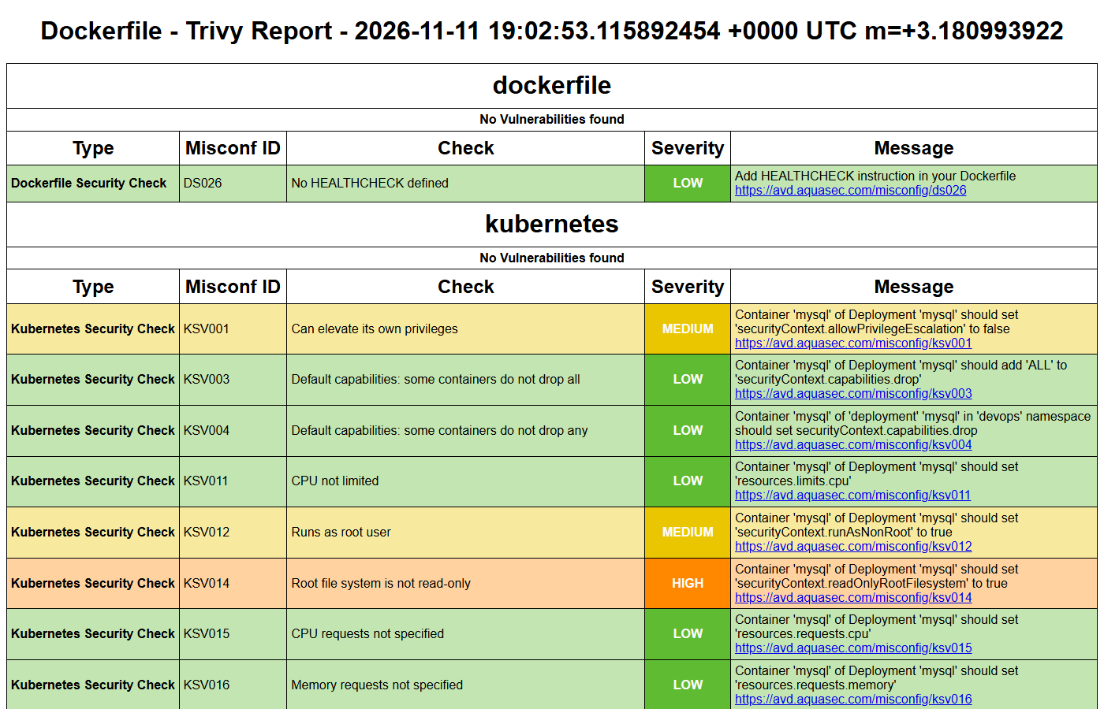
Trivy IaC report

4.5 Static analysis (SAST): SonarQube with Quality Gate
SonarQube was already in the DevOps pipeline but only reported results. The build now waits for and enforces the Quality Gate (-Dsonar.qualitygate.wait=true), so a failed gate stops the pipeline before the image is built. Result: Quality Gate Passed.
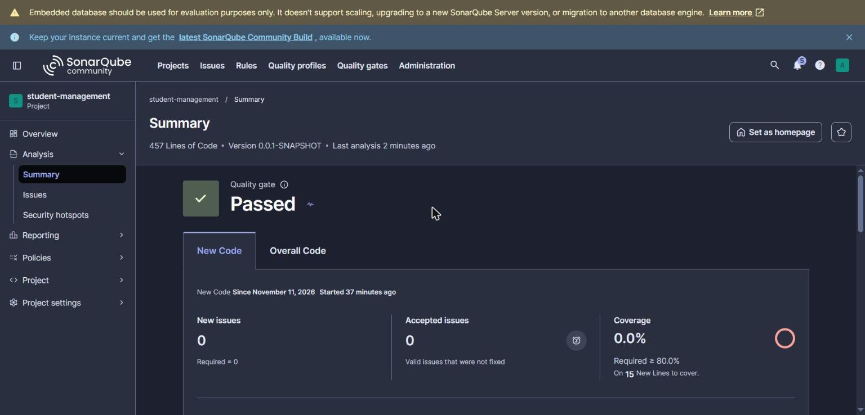
SonarQube

4.6 Container security: image scan (Trivy image)
The freshly built image is scanned before it is pushed to Docker Hub.
 | OS packages | Application libraries
Initial (17-jdk, Boot 3.5.5) | 70 CVEs (2 HIGH, 0 CRITICAL) | 71 CVEs (9 CRITICAL)
Final (17-jre, patched libraries) | 62 CVEs (2 HIGH, 0 CRITICAL) | 0 unaccepted CRITICAL
The container runs as uid=10001(app), verified with docker run --entrypoint id.
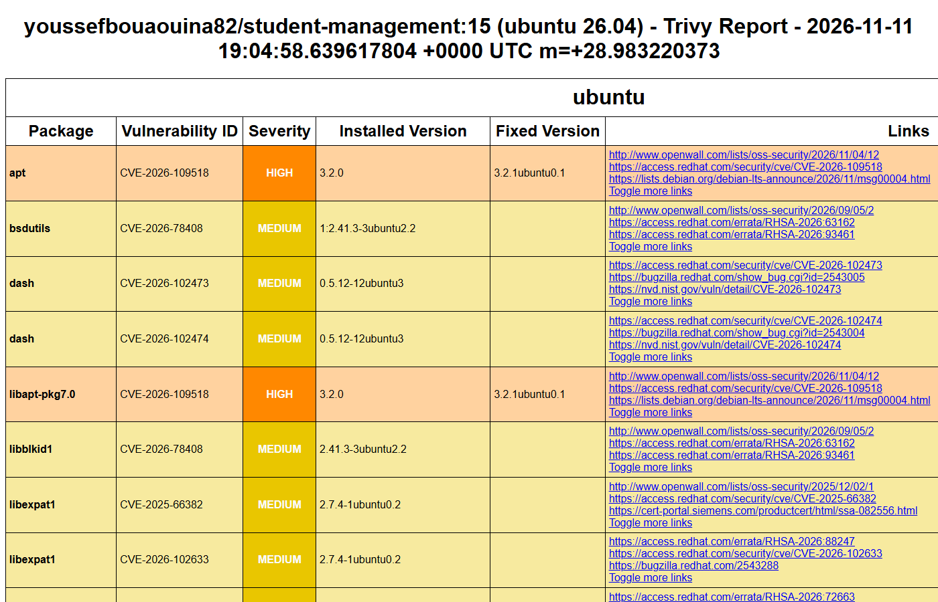
Trivy image report

5. Phase 2: Acceptance

5.1 Lab 3: Security acceptance tests with Gauntlt
Goal: turn security requirements into executable BDD scenarios, run against the deployed application after every deployment.
Configuration: security/gauntlt/ holds a Dockerfile (Ruby 3.1, gauntlt 1.0.13, nmap, curl) and two attack files:
Attack file | Scenario | Expected
nmap.attack | Application port 8089 is reachable | 8089/tcp open
nmap.attack | MySQL (3306/33060) is not exposed outside the cluster | ports not open
http.attack | Application is healthy | /actuator/health returns UP
http.attack | /actuator/env (configuration, secrets) is not exposed | 404
http.attack | /actuator/heapdump (memory contents) is not exposed | 404
http.attack | HTTP TRACE is disabled (Cross-Site Tracing) | not 200
http.attack | Security headers are present (X-Frame-Options, X-Content-Type-Options, CSP) | headers present
http.attack | Invalid input does not leak a Java stack trace | no Exception in body
Integration: the stage runs after the deployment, waits for the health endpoint, then runs gauntlt in its container with host networking. Output: reports/gauntlt-report.txt. Result (build #15): 8 scenarios passed, 36 steps passed.
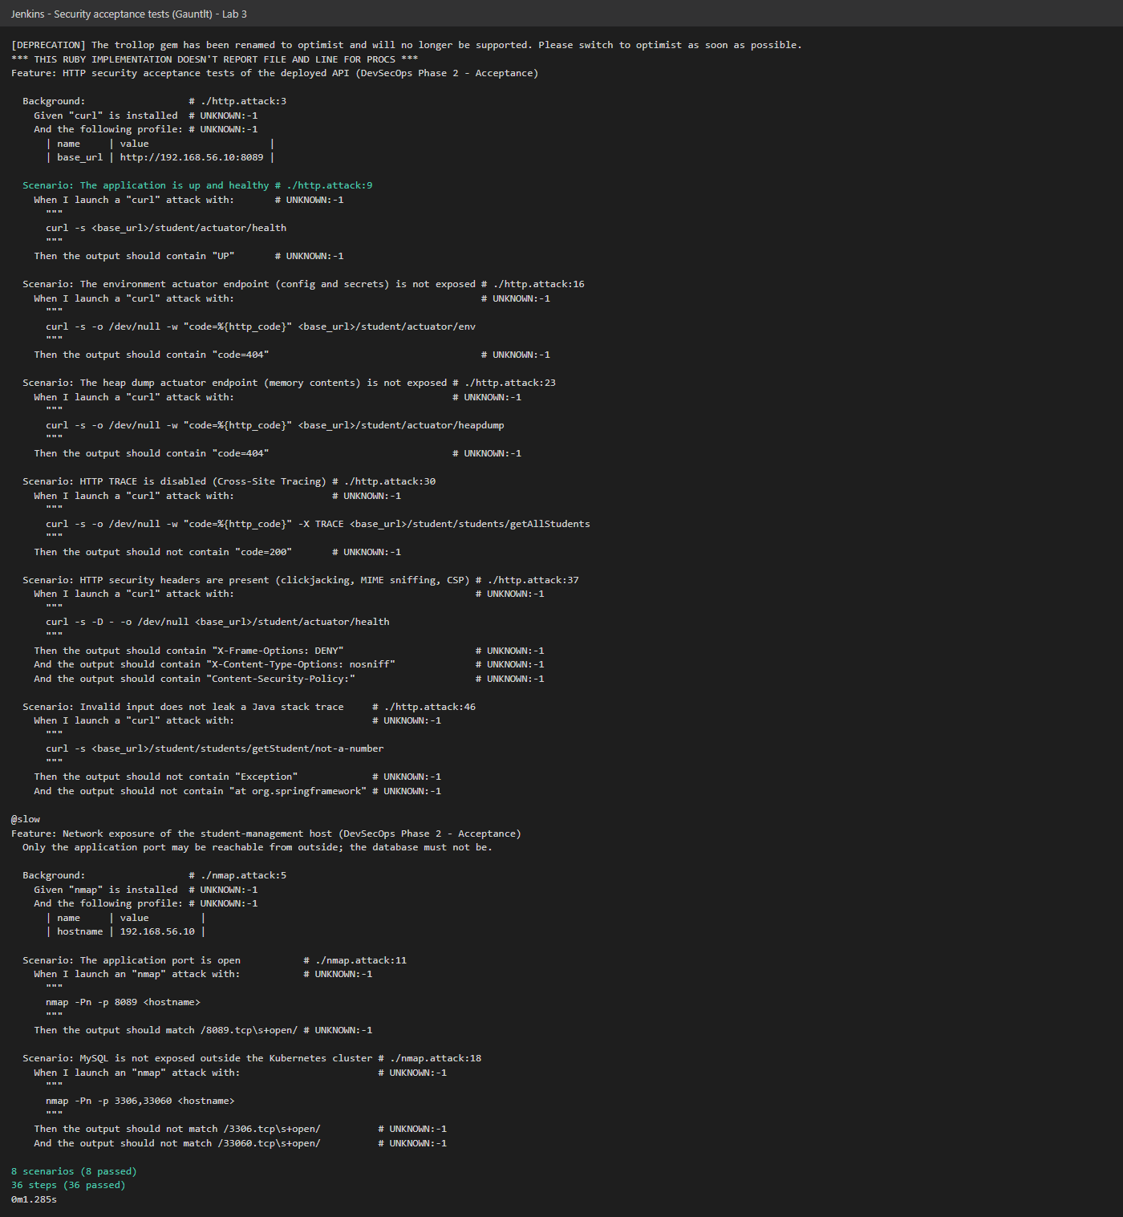
Gauntlt results

6. Phase 3: Production

6.1 Security smoke test: OWASP ZAP Baseline
Goal: after each release, quickly check the running application for obvious web vulnerabilities (a security smoke test).
Tool: zap-baseline.py (OWASP ZAP) spiders the application from Swagger UI for 2 minutes and applies passive rules (security headers, cookies, information disclosure, vulnerable JS…). Reports: reports/zap/zap-baseline-report.html|json|md. FAIL-level alerts mark the build UNSTABLE.
First run (build #2): 0 FAIL, 11 WARN, 57 PASS. The warnings included Vulnerable JS Library, missing Content-Security-Policy, Anti-clickjacking, X-Content-Type-Options, Cross-Origin-* and Permissions-Policy headers, and Application Error Disclosure.
Remediation: - SecurityHeadersFilter (servlet filter) adds CSP, X-Frame-Options: DENY, X-Content-Type-Options: nosniff, Referrer-Policy, Permissions-Policy, Cross-Origin-Opener/Embedder/Resource-Policy and Cache-Control: no-store to every response. - server.error.include-*=never: no stack traces, exception names or messages in error responses. - The vulnerable JS library was fixed by the Retire.js remediation (4.3).
Final run (build #15): 0 FAIL, 6 WARN, 62 PASS (build #2 had 11 WARN and 57 PASS). Remaining alerts:
Risk | Alert | Comment
Medium | CSP: style-src 'unsafe-inline' | Swagger UI needs inline styles; accepted for the documentation page
Medium | CSP header not set (1 URL) | The server root / (outside the /student application) answers Tomcat’s default 404
Low | Permissions-Policy not set (3 URLs) | Same root / static paths outside the application filter
Low | Timestamp disclosure | Unix timestamps in Swagger UI JavaScript (false positive)
Info | Modern Web Application, cache-related | Informational only
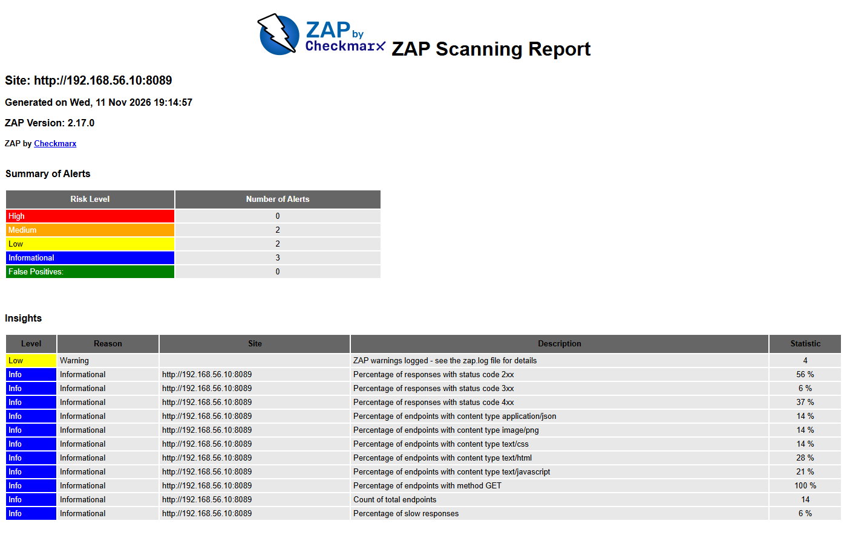
OWASP ZAP baseline report

6.2 Secrets management
No secret is stored in the repository or the Jenkinsfile:
Secret | Stored in | Used by
Docker Hub token | Jenkins credential dockerhub-credentials | Push stage (--password-stdin)
SonarQube token | Jenkins credential sonar-token | SAST stage
MySQL root password | Jenkins credential mysql-root-password → Kubernetes Secret mysql-secret | MySQL and Spring pods (secretKeyRef)
Jenkins masks these values in the console log, and the pre-commit stage (4.1) blocks any new secret from being committed.

7. Phase 4: Operations

7.1 Continuous security monitoring with Prometheus alert rules
Prometheus scrapes the application (/student/actuator/prometheus). We added security alert rules (infra/monitoring/alert-rules.yml):
Alert | Detects | Rule (summary)
StudentAppDown | Application unreachable (DoS, failed deployment) | up == 0 for 1 min
SuspiciousClientErrorRate | Bursts of 4xx: scanning, fuzzing, brute force | 4xx rate > 0.2 req/s for 30 s
ServerErrorRate | 5xx errors under input or attack | 5xx rate > 0.1 req/s for 2 min
HeapExhaustion | Memory exhaustion / memory DoS | heap > 90% for 5 min
Pipeline stage Continuous Monitoring Check: 1. Simulates an attack: about 100 seconds of requests to a non-existent admin login page (a scanner or brute-force pattern). 2. Queries the Prometheus API (security/monitoring_check.py) and records scrape-target health, the state of each security rule and the active alerts in reports/monitoring-check.txt. The stage fails if the application is not monitored.
Result in build #15: the simulated attack was detected. SuspiciousClientErrorRate went to FIRING (4xx rate about 2.5 req/s, threshold 0.2), the Grafana dashboard shows the 404 spike, and the stage ended with RESULT: OK.
StudentAppDown was also seen firing on the fresh cluster before the first deployment, which shows that availability monitoring works.
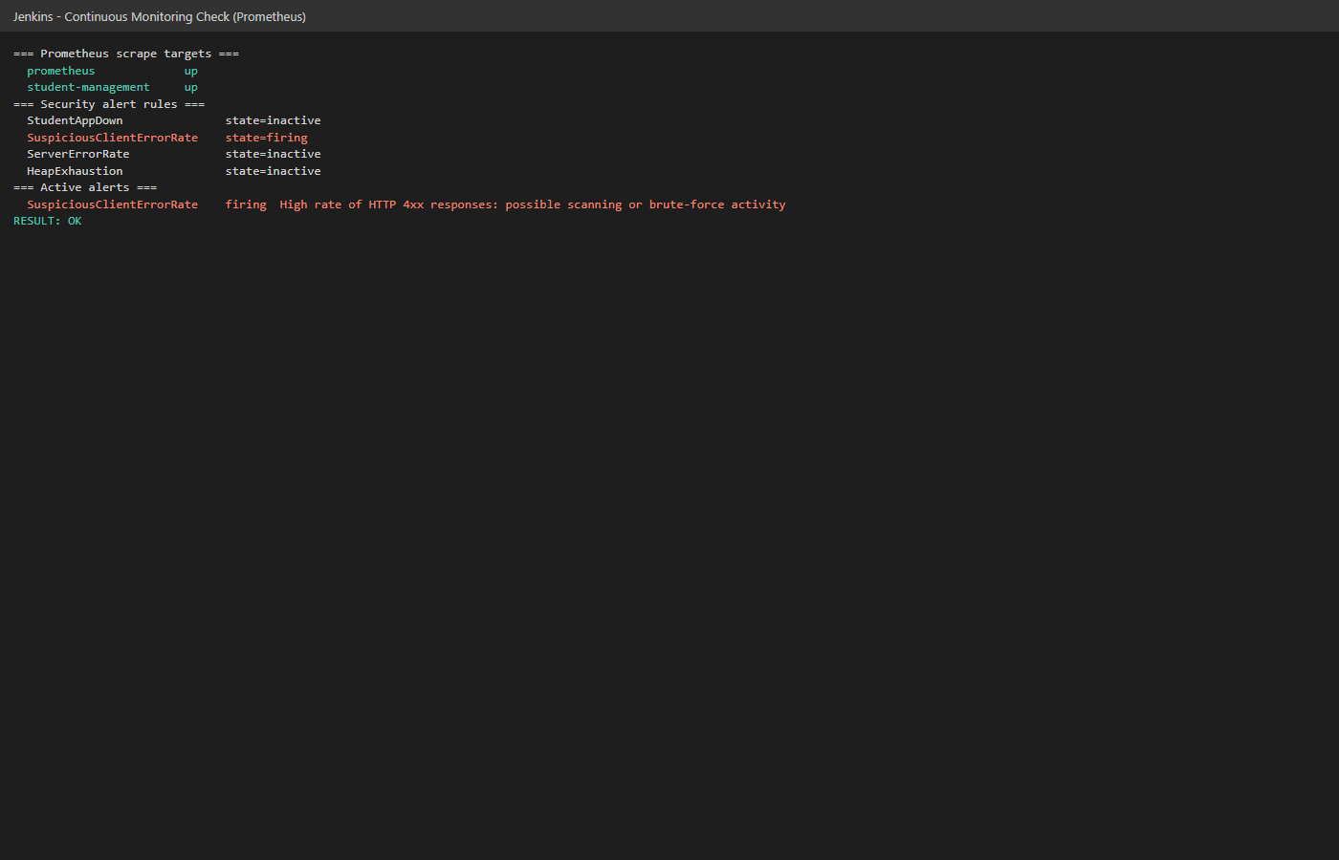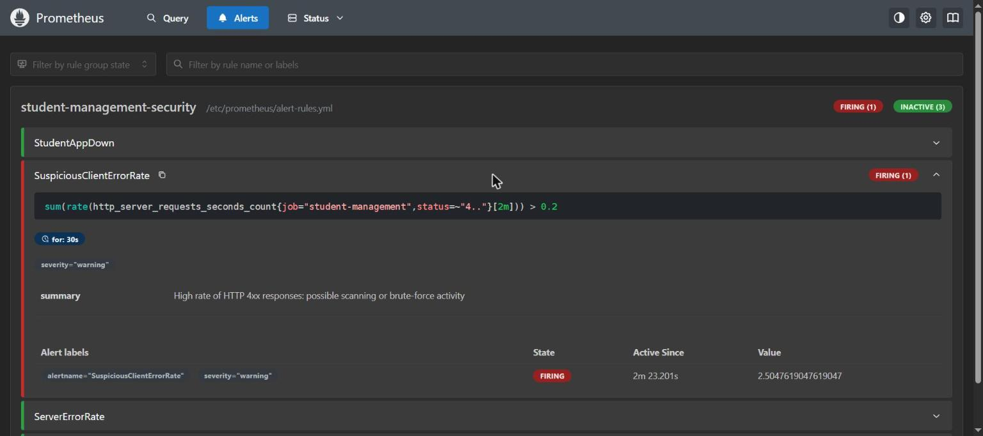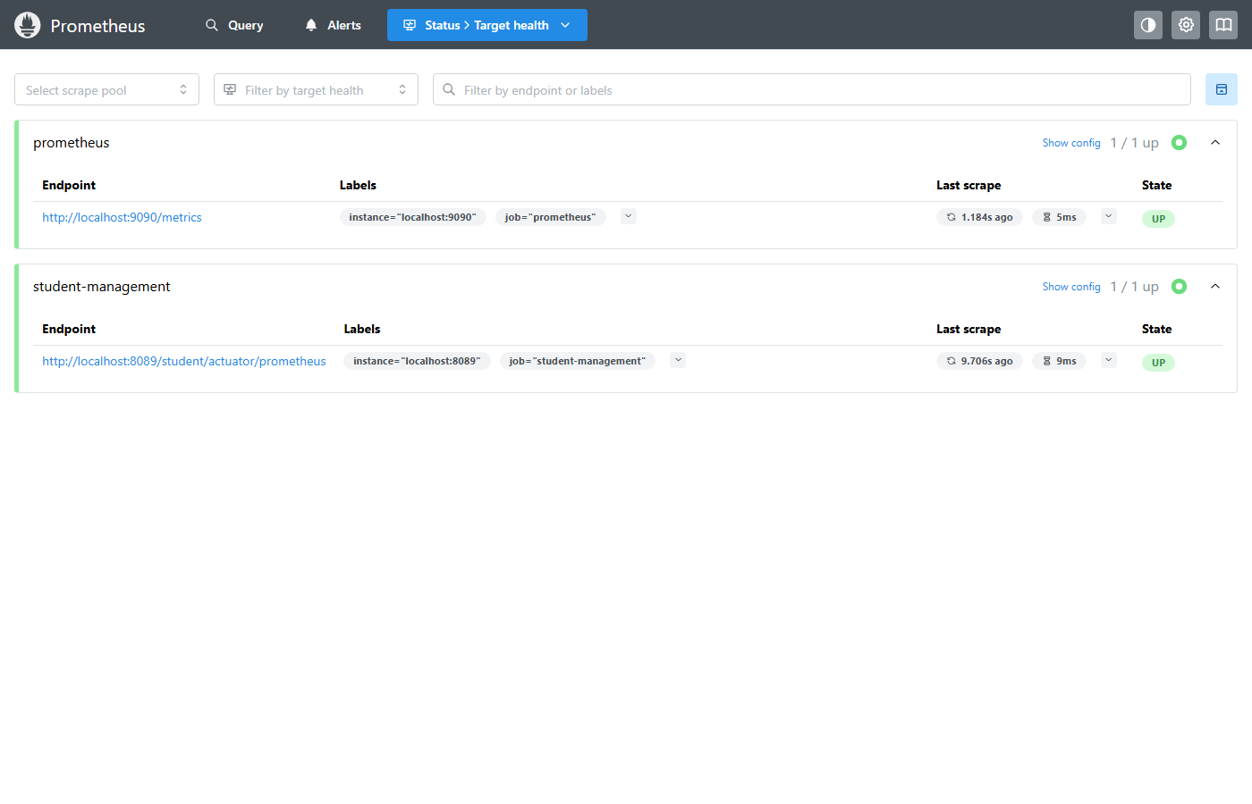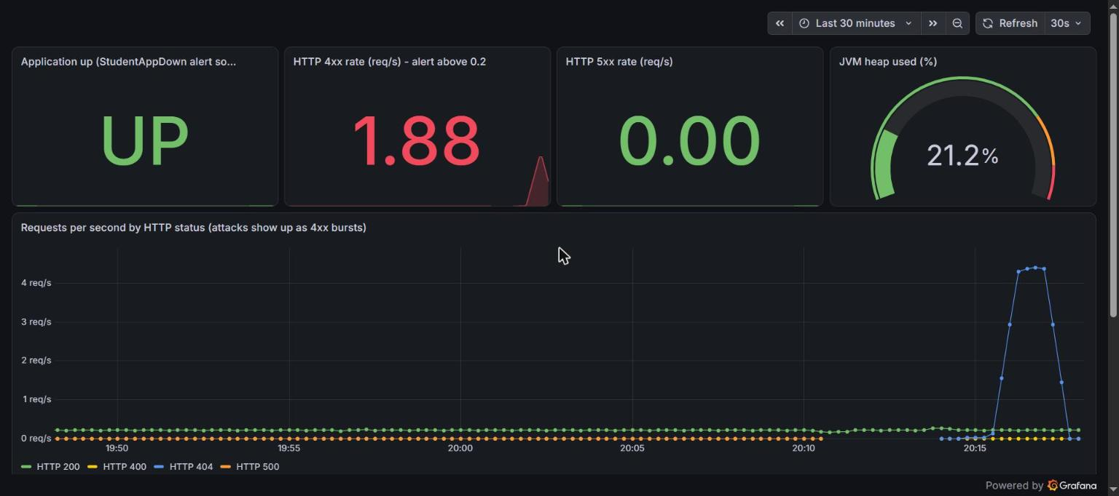

8. Reports produced by each build
Report | Tool | Phase
secrets-scan.txt | pre-commit / HMRC hooks (Lab 1) | Development
trivy-sca-report.html/.txt | Trivy (Java SCA) | Development
trivy-iac-report.html/.txt | Trivy (IaC) | Development
retire-report.json/.txt | Retire.js (Lab 2) | Development
SonarQube project dashboard | SonarQube | Development
Grafana dashboard DevSecOps Security Monitoring | Grafana (infra/monitoring/grafana/dashboards) | Operations
trivy-image-report.html/.txt | Trivy (image) | Development
gauntlt-report.txt | Gauntlt (Lab 3) | Acceptance
zap/zap-baseline-report.html/.json/.md | OWASP ZAP | Production
monitoring-check.txt | Prometheus API | Operations
All are archived by Jenkins (archiveArtifacts 'reports/**') and downloadable from each build. A copy of the final build’s reports (build #15) and its console log is in docs/evidence/build-15/.
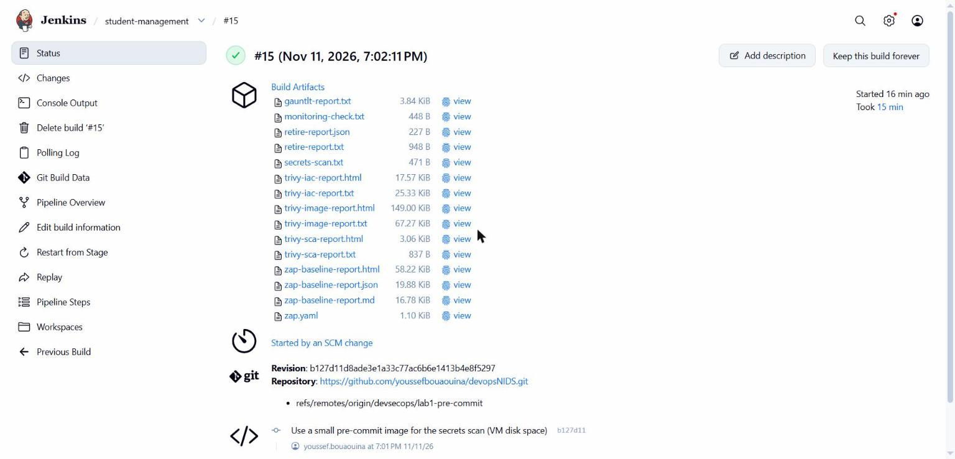
Jenkins build artifacts

9. Problems met and how we solved them
Problem | Solution
Retire.js only scans JavaScript, and the app is Java | Retire.js on the JS bundled in the jar (Swagger UI) + Trivy for the Java libraries
Gauntlt 1.0.13 does not run on recent Ruby; Debian 11 images are archived | Custom image on Ruby 3.1 (Debian 12)
Trivy timed out on the first image scan (vulnerability DB download) | Persistent DB cache + --timeout 20m
Security tools would need installing on the Jenkins VM | Every tool runs in a Docker container (python, trivy, node, gauntlt, zap)
VM disk 99% full: Jenkins executor went offline and SonarQube’s Elasticsearch became read-only | Removed unused images, smaller pre-commit image (Alpine), restarted SonarQube
Polling every minute queued duplicate builds while the executor was offline | Polling every 2 minutes, queue cleared

10. Limits and next steps
- Spring Boot 4 migration to remove the two accepted SSE CVEs (review date 2027-01-31).
- MySQL hardening: use a non-root MySQL image to fix the remaining IaC findings.
- Base image: 2 HIGH CVEs in Ubuntu packages with no fix yet; consider a distroless JRE image.
- Authentication: the API has no authentication. Spring Security would be the next application-level control, and ZAP could then run an authenticated scan.
- SonarQube findings: SonarQube reports security hotspots (e.g. persistent entities used as request bodies, rule java:S4684); request DTOs would remove them.
- Alert routing: connect Prometheus to Alertmanager (e-mail/Slack) so alerts reach the team.

11. How to run
- cd infra/vagrant && vagrant up (Jenkins, SonarQube, Minikube, Prometheus, Grafana).
- Jenkins: add the credentials dockerhub-credentials, sonar-token, mysql-root-password.
- The job student-management (infra/jenkins/student-management-job.xml) builds on every push, or use Build Now.
- Results: build page → Artifacts (reports/), SonarQube :9000, Prometheus :9090/alerts, Grafana :3000.

12. Final result (build #15)
Stage | Result
Secrets Scan (Lab 1) | 3 hooks Passed
SCA + IaC (Trivy) | jar: 0 vulnerabilities; IaC: Dockerfile 1 LOW, spring-app 2 MEDIUM
JS Dependency Scan (Lab 2, Retire.js) | 0 findings
SonarQube | Quality Gate Passed
Container Scan (Trivy) | 0 CRITICAL (OS: 62, 2 HIGH unfixed upstream; jar: 0)
Deploy | hardened pod rolled out
Gauntlt (Lab 3) | 8/8 scenarios, 36/36 steps passed
OWASP ZAP | 0 FAIL, 6 WARN, 62 PASS
Monitoring | attack detected, alert FIRING, RESULT OK
Pipeline | SUCCESS (17 stages, 15 min)

