
Cairo University
Faculty of Computers and Artificial Intelligent

CS251
Software Engineering I

Parking Garage

Software Design
ID | Name
20200215 | Sara Ashraf Ali
20200674 | Youssef Nasser Abdel Hafeez
20200574 | Merahan Soliman Mohamed
20200278 | Abd El Rahman Ahmed Samir

May 2022

Contents
Team 3
Document Purpose and Audience 3
System Models 4
I. Class diagrams 4
Important Algorithm 5
II. Sequence diagrams 6
Class - Sequence Usage Table 11
Ownership Report 12

Team
ID | Name | Email | Mobile
20200215 | Sara Ashraf Ali | Sara.ashraf1820@gmail.com | 01145402822
20200674 | Youssef Nasser Abdel Hafeez | Y556217@gmail.com | 01117683297
20200574 | Merahan Soliman Mohamed | Merahansolimann@gmail.com | 01208894421
20200278 | Abd El Rahman Ahmed Samir | bedosamir48@gmail.com | 01018618330

Document Purpose and Audience
- The document purpose for introducing the software design specification for Parking Garage application. (Class Diagram and sequence diagram).
- Audience: Customer (the owner of the garage).

System Models

I. Class diagrams
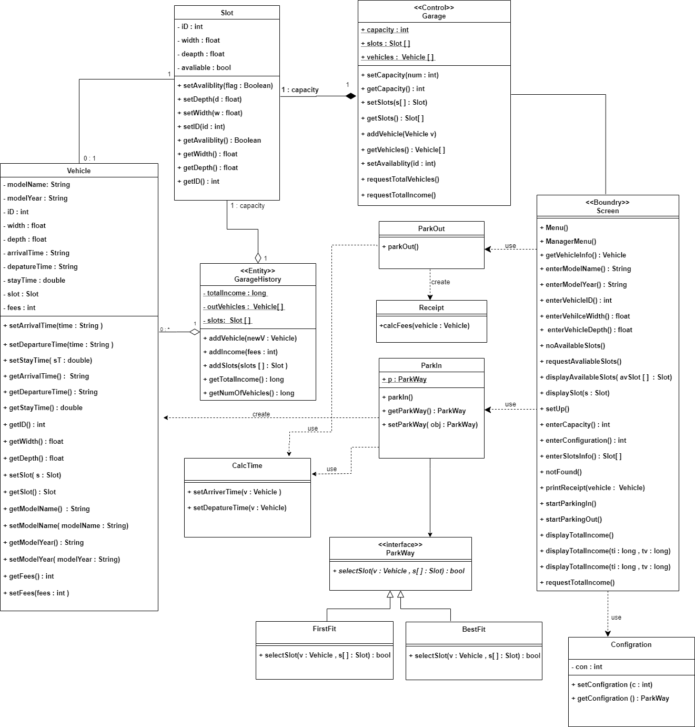

Class ID | Class Name | Description & Responsibility
1 | Screen | It’s responsible for displaying any data and transferring the interaction stage between the system and the operator.
2 | Garage | It’s responsible for the operations done by the system and store garage data.
3 | ParkIn | It’s responsible for park in process.
4 | ParkOut | It’s responsible for park out process.
5 | Slot | Contains the information of the slot (ID, width, depth and availability) and responsible for setting the availability
6 | Vehicle | It’s responsible for carrying all the data concerning all vehicles registered in the system such as (Vehicle’s info, Dimensions, Arrival Time, Departure Time).
7 | Receipt | It’s responsible for calculating the fees of each vehicle in the garage at the leaving time.
8 | GarageHistory | It’s responsible for carrying data such as (Vehicles, Total Income).
9 | CalcTime | It’s responsible for setting arrival time and departure time.
10 | Configuration | It’s responsible for set the park way that will garage will work on it.
11 | ParkWay | It’s a interface class that inherit from it two child such(FirstFit,BestFit)
12 | FirstFit | It’s responsible for set garage select first slot.
13 | BestFit | It’s responsible for set garage select Best suitable slot.

Important Algorithm

II. Sequence diagrams

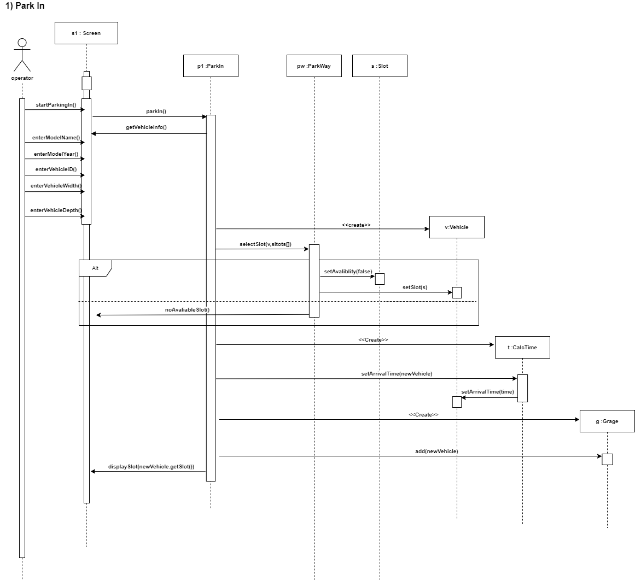

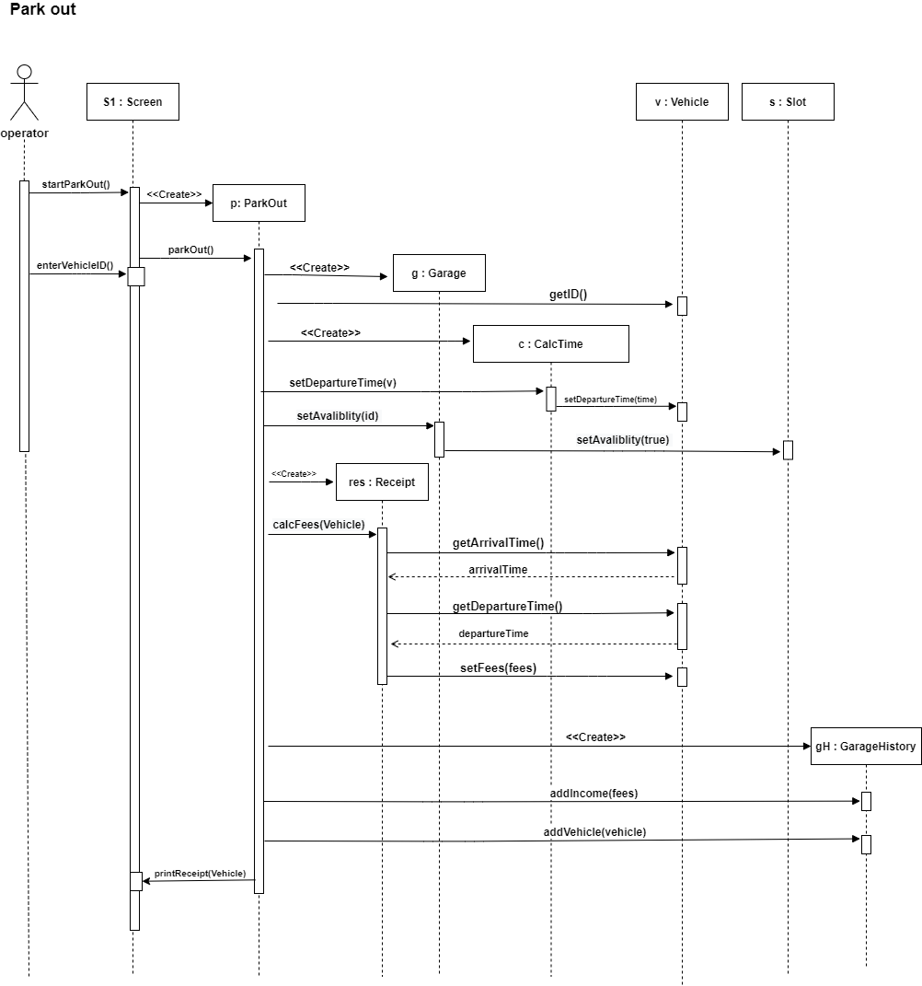

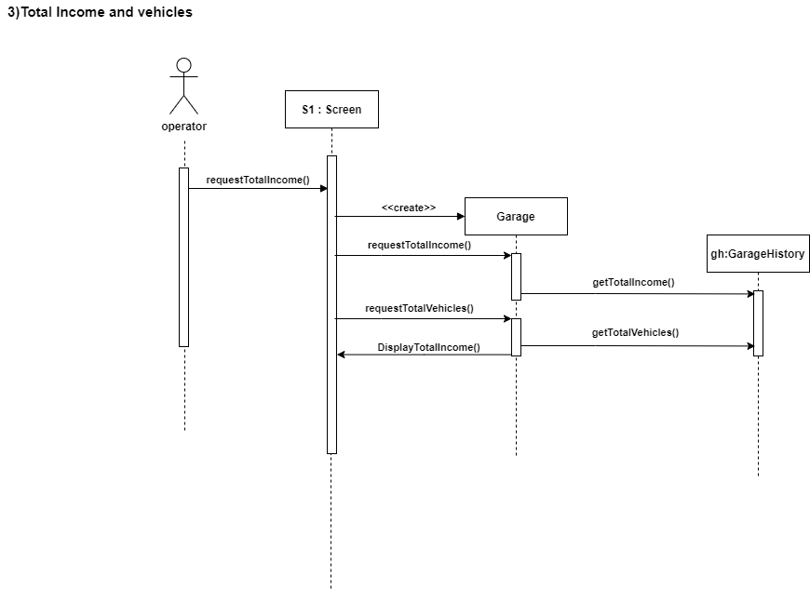

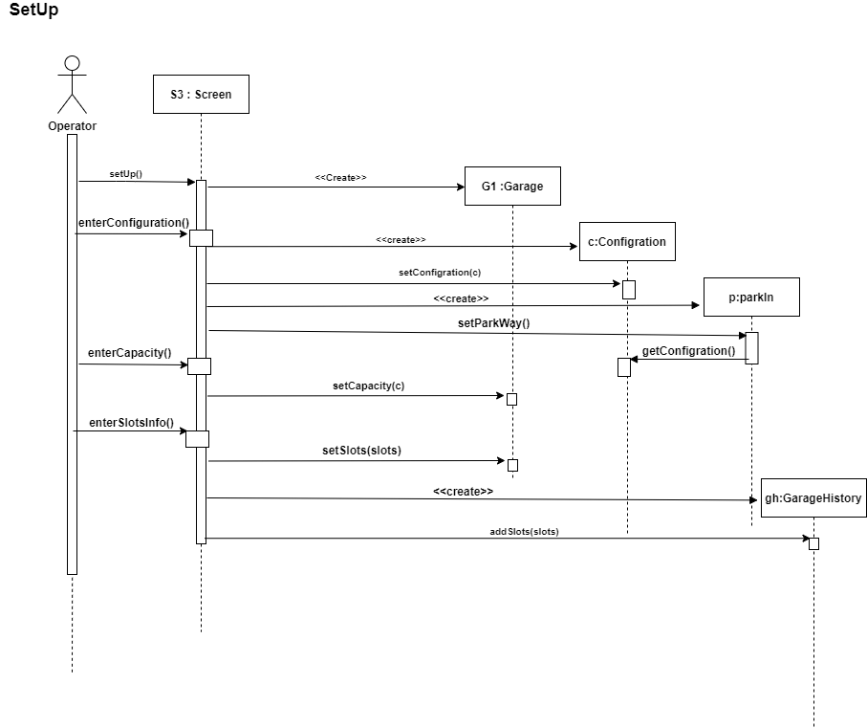

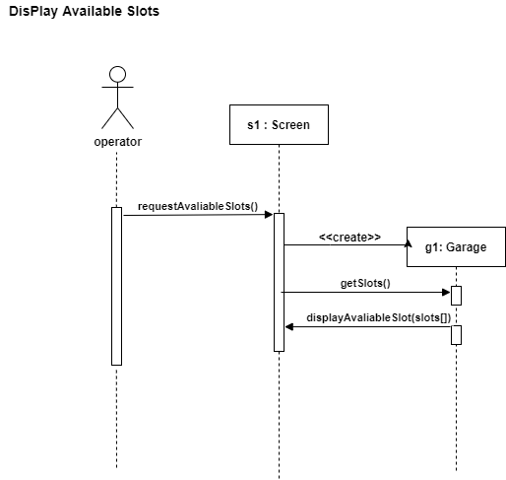

Class - Sequence Usage Table

Class Name | Sequence Diagrams | Overall used methods
Screen | 1, 2, 3, 4, 5 | startParkingIn()  enterModelName()  enterModelYear()  enterVehicleID()  enterVehicleWidth()  enterVehicleDepth()  getVehicleInfo()  noAvaliableSlot()  displaySlot()  startParkingOut()  printReceiptVehicle()  requestTotalIncome()  displayTotalIncome()  requestAvailableSlots()  displayAvaliableSlot()  setup()  enterConfiguration()  enterCapacity()  enterSlotsInfo()
Garage | 1, 2,3,4,5 | add()  setAvalibilty()  requestTotalIncome()  requestTotalVehicles()  getSlots()  displayAvailiableSlot()  setCapacity()  setSlots()
Slot | 1, 2 | SetAvailibilty(flag)
Vehicle | 1, 2 | setSlot()  setArrivalTime()  getID()  setDepartureTime()  getArrivalTime()  getDepartureTime()  setFees()
Receipt | 2 | CalcFees(stayTime)
ParkIn | 1,4 | parkIn()  setParkWay()
ParkOut | 2 | ParkOut()
ParkWay | 1 | selectSlot()
Configuration | 4 | setConfiguration()  getConfiguration()
CalcTime | 1,2 | setArrivalTime()  setDepartureTime()
Receipt | 2 | calcFees()
GarageHistory | 2,3,4 | addIncome()  addVehicle()  getTotalIncome()  getVehicles()  addSlots()

Ownership Report

Item | Owners
Class Diagram | All the team
Sequence Diagram | All the team

