
Cairo University
Faculty of Computers and Artificial Intelligent

CS251 - Software Engineering I

Parking Garage
Software Requirements Specifications (SRS)

ID | Name
20200215 | Sara Ashraf Ali
20200674 | Youssef Nasser Abdel Hafeez
20200574 | Merahan Soliman Mohamed
20200278 | Abd El Rahman Ahmed Samir

6/2022

Contents
Team 3
Document Purpose and Audience 3
Introduction 3
Software Purpose 3
Software Scope 3
Definitions, acronyms, and abbreviations 4
Requirements 4
Functional Requirements 4
Non-Functional Requirements 4
System Models 5
Use Case Model 5
Use Case Tables 6
Ownership Report 12
Policy Regarding Plagiarism: 12

Team
ID | Name | Email | Mobile
20200215 | Sara Ashraf Ali | Sara.ashraf1820@gmail.com | 01145402822
20200674 | Youssef Nasser Abdel Hafeez | Y556217@gmail.com | 01117683297
20200574 | Merahan Soliman Mohamed | Merahansolimann@gmail.com | 01208894421
20200278 | Abd El Rahman Ahmed Samir | bedosamir48@gmail.com | 01018618330

Document Purpose and Audience
- The document purpose:
for introducing the software requirements specification for Parking Garage application that lists all the functionalities and the guideline that the developers will walk through to achieve the required software and satisfy the customer.
- Audience:
Customer (the owner of the garage).

Introduction

Software Purpose
- Parking garage application which Helps the customer for parking his car and helps the owner of the garage to control the system of the garage.

Software Scope
- Helps the customer to park in and park out easily.
- Calculate the time-of-stay of the car in the garage and the parking fees.
- The owner of the garage can calculate the total income and the number of vehicles since the beginning of the system.
- The owner of the garage can display the available slots.

Definitions, acronyms, and abbreviations
24/7 | The system works all the time
First fit | The vehicle will park in the first free slot available from the parking garage slots
Best fit | The vehicle will park in the slot with the minimum dimension to hold the vehicle.

Requirements

Functional Requirements
- The system allows the operator to enter the information of the vehicle (model name, unique identification number, Model year and vehicle dimensions (vehicle width and depth).)
- The system finds a suitable available slot for each vehicle according to the chosen parkway.
- The application records the arrival time when the vehicle enters the garage and records the departure time when the vehicle leaves the garage.
- The application calculates the fees of each vehicle and print the receipt contains all the information of the vehicle.
- The system allows the operator to enter the information of the garage (the number of slots, the information of each slot (width, depth, and Id), and the park in configuration).
- The system allows the operator to display the available parking slots.
- The system allows the operator to display the total income and the total number of vehicles since the beginning of the system.

Non-Functional Requirements

Non-Functional | Details
Security | - If the system dropped in any time, there will not be a data loss.
Availability | - The system will be available 24/7.
supportability | - The operator must be able to modify any information without affecting the existing system.
Response Time | - The response time for searching for a free slot for a vehicle will not take more than 2 seconds.  - The response time for getting the total income and the total number of vehicles will not take more than 2 seconds.  - while the car is getting out of the garage the receipt will come out within 30 seconds at most.

System Models

Use Case Model

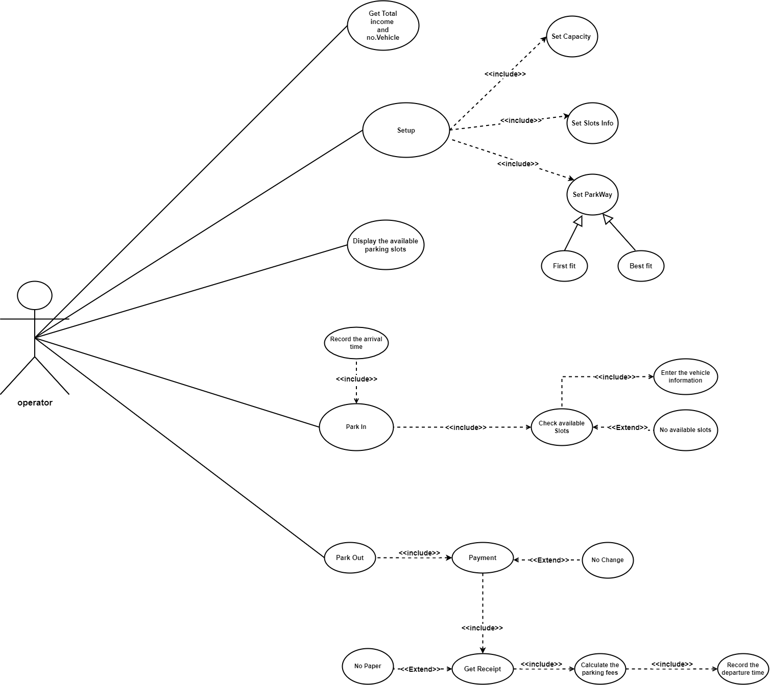

Use Case Tables

Use Case ID: | 1
Use Case Name: | Get total income and no. vehicles
Actors: | Operator
Pre-conditions: | operator chooses manager menu
Post-conditions: | The Manager will be able to know the total income and total number of vehicles.
Flow of events: | User Action | System Action
 | 1-operatorr chooses from menu to get the total income and total number of vehicles.
 |  | 2- the system displays the total income and total number of vehicles on the screen.
Exceptions: | User Action | System Action
 | 1-the manger asks to get the total income and total number of vehicles.
 |  | 2-the system broke down and failed to show the results.
Includes: | none
Notes and Issues: | The response time for getting the total income and the total number of vehicles will not take more than 2 seconds.

Use Case ID: | 2
Use Case Name: | Display Available Slots.
Actors: | Operator
Pre-conditions: | operator chooses manager menu.
Post-conditions: | Manger will be able to see all the available slots in his garage.
Flow of events: | User Action | System Action
 | operator chooses from menu to display the available slots.
 |  | 2-the system displays the available slots on the screen.
Exceptions: | User Action | System Action
 | 1-the manager asks to display all available slots.
 |  | 2-the system broke down and failed to show the results.
Includes: | none
Notes and Issues: | N/A

Use Case ID: | 3
Use Case Name: | Park in
Actors: | operator
Pre-conditions: | The operator asks to park in
Post-conditions: | The driver parked the car in the garage.
Flow of events: | User Action | System Action
 | 1-The operator starts parking in the garage.
 |  | 2- System asks for the vehicle info
 | 3-The driver will enter the car’s information (model year, model name, id, width, depth)
 |  | 4- System starts to select a suitable slot for the vehicle and the selected slot will be unavailable.
 |  | 5-the system will save the arrival time of the car.
 |  | 6-the system will save the information of the vehicle.
 |  | 7- the system displays the information of the selected slot.
 | 8-The driver park in the designated area.
Exceptions: | User Action | System Action
 |  | 1-System check available slots for the driver.
2- System Cannot find an empty slot for the driver.
3-System sends a message.
Includes: | Check available slots, Enter the vehicle information.
Notes and Issues: | The response time for searching for a free slot for a vehicle will not take more than 2 seconds.

Use Case ID: | 4
Use Case Name: | Park out
Actors: | Operator
Pre-conditions: | The operator parked in the garage
Post-conditions: | The driver gets successfully out of the garage
Flow of events: | User Action | System Action
 | 1- the operator asks to park out.
 |  | 2- the system will ask to enter the id of the car.
 | 3-the operator enters the id of the car.
 |  | 4-the system will calculate the departure time.
 |  | 5-the system will make the slot available.
 |  | 6-the system will calculate the fees.
 | 7-the driver will pay the fees.
 |  | 8-the system save the information of the vehicle and add the fees to the total income.
Exceptions: | User Action | System Action
 | 1-There is no paper to print the receipt.
 |  | 2-the system can’t print the receipt and the driver will know the fees only from the screen
Includes: | It will include (payment, get receipt, calculating the parking fees, record the departure time).
Notes and Issues: | the receipt will come out within 30 second at most.

Use Case ID: | 5
Use Case Name: | Setup
Actors: | operator
Pre-conditions: | The operator starts the garage.
Post-conditions: | The system will be ready to use.
Flow of events: | User Action | System Action
 | 1-the operator starts to setup the system
 |  | 2-the system asks to choose configuration
 | 5- the operator chooses the park-in configuration (there are two configurations)
 |  | 6-The system will save the chosen configuration
 |  | 7-the system will be ready to park by the chosen way
 |  | 8- the system will request the number of slots.
 | 9- the operator will enter the number of slots.
 |  | 10- the system will save the number of slots.
 |  | 11-the system will request the information of each slot.
 | 12-the operator will enter the information of each slot.
 |  | 13-the system will save the information of each slot.
 |  | 14-the system will save the slots in the database.
Exceptions: | User Action | System Action
 | 1-the operator enters invalid information.
 |  | 2-the system will let him to enter the information again.
Includes: | It will include (set capacity, set slots info and set configuration)
Notes and Issues: | The operator can modify any information without affecting the existing system.

Ownership Report

Item | Owners
Introduction | All the team
Requirements | All the team
Use Case model | All the team
Use Case table | All the team

Policy Regarding Plagiarism:

Students have collective ownership and responsibility of their project. Any violation of academic honesty will have severe consequences and punishment for ALL team members.
- تشجع الكلية على مناقشة الأفكار وتبادل المعلومات ومناقشات الطلاب حيث يعتبر هذا جوهريا لعملية تعليمية سليمة
- ساعد زملاءك على قدر ما تستطيع وحل لهم مشاكلهم في الكود، ولكن تبادل الحلول غير مقبول ويعتبر غشا.
- أي حل يتشابه مع أي حل آخر بدرجة تقطع بأنهما منقولان من نفس المصدر سيعتبر أن صاحبيهما قد قاما بالغش.
- قد توجد على النت برامج مشابهة لما نكتبه هنا أي نسخ من على النت يعتبر غشا يحاسب عليه صاحبه.
- إذا لم تكن متأكدا أن فعلا ما يعد غشا فلتسأل المعيد أو أستاذ المادة.
- في حالة ثبوت الغش سيأخذ الطالب سالب درجة المسألة، وفى حالة تكرار الغش سيرسب الطالب في المقرر.

