

Egypt University of Informatics

Computer and Information Systems

Data Analysis Course

The Analysis of Exercise On Students Academic Performance

Submitted by: Youssef Hazem El Shaarawy

9/3/2024

# Introduction

Exercise and academic performance in students is a topic of ongoing research. Some studies suggest a positive correlation, indicating that regular physical activity could enhance cognitive abilities and concentration. However, the extent and nature of this relationship can vary widely among individuals. It’s also important to balance exercise with other factors like adequate rest and a healthy diet. Further research is needed to fully understand this complex relationship.

# Research Question

How does regular physical exercise influence the academic performance of college students?

# Hypothesis

College students who engage in regular physical exercise have higher academic performance compared to those who do not.

# Population of Interest:

College Students

# Sampling Method:

Convenience Sampling : The survey that was made to collect the data was only sent to online groups filled with college students that led to get a better sample with no one out of the population.

# Bias Identification:

1. **Selection Bias**: To avoid this, the survey would be distributed to a diverse and representative sample of college students, not just to those who are known to exercise regularly or perform well academically.

2.Response Bias: The questions are designed to be neutral and do not lead the respondent towards a particular answer. For example, the question “Do you feel that regular exercise impacts your academic performance?” is open-ended and does not imply a positive or negative impact.

**3.Confirmation Bias**: it’s important to avoid favoring information that confirms your preconceptions. The data collected from this survey would be analyzed objectively, and conclusions would be drawn based on the data, not personal beliefs or hypotheses.

# Survey Questions:

**What is your major?**

**What year are you in?**

**How often do you exercise in a week?**

**Do you feel that regular exercise impacts your academic performance? How much on scale from 1 to 5? If five is the best and 0 is doesn't affect me at all?**

**What is your gender?**

Online survey link: <https://forms.gle/PV9qspw6SYn8VSNB9>

Number of samples collected: 31

# Analysis:

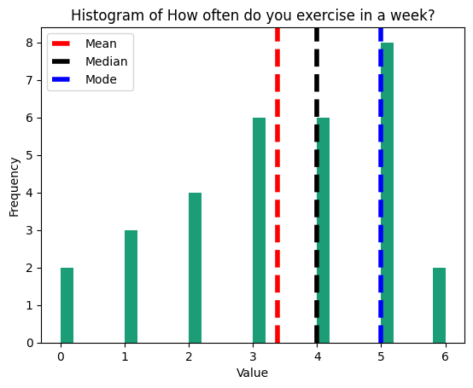

The histogram represents the frequency of responses to the question “How often do you exercise in a week?” among a group of individuals. The mode, or most common response, is 5 times per week, while the mean and median both fall between 3 and 4 times per week, indicating that on average, individuals in this group exercise 3 to 4 times per week.

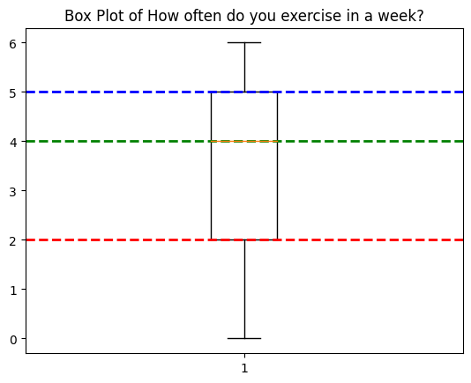

This is a boxplot that shows the Q1, Q2 and median of “How often do you exercise in a week?”.

Mean = 3.3870967741935485 , Median = 4.0 and Mode = 5.0

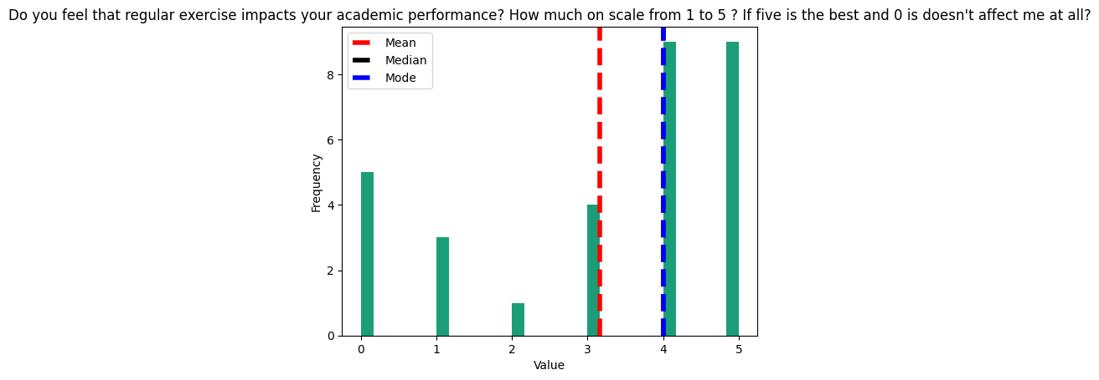

The histogram shows responses to how exercise impacts academic performance, with a mode and median of 5, indicating many students see a significant impact. However, the highest frequency is at 0, suggesting a substantial number believe exercise doesn’t affect their performance.

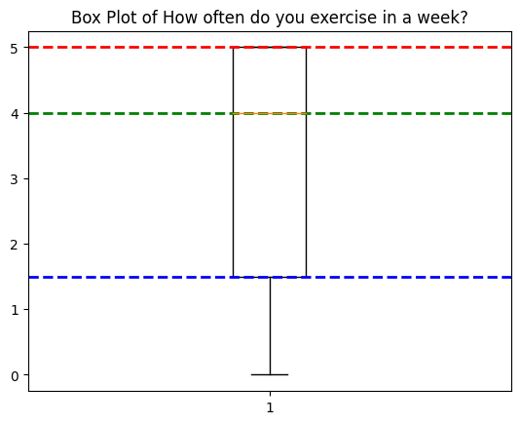

This is a boxplot that shows the Q1, Q2 and median of "Do you feel that regular exercise impacts your academic performance? How much on scale from 1 to 5? If five is the best and 0 is doesn't affect me at all?"

Mean = 3.161290322580645, Median = 4.0 and Mode = 4.0

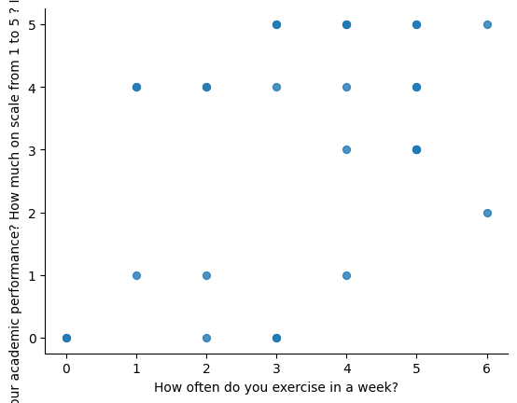

Scatter plot that shows the correlation between the how often you exercise and the academic performance which is a moderate relation that has a correlation of (0.43968423815794316).

# Conclusion

I Conclude based on the data collected and the results shown that there is a moderate relation between the amount you exercise and your academic performance.

# 

# Any potential issues

The issues discovered:

1. the sample collected may be too little to get a good reading of the situation

1. There may a lot of confounding variables that may not be constant between the survey takers
2. The operations made may not be significant enough to have collected a good conclusion.