IoT in Smart Buildings: Automation, Efficiency, and Implementation Barriers
Youssef Hatem Farid Ahmed (2400453@eng.asu.edu.eg)
General Engineering, Faculty of Engineering, Ain Shams University

Abstract

Keywords: Smart Buildings, IoT, Building Management Systems (BMS), Case Study, Barriers

Introduction
Smart buildings use IoT to save energy and make operations easier, but they can be expensive and face many challenges. So, by answering our Research Question: What is the role of IoT in enhancing automation and efficiency in smart building systems, and what barriers arise during implementation? We could now prove by numbers the amount of energy saved and examine the barriers faced during implementation and that’s the aim of the review.

Figure 1 shows the outline of this research. Following the introduction, Section 2 presents real-life case studies that prove IoT’s value in smart buildings. Large projects like the Gulf’s Al Bahr Towers, which cut cooling energy by 20%, and Egypt’s administrative buildings show how automation improves efficiency and satisfaction. Smaller cases, such as a Hong Kong office and a Polish smart home, show similar benefits on a smaller scale. Second, Section 3 explains the data-driven processes that make this automation possible showing how IoT devices collect data, detect occupancy, and process large datasets within a Building Management System for efficient control. Then, Section 4 then explores barriers to implementation, including high costs, technical issues, and privacy risks. These challenges are closely linked to the processes in Section 3 as if data handling is poor, it can lead to delays, errors, or privacy breaches, reducing trust and adoption. Finally, Section 5 presents the discussion and conclusions of this article.
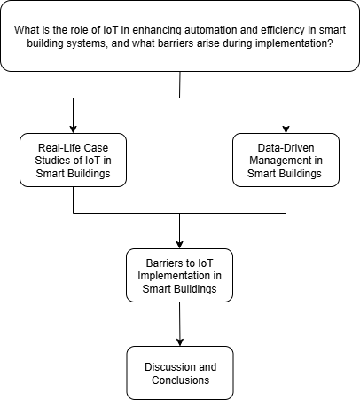
Figure 1: Research outline and structure

Real-Life Case Studies of IoT in Smart Buildings
In that topic, it shows real examples of IoT in buildings, explaining how they work, what benefits they achieved, and what challenges appeared during use.

Egypt & Gulf Region: Large-Scale Sustainable Buildings — [10], [11]
It shows how IoT in landmark buildings, like Egypt’s administrative buildings in Beverly Hills Compound Elsheikh Zayed and the Gulf’s Al Bahr Towers, use automation for lighting, cooling, and façades to cut energy waste and support long-term sustainability goals.

Hong Kong Office & Polish Smart Energy House: Real-Time Monitoring for Comfort & Efficiency — [4], [5]
It shows how IoT in a Hong Kong office and a Polish home helps in saving energy and improving efficiency on a smaller scale than large landmark buildings. These systems use live monitoring and quick automated adjustments to control conditions like temperature, lighting, and air quality for better comfort and reduced waste.

Data-Driven Management in Smart Buildings
In that topic, it explains how IoT data is collected, processed, and utilized in Building Management Systems (BMS) to automate operations, improve efficiency, and enhance comfort.

IoT Architectures for BMS — [1], [3]
It introduces how IoT devices and systems are set up to work together in a Building Management System which allows smart buildings to automate operations and improve efficiency.

Occupancy Detection and Prediction for Automation — [9], [12]
It explains how smart buildings use sensors and past usage patterns to know what spaces are occupied and when to adjust systems like lighting and HVAC which boosts automation and saves energy.

Data Processing and Integration in BMS — [2], [3]
It describes how smart buildings manage large volumes of IoT data by storing it in local servers or cloud platforms and merging information from different devices into a unified Building Management System. This integration ensures the system has accurate, complete data for automation and efficiency improvements. (This sets up Subtopic 4.3, where we explore the risks and problems that can occur if these processes are not managed well.)

Barriers to IoT Implementation in Smart Buildings
What are you talking about in this topic? (1-2 sentences)

Cost and Investment Challenges — [8], [6]
It shows how high installation and maintenance costs can slow IoT adoption, especially for large-scale projects like those in Egypt and the Gulf. Limited budgets can affect system quality and long-term sustainability.

Technical Reliability and Maintenance Issues — [7], [2]
It shows how hardware failures, software bugs, and difficulty updating systems over time can reduce IoT performance. Real-life cases show that keeping devices reliable and systems up-to-date requires ongoing technical support, which is often underestimated.

Data Management and Privacy Concerns — [3], [8], [12]
It examines the potential risks that arise when data storage, processing, or integration is poorly managed, it can cause delays, errors, or even security breaches. Weak privacy protection or unclear consent policies may reduce trust and adoption, limiting the system’s long-term success.

Discussion and Conclusions

References

