IoT in Smart Buildings: Automation, Efficiency, and Implementation Barriers
Youssef Hatem Farid Ahmed (2400453@eng.asu.edu.eg)
General Engineering Department, Faculty of Engineering, Ain Shams University

Abstract
This review examines the role of the Internet of Things (IoT) in enhancing automation and efficiency in smart buildings, while also addressing barriers to adoption. Case studies from Egypt, the Gulf, Hong Kong, and Poland show how IoT improves energy use, comfort, and sustainability at both large and small scales. The review also outlines how IoT data is managed through Building Management Systems (BMS) and identifies challenges such as costs, technical reliability, and privacy risks.
Keywords: Smart Buildings, IoT, Building Management Systems (BMS), Case Study, Barriers.

Introduction
Smart buildings use IoT to save energy and make operations easier, but they can be expensive and face many challenges. By answering my research question: “What is the role of IoT in enhancing the automation and efficiency of smart building systems, and what barriers arise during its implementation?” We could now quantify energy savings and examine the barriers faced during implementation and that is the aim of the review.
Figure 1 shows the outline of this research. Following the introduction, Section 2 presents real-life case studies showing how IoT improves efficiency in both large landmark buildings and smaller-scale projects. Section 3 explains the data-driven processes that enable such automation, including device integration, occupancy detection, and data management. Section 4 then discusses the barriers to IoT implementation, such as cost, technical reliability, and privacy risks. Finally, Section 5 provides the discussion and conclusions of this review.
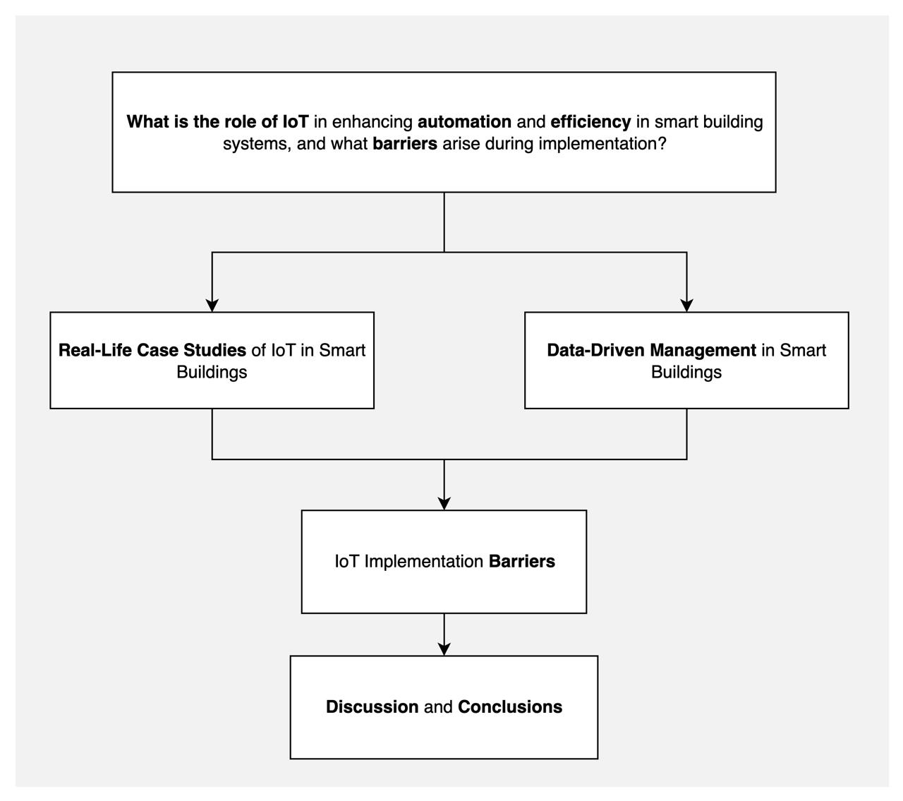
Figure 1: Research outline and structure

Real-Life Case Studies of IoT in Smart Buildings
This section shows real examples of IoT in buildings, explaining how it worked, what benefits it achieved, and what challenges appeared during use.

Egypt & Gulf Large-Scale Sustainable Buildings
IoT technologies have shown strong potential for energy savings and sustainable operation in large-scale projects. In Egypt’s Beverly Hills Compound Elsheikh Zayed, IoT systems improved energy efficiency, reduced waste, and raised occupant awareness [1]. Similarly, the Al Bahr Towers in the Gulf used automated mashrabiya façades to cut cooling demand by nearly 20% [2]. Despite these benefits, challenges remain, including high costs, limited expertise, and ongoing maintenance requirements [1],[2].

Hong Kong Office & Polish Smart Energy House
IoT has also proven effective in smaller-scale settings. In a Hong Kong office, IoT sensors with a digital twin system optimized HVAC, lighting, and air quality, reducing energy use and improving comfort [3]. In Poland, a smart energy house used IoT to track and adjust temperature, water, and storage, enhancing efficiency [4]. While both cases show IoT’s benefits in real-time monitoring and quick responses, they also reveal challenges such as calibration, connectivity, complexity, and technical knowledge requirements [3],[4].

Data-Driven Management in Smart Buildings
In that topic, it explains how IoT data is collected, processed, and utilized in Building Management Systems (BMS) to automate operations, improve efficiency, and enhance comfort.

IoT Architectures for BMS
IoT architecture in smart buildings usually follows a layered structure. At the base, sensors capture data such as temperature, occupancy, or lighting levels. This information is then transmitted through communication networks to a Building Management System (BMS), which processes the data and coordinates building operations [5]. Reviews also highlight that effective architectures are designed for interoperability, where devices from different manufacturers can function together, and scalability, allowing new sensors and systems to be added as buildings evolve. This structure ensures that diverse IoT devices can be integrated into a single platform, making centralized monitoring and automated control possible [6].

Occupancy Detection and Prediction for Automation
Occupancy detection is central to IoT-based Building Management Systems, using motion sensors, Wi-Fi, and RFID to identify room use [7]. Prediction techniques build on this by analyzing historical data to anticipate occupancy, such as pre-cooling meeting rooms for comfort and energy savings [8]. Together, these functions make building automation more efficient by ensuring systems run only when and where needed.

Data Processing and Integration in BMS
Smart buildings generate large data from many different devices, including sensors for temperature, occupancy, lighting, and energy use. To handle this, the data is stored either locally, using on-site servers, or in cloud platforms that can manage larger volumes and allow remote access [9]. Once collected, the information must be cleaned, organized, and then merged into a single Building Management System (BMS) so that it can be used for automated control [6]. Poor management at this step can cause errors, delays, or security risks, and the related challenges will be discussed in Subtopic (4.2).

Barriers to IoT Implementation in Smart Buildings
In that topic, it shows the main challenges that appear after IoT is used in smart buildings, linking lessons from the real-life examples in Section 2 with the data processes in Section 3. This section explains how problems like cost, technical issues, and privacy risks can still arise.

Financial and Technical Barriers
IoT implementation in smart buildings often faces two connected barriers: high costs and technical reliability. Large-scale projects, such as those in Egypt and the Gulf, show that installation and maintenance require significant investment, and limited budgets can reduce system quality or threaten long-term sustainability [1],[2]. At the same time, hardware failures, software bugs, and difficulties with system updates make it challenging to keep IoT devices running smoothly [10]. These technical issues often demand continuous spending on upgrades and support, which links them directly to financial barriers.

Data Management and Privacy Concerns
Smart buildings depend on the continuous collection and integration of large datasets, as described in Subtopic (3.3). If this process is poorly managed, it can lead to errors in automation, delays in system responses, or even system failures. Beyond performance issues, there are also privacy risks. IoT devices in buildings often gather sensitive data such as occupancy patterns or user behavior, and without strong consent mechanisms, this information can be misused [11]. Some studies suggest tools that let users control how their data is used, but these are not widely applied in practice. Weak data management not only harms system performance but also reduces user trust, which is vital for the success of IoT in smart buildings [8].

Discussion and Conclusions

IoT enables measurable gains in smart buildings, with studies reporting energy consumption reductions of up to 30% and operating expense savings of around 20% [9]. Case studies confirm these benefits in both large-scale and small-scale deployments, where automation improves efficiency and comfort. However, barriers remain, including high costs, technical failures, and privacy concerns. Solving these issues with cheaper solutions, better system integration, and stronger data management is key for the long-term success of IoT in smart buildings.

References
[1] V. Ibrahim, “Internet of Things ‘IoT’: As a tool in Architecture for the Concept of Sustainability in Egypt,” Sohag Eng. J., vol. 0, no. 0, pp. 0–0, Sept. 2022, doi: 10.21608/sej.2022.154729.1016.
[2] J. Willis, “Fast Forwards: 10 Years of Sustainable Initiatives in the Gulf Region,” Archit. Des., vol. 85, no. 1, pp. 114–119, Jan. 2015, doi: 10.1002/ad.1861.
[3] G. Piras, S. Agostinelli, and F. Muzi, “Smart Buildings and Digital Twin to Monitoring the Efficiency and Wellness of Working Environments: A Case Study on IoT Integration and Data-Driven Management,” Appl. Sci., vol. 15, no. 9, p. 4939, Apr. 2025, doi: 10.3390/app15094939.
[4] L. Rojek, S. Islam, M. Hartmann, and R. Creutzburg, “IoT-Based Real-Time Monitoring System for a Smart Energy House,” Electron. Imaging, vol. 33, no. 3, pp. 38-1-38–10, June 2021, doi: 10.2352/ISSN.2470-1173.2021.3.MOBMU-038.
[5] K. M. Al-Obaidi, M. Hossain, N. A. M. Alduais, H. S. Al-Duais, H. Omrany, and A. Ghaffarianhoseini, “A Review of Using IoT for Energy Efficient Buildings and Cities: A Built Environment Perspective,” Energies, vol. 15, no. 16, p. 5991, Aug. 2022, doi: 10.3390/en15165991.
[6] A. Taboada-Orozco, K. Yetongnon, and C. Nicolle, “Smart Buildings: A Comprehensive Systematic Literature Review on Data-Driven Building Management Systems,” Sensors, vol. 24, no. 13, p. 4405, July 2024, doi: 10.3390/s24134405.
[7] K. Akkaya, I. Guvenc, R. Aygun, N. Pala, and A. Kadri, “IoT-based occupancy monitoring techniques for energy-efficient smart buildings,” in 2015 IEEE Wireless Communications and Networking Conference Workshops (WCNCW), New Orleans, LA, USA: IEEE, Mar. 2015, pp. 58–63. doi: 10.1109/WCNCW.2015.7122529.
[8] I. Khan, O. Zedadra, A. Guerrieri, and G. Spezzano, “Occupancy Prediction in IoT-Enabled Smart Buildings: Technologies, Methods, and Future Directions,” Sensors, vol. 24, no. 11, p. 3276, May 2024, doi: 10.3390/s24113276.
[9] M. Poyyamozhi, B. Murugesan, N. Rajamanickam, M. Shorfuzzaman, and Y. Aboelmagd, “IoT—A Promising Solution to Energy Management in Smart Buildings: A Systematic Review, Applications, Barriers, and Future Scope,” Buildings, vol. 14, no. 11, p. 3446, Oct. 2024, doi: 10.3390/buildings14113446.
[10] E. O. T. Affonso et al., “The Main Barriers Limiting the Development of Smart Buildings,” Buildings, vol. 14, no. 6, p. 1726, June 2024, doi: 10.3390/buildings14061726.
[11] C. Pathmabandu, J. Grundy, M. B. Chhetri, and Z. Baig, “Privacy for IoT: Informed consent management in Smart Buildings,” Future Gener. Comput. Syst., vol. 145, pp. 367–383, Aug. 2023, doi: 10.1016/j.future.2023.03.045.

