

**Steel Express Inventory Management System**

The Graduation Project Submitted to

The Faculty of Computers and Artificial Intelligence,

Cairo University

In Partial Fulfillment of the Requirements

for theBachelor Degree

In

**Operations Research and Decision Support**

**Mohammed Hazem Ammar 20190429**

**Youssef Emad Hussain 20180347**

**Zinab Mohy El-din 20180113**

**Amr Ahmed Ahmed 20180185**

***Under Supervision of:***

**DR. Ghada Tolan**

**February/2023**



**Steel Express Inventory Management System**

**Mohammed Hazem Ammar**

**Youssef Emad Hussain**

**Zinab Mohy El-din**

**Amr Ahmed Ahmed**

*Supervised By*

**Supervisor Name**

**DR. Ghada Tolan**

**CAIRO UNIVERSITY**

**February/2023**

# **Abstract**

**Introduction: Efficient management of stock holding and shortage challenges is vital for business sustainability and customer satisfaction.**

**Technology Integration: The Inventory Management System (IMS) integrates RFID, barcode scanning, and real-time analytics for comprehensive stock tracking.**

**Demand Forecasting: Advanced algorithms enable accurate demand forecasting, facilitating proactive stock replenishment strategies.**

**Centralized Control: The IMS offers centralized control over inventory, allowing for precise management and optimization of stock levels.**

**Automated Triggers: Automated triggers within the IMS initiate replenishment actions based on predefined thresholds, minimizing holding costs and preventing shortages.**

**Customizable Reporting: Customizable reporting tools provide insights into stock movement patterns, aiding in informed decision-making and strategic planning.**

**ERP Integration: Seamless integration with existing ERP systems ensures synchronized data exchange and process alignment across the organization.**

**Scalability and Adaptability: The IMS is designed to scale with business growth and adapt to changing market dynamics, offering flexibility and resilience.**

**Benefits: Implementation of the EOQ enables organizations to optimize stock levels, mitigate shortages, enhance customer satisfaction, and drive sustainable growth and competitiveness in the market.**

**DECLARATION**

We hereby declare that our dissertation is entirely our work and genuine / original. We understand that in case of discovery of any PLAGIARISM at any stage, our group will be assigned an F (FAIL) grade and it may result in withdrawal of our bachelor’s degree.

Group members:

**Name Signature**

Youssef emad hussin ___________________

Zinab Mohy El-din ___________________

Mohamed Ahmed Abd El-Menem ___________________

Amr Ahmed Ahmed ___________________

**Introduction**

Inventory management is a fundamental aspect of operations for businesses FOR AL-ASHRY –STEEL across various industries, encompassing the planning, control, and optimization of stock levels to meet customer demand while minimizing holding costs and mitigating shortages. In today's dynamic and competitive marketplace, the effective management of inventory is essential for maintaining customer satisfaction, streamlining operations, and.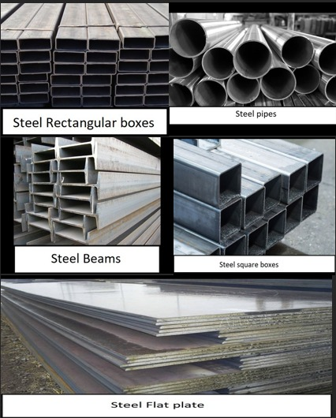

Inventory Management Systems (IMS) play a pivotal role in modern businesses by providing a structured approach to inventory control and optimization. These systems leverage technology, data analytics, and best practices to streamline inventory operations, enhance visibility into stock levels, and facilitate informed decision-making.

At its core, an IMS typically includes features such as stock tracking, demand forecasting, replenishment strategies, and reporting functionalities. By integrating technologies such as RFID, barcode scanning, and real-time data analytics, IMS enables organizations to accurately monitor stock movements, anticipate demand fluctuations, and optimize inventory levels accordingly.

One of the key advantages of IMS is the ability to centralize inventory control, allowing businesses to manage stock across multiple locations or warehouses from a single platform. This centralized approach enhances coordination, reduces the risk of stockouts or overstocking, and improves overall efficiency.

Furthermore, IMS often offers automation capabilities, such as automated replenishment triggers based on predefined thresholds or predictive algorithms. This automation not only reduces manual intervention but also ensures timely replenishment of stock, minimizing holding costs and preventing shortages.

Integration with existing Enterprise Resource Planning (ERP) systems is another critical aspect of IMS, enabling seamless data exchange and alignment of inventory management processes with other business functions such as sales, procurement, and finance.

**In summary, Inventory Management Systems play a vital role in optimizing inventory operations, enhancing efficiency, and driving business success. By leveraging technology, data-driven insights, and streamlined processes, IMS empowers organizations to meet customer demands effectively, minimize costs, and maintain a competitive edge in the market.**

**Problem Statement**

**Inefficient inventory management poses significant challenges for businesses, leading to increased holding costs, stock shortages, and operational inefficiencies. Despite the availability of various inventory management tools and techniques, many organizations struggle to effectively control and optimize their stock levels, resulting in compromised customer satisfaction and decreased profitability. Key issues include:**

**Poor Visibility: Lack of real-time visibility into inventory levels and movements across multiple locations or warehouses hampers decision-making and leads to inaccuracies in demand forecasting.**

**Manual Processes: Reliance on manual inventory tracking methods results in errors, delays, and increased labor costs, hindering the ability to respond promptly to changing demand patterns.**

**Stockouts and Overstocking: Inability to anticipate demand fluctuations and optimize stock levels often leads to stockouts, causing lost sales opportunities and customer dissatisfaction, or overstocking, resulting in increased holding costs and potential obsolescence.**

**Ineffective Replenishment: Inefficient replenishment strategies, such as ad-hoc ordering or reactive restocking, contribute to inventory imbalances, increased carrying costs, and reduced cash flow.**

**Lack of Integration: Silod inventory management processes and systems that are not integrated with other business functions, such as sales, procurement, and finance, impede operational efficiency and hinder holistic decision-making.**

**Complexity in Data Analysis: Difficulty in analyzing large volumes of inventory data and extracting actionable insights limits the ability to optimize inventory levels and make informed decisions.**

**Addressing these challenges requires the implementation of a robust Inventory Management System (IMS) that integrates advanced technologies, automates processes, enhances visibility, and aligns inventory management with overall business objectives. By addressing these key issues, organizations can improve operational efficiency, reduce costs, enhance customer satisfaction, and maintain a competitive edge in the market.**

**Scope of Work**

Data Collection and Analysis: Gather historical inventory data and analyze it to identify demand patterns, lead times, and holding costs.

Parameter Estimation: Determine the parameters required for the EOQ model, including annual demand, ordering cost, and holding cost.

EOQ Calculation: Utilize the EOQ formula to calculate the optimal order quantity that minimizes total inventory costs.

Reorder Point Determination: Calculate the reorder point based on the EOQ, lead time, and demand variability to ensure timely replenishment and prevent stockouts.

**ROP=D×LT**

Safety Stock Calculation: Determine the appropriate level of safety stock to buffer against demand variability and lead time uncertainty.

Implementation and Integration: Implement the EOQ model within the Inventory Management System (IMS) and integrate it with existing systems and processes.

By following this scope of work, organizations can effectively implement the EOQ model in inventory management, optimize inventory levels, and minimize costs to meet customer demands efficiently.

**Objectives and Methodology**

**Reducing Holding Costs:**

EOQ helps in determining the optimal order quantity that minimizes holding costs. By ordering the EOQ, businesses can avoid overstocking, thereby reducing storage costs associated with excess inventory.

Additionally, EOQ ensures that inventory turnover is optimized, minimizing the risk of inventory obsolescence and associated costs.

By implementing EOQ, organizations can better manage inventory levels, leading to lower insurance costs as the risk of inventory loss or damage is reduced due to lower inventory levels.

**Minimizing Stockouts:**

EOQ aids in setting appropriate reorder points and safety stock levels based on demand variability and lead time. This ensures that sufficient inventory is available to meet customer demand, minimizing the risk of stockouts and potential lost sales opportunities.

By accurately calculating reorder points and safety stock levels, businesses can improve customer satisfaction and loyalty by consistently fulfilling orders on time.

**Lowering Ordering Costs:**

EOQ helps in determining the optimal order frequency and quantity, thereby reducing the costs associated with placing and processing orders.

By ordering in larger quantities less frequently (as dictated by the EOQ), businesses can take advantage of economies of scale, reducing per-unit ordering and setup costs.

Furthermore, EOQ minimizes the administrative costs associated with managing inventory, as fewer orders need to be processed and tracked.

**TABLE OF CONTENTS**

**Chapter 1: Introduction to inventory management Definition ………….…………… ...**16

* 1. Introduction………………………………………………………………………….…......16
     1. What is Inventory management………………………………………………………….16
     2. Types of Inventory……………………………………………………………………....16
     3. Inventory Model………………………………………………………………………....16
     4. Types of Inventory models………………………………………………………………17
  2. Problem ….…………………………...………………………………….………………..18
  3. Our Goals ….…………………………...………………………………….………….…..18

1.3.1 How to reach our goal…………………...………………………………….……………18

* 1. Development Methodology……………………………………………………………….18
  2. Tools used …………………………………………………………………………….….19
  3. Imported libraries………………………………………………………………………... 19
  4. Report layout ………………………………………………………………………….….19

**Chapter 2 : Our work ………………………………………………………………………..20**

2.1 Overview of Project ………………………………………………………………………..20

2.2 Project map…………………………………………………………………………………20

**Chapter 3 : Our Data ……………………………………………………………………….. 2**

3.1 Data Collection …………………………………………………………………………... 21

3.2 Data Cleaning ……………………………………………………………………………..22

**Chapter 4 : Model Implementation ……………………………………………………….. 25**

4.1 EOQ and ROP……………………………………………………………………………..25

4.2 Model on Data……………………………………………………………………………..26

4.2.1 Reading on python………………..……………………………………………………..26

4.2.2 Calculating average price for purchasing.……………………………………...…...…..26

4.2.3 Calculating average price for sales.…………………………………….……...………..27

4.2.4 Calculating average quantity per order...…………………………….………...………..27

4.2.5 Calculating average order cost………...………………………………………...………...28

4.2.6 Calculating order cost for each product.………………………………………...………...28

4.2.7 Calculating Shortage cost for each type………………………………………...………...29

4.2.8 EOQ-Model-Implementation……….…………………………………………...………...29

4.2.9 Calculating re-order-point…………….………………………………………...………...32

4.2.10 pivot table using python……………………………………………………...………...33

4.2.11 Calculating stock for each week….….………………………………………...………...33

4.2.12 Calculating holding cost for each week for each type…..……………………………….34

4.2.13 Calculating holding cost for each week for each type…..……………………………….34

4.2.14 Calculating EOQ for purchase for new stock……….…..……………………………….35

4.2.15 Calculating holding cost for stock after EOQ…………..……………………………….38

4.2.16 Calculating order cost for stock after EOQ……………..……………………………….38

4.2.17 Calculating cost after and before EOQ……………. …..……………………………….39

4.2.18 Holding and order cost before EOQ………………..…..……………………………….39

4.2.19 Holding and order cost after EOQ………………..…..……………...………………….39

4.2.20 Calculating saving for each type….………………..…..……………………………….40

4.2.21 Importing Data into excel file………………..…..……………………………………..40

**Chapter 5 : Excel Pivot Files..……………………………………………………..……….. 41**

5.1 Steel Flat Plate………………………………………..…..…………………………….….41

5.2 Square Boxes……….…………………………………..…..…………………………..….42

5.3 Beams………………………………………….……..…..…………………………….….42

5.4 Pipes………...………………………………………..…..…………………………….….43

5.5 Rectangular Boxes…….……………………………..…..…………………………….….43

**Chapter 6 : Data Visualization..……………………………………………………..………44**

6.1 All………………..…….……………………………..…..…………………………….….44

6.1.1 Correlation Matrix…….……………………………..…..…………………………….….44

6.1.2 Bar Chart for sales for every type.…………………..…..…………………………….….44

6.1.3 Bar Chart for average price sales for every type.…………………..………………….….45

6.1.4 Pie Chart for sales for every type.……………………………...…..………………….….45

6.1.5 Box-plot for sales.…………………..…………………………………………………….46

6.1.6 Box-plot for purchase.………………………………….…………..………………….….46

6.1.7 Sales over time ………………………………….…………………..…………………….47

6.1.8 Purchase over time ………………………………….…………………………………….48

6.2 Steel Flat Plate ………………………………….…………………..……………………….49

6.2.1 Old purchase and EOQ over time….…………….…………………..…………………….49

6.2.2 Holding cost before and after EOQ……..……….…………………..…………………….49

6.2.3 Stock cost before and after EOQ……..……….…………………..……………………….49

6.3 Square Boxes………………………………….…………………..………………………....50

6.3.1 Old purchase and EOQ over time….…………….…………………..…………………….50

6.3.2 Holding cost before and after EOQ……..……….…………………..…………………….50

6.3.3 Stock cost before and after EOQ……..……….…………………..……………………….51

6.4 Rectangular Boxes………………………..……….…………………..…………………….51

6.4.1 Old purchase and EOQ over time….…………….…………………..…………………….52

6.4.2 Holding cost before and after EOQ……..……….…………………..…………………….52

6.4.3 Stock cost before and after EOQ……..……….…………………..……………………….53

6.5 Pipes………………………..……….……………………..…………..…………………….53

6.5.1 Old purchase and EOQ over time….…………….…………………..…………………….53

6.5.2 Holding cost before and after EOQ……..……….…………………..…………………….54

6.5.3 Stock cost before and after EOQ……..……….…………………..……………………….54

6.6 Beams………………………..……….……….………………………..…………………….55

6.5.1 Old purchase and EOQ over time….…………….…………………..…………………….55

6.6.2 Holding cost before and after EOQ……..……….…………………..…………………….55

6.6.3 Stock cost before and after EOQ……..……….…………………..……………………….56

7 **conclusion**………..……….…………………..……………………………………………....57

8 **references**………..……….…………………..……………………………………………....59

**Chapter 1: Introduction Inventory Management Definition**

* 1. **What is Inventory management**

Inventory Management Systems (IMS) play a pivotal role in modern businesses by providing a structured approach to inventory control and optimization. These systems leverage technology, data analytics, and best practices to streamline inventory operations, enhance visibility into stock levels, and facilitate informed decision-making.

At its core, an IMS typically includes features such as stock tracking, demand forecasting, replenishment strategies, and reporting functionalities. By integrating technologies such as RFID, barcode scanning, and real-time data analytics, IMS enables organizations to accurately monitor stock movements, anticipate demand fluctuations, and optimize inventory levels accordingly.

* + 1. **Types of Inventory**

There are four different top-level inventory types: raw materials, work-in-progress (WIP), merchandise and supplies, and finished goods. These four main categories help businesses classify and track items that are in stock or that they might need in the future

* + 1. **Inventory Model**

An inventory model, also known as inventory management or inventory control, is a mathematical model used to optimize the amount of inventory a company should maintain in order to meet customer demand while minimizing costs. These models are crucial for businesses that deal with stocking and selling physical goods.

* + 1. **Types of Inventory models**
* **Economic Order Quantity (EOQ)**: EOQ determines the optimal order quantity that minimizes total inventory costs, considering factors like ordering costs, holding costs, and demand rate.
* **Reorder Point (ROP) Model**: This model determines when to reorder inventory by setting a reorder point that triggers an order when inventory levels reach a certain threshold.

•**Periodic Review Models**:

* **Fixed-Order Interval Model**: Inventory is reviewed and replenished at regular time intervals, regardless of inventory levels.
* **Base Stock Policy**: Inventory is replenished to a predetermined base stock level at each review period.

• **Probabilistic Inventory Models**:

* **Single-Period Inventory Model**: Used for perishable or seasonal goods where demand is uncertain and occurs only over one period.
* **Stochastic Inventory Models**: Incorporate probabilistic factors into inventory decisions, considering demand variability and lead time uncertainty.

• **Multi-Echelon Inventory Models**:

* **Multi-Echelon Inventory Optimization (MEIO)**: Optimizes inventory levels across multiple stages of a supply chain to minimize total costs while meeting service level requirements.

•

**ABC Analysis**:

* Classifies inventory into categories based on value and usage frequency (e.g., A-items are high-value items with lower frequency, while C-items are low-value items with higher frequency). This helps prioritize inventory management efforts.

**Just-In-Time (JIT) Inventory Model**:

* Inventory is kept at minimal levels, and orders are fulfilled just in time to meet customer demand. JIT aims to minimize holding costs and reduce waste in the production process.
  1. **Problem Statement**

Since its inception, the company has faced unstable orders, which made it face a problem in determining the quantities that must be available in the store or the times when large quantities must be available to suit customers' requests. So, we decided to work on each product individually to determine the right amount we have without incurring huge expenses. And the times we must make order for each product to always satisfying customers. Especially with changing requests, it was difficult to easily implement predictions on the data directly.

* 1. **OUR Goals**
  2. **Maximize Profit**
  3. **Reduce holding**
  4. **Reduce Order cost**
     1. **How to reach our Goal :**
  5. Calculate EOQ For each sheet
  6. Calculate Re-order point for each sheet
  7. Show each product and how it saves money after using EOQ
  8. **Development Methodology**

First, we obtained authentic data from EL-ASHRY company. We performed data cleaning and analysis on the exports and imports sheets. This identifying product types, eliminating unnecessary columns, converting all dates into numerical format, and aggregating the data on a weekly basis instead of daily.

Second we implemented an Economic Order Quantity (EOQ) model and a Reorder Point model. Both models were applied using Python in addition to Excel for analysis and computation.

Last we made Data visualization: create some chart on some product to show the effect of using EOQ model on costs.

* 1. **Tools Used :**

1. Excel.
2. (Jupyter)Nootook
3. Python

**1.6 Imported libraries :**

import pandas as pd

import numpy as np

import math

import seaborn as sns

import matplotlib.pyplot as plt

import plotly.express as px

* 1. **Report Layout :**

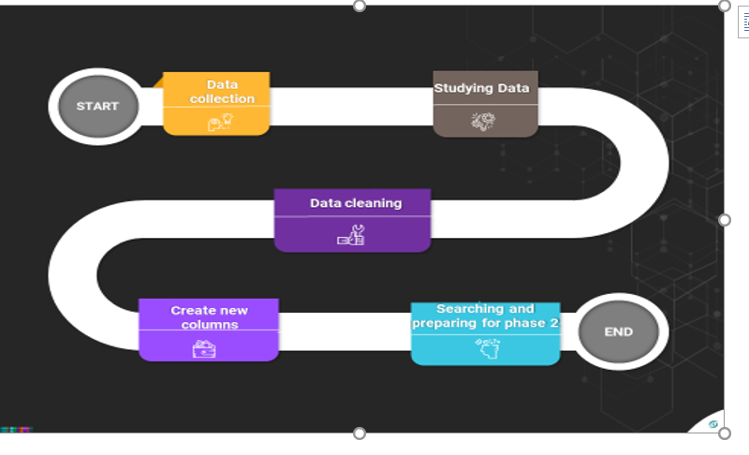

**Chapter 2: Our Work (What we did ) :**

**2.1 Overview of project :**

We used EOQ and ROP Model to get the optimal quantity to order and the when to make and

EOQ helps in minimizing total inventory costs by determining the optimal order quantity, balancing holding costs and ordering costs. ROP ensures that inventory is replenished at the right time, minimizing stock outs and the associated costs of lost sales or rush orders and EOQ ensures that inventory levels are optimized, preventing overstocking or understocking situations. EOQ provides a systematic approach to ordering by determining the optimal order quantity based on economic principles. This streamlines the ordering process and reduces administrative overhead associated with frequent or irregular ordering. This leads to efficient utilization of warehouse space and working capital ROP helps in optimizing inventory levels by ensuring that inventory is replenished only when needed. This prevents excessive inventory buildup, reduces holding costs, and maximizes the efficient use of warehouse space Setting the ROP helps in avoiding overstocking situations where excess inventory accumulates. By maintaining a balance between demand and inventory levels, businesses can minimize the costs associated with excess inventory, such as storage costs, obsolescence, and depreciation EOQ provides a systematic approach to ordering by determining the optimal order quantity based on economic principles. This streamlines the ordering process and reduces administrative overhead associated with frequent or irregular ordering.

ROP allows businesses to adjust the level of safety stock based on factors such as demand variability, lead time uncertainty, and service level requirements. This flexibility enables businesses to adapt their inventory management strategies

Overall, the combined use of EOQ and ROP leads to improved efficiency, cost savings, and better customer service in inventory management.

**2.2 Project map :**

1 - Data collection

2- Data Preparation

3- Data cleaning

4- Apply EOQ model and Reorder Point model on data.

5- Data visualization

**Chapter 3: Our Data :**

We focused on the products of, which are: Steel Flat Plate. RECTANGULAR BOXES, PIPES, SQUARE BOXES and Beams In this chapter, we will deal with data since its acquisition, but at the beginning we will present these products.

**3.1 Data Collection**

We collected our data from from sheets of EL-ASHRY company from the exports and imports sheets.

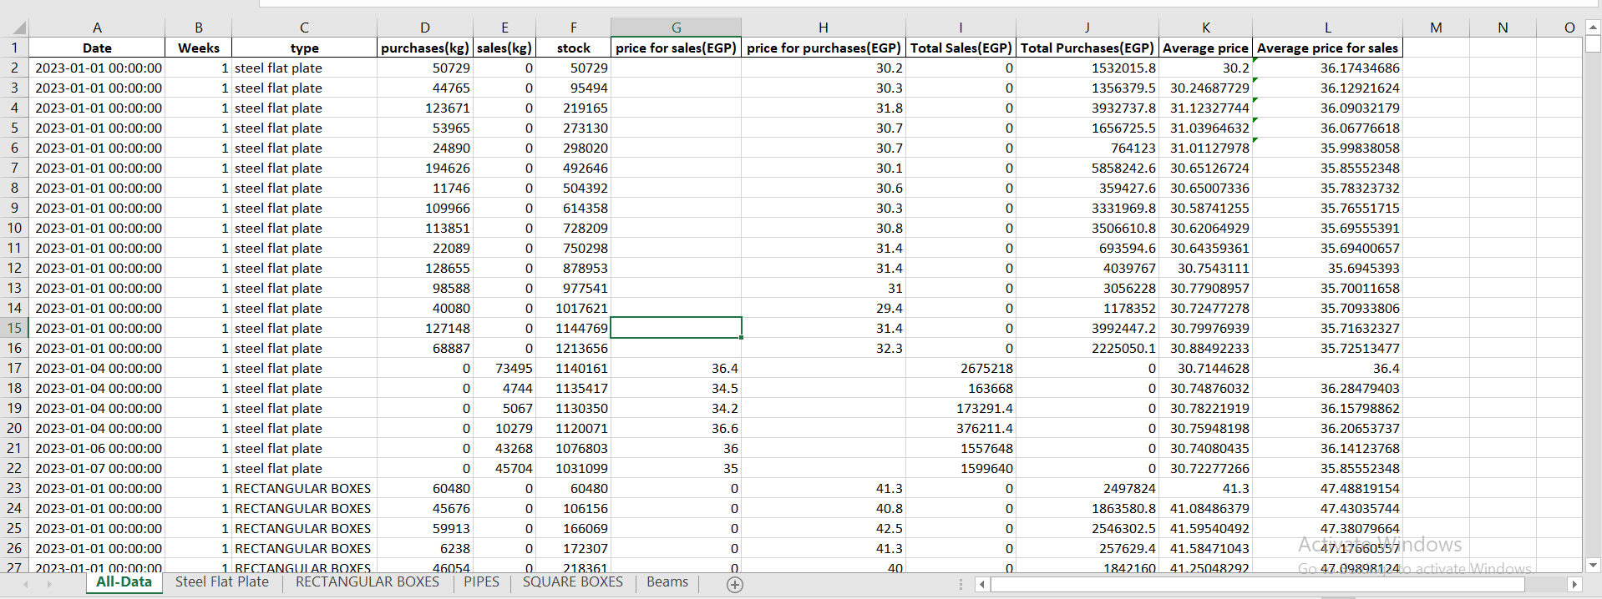

**3.2 Data cleaning :**

* Extract the Data from ERP system
* Cleaned the data and remove redundant data and columns
* create new column named stock = sum of purchases per month - sum of sales per month
* Calculate new column total sales = sale(kg) * price(of sales)
* Calculate new column total purchase = purchase(kg) * price of (purchase)
* We calculated holding cost 0.3* (sum of purchases (kg) + sum of stock) per week in the inventory
* We calculated order cost 0.07*Sum of purchases (Kg)* Purchase price per unit

**Beams** :

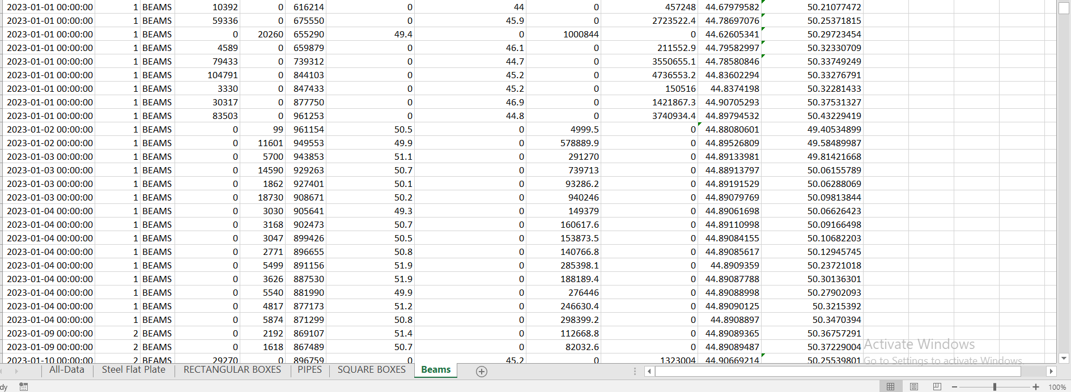

**Steel-flate-plates :**

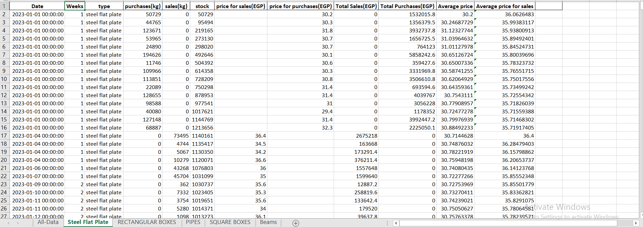

**PIPES :**

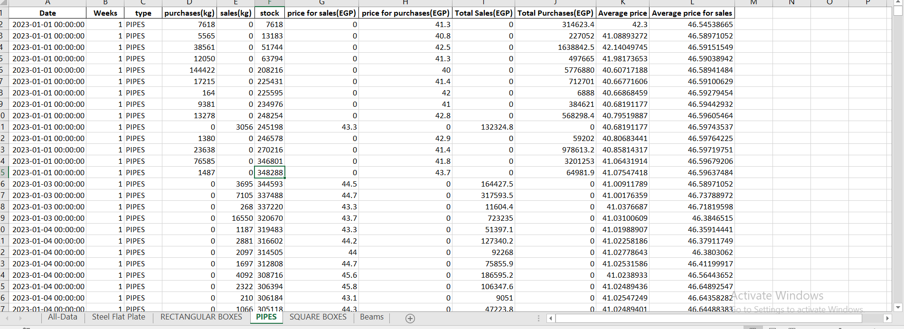

**SQUARE BOXES :**

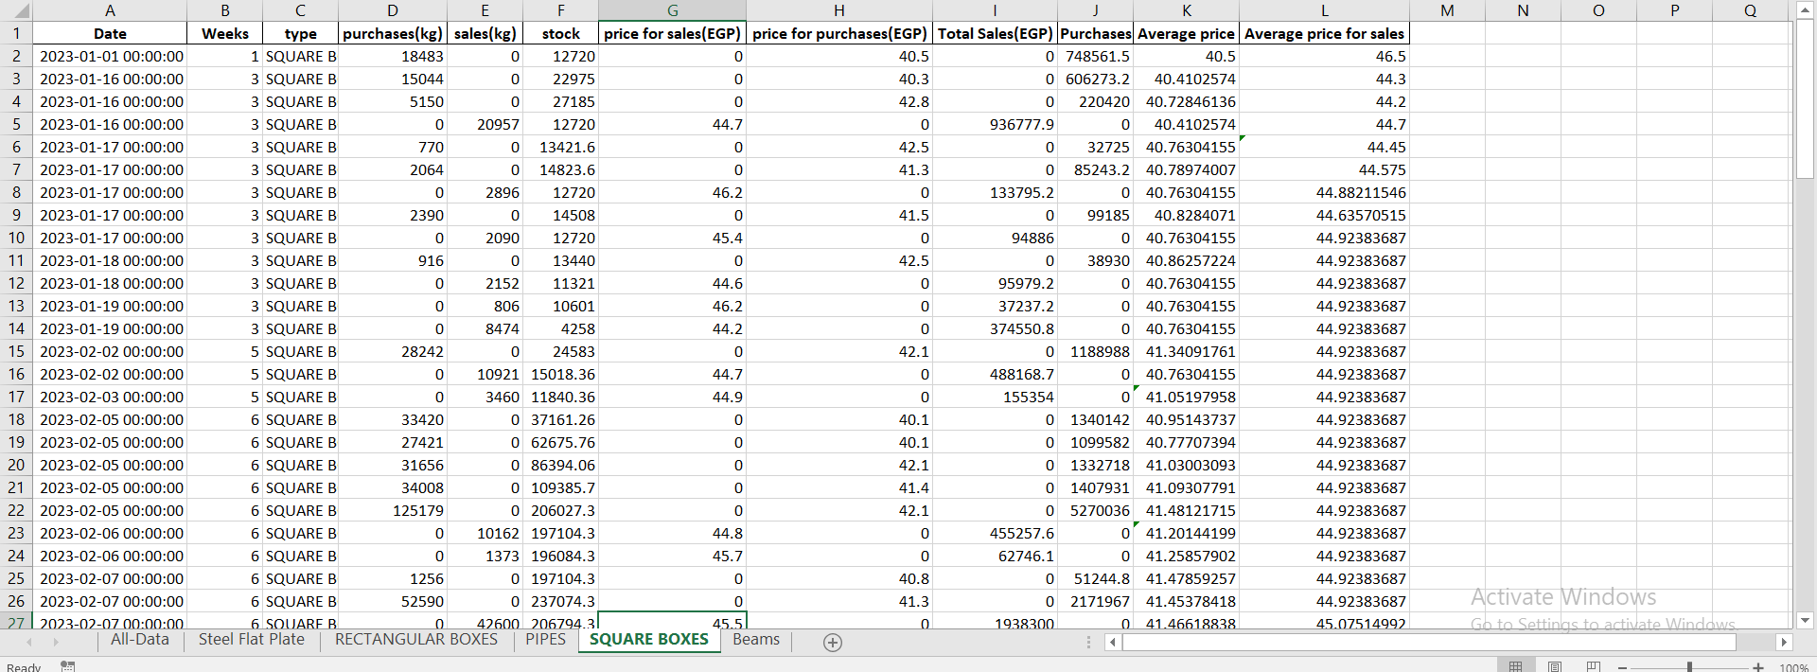

**RECTANGULAR BOXES:**

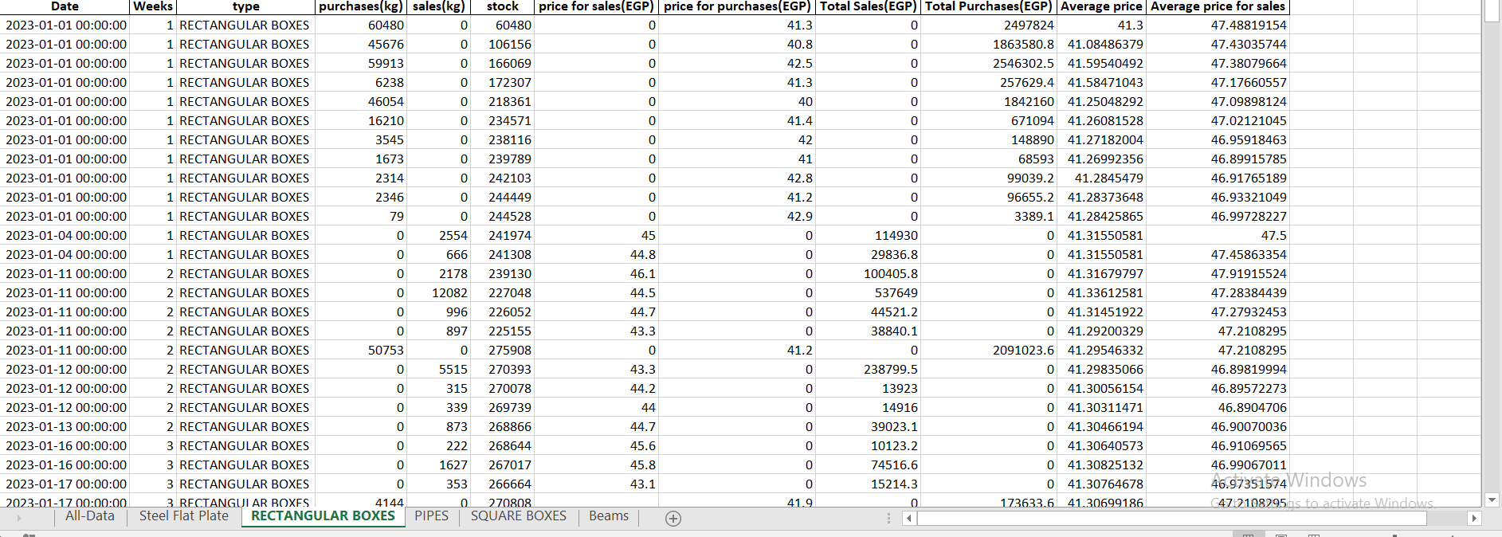

4.0 **Model Implementation ( Using python ) :**

4.1 **EOQ and ROP :**

Many companies overlook the benefits of basic inventory models, often relying on software packages for inventory control. However, inaccurate data entry can lead to subpar results, undermining the effectiveness of inventory models like the Economic Order Quantity (EOQ). Without precise inputs such as product costs, activity costs, forecasts, history, and lead times, companies struggle to derive meaningful insights from these models. Additionally, some companies refrain from utilizing EOQ due to a lack of understanding of its mechanics. Even when employing sophisticated software, relying solely on default settings can exacerbate issues rather than mitigate them. To regain control, companies must grasp the fundamental concepts of EOQ and recognize that software packages are tools to assist, not replace traditional methods. The EOQ formula, originating from disciplines like engineering and business, offers valuable insights into cost tradeoffs and inventory management, yet its applicability is often overlooked or misunderstood, particularly in industries like retail and manufacturing. Therefore, a deeper understanding of EOQ and its principles is essential for optimizing inventory management practices.

Q = economic order quantity

D= the annual demand of product in quantity per unit time

S = Order cost

H = Holding Cost

Another critical aspect of inventory management alongside EOQ is the calculation of the reorder point (ROP) and safety stock. The reorder point signifies the inventory level at which a new order should be initiated to replenish stock, while the safety stock represents an additional buffer to guard against stockouts or delays. Determining the reorder point necessitates consideration of three key factors:

1. Demand: This refers to the daily usage or sales volume of inventory.
2. Lead time: The duration, measured in days, required for an order to be fulfilled from the moment it is placed.
3. Reorder point is calculated by:
4. Reorder Point=(AVG-Demand- / week) *Lead-time

* 1. **Model on Data :**

**4.2.1) Frist we read the data for every sheet on python**

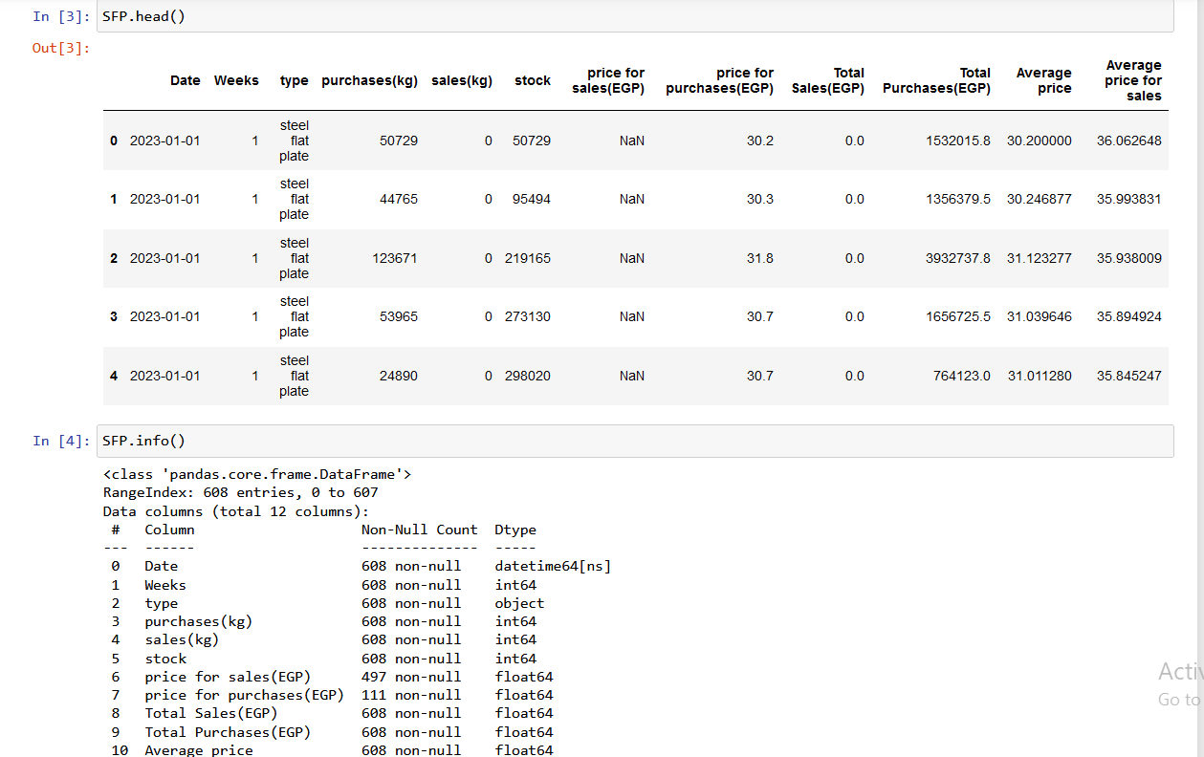

**4.2.2)We calculated average price for purchase for each type**

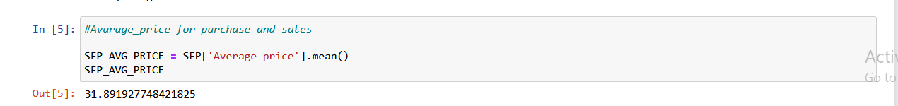 Steel Flat Plate = 31.98

RECTANGULAR BOXES =41.58242458529777

SQUARE BOXES = 41.371621372307104

BEAMS = 45.27848585763299

PIPES = 41.28665747264758

**4.2.3)We calculated average price for sales for each type**



Steel flat plate= 37.7

RECTANGULAR BOXES = 47.01065320128353

SQUARE BOXES = 45.14100454662087

BEAMS = 51.07871239160648

PIPES = 47.009084904726265

**4.2.4)We calculated average quantity per order for s each type**

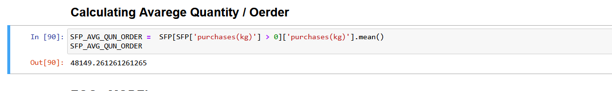

Steel flat plate= 48149.261261261265

RECTANGULAR BOXES = 19354.21686746988

SQUARE BOXES = 22221.58620689655

BEAMS = 20916.91605839416

PIPES = 8922.782258064517

4.2.5)We calculated Average order cost for each type

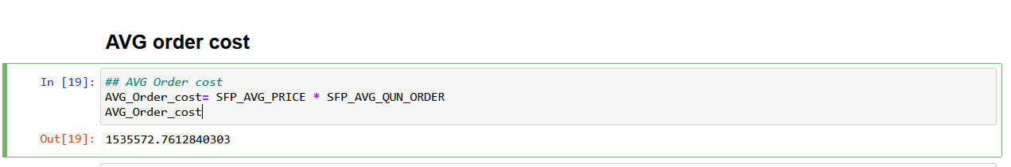

Steel flat plate= 1535572.7612840303

RECTANGULAR BOXES = 804795.2632990644

SQUARE BOXES = 919343.0508438061

BEAMS = 947086.2879352963

PIPES = 368391.8547917267

4.2.6)

We calculated Order cost for each product by calculating

Order-percentage = 0.07 * total-order-cost

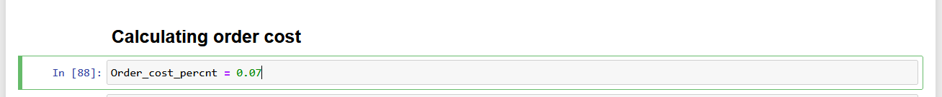

Steel flat plate= 107490.09328988213

RECTANGULAR BOXES = 56335.66843093451

SQUARE BOXES = 64354.013559066436

BEAMS = 66296.04015547075

PIPES = 25787.42983542087

**4.2.7)Calculate shortage cost per unit for each product** :

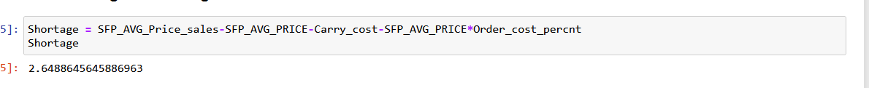

Steel flat plate = 2.6

RECTANGULAR BOXES = 2.2155

SQUARE BOXES = 2.33

BEAMS = 1.67

PIPES = 2.53

**4.2.8)EOQ-Model-Implementation :**

Steel flat plate :

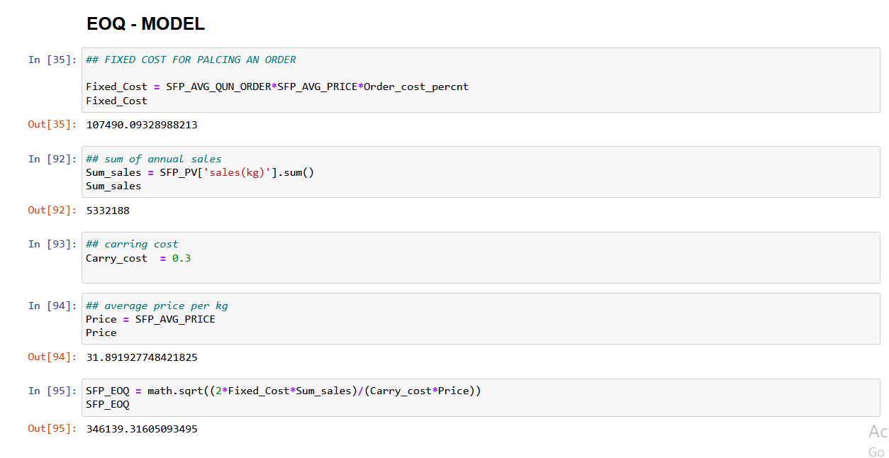

RECTANGULAR BOXES :

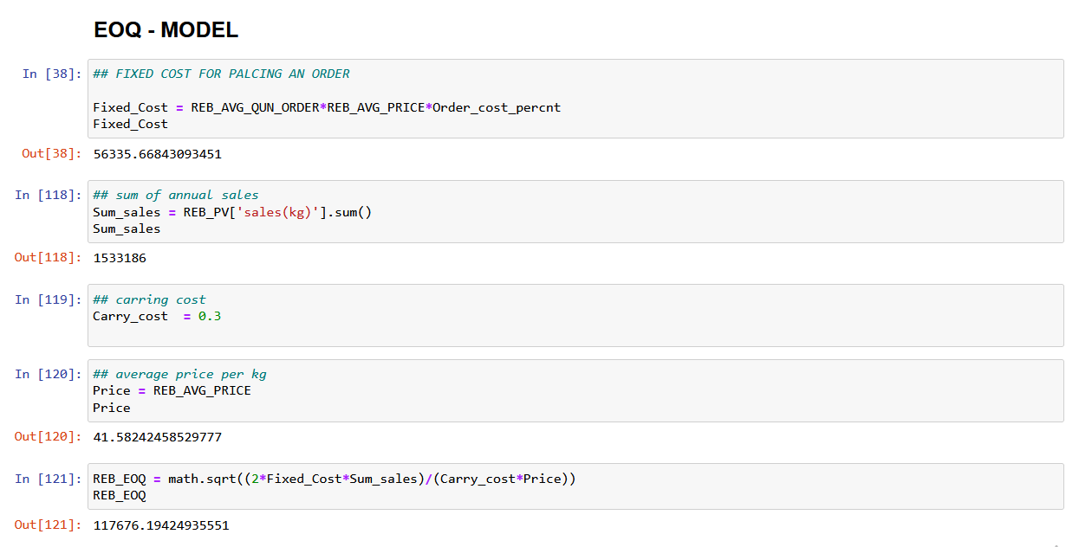

SQUARE BOXES :

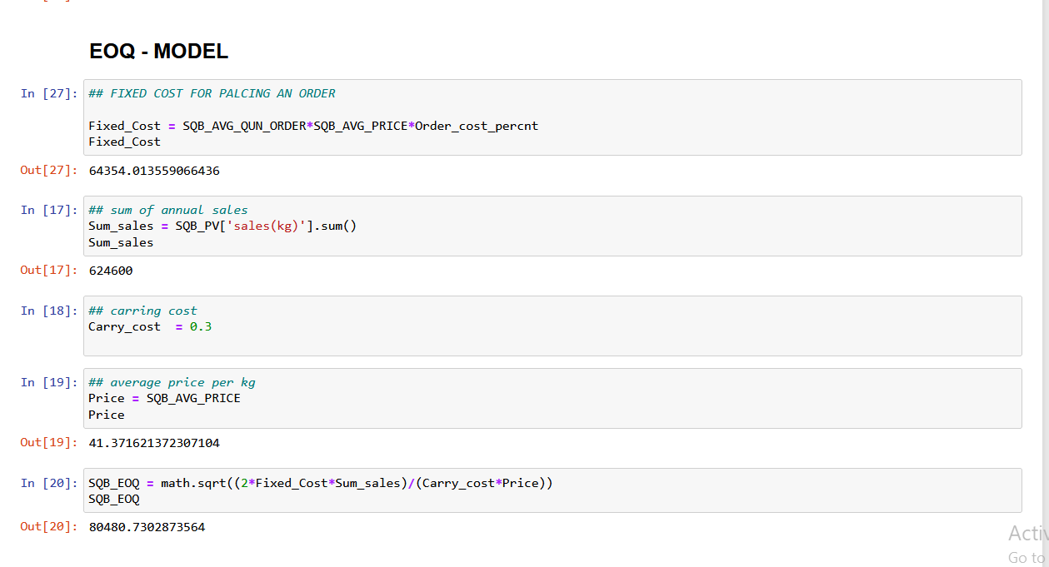

BEAMS :

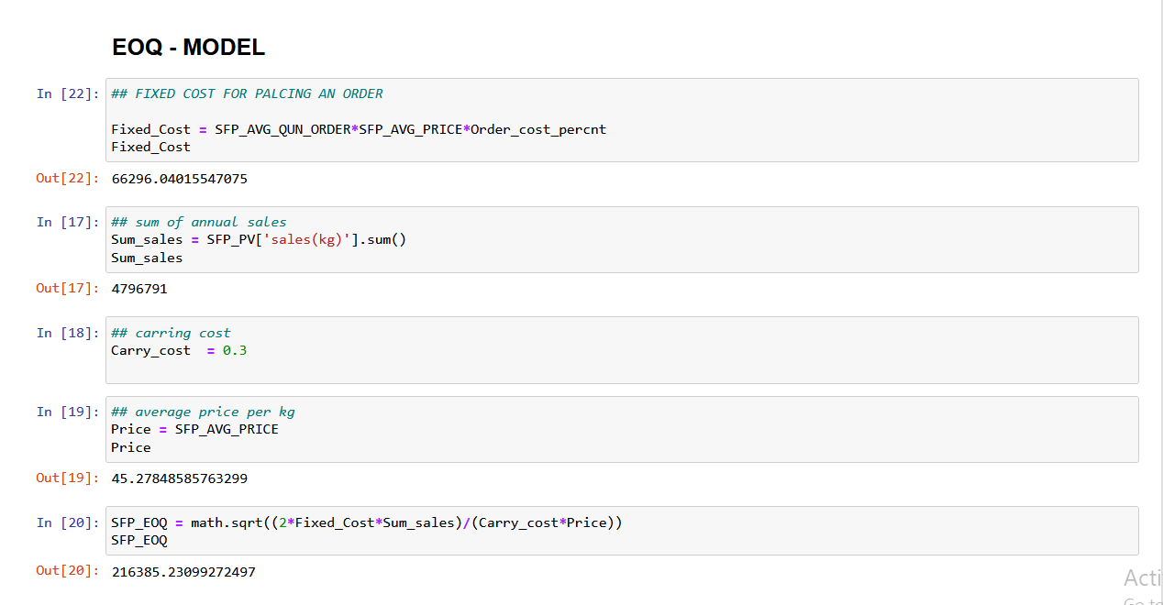

PIPES :

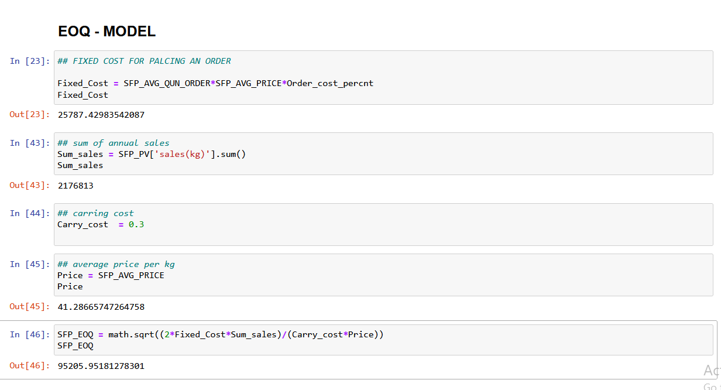

**EOQ – for each type :**

Steel flat plate = 346139.31605093495

RECTANGULAR BOXES = 117676.19424935551

SQUARE BOXES = 80480.7302873564

BEAMS = 216385.23099272497

PIPES = 95205.95181278301

**4.2.9)Calculate Re-order-point for each type :**

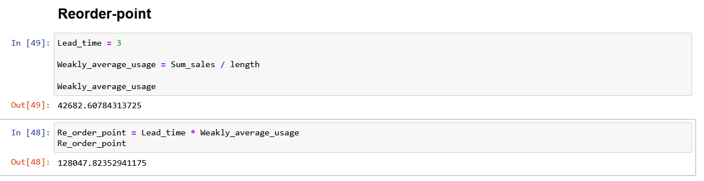

**ROP FOR EACH TYPE:**

Steel flat plate = 313658.1176470588

RECTANGULAR BOXES = 99990.39130434782

SQUARE BOXES = 60445.161290322576

BEAMS = 282164.17647058825

PIPES = 128047.82352941175

**4.2.10) We made pivot table using python by weeks for sum of sales and purchase**   
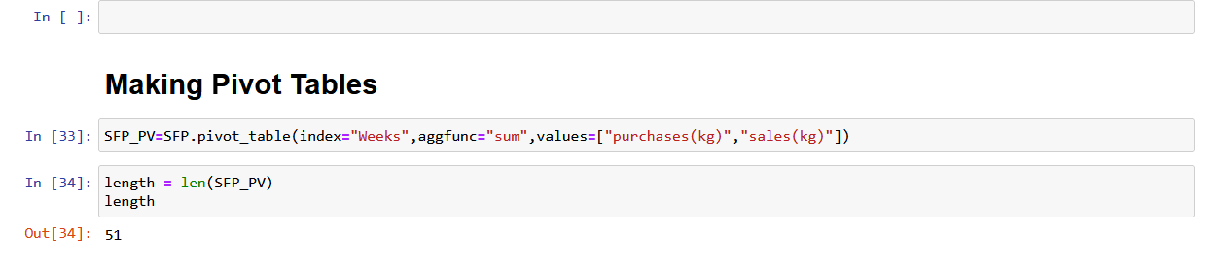  
**4.2.11) Calculate stock for each week :**

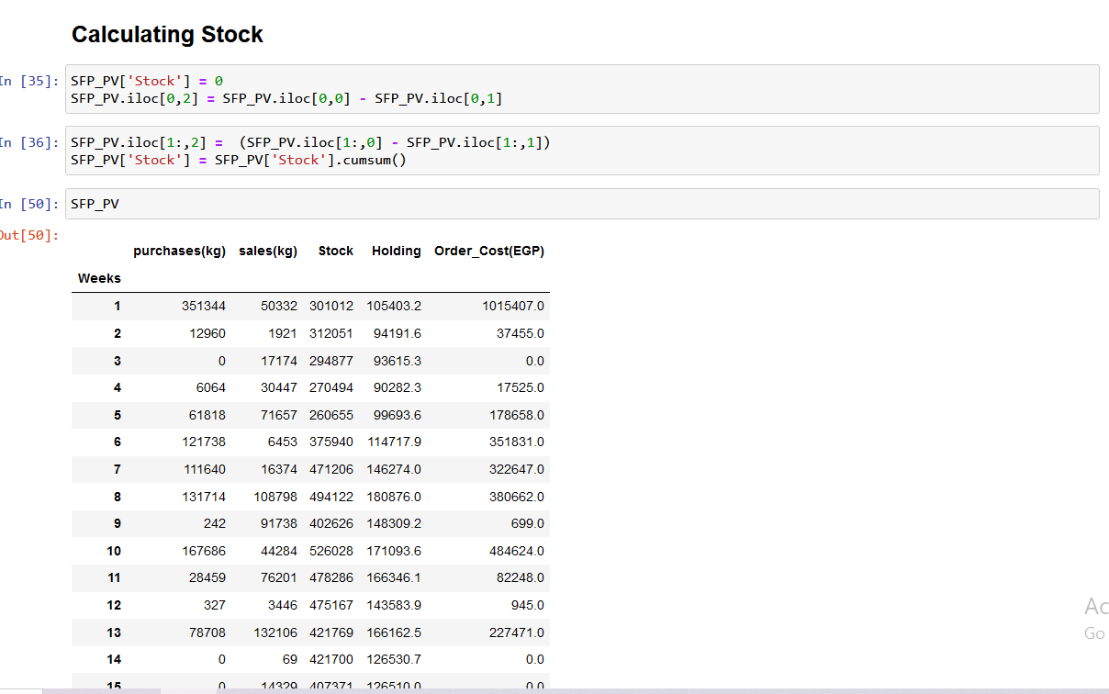

**4.2.12) Calculate holding cost for every week for each type : carrying cost = 0.3**

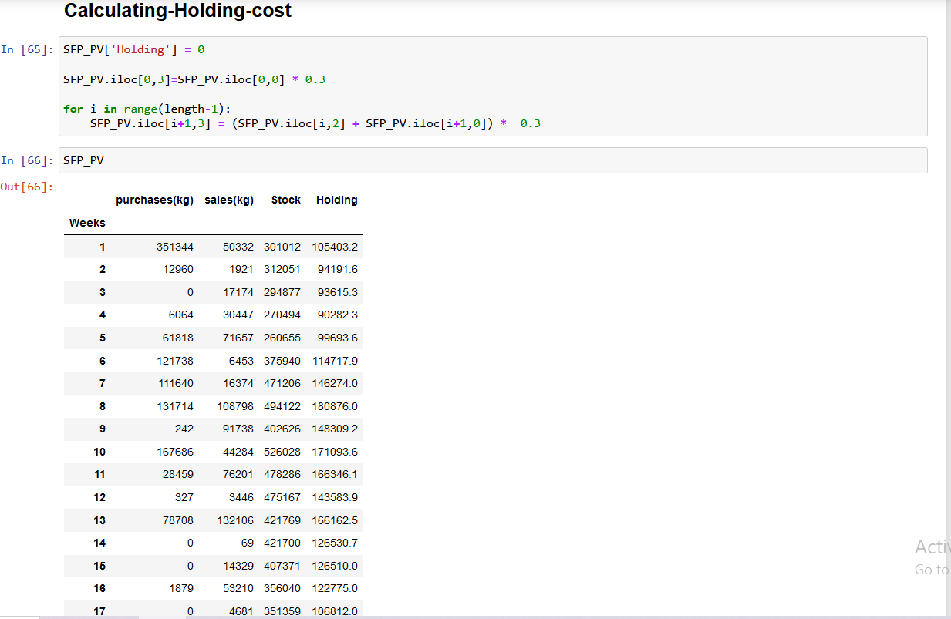

**4.2.13) Calculate holding cost for every week for each type : purchase_each_week * 0.07 * avg-order-price**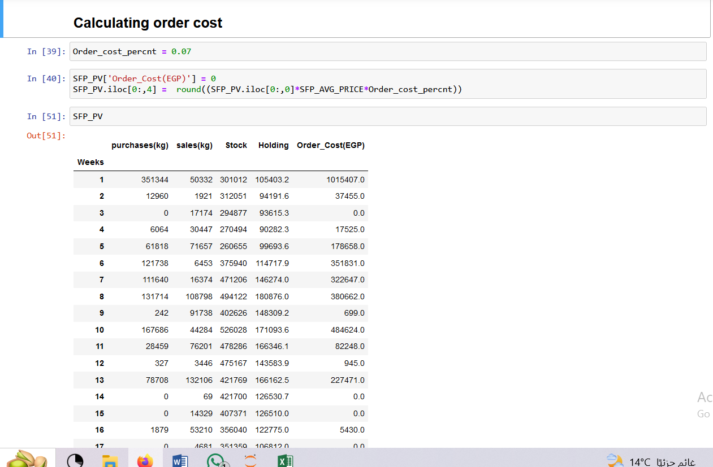

**4.2.14) Calculating and EOQ for purchase New-stock :**

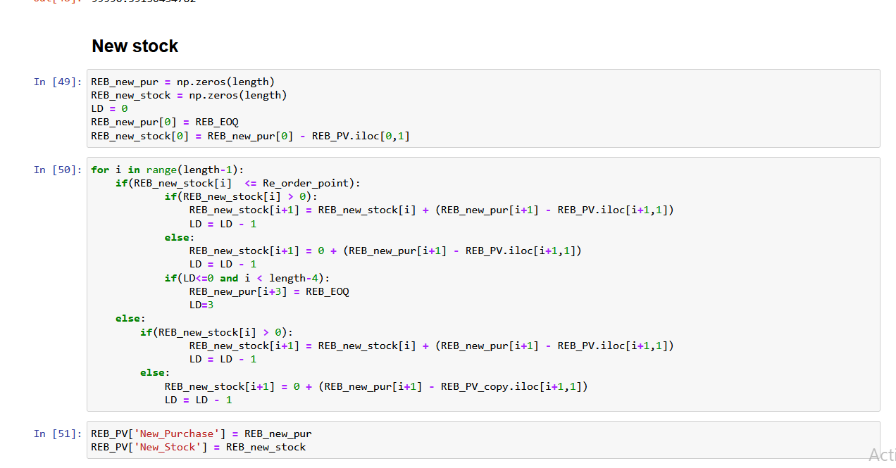

Steel flat plate :

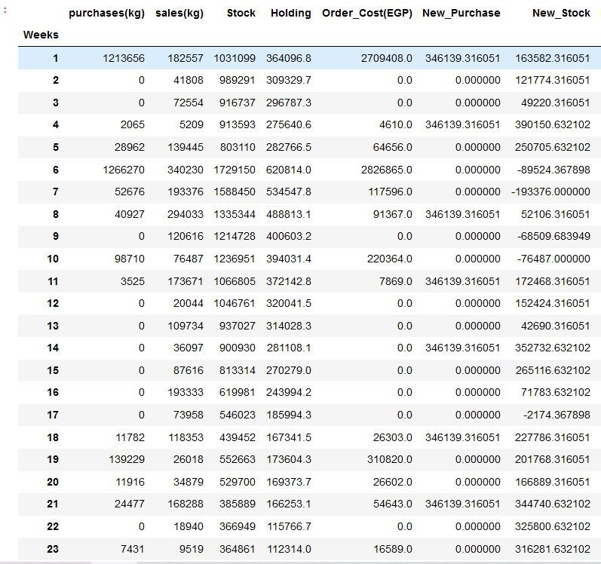

Rectangle-boxes :

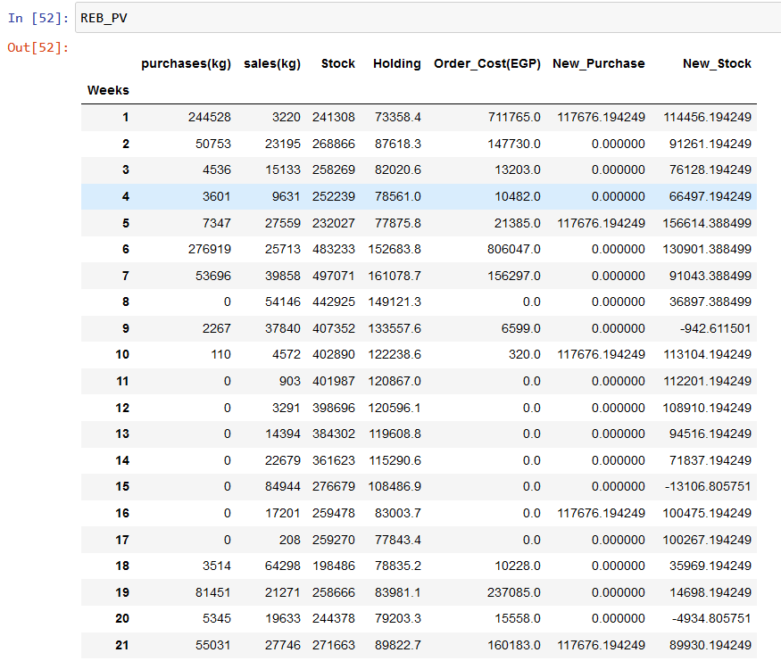

Square-Boxes :

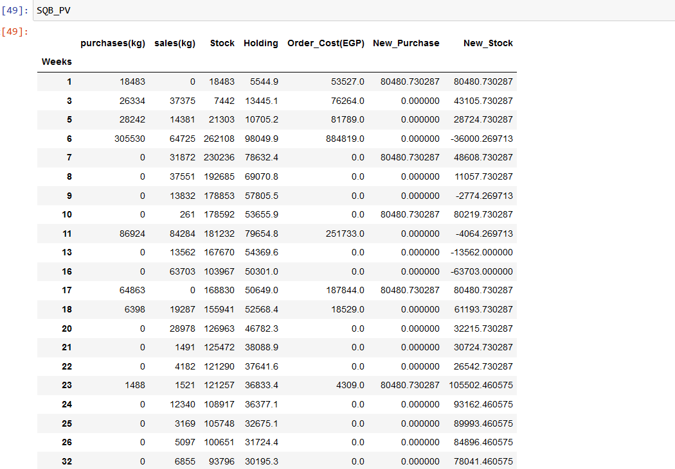

Beams : 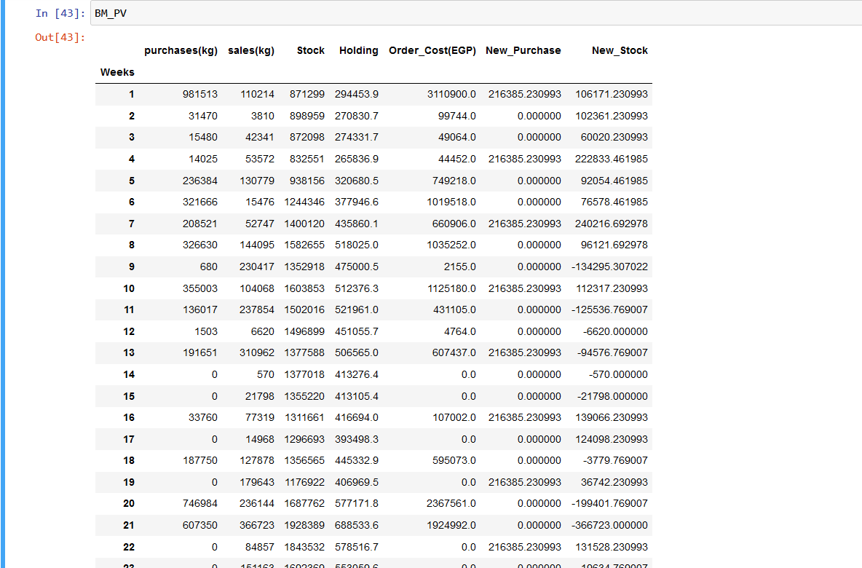

PIPES :

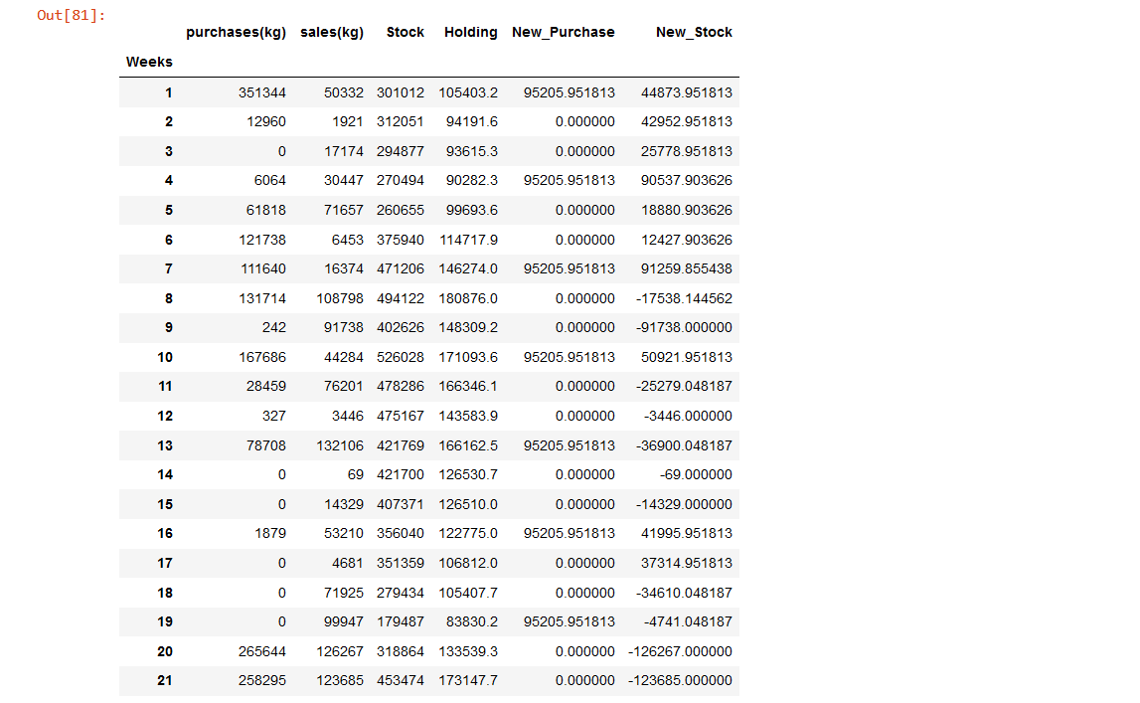

**4.2.15 ) calculating Holding cost for stock after EOQ :**

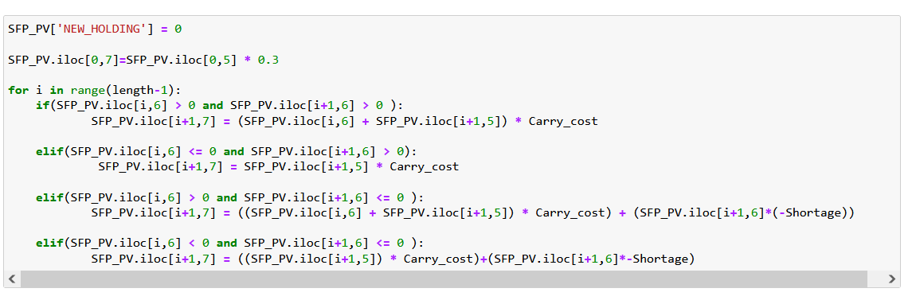

**4.2.16) calculating order cost for stock after EOQ :**

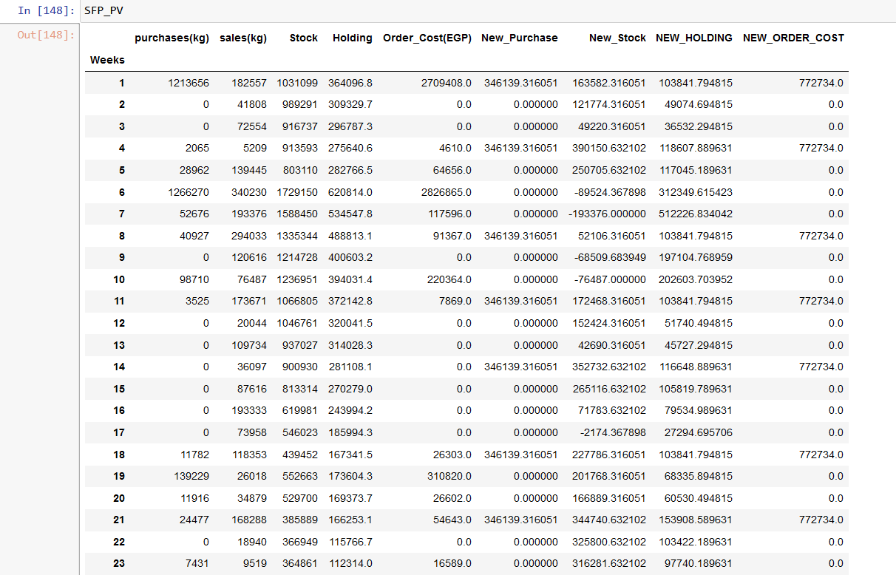

**4.2.17) Calculating-cost-after and before EOQ :**

**4.2.18 ) Holding and order cost Before EOQ :**



Steel flat plate= 26840189.3

RECTANGULAR BOXES = 10231224

SQUARE BOXES = 3049488.599

BEAMS = 39703570.59

PIPES = 10204658.8

**4.2.19 ) Holding and order cost After EOQ :**

  
 Steel flat plate = 7334924.287854968

RECTANGULAR BOXES = 5575068.36802

SQUARE BOXES = 2301927.893

BEAMS = 16704879.338

PIPES = 7334924.287854968

**4.2.20) Calculate Saving for each type :**

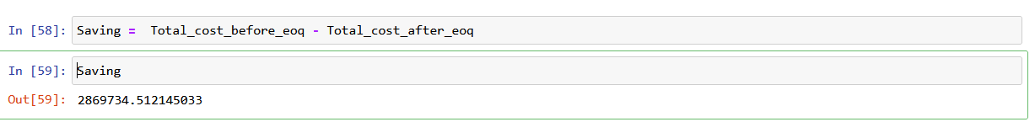

Steel flat plate = 10807433.557745527

RECTANGULAR BOXES = 4656155.9319722075

SQUARE BOXES = 747560.7060287455

BEAMS = 22998691.261

PIPES = 2869734.512145

**4.2.21) We imported the data into excel File :**



**5) Excel –PIVIOT-FILES :**

**5.1) Steel Flat Plate :**

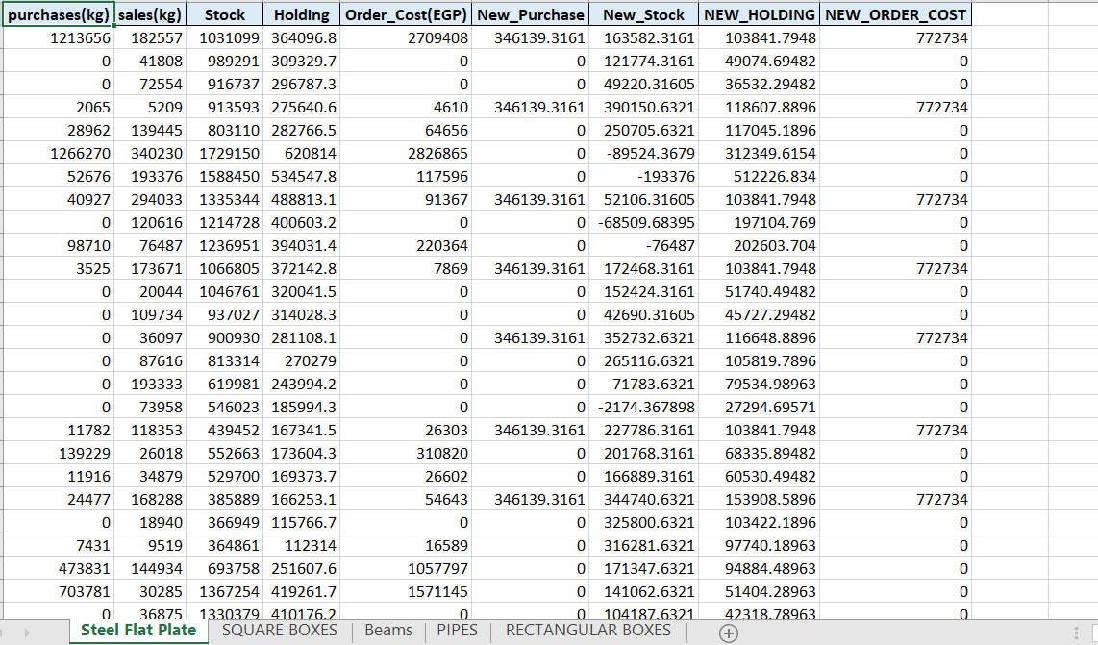

**5.2) SQUARE BOXES :**

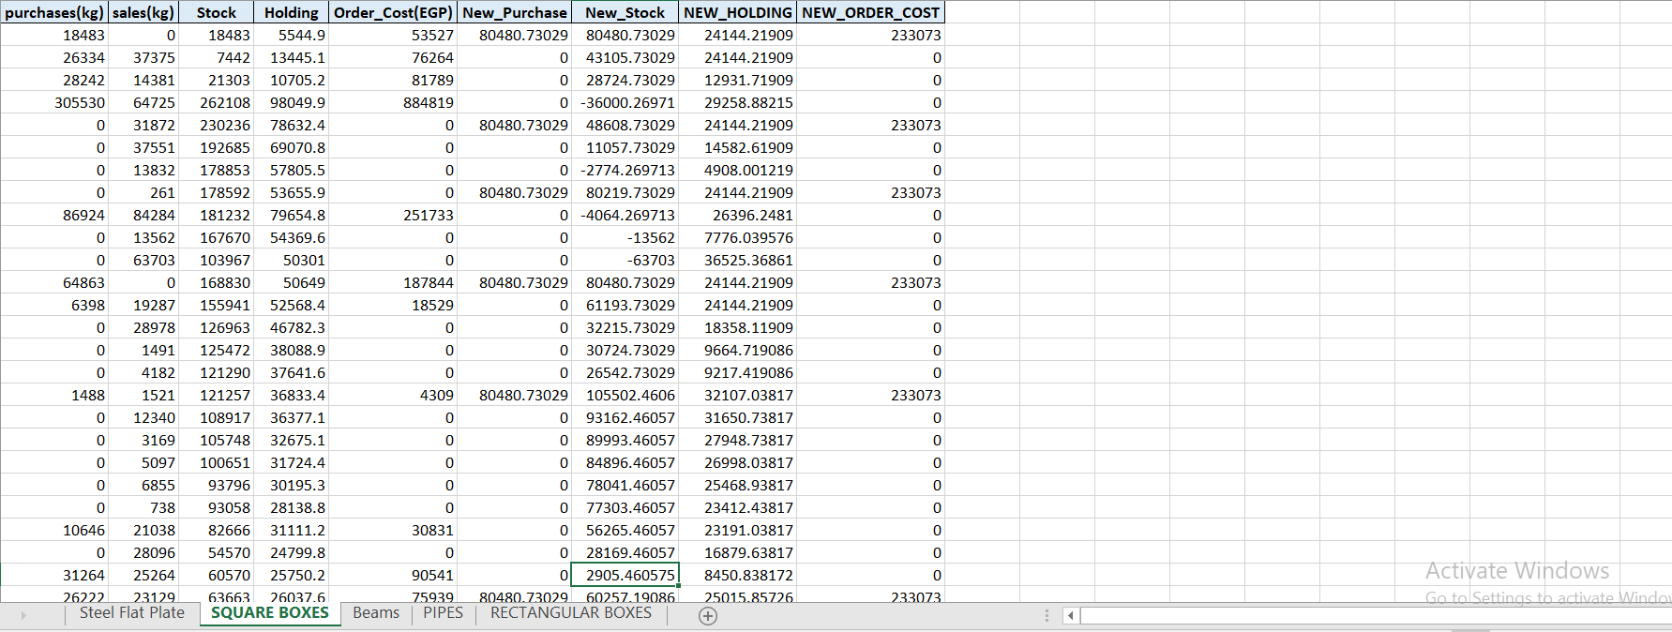

**5.3) BEAMS :**

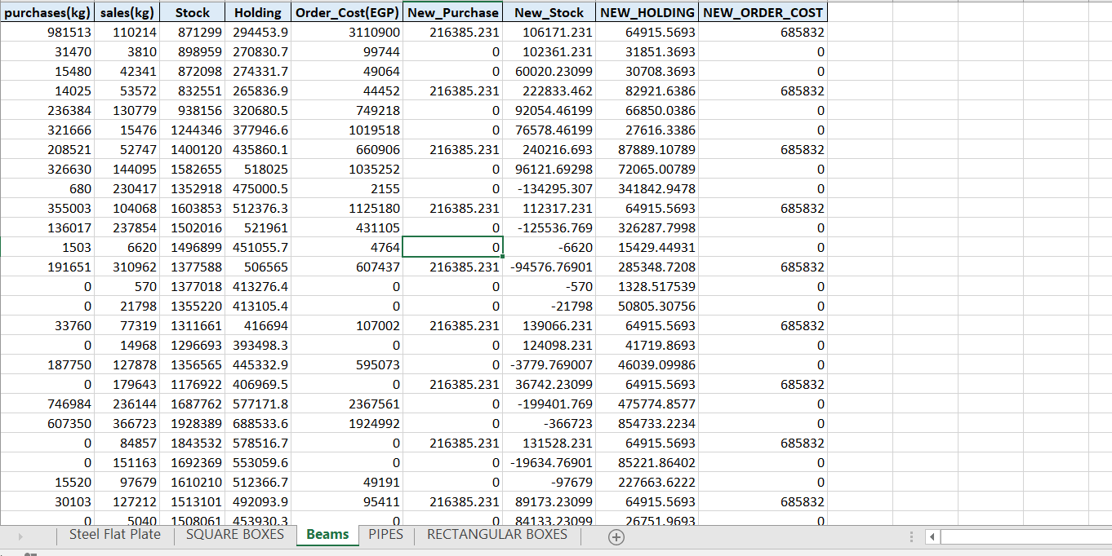

**5.4)PIPES :**

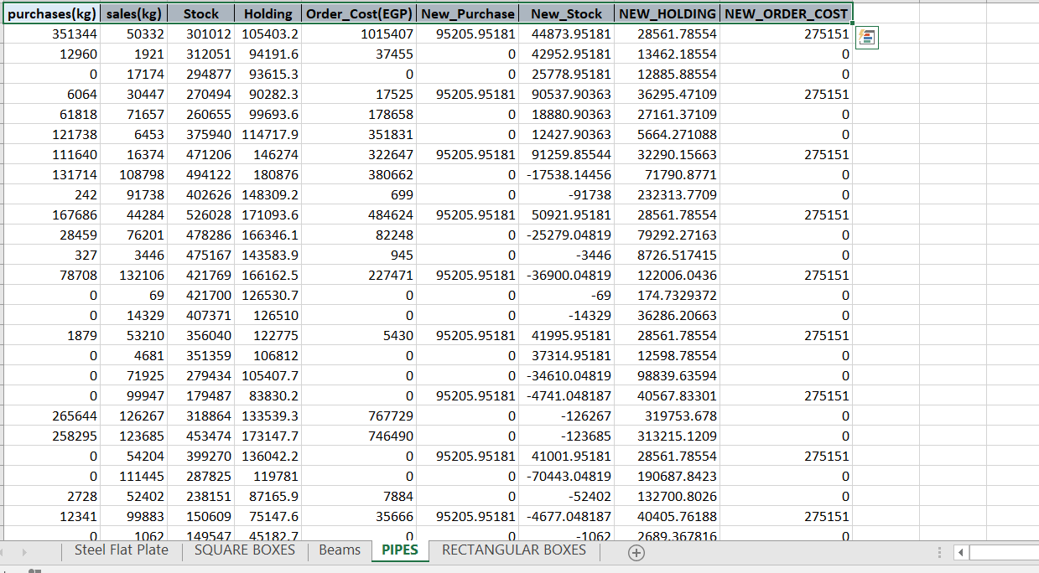

**5.5) RECTANGULAR BOXES :**

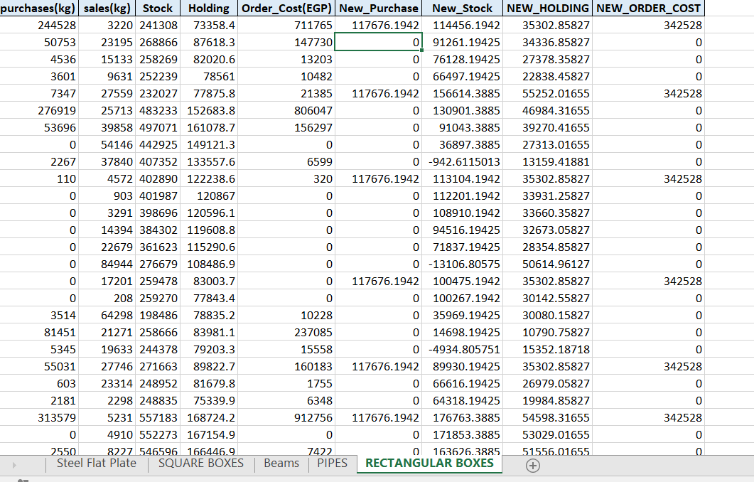

**6) Data Visualization :**

We create some charts to make it easier to see the data before doing any implementation

**6.1) ALL**

**6.1.1) correlation matrix**

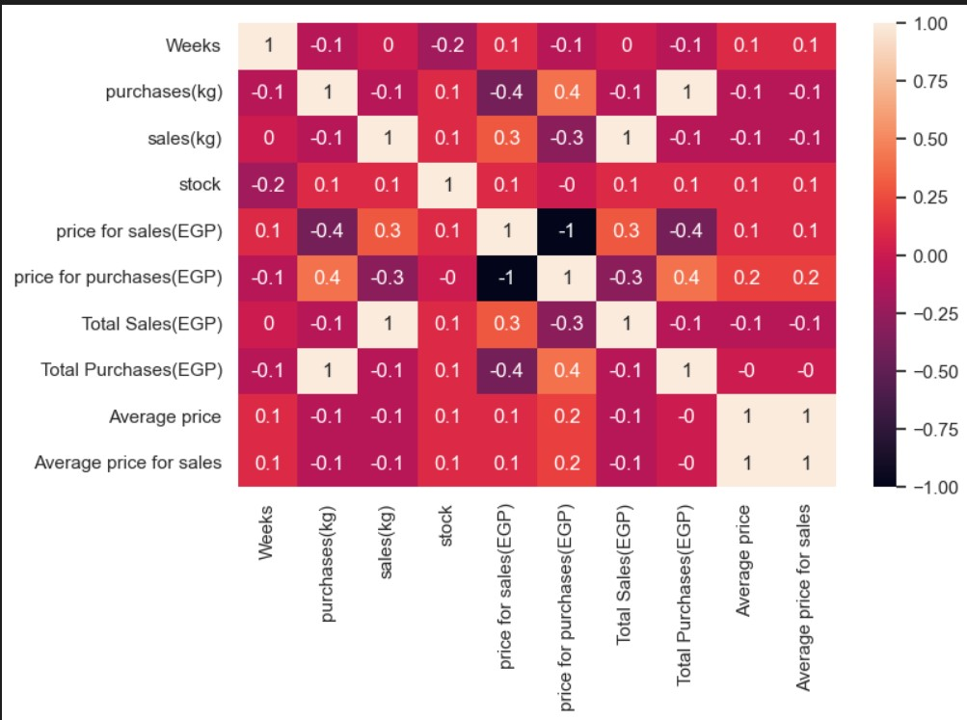**6.1.2) Bar Chart For sales for every type**

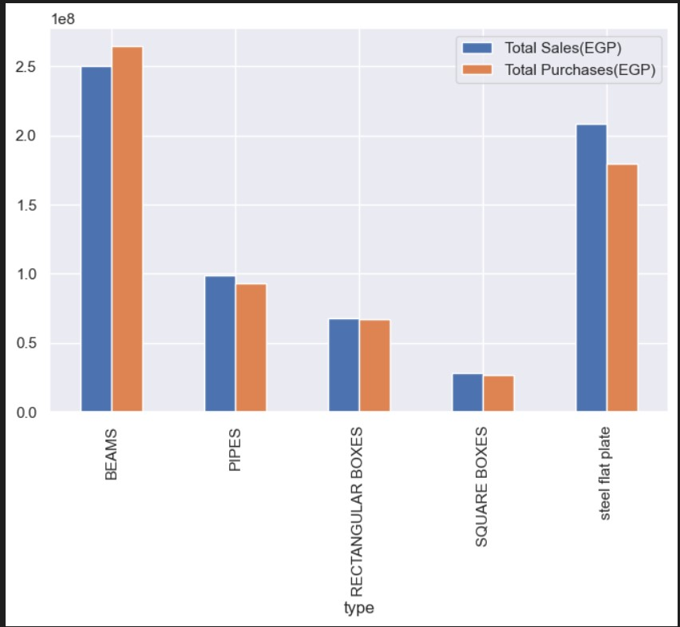

**6.1.3 ) Bar Chart For average price sales for every type**

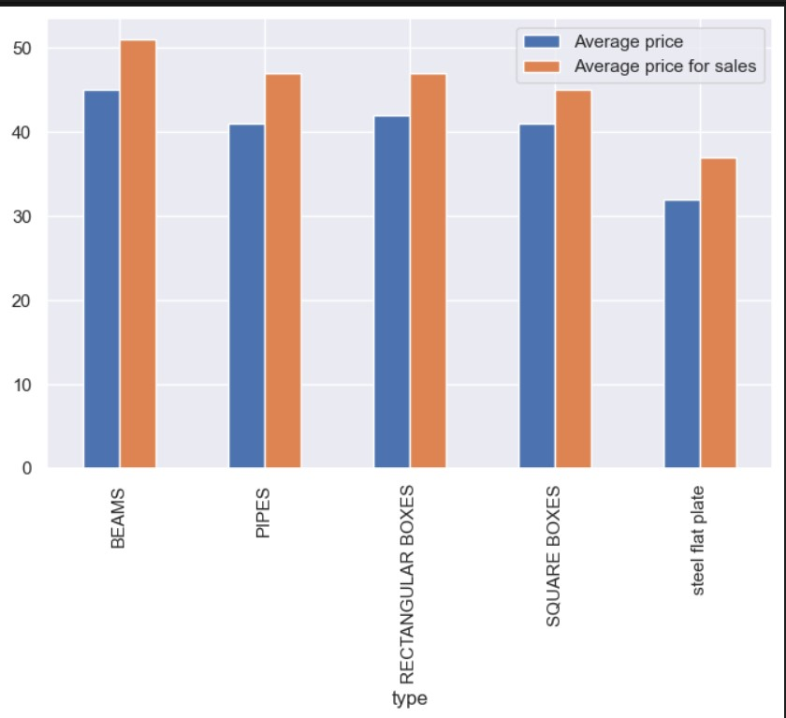

**6.1.4) Pie Chart For sales for every type :**

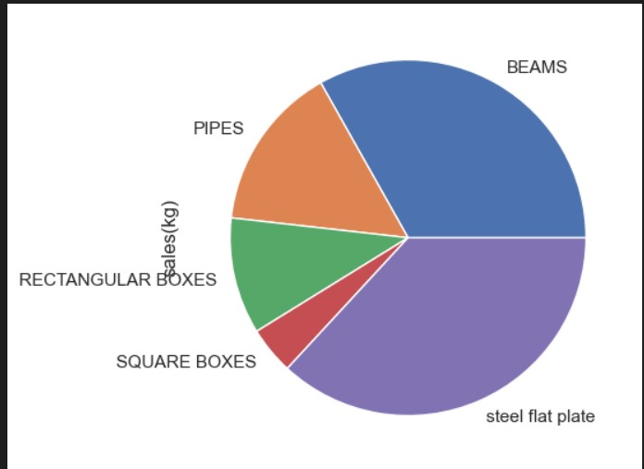

**6.1.5) Box-plot for sales**

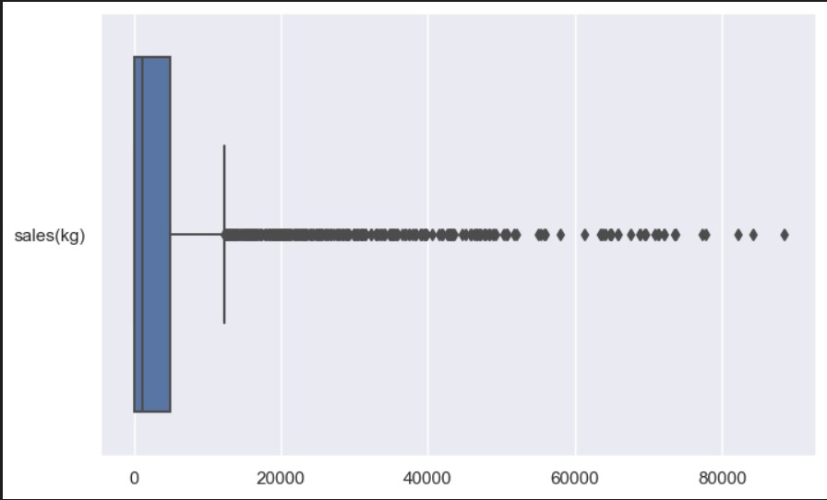

**6.1.6) Box-plot for Purchase :**

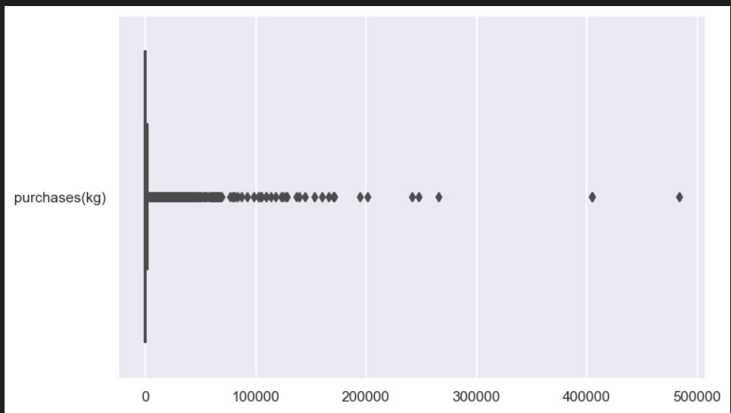

**6.1.7) Sales over time**

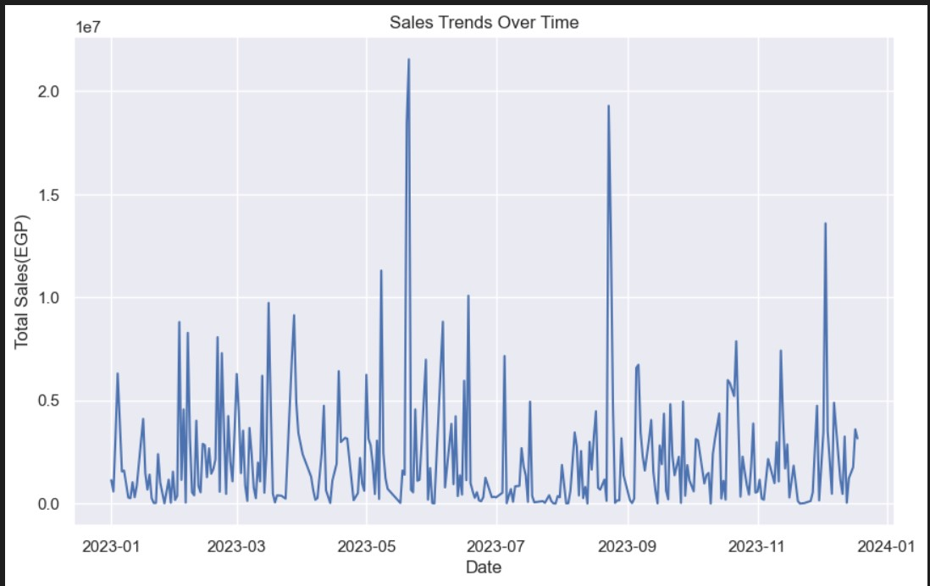

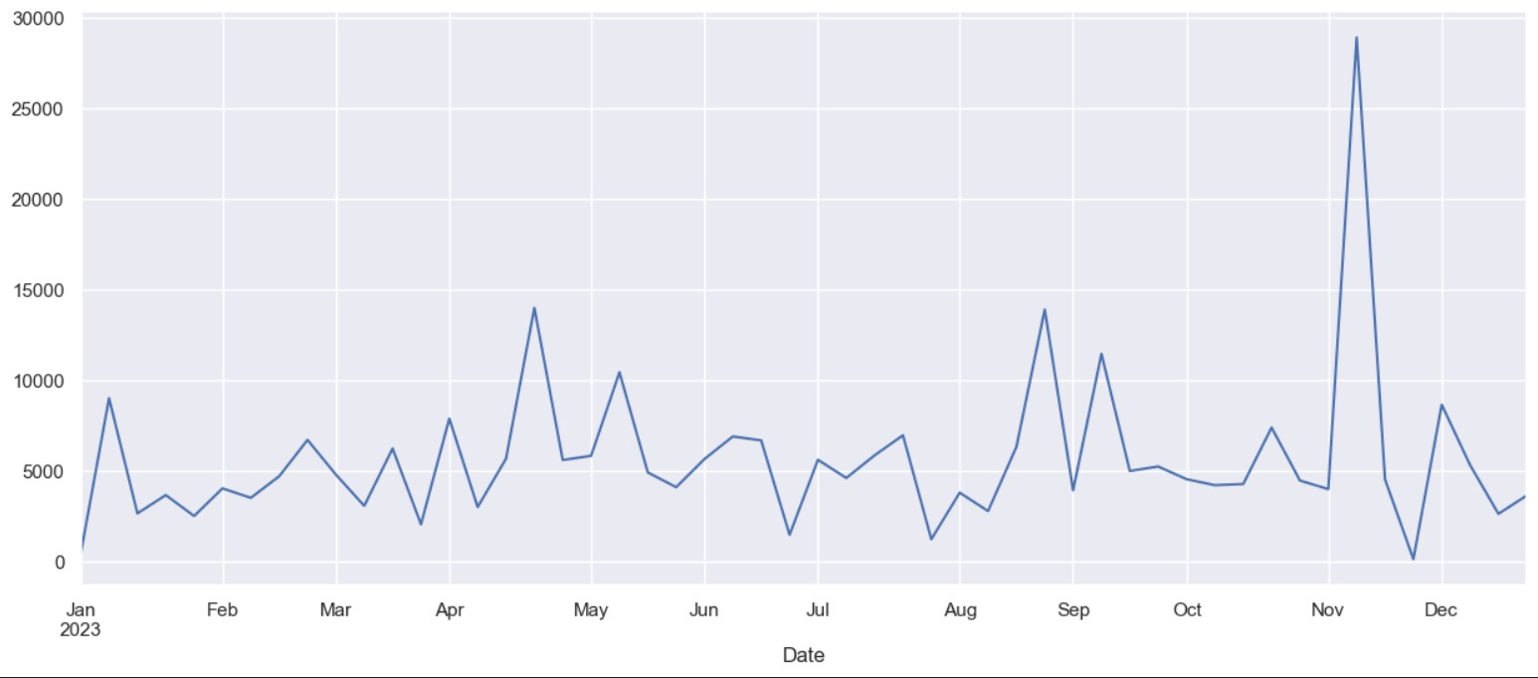

**6.1.8) Purchase over time**

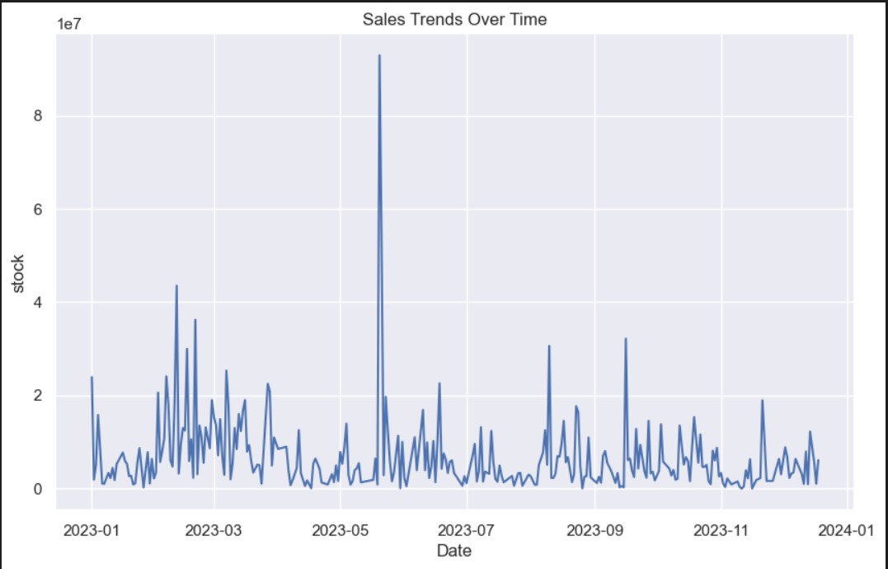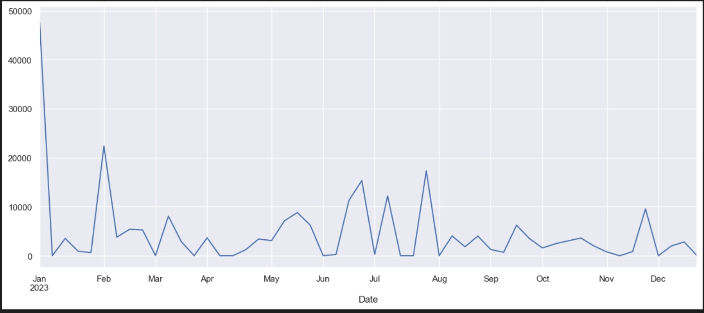

**6.2) Steel flat plate :**

**6.2.1 ) OLD purchase and EOQ over time :**

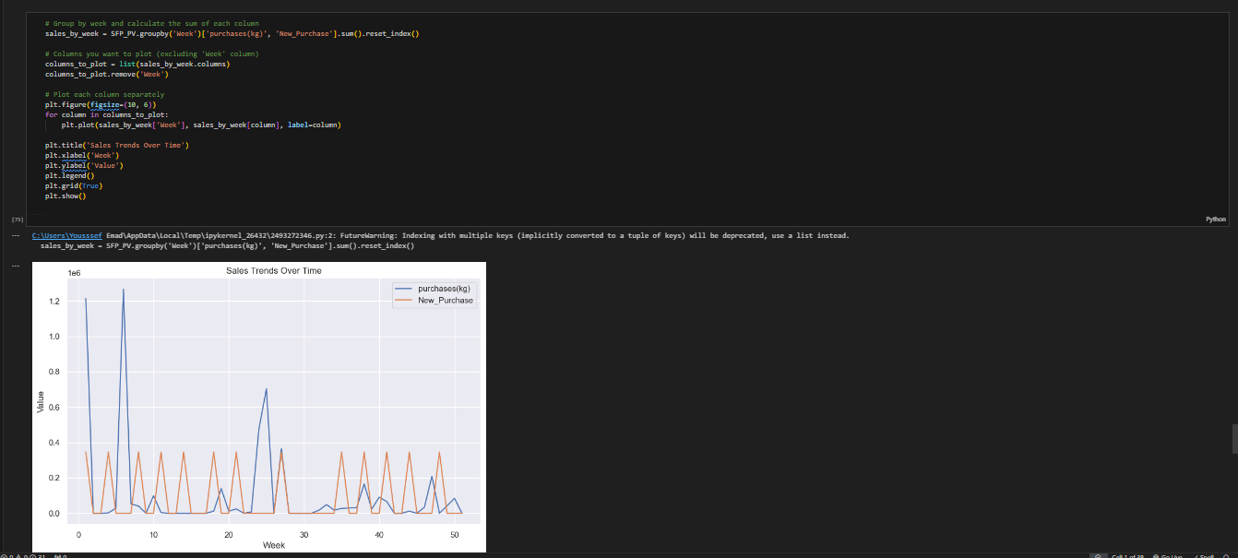

**6.2.2) Holding Cost before and after EOQ:**

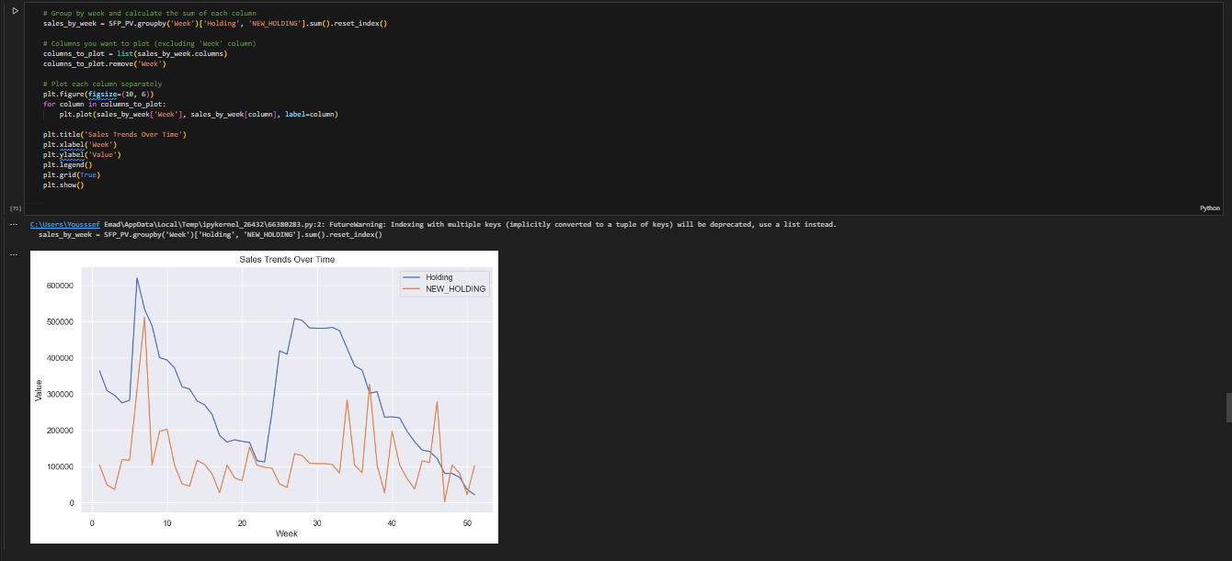

**6.3.1) Stock Cost before and after EOQ:**

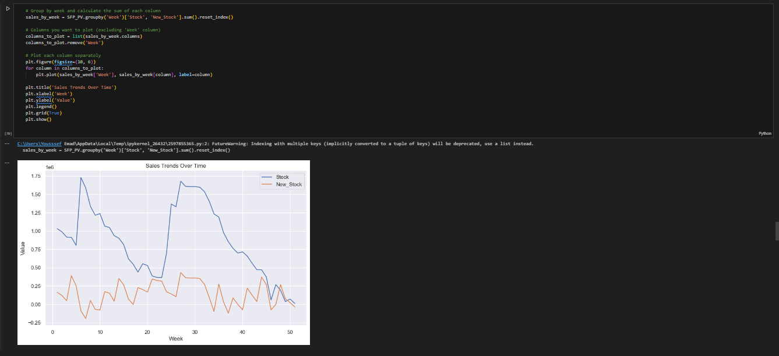

**6.3)** **Square Boxes:**

**6.3.1 ) OLD purchase and EOQ over time**

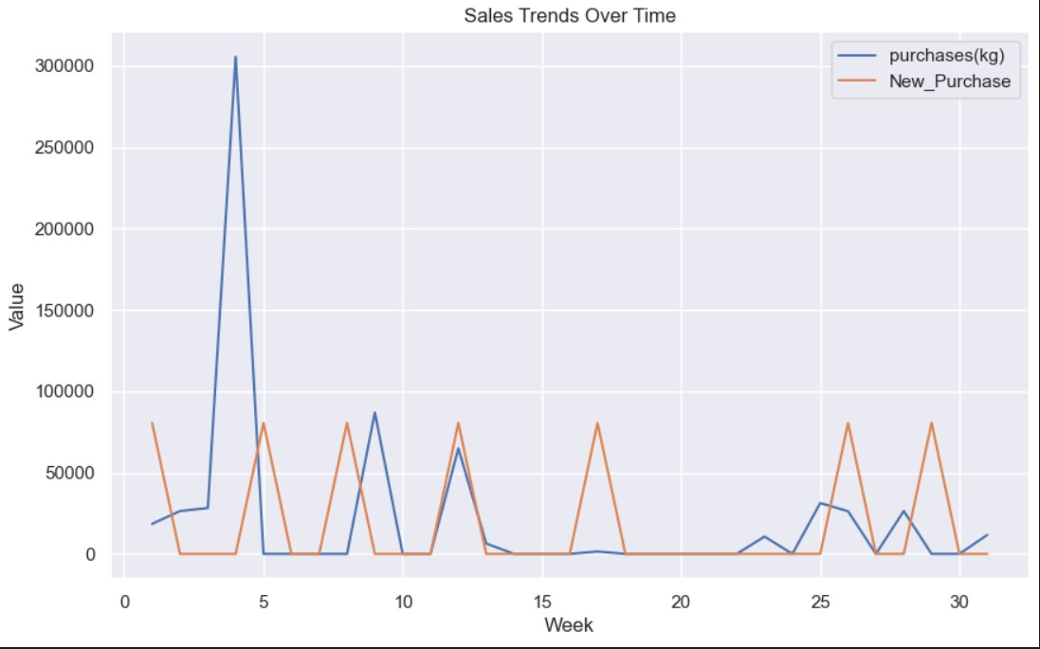

**6.3.2) Holding Cost before and after EOQ:**

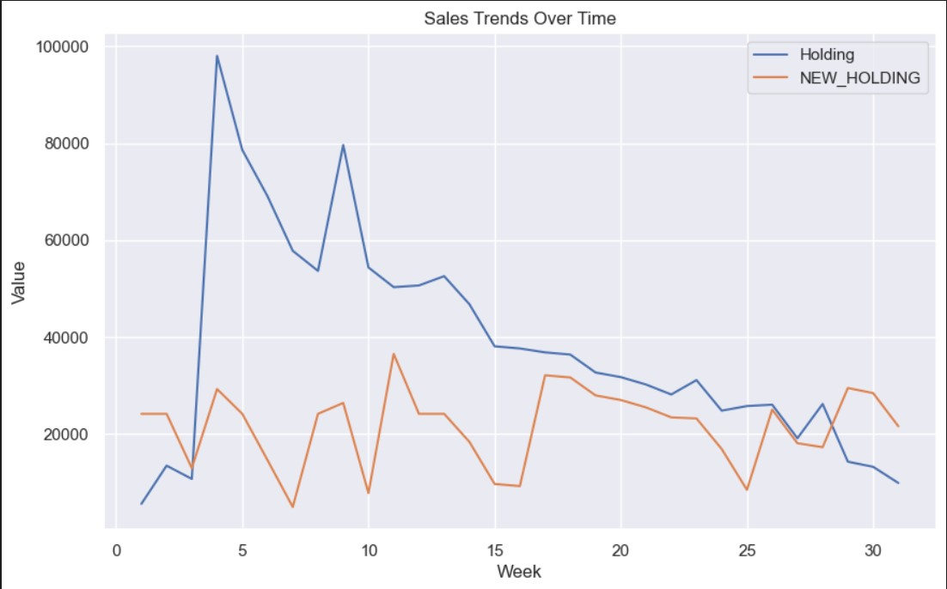

**6.3.3) Stock Cost bfore and after EOQ:**

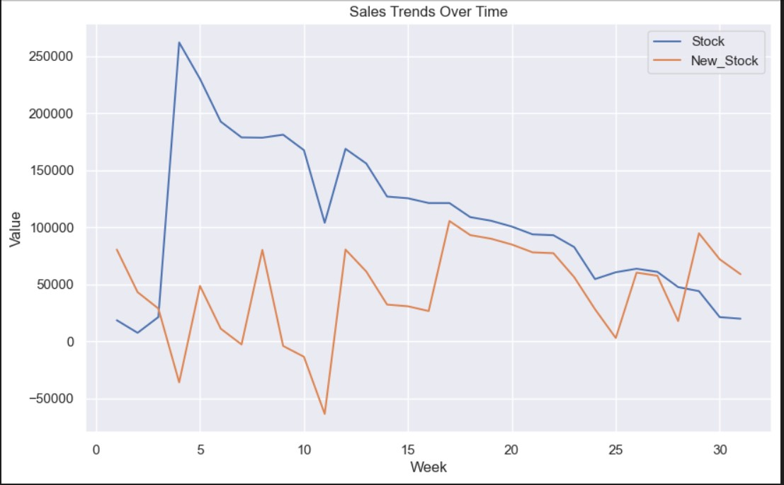

**6.4) RECTANGULAR BOXES:**

**6.4.1 ) OLD purchase and EOQ over time**

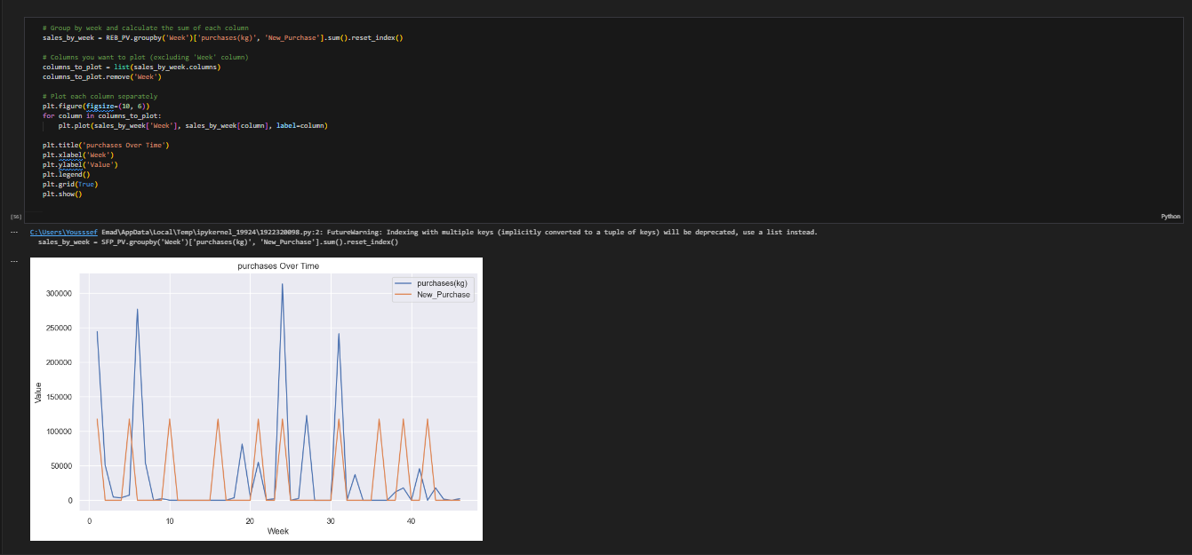

**6.4.2) Holding Cost before and after EOQ:**

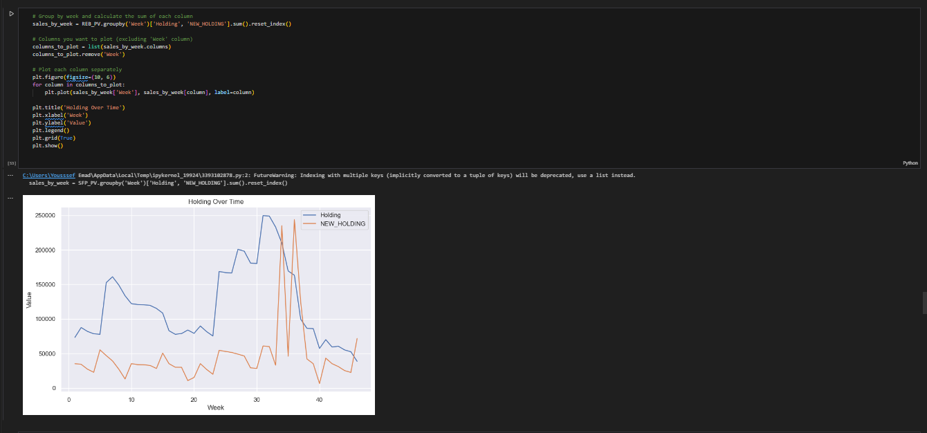

**6.4.1) Stock Cost before and after EOQ:**

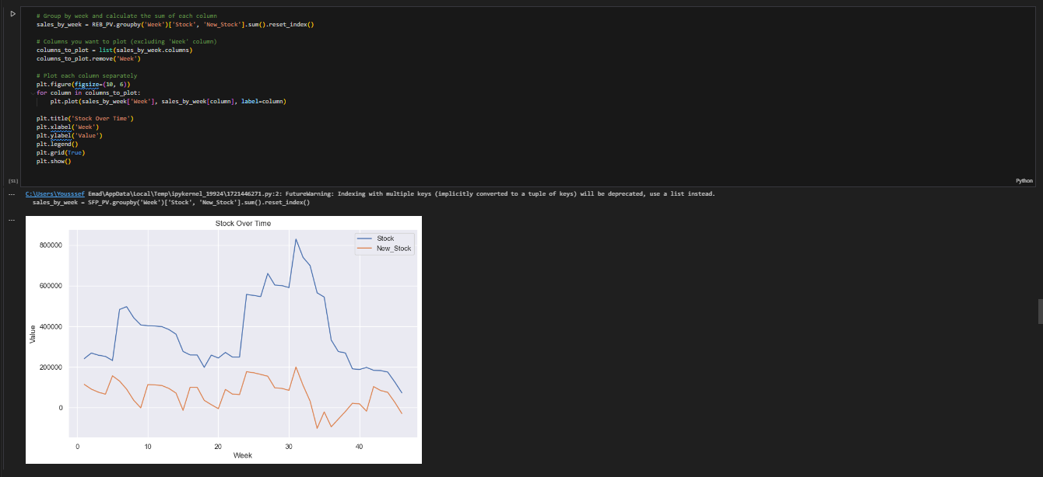

**6.5) Pipes**

**6.5.1 ) OLD purchase and EOQ over time**

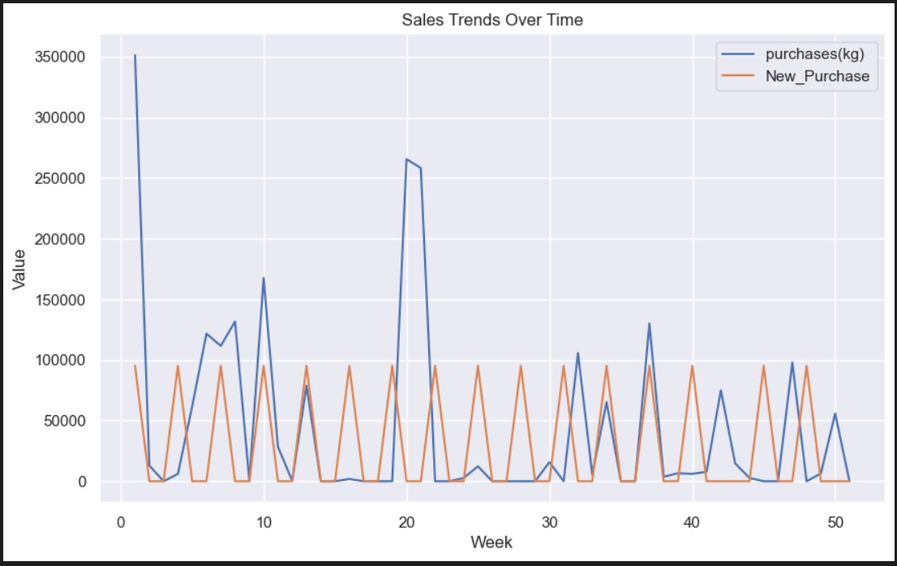

**6.5.2) Holding Cost before and after EOQ:**

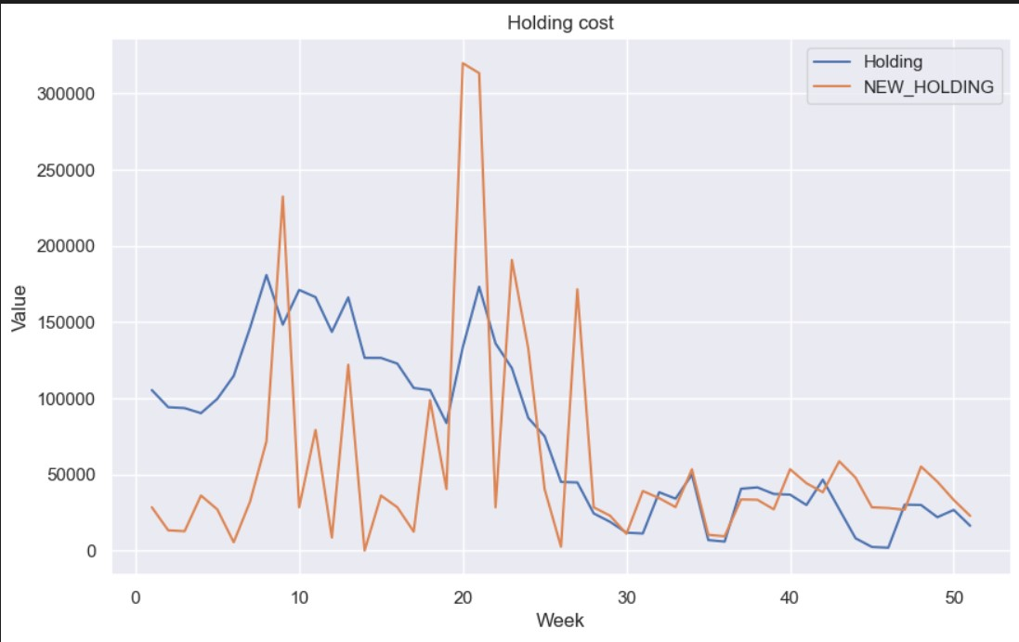

**6.5.3) Stock Cost before and after EOQ**

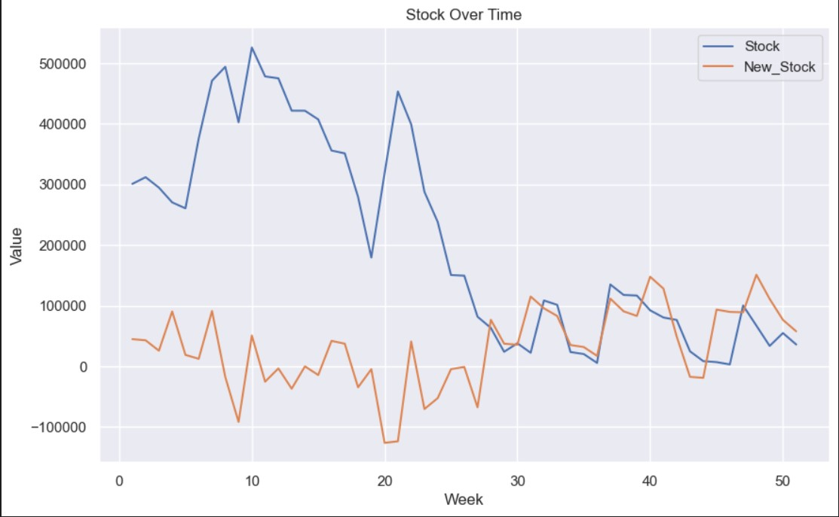

**6.6)Beams :**

**6.6.1 ) OLD purchase and EOQ over time**

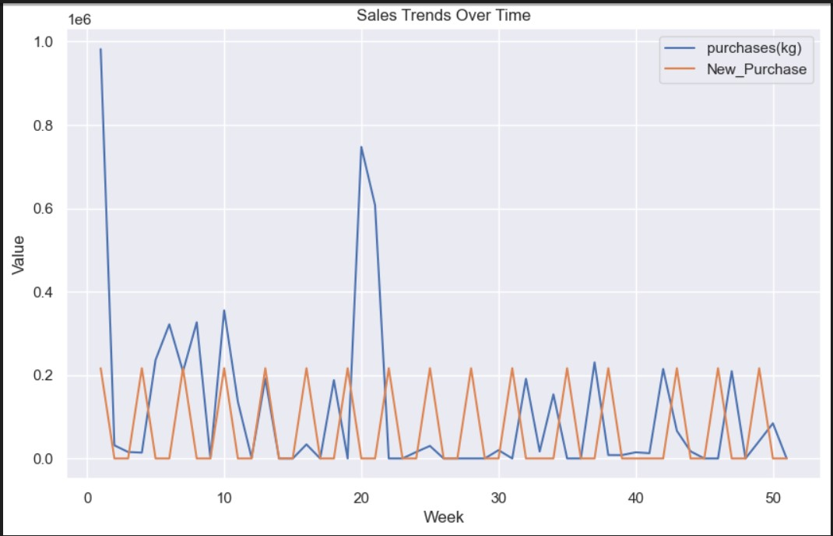

**6.6.2) Holding Cost before and after EOQ:**

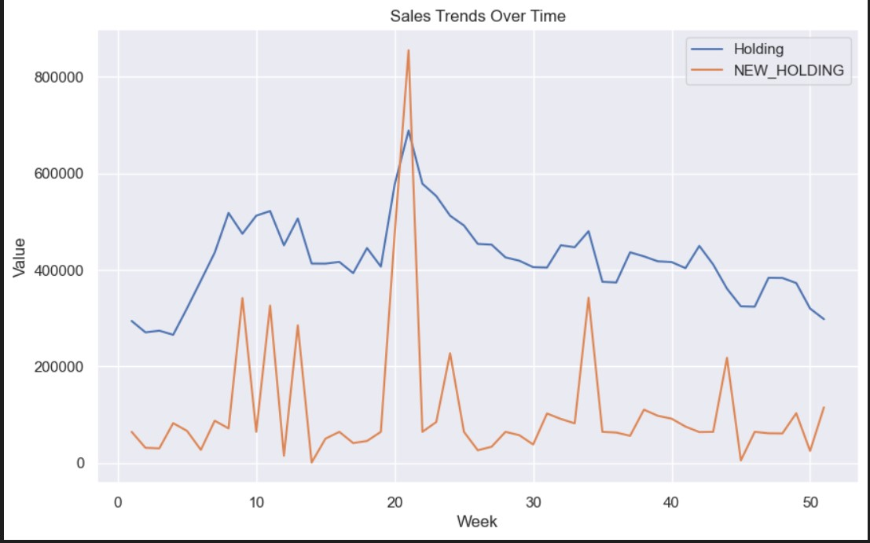

**6.5.3) Stock Cost before and after EOQ**

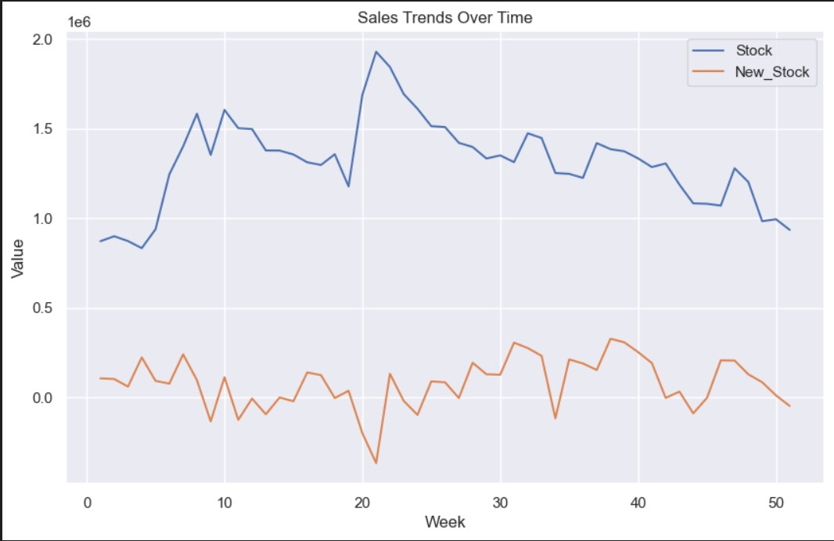

**7) Conclusion:**

At first we collected the data from El-Ashry steel we found that AL-Ashry steel make a lot of random purchases of large quantities of iron and small of percentage sales so it costs high holding cost to the company and it is placed in the warehouse and the company bears a large proportion of the holding cost.

We made some preparations to make the data to begin our work we calculated stock and made some visualizations to understand the data.

We made the calculations that requiredfor the EOQ model to determine the optimal quantity to order after applying EOQ and we calculated ROP (Re-order-point) to determine when to place an order.

**We calculated the cost before EOQ for each type :**

Steel-flat-plate = 26840189

RECTANGULAR BOXES =10231224

SQUARE BOXES = 3049488.599

BEAMS = 39703570.59

PIPES = 10204658.8

**We calculated total cost after EOQ for every type :**

Steel-flat-plate = 7334924.2

RECTANGULAR BOXES =5575068.3

SQUARE BOXES = 2301927.893

BEAMS = 16704879

PIPES = 7334924.287854968

**We saved for the company a total cost of 42,079,575 and for each type we saved As follow :**

Steel flat plate = 10807433.557745527

RECTANGULAR BOXES = 4656155.9319722075

SQUARE BOXES = 747560.7060287455

BEAMS = 22998691.261

PIPES = 2869734.512145

**References :**

[**https://www.brightworkresearch.com/references-for-brightwork-eoq-articles**](https://www.brightworkresearch.com/references-for-brightwork-eoq-articles)

[**https://www.investopedia.com/terms/e/economicorderquantity.asp#:~:text=Economic%20order%20quantity%20(EOQ)%20is,has%20been%20refined%20over%20time**](https://www.investopedia.com/terms/e/economicorderquantity.asp#:~:text=Economic%20order%20quantity%20(EOQ)%20is,has%20been%20refined%20over%20time)

[**https://corporatefinanceinstitute.com/resources/accounting/what-is-eoq-formula/**](https://corporatefinanceinstitute.com/resources/accounting/what-is-eoq-formula/)

[**https://dclcorp.com/blog/inventory/economic-order-quantity-eoq/**](https://dclcorp.com/blog/inventory/economic-order-quantity-eoq/)

[**https://www.sortly.com/blog/what-are-the-most-common-inventory-control-models/**](https://www.sortly.com/blog/what-are-the-most-common-inventory-control-models/)

[**https://www.linkedin.com/pulse/inventory-optimization-mathematical-statistical-perspective-sada**](https://www.linkedin.com/pulse/inventory-optimization-mathematical-statistical-perspective-sada)

[**https://www.linkedin.com/advice/1/what-best-inventory-management-models-products-lgzvf**](https://www.linkedin.com/advice/1/what-best-inventory-management-models-products-lgzvf)