AMIT Graduation Project

**Youssef Mohamed Farghaly H24 Online**

The first problem encountered is that I have only one MCU, therefore I had to use Proteus simulator.

I have only one MCU so I had to use Proteus Simulator .

The mobile app will be replaced by a virtual terminal input to the first Bluetooth HC-06 Module using RXD and TXD. Which can be seen in the following figure:

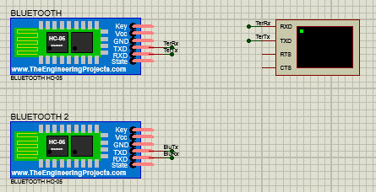

The First Bluetooth module is paired with the second Bluetooth module also HC-06 using a program called Virtual Serial Port Driver. This program recognizes the two modules as COM1 and COM2 and pairs them. This can be seen in the following figure:

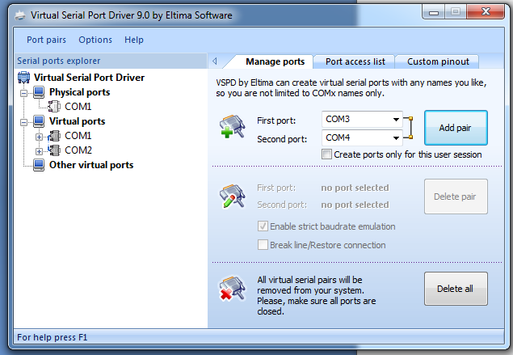

Now that communication between the Bluetooth is done.

The next step is connecting the second Bluetooth module to the Master Atmega32 MCU. This communication is done using UART communication protocol. Where the RXD and TXD of the MCU is connected to RXD and TXD in the Bluetooth.

The third step is connecting both MCU's using SPI communication, where the first MCU that is connected to the Bluetooth is the Master while the Second is connected to the actuators or LED's is the slave. In order for SPI communication to occur SS,MOSI,MISO and SCK are connected to each other. Which can be seen in the following figure:

Finally, the Slave receives the Data transmitted from the master and check if it's a value of char 1 or char 2, if it's a signal of '1' then the actuators connected to PC2 and PD3 are on , if it's a value of '2' then it's off .

The whole Image can be seen as follows:

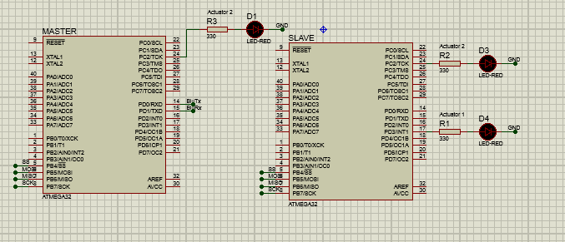

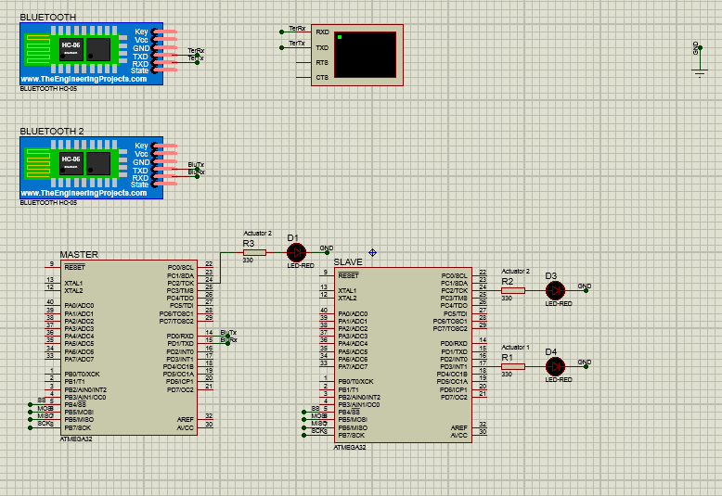

**The Code:**

Regarding the Code and the Architecture used. The MCAL LAYER for the Master IS DIO,UART and SPI. While, the MCAL layer for the slave is DIO and SPI.

The master had to initialize UART to interact with Bluetooth module through TXD and RXD channels. In addition, initialize SPI to connect with the second MCU(Slave).

The slave needed SPI to receive data and check on this data, if it's a value of char '1' then we activated the LED's using DIO, if it's a value of '2' then we deactivate it.