5 classes (10 BPM, 15 BPM, 20 BPM, Empty, No Breathing), 405 total samples each class (sliding window reading in 15 seconds +1 second for the next sample in a file), 20 epochs -

2D CNN: 90.27% Accuracy  
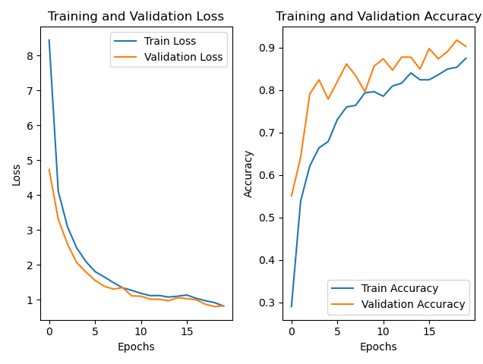

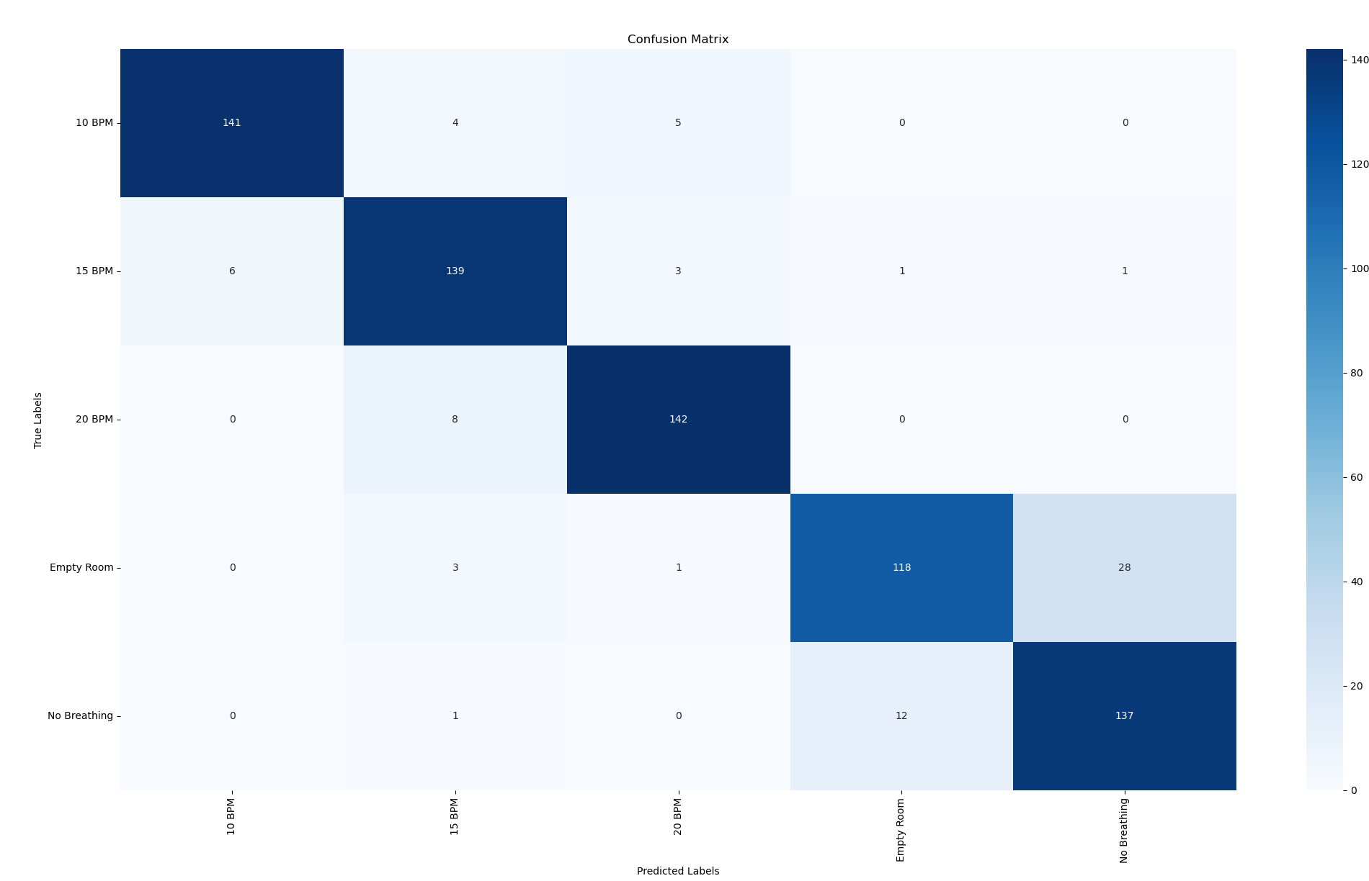

1D CNN: 92.40% Accuracy

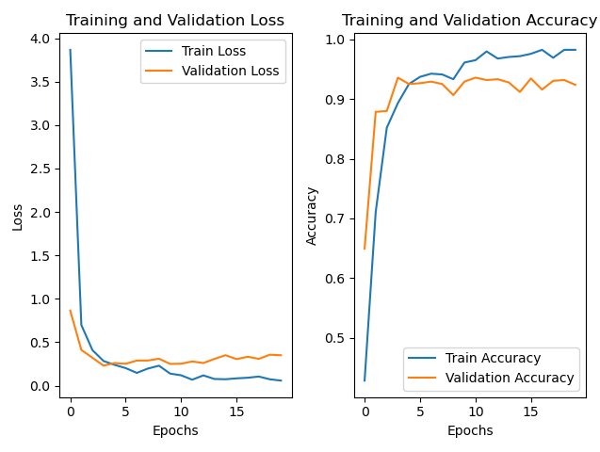

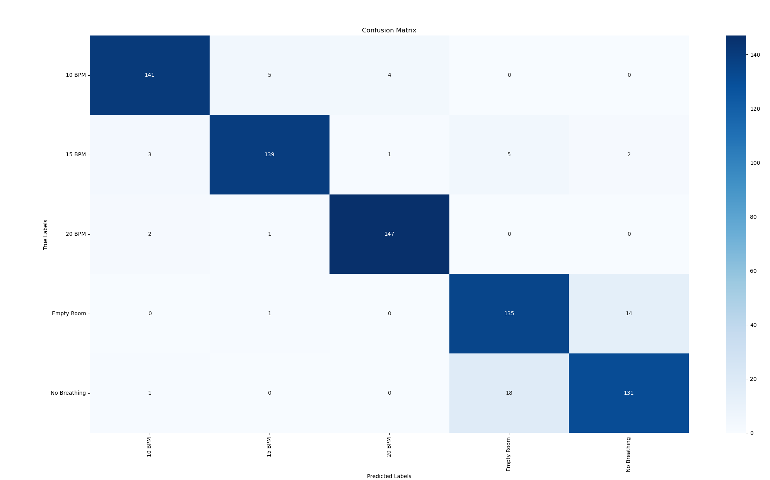

Pre Trained ResNet152: 94.33% Accuracy

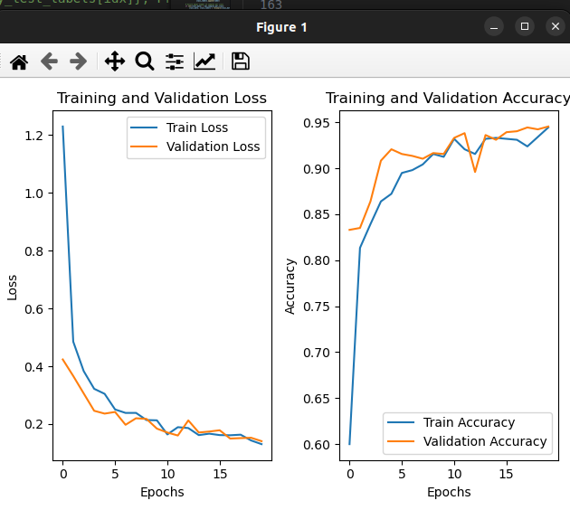

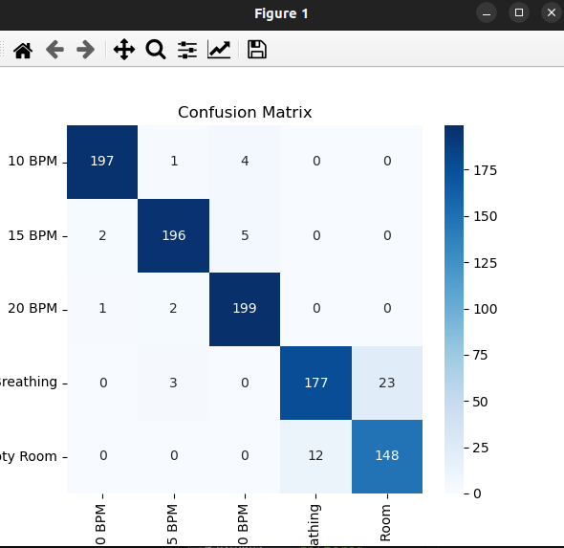

Conv1D + LSTM Hybrid Model: 84.67% Accuracy  
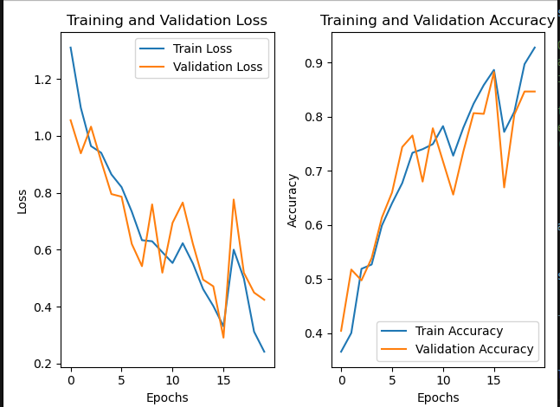

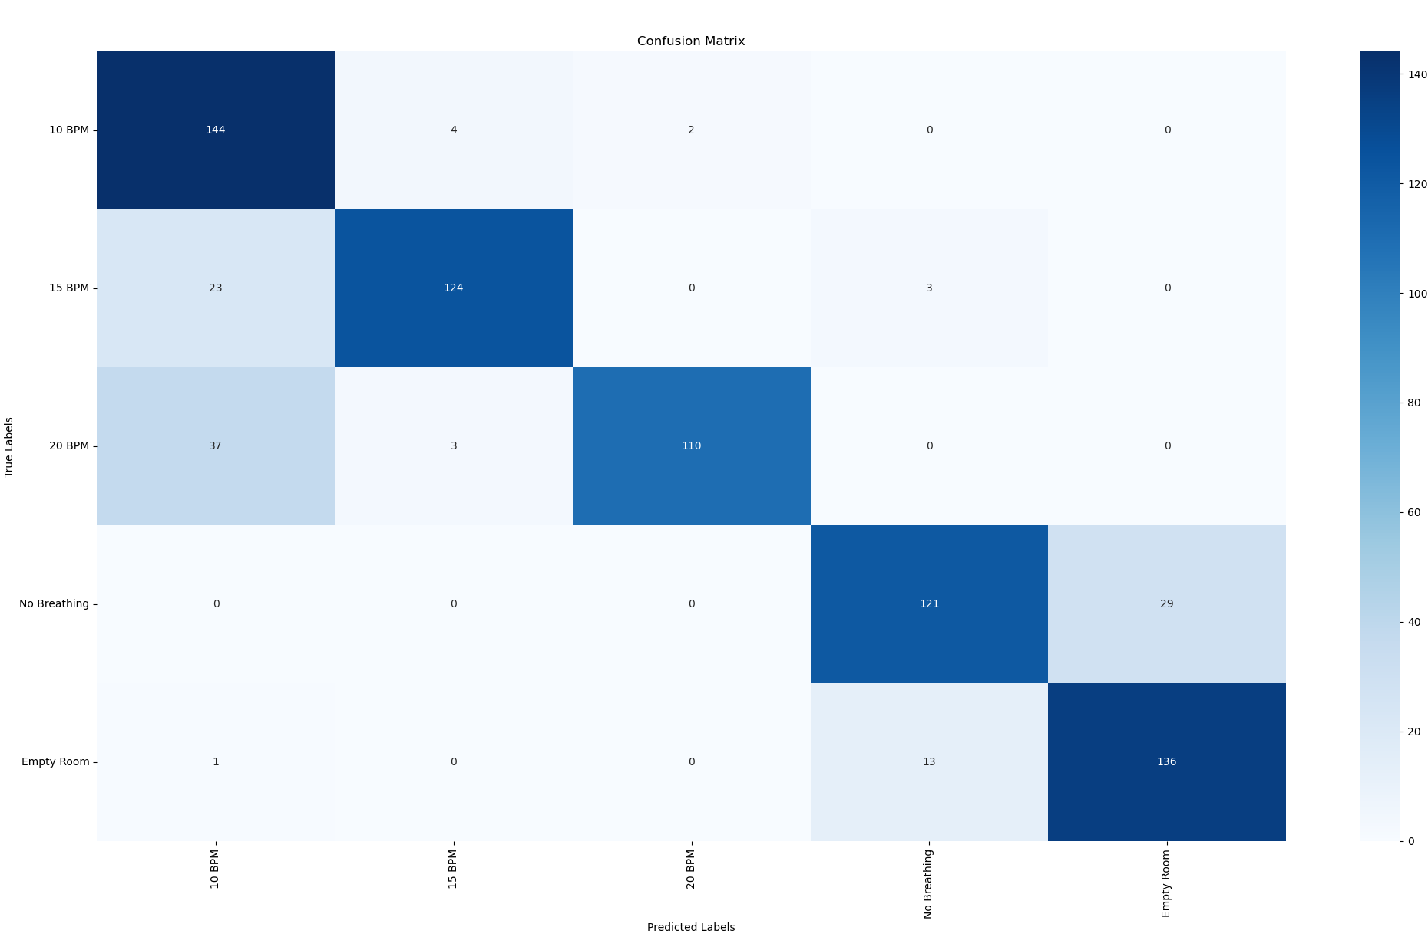

LSTM: 69.20%  
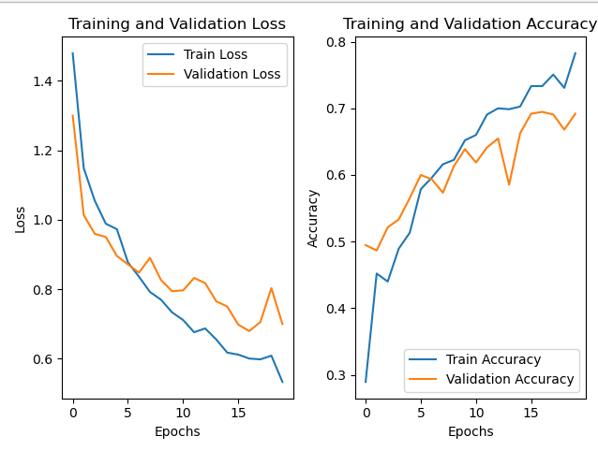

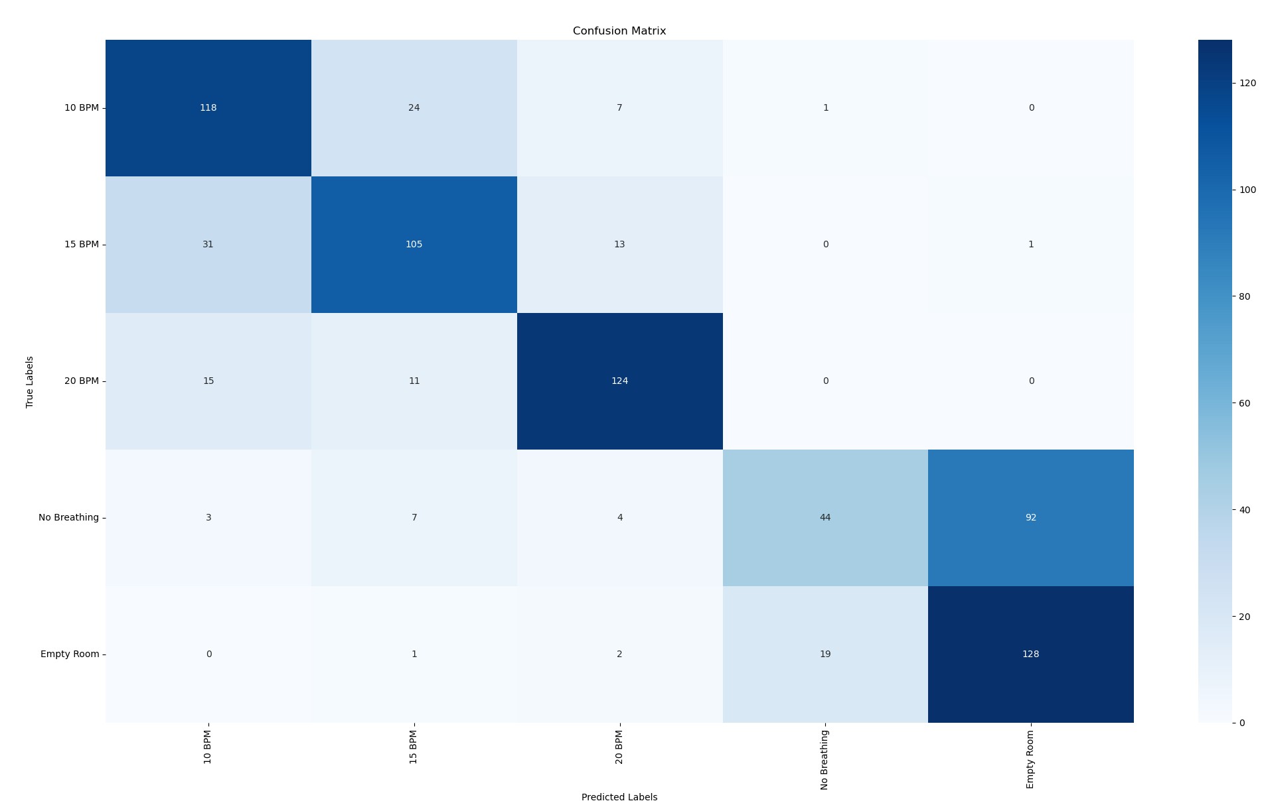

Extended Classes (<10 BPM, 11-13BPM, 14-16BPM, 17-19BPM, >20 BPM) - csi_br_cnn_1dconv_golden.h5

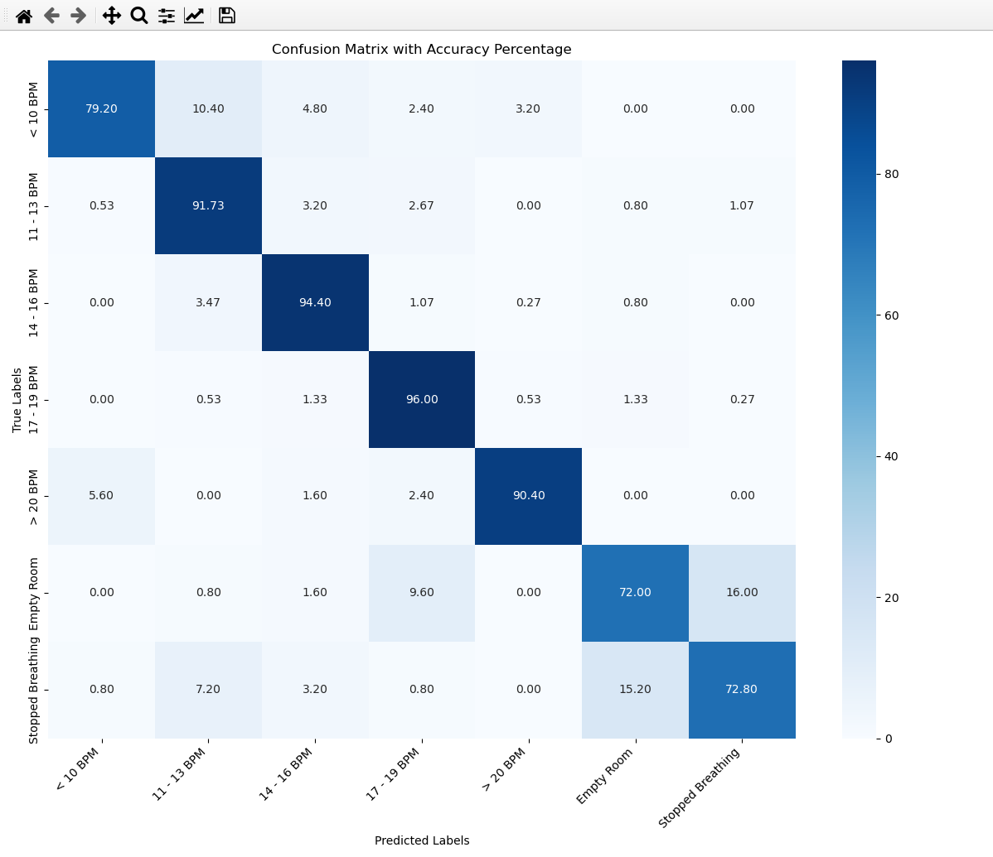

ML Results with equal training and testing for all classes:  
