Name: youssef hamdy mostafa

B.N: 1055

Date: 22-5-2020

Topic: Operating Systems

Github-link

Application Brief:

**What Operating Systems Do**Operating systems define how a computer stores files, switches between different applications, manages memory, keeps itself secure, and interacts with peripherals like printers and cameras. Different operating systems take different approaches to all of these, which is why you normally can't run a Windows program on a Macintosh computer and why permissions look different on an Android phone than on an iPhone.

# Some operating systems are designed by groups of people around the world, like the open source, freely available operating system Linux, while others are commercial products made by one company, such as Microsoft's Windows and Apple's macOS.

# **Objectives of Operating System**

# The objectives of the operating system are −

# To make the computer system convenient to use in an efficient manner.

# To hide the details of the hardware resources from the users.

# To provide users a convenient interface to use the computer system.

# To act as an intermediary between the hardware and its users, making it easier for the users to access and use other resources.

# To manage the resources of a computer system.

# Screenshots

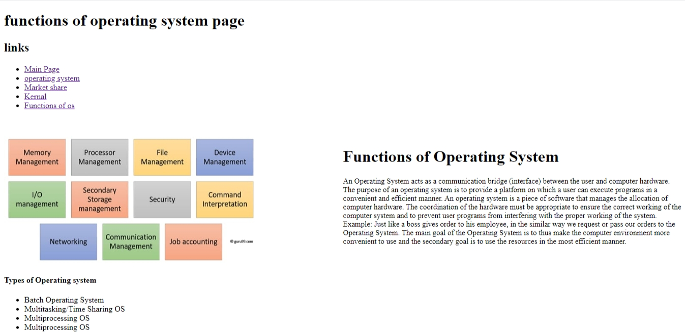

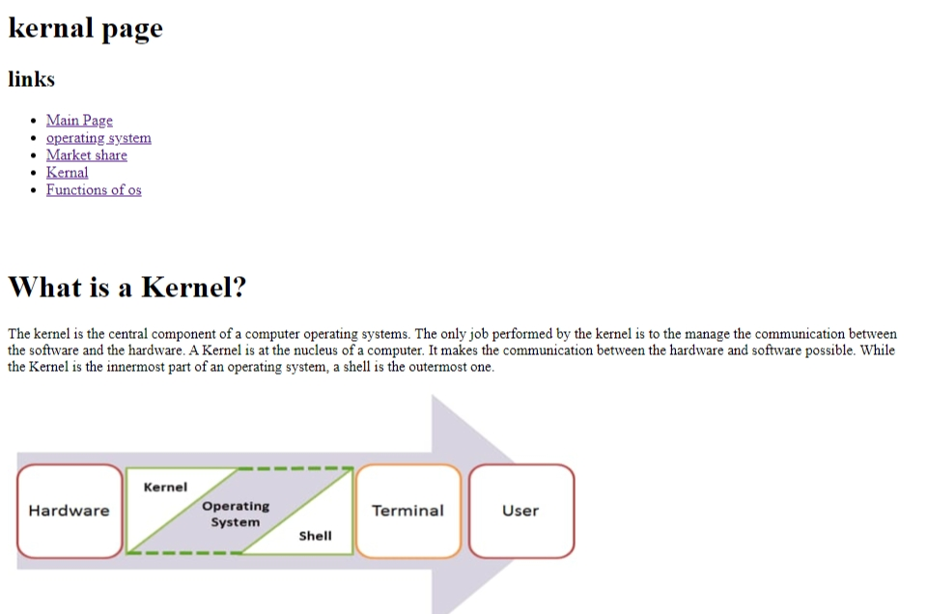

Source code : of main page