***Yossef hassan Othman***

***26/10/2024***

***We school Qena***

***Task 1***

***Introduction:***

In an era where technology has become an essential part of our daily lives, and where every individual owns a smart device like a phone or tablet, providing easy access to information and digital interaction, the need for robust protection for databases and personal information has emerged. In this context, companies like **Frontpoint** offer advanced solutions for securing homes and properties, granting users peace of mind in a rapidly changing world. On the other hand, **AJAX** technology stands as one of the fundamental tools in modern web development, contributing to faster and more interactive applications, ensuring a smooth and comfortable user experience. In this report, we will explore the strengths of both AJAX and Frontpoint and examine how they align with good web design principles to achieve the highest levels of security and usability.

***First, Let’s talk about the features and design of both sites***

***1-Fontpoint security***

***Features:***

* **Smart Security Cameras**: Frontpoint’s cameras provide high-resolution imaging with capabilities such as night vision and motion detection. These cameras send instant alerts to the user when any unusual movement is detected, providing around-the-clock home protection.
* **Versatile Sensors**: Frontpoint’s security systems include sensors for windows and doors to detect any breaches, as well as motion sensors. These devices offer comprehensive home perimeter protection, instantly notifying the user of any potential intrusion.
* **Advanced Additional Security Features**:
  + **Personal Emergency Information**:

 The system allows users to add personal medical information, such as pre-existing conditions and allergies, so emergency responders can access this information immediately during emergencies, saving valuable time and enabling faster, more appropriate care.

* + **Alarm Verification Recording (AVS-01)**:

Frontpoint’s monitoring service uses this standard to ensure the precise recording of alarms, which helps minimize false alarms and enhance security.

* + 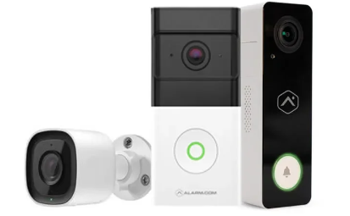**External Camera Rebate Program**: In some U.S. cities, users can enroll in programs that provide rebates for sharing external security footage with local police departments, helping to enhance community safety.



* + **Pet Protection**: The system allows users to add their pets' information to their accounts to better protect them during emergencies.



* + **Professional DR Installation**: Frontpoint offers a professional installation service for security systems, allowing users to rely on experts for the best installation experience.
* **Integrated App**: The Frontpoint app provides full remote control of security systems, allowing users to enable or disable alerts, watch live video, and easily manage settings through iOS and Android devices.
* **Ease of Installation**: The system includes clear instructions for DIY installation, so users can set up the system themselves quickly and without technical assistance, providing flexibility and ease of use.

***Design:***

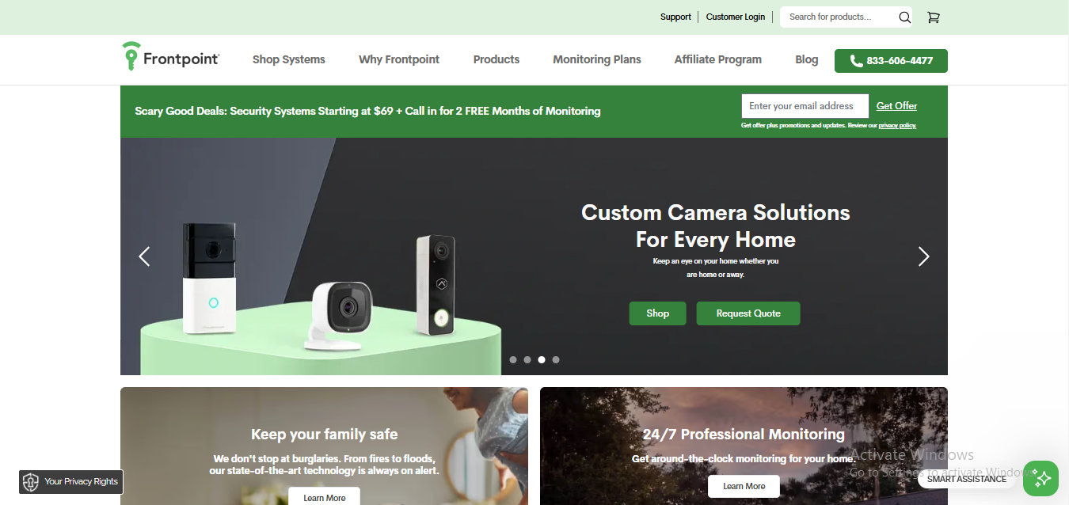The Frontpoint website is modern and straightforward, suitable for the security field, with comfortable colors and clear fonts that reflect professionalism. The design features an easy-to-navigate interface, with large buttons and icons suitable for all users, facilitating browsing. The website is also responsive, working efficiently on all devices, whether computers or smartphones, providing an organized and convenient browsing experience.

***2-Ajax***

***AJAX (Asynchronous JavaScript and XML) is a technology that allows web applications to communicate with the server and exchange data without the need to reload the entire page. This technology contributes to creating fast, interactive web applications that offer a seamless user experience.***

***Features:***

* **All-in-One Solution for Apartments**: The Ajax security system offers multiple solutions, making the apartment safer and more comfortable. The system includes intrusion protection, video surveillance, fire detection, water leak prevention, and automation capabilities to meet various safety needs.
* **Smart Security Cameras**: The system provides high-quality cameras with features such as night vision and motion detection, along with instant alerts when any unusual movement is detected, enhancing home monitoring around the clock.
* **Advanced Sensors**: The system includes sensors for windows and doors, as well as motion detectors that immediately alert users when predefined boundaries are breached, providing comprehensive protection for the residence.
* **Full Control via Ajax Apps**: The Ajax app allows users to easily monitor their homes remotely, receiving instant notifications for any alarms, viewing recorded security camera footage, and controlling connected smart devices.
* **Integrated Automation System**: The system offers advanced capabilities for controlling home appliances through smart automation scenarios. Users can manage devices remotely or allow the system to automatically control these devices. This includes automatic arming and disarming of the security system.
* **Design Suited for Any Interior**: Ajax devices come with a simple design and neutral colors that fit various interior décors, making them suitable for renovated apartments. The system also features easy-to-install wireless solutions, ideal for users looking for simple and effective security options without complicated installation.

***Design:***

* **User-Friendly and Easy Navigation**: The Ajax website features an elegant interface with an organized main menu clearly displaying the main options, such as products, features, and support services.
* **Calm and Neutral Colors**: The website uses neutral colors like white and black with touches of soft hues, reflecting a professional and secure atmosphere.
* **High-Quality Images**: The site stands out with high-quality images of various devices and products, helping users understand the appearance and uses of the devices more clearly.
* **Responsive Structure**: The website is designed to be fully responsive across all devices, allowing users to browse easily from computers, smartphones, or tablets.
* **Focus on Easy Information Access**: Information about products and services is presented in an organized manner, enabling users to easily obtain details about product features, operation, and security scenarios.
* **Fast Loading Speed**: The site is characterized by fast performance and high page loading speeds, providing a comfortable browsing experience for users and facilitating smooth navigation between sections.

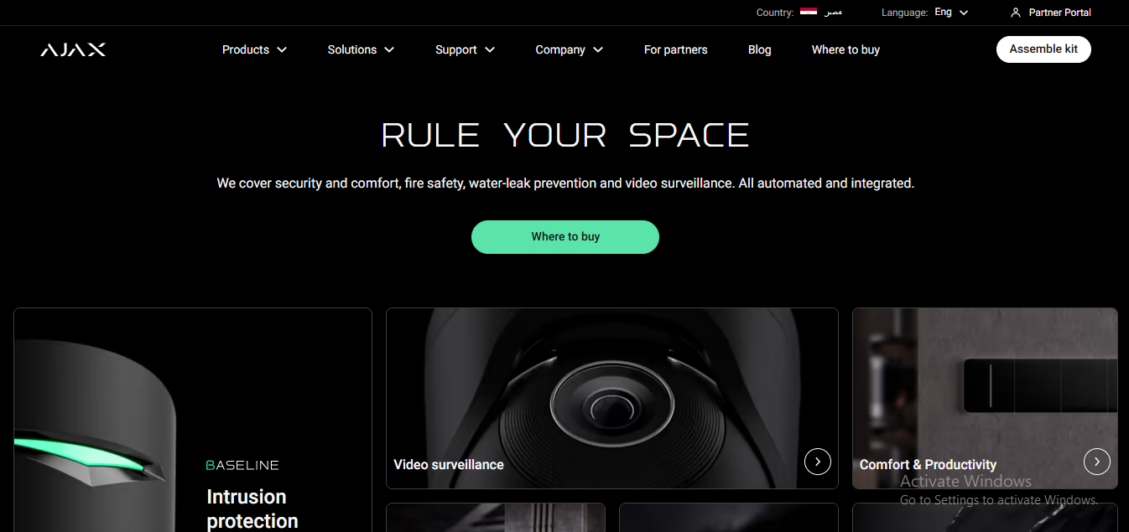

***Socend, principles of Good Website Design and Their Impact on User Experience***

Good website design relies on a set of fundamental principles that contribute to enhancing user experience and facilitating interaction with the site. In this context, we will discuss how AJAX and Frontpoint align with these principles and how they affect user experience.

***1- Easy Navigation***

* **AJAX**:  
  By updating content without the need to reload the page, websites using AJAX can provide a seamless navigation experience. Users can easily move between different sections, improving interaction speed with the content.
* **Frontpoint**:  
  The Frontpoint website features a clear design that enhances navigation ease. Large buttons and organized menus make it easy for users to access different services, reducing the time spent searching for information.

***2- Responsive Design***

* **AJAX**:  
  AJAX can be utilized in designing responsive user interfaces, meaning the site performs well on various devices, such as smartphones and tablets. This responsiveness significantly improves user experience.
* **Frontpoint**:  
  Frontpoint employs a responsive design that ensures a consistent user experience across all devices, making it easy for customers to access security information and control their protection systems from any device.

***3- Style Consistency***

* **AJAX**:  
  Although AJAX itself does not represent a specific design, it can be used in sites with a consistent style across different pages, enhancing the continuity of the user experience.
* **Frontpoint**:  
  Frontpoint features a consistent design throughout its pages, creating a sense of professionalism and trust. The colors and fonts used align well with the security theme, making it easier for users to recognize the brand.

***4- Use of White Space***

* **AJAX**:  
  This technology allows for better use of white space, making content clearer and more comfortable to read, thus reducing visual clutter.
* **Frontpoint**:  
  Frontpoint effectively applies the principle of using white space, helping users focus on the main content without distractions, which improves user impressions.

***5- Easy-to-Read Text***

* **AJAX**:  
  Websites using AJAX can present easily readable text with good contrast between the background and the text, enhancing content comprehension.
* **Frontpoint**:  
  Frontpoint ensures the use of clear fonts in appropriate sizes, making it easier for users to read important information without straining their eyes.

***In the end***

***Conclusion and Recommendations***

In conclusion, both AJAX and Frontpoint exemplify effective approaches to website design and user experience in their respective fields. AJAX enhances web applications by facilitating faster, more interactive user experiences through seamless data exchange without page reloads. This technology is essential for modern web applications, enabling features such as live chats and dynamic content updates.

***Recommendations:***

***1- For AJAX Implementers:***

* **Focus on User-Centric Design**: Ensure that the integration of AJAX is guided by user needs. This includes maintaining clear feedback mechanisms, so users are aware of ongoing processes (e.g., loading indicators).
* **Optimize Performance**: Regularly test and optimize the performance of AJAX functionalities to ensure they enhance, rather than hinder, user experience. This involves monitoring loading times and responsiveness.

***2- For Frontpoint:***

* **Continuous User Testing**: Regularly conduct user testing sessions to gather feedback on navigation and design elements. This will help identify areas for improvement and ensure the website evolves with user expectations.
* **Enhance Content Accessibility**: While the website is already well-designed, further enhancing content accessibility—such as offering text-to-speech options or language translation—can attract a broader audience and improve user satisfaction.

***3- For Both:***

* **Stay Updated with Trends**: Both AJAX and Frontpoint should stay abreast of web design trends and technological advancements. This includes embracing new design philosophies, ensuring compatibility with emerging devices, and incorporating user feedback into design decisions.
* **Integrate Security Features**: As both AJAX and Frontpoint deal with user data, ensuring robust security measures is paramount. This includes implementing secure coding practices for AJAX and maintaining high standards of data protection on Frontpoint's website.

***Thanks for readinng***