


Zagazig University
Faculty of Computers and Informatics
Artificial Intelligence and Data Science Program

SMART PARKING

BY
- Ahmed Abdelkareem Fawzy Abdelkareem
- Mohamed AbdElbaset Abdo
- Mostafa Ismail Mohamed
- Youssef Ibrahim Soliman
- Mohamed Ehab Abdulhafize

Under Supervision Of
Professor Dr. Suad Naguib
ENG. Mahmoud Attia

2024-2025

Smart Parking
Ahmed Abdelkareem, Mohamed Abdelbaset, Mostafa Ismail
Youssef Ibrahhim ,Mohamed Ehab
ABSTRACT
Smart Parking is an intelligent parking management system designed for shopping malls, aiming to reduce the time and effort spent searching for vacant parking spaces. The project addresses the problem of inefficient parking in high-traffic areas by automating vehicle entry and enhancing user interaction.
The system's objectives include identifying vacant parking spaces using artificial intelligence, automating vehicle registration through license plate recognition, and enabling users to reserve parking spaces and locate their parked cars via a dedicated mobile app.
The system integrates real-time camera data with AI-based space detection, license plate recognition using computer vision, a mobile app developed using Flutter, and an SQL database for storing system and user data. The expected outcome is a seamless and efficient parking experience that optimizes space utilization, reduces internal congestion, and improves customer satisfaction in shopping malls.
1. Introduction
1.1 Introduction and Significance
During peak hours and weekends, customers often spend a significant amount of time circling the parking lot in search of an empty spot. This not only causes delays and dissatisfaction but also contributes to traffic congestion and overcrowding at mall entrances.
This negatively impacts customer satisfaction, increases fuel consumption, and can even reduce potential sales for mall businesses due to lost foot traffic.
The Smart Parking project aims to address this issue by offering an intelligent, fully automated parking management system tailored for shopping malls. The system’s core objectives are to reduce waiting time, provide real-time space detection using artificial intelligence (AI), and enable users to reserve parking spots in advance through a mobile application. Additionally, the system helps users remember where they parked and recommends parking areas closest to their target store within the mall.
By eliminating the need for human intervention in parking management and enhancing the overall experience for mall visitors, the system not only improves traffic flow but also contributes to better service quality and operational efficiency for mall operators.
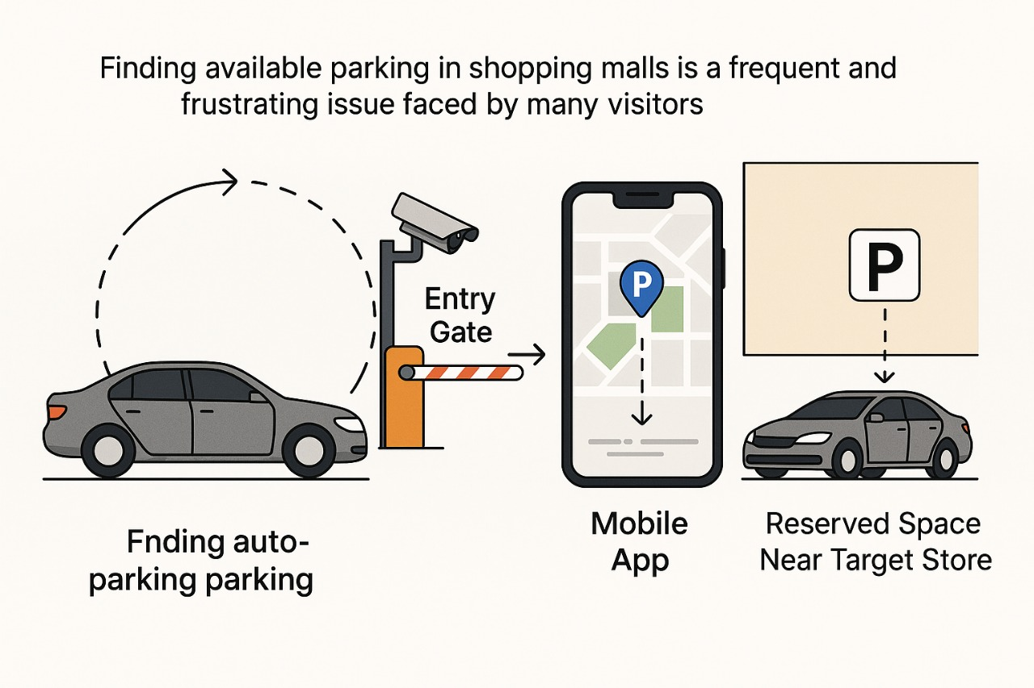
1.2 Contribution to Scientific Discovery
The Smart Parking system contributes to the advancement of intelligent transportation and urban infrastructure by integrating machine learning, computer vision, and mobile technologies into a unified and fully automated parking management solution. Unlike traditional systems that rely on manual operations or ultrasonic sensors, this project leverages artificial intelligence to detect available parking spaces in real time and recognize license plates at entry gates with high accuracy—without requiring physical infrastructure in every parking spot.
A key innovation of this system is its ability to suggest parking spots closest to the user's target destination within the shopping mall, enhancing convenience and user experience. Furthermore, the mobile application supports live parking availability, allows users to reserve spots in advance, and helps them remember where they parked, reducing unnecessary movement and internal traffic.
From a scientific and industrial perspective, the project introduces a practical implementation of AI-based space optimization, contributing to the growing field of smart cities and intelligent mobility. In addition, the system stores anonymized data that can be used for future analytics or performance tuning. The underlying AI model is also designed to be retrainable and scalable, allowing it to adapt to other environments such as airports, universities, or hospitals.
2. Related Work
Several smart parking systems have been developed in recent years to address the challenges of urban traffic and parking space optimization. Most existing solutions rely on sensor-based approaches, using ultrasonic or infrared sensors installed in each parking spot to detect vehicle presence. While such systems are effective in closed environments like airports or garages, they require significant infrastructure investment and are difficult to scale in large, open areas such as shopping mall parking lots.
Some mobile applications, such as ParkMobile, JustPark, and ParkPlus, provide parking reservations and payment features. However, these platforms typically depend on manual input from parking lot managers or static databases, and they lack real-time space detection and automatic vehicle recognition.
Recent research in the domain of intelligent parking has explored the use of computer vision and AI to detect free spots using CCTV footage. However, many of these studies remain at the prototype stage or focus only on detecting availability without integrating a full user-oriented system that includes mobile interaction, reservation, and guidance.
In contrast, the Smart Parking project presented in this work introduces a fully automated and real-time system that combines license plate recognition, AI-powered space detection, and a user-friendly mobile application. It fills a critical gap by offering personalized parking recommendations based on the user’s destination inside the mall and ensures a seamless experience without human intervention.
Feature | ParkMobie /JustPark | Sensor-Based Systems | Proposed Smart Parking
Real-time space detection | No | Yes (with sensors) | Yes (AI & computer vision)
License plate recognition | No | No | Yes
Mobile reservation | Yes | No | Yes
Infrastructure cost | Low | High | Low
Destination-based guidance | No | No | Yes
Full automation (no human input) | No | No | Yes
Scalability and flexibility | Medium | Limited | High
Table 1: A comparative analysis between popular parking systems and the proposed Smart Parking solution. Unlike existing systems, our approach integrates real-time AI-powered detection, license plate recognition, and user-centric features such as destination-aware parking suggestions — all with minimal infrastructure and full automation.

3. Software Description
3.1 Software Architecture
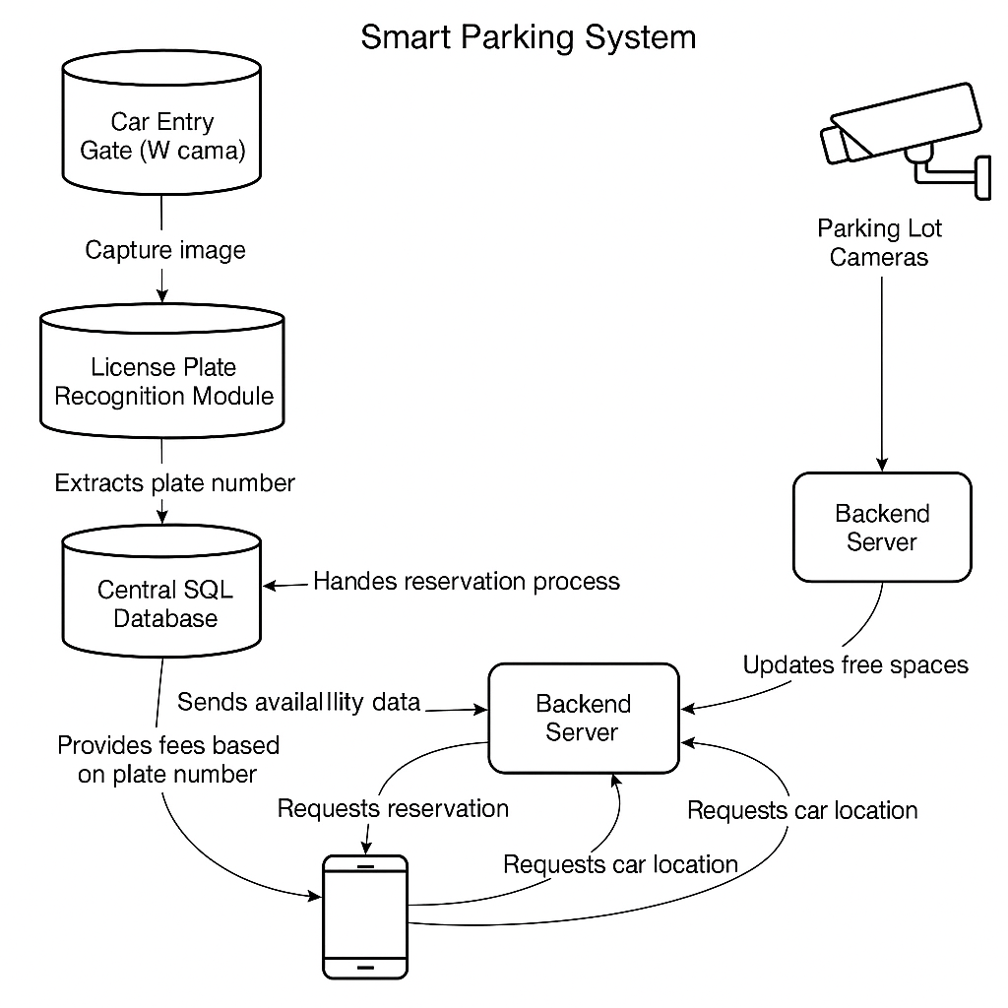
The Smart Parking system is built on a modular, layered architecture that integrates computer vision, machine learning, cloud-based services, and mobile application components to provide a seamless and fully automated parking experience. Each component performs a specific role, and they communicate through a shared backend system and centralized database. The system begins when a vehicle enters the mall's parking area. A surveillance camera captures the car's license plate, and an AI-powered license plate recognition model processes the image to extract the vehicle number. This data is automatically sent to the backend server, where the system checks for pre-registered vehicles or starts a new registration session.Simultaneously, cameras installed around the parking area feed real-time video to the AI model, which detects available spots using computer vision techniques. This availability information is continuously updated in a central SQL database.
Figure 2: System architecture of the Smart Parking solution. The diagram illustrates the flow of data between the main components: license plate is captured and processed at the entry gate, stored in the central SQL database, and used to calculate fees. Parking lot cameras provide real-time space availability to the backend server, which updates the mobile app. The mobile app allows users to view available spots, make reservations, and locate their parked car.

3.2 Tools and Technologies Used
The Smart Parking system was developed using a carefully selected set of modern tools and technologies, chosen to ensure reliability, scalability, and cross-platform compatibility. The table below summarizes the key components and the rationale behind each choice:
Tool / Technology | Purpose
FastAPI | Used to build a fast, lightweight backend API to handle requests between modules.
Flutter | Chosen for mobile app development due to its support for both Android and iOS platforms from a single codebase.
PostgreSQL | A powerful and efficient relational database used to store user data, car plate numbers, and parking spot statuses.
YOLOv11 | Utilized to detect car plates at the entry gate, trained using a custom dataset managed with Roboflow.
OpenCV + OCR | Used to process license plate images and extract the plate number as text.
SVM (Support Vector Machine) | Implemented to detect and classify available parking spots based on camera feeds.
Roboflow | Used for dataset annotation, preprocessing, and automated training workflows.
Kaggle API | Used to run and manage training/inference jobs on cloud-based GPU resources.
GitHub | Version control and collaboration platform for managing source code.
Visual Studio Code | Main development environment used for writing and testing code.
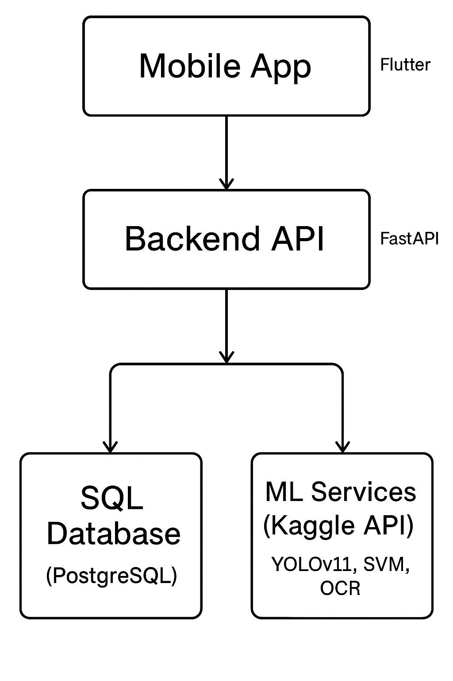
Table 2: Summary of the key tools and technologies used in the Smart Parking system, including backend frameworks, mobile development platforms, machine learning tools, cloud resources, and development environments.
Figure 3: Technology stack showing the interaction between the mobile app, backend API, database, and machine learning services deployed via cloud infrastructure.
3.3 Software Functionalities
The Smart Parking system offers a set of integrated software features that work together to provide a seamless parking experience for both mall visitors and parking administrators. Each feature is designed to address a specific pain point in the traditional parking process, from congestion and time waste to user frustration and lack of automation.

1. License Plate Recognition
At the entry gate, a camera captures an image of the vehicle's license plate. This image is processed using computer vision (YOLO11+OpenCV + OCR) to extract the text-based plate number, which is then stored in the database. This feature eliminates the need for manual registration and allows for automated vehicle tracking.
2. Real-Time Parking Space Detection
Cameras installed across the parking area continuously monitor available spots. Using object detection models (SVM), the system identifies empty parking spaces in real time. This ensures up-to-date information is always available for users via the mobile app.

3. Mobile Application Integration
The Flutter-based mobile app enables users to:
- View available parking spots
- Reserve a space before arriving
- Get directions to the nearest spot based on their destination store inside the mall
- Receive reminders of where they parked
This functionality greatly reduces the time wasted in searching for parking and improves user satisfaction.

4. Automatic Fee Estimation
Once a license plate is recognized and stored in the database, the system records the time of entry. Upon exit, the app calculates the parking fee based on duration and displays it to the user automatically — without any human interaction.

5. Centralized Backend and Database Communication
The backend (built with FastAPI) handles communication between the detection modules, database (PostgreSQL), and mobile app. This ensures secure and real-time data flow between components, allowing users to access accurate information at all times.
4. Methodology
4.1 Data Collection and Preprocessing

4.1.1 License Plate Dataset:
A custom dataset was created for the task of license plate detection, which is the first step toward automating vehicle entry registration. The dataset includes images of vehicles captured from various angles and under different lighting conditions, ensuring diversity and robustness.
- Source: The dataset was built using Roboflow, where custom images were uploaded and annotated manually.
- Classes: A single class — license_plate
- Annotation Method: Bounding boxes were drawn around license plates using Roboflow’s annotation tool.

Preprocessing Steps
- All images were resized to 640*640 pixels to match YOLOv11 input requirements.
- Images were normalized and converted to RGB format.
- Augmentation techniques were applied during dataset preparation to increase robustness. These included:
  - Horizontal flipping
  - Random brightness/contrast adjustment
  - Image rotation (±15 degrees)

Dataset Split
Subset | Percentage | Number of Images
Training | 67% | 1,773
Validation | 16% | 435
Testing | 16% | 432
Table 3: Dataset split for training, validation, and testing phases. The dataset was divided using a 67-16-16 ratio to ensure the model is trained on a representative portion while retaining enough data for validation and unbiased evaluation.
This dataset ensures that the detection model can generalize well to different environments and vehicle types.
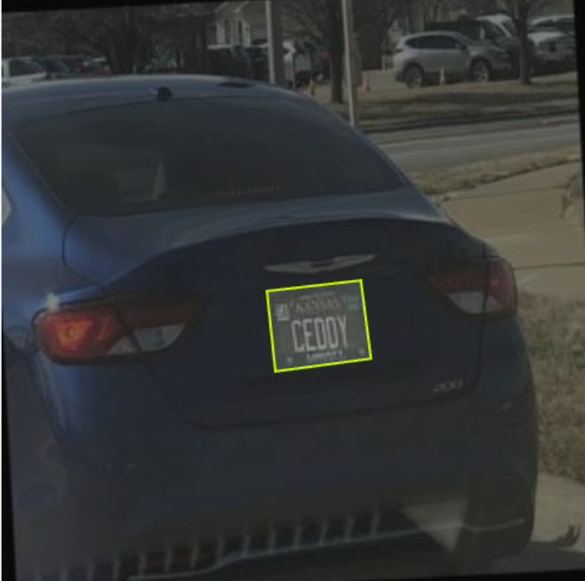
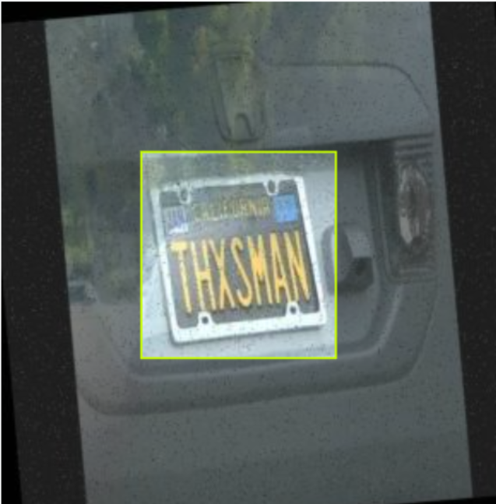
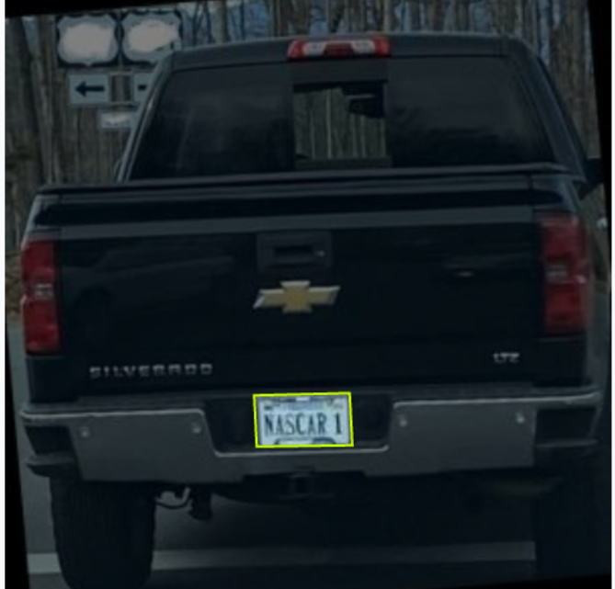
Figure 4: Sample labeled images from the license plate dataset showing bounding boxes around license plates.
4.1.2 Parking Slot Detection :

Dataset Description
The dataset used in this study comprises labeled images of individual parking spots, specifically designed to support binary classification tasks. Each image corresponds to a single parking space and is annotated with one of two possible classes:
- empty – indicating that the parking spot is unoccupied.
- not_empty – indicating that the parking spot is occupied by a vehicle.

Data Preprocessing
To reduce computational complexity and accelerate the training process, the following preprocessing steps were applied:
- All images were resized to a fixed resolution of 15×15 pixels.
- Each image was flattened into a one-dimensional feature vector, suitable for input into traditional machine learning classifiers.
The categorical labels were numerically encoded as:
  - 0 → empty
  - 1 → not_empty
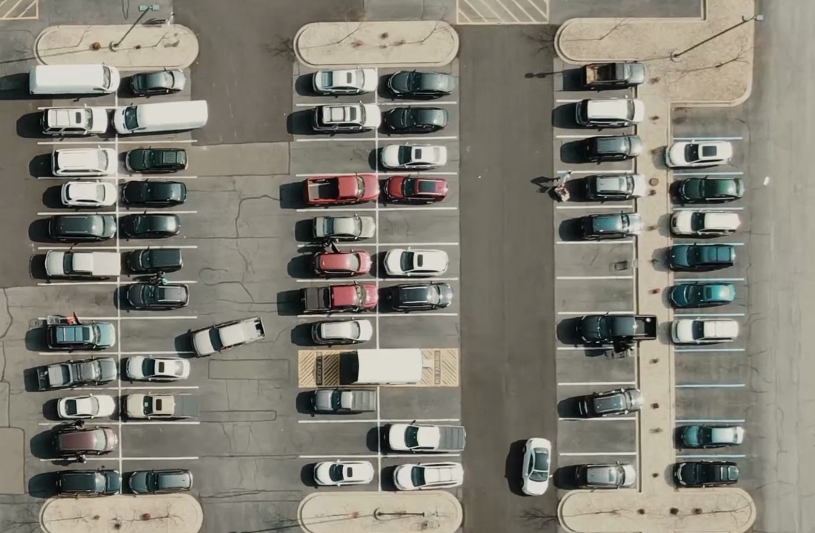
Figure 5: Sample image of a parking spot from the dataset (unannotated).
4.2 Model Development

4.2.1 car Plate Detection Model

Overview
The system utilizes a two-stage pipeline for vehicle identification at entry gates. First, YOLOv11 is employed for accurate license plate detection, leveraging its high-speed object detection capabilities. Following detection, the identified plate region is processed using Optical Character Recognition (OCR) to extract the plate number as text. This integrated approach enables automated gate access and vehicle registration without the need for human intervention.

System Architecture
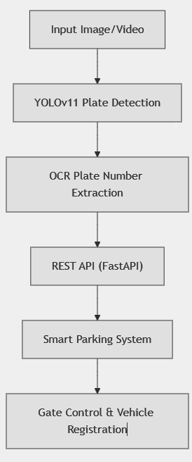

Key Features of the Plate Detection and Recognition System
- AI-Powered Plate Detection
The system utilizes YOLOv11 for robust and real-time license plate localization, ensuring high accuracy under various environmental conditions.
- High-Quality Annotated Dataset
Training and validation were performed using a custom Roboflow dataset containing over 2,600 expertly annotated images, enhancing model reliability and generalization.
- Accurate Plate Number Extraction
Advanced Optical Character Recognition (OCR) techniques are employed to extract text from detected plate regions with high precision.
- RESTful API Integration
A FastAPI-based backend delivers real-time detection and recognition results via RESTful endpoints, enabling smooth integration with external systems.
- Smart Parking System Compatibility
The model is fully integrated into the Smart Parking framework, enabling automatic gate control, vehicle registration, and real-time database updates.
- Performance Evaluation and Monitoring
The system is evaluated using confusion matrices, accuracy metrics, and visual analysis tools to ensure consistent performance.
- Continuous Improvement and Fine-Tuning
Model performance is improved through iterative fine-tuning and post-processing of OCR outputs to handle edge cases and real-world variability.
- Version Control and Documentation
All code, experiments, and datasets are managed using GitHub, ensuring reproducibility and organized project development.
Hyperparameter | Value | Description
epochs | 50 | Training iterations until convergence.
batch | 8 | Small size to lower memory and overfitting.
imgsz | 640 | Input image size for YOLOv11.
lr0 | 0.003 | Initial learning rate.
lrf | 0.01 | Learning rate decay.
momentum | 0.937 | Speeds up convergence.
weight_decay | 0.0005 | Prevents overfitting.
patience | 20 | Early stop if no improvement.
cache | True | Speeds up data loading.
Table 4: YOLOv11 training hyperparameters used in the license plate detection model. These values were selected based on the dataset size and hardware limitations to ensure stable and efficient learning.
4.2.2 Parking Spot Classification Model
This module is responsible for determining whether a given parking spot is occupied or vacant based on visual input. A Support Vector Machine (SVM) classifier was used due to its effectiveness in binary image classification tasks with small to medium-sized datasets.

System Overview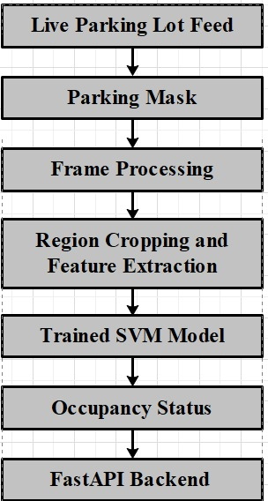

Model Training
The parking spot classifier was developed using the sklearn.svm.SVC implementation of the Support Vector Machine (SVM) algorithm. To ensure optimal performance, a Grid Search with Cross-Validation (GridSearchCV) was conducted over a defined set of hyperparameter values:
- C: {1, 10, 100, 1000}
- gamma: {0.01, 0.001, 0.0001}
These ranges were selected to balance model complexity and generalization performance. The dataset—consisting of labeled images of individual parking spots—was split using an 80/20 train-test split to evaluate the classifier’s performance effectively.The best-performing model, as determined by cross-validation accuracy, was saved to disk as SVM_model.pkl for deployment and inference.
4.3 Implementation

4.3.1 Car Plate Detection (YOLO + OCR)
This module is responsible for detecting car license plates at the mall’s entry gate using a deep learning model and extracting the corresponding plate number using Optical Character Recognition (OCR).
Model Training and Loading
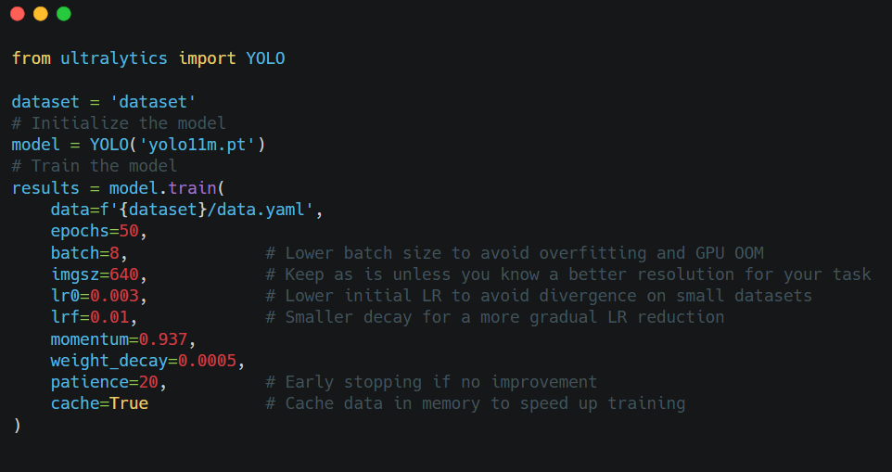
The detection model was implemented using YOLOv11, a state-of-the-art object detection algorithm. The model was trained on a custom dataset of over 2,600 annotated license plate images using the Roboflow platform.
Figure 6: Code snippet showing YOLOv11 training configuration.
After training, the model was exported and loaded into the detection pipeline for real-time inference.

Real-Time Plate Detection
Once trained, the YOLOv11 model is used to detect license plates in
incoming frames from a live video feed or image. The model returns the bounding box coordinates of the detected plate area with high confidence, even under varying lighting and angle conditions.
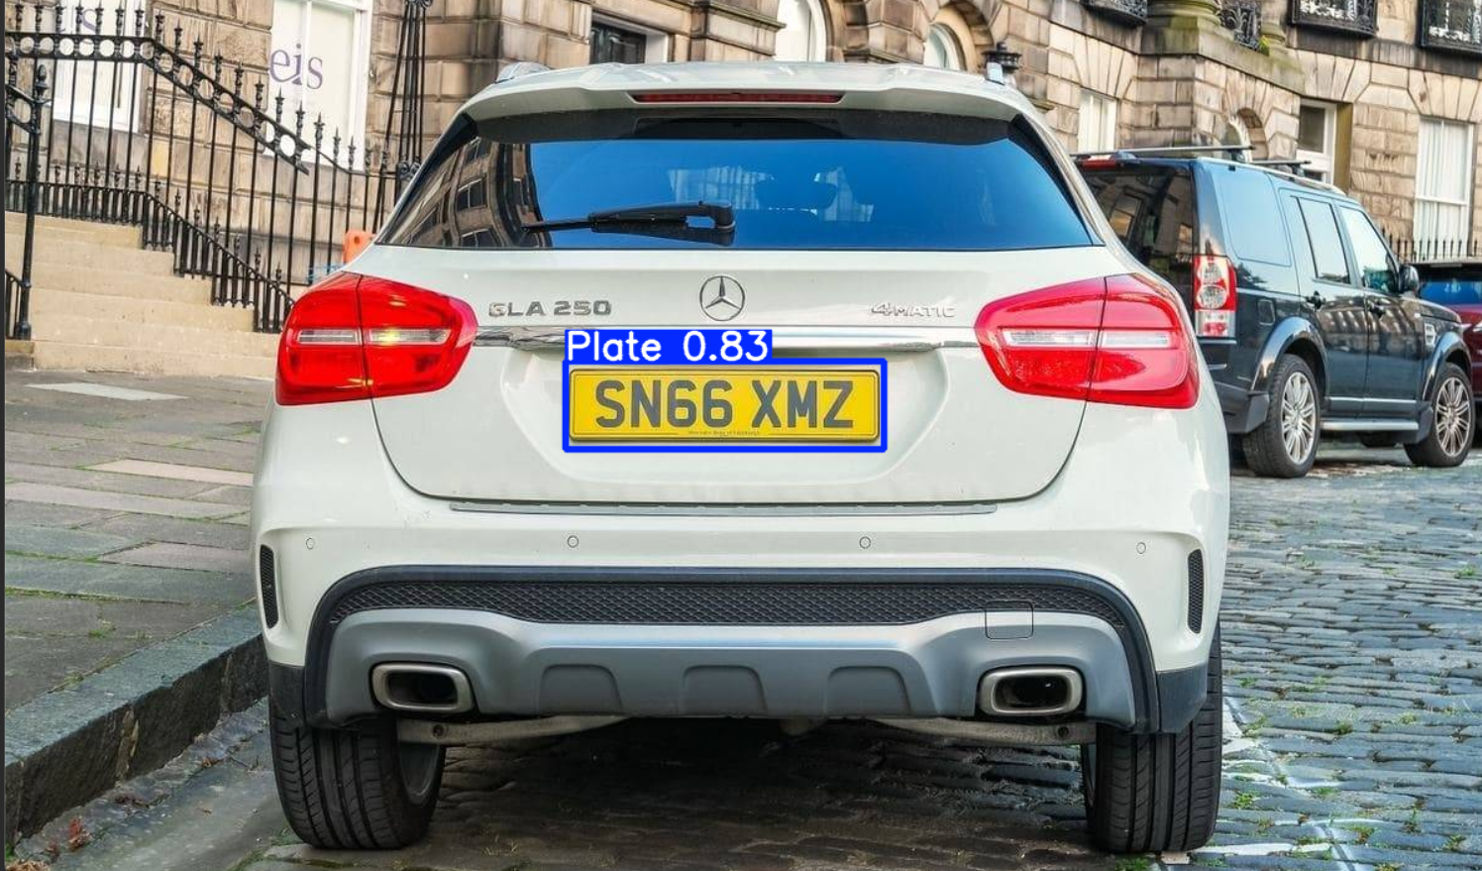
Figure 7: Detected license plate using YOLOv11 from a live camera feed.

Text Extraction with OCR
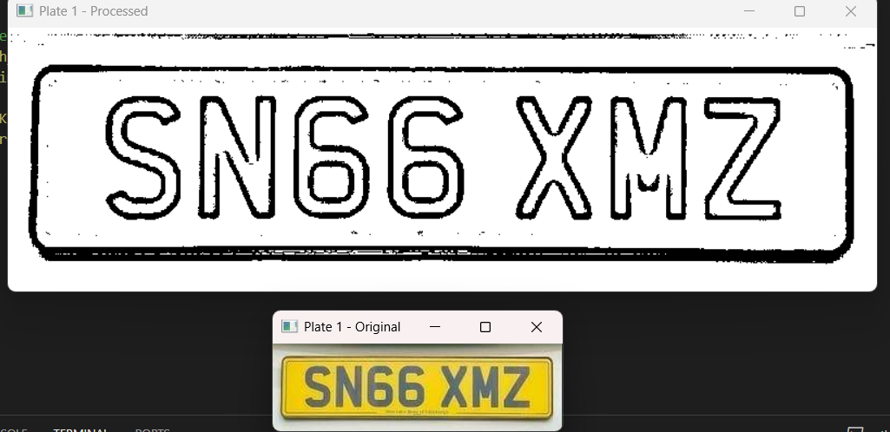
After the license plate region is localized, it is passed through a preprocessing pipeline (grayscale conversion, thresholding, etc.) and then processed using Tesseract OCR to extract the plate number as text. This step transforms visual input into a string representation that is later used for registration and database operations.
Figure 8: OCR output showing the extracted license plate number.

4.3.2 Parking Spot Classification (SVM)
This module is responsible for determining whether each parking spot is occupied or vacant, based on visual input from a live camera feed.

Model Training
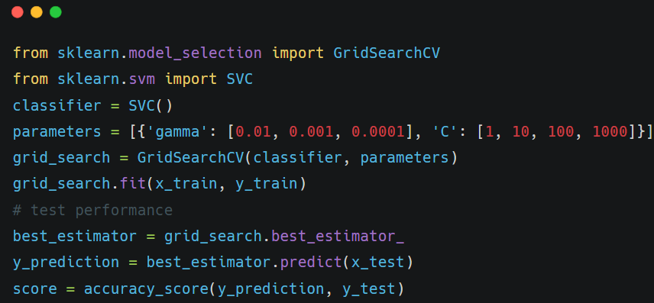
As detailed in Section 4.1.2, the dataset consists of cropped images of individual parking spaces. These images were resized and flattened into one-dimensional feature vectors to reduce computational complexity. The corresponding labels (empty or not empty) were used to train a Support Vector Machine (SVM) classifier implemented using sklearn.svm.SVC.
Figure 9: Training pipeline of the parking occupancy classification model using Support Vector Machine (SVM
To optimize the model’s accuracy, a Grid Search with Cross-Validation was performed over a range of hyperparameters. This process enabled the selection of the best configuration without overfitting. The finalized model was serialized and saved as SVM_model.pkl for deployment.

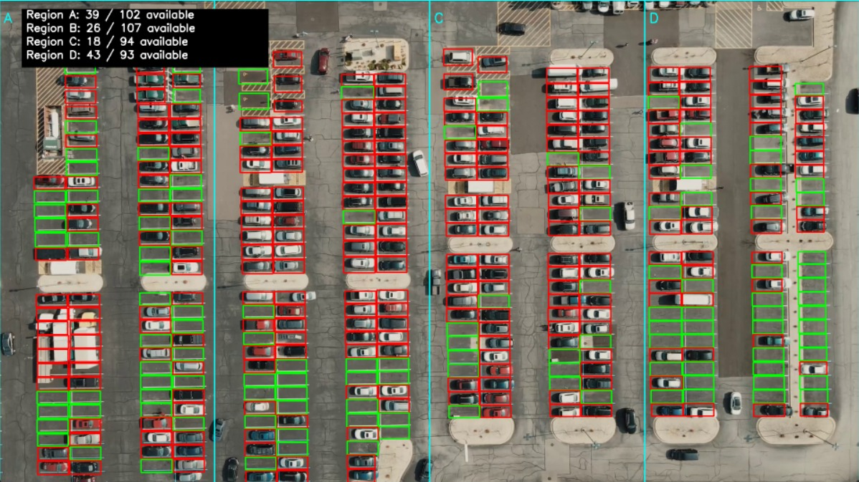
Real-Time Detection and Integration
Figure 10: Real-time video frame showing classified parking spots (e.g., green for empty, red for occupied).
During execution, incoming frames are processed to extract the defined parking regions using a pre-generated mask. Each region is classified by the trained SVM model to determine its occupancy status.
The results are passed to the FastAPI backend, which updates the system in real time and communicates with the mobile application interface.This component plays a crucial role in automating parking space monitoring, ensuring the system delivers accurate and up-to-date availability data to users.

4.3.4 PostgreSQL Database Design
The system’s backend is powered by a well-structured PostgreSQL relational database. It is responsible for managing all dynamic operations, including user registration, parking session tracking, fee calculation, and archival of historical data.

Entity Relationship Overview
The database consists of three core tables: users, car, and parking_history.
- users: Stores the credentials and registration details of users. Each user is uniquely identified by their email and is linked to a single car plate.
- car: Tracks real-time parking sessions, including entry and exit times, parking segment, and payment status. It references the user's email as a foreign key.
- parking_history: Archives all completed parking sessions. It is a read-only table used for reporting, analytics, and user history logs.
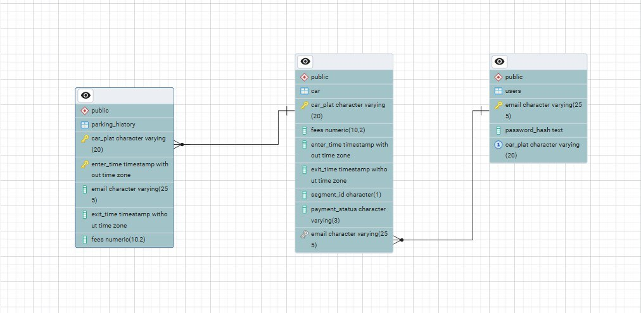
Figure 11: Entity Relationship Diagram (ERD) illustrating the core database schema.

Triggers and Automation
PostgreSQL was chosen due to its robust support for triggers and automation. The following key triggers were implemented:
- Fee Calculation Trigger: Automatically calculates parking fees when exit_time is updated, based on the duration of stay.
- Auto-Move to Archive: When a parking session ends, the record is transferred from car to parking_history, and then deleted from the active table.
- Auto-Insert on Registration: When a new user registers with a car plate, a corresponding record is automatically inserted into the car table with the current timestamp.
These features enable a highly automated and consistent data workflow with minimal backend logic.

Integration with FastAPI
The PostgreSQL database is integrated with the FastAPI backend via an ORM (e.g., SQLAlchemy or psycopg2). API endpoints handle:
- New user registration and car linking
- Car entry and exit with timestamp logging
- Fee status updates and payment confirmations
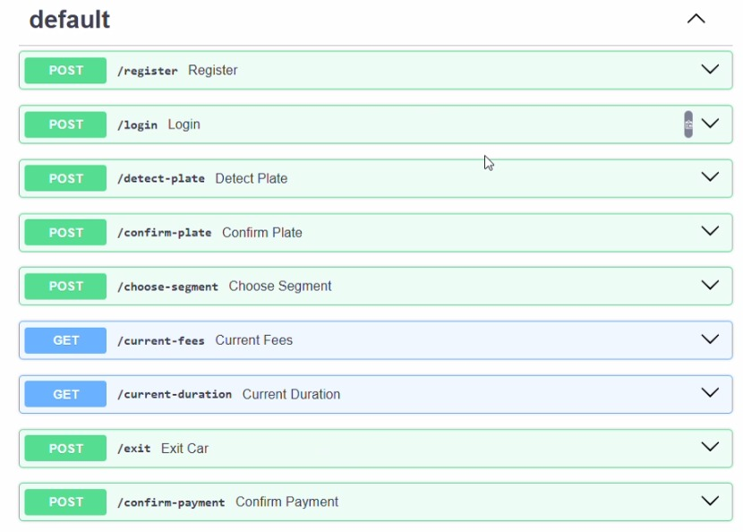
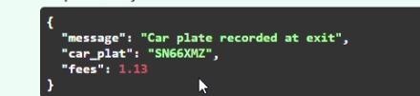
- Historical queries for users and administrators
- Figure 12 shows the list of defined endpoints exposed by the backend API along with a sample response returned by the system.
FastAPI ensures low-latency access to the database and real-time synchronization with both the mobile application and the smart gate modules.

Why PostgreSQL?
PostgreSQL was selected for the following reasons:
- Native support for triggers, constraints, and complex relationships
- High integrity and consistency for transactional systems
- Open-source, scalable, and compatible with FastAPI
- Ideal for real-time systems with time-based records and archival needs
4.3.5 Mobile Application (Flutter)
The mobile application was developed using Flutter, a cross-platform UI toolkit developed by Google. This choice was driven by Flutter's ability to produce native-quality apps for both Android and iOS from a single codebase, ensuring consistency in design and reducing development time, Purpose and Role
The mobile app serves as the main interface between the user and the smart parking system. It allows users to:
- View real-time availability of parking spots.
- Select a target destination (e.g., store or area within the mall), and get suggestions for the nearest available parking spots.
- Receive QR codes at entry points to confirm car identity and parking assignment.
- Track current parking session including fees, duration, and parking segment.
- Receive exit summaries and confirm payments (via future integration with payment gateways).

Key Features
- Live Parking Availability: Updated in real-time using SVM-based classification from the backend.
- Interactive Map UI: Displays zones and available spots using color indicators.
- Spot Reservation (Future): Allows the user to optionally reserve a nearby spot after selecting their destination.
- Entry Confirmation via QR: At the parking gate, a QR code is displayed on a small screen; the user scans it with the app to confirm entry.
- Integrated APIs: All app features communicate with the backend through FastAPI endpoints, including detection, duration, fees, and payment confirmation.
- Multilingual Support: Designed with support for both English and Arabic user interfaces.

UI Design Approach
The app was built following the MVVM (Model-View-ViewModel) design pattern:
- Model: Handles data such as spot status, user session, and parking info.
- View: Built using Flutter widgets for a responsive UI.
- ViewModel: Manages state and business logic between the backend and UI.
This pattern improves testability, simplifies state management, and ensures a reactive user experience.
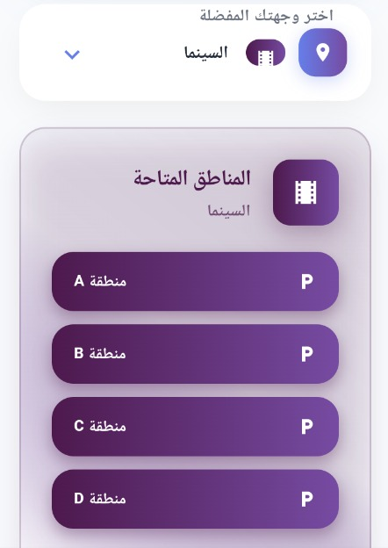
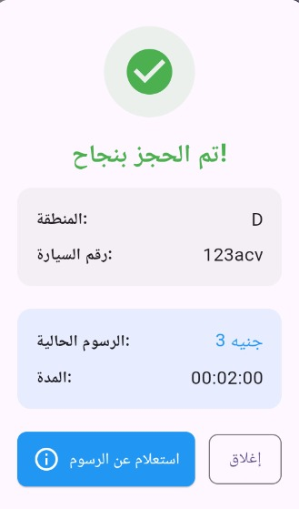
Figure 13: Mobile app interface showcasing real-time availability of parking spots. The left screen displays all available spots, while the right screen recommends the nearest available spots based on the user’s selected destination.
Figure 14: Mobile payment confirmation screen showing total parking fees and payment status.
5. Results and Discussion
5.1 Model Performance

5.1.1 Car Plate Detection (YOLOv11 + OCR)
The YOLOv11 model was trained on a custom dataset for license plate detection. During training, key loss components were monitored—box loss, classification loss, and DFL loss—alongside evaluation metrics such as precision, recall, mAP@0.5, and mAP@0.5:0.95.
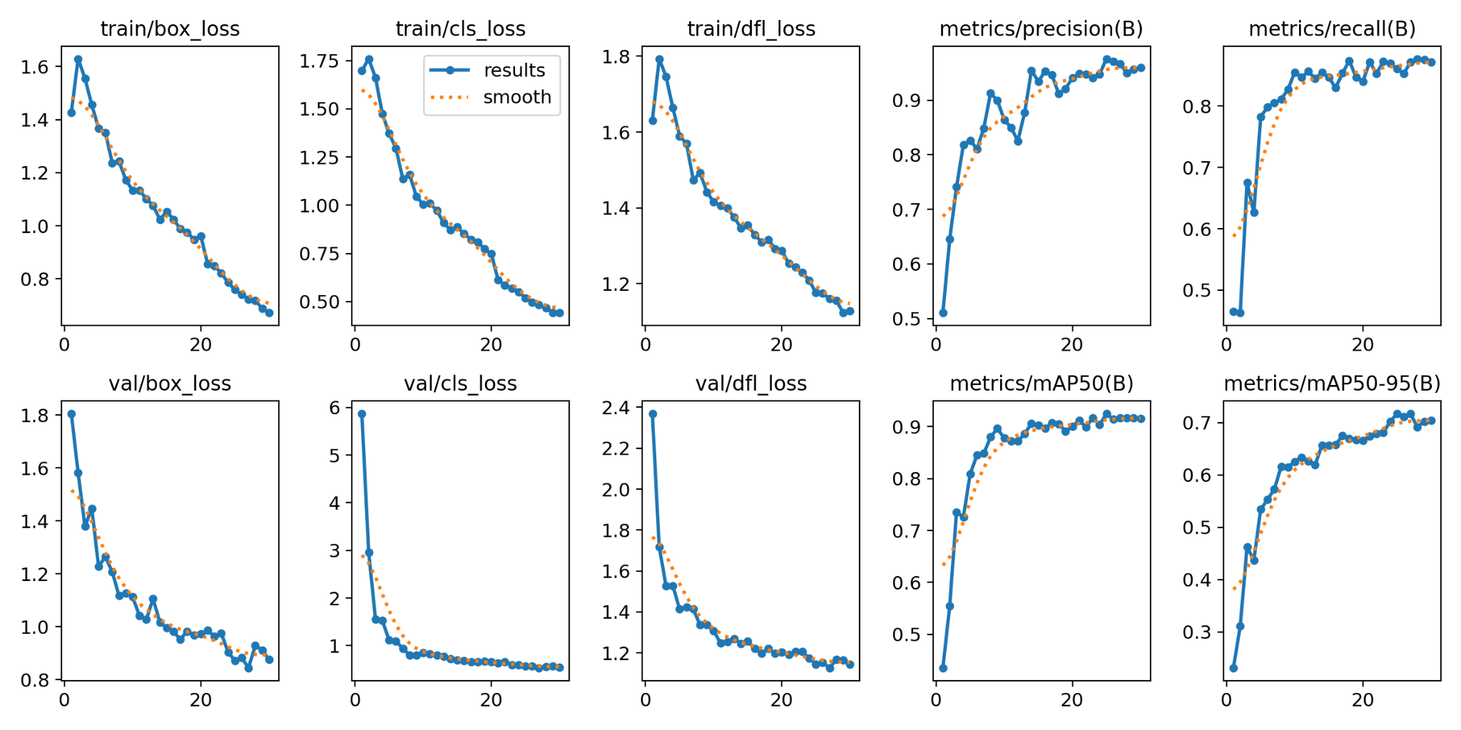
As shown in the figure below, the training and validation losses gradually decreased while precision and mAP steadily improved, indicating stable and effective model convergence.
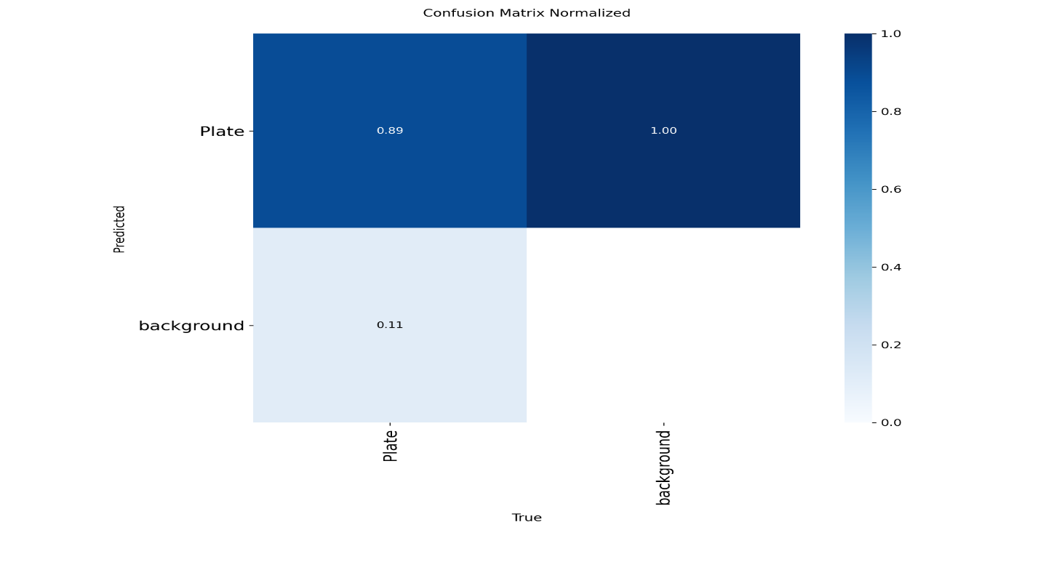
Figure 15: YOLOv11 training and validation curves for loss and evaluation metrics.
Figure 16: Confusion matrix illustrating the performance of the YOLOv11 license plate detection model.
The matrix shows that the model achieved high accuracy, with the majority of predictions correctly classified.
To further analyze the model’s performance, precision-recall and F1 score curves were plotted. These curves provide insight into the model’s behavior across different confidence thresholds and help evaluate its robustness in real-world scenarios.
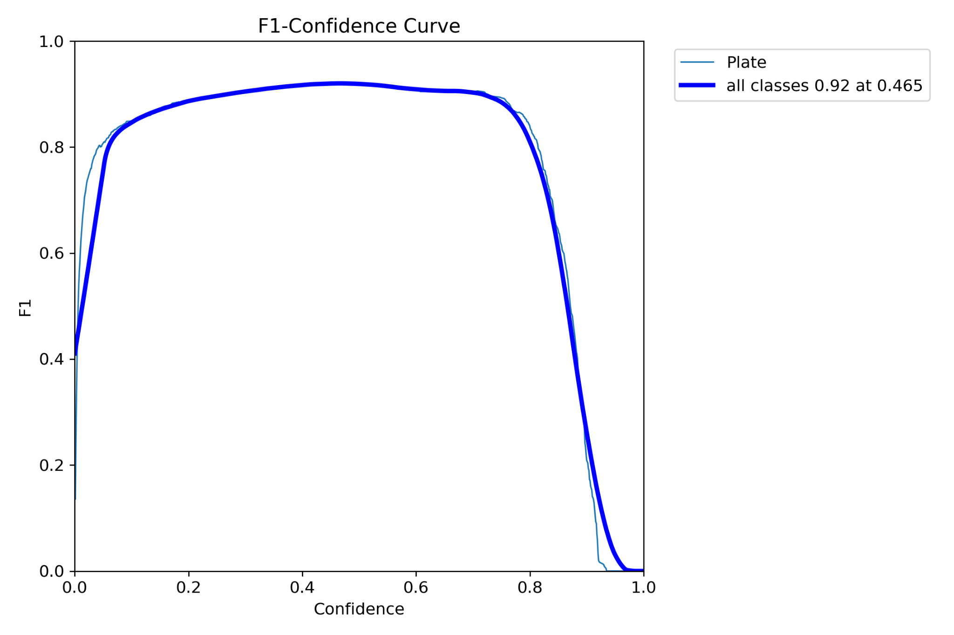 Figure 17 – Precision-Recall + F1 curves
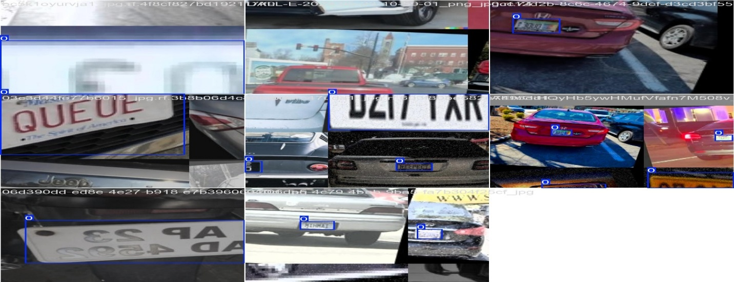
Representative test results are shown below, demonstrating the model’s performance in real-world scenarios.
Figure 18: Sample output showing successful license plate detection and recognition.

5.1.2 Parking Spot Classification (SVM Model)
The Support Vector Machine (SVM) model achieved 100% accuracy on the test set, with all classification metrics — precision, recall, and F1-score — equal to 1.0. While this performance appears perfect, it is important to note that the dataset used for training and testing was collected from a single parking area only.
As a result, the visual features of the parking spots were highly consistent, which may have reduced the complexity of the classification task. For broader deployment, additional datasets from different parking environments would be necessary to ensure robustness and generalizability of the model.
5.2 Interpretation of Results
The results obtained from both models—YOLOv11 for license plate detection and the SVM classifier for parking spot classification—indicate strong performance in controlled test environments.
The high accuracy, precision, and recall achieved by both models suggest that the system is capable of real-time, reliable deployment in a structured parking environment such as shopping malls.
Compared to traditional solutions that rely on manual parking attendants or basic sensor-based systems, the proposed approach provides a fully automated pipeline—from car entry and plate recognition to real-time spot detection and mobile-based reservation. This offers greater scalability and reduces operational overhead.
However, several limitations were observed during implementation. The car plate detection model may underperform in poor lighting conditions or when plates are occluded. Additionally, the parking spot classifier was trained using data from a single parking layout. As each parking lot has different camera angles, lighting conditions, and spatial arrangements, the model would require fine-tuning with location-specific data to maintain high accuracy and reliability across different environments. Further challenges included limited dataset availability, annotation workload, and occasional OCR misreads for low-resolution or blurry plates.
Overall, the results demonstrate the feasibility of integrating machine learning into parking systems. With broader datasets and more diverse testing conditions, the system can be scaled to support a variety of real-world deployments.
6. Illustrative Examples
To demonstrate the end-to-end functionality of the Smart Parking system, this section presents a complete scenario from car entry to exit, showcasing how various system components interact in real time.

Example: Full Parking Session Flow
- Vehicle Entry and License Plate Recognition
Upon arrival at the mall’s parking entrance, a camera captures the incoming vehicle’s license plate. The image is processed using a YOLOv11-based detection model, which localizes the plate region. Optical Character Recognition (OCR) is then applied to extract the plate number as text. This number is saved in the PostgreSQL database and associated with the user’s profile.
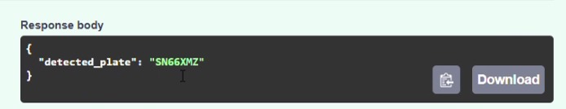
Figure 19: Detected license plate and extracted number displayed via the API.
To ensure accuracy and prevent incorrect plate assignments, the detected plate number is displayed on a nearby screen inside the parking gate in the form of a QR code. The user is required to scan and approve the result using the mobile application, confirming the correct plate before proceeding.

Figure 20: QR code display at the parking entrance for user plate number confirmation, generated after license plate detection and OCR processing.
- Parking Spot Detection and Mobile Interaction
The parking lot is continuously monitored by a static overhead camera. The captured frames are analyzed using a pre-trained Support Vector Machine (SVM) model to classify each spot as either "empty" or "not empty". The system updates the availability status in real time, and the mobile app presents the user with nearby available spots.
The user has two interaction options:
- Browse all available parking spots in real time
- Select the store or area they plan to visit, and the system will recommend the nearest available spots based on that location.
- Exit and Fee Calculation
When the user leaves, the system re-detects the vehicle and records the exit_time. A backend trigger automatically calculates the total parking duration and assigns the appropriate fee. This transaction is saved to the parking_history table, and the active session is removed from the car table.
This example illustrates the system’s ability to operate autonomously without human intervention while maintaining high accuracy and real-time performance across detection, data management, and user interaction.
7. Impact
7.1 Target Audience
The primary beneficiaries of the Smart Parking system are:
- Mall Visitors:
Individuals who frequently face difficulties finding available parking during peak hours. The system provides real-time information about vacant spots, reduces search time, and improves the overall parking experience by suggesting the closest spots to their intended destination.
- Mall Administration and Facility Management:
The system enables efficient parking management through automation. Real-time monitoring of parking usage, automated entry/exit logging, and fee calculation reduce the need for human intervention and improve operational efficiency.
- Security and Operations Teams:
By maintaining a centralized and continuously updated record of vehicle entries and exits, the system enhances security and supports traffic flow analysis. Additionally, this data can be used to investigate parking-related incidents, such as vehicle collisions, unauthorized parking, or suspicious behavior.
- Mobile App Users:
Users benefit from the ability to reserve spots in advance, track where they parked, and complete payment processes seamlessly through the application.
This multi-stakeholder design ensures that the Smart Parking system addresses the pain points of both end users and system operators, resulting in a more organized, efficient, and user-friendly parking environment.

7.2 Innovative Aspects of the Design
The Smart Parking system introduces several innovative elements that distinguish it from traditional parking solutions:
- AI-Based Parking Spot Detection
Instead of relying on physical sensors installed in each parking spot, the system uses computer vision and a Support Vector Machine (SVM) classifier to analyze video feeds and determine spot availability. This significantly reduces infrastructure costs and simplifies deployment.
- License Plate Recognition and OCR Pipeline
A combination of YOLOv11 and Optical Character Recognition (OCR) is used for accurate, real-time plate detection and text extraction. This enables fully automated entry and exit without human intervention or RFID systems.
- Location-Aware User Assistance
The mobile application allows users to select their destination within the mall. Based on this input, the system recommends the nearest available parking spots, optimizing the experience and minimizing walking distance—an uncommon feature in typical smart parking systems.
- Automated Fee Calculation and Archiving via Database Triggers
The backend system leverages PostgreSQL triggers to automate parking fee calculation, session archiving, and user-car linking. This reduces backend complexity and ensures data integrity with minimal manual logic.
- Cross-Platform Mobile App with Real-Time Updates
Built using Flutter, the mobile application supports both Android and iOS platforms from a single codebase and synchronizes in real-time with the backend for live parking status, fee updates, and spot reservations.
Together, these design innovations result in a cost-effective, scalable, and user-centric parking solution that improves upon existing systems by reducing hardware dependencies, increasing automation, and enhancing user convenience.
7.3 Reliability
The reliability of the Smart Parking system was ensured through rigorous testing and validation procedures across all core components:
- Model Validation and Performance Testing
Both the car plate detection and parking spot classification models were trained and evaluated using diverse, annotated datasets. The models achieved high accuracy on unseen test data, with consistent performance across different lighting and environmental conditions.
- Backend and API Testing
The FastAPI backend was tested using automated unit and integration tests to verify endpoint functionality, data consistency, and response times. Critical operations such as vehicle entry logging, fee calculation, and historical archiving were validated under multiple scenarios.
- Database Integrity and Automation
PostgreSQL constraints and triggers were implemented to enforce data integrity, automate fee computation, and reduce manual errors. These features were stress-tested to ensure stable performance under concurrent user operations.
- Real-Time Video Detection Stability
The real-time parking spot detection module was tested on continuous video feeds to confirm that it could reliably detect changes in occupancy without false positives or system crashes.
- Mobile Application Reliability
The Flutter-based app was tested across different Android and iOS devices to ensure cross-platform consistency, stable data synchronization, and smooth user experience.
These extensive testing procedures confirm that the system is reliable, scalable, and ready for deployment in real-world mall environments.
7.4 Added Value
The Smart Parking system introduces tangible benefits across multiple domains:
- For End Users
The system enhances the parking experience by minimizing search time, allowing spot reservations, and guiding users to the closest parking area to their destination within the mall. Features like car location memory and instant fee calculation add further convenience and user satisfaction.
- For Mall Operators and Facility Managers
The automation of parking operations reduces the need for manual staff, streamlines vehicle flow, and improves security through accurate entry/exit logs. Real-time analytics offer insights into parking demand, peak times, and operational efficiency.
- For Researchers and Developers
The modular system architecture and open-source technologies (YOLO, SVM, FastAPI, PostgreSQL, etc.) make it a valuable reference for future development in smart city infrastructure, computer vision applications, and real-time systems.
- For the Industry
This project serves as a scalable model for smart parking systems in various sectors—including airports, universities, hospitals, and event venues. Its cost-effective, sensor-free design makes it easier to deploy in both new and existing infrastructures.

Future Enhancements
- Integration with digital payment gateways.
Deployment of multi-camera fusion for large-scale lots.
- Adaptive learning based on parking behavior trends.
- Admin dashboard for live monitoring and analytics.
By bridging AI, real-time systems, and mobile UX, this solution provides a modern, efficient, and user-centric alternative to traditional parking systems..
8. Conclusions
The Smart Parking system presented in this project offers a practical and intelligent solution to the challenges faced by visitors in shopping mall parking areas. By combining AI-powered license plate detection, real-time parking space monitoring, and mobile-based user interaction, the system enhances the parking experience through automation and convenience.
The project demonstrated the feasibility of integrating machine learning models such as YOLO and SVM with modern backend technologies like FastAPI and PostgreSQL. The developed models achieved high accuracy in detecting both license plates and the availability of parking spots. Furthermore, the mobile application provided users with features such as real-time reservation, parking history, and guidance to the nearest available spot.
The significance of this work lies in its potential to reduce traffic congestion, improve customer satisfaction, and streamline mall operations. The system also provides a foundation for future expansions, including spot-level detection, digital payment integration, and gate automation through embedded systems.
Throughout the development process, several challenges were encountered — such as the need for dataset collection tailored to each specific parking lot, model tuning for real-world performance, and hardware integration. These challenges provided valuable learning experiences in data preprocessing, model deployment, and real-time system design.
Overall, the Smart Parking system showcases how AI, computer vision, and real-time software engineering can be combined to solve real-world problems with measurable impact and scalability.

9. Future Directions
While the current implementation of the Smart Parking system has proven successful in automating and improving the parking experience, several areas remain open for further development and enhancement.
One of the primary future goals is to collect larger and more diverse datasets from real-world parking lots. Specifically, we aim to move beyond general region-level detection and train the system to identify individual parking spots with greater precision. This requires fine-tuning the detection model using custom datasets from larger parking areas with clear spot-level annotations.
Another important direction is the integration with embedded systems to enable full automation of gate control. By connecting the license plate recognition output to microcontrollers (e.g., Arduino or Raspberry Pi), the system will be able to automatically open the entry gate for authorized vehicles, eliminating the need for manual checks and further improving the user experience.
In addition, the system could benefit from integration with digital payment gateways, allowing users to pay their parking fees seamlessly via the mobile app. This would enhance convenience and reduce the need for physical payment stations.
Future versions of the system can also explore scaling the deployment to larger environments such as airports, universities, or public parking lots, where demand for smart parking is high.
Lastly, enhancing the user experience (UX) within the mobile app—such as adding interactive mall maps, real-time occupancy notifications, and personalized suggestions—can make the system more user-friendly and efficient.
.

References
[1] Ultralytics, “YOLOv11 - You Only Look Once, Version 11,” Ultralytics Documentation, 2024. [Online]. Available: https://docs.ultralytics.com
[2] TextExtractor OCR, “TextExtractor - Lightweight Optical Character Recognition for License Plate Reading,” GitHub, 2024. [Online]. Available: https://github.com/
[3] OpenCV, “Open Source Computer Vision Library,” OpenCV.org. [Online]. Available: https://opencv.org
[4] FastAPI, “FastAPI Documentation,” Tiangolo.com. [Online]. Available: https://fastapi.tiangolo.com
[5] PostgreSQL Global Development Group, “PostgreSQL: The World’s Most Advanced Open Source Relational Database,” PostgreSQL Documentation. [Online]. Available: https://www.postgresql.org
[6] Kaggle, “Kaggle API: Dataset and Notebook Access for Developers,” Kaggle Documentation, 2024. [Online]. Available: https://www.kaggle.com/docs/api
[7] Roboflow, “Roboflow: Organize, Label, and Preprocess Datasets for Computer Vision,” Roboflow Platform. [Online]. Available: https://roboflow.com
[8] scikit-learn, “Support Vector Machines – sklearn.svm.SVC,” scikit-learn Documentation. [Online]. Available: https://scikit-learn.org/stable/modules/svm.html
[9] Flutter, “Flutter: Build for Any Screen,” Google Developers. [Online]. Available: https://flutter.dev
[10] GitHub, “GitHub Documentation,” GitHub Docs. [Online]. Available: https://docs.github.com
[11] Visual Studio Code, “VS Code: Code Editing. Redefined,” Microsoft Docs. [Online]. Available: https://code.visualstudio.com
[12] Postman, “API Platform for Building and Using APIs,” Postman Documentation, 2024. [Online]. Available: https://www.postman.com

Appendices

Endpoint | Method | Purpose / Description
register | POST | Register a new user with email and password.
login | POST | Authenticate user and return JWT token.
detect-plate | POST | Detect car plate number from an uploaded image (no DB insert).
confirm-plate | POST | Confirm scanned plate and email; save data to users and car tables.
choose-segment | POST | Assign a parking segment (A–D) for the given car plate.
current-fees | GET | Retrieve live parking fee for the current car session (based on database view).
current-duration | GET | Retrieve total time the car has been parked (live duration).
exit | POST | At exit: detects plate, saves exit time, and returns plate + fee.
confirm-payment | POST | Update payment status to “yes” after exit confirmation.
status | Post | Accepts an uploaded image and returns the current parking status by region.
last-status | Get | Returns the most recent detection result without re-processing an image.
Table 5: Summary of core API endpoints used in the Smart Parking system.
This table outlines the main RESTful endpoints exposed by the FastAPI backend. Each endpoint serves a specific role in handling user authentication, license plate detection, parking management, and fee processing. These endpoints are designed to ensure efficient and real-time communication between the mobile application, backend services, and the database systems




The following figures present the key user interface components of the Smart Parking mobile application developed using Flutter. These screens illustrate the app’s core functionalities, including:

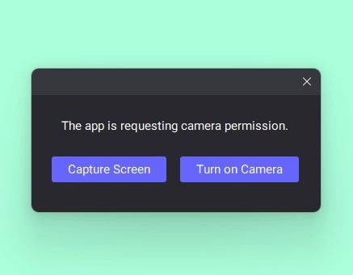

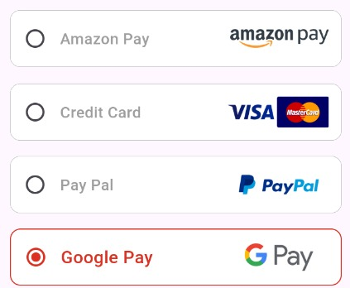


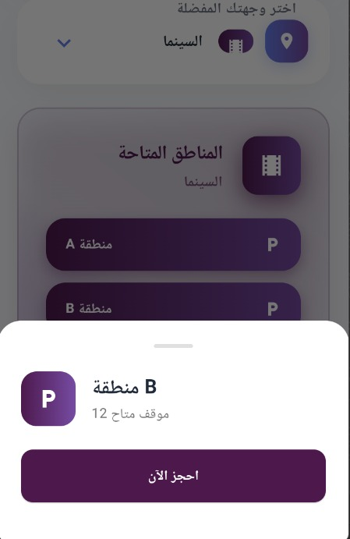




Figures 1–12: User Interface Screens of the Mobile Application
These images showcase the main UI components of the Smart Parking app, including login, available spot views, plate confirmation, and payment screens.
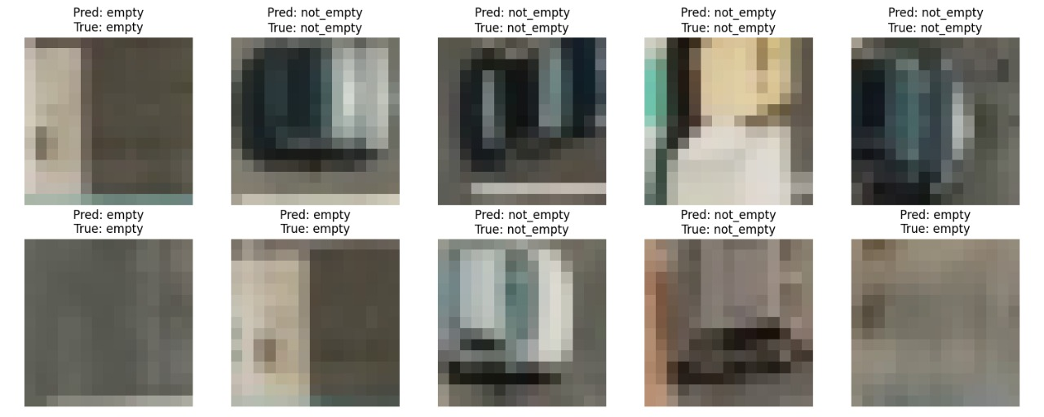
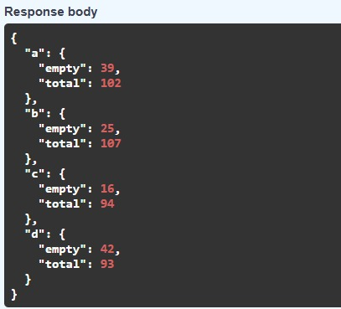
Figure 14: Sample predictions from the SVM model for parking spot classification.
Each image shows the predicted and actual (true) class label: either "empty" or "not_empty". The results indicate high accuracy with correctly matched predictions across various lighting and angle conditions.
Figure 13: API response showing predicted parking spot status.
The system returns the car plate number along with the real-time duration of the vehicle’s presence in the parking lot.

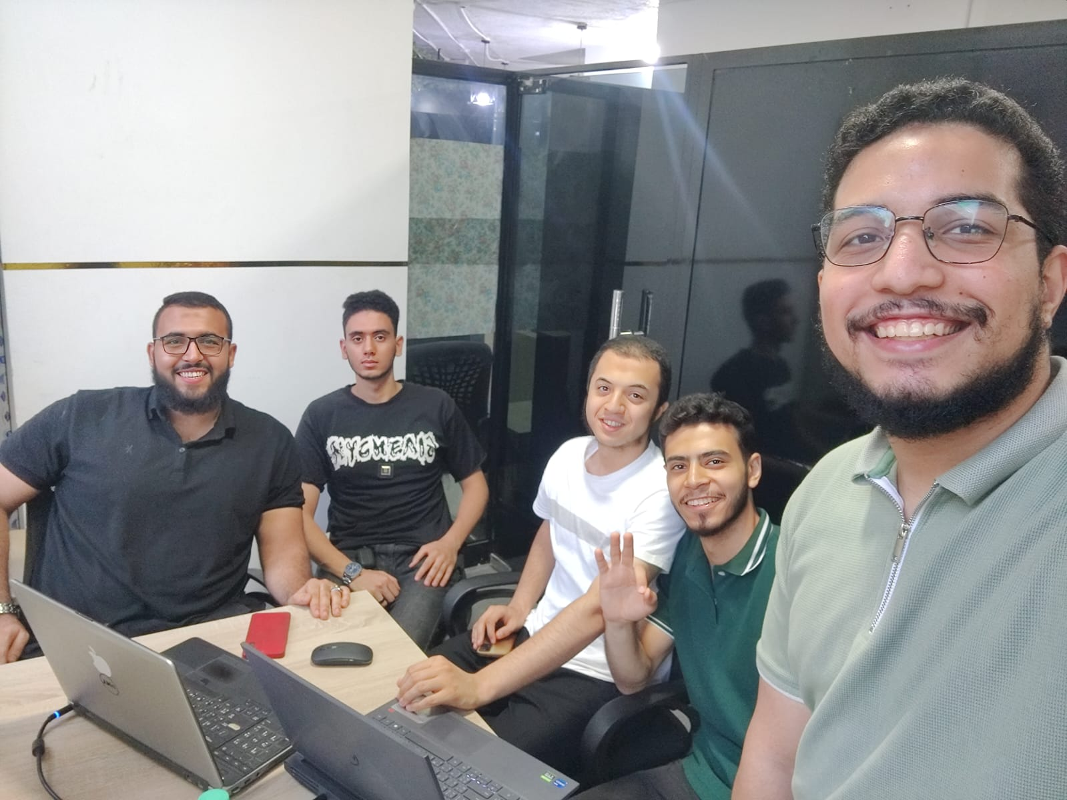

Figure 14 : Team members during live testing and system integration phase at the workspace.

