

**Faculty of engineering - Shoubra Benha University**

# Research Article / Research Project / Literature Review

in fulfillment of the requirements of

|  |  |
| --- | --- |
| **Department** | **Engineering Mathematics and Physics** |
| **Division** | ----------- |
| **Academic Year** | **2019-2020 Preparatory** |
| **Course name** | **Computer** |
| **Course code** | **ECE001** |

**Title: -**

**Computer Architecture**

By:

|  |  |  |  |
| --- | --- | --- | --- |
|  | Name | Edu mail | B.N |
| 1 | يوسف اسماعيل محمد حسنين | Youssif196179@feng.bu.edu.eg | 1043 |

## Approved by:

|  |  |
| --- | --- |
| Examiners committee | Signature |
|  |  |
|  |  |
|  |  |
|  |  |
|  |  |

**Research objectives**

This research aims to Understand the meaning of computer Architecture,

The history of computer development, the different types of architectures and its applications.

Create a website to represent the topics above using HTML.

# Abstract

Computer architecture concentrates on the logical aspects of computer design as opposed to the physical or electronic aspects. The underlying logical design of most modern computers is still based on that of the earliest electronic computers despite decades of progress in electronic circuitry. the innovations that have occurred in computer architecture have been driven by two different goals: higher performance and lower cost. Performance driven improvements have yielded computer systems with increasingly higher computation speeds and throughput. Cost driven improvements have yielded systems that are easier to use and applicable to a broader range of automatic control problems. Improvements in electronic circuitry have not led directly to architectural innovations; computers that pioneered new circuit technologies usually relied on older architectural concepts.

GitHub:

<https://github.com/youssefismael/html_project>

GitHub Pages:

<http://youssefismael.github.io/html_project/>

**Introduction**

Computer architecture is a specification describing how hardware and software technologies interact to create a computer platform or system. When we think of the word architecture, we think of building a house or a building. Keeping that same principle in mind, computer architecture involves building a computer and all that goes into a computer system.

### First Generation (1940-1950) – Vacuum Tube

ENIAC- 1945: Designed by Mauchly & Echert, built by US army to calculate trajectories for ballistic shells during WWII, used 18000 vacuum tubes and 1500 relays, programmed by manually setting switches

UNIVAC – 1950: the first commercial computer

### Second Generation (1950-1964) – Transistors

William Shockley, John Bardeen, and Walter Brattain invent the transistor that reduce size of computers and improve reliability.

* First operating Systems: handled one program at a time
* On-off switches controlled by electricity
* High level languages
* Floating point arithmetic
* Reduced the computational time from milliseconds to microseconds
* First operating Systems: handled one program at a time
* 1959 – IBM´s 7000 series mainframes were the company´s first transistorized computers

### Third Generation (1964-1974) – Integrated Circuits (IC)

* Microprocessor chips combines thousands of transistors, entire circuit on one computer ship
* Semiconductor memory
* Multiple computer models with different performance characteristics
* Smaller computers that did not need a specialized room
* 2 Mb memory, 5 MIPS
* Use of cache memory
* IBM’s System 360 – the first family of computers making a clear distinction between architecture and implementation

### Fourth Generation (1974-present) Very Large-Scale Integration (VLSI)/Ultra Large Scale Integration (ULSI)

* Combines millions of transistors
* Single-chip processor and the single-board computer emerged
* Creation of the Personal Computer (PC)
* Wide spread use of data communications
* Artificial intelligence: Functions & logic predicates
* Object-Oriented programming: Objects & operations on objects
* Massively parallel machine
* Smallest in size because of the high component density

# Literature Review

## Categories of Computer Architecture

Computer architecture consists of three main categories.

### System design

This includes all the hardware parts, such as CPU, data processors, multiprocessors, memory controllers and direct memory access. This part is the actual computer system.

### Instruction set architecture

The includes the CPU’s functions and capabilities, the CPU’s programming language, data formats, processor register types and instructions used by computer programmers. This part is the software that makes it run, such as Windows or Photoshop or similar programs.

### Microarchitecture

This defines the data processing and storage element or data paths and how they should be implemented into the instruction set architecture. These might include DVD storage devices or similar devices.

## Computer Architecture Implementation

Once an instruction set and micro-architecture have been designed, a practical machine must be developed. This design process is called the implementation. Implementation is usually not considered architectural design, but rather hardware design engineering. Implementation can be further broken down into several steps:

1. **Logic implementation**

designs the circuits required at a logic-gate level

1. **Circuit implementation**

does transistor-level designs of basic elements (e.g., gates, multiplexers, latches) as well as of some larger blocks (ALUs, caches etc.) that may be implemented at the log-gate level, or even at the physical level if the design calls for it.

1. **Physical implementation**

draws physical circuits. The different circuit components are placed in a chip floorplan or on a board and the wires connecting them are created.

1. **Design validation**

tests the computer as a whole to see if it works in all situations and all timings. Once the design validation process starts, the design at the logic level are tested using logic emulators. However, this is usually too slow to run realistic test.

**Different architectures were designed by different manufacturers like:**

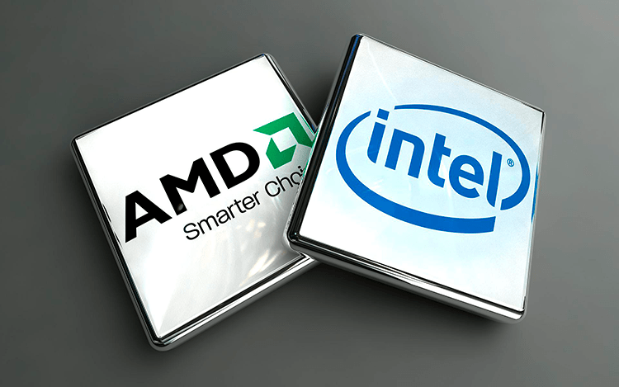

* **x86, made by Intel and AMD**

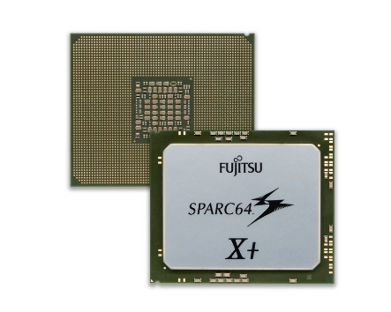

* **SPARC, made by Sun Microsystems**

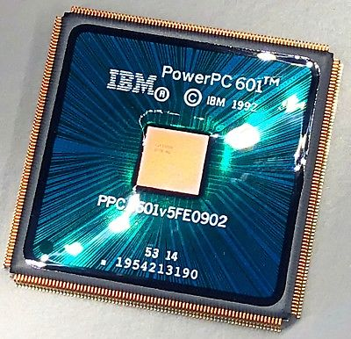

* **PowerPC, made by Apple, IBM, and Motorola**

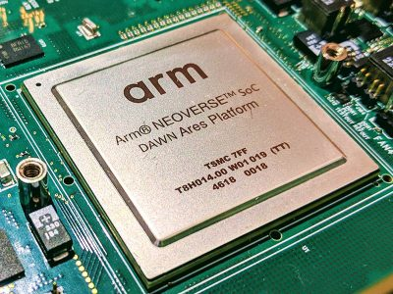

* **ARM, made by ARM**

# Website

The website consists of 5 pages section:

* First page is definition of Computer Architecture.
* Second is the History of Computer Architecture.
* Third is different categories of computer architecture.
* Forth is the implementation steps.
* And fifth contains some Examples.

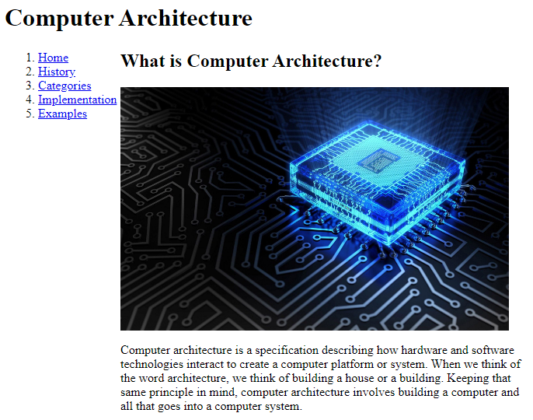

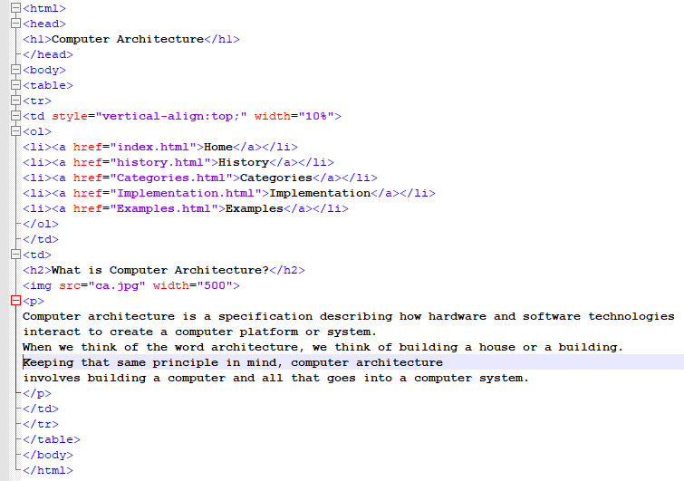

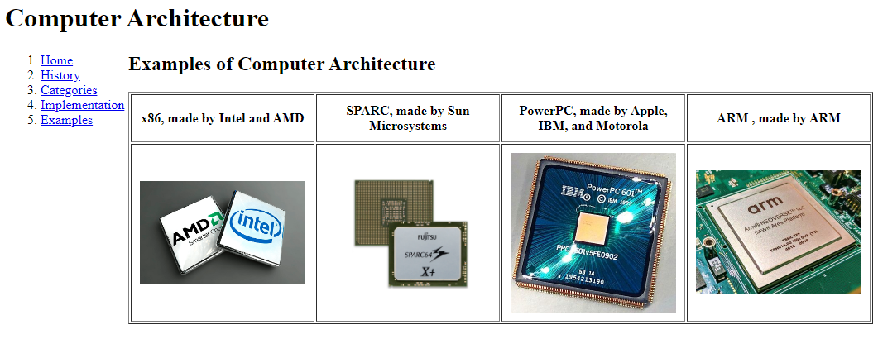

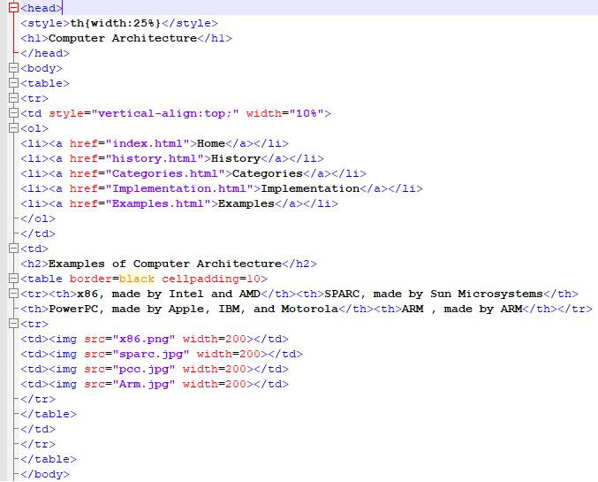

# Conclusions

Computer architecture is the heart of computer build you can’t start any building project without the proper design and engineering exactly that’s how you build a computer.

Every mobile, laptop, tv even the fridge has a computer inside to maintain it’s functioning as intended. This computer has already been designed by a computer architect who understands Computer architecture well.