1. Using analytical methods calculate the following for the given set of tasks

a) Calculate the system hyperperiod

b) Calculate the CPU load

c) Check system schedulability using URM and time demand analysis techniques (Assuming the given set of tasks are scheduled using a fixed priority rate -monotonic scheduler)

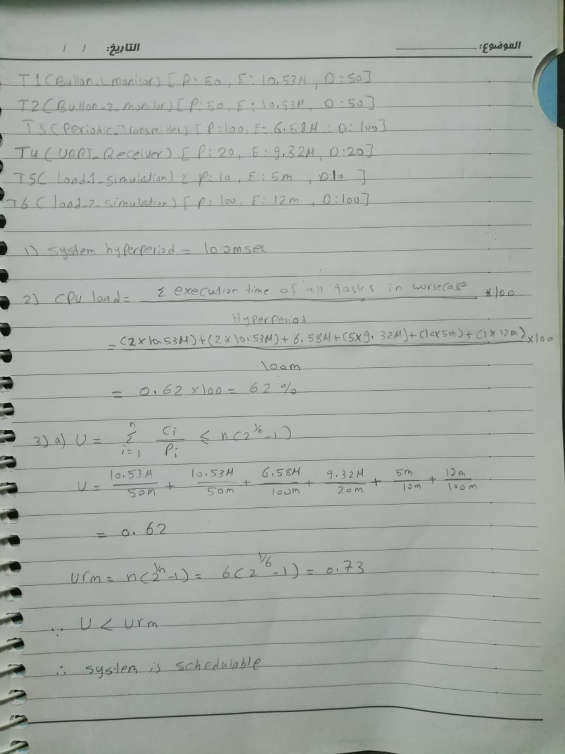

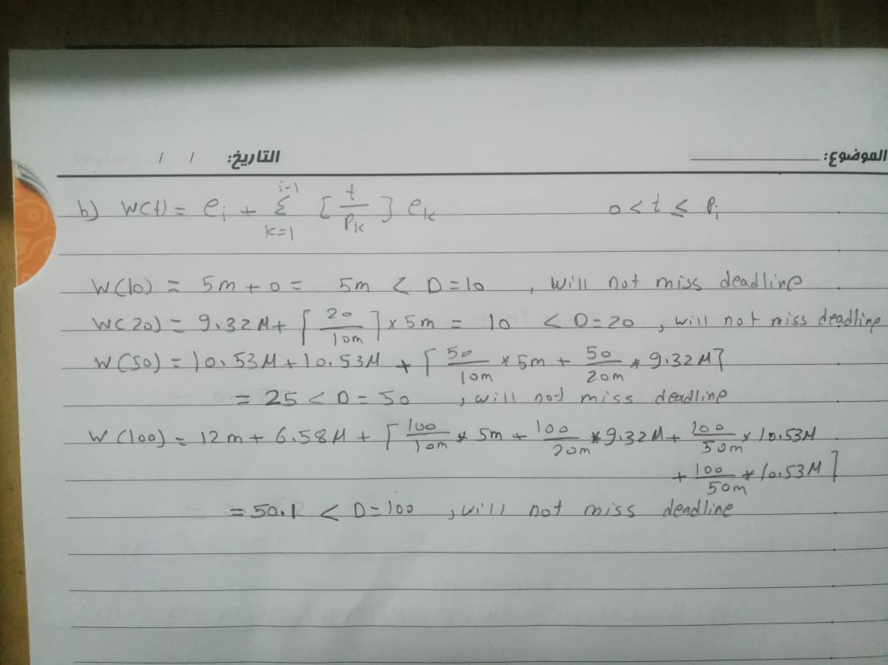

2. Using Simso offline simulator, simulate the given set of tasks assuming:

"Fixed priority rate monotonic scheduler "

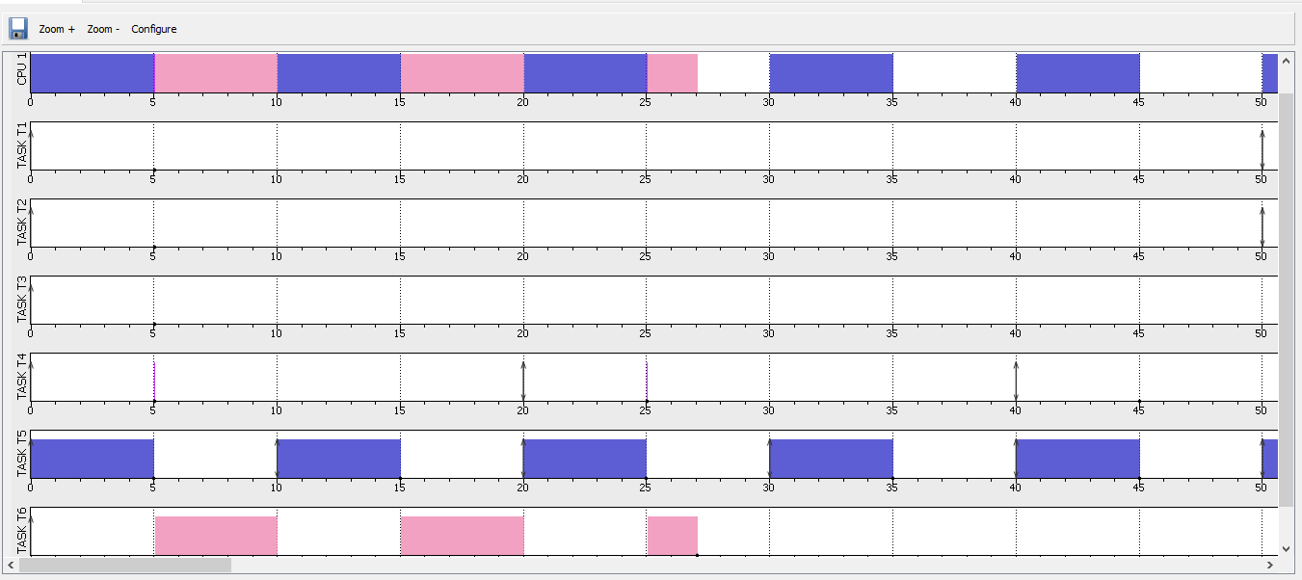

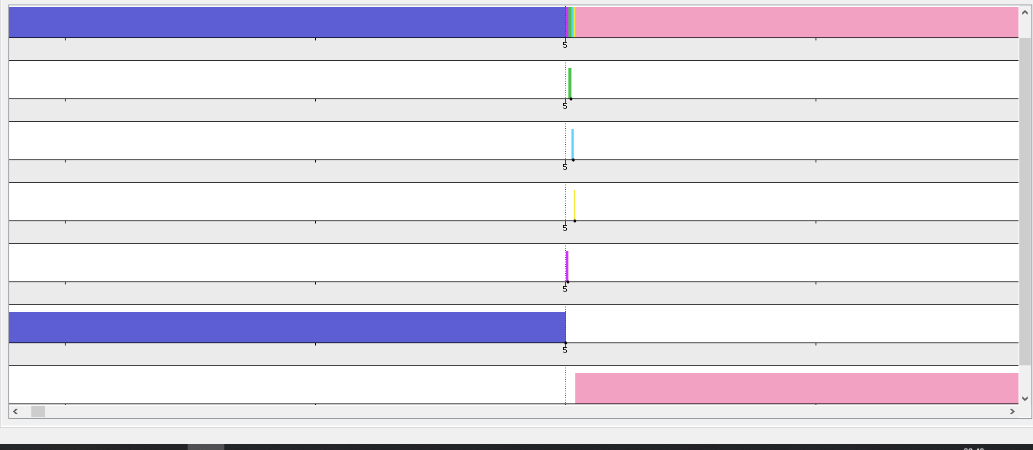



3. Using Keil simulator in run-time and the given set of tasks:

a) Calculate the CPU usage time using timer 1 and trace macros

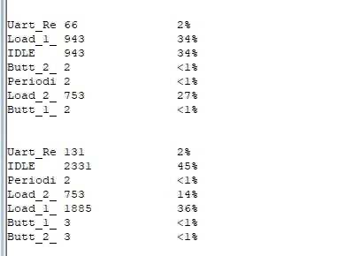

b) Using trace macros and GPIOs, plot the execution of all tasks, tick, and the idle

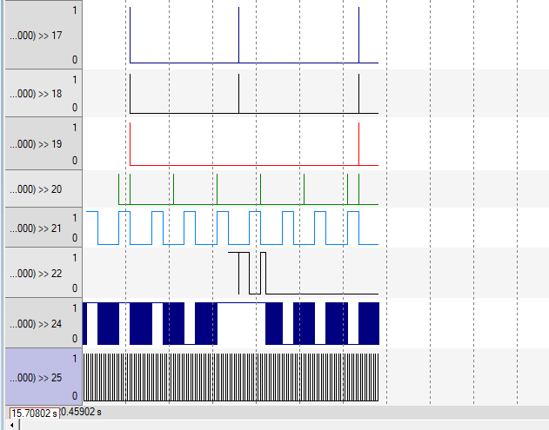task on the logic analyzer

Butt_1_Monitor

Butt_2_Monitor

Periodic_Transmitter

Uart_Receiver

Load_1_Simulation

Load_2_Simulation

IdleHook

TickHook

Comment:

I get results as expected