 |  |  |  |  |  |  |  |  |  | APPLICATION FORM |  |  |  |  |  |  |  |  |  | Branch/AE: {agent_name}
HIPTV |  |  |  |  |  |  |  |  |  |  |  |  |  |  | HIPTV w/ Broadband
FOR RESIDENTIAL SUBSCRIBERS
Last Name: {last_name} |  |  |  |  |  |  |  |  |  | First Name: {first_name} |  |  |  |  |  |  |  |  |  | Middle Name: {middle_name}
House Phone:  {hp} |  |  |  |  |  | Office Phone: {op}  Mobile Phone: {mobile} |  |  |  |  |  | Email Address: {email} |  |  |  |  |  | ID Type/No.: {id_no} |  |  |  |  |  | Proof of Bill Address: {POB}
Birthdate: {birthdate} |  |  |  |  |  | Age: {age} |  |  |  |  |  | Sex: {sex} |  |  |  |  |  | Civil Status: {civil_status} |  |  |  |  |  | Spouse Name: {spouse_name}
Home Address: |  |  |  |  |  |  |  |  |  |  |  |  |  |  | Work Information
House/Block/Unit No.: {house_no}  Street: {street}  Building: {building}  District/Subdivision: {subd}  Barangay: {barangay}  Municipality: {municipality} |  |  |  |  |  |  |  |  |  |  |  |  |  |  | Occupation/Position: {occupation}  Employer: {employer}  Address: {occ_address}  Spouse Occupation: {spouse_occ}  Employer: {spouse_emp}  Address: {spouse_add_occ}
House: |  |  |  |  | {box_owned} owned |  |  |  |  | {box_rent} rent |  |  |  |  | {box_living_with_relatives} living w/relatives
Home Type: |  |  |  |  | {box_single_detached} single detached |  |  |  |  | {box_condominium} condominium |  |  |  |  | {box_apartment} apartment |  |  |  |  | {box_townhouse} townhouse |  |  |  |  | {box_others} others
FOR BUSINESS SUBSCRIBERS
Company Name:
Address:

Nature of Business: |  |  |  |  |  |  |  |  |  | No. of Years in Business: |  |  |  |  |  |  |  |  |  | SEC/DTI Registration No.:
Authorized Signatory: |  |  |  |  |  |  |  |  |  | Position/Designation: |  |  |  |  |  |  |  |  |  | Office Phone:  Fax Phone:
TO BE FILLED UP BY THE COMPANY |  |  |  |  |  |  |  |  |  |  |  | Installation Address Sketch / Landmarks
Monthly Recurring Charge (MRC)
VIDEO SERVICE
HIPTV :
TV Extension :
No. of TV extension:

Sub-Total:

BROADBAND SERVICE:
Cheetah Broadband

{plan_name} : {plan_value}

Sub-Total:

TOTAL MRC: {plan_value}

Initial Charges:
Installation Fee - TV :
Installation Fee - TV Extension:
Installation Fee - Broadband :
One Month Security Fee :
Others :
:

Total Inital Charge: {plan_value}
I affirm that the above information and supporting documents are true and correct. I hereby confirm that I have carefully read and understood the terms and conditions of this service agreement written at the back. I hereby undertake to pay the service provider the above charges pursuant to the agreement and to maintain good standing of my subscription to service provider.
 |  |  |  |  | Subscriber’s Signature: |  |  |  |  |  |  |  |  |  |  |  |  |  |  | Date: {date}

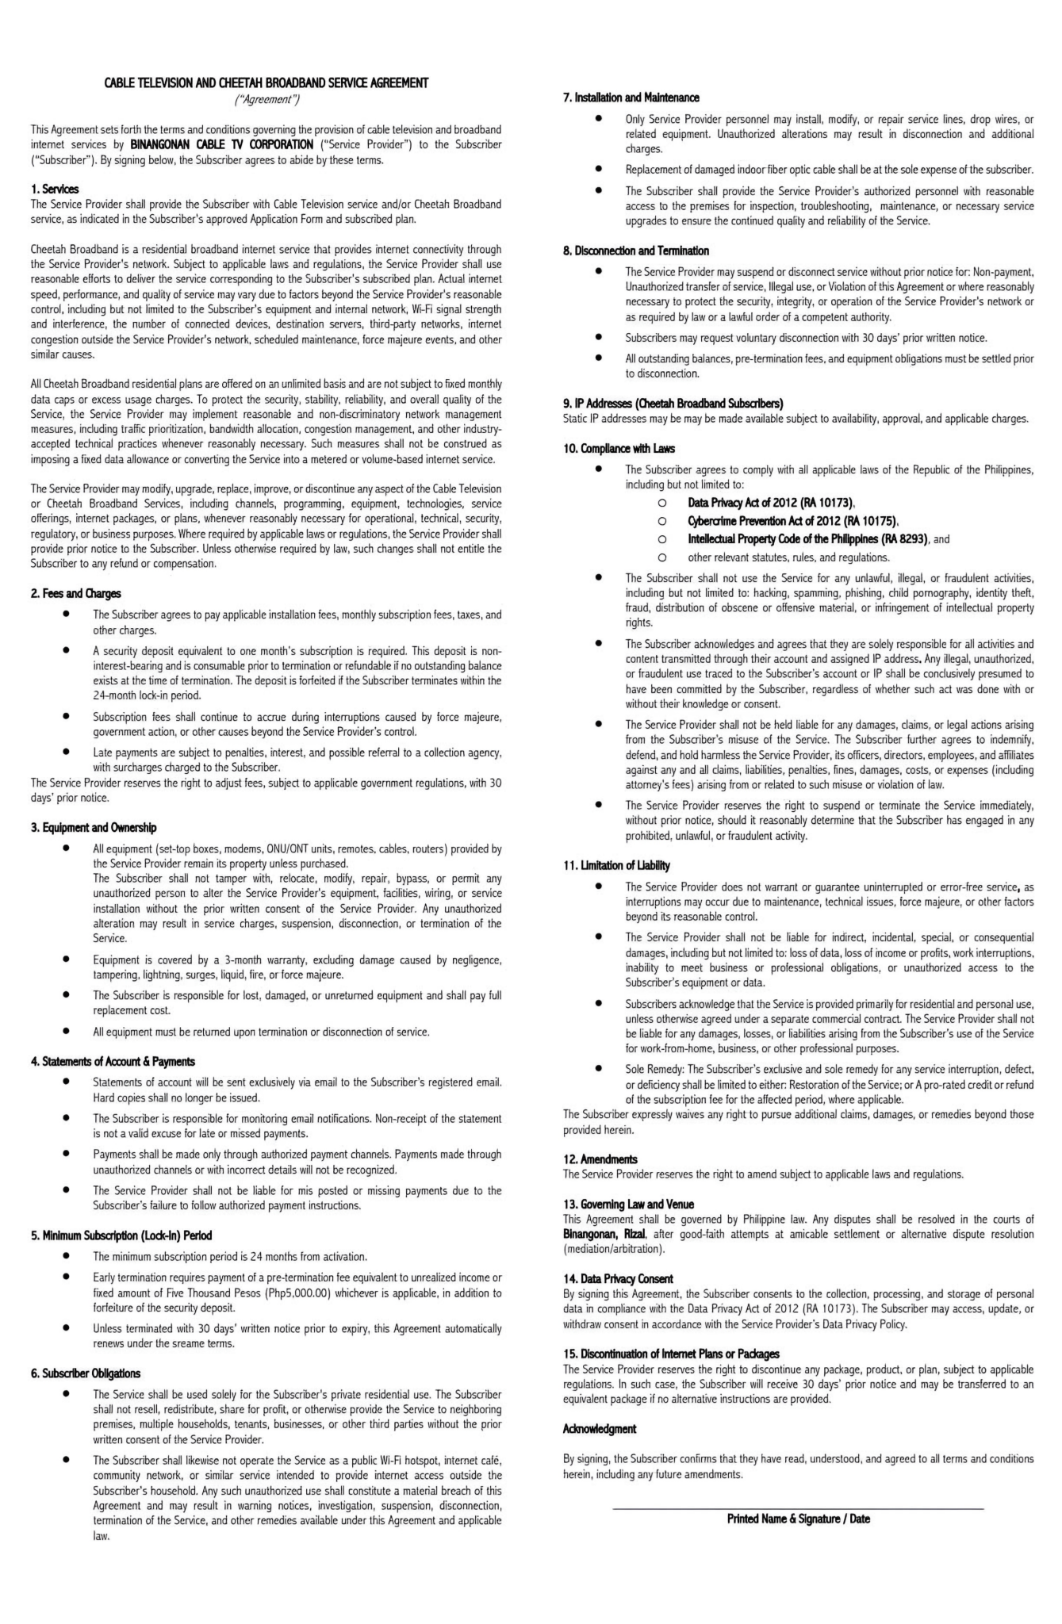

{first_name} {last_name} / {date}

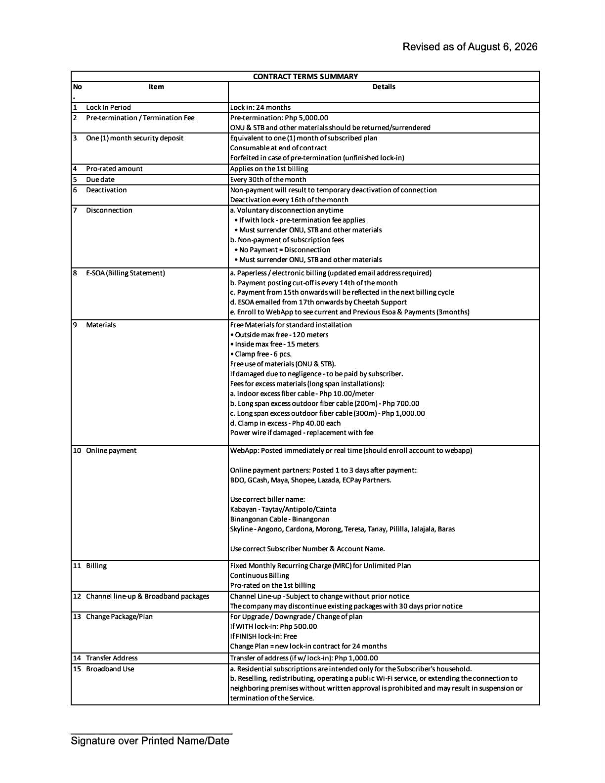
{first_name} {last_name} / {date}

REQUIREMENTS:

