Udacity Project 4 - Screenshots

Table of Contents
1 - Build Jobs that failed because of compile errors. 2
2 - Failed unit tests 3
3 - Failure because of vulnerable packages 4
4 - An alert from one of your failed builds 5
5 - Console output of appropriate failure for infrastructure creation job 6
6 - Console output of a smoke test job that is failing appropriately 7
7 - Console output of a successful rollback after a failed smoke test 8
8 - Console output of successful promotion of new version to production in CloudFront 9
9 - Console output of a successful rollback after a failed smoke test 10
10 - Evidence that deploy jobs only happen on master branch 11
11 - Evidence that Prometheus is monitoring memory, cpu and disk usage of EC2 instances 12
12 - Evidence that Prometheus and AlertManager send alerts when certain conditions exist in the EC2 instance 13

1 - Build Jobs that failed because of compile errors
Job (10)
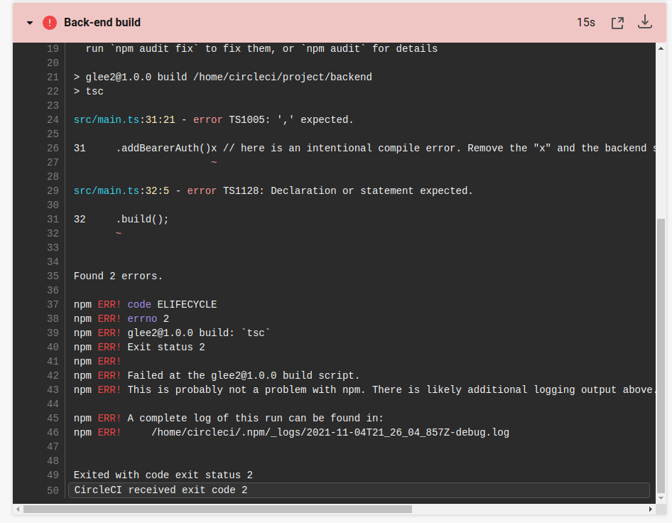

2 - Failed unit tests

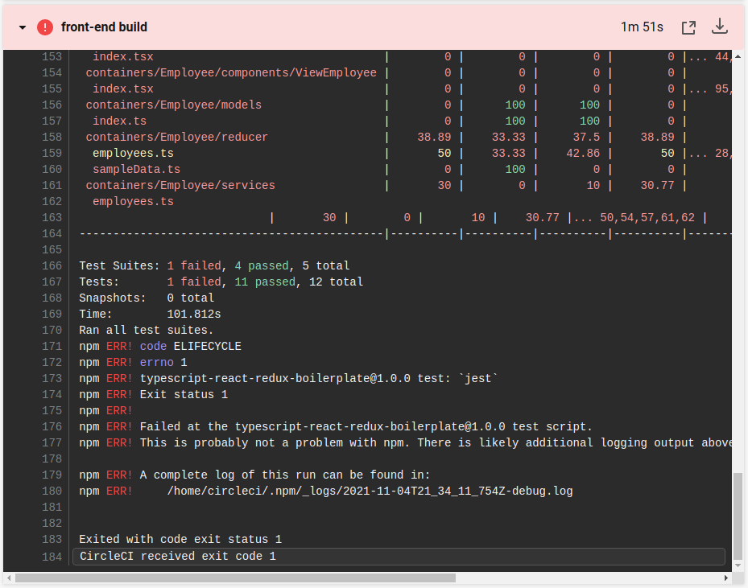
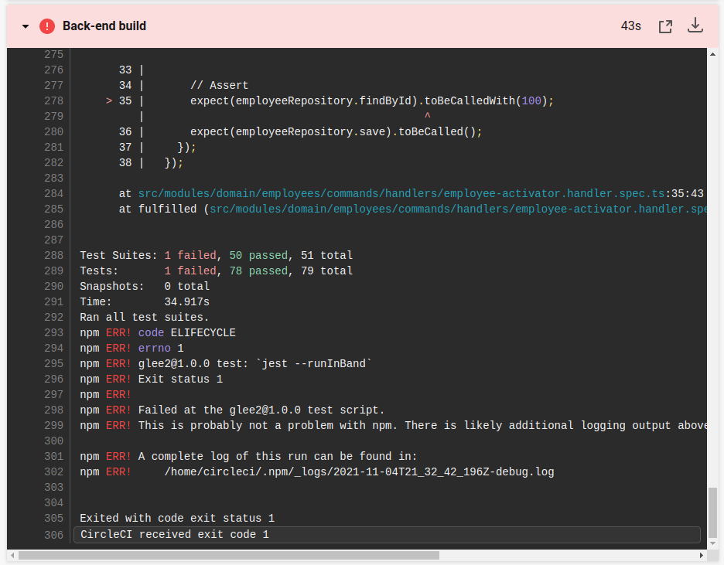

3 - Failure because of vulnerable packages
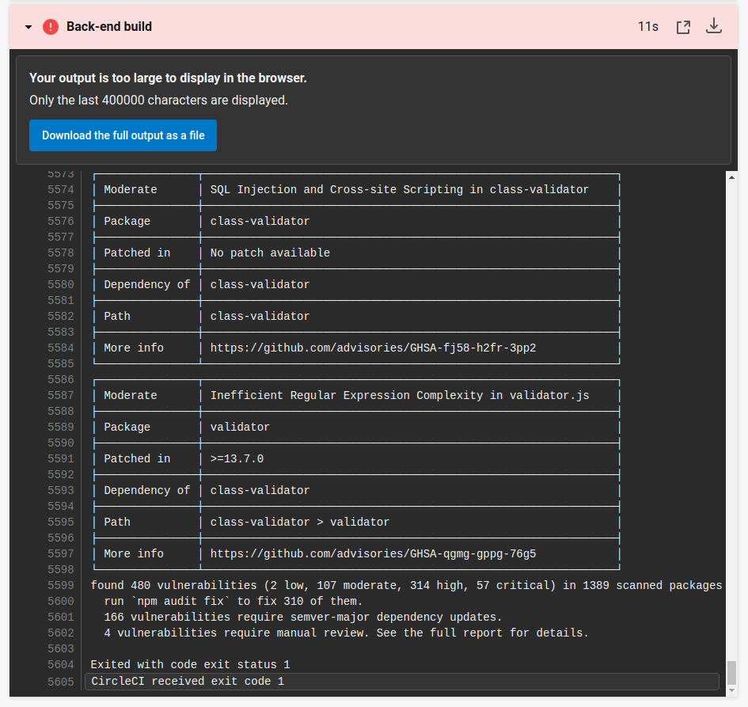

4 - An alert from one of your failed builds
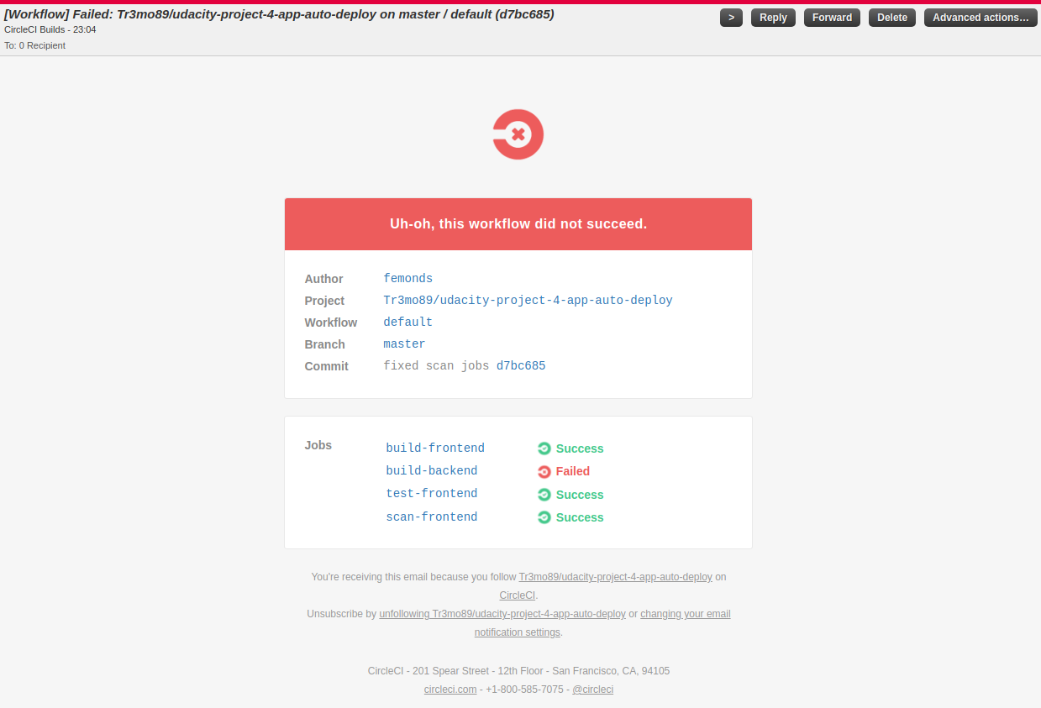

5 - Console output of appropriate failure for infrastructure creation job

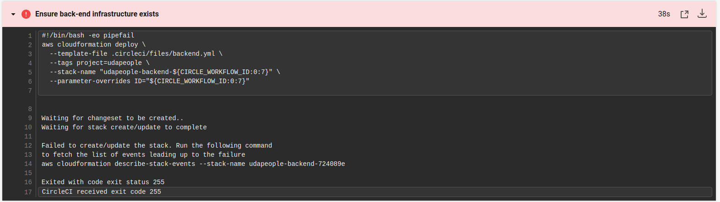

6 - Console output of a smoke test job that is failing appropriately

7 - Console output of a successful rollback after a failed smoke test

8 - Console output of successful promotion of new version to production in CloudFront

9 - Console output of a successful rollback after a failed smoke test

10 - Evidence that deploy jobs only happen on master branch

11 - Evidence that Prometheus is monitoring memory, cpu and disk usage of EC2 instances

12 - Evidence that Prometheus and AlertManager send alerts when certain conditions exist in the EC2 instance

