Svc – rbf, c=1

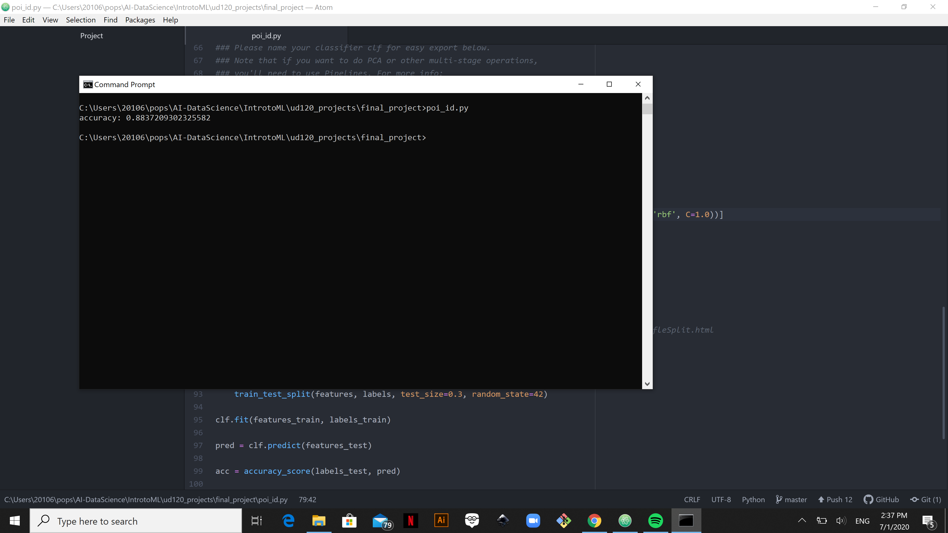

gaussianNB ,pca=2

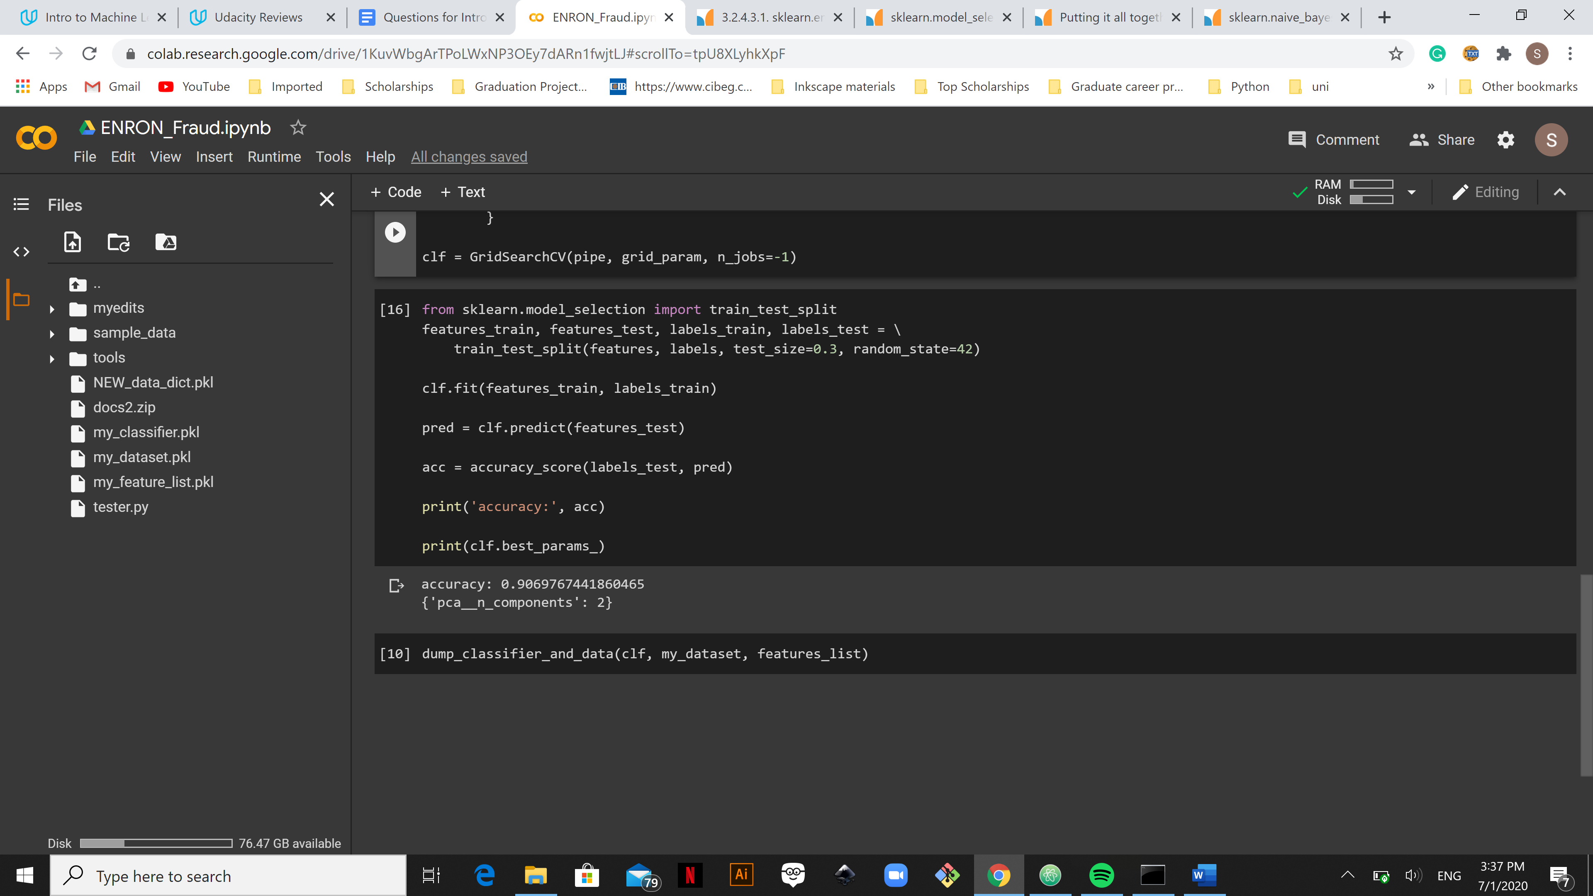

Rfclf

88

Scv, gridsearch

Kbest – done

# ensemble, kneigh, LDA, logistic reg

Evaluation