Vanilla & Rihan
Digital Marketing Strategy & Campaign Execution Project
Prepared By
- Youssef Shaaban
- Noha Mahmoud
- Yasmin Rabea
- Aml Meligy
Instructor
Moamen Elbadry
Industry
Premium Sweets, Chocolates, Snacks & Seasonal Gifting
Location
Alexandria, Egypt

Table of Contents
- Executive Summary
- Project Overview
- Brand Background
- Mission, Vision & Brand Identity
- Team Structure & Responsibilities
- SMART Objectives
- SOSTAC Marketing Model
- Market Research
- Competitor Analysis
- SWOT Analysis
- PESTEL Analysis
- Target Audience
- Buyer Personas
- Customer Needs & Pain Points
- Marketing Funnel
- Creative Strategy
- Content Strategy
- Content Pillars
- Social Media Platform Analysis
- Campaign Strategy
- Campaign Performance & KPIs
- Customer Journey Map
- Risk Analysis & Mitigation
- Future Growth Opportunities
- Recommendations
- Key Insights
- Conclusion
- Final Deliverables

1. Executive Summary
Vanilla & Rihan is a premium retail store based in Alexandria specializing in chocolates, candies, nuts, freeze-dried fruits, spreads, processed cheese, imported snacks, and seasonal gifting products.
This project focused on transforming Vanilla & Rihan from a traditional local sweets store into a modern gourmet destination through strategic digital marketing, trend-based short-form content, and data-driven advertising campaigns.
The campaign relied heavily on TikTok, Instagram, and Facebook reels to increase:
- Brand Awareness
- Audience Engagement
- Customer Trust
- Store Visibility
- Direct Sales Opportunities
One of the strongest strategic advantages of the campaign was the implementation of a Radical Transparency Strategy, where prices and offers were displayed directly inside content instead of using the traditional “Price in DM” approach.
The campaign successfully generated:
- 18.5K+ Users Reached
- 878 Total Interactions
- 4,348 ThruPlays
- 0.35 EGP Peak Cost Per Result
- Direct customer inquiries and sales conversions
The project demonstrated how creative storytelling, relatable content, and short-form video marketing can help a local food brand build strong digital positioning with limited resources and budget.

2. Project Overview
Brand Name
Vanilla & Rihan
Industry
Premium Sweets, Chocolates, Snacks & Seasonal Products
Project Focus
Building a strong social media presence and increasing customer engagement through strategic digital marketing campaigns.
Main Platforms Used
- Facebook
- Instagram
- TikTok
Main Deliverables
- Content Strategy
- Social Media Campaigns
- Paid Meta Ads
- Reels & Short Videos
- Posters & Promotional Content
- Performance Analysis
- Marketing Strategy Documentation

3. Brand Background
Vanilla & Rihan started as a local sweets and snacks retail store aiming to provide premium imported products and trendy gourmet items to customers in Alexandria.
The brand offers:
- Chocolates
- Candies
- Nuts & Kernels
- Freeze-Dried Fruits
- Imported Snacks
- Eid Products
- Seasonal Gifts
- Gourmet Spreads
- Processed Cheese
- Bakery & Toast Products
The brand aimed to create an enjoyable shopping experience through visually attractive products, modern presentation styles, and engaging customer interaction.
Unlike traditional sweets stores, Vanilla & Rihan positioned itself as a modern gourmet destination rather than only a nut or candy shop.

4. Mission, Vision & Brand Identity
Mission
To provide premium sweets and snack products through enjoyable customer experiences, trendy content, and high-quality service.
Vision
To become one of the most recognized gourmet sweets and snacks brands in Alexandria through creative branding and digital marketing excellence.
Brand Personality
- Trendy
- Friendly
- Energetic
- Relatable
- Modern
- Community-Oriented
Tone of Voice
- Conversational
- Fun
- Emotionally engaging
- Egyptian relatable communication style
- Friendly and approachable
Visual Identity
Brand Colors
- Yellow
- Black
- White
Style Direction
- High-contrast visuals
- Warm food lighting
- Dynamic video editing
- Close-up product visuals
- Fast-paced reels

5. Team Structure & Responsibilities
Brand Owner
Responsibilities
- Product preparation
- Filming content
- Product showcasing
- Campaign funding
- Managing store operations
Youssef Shaaban
Responsibilities
- Campaign Management
- Meta Ads Setup
- Campaign Monitoring
- Performance Analysis
Noha Mahmoud
Responsibilities
- Content Calendar Planning
- Content Organization
- Scheduling Strategy
Yasmin Rabea
Responsibilities
- Poster Design
- Presentation Support
- Creative Assistance
Aml Meligy
Responsibilities
- Video Editing Assistance
- Creative Support
- Presentation Preparation

6. SMART Objectives
Specific
Execute targeted social media campaigns focused on short-form video marketing and audience engagement.
Measurable
- Reach more than 15,000 users
- Achieve strong engagement rates
- Maintain low Cost Per Result
- Increase social media interactions
Achievable
The campaign successfully achieved:
- 18.5K+ Reach
- 878 Interactions
- 0.35 EGP CPR
Relevant
The project directly addressed customer communication gaps in the local sweets market.
Time-Bound
Campaign execution was completed between April 21 and May 10.

7. SOSTAC Marketing Model
S — Situation Analysis
Vanilla & Rihan operates in a highly competitive food and sweets market in Alexandria.
Most competitors relied on:
- Static product photography
- Traditional posting methods
- Weak customer interaction
- “Price in DM” communication
This created customer friction and reduced purchase intent.
Vanilla & Rihan identified this market gap and built its campaign around:
- Transparency
- Fast communication
- Trend-based content
- Relatable storytelling
- Reels-focused marketing
Current Social Media Presence
- Instagram: 946 Followers
- TikTok: 3,563 Followers
- Facebook: 2,100 Followers
Campaign Results
- 18.5K+ Users Reached
- 878 Interactions
- 4,348 ThruPlays
- 0.35 EGP CPR
- 2 Direct Sales Generated

O — Objectives
Primary Objectives
- Increase brand awareness
- Build strong social media visibility
- Increase audience engagement
- Generate customer inquiries
- Promote seasonal products effectively
Secondary Objectives
- Improve customer trust
- Increase audience retention
- Position Vanilla & Rihan as a gourmet destination
- Increase repeat customer interaction

S — Strategy
The strategy focused on combining:
- Trend-based short-form videos
- Emotional storytelling
- Radical transparency
- Fast customer interaction
- Community-driven communication
The campaign aimed to position Vanilla & Rihan as:
“A modern gourmet sweets destination in Alexandria.”
Core Strategic Pillars
- Transparency Strategy
- Reels-first content
- Seasonal emotional hooks
- Fast customer response
- Community-focused engagement

T — Tactics
Content Marketing
- Reels
- TikTok videos
- Product showcase videos
- Seasonal content
- Offer announcements
- Event coverage
Paid Advertising
- Meta Engagement Campaigns
- Video Views Campaigns
- Local Alexandria targeting
- Audience segmentation
Engagement Tactics
- Fast replies
- WhatsApp support
- Emotional captions
- Relatable hooks

A — Action
Execution Process
- The brand owner handled filming and product showcasing.
- The team handled editing and campaign execution.
- Content calendars were organized weekly.
- Reels were distributed across all platforms.
- Campaigns were monitored daily.
Team Execution Roles
- Youssef → Campaign Management
- Noha → Content Planning
- Yasmin → Design Support
- Aml → Editing Support

C — Control
Campaign performance was monitored through:
- Meta Ads Insights
- Reach Metrics
- Video Views
- Engagement Rate
- Customer Interactions
- Sales Conversion Tracking
Future Optimization Opportunities
- TikTok-focused growth
- Influencer collaborations
- Retargeting campaigns
- WhatsApp promotions

8. Market Research
Market Trends
- Growing demand for imported snacks
- High engagement with food reels
- Increasing popularity of TikTok food content
- Strong seasonal purchasing behavior
- Customers prefer visually satisfying food videos
Consumer Behavior Insights
Modern audiences prefer:
- Transparent pricing
- Fast customer response
- Relatable content
- Trend-based products
- Authentic experiences

9. Competitor Analysis
Main Competitors
- Local sweets stores
- Imported snacks stores
- Candy brands on Instagram & TikTok
- Gourmet food retailers
Market Gaps Identified
1. Price Ghosting
Most competitors hide prices and ask customers to send direct messages.
2. Weak Interaction
Slow responses to customer inquiries reduce conversion opportunities.
3. Generic Content
Traditional product posting without storytelling or emotional engagement.
Vanilla & Rihan Competitive Advantage
- Radical Transparency Strategy
- Fast customer communication
- Authentic product videos
- Relatable Egyptian communication style
- Trend-based reels
- Real product experience

10. SWOT Analysis
Strengths
- Trendy product selection
- Strong visual presentation
- Engaging reels
- Seasonal marketing opportunities
- Affordable campaign execution
- Authentic content style
Weaknesses
- Limited campaign budget
- Small-scale operations
- Limited analytics history
- No professional studio setup
Opportunities
- Growing TikTok food audience
- Seasonal demand growth
- Influencer collaborations
- Community-based content expansion
Threats
- Strong competition
- Rising advertising costs
- Changing algorithms
- Seasonal purchasing fluctuations

11. PESTEL Analysis
Political Factors
Import regulations may affect product availability.
Economic Factors
Inflation impacts customer purchasing power.
Social Factors
Social media trends strongly influence food purchasing decisions.
Technological Factors
TikTok and Reels algorithms support viral food content.
Environmental Factors
Packaging quality impacts customer perception.
Legal Factors
Compliance with food safety regulations is essential.

12. Target Audience
Primary Audience
- Young adults aged 18–35
- Trend followers
- Food lovers
- Social media users
- Imported snacks enthusiasts
Secondary Audience
- Families
- Seasonal shoppers
- Gift buyers
- Eid customers
Geographic Targeting
Alexandria, Egypt

13. Buyer Personas
Persona 1 — The Trend Follower
- Age: 20–28
- Active on TikTok & Instagram
- Loves trending snacks
- Influenced by reels and food trends
Persona 2 — The Seasonal Shopper
- Age: 25–40
- Purchases Eid gifts and sweets
- Interested in premium products
- Values convenience and presentation

14. Customer Needs & Pain Points
Customer Needs
- Premium products
- Affordable offers
- Trendy snacks
- Fast customer response
- Trustworthy local stores
Pain Points
- High market prices
- Weak customer communication
- Hidden pricing strategies
- Difficulty finding imported products

15. Marketing Funnel
Awareness
- Reels
- TikTok videos
- Meta Ads
Consideration
- Product showcases
- Event coverage
- Storytelling content
Conversion
- Offers
- WhatsApp communication
- Direct customer interaction
Retention
- Seasonal campaigns
- Interactive content
- Consistent engagement

16. Creative Strategy
Campaign Concept
“The Candy Conqueror”
The campaign built a bold and memorable brand personality through:
- Trendy reels
- Relatable humor
- Emotional storytelling
- Product close-ups
- Fast-paced editing
Creative Positioning
- Premium yet approachable
- Trendy but relatable
- Entertaining and modern
- Community-oriented
Main Creative Hooks
- Eid excitement
- Seasonal offers
- Humor-based captions
- Product sensory visuals
- Direct pricing communication

17. Content Strategy
Main Content Types
- Reels
- Short Videos
- Product Showcases
- Seasonal Promotions
- Offer Announcements
- Behind-the-scenes content
- Event Coverage
Content Style
- Fast-paced editing
- Fun communication
- Conversational tone
- Emotional hooks
- Relatable captions

18. Content Pillars
1. Hero Content
Major campaign moments and featured events.
Examples:
- Milky tasting event
- Major seasonal launches
2. Daily Crave Content
Daily product showcases.
Examples:
- Chocolates
- Candy offers
- Freeze-dried fruits
- Imported snacks
3. Transparency Content
Price-focused communication.
Examples:
- Price posters
- Offer announcements
- FAQ videos
4. Seasonal Content
Holiday-focused content.
Examples:
- Eid chocolates
- Seasonal gifts
- Holiday promotions

19. Social Media Platform Analysis
Instagram Analysis
Strengths
- Best overall engagement
- Strong reels performance
- Strong visual branding
Weaknesses
- Requires posting consistency

TikTok Analysis
Strengths
- Highest viral potential
- Strong organic reach
- Trend-driven visibility
Weaknesses
- Requires constant trend adaptation

Facebook Analysis
Strengths
- Strong local audience
- Effective for offers and inquiries
- Good community interaction
Weaknesses
- Lower organic reach compared to TikTok

20. Campaign Strategy
Campaign Types
Campaign 1
- Objective: Video Views
- Duration: 25 April – 26 April
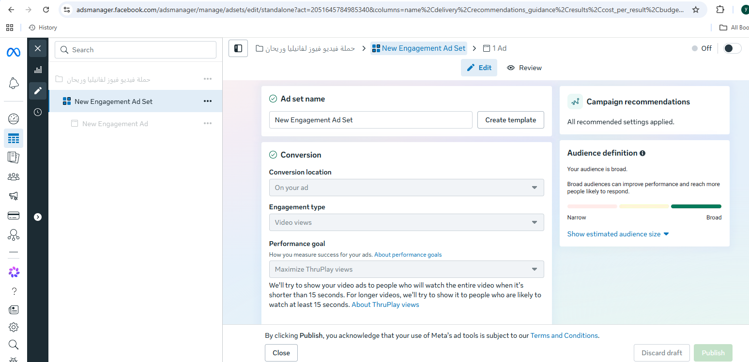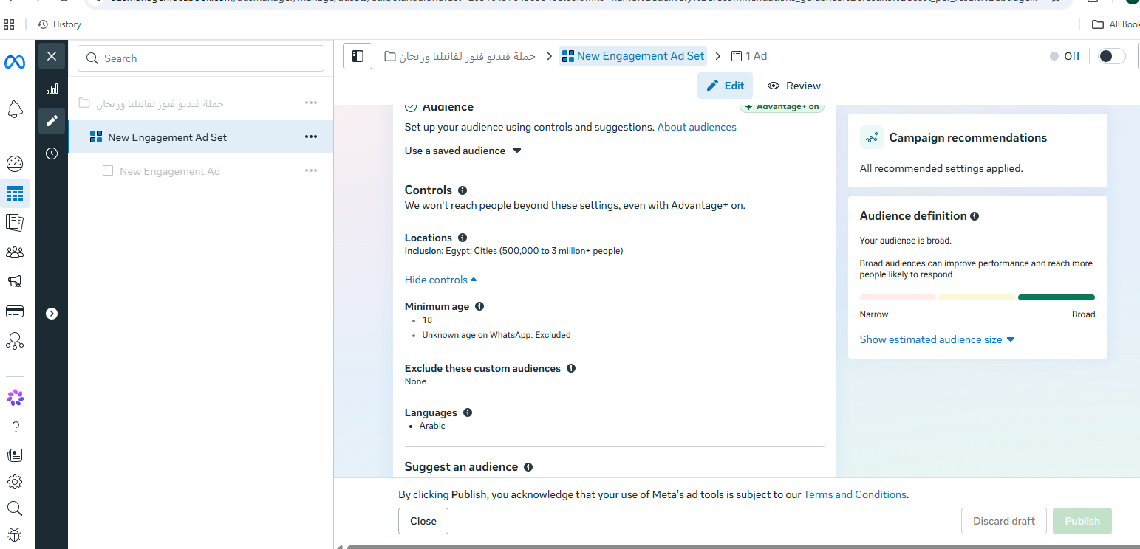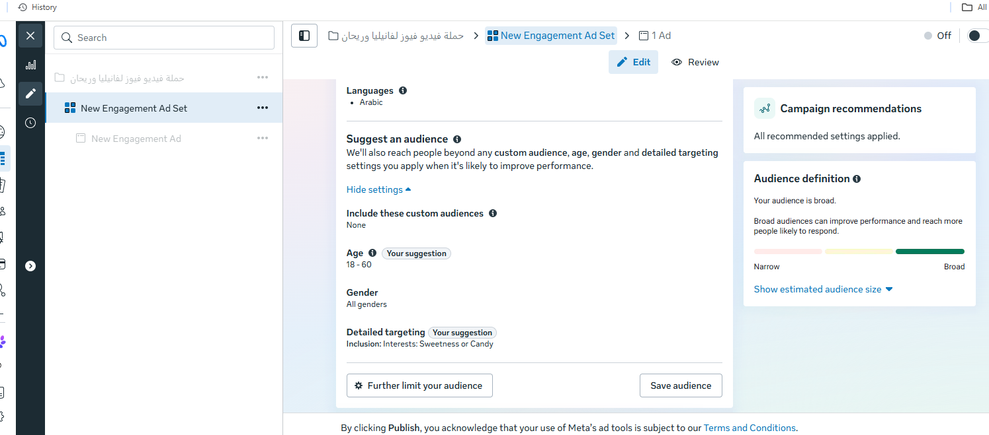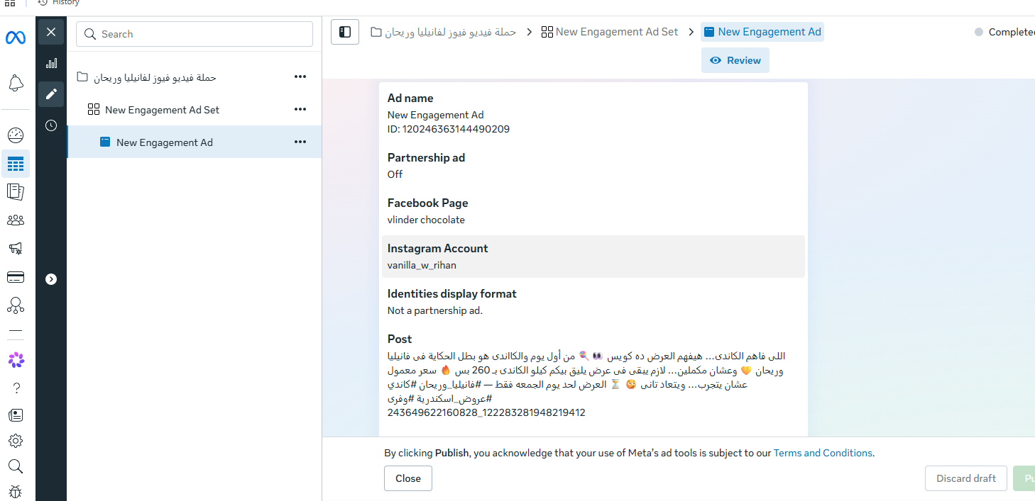
Campaign 2
- Objective: Engagement
- Duration: 27 April – 1 May
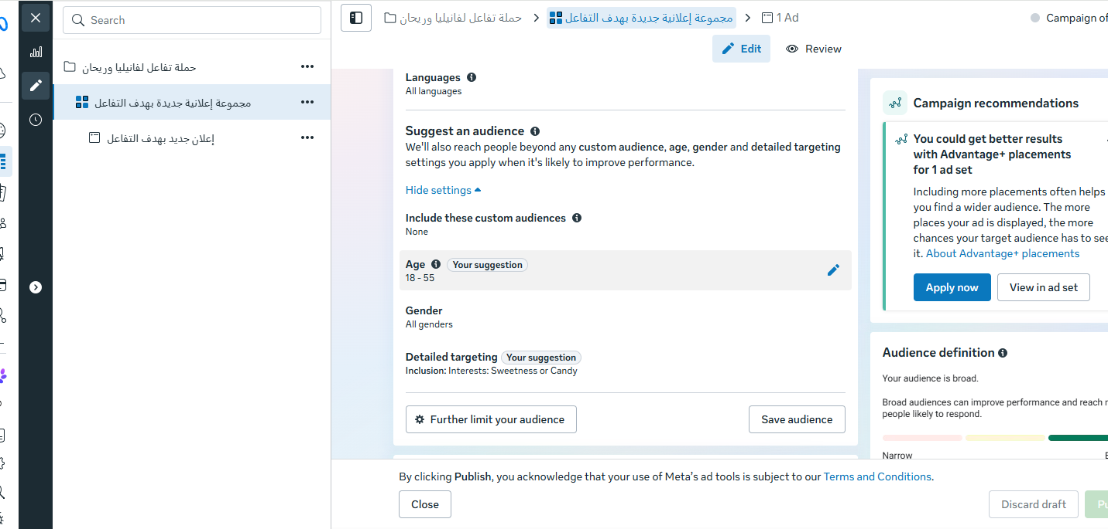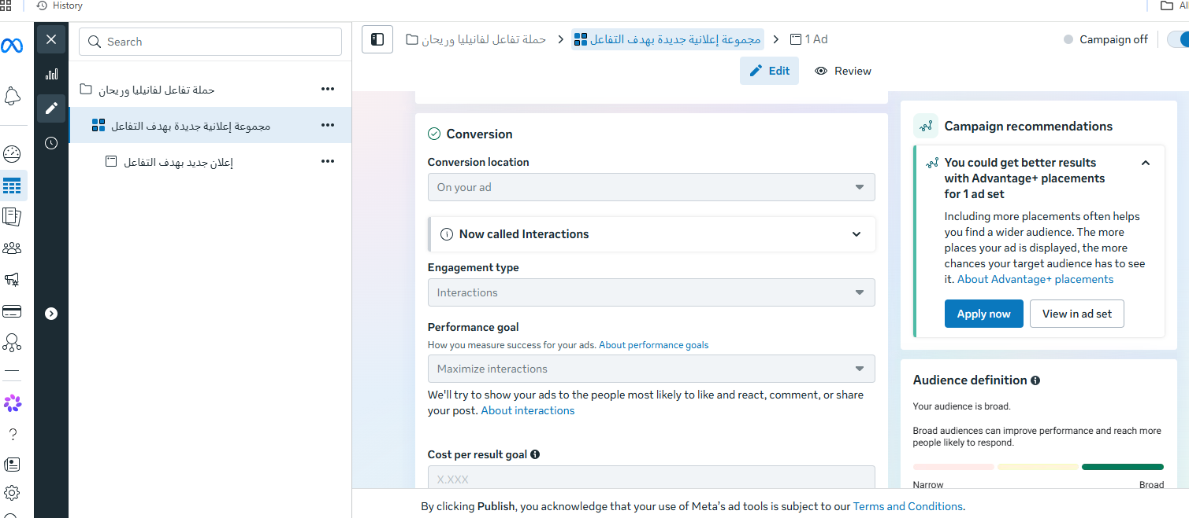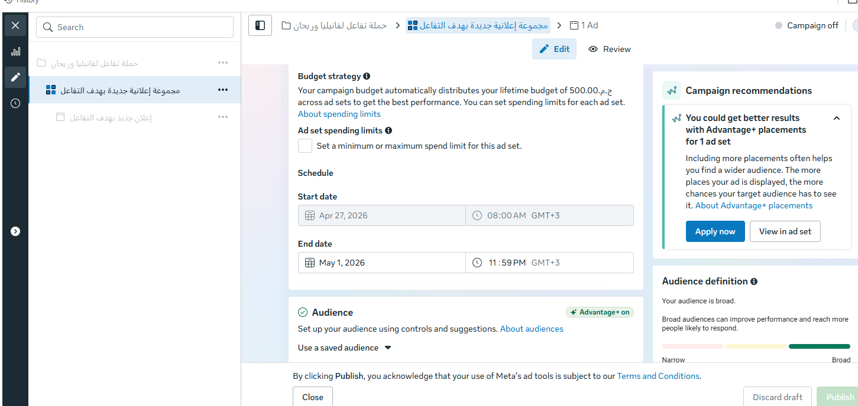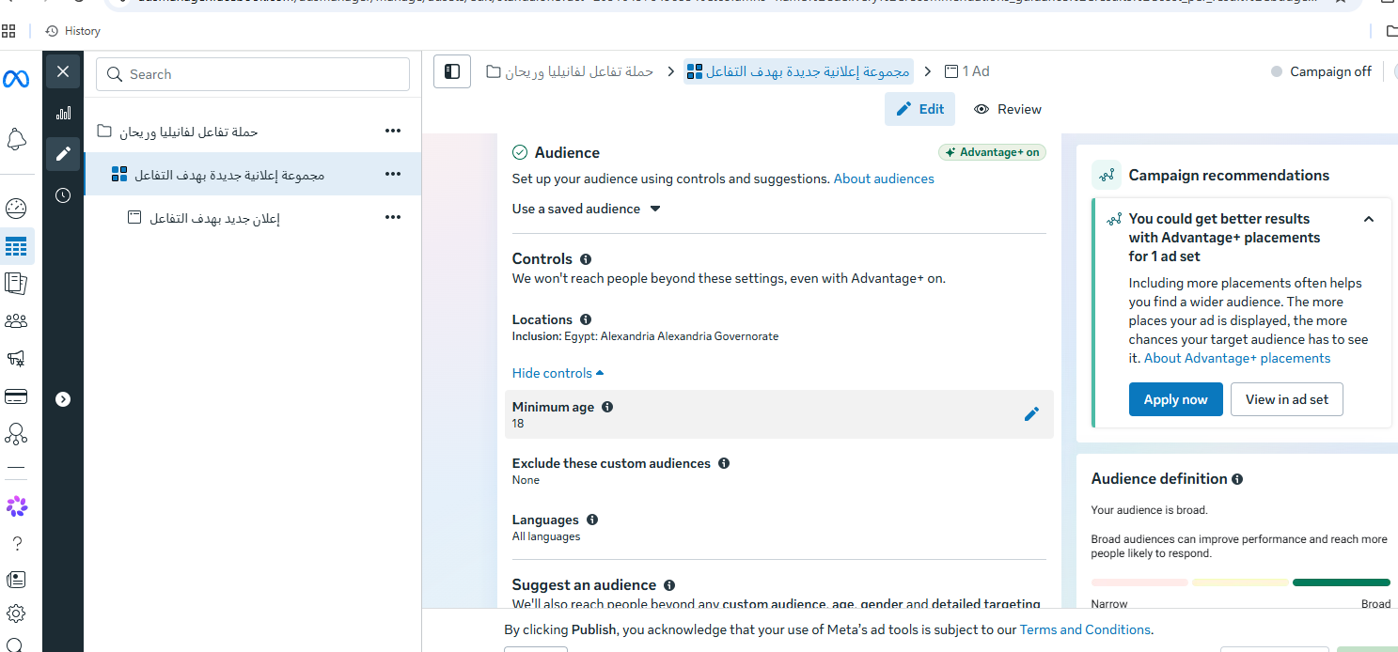
Audience Interests
- Chocolates
- Snacks
- Imported food
- Candies
- Seasonal products
- Food lovers
Platform Distribution
- TikTok
- Instagram Reels
- Facebook Reels

21. Campaign Performance & KPIs
Campaign Results
- 18.5K+ Users Reached
- 878 Total Interactions
- 4,348 ThruPlays
- 0.35 EGP Peak CPR
- 2 Direct Sales
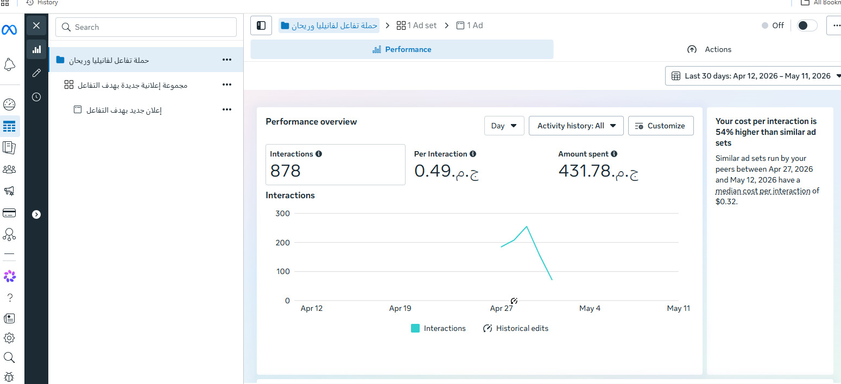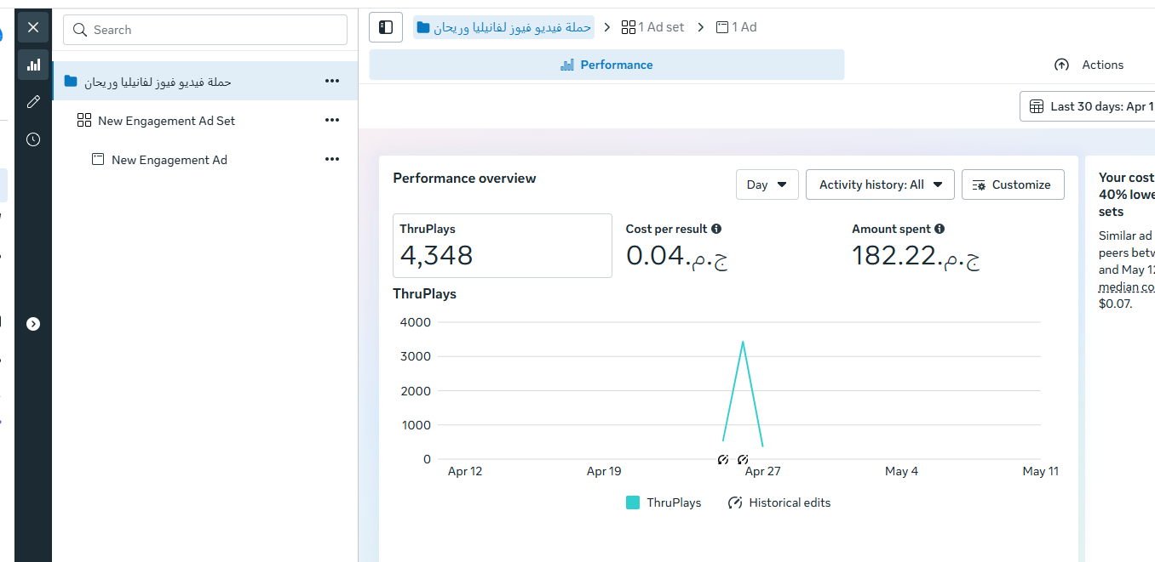
Engagement KPIs
- Likes
- Shares
- Saves
- Comments
- Video retention
Conversion KPIs
- Customer inquiries
- WhatsApp messages
- Sales conversions

22. Customer Journey Map
Stage 1 — Discovery
Users discover reels through TikTok and Instagram.
Stage 2 — Interest
Users visit the profile and explore products.
Stage 3 — Trust Building
Transparent pricing increases trust.
Stage 4 — Action
Users contact through WhatsApp or direct messages.
Stage 5 — Conversion
Purchase completed through store visit or delivery.

23. Risk Analysis & Mitigation
Risk 1 — Limited Budget
Solution
Low-cost mobile filming and authentic content.
Risk 2 — Algorithm Changes
Solution
Multi-platform content distribution.
Risk 3 — Inflation & Pricing Sensitivity
Solution
Value offers and transparent pricing.

24. Future Growth Opportunities
Expansion Opportunities
- Influencer collaborations
- TikTok-first content strategy
- WhatsApp loyalty campaigns
- Retargeting ads
- Seasonal automation
- Customer-generated content
Long-Term Vision
Position Vanilla & Rihan as one of Alexandria’s strongest gourmet sweets and snack brands.

25. Recommendations
Strategic Recommendations
- Increase posting consistency
- Improve product photography
- Expand TikTok production
- Use influencer marketing
- Launch seasonal campaigns regularly
- Implement retargeting campaigns
Operational Recommendations
- Build stronger analytics tracking
- Develop customer loyalty programs
- Improve WhatsApp automation
- Increase branded packaging quality

26. Key Insights
Strategic Insights
- Transparency improved conversion quality.
- Reels generated the strongest engagement.
- TikTok delivered the highest organic reach.
- Instagram achieved the strongest engagement quality.
- Facebook performed best for inquiries and offers.
- Emotional storytelling increased watch time.
Consumer Insights
Modern audiences respond strongly to:
- Authenticity
- Relatable communication
- Direct pricing
- Fast interaction
- Trend-based content

27. Conclusion
The Vanilla & Rihan project successfully demonstrated how a local gourmet sweets and snacks brand can build strong digital visibility using strategic social media marketing and short-form video content.
Through the SOSTAC framework, the campaign combined:
- Situation Analysis
- Strategic Planning
- Creative Execution
- Paid Advertising
- Audience Engagement
- Performance Monitoring
Despite limited resources and budget, the campaign achieved measurable results and successfully positioned Vanilla & Rihan as a modern gourmet destination in Alexandria.
One of the project’s strongest competitive advantages was its transparency-driven communication strategy, which reduced customer friction and increased high-intent engagement.
The project also highlighted the growing effectiveness of:
- TikTok marketing
- Reels-based communication
- Emotional storytelling
- Trend-focused content
- Community engagement
Overall, the project demonstrated strong potential for future scalability through:
- Consistent branding
- Influencer collaborations
- Retargeting strategies
- TikTok-first growth
- Seasonal campaigns
- Loyalty-focused customer communication

28. Final Deliverables
The final project includes:
- Executive Summary
- Brand Analysis
- SWOT Analysis
- PESTEL Analysis
- Competitor Analysis
- SOSTAC Marketing Model
- Content Strategy
- Social Media Strategy
- Campaign Execution Plan
- Performance Analysis
- KPIs & Insights
- Recommendations
- Customer Journey Map
- Growth Opportunities
- Presentation Structure

