Design Document

Client-Side Component Interaction Diagram
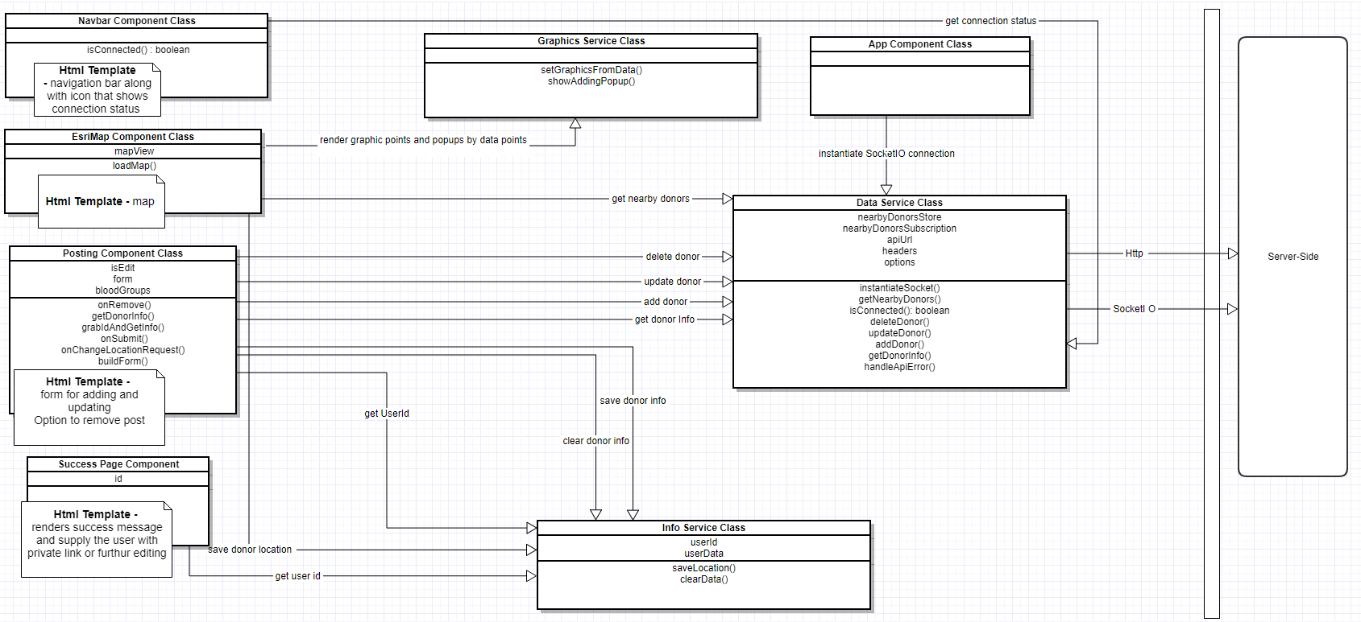

Server-side Component Interaction Diagram
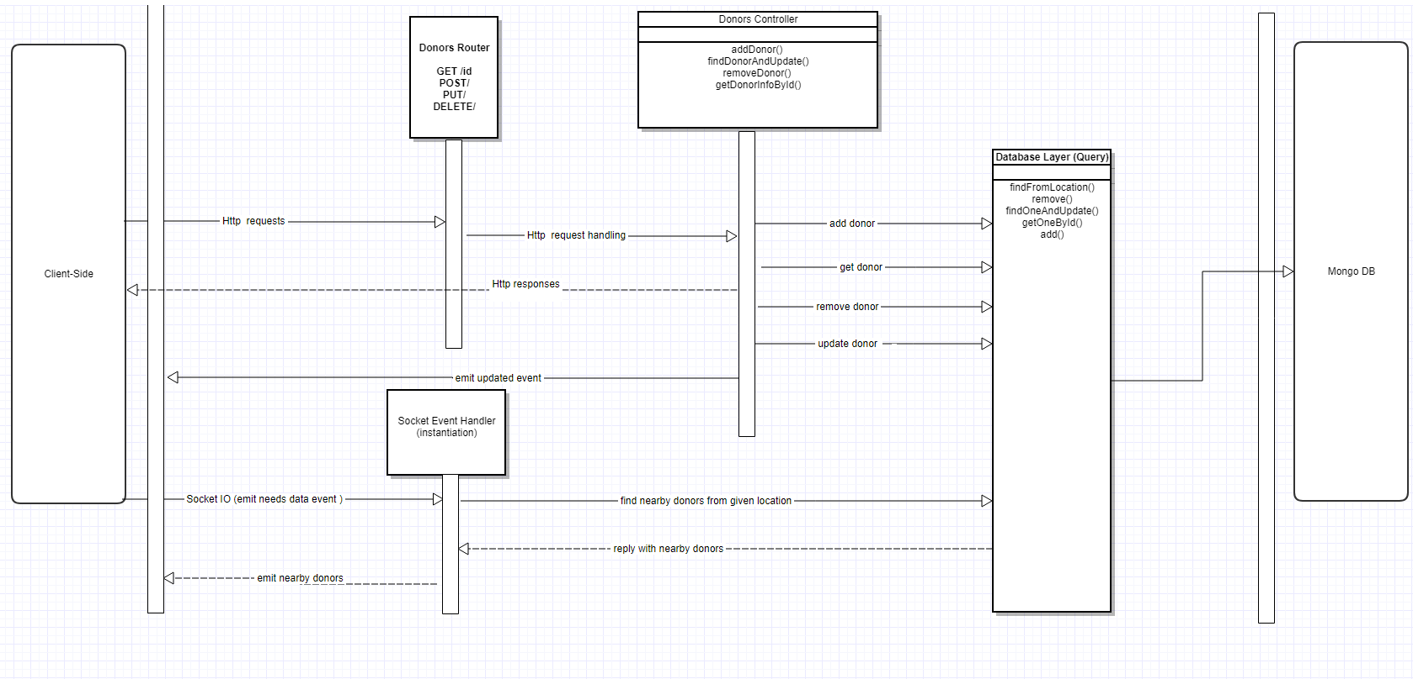

Instructions to build

Prerequisite to be installed

Node >=6.9.5<7.x.x
Npm >=5.2

Installation Instructions
Go to Code Folder => Client Folder => Open terminal => npm install
Go to Code Folder => Server Folder => Open terminal => npm install
Go to Tests Folder => Open terminal => npm install

Running app locally
Go to Code Folder => Client Folder => Open terminal => npm start
Go to Code Folder => Server Folder => Open terminal => npm start

Running tests locally
- Client-side-tests
  - Go to Code Folder => Client Folder => Open terminal => run npm t

- Server-side tests
  - These tests need an internet connection to be executed
  - Go to Code Folder => Server Folder => Open terminal => run npm t
- To include coverage results in tests

Tests coverage results
Go to Code Folder => Client Folder => Client Folder => Double click index.html
Go to Code Folder => Server Folder => Open terminal => npm t

Set MONGODB_URI

Technologies used
Angular 4 as a client side framework
Istanbul for Test Coverage
Jasmine Test Runner
Karma Test Runner
Esri-Loader Module

git subtree push --prefix Code/Server heroku master

