

**Faculty of engineering - Shoubra**

**Benha University**

**Research Article / Research Project / Literature Review**

in fulfillment of the requirements of

|  |  |
| --- | --- |
| **Department** | Engineering mathematics and physics |
| **Division** |  |
| **Academic Year** | **2019-2020 preparatory** |
| **Course name** | Computer |
| **Course code** | ECE001 |

**Title: -**

**Programming languages.**

By:

|  |  |  |  |
| --- | --- | --- | --- |
|  | Name | Edu mail | B.N |
| 1 | Youssef Sherif Ahmed | Youssif196191@feng.bu.edu.eg | 1060 |

**Approved by:**

|  |  |
| --- | --- |
| Examiners committee | Signature |
| Dr. Ahmed Bayoumi |  |
| Dr. Shady Elmashad |  |
| Dr. AbdElHamid Attaby |  |
|  |  |
|  |  |

**Research objectives**

The report aims to give a sufficient overview on programing languages, what they are what are their uses, also give fast look on top 4 used language and the field where each is used most.

**Abstract**

Programming languages these days are used everywhere around us and can do everything human want to do, even it can do human's work, they are used in mobile phone to design applications and games, and used to build-up operating systems, they have the same uses for computers and laptops, also used to develop websites and secure them, they can be used to build-up systems that are applied to machines to work at a specific rate to do specific job, also can be used in a robot to perform tasks.

**Table of contents**

|  |  |
| --- | --- |
| **Subject / section** | **Page** |
| Research objectives | 1 |
| Abstract | 2 |
| Introduction | 6 |
| C sharp | 10 |
| Java | 11 |
| Python | 13 |
| JavaScript | 14 |
| Links | 16 |
| References | 17 |

**List of Figures (If any)**

|  |  |  |
| --- | --- | --- |
| **Figure I.D** | **Description** | **Page** |
|  |  |  |
|  |  |  |
|  |  |  |
|  |  |  |
|  |  |  |
|  |  |  |

**List of Tables (If any)**

|  |  |  |
| --- | --- | --- |
| **Table I.D** | **Description** | **Page** |
|  |  |  |
|  |  |  |
|  |  |  |
|  |  |  |
|  |  |  |
|  |  |  |

**Introduction**

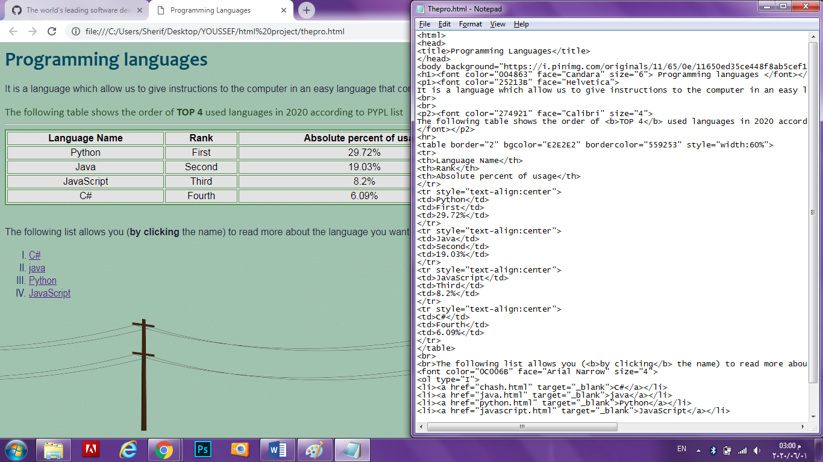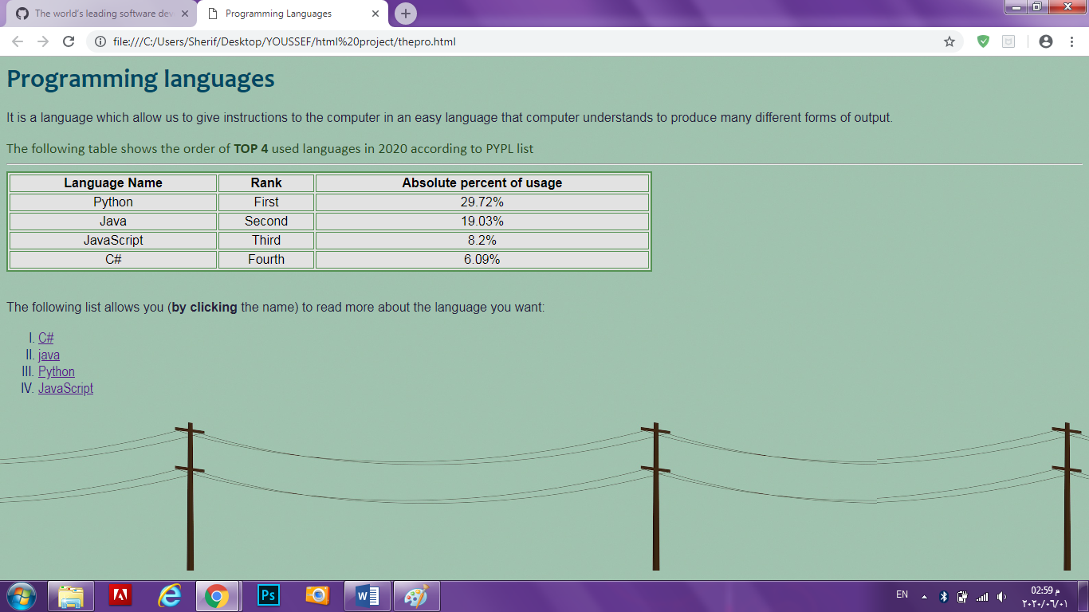It is a language which allow us to give instructions to the computer in an easy language that computer understands to produce many different forms of output.

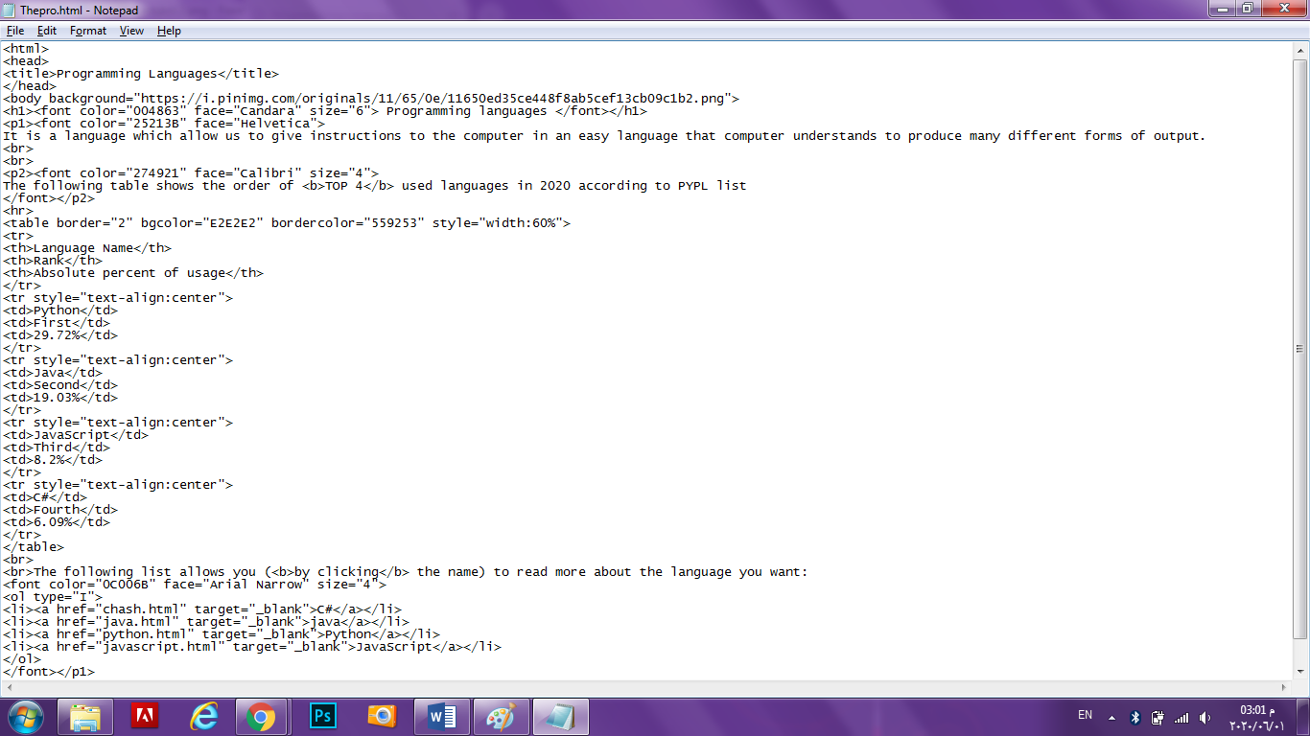

<html>

<head>

<title>Programming Languages</title>

</head>

<body background="https://i.pinimg.com/originals/11/65/0e/11650ed35ce448f8ab5cef13cb09c1b2.png">

<h1><font color="004863" face="Candara" size="6"> Programming languages </font></h1>

<p1><font color="25213B" face="Helvetica">

It is a language which allow us to give instructions to the computer in an easy language that computer understands to produce many different forms of output.

<br>

<br>

<p2><font color="274921" face="Calibri" size="4">

The following table shows the order of <b>TOP 4</b> used languages in 2020 according to PYPL list

</font></p2>

<hr>

<table border="2" bgcolor="E2E2E2" bordercolor="559253" style="width:60%">

<tr>

<th>Language Name</th>

<th>Rank</th>

<th>Absolute percent of usage</th>

</tr>

<tr style="text-align:center">

<td>Python</td>

<td>First</td>

<td>29.72%</td>

</tr>

<tr style="text-align:center">

<td>Java</td>

<td>Second</td>

<td>19.03%</td>

</tr>

<tr style="text-align:center">

<td>JavaScript</td>

<td>Third</td>

<td>8.2%</td>

</tr>

<tr style="text-align:center">

<td>C#</td>

<td>Fourth</td>

<td>6.09%</td>

</tr>

</table>

<br>

<br>The following list allows you (<b>by clicking</b> the name) to read more about the language you want:

<font color="0C006B" face="Arial Narrow" size="4">

<ol type="I">

<li><a href="chash.html" target="_blank">C#</a></li>

<li><a href="java.html" target="_blank">java</a></li>

<li><a href="python.html" target="_blank">Python</a></li>

<li><a href="javascript.html" target="_blank">JavaScript</a></li>

</ol>

</font></p1>

</body>

</html>

**Literature Review**

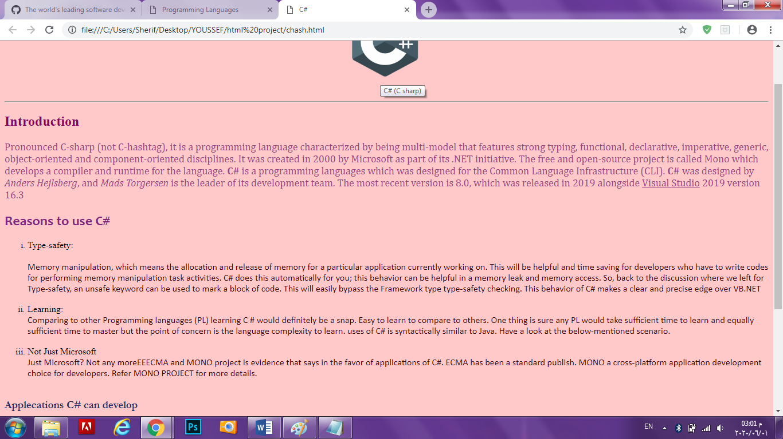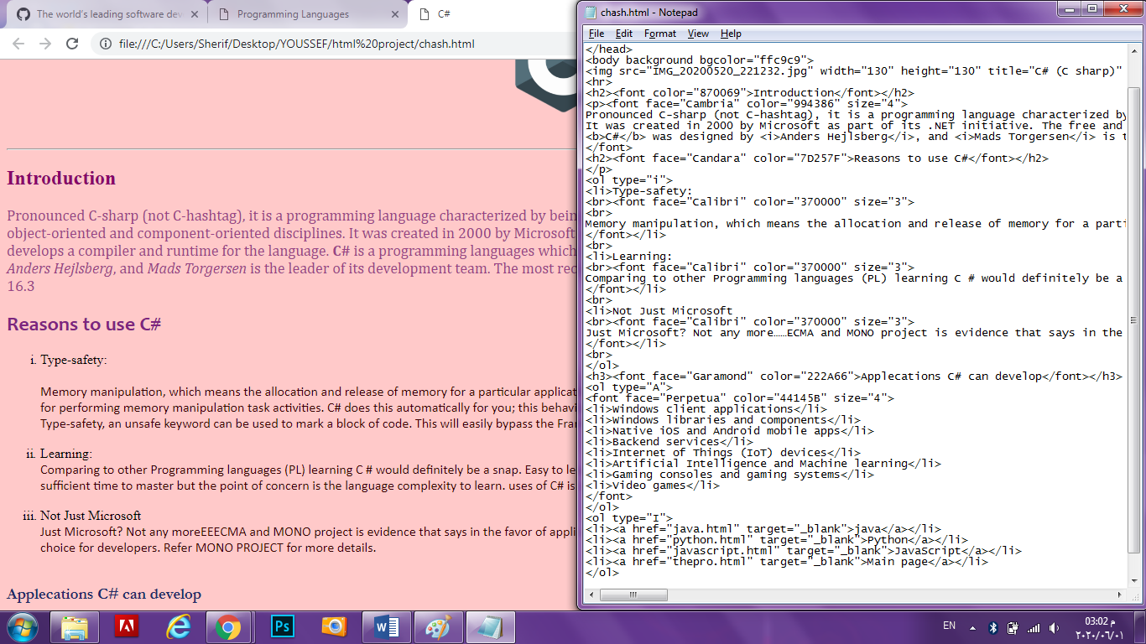**C# (C sharp)**

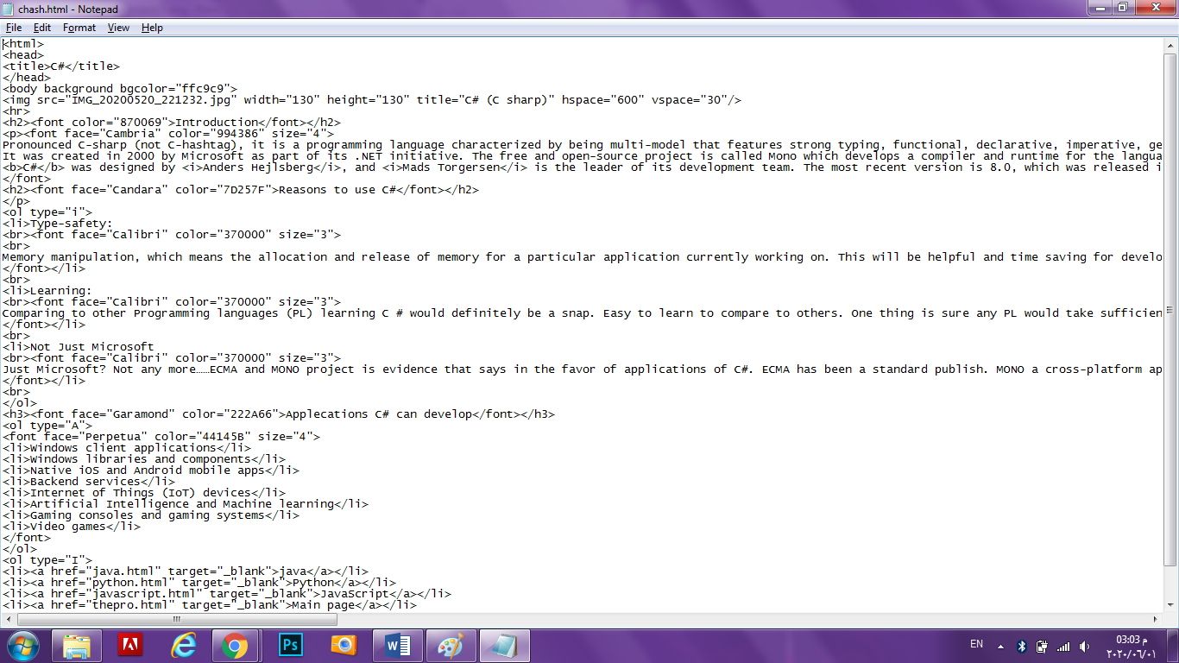

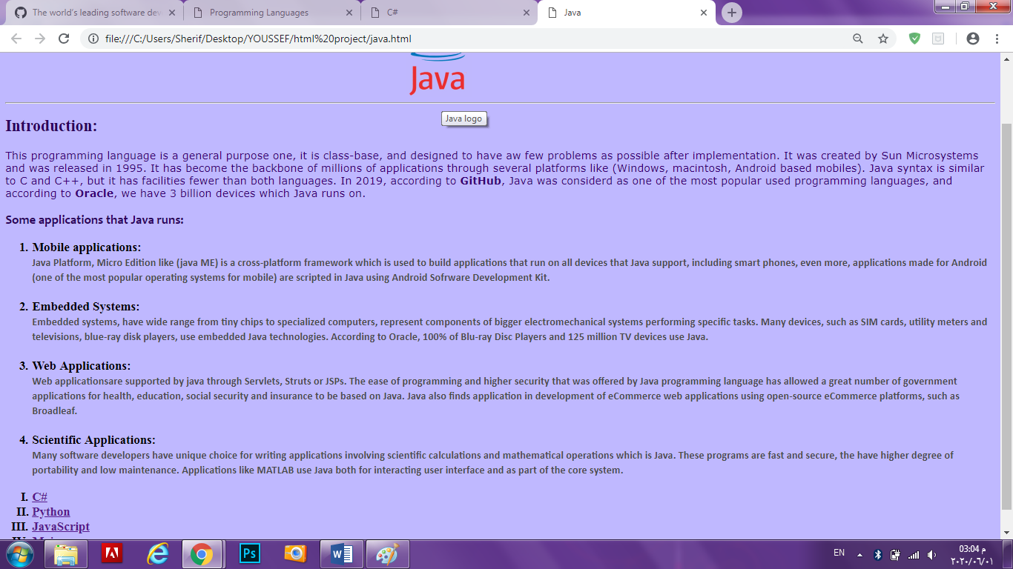**Java**

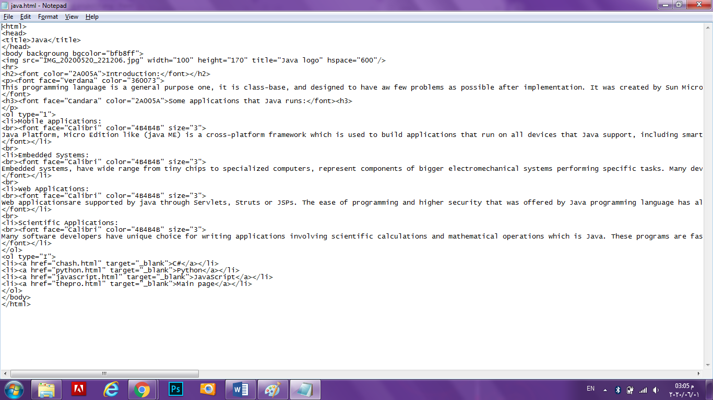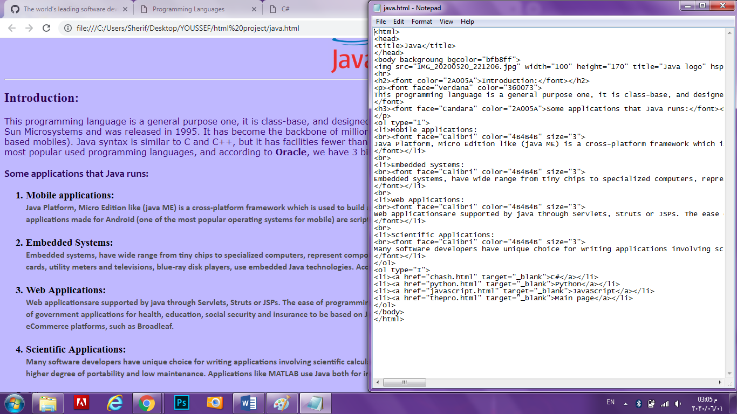

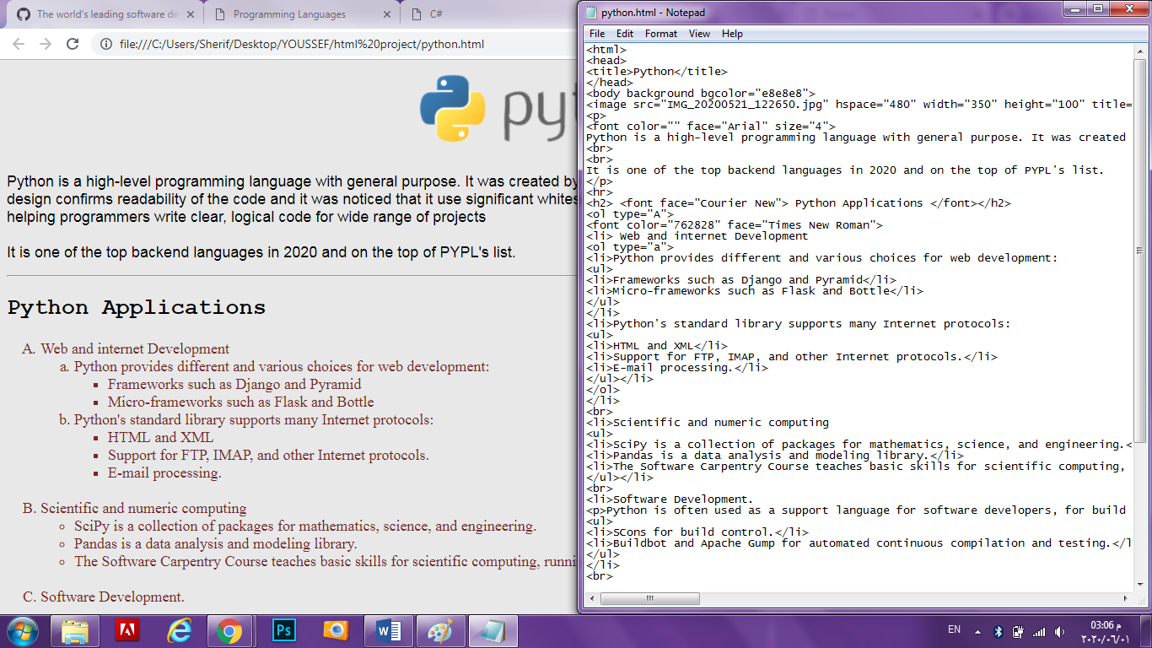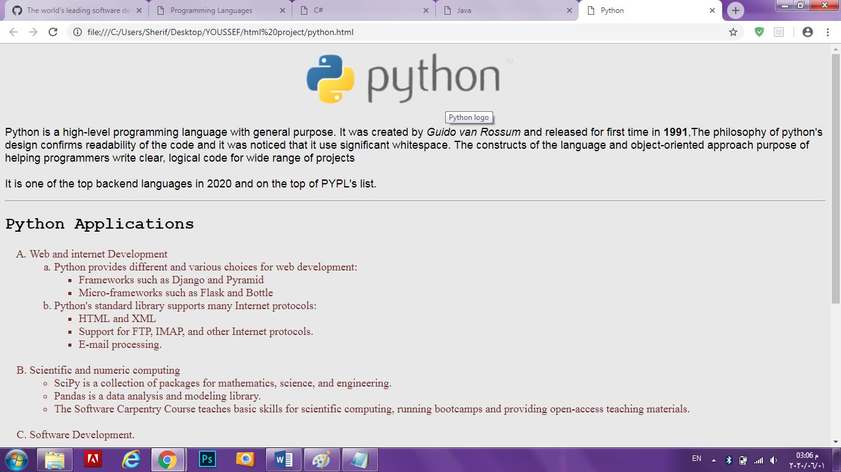**Python**

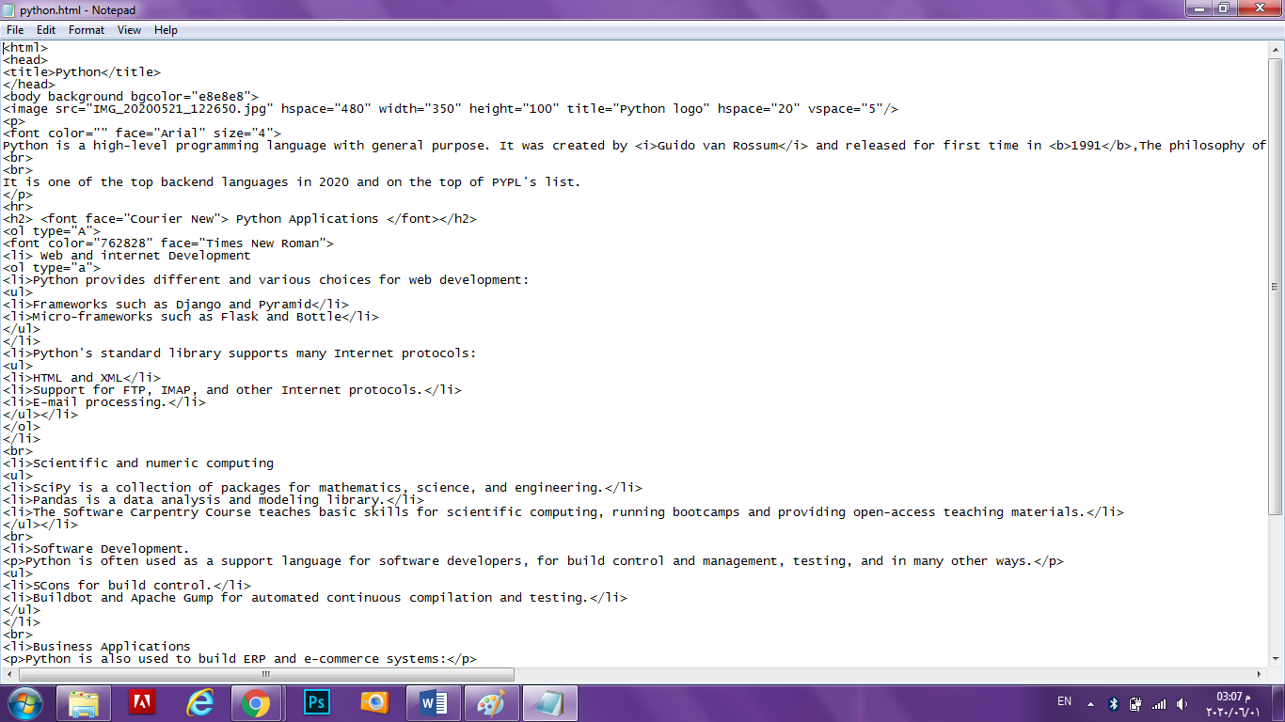

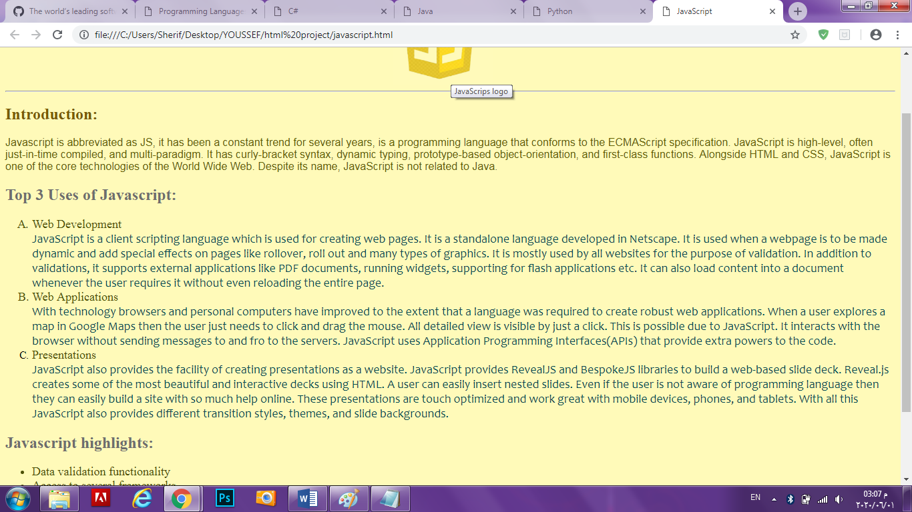**JavaScript**

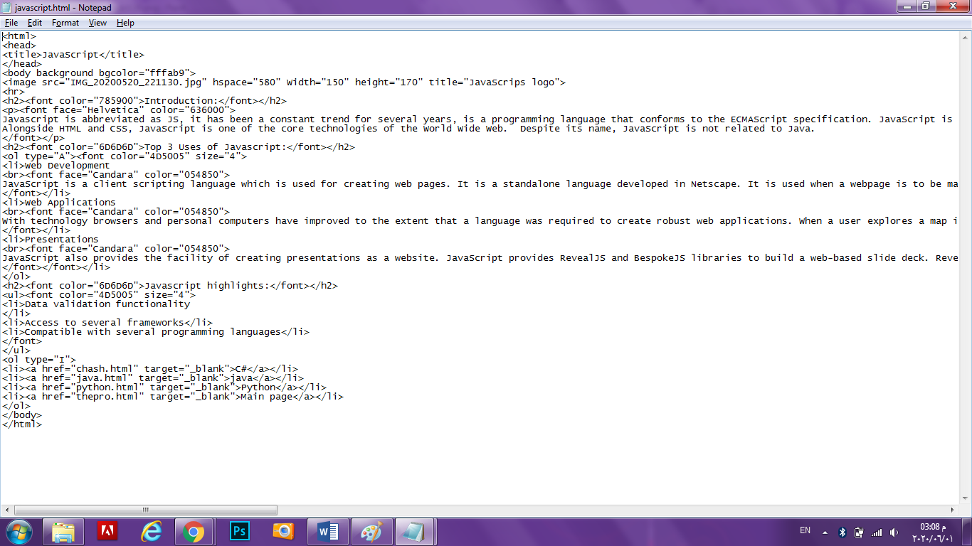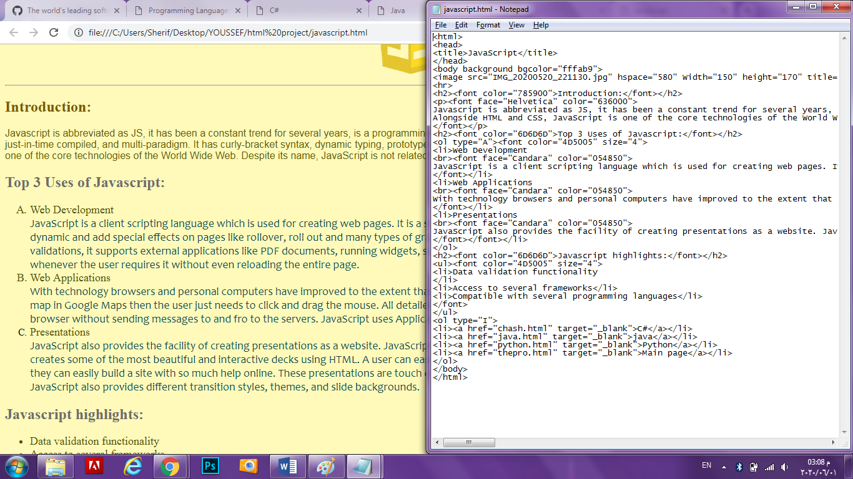

**Links**

* **GIThub Link** (main page)

<https://youssefsherifa.github.io/ECE001/>

(4 Pages)

<https://youssefsherifa.github.io/ECE001/chash.html>

<https://youssefsherifa.github.io/ECE001/java.html>

<https://youssefsherifa.github.io/ECE001/python.html>

<https://youssefsherifa.github.io/ECE001/javascript.html>

* <file:///C:/Users/Sherif/Desktop/YOUSSEF/Final%20computer%20project/Thepro.html>
* <file:///C:/Users/Sherif/Desktop/YOUSSEF/Final%20computer%20project/chash.html>
* <file:///C:/Users/Sherif/Desktop/YOUSSEF/Final%20computer%20project/java.html>
* <file:///C:/Users/Sherif/Desktop/YOUSSEF/Final%20computer%20project/python.html>
* <file:///C:/Users/Sherif/Desktop/YOUSSEF/Final%20computer%20project/javascript.html>

**References**

* <https://www.educba.com/uses-of-javascript/>
* <https://www.educba.com/uses-of-c-sharp/>
* <https://www.invensis.net/blog/it/applications-java-programming-language/>
* <https://www.cleveroad.com/blog/programming-languages-ranking>
* <https://www.python.org/about/>
* <https://www.webopedia.com/TERM/P/programming_language.html>
* https://www.hostinger.com/tutorials/best-html-web-fonts