NASA Space Apps 2024

SDGs in Classroom:

* SDG4: Quality Education
* SDG7: Affordable and Clean Energy
* SDG13: Climate Action

Tools that will be embedded in the platform:

Earth Observations Toolkit for Sustainable Cities and Human Settlements

* <https://sdgstoday.org/>

الموقع دا بيحكي اهداف التنمية المستدامة في شكل قصة تقاعلية

هنحطه في قلب الموقع بالطريقة المناسبة

ركز علي دول:

* SDG4:
  + Map: <https://sdgstoday.org/dataset/my-school-today>
  + Story: <https://sdgstoday.org/storymap_page/quality-education>
  + Academy Course: <https://sdgacademy.org/goal/quality-education/>
  + Pathway to learn: <https://learn.arcgis.com/en/paths/sdg-4-quality-education/>
* SDG7:
  + Map: <https://sdgstoday.org/dataset/access-electricity>
  + Story: <https://sdgstoday.org/storymap_page/affordable-and-clean-energy>
  + Academy Course: <https://sdgacademy.org/goal/affordable-and-clean-energy/>
  + Pathway to learn: <https://learn.arcgis.com/en/paths/sdg-7-affordable-clean-energy/>
* SDG13:
  + Map: <https://sdgstoday.org/dataset/global-temperature-change>
  + Story: <https://sdgstoday.org/storymap_page/climate-action>
  + Academy Course: <https://sdgacademy.org/goal/climate-action/>
  + Pathway to Learn: <https://learn.arcgis.com/en/paths/sdg-13-climate-action/>
* <https://eo4sdg.org/>

This is the website of the EO4SDG Initiative, which NASA has supported since 2016. Here you can discover real-life applications of satellite data to help countries monitor environmental conditions and report SDG progress. وهيتحط في صفحة المصادر بالطريقة المناسبة

* <https://www.geoportal.org/>

is an online map-based user interface which allows users to discover and access Earth observation data and resources from different providers from all over the world.

الtool دي سكس

الكلام اللي فات دا كله جاي من مصدر واحد بس اللي هو دا

المصدر التاني:

* <https://worldview.earthdata.nasa.gov/>

حطها في الموقع باي طريقة ويكون التفاعل فيها من خلال الموقع لو تقدر

NASA's Worldview tool allows users to interactively browse and download over 1,200 global, full-resolution satellite imagery layers. It's designed for real-time viewing, with many layers updated daily and available within three hours of observation. The tool supports a variety of applications, including wildfire management, air quality monitoring, and flood response, providing insights into natural hazards and environmental changes.

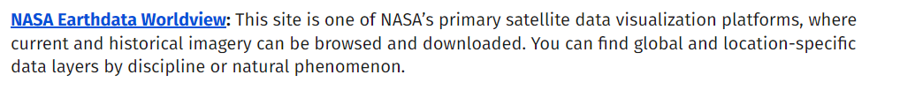

المصدر التالت:

Snow cover map: <https://earthobservatory.nasa.gov/global-maps/MOD10C1_M_SNOW>

Rainfall: <https://earthobservatory.nasa.gov/global-maps/GPM_3IMERGM>

Temperature: <https://earthobservatory.nasa.gov/global-maps/MOD_LSTD_M>

حط الصفحة دي للطلاب اللي عاوزة تستكشف اكتر: <https://earthobservatory.nasa.gov/global-maps>

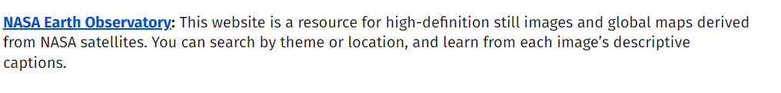

المصدر الرابع:

حط المابة دي: <https://sedac.ciesin.columbia.edu/mapping/viewer/>

