Test Summary Report – OrangeHRM

1. Project Information
• Project Title: Testing HRM Orange Website
• Team Name: Team 3
• Team Members: Youssef Zaafan, Ahmed Sayed, Mariana Shawky, Salma Mamdouh, Youssef Qabil
• Testing Scope: Manual & Automation
• Environment: Chrome Browser – Web Application

2. Test Execution Overview
• Manual Test Cases Executed: 97
- Passed: 78
- Failed: 19
• Automation Test Cases Executed: 21
- Passed: 21
- Failed: 0

3. Manual Test Execution Charts
Bar Chart:
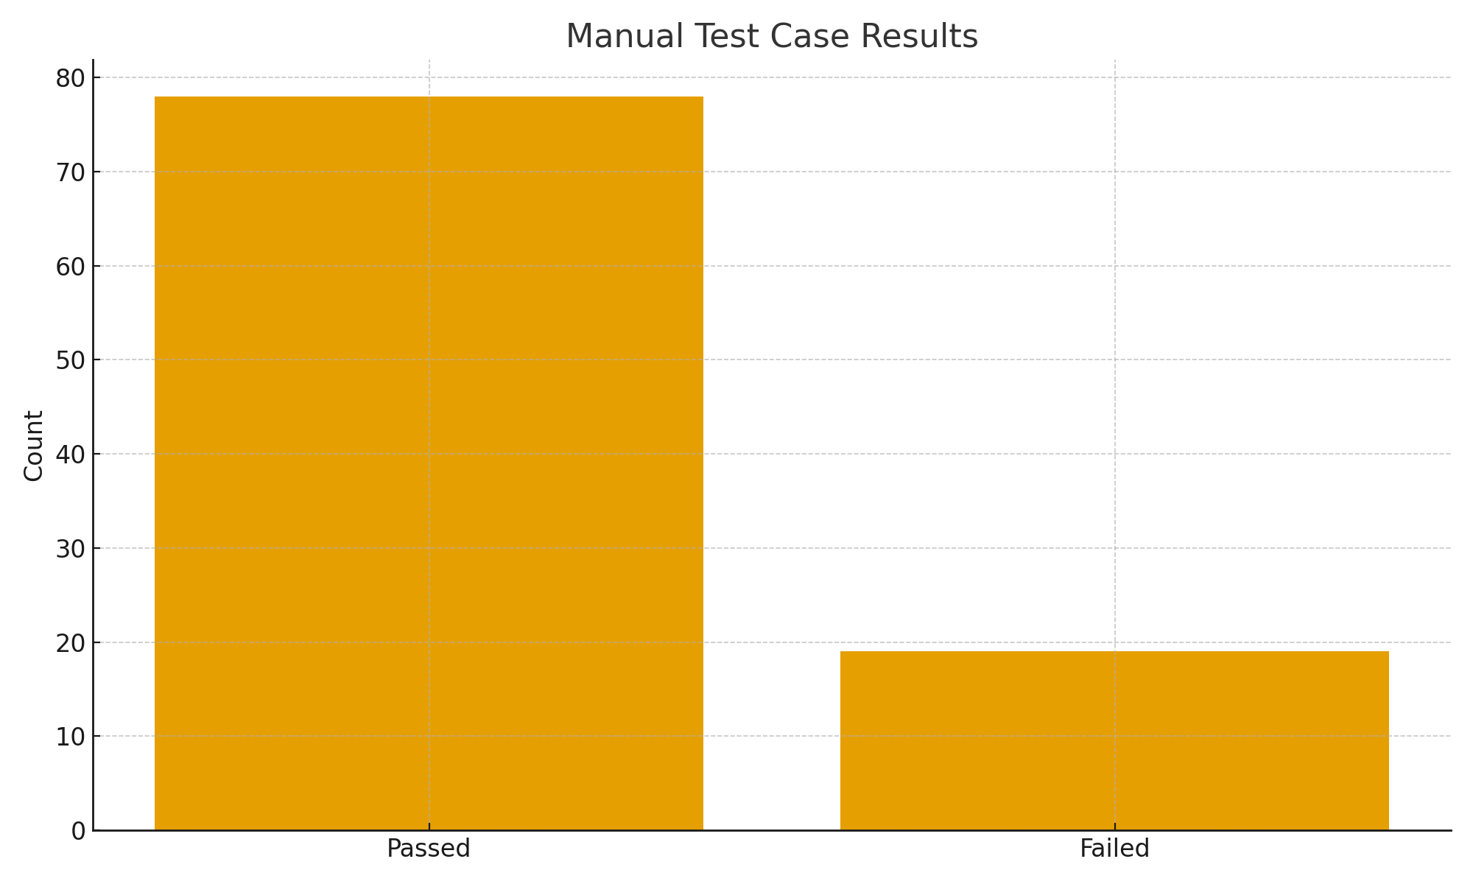
Pie Chart:
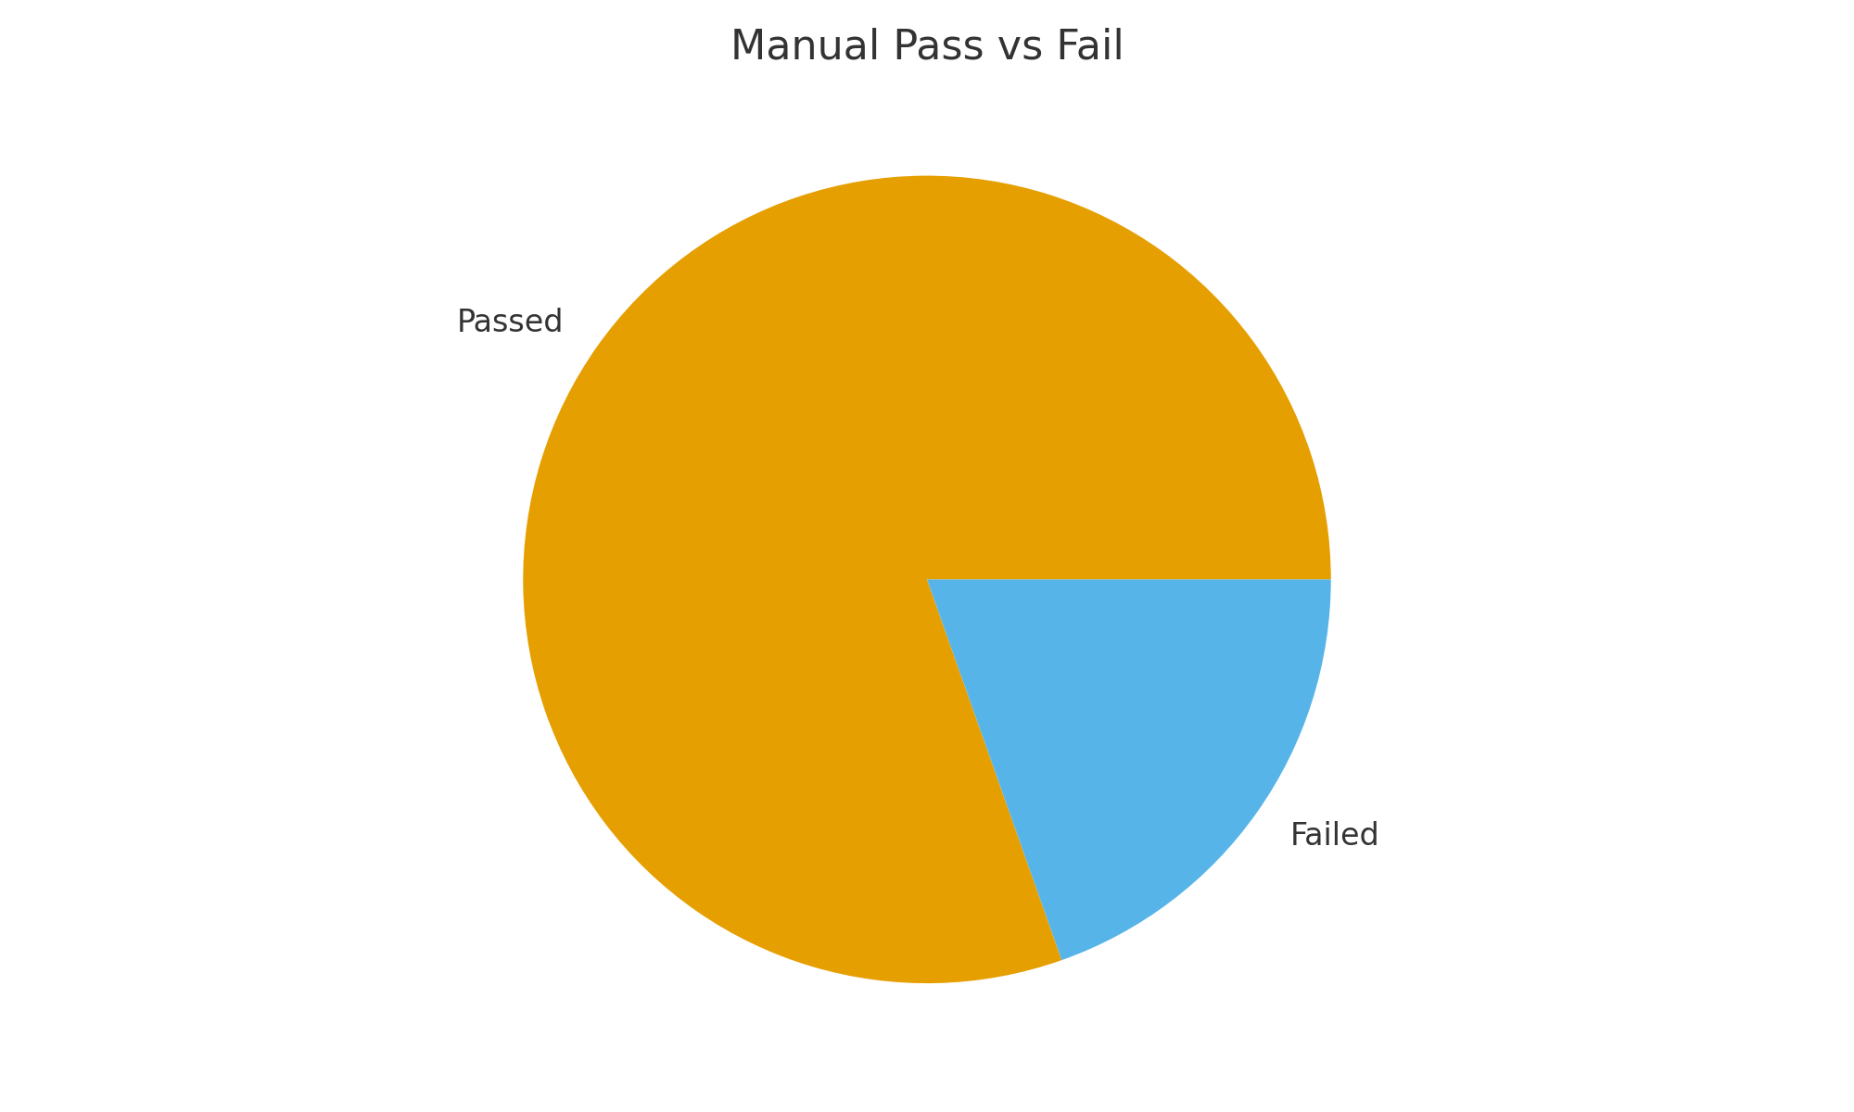

4. Test Scope Summary
Testing covered Login, Admin, PIM (Employee List & Add Employee), User Role Management, Search/Filtering, Validations, UI/UX, Navigation, and Performance checks.

5. Defect Distribution by Module
• Employee List: 1
• Add Employee: 1
• Admin: 2
• Login: 2
• Leave List: 2
• My Info: 11

6. Automation Test Execution Charts
Bar Chart:
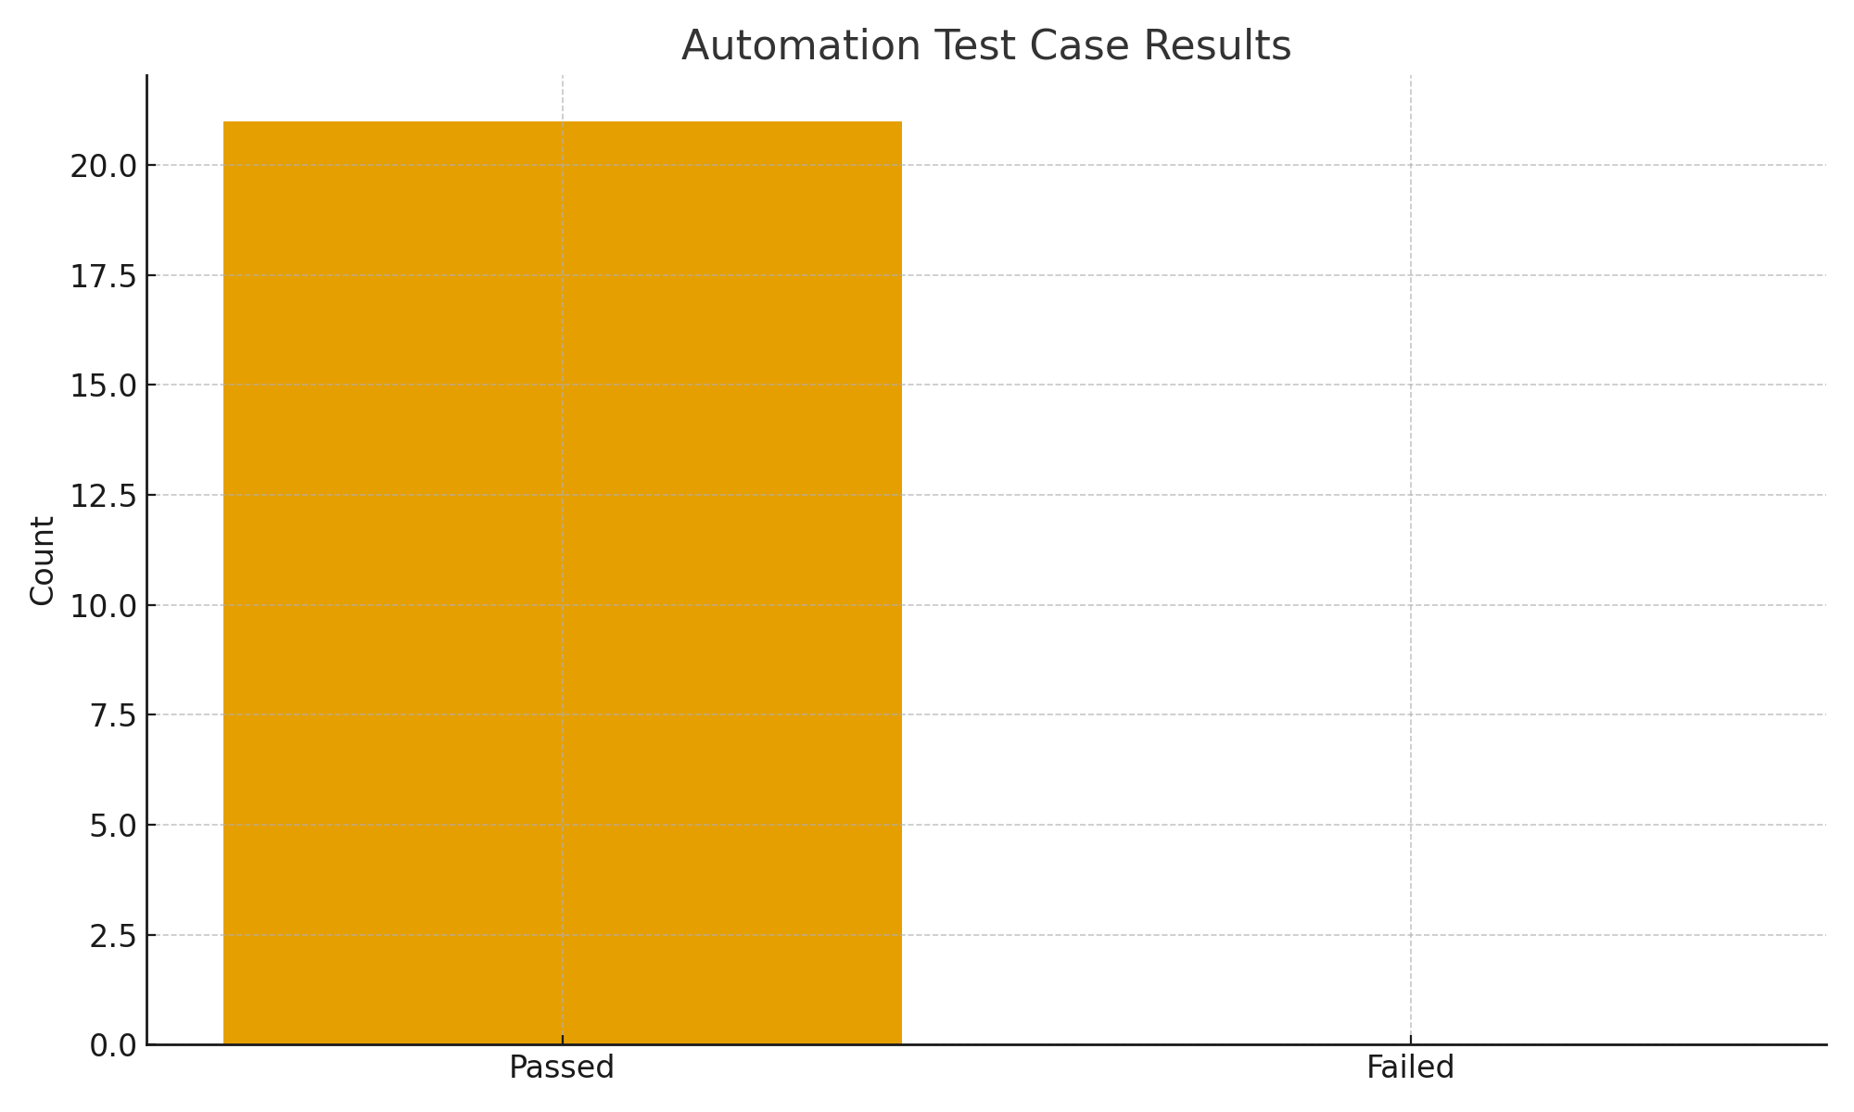
Pie Chart:
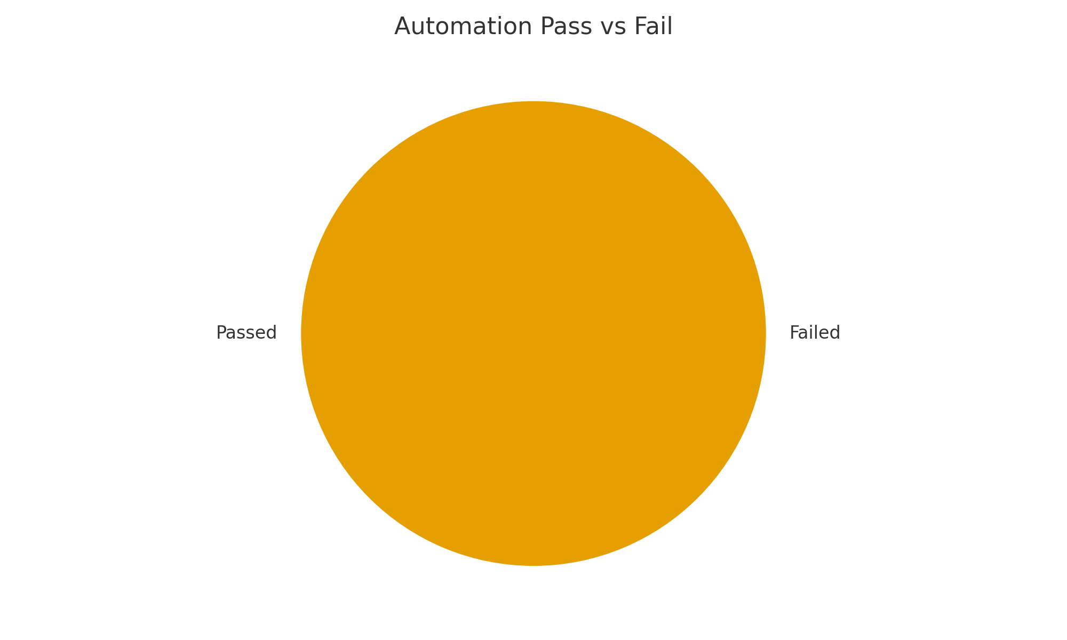

7. Automation Testing Summary
Automation Framework: Selenium 4.27.0 – TestNG 7.10.2
Total Automation Cases: 21
All test cases passed successfully with no failures detected.

8. Overall System Assessment
The system shows good stability with most workflows functioning correctly. Pass rate is approximately 84%. Issues identified are mostly related to validations, UI alignment, and performance delays.

9. Risks & Concerns
• UI inconsistencies on some screens
• Slow performance on Admin module
• Missing/unclear validation messages
• Data accuracy issues in PIM

10. Recommendations
• Fix high-severity defects before next test cycle
• Re-test Admin & Employee List module after fixes
• Enhance UI structure and validation logic
• Conduct follow-up performance tests

9. Final Conclusion
The OrangeHRM platform demonstrates acceptable functionality with 99 out of 118 cases passing. Addressing the identified issues will significantly improve system stability and user experience.

