Binary Sentiment Classification with Logistic Regression
End-to-End Analysis Report — IMDB 50K Reviews Dataset
CS 420 — Machine Learning & NLP | Algorithm: Logistic Regression | Loss: Binary Cross-Entropy | Seed: 42
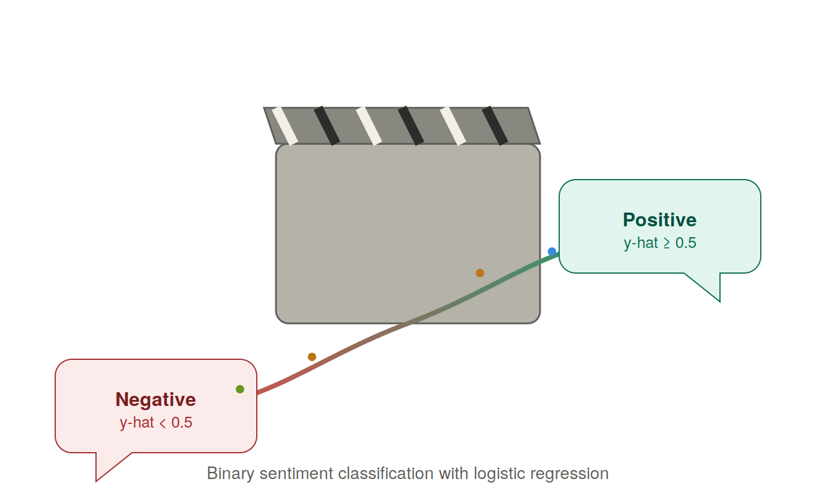

1. Executive Summary
This report documents an end-to-end sentiment classification pipeline built on the IMDB 50,000-review dataset. Raw review text was converted into Bag-of-Words (BoW) count features (10,000-word vocabulary) and used to train a Logistic Regression classifier that minimizes Binary Cross-Entropy (BCE) loss. The model was evaluated on a held-out 20% test set (10,000 reviews) and further cross-validated with an independent SQL-based analysis layer.
Headline result: the model reaches 87.6% test accuracy and a 0.941 ROC-AUC, confirming that a simple linear BoW model already captures the large majority of lexical sentiment signal in movie reviews, while remaining vulnerable to sarcasm, negation, and long dark-themed plot summaries — as detailed in Section 5.

2. Dataset Overview
Property | Value
Total reviews | 50,000
Positive / Negative split | 25,000 / 25,000 (perfectly balanced)
Train / Test split | 40,000 / 10,000 (80% / 20%, stratified, seed = 42)
Feature representation | Bag-of-Words, CountVectorizer, max_features = 10,000
Preprocessing | HTML tag removal, lowercasing, non-letter stripping, English stop-word removal

3. Project Pipeline
The end-to-end pipeline used in this project is summarized below: raw reviews are cleaned and vectorized, the logistic regression model is trained under Binary Cross-Entropy loss, the model is evaluated and interpreted, and results are cross-checked through an independent SQL layer.
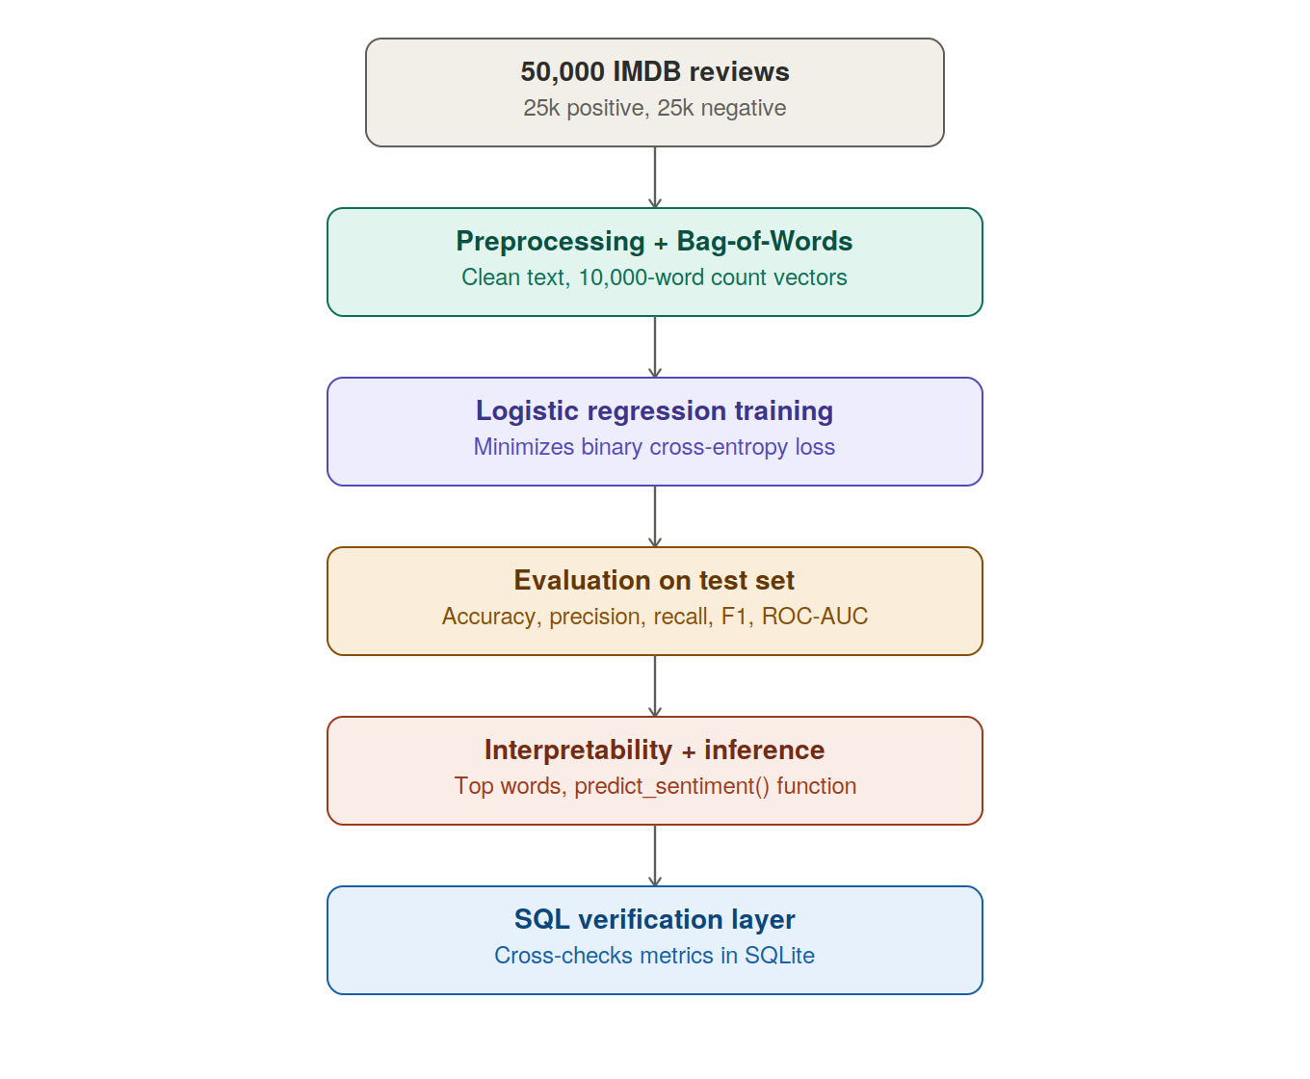

4. Model Training
The Logistic Regression model (solver = lbfgs) was trained on the 40,000-review training split. Training loss was tracked across increasing optimizer iterations to verify convergence to a stable minimum, shown below.
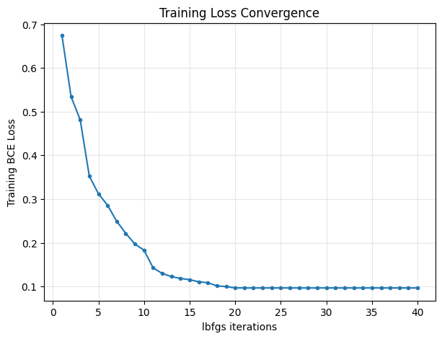
The loss drops sharply within the first ~15 iterations and flattens near 0.095, confirming the optimizer converged to a stable minimum well before the 1,000-iteration budget used for the final model.

5. Test-Set Evaluation (threshold = 0.5)
Metric | Value
Test BCE (Log Loss) | 0.3993
Accuracy | 87.62%
Precision | 87.44%
Recall | 87.86%
F1-Score | 87.65%
ROC-AUC | 0.9410

4.1 Confusion Matrix
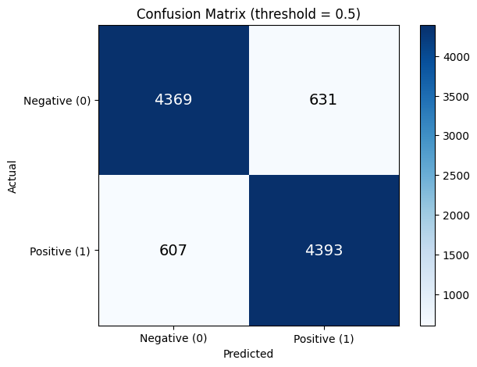
Of 5,000 negative test reviews, 4,369 were correctly classified and 631 were false positives. Of 5,000 positive test reviews, 4,393 were correctly classified and 607 were false negatives — the model is essentially balanced between the two error types, consistent with the balanced training data.

4.2 Threshold Experiment
Precision and Recall were recomputed at three probability thresholds to illustrate the standard precision/recall trade-off:
Threshold (τ) | Precision | Recall | F1
0.3 | 0.8413 | 0.9140 | 0.8762
0.5 | 0.8744 | 0.8786 | 0.8765
0.7 | 0.8998 | 0.8302 | 0.8636
Lowering τ to 0.3 favors Recall (0.914) over Precision (0.841) — appropriate for a use case such as a complaint/crisis-detection filter, where missing a genuinely negative review (a false negative) is costlier than a handful of extra false alarms.

6. Error Analysis
Manual inspection of the model's most confident mistakes reveals two recurring failure patterns, both direct consequences of the Bag-of-Words assumption (no word order, no negation handling):
- False Positives: negative reviews that use strongly positive vocabulary sarcastically, or that favorably compare the reviewed film to another one before criticizing it — the model has no mechanism to detect sarcasm or track which entity a word refers to.
- False Negatives: positive reviews (often for horror, war, or tragedy films) whose plot description uses many negative-coded words ("death", "brutal", "terrifying"), which numerically outweigh a short but decisive positive verdict such as "a masterpiece."
This same limitation shows up in the three custom benchmark predictions:
Review | Predicted | P(positive)
"An absolute triumph of cinema with breathtaking visuals and stellar acting." | Positive | 0.7129
"I thoroughly enjoyed wasting two hours of my life staring at a completely incoherent plot." (sarcasm) | Negative | 0.2022
"The cinematography was not bad, but the pacing was not good either." (double negation) | Negative | 0.3276
Case 2 and case 3 sit noticeably closer to the 0.5 decision boundary than case 1 — the model is measurably less confident precisely where BoW's word-order-blindness is exposed.

7. Model Interpretability
The 10 largest positive and negative learned weights are shown below:
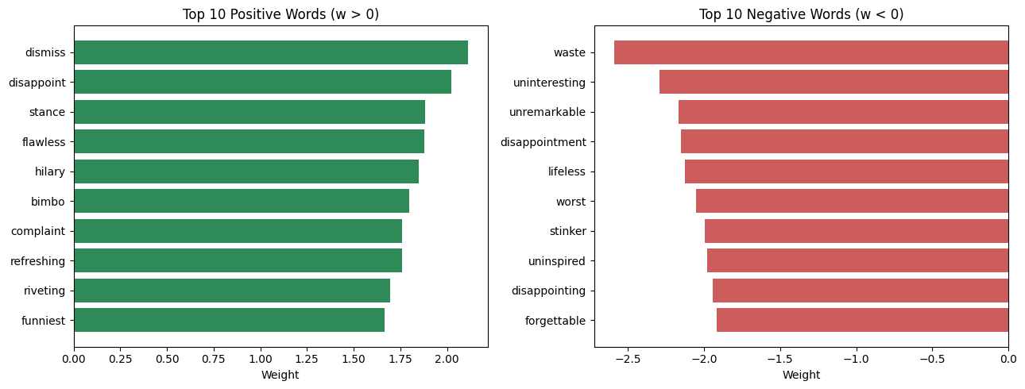
Most negative-weighted words are intuitive, unambiguous sentiment words ("waste", "disappointing", "forgettable", "worst"). Interestingly, a few words that sound negative in isolation — "dismiss" and "disappoint" — appear among the top positive weights. This is a direct, visible symptom of the BoW negation problem discussed in Section 5: these words most often co-occur in the training data inside phrases like "never disappoints" or "doesn't dismiss," so the model has learned a positive association with the bare token despite its negative surface meaning.

8. Independent SQL-Based Verification
The full set of 10,000 test predictions was exported into a SQLite table (predictions) with columns review, true_label, pred_label, and proba. The confusion matrix and core metrics were then recomputed with pure SQL aggregate queries as a cross-check of the Python/scikit-learn results:
tp | fp | fn | tn | accuracy | precision | recall
4393 | 631 | 607 | 4369 | 0.8762 | 0.8744 | 0.8786
The SQL-derived accuracy (0.8762), precision (0.8744), and recall (0.8786) match the scikit-learn results exactly, confirming the evaluation pipeline is internally consistent.
A second query computed the average predicted probability grouped by true class, as a simple calibration check:
True Label | Avg. Predicted P(positive) | # Reviews
0 (Negative) | 0.1466 | 5,000
1 (Positive) | 0.8532 | 5,000
Both averages sit close to their ideal extremes (0 and 1 respectively) and are roughly symmetric around 0.5, indicating the model is reasonably well-calibrated and not systematically biased toward either class.

9. Conclusion
A Bag-of-Words representation combined with Logistic Regression trained under Binary Cross-Entropy loss is a strong, interpretable baseline for IMDB sentiment classification, reaching 87.6% accuracy and 0.94 ROC-AUC with a simple linear model. Its main weaknesses — sarcasm, negation, and length-imbalanced sentiment cues — are exactly the failure modes predicted by the theoretical limitations of the BoW assumption discussed in the coursework, and were empirically confirmed both through manual error inspection and through the independent SQL verification layer.

