

**Faculty of engineering - Shoubra**

**Benha University**

**Research Article / Research Project / Literature Review**

in fulfillment of the requirements of

|  |  |
| --- | --- |
| **Department** | **Engineering Mathematics and  Physics** |
| **Division** | **-----------** |
| **Academic Year** | **2019-2020 Preparatory** |
| **Course name** | **Computer** |
| **Course code** | **ECE001** |

**Title: -**

**Artificial Intelligence**

By:

|  |  |  |  |
| --- | --- | --- | --- |
|  | Name | Edu mail | B.N |
| 1 | يوستينا نادي جبره زاخر ذكي | Youstina196176@feng.bu.edu.eg | 1045 |

**Approved by:**

|  |  |
| --- | --- |
| Examiners committee | Signature |
| Dr.Ahmed Bayoumi |  |
| Dr.Shady Elmashad |  |
| Dr. Abdelhamid Attaby |  |
|  |  |

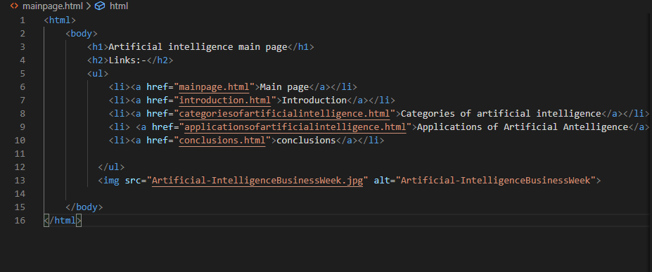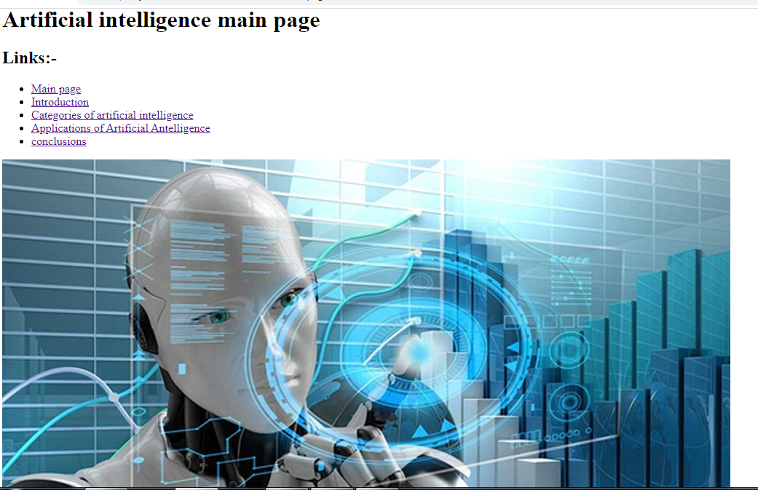  
**screenshots :**  
  
  
  
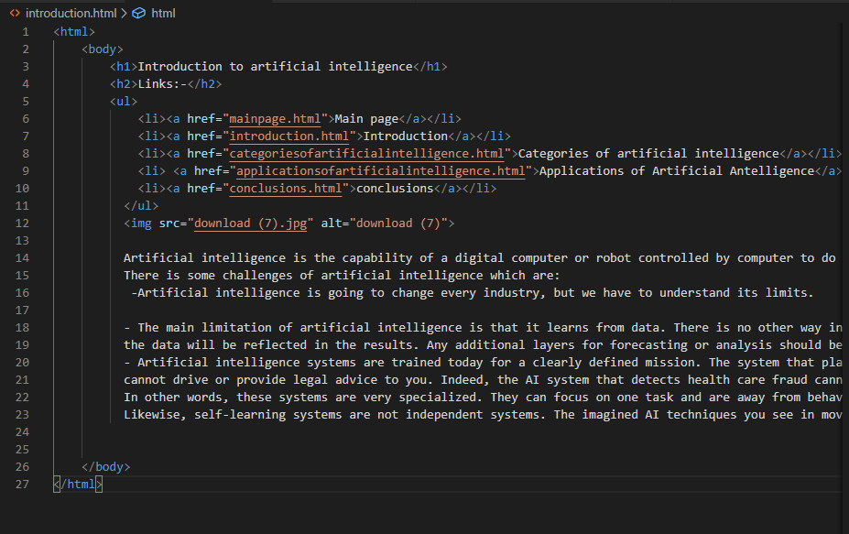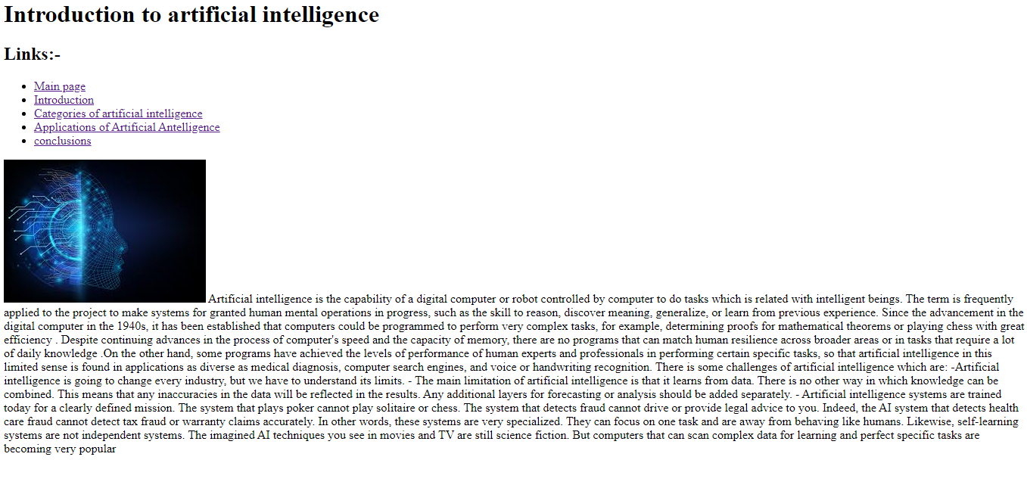  
  
  
  
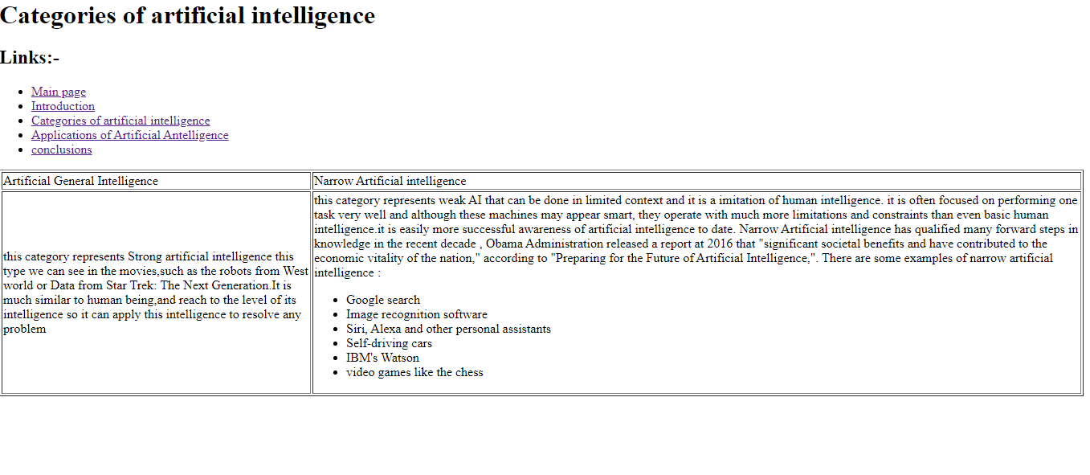  
  
  
  
  
  
  
  
  
  
  
  
  
  
  
  
  
  
  
  
  
  
  
  
  
  
  
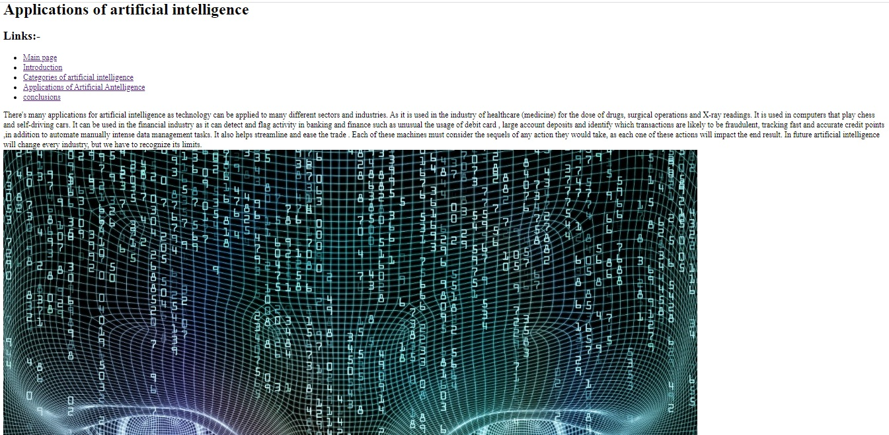  
  
  
  
  
  
  
  
  
  
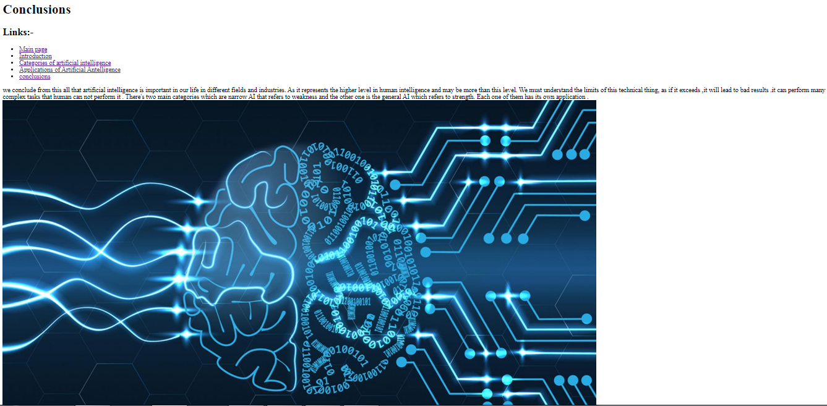  
  
  
  
  
  
  
  
  
  
  
  
  
  
  
  
  
  
  
  
  
  
  
  
  
  
  
  
  
  
  
  
  
  
  
  
  
  
  
  
  
  
  
  
  
  
  
  
  
  
Artificial Intelligence is a branch of computer science interests with building intelligent machines which can perform tasks that likely need human intelligence. these tasks from the most simple to those that are even more complex. Computers could be trained to achieve some mission jobs by doing process of huge amounts of information and recognizing patterns within the data. There's two categories one of them is narrow AI which refers to weak AI while the other is the general intelligence which refers to strong AI. Both of them have its own application .Artificial intelligence is used in many fields and industries as medicine , financial industry ,video games ,etc. we have to understand the limitation of this artificial intelligence to not reach bad results if we encroach this limits .I chose this one of topics as I want to know what is artificial intelligence and how it works and why it is so important nowadays .

**References**- <https://builtin.com/artificial-intelligence>  
- <https://www.investopedia.com/terms/a/artificial-intelligence-ai.asp>  
-<https://www.britannica.com/technology/artificial-intelligence>  
-<https://www.sciencemag.org/news/2020/04/artificial-intelligence-evolving-all-itself>  
-<https://sova.si.edu/search?q=artificial+intelligence>  
-<https://archive.org/stream/artificialintell0000luge#page/188/mode/2up>  
-<https://openlibrary.org/works/OL2710037W/Artificial_intelligence>  
- <https://www.socioweb.com/directory/search.php?condition=and&filled=1&search=artificial+intelligence&whichtype=links>