🎓
GRADE & GRIND
A Freelance Platform for University Students
──────────────────────────────────────
ITERATION 1 — PROJECT REPORT
Foundations of Software Engineering | Spring 2026
CS3051 | FAST-NU Lahore
Sadeem 24L-2502
Mahnoor 24L-2533
Yousuf 24L-2539

1. Project Overview
Grade & Grind is a web-based freelancing platform designed exclusively for university students in Pakistan. It connects students who possess in-demand skills with clients who need affordable, quality services for short-term tasks. The platform addresses the gap between student talent and real-world opportunities by providing a structured, academic-focused freelance ecosystem.

1.1 Project Identification
Project Title | Grade & Grind
Type | Web Application (Full Stack)
Course | CS3051 — Foundations of Software Engineering
Iteration | Iteration 1 of 3
Iteration Period | Weeks 1 & 2 — Spring 2026 – 2 weeks in total
University | FAST-NU Lahore, Pakistan
Tech Stack | React (Frontend) · Node.js / Express (Backend) · SQL Server (Database) · Firebase (Auth)

1.2 Team
Sadeem | 24L-2502 — Project Lead & Full Stack Developer
Mahnoor | 24L-2533 — Full Stack Developer
Yousuf | 24L-2539 — Full Stack Developer

2. Iteration 1 — Scope & Goals
Iteration 1 focuses on delivering a fully functional Minimum Viable Product (MVP) covering the core modules needed for users to register, set up their profiles, post gigs, and browse the platform. This forms the foundation upon which Iterations 2 and 3 will build.

2.1 Modules Delivered in Iteration 1
- User Registration & Authentication (Firebase + SQL Server)
- Student Profile & CV Upload (Cloudinary)
- Client Gig Posting & Management
- Gig Dashboard (student and client views)
- Core Database Schema — all 12 tables created with dummy data
- Backend REST API — auth, gig, and student profile routes
- Frontend Authentication Page — sign in, sign up, Google OAuth, forgot password

2.2 Modules Deferred to Later Iterations
Iteration 2 | Skill-Based Gig Matching, Application Acceptance & Status Management, Review & Rating System, Leaderboard
Iteration 3 | Real-Time Messaging, Secure Payment Processing, Email Notifications, Admin Panel & Monitoring

3. User Stories & Completion Status
The following table lists all user stories planned for Iteration 1, the feature they belong to, and their current completion status as tracked on the Trello board.

User Story | Feature | Status
As a new user I can register as a student or client using email and password | Auth | Done
As a new user I receive an email verification link after signing up | Auth | Done
As a registered user I can sign in with my email and password | Auth | Done
As a registered user I can sign in using my Google account | Auth | Done
As a signed-in user I can reset my forgotten password via email | Auth | Done
As a student I can view and update my profile (bio, degree, graduation year) | Student Profile | Done
As a student I can upload my CV as a PDF file | Student Profile | Done
As a student I can upload a profile picture | Student Profile | Done
As a student I can add and update my skills list (up to 20 skills) | Student Profile | Done
As a student I can see all open gigs on the platform | Gig Dashboard | Done
As a student I can view the detail of any gig | Gig Dashboard | Done
As a student I can apply to an open gig with a cover letter | Gig Dashboard | Done
As a student I can see my application history and statuses | Gig Dashboard | Done
As a client I can post a new gig with title, description, budget, deadline, category | Gig Posting | Done
As a client I can edit my open gigs | Gig Posting | Done
As a client I can delete my open gigs | Gig Posting | Done
As a client I can view all applications submitted to my gigs | Gig Posting | Done
As a client I can browse all available student profiles | Student Browse | Done

4. Trello Board — Task Tracking
All user stories and development tasks for Iteration 1 were managed on our Trello board. The board is organized into four columns: Backlog, In Progress, In Review, and Done. Screenshots below capture the state of the board at three key points during the iteration.

4.1 Starting State — Beginning of Iteration 1
All user stories begin in the Backlog column. No development has started yet. The cards are organized by feature module.

TRELLO SCREENSHOT — STARTING STATE (paste here)
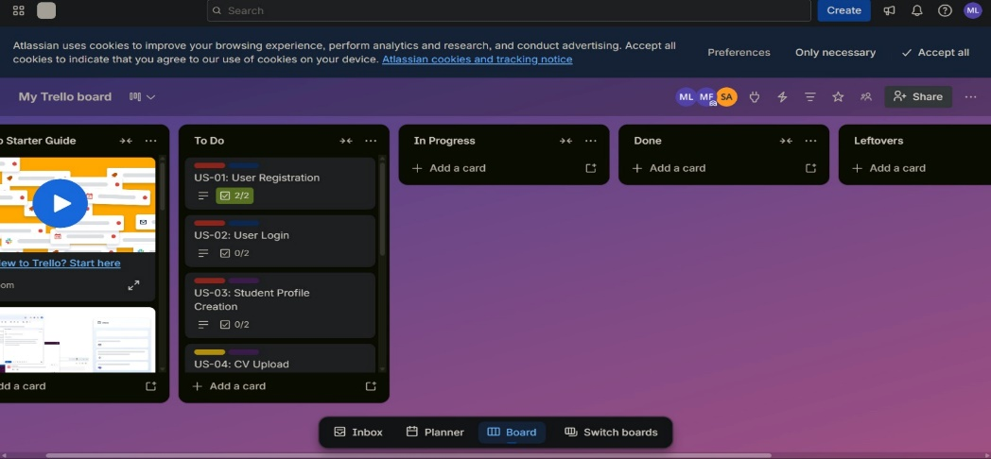

4.2 Middle State — Mid-Iteration Progress
Authentication and database setup tasks have been moved to Done. Student profile and gig posting cards are In Progress. The team is actively working on backend API routes.

TRELLO SCREENSHOT — MIDDLE STATE (paste here)
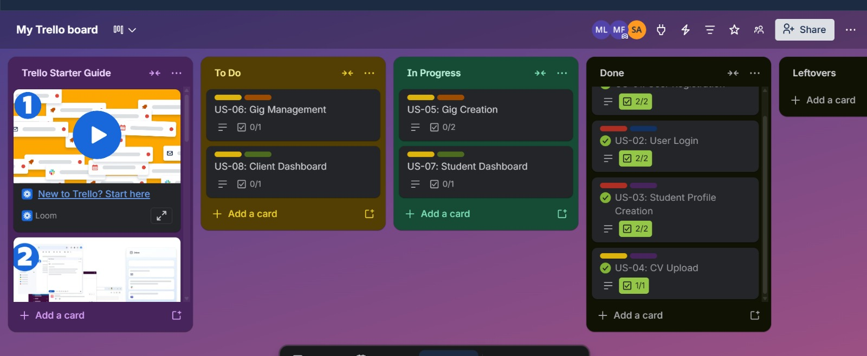

4.3 Ending State — End of Iteration 1
All planned user stories are in the Done column. The board reflects a completed iteration with all 18 user stories marked as finished and verified through Postman testing.

TRELLO SCREENSHOT — ENDING STATE (paste here)
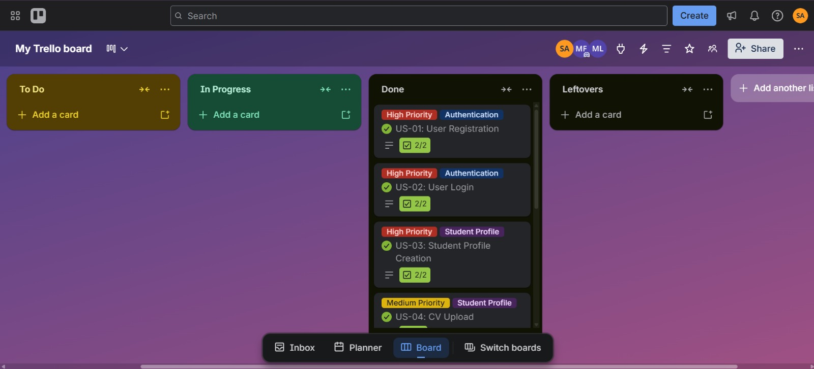

5. System Architecture

5.1 Tech Stack
Frontend | React 18 with Vite, React Router v6, Tailwind CSS
Backend | Node.js with Express.js — REST API
Database | Microsoft SQL Server (SSMS) — 12 tables
Authentication | Firebase Authentication — email/password + Google OAuth
File Storage | Cloudinary — profile pictures (JPG/PNG) and CV uploads (PDF)
HTTP Client | Axios with automatic Firebase token injection via interceptor
Dev Tools | Postman (API testing), SSMS (database management), VS Code

5.2 Request Flow
Every authenticated request from the React frontend follows this path:

- React frontend fires an Axios request. The Axios interceptor automatically attaches the current user's Firebase ID token as a Bearer token in the Authorization header.
- The Express backend receives the request. The verifyToken middleware extracts the Bearer token and calls Firebase Admin SDK to verify it.
- Firebase Admin SDK confirms the token is valid and returns the decoded user email.
- The middleware looks up the user in SQL Server using their email, attaches the full user record to req.user, and calls next().
- The roleGuard middleware checks the user's Role field (student, client, or admin) against the route's required role. Access is denied with 403 if the role does not match.
- The route controller executes the business logic and calls the model layer.
- The model layer runs parameterized SQL queries against SQL Server using the mssql connection pool.
- The response is returned as JSON to the frontend.

6. Database Schema
The GradeAndGrindDB database contains 12 tables designed to support all platform features across all three iterations. All tables were created and populated with dummy data in Iteration 1.

6.1 Tables Created
# | Table Name | Primary Key | Purpose
1 | Users | UserID | All users — students, clients, admins
2 | StudentProfiles | ProfileID | Extended profile info for students
3 | ClientProfiles | ClientProfileID | Extended profile info for clients
4 | StudentSkills | StudentSkillID | Skills listed by students
5 | Gigs | GigID | Tasks posted by clients
6 | Applications | ApplicationID | Student applications to gigs
7 | Wallets | WalletID | Token balance per user
8 | Transactions | TransactionID | Token movements (topup, payment, etc.)
9 | Messages | MessageID | Direct chat between users
10 | Reviews | ReviewID | Post-gig ratings and comments
11 | Notifications | NotificationID | In-app alerts for all events
12 | Reports | ReportID | User/gig reports resolved by admin

7. REST API Endpoints

7.1 Authentication Routes (/api/auth)
Method | Endpoint | Auth / Role | Description
POST | /api/auth/register | Firebase token (header) | Register new user after Firebase signup
POST | /api/auth/login | Firebase token (header) | Verify token and return user profile

7.2 Gig Routes (/api/gigs)
Method | Endpoint | Auth / Role | Description
GET | /api/gigs | Any logged-in user | List all open gigs
GET | /api/gigs/my | Client only | Get client's own posted gigs
GET | /api/gigs/:id | Any logged-in user | Get single gig detail
POST | /api/gigs | Client only | Post a new gig
PUT | /api/gigs/:id | Client only | Edit an open gig
DELETE | /api/gigs/:id | Client only | Delete an open gig
GET | /api/gigs/:id/applications | Client only | View all applicants for a gig
POST | /api/gigs/:id/apply | Student only | Apply to a gig with cover letter

7.3 Student Profile Routes (/api/student)
Method | Endpoint | Auth / Role | Description
GET | /api/student/profile | Student only | Get own full profile + skills
PUT | /api/student/profile | Student only | Update profile, skills, CV, pic
GET | /api/student/applications | Student only | Get own application history
GET | /api/student/browse | Any logged-in user | Browse all student profiles
GET | /api/student/:id | Any logged-in user | Get one student profile by ID

8. Key Implementation Details

8.1 Authentication Flow
Firebase handles all credential management. The backend never stores passwords. The flow works as follows:
- Registration: Firebase creates the account and sends a verification email. The frontend then calls /api/auth/register with the Firebase token and profile fields to persist the user in SQL Server.
- Login: Firebase verifies the password on the client side. The frontend sends the Firebase ID token to /api/auth/login. The backend verifies it via Firebase Admin SDK and returns the user profile from SQL Server.
- Every subsequent request: The Axios interceptor automatically attaches the current Firebase ID token. The verifyToken middleware verifies it on every protected route.
- Google OAuth: Handled entirely by Firebase signInWithPopup. If the user's email is already in SQL Server they are logged in; if not they are redirected to complete their profile.

8.2 Match Score Algorithm
When a student applies to a gig, a match score (0–100%) is automatically calculated by the computeMatchScore function in gigModel.js. The algorithm works as follows:
- Fetch the gig's RequiredSkills column from SQL Server (comma-separated string, e.g. "React,Node.js,SQL").
- Fetch all SkillName entries from the StudentSkills table for the applying student.
- Split required skills into an array and normalize to lowercase.
- Count how many required skills appear in (or contain) the student's skill list using partial string matching.
- Score = (matched skills / total required skills) × 100, rounded to the nearest integer.
A gig requiring "React, Node.js, SQL" where the student has "React" and "Node.js" would yield a score of 67%.

8.3 File Uploads — Cloudinary
Profile pictures and CVs are stored on Cloudinary, not on the local server. multer-storage-cloudinary is used as the multer storage engine. The params function inspects the fieldname to route files to the correct Cloudinary folder:
- profilePic field → gradeandgrind/profiles folder, auto-cropped to 300×300 px
- cv field → gradeandgrind/cvs folder, stored as raw PDF resource
The returned Cloudinary URL is saved directly into the SQL Server database (CVURL or ProfilePic column).

8.4 Role-Based Access Control
Two middleware functions enforce authorization:
- verifyToken: Verifies the Firebase token on every protected route. Attaches the full SQL Server user record to req.user. Rejects banned users.
- roleGuard(role): Checks req.user.Role against the allowed role for the route. Returns 403 if the role does not match. Accepts multiple roles (e.g. roleGuard("student", "admin")).

9. Frontend — Authentication Page
The AuthPage.jsx component is the entry point to the platform. It implements a two-panel layout: a marketing panel on the left (hidden on mobile) and an authentication form on the right.

9.1 Features Implemented
- Tab-based navigation between Sign In and Create Account forms
- Role selector — students and clients have different onboarding fields
- Student-specific fields: university selector (12 Pakistani universities), phone number with live validation
- Real-time password strength indicator showing 4 checks (8+ chars, uppercase, number, no spaces)
- Forgot password flow — sends Firebase reset email without leaving the page
- Google OAuth sign-in via Firebase signInWithPopup
- Comprehensive frontend validation before any API calls are made
- Error and success banners with distinct amber/green/red colour coding
- Fully responsive — mobile view collapses to single column

9.2 Frontend Validation Rules
First / Last Name | Minimum 2 characters, letters only, no numbers or special characters
Email | Valid RFC format, blocked disposable domains (test.com, mailinator.com, etc.)
Phone | Optional — must be exactly 11 digits starting with 03 if provided
University | Required for students — dropdown with 12 pre-loaded Pakistani universities
Password | Minimum 8 characters, at least one uppercase letter and one number, no spaces

10. API Testing — Postman
All backend routes were tested using Postman. Since Firebase tokens require a live browser session, a test bypass was added to verifyToken middleware: passing the x-test-email header with a valid user email from the dummy data grants access without a Firebase token. This header is removed before production deployment.

10.1 Test Cases Executed
# | Request | Test Email Used | Expected Result
1 | GET /api/health | — | 200 { status: "ok" }
2 | GET /api/gigs | sadeem@gmail.com | 200 gigs array (3 open gigs)
3 | GET /api/gigs/1 | sadeem@gmail.com | 200 single gig detail
4 | GET /api/gigs/my | techcorp@gmail.com | 200 client's 3 posted gigs
5 | POST /api/gigs (valid body) | techcorp@gmail.com | 201 gigID returned
6 | POST /api/gigs (title < 10 chars) | techcorp@gmail.com | 400 validation error
7 | POST /api/gigs/1/apply | mahnoor@gmail.com | 201 applicationID + matchScore
8 | POST /api/gigs/1/apply (duplicate) | sadeem@gmail.com | 409 already applied
9 | GET /api/gigs/1/applications | techcorp@gmail.com | 200 applicants sorted by score
10 | GET /api/gigs/1/applications (wrong client) | designhub@gmail.com | 200 empty array (not owner)
11 | GET /api/student/profile | sadeem@gmail.com | 200 full profile + skills
12 | PUT /api/student/profile | sadeem@gmail.com | 200 updated profile returned
13 | GET /api/student/applications | sadeem@gmail.com | 200 application history
14 | GET /api/student/browse | techcorp@gmail.com | 200 all students with skills
15 | GET /api/student/3 | techcorp@gmail.com | 200 Yousuf's public profile
16 | POST /api/gigs (as student — role guard) | sadeem@gmail.com | 403 access denied
17 | GET /api/gigs/my (as student — role guard) | sadeem@gmail.com | 403 access denied
18 | GET /api/gigs (no header — no auth) | — | 401 authentication required

11. Challenges & Solutions
Firebase token in Postman | Firebase tokens require a live browser. Solved by adding an x-test-email bypass header in verifyToken for development, removed before production.
Cloudinary multi-field upload | Profile pic and CV need different Cloudinary folders. Solved by using a dynamic params function in multer-storage-cloudinary that checks file.fieldname.
SQL Server connection string | Named instances require double backslash in .env (DB_SERVER=localhost\\SQLEXPRESS). Took time to diagnose the ECONNREFUSED error.
Google OAuth new user flow | Google sign-in users have no profile in SQL Server on first login. Solved by catching the 404 response and redirecting to a /complete-profile page.
Role guard on /api/gigs/my | Express matches /my as a dynamic :id parameter. Fixed by registering the /my route before the /:id route in gigRoutes.js.

12. Plan for Iteration 2
Iteration 2 focuses on completing the full gig lifecycle — from application through acceptance, rejection, and status tracking — along with the skill-based matching algorithm and the leaderboard.

12.1 Planned Features
- Application acceptance / rejection by client with automatic gig status change to in_progress
- Student application withdrawal
- Full skill-based gig matching improvements — weighted scoring using CV analysis
- Gig status management — Open → In Progress → Completed → Cancelled transitions
- Review and rating system — post-completion reviews for both students and clients
- Leaderboard — top students ranked by rating × 40 + reviews × 30 + completed gigs × 30
- Complete client dashboard UI with gig management and applicant review screens
- Complete student dashboard UI with application tracking and status indicators

12.2 Technical Additions Planned
- applicationController.js and applicationModel.js — accept/reject/withdraw endpoints
- reviewController.js and reviewModel.js — create and fetch reviews
- leaderboardController.js — ranked student query with composite score
- Additional frontend pages: ClientDashboard.jsx, StudentDashboard.jsx, GigDetailPage.jsx

Appendix — Project File Structure
The repository is organized as follows:

File / Folder | Purpose
backend/config/db.js | SQL Server connection pool using mssql
backend/config/firebase.js | Firebase Admin SDK initialization
backend/middleware/verifyToken.js | Firebase token verification middleware
backend/middleware/roleGaurd.js | Role-based access control middleware
backend/features/auth/ | authController.js, authModel.js, authRoutes.js
backend/features/gigs/ | gigController.js, gigModel.js, gigRoutes.js
backend/features/studentProfile/ | studentProfileController.js, Model.js, Routes.js
backend/server.js | Express app entry point, route registration
database/GradeAndGrindDB.sql | Full schema — 12 tables + dummy data + commented queries
frontend/src/config/firebase.js | Firebase client SDK config (auth + Google provider)
frontend/src/api/axios.js | Axios instance with Firebase token interceptor
frontend/src/context/AuthContext.jsx | Global auth state via React Context
frontend/src/pages/AuthPage.jsx | Full sign in / sign up / forgot password UI
frontend/src/App.jsx | Router setup with protected route component

End of Iteration 1 Report — Grade & Grind | FAST-NU Lahore | Spring 2026

