National University of Computer and Emerging Sciences
FAST-NU, Lahore, Pakistan
CS3051 | Foundations of Software Engineering | Spring 2026

Grade & Grind
A Freelance Platform for University Students
Iteration 1 Report | Sprint Backlog

Group Members
Sadeem (24L-2502) - Project Lead
Mahnoor (24L-2533) - Full Stack Developer
Yousuf (24L-2539) - Full Stack Developer
Deliverable # 2
March 25, 2026

Project Introduction: Grade & Grind

Grade & Grind is a dedicated freelance marketplace platform designed to bridge the gap between student talent and professional opportunities. By focusing on the unique needs of the university ecosystem, the platform allows students to showcase their skills through professional profiles and CV uploads while providing clients with a streamlined process for gig creation and management. This first iteration of the project establishes the core infrastructure of the marketplace, focusing on secure user authentication, personalized dashboards for both students and clients, and the essential tools required to post and manage freelance service listings.

1. Sprint 1 Overview

Sprint Duration | 2 weeks (14 days)
Sprint Goal | Deliver a working Minimum Viable Product (MVP) where users can register, create profiles, post gigs, and view basic dashboards.
Modules Included | User Registration and Authentication  Student Profile and CV Upload  Client Gig Posting and Management  Student Dashboard and Client Dashboard
Total Estimated Effort | 192 hours across 8 user stories

2. User Stories

Story ID: US-01 Story Title: User Registration | Priority: High Estimated Hours: 40
User Story | As a new user, I want to register on the platform as either a student or a client so that I can access role-specific features and start using the platform.
Description | This story involves developing a user registration system that allows new users to create accounts on the Grade & Grind platform. Users can choose between student and client roles, and the system validates their input, ensures email uniqueness, and sends a verification email.
Sub User Stories | - As a user, I want the registration form to validate my inputs so that I provide correct information.  - As a user, I want to receive an email verification link so that I can confirm my email address.
Acceptance Criteria | - User can choose between student or client role.  - Email must be unique and in valid format.  - Password must be at least 8 characters with uppercase, lowercase, and number.  - System sends verification email after registration.  - All UI components reflect the selected registration type.

Story ID: US-02 Story Title: User Login | Priority: High Estimated Hours: 24
User Story | As a registered user, I want to log in to my account using my email and password so that I can access my personalized dashboard and platform features.
Description | This story implements secure user authentication. Users enter their credentials, the system validates them, and creates an authenticated session using JWT tokens. It includes session management and password reset functionality.
Sub User Stories | - As a logged-in user, I want my session to be maintained so that I do not have to log in repeatedly.  - As a user who forgot my password, I want to reset it using my email so that I can regain access.
Acceptance Criteria | - System validates credentials against database.  - Successful login redirects to role-specific dashboard.  - Session is maintained with JWT token.  - Password reset link available on login page.

Story ID: US-03 Story Title: Student Profile Creation | Priority: High Estimated Hours: 32
User Story | As a student, I want to create a detailed profile with my skills, education, and experience so that clients can find me and understand my qualifications.
Description | Students build comprehensive profiles including academic information, skills, education history, and project experience. Profiles can be saved as drafts or published for client viewing.
Sub User Stories | - As a student, I want to add, edit, and remove skills from my profile.  - As a student, I want to preview how my profile looks to clients before publishing.
Acceptance Criteria | - Profile form includes university, major, graduation year, bio, and skills.  - Students can add multiple skills as tags.  - Profile can be saved as draft or published.  - Published profiles are visible to clients.

Story ID: US-04 Story Title: CV Upload | Priority: Medium Estimated Hours: 16
User Story | As a student, I want to upload my CV in PDF format so that clients can download and review my complete professional background.
Description | This feature allows students to upload their CV as a PDF file. The system validates file type and size, stores it securely on Cloudinary, and makes it available for client download.
Sub User Stories | - As a student, I want the system to validate my CV file before upload.
Acceptance Criteria | - Only PDF files accepted.  - File size limited to 5MB.  - CV stored securely on Cloudinary.  - Clients can download CV from student profile.

Story ID: US-05 Story Title: Gig Creation | Priority: High Estimated Hours: 32
User Story | As a client, I want to post a gig with detailed requirements so that students can understand what I need and apply for the job.
Description | This feature enables clients to create and post job listings on the platform. Clients specify all job details including title, description, category, required skills, budget, and deadline. The system validates all inputs and publishes the gig for students to view.
Sub User Stories | - As a client, I want to format my gig description with rich text so that I can present information clearly.  - As a client, I want to select a category for my gig so that it can be properly classified.
Acceptance Criteria | - Form includes title, description, category, skills, budget, deadline, and duration.  - Skills can be added as multiple tags.  - Budget must be a positive number.  - Deadline must be a future date.  - Published gigs are visible to students.

Story ID: US-06 Story Title: Gig Management | Priority: Medium Estimated Hours: 24
User Story | As a client, I want to edit, pause, or close my posted gigs so that I can manage my job postings based on changing needs.
Description | This feature provides clients with full control over their posted gigs. Clients can edit gig details, temporarily pause gigs to stop receiving applications, or permanently close completed gigs. All status changes are reflected immediately on the platform.
Sub User Stories | - As a client, I want to see the status of each gig at a glance so that I can quickly understand which gigs are active, paused, or closed.
Acceptance Criteria | - Client can view all their posted gigs on dashboard.  - Edit button opens gig form with existing data.  - Pause option temporarily hides gig from students.  - Close option permanently marks gig as closed.  - Gig status clearly displayed on dashboard.

Story ID: US-07 Story Title: Student Dashboard | Priority: Medium Estimated Hours: 24
User Story | As a student, I want to view available gigs on my dashboard so that I can find opportunities that match my skills.
Description | The student dashboard is the main interface where students discover job opportunities. It displays all active gigs in an organized, easy-to-browse format with key information visible at a glance. Students can filter and search to find relevant opportunities.
Sub User Stories | - As a student, I want to filter gigs by category so that I can focus on opportunities relevant to my expertise.
Acceptance Criteria | - Dashboard displays all active gigs.  - Each gig shows title, category, budget, deadline, and required skills.  - Gigs displayed in card format.  - Student can click gig to view full details.  - Profile completion status shown on dashboard.

Story ID: US-08 Story Title: Client Dashboard | Priority: Medium Estimated Hours: 24
User Story | As a client, I want to view all my posted gigs and browse student profiles on my dashboard so that I can manage my job postings and find qualified students.
Description | The client dashboard provides a comprehensive view of all posted gigs and access to the student talent pool. Clients can quickly manage their gigs, monitor their status, and search for students with specific skills to proactively reach out for projects.
Sub User Stories | - As a client, I want to search for students by skills so that I can find candidates who match my project requirements.
Acceptance Criteria | - Dashboard displays all of the client's posted gigs.  - Each gig card shows status, title, budget, and deadline.  - Quick action buttons for edit, pause, and close on each gig.  - Section to browse student profiles.  - Student cards show name, university, skills, and rating.

3. Structured Specifications

The following structured specifications define detailed functional, UX, performance, and security requirements for each user story and its sub-user stories.

US-01: User Registration
US-01.1: Input Validation
Type | Specification
Functional | Email validation must check for proper format (contains @ and valid domain).
Functional | Password must be validated for minimum 8 characters, at least one uppercase, one lowercase, and one digit.
UX | Real-time validation errors must be displayed below each input field as the user types.
Performance | Validation checks must complete within 100ms to provide instant feedback.

US-01.2: Email Verification
Type | Specification
Functional | Verification email must be sent immediately after successful registration.
Functional | Verification token must be unique, cryptographically secure, and expire after 24 hours.
UX | User must receive clear feedback that verification email has been sent.
Security | Verification links must be single-use and invalidated after successful verification.

US-02: User Login
US-02.1: Session Management
Type | Specification
Functional | Session tokens must use JWT format and include user ID, email, role, and expiration.
Functional | Sessions must expire after 24 hours of inactivity and require re-authentication.
Security | All protected routes must verify a valid session token before granting access.
Performance | Token verification must complete in under 50ms to avoid delays in page loads.

US-02.2: Password Reset
Type | Specification
Functional | Password reset token must be cryptographically secure and expire after 1 hour.
Functional | Reset email must contain a unique link that validates the token before allowing password change.
Security | Old password must be invalidated immediately after successful reset.
UX | User must receive confirmation email after password is successfully changed.

US-03: Student Profile Creation
US-03.1: Skills Management
Type | Specification
Functional | Students must be able to add skills by typing and pressing Enter or clicking an Add button.
Functional | Each skill must be stored as a separate entry in the database for efficient matching.
UX | Skills must be displayed as removable tags with an X icon for deletion.
UX | Skill input must provide autocomplete suggestions based on commonly used skills.

US-03.2: Profile Preview
Type | Specification
Functional | Preview must display profile exactly as clients will see it, including all fields and formatting.
UX | Preview mode must have a clear Back to Edit button to return to editing interface.
UX | Preview must be accessible from profile edit page without saving changes.
Performance | Preview must load within 200ms to provide instant feedback.

US-04: CV Upload
US-04.1: File Validation
Type | Specification
Functional | System must validate file type is PDF before allowing upload.
Functional | File size must not exceed 5MB; larger files must be rejected with a clear error message.
Security | Server-side validation must verify file type by content, not just extension.
UX | Upload progress bar must show percentage while file is uploading.

US-05: Gig Creation
US-05.1: Rich Text Description
Type | Specification
Functional | Rich text editor must support bold, italic, underline, bullet lists, and numbered lists.
Functional | Formatted content must be stored as HTML in the database.
Security | HTML content must be sanitized to prevent XSS attacks before rendering.
UX | Editor toolbar must be easily accessible and intuitive to use.

US-05.2: Category Selection
Type | Specification
Functional | Categories must include: Web Development, Mobile Development, Graphic Design, Content Writing, Data Entry, Digital Marketing, Video Editing, and Other.
Functional | Each gig must have exactly one category assigned.
UX | Category must be displayed prominently on gig cards with color-coded badges.
Performance | Category filter must update results in under 100ms.

US-06: Gig Management
US-06.1: Status Indicators
Type | Specification
Functional | Gig status must be one of: Active (green), Paused (yellow), or Closed (red).
UX | Status badge must be clearly visible on each gig card with appropriate color coding.
UX | Dashboard must provide a filter to show gigs by status (All, Active, Paused, Closed).
Performance | Status changes must reflect immediately without page refresh.

US-07: Student Dashboard
US-07.1: Gig Filtering
Type | Specification
Functional | Filter dropdown must include all available categories plus an All Categories option.
Functional | Filtered results must show only gigs matching the selected category.
UX | Filter selection must persist during the session until manually changed.
Performance | Filter application must be instant with no visible loading delay.

US-08: Client Dashboard
US-08.1: Student Search
Type | Specification
Functional | Search must work on student name, university name, and skills.
Functional | Search results must update in real-time as the user types.
UX | Search bar must have clear placeholder text indicating search capabilities.
Performance | Search must return results within 300ms for a responsive user experience.

4. Non-Functional Requirements

The following non-functional requirements (NFRs) define the quality attributes and operational constraints for the Grade & Grind platform. These are specified using natural language and apply across all modules delivered in this iteration.

4.1 Performance
The platform must be responsive and efficient under normal usage conditions. All API endpoints must respond within 500ms for standard database queries under a typical load of up to 100 concurrent users. Frontend page transitions must complete within 1 second on a standard broadband connection. The token verification middleware must process each request in under 50ms to avoid introducing latency into the request pipeline. Category and status filter operations on the dashboard must update results in under 100ms. Search results on the client dashboard must return within 300ms as the user types.

4.2 Usability
The platform must be intuitive for first-time users with no prior experience of freelancing platforms. A new user must be able to complete registration and log in within 3 minutes of visiting the site for the first time. All error messages must be written in plain language and indicate clearly what the user must do to correct the problem. The authentication page must function correctly on mobile devices, tablets, and desktop screens without loss of functionality. Validation errors must appear in real time below the relevant field, not after form submission.

4.3 Security
All user passwords are managed exclusively by Firebase Authentication; the backend never stores or handles plaintext passwords. Every protected API route requires a valid Firebase ID token passed as a Bearer token in the Authorization header. The roleGuard middleware must reject any request where the authenticated user's role does not match the required role for the route, returning a 403 Forbidden response. File uploads must be validated server-side by file content rather than relying solely on the file extension to prevent malicious uploads. Any HTML content submitted through the gig description field must be sanitized before storage and before rendering to prevent cross-site scripting attacks. Verification email links must be single-use tokens that expire after 24 hours, and password reset tokens must expire after 1 hour.

4.4 Reliability
The backend API must return structured error responses for all failure cases so that the frontend can display an appropriate message rather than crashing. The Cloudinary file upload integration must handle upload failures gracefully and return a descriptive error if the upload does not succeed, rather than storing a null URL in the database. Firebase token expiry must be handled cleanly by returning a 401 Unauthorized response, prompting the frontend to redirect the user to the login page. The SQL Server connection pool must be configured to retry failed connections and log errors to the console for developer visibility.

4.5 Scalability
The database schema has been designed with all 12 tables in place from Iteration 1, including tables for future features such as messaging, payments, reviews, and notifications. This ensures the schema does not need to be restructured in later iterations. The backend is organized using a feature-based folder structure (auth, gigs, studentProfile) so that new feature modules can be added in Iterations 2 and 3 without modifying existing modules. The Cloudinary integration separates profile pictures and CVs into distinct folders, allowing storage policies to be adjusted independently as usage grows.

4.6 Maintainability
All backend routes follow RESTful conventions and are documented with Postman test cases so that new team members or future developers can understand expected inputs and outputs without reading the source code. The verifyToken and roleGuard middleware are implemented as standalone, reusable functions that can be applied to any route without modification. Environment-specific configuration (database credentials, Firebase keys, Cloudinary keys) is stored in a .env file and must never be committed to version control. A .env.example file with placeholder values is committed to the repository to communicate required configuration to any developer setting up the project.

4.7 NFR Summary
NFR Category | Metric / Threshold | Requirement
Performance | API response under 500ms | All endpoints must respond within 500ms under normal load (up to 100 concurrent users).
Performance | Token verification under 50ms | Firebase token verification middleware must not add more than 50ms to request processing time.
Performance | Filter and search under 100-300ms | Dashboard filters must update in under 100ms; student search must return results within 300ms.
Usability | Registration within 3 minutes | A new user must be able to complete registration and first login within 3 minutes.
Usability | Mobile-responsive UI | Authentication and dashboard pages must be fully functional on mobile, tablet, and desktop.
Security | No plaintext passwords | Passwords are managed by Firebase; the backend never stores or processes plaintext credentials.
Security | Role-based access control | Every protected route enforces role verification; unauthorized access returns 403.
Security | Server-side file validation | Uploaded files must be validated by content type on the server, not only by extension.
Reliability | Structured error responses | All API failures must return a structured JSON error response with a descriptive message.
Reliability | Token expiry handling | Expired Firebase tokens must return 401, prompting client-side redirect to login.
Scalability | Feature-based architecture | Backend modules are isolated by feature so new modules can be added without modifying existing ones.
Maintainability | .env and .env.example | Secrets stored in .env (not committed); .env.example committed with placeholder values.

5. Scrum Board

All user stories and development tasks for Sprint 1 were tracked on Trello. The board is organized into four columns: Backlog, In Progress, In Review, and Done. The three snapshots below capture the state of the board at the start, midpoint, and end of the sprint.

5.1 Starting State
All user stories begin in the Backlog column. No development has started. Cards are organized by feature module and estimated hours are assigned.
Snapshot 1: Beginning of Sprint 1 - All stories in Backlog
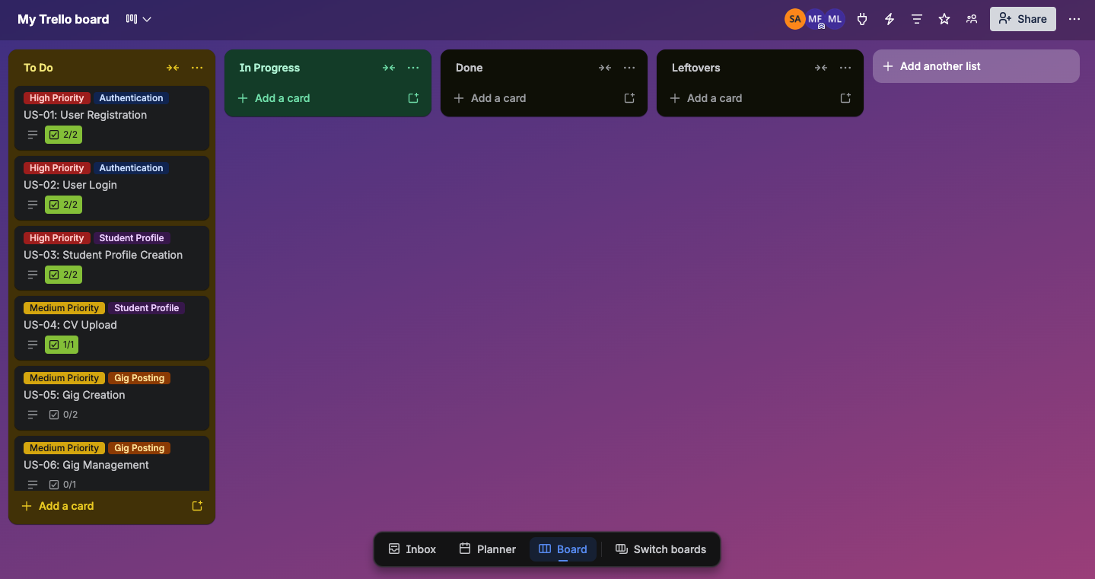

5.2 Mid-Sprint State
Authentication and database setup tasks have been moved to Done. Student profile and gig posting cards are In Progress. The team is actively working on backend API routes.
Snapshot 2: Mid-Sprint - Authentication done, Profile and Gig in progress
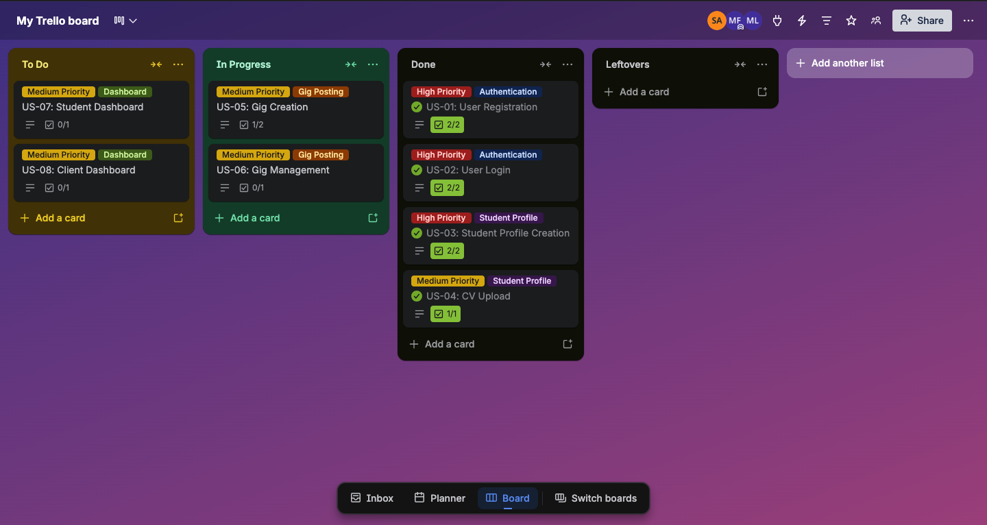

5.3 Ending State
All planned user stories are in the Done column. All 8 user stories were completed and verified through Postman testing within the 14-day sprint. No stories were carried over as leftovers.
Snapshot 3: End of Sprint 1 - All stories completed

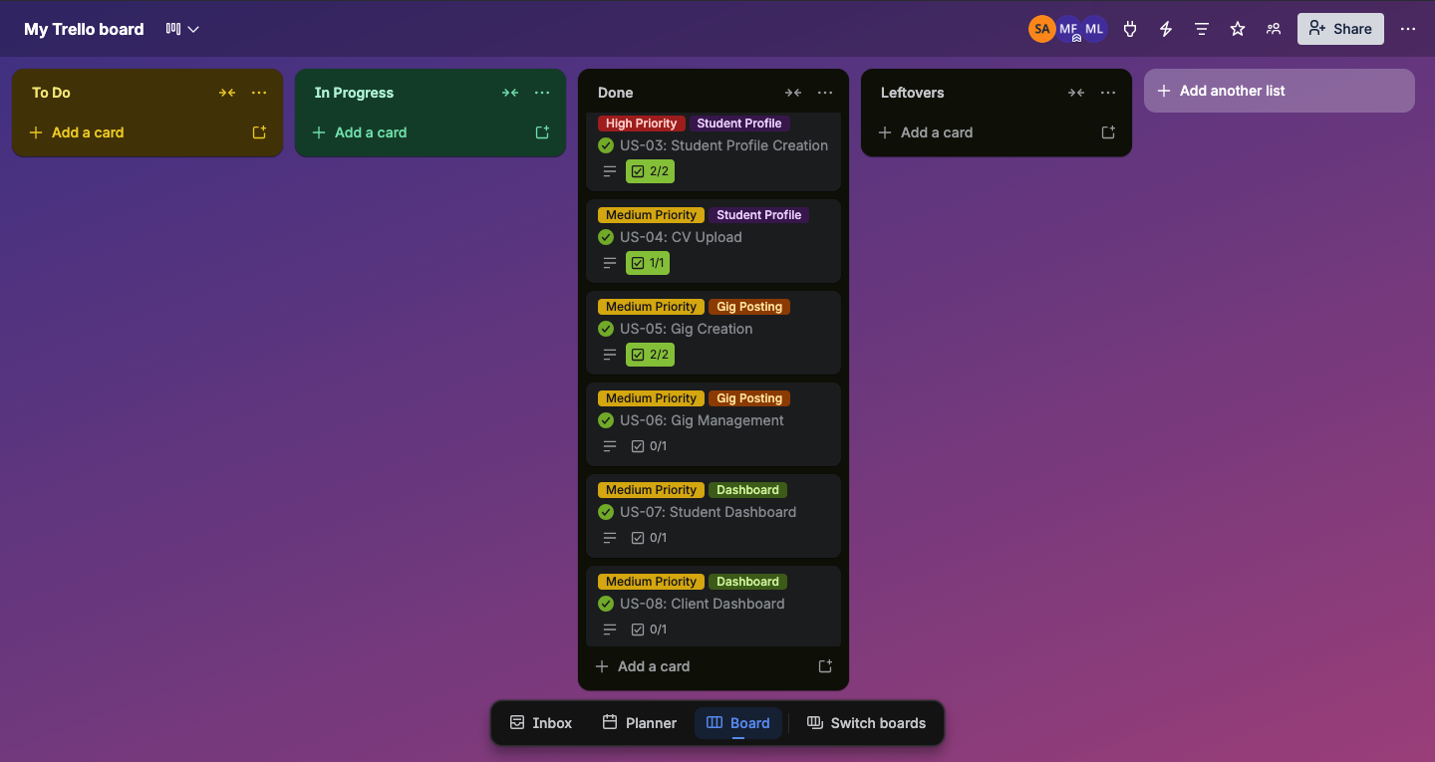

6. Product Burn-Down Chart

Sprint 1 Burn-Down Chart
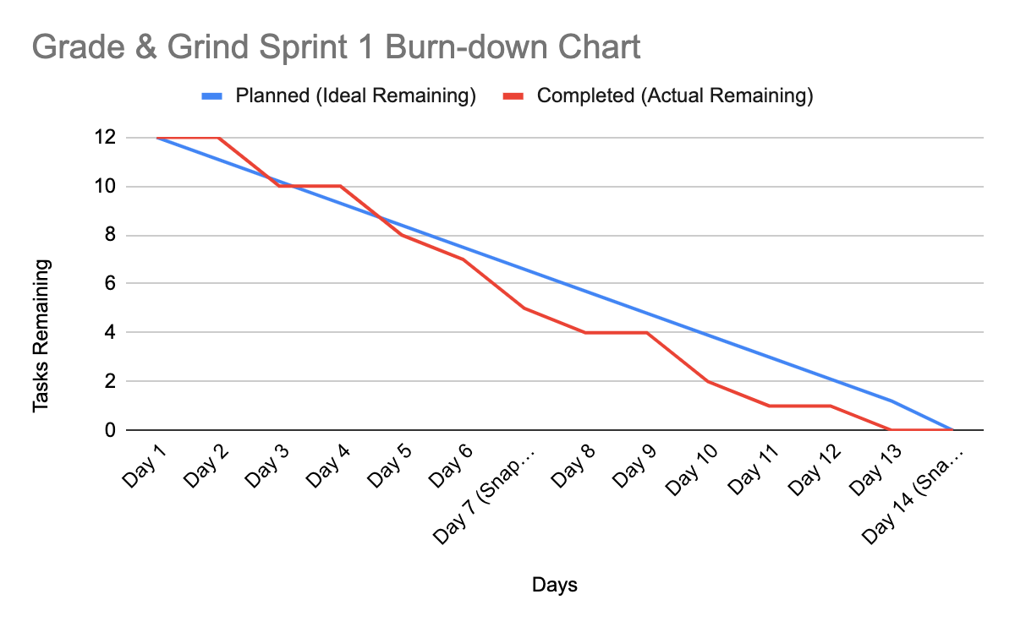

7. Work Division

The following table outlines how development responsibilities were divided across team members for Sprint 1.

Member | Role | Responsibilities in Sprint 1
Sadeem24L-2502 | Project Lead, Full Stack Developer | Student profile routes and model layer, CV upload via Cloudinary, frontend AuthPage component
Mahnoor24L-2533 | Full Stack Developer | Gig CRUD routes and model layer, client gig management endpoints, student browse endpoint, database population with dummy data, frontend routing setup
Yousuf24L-2539 | Full Stack Developer | Firebase auth integration, backend middleware (verifyToken, roleGuard), SQL Server schema design, Postman testing coordination, project management

End of Iteration 1 Report | Grade & Grind | FAST-NU Lahore | Spring 2026

