**Human Agent Interaction: Hospital Management Game**

**User Manual**

**Authors:**

Yousuf Hussain

Tanmay Patil

Syed Zafar Shah

Tharun Niranjan

Aditya Bivalkar

**Table of Contents**

**1. Introduction** **2**

**2. Authentication** **2**

**3. Cookie Deletion** **4**

**4. Game Configuration (and Admin Panel)** **7**

**5. Manage Admins** **8**

**6. Managing Super Admin** **9**

**7. Reporting & Data Exports** **10**

**8.** **Playing the Game 12**

**9. Browser Compatibility** **22**

**10****.** **Running the Application 23**

### 1. Introduction

This is a user manual for the hospital management game hosted on the website of ADAPT LAB- <https://adapt.engineering.asu.edu/>. The game is hosted in the form of a web application. This user manual document explains in detail how different classes of users such as admin, super admin and player can interact with the application.

The user manual starts with the **Authentication** section where it explains how an admin user can log into the system using his/her gmail credentials. The game uses browser cookies for managing the game states so that the players can resume the game from where they left in case they close the browser before finishing the game. The **Cookie Deletion** section explains how to delete cookies can be deleted to play the game from start. The **Game Configuration** section explains how the admin user can set different game configurations and activate/deactivate them. The **Manage Admins** section talks about how the super admin can add/delete other admin users. The **Manage Super Admin** section explains how to insert super admin user into the Mongodb database. The **Reporting and Data Exports** section explains how the admin user can download the data about the moves made by players while playing the game, etc. The **Running the Application** section how the players can access the game. Finally, the **Browser Compatibility** section specifies the browsers with their versions where all the features of the web application are well supported.

### 2. Authentication

To access the admin panel, you have to login into the application with your registered ASU email id.

The authentication workflow is as follows:

* Go to login page by clicking the Login button in the upper right corner.

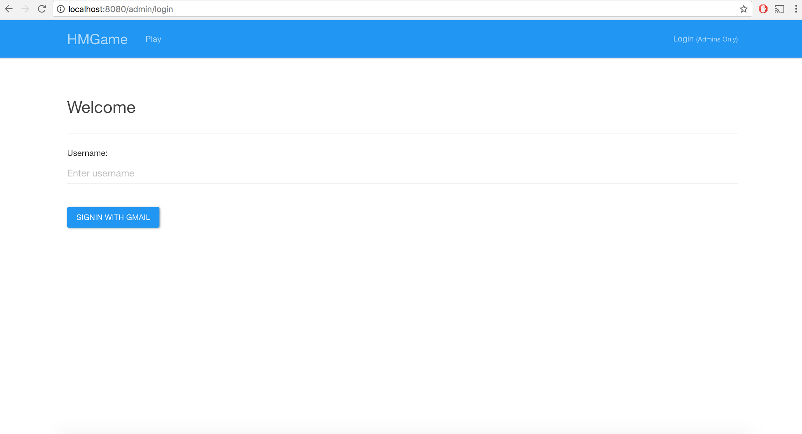

* Enter your valid email address into the text box labelled “Username”.
* If you get the following error,   
  “*Sorry! There is no admin user with the username you provided.*”,   
  then your email address is not registered with the app (Note: On more information on how to register new users, read *Topic #5 Manage Admins*.).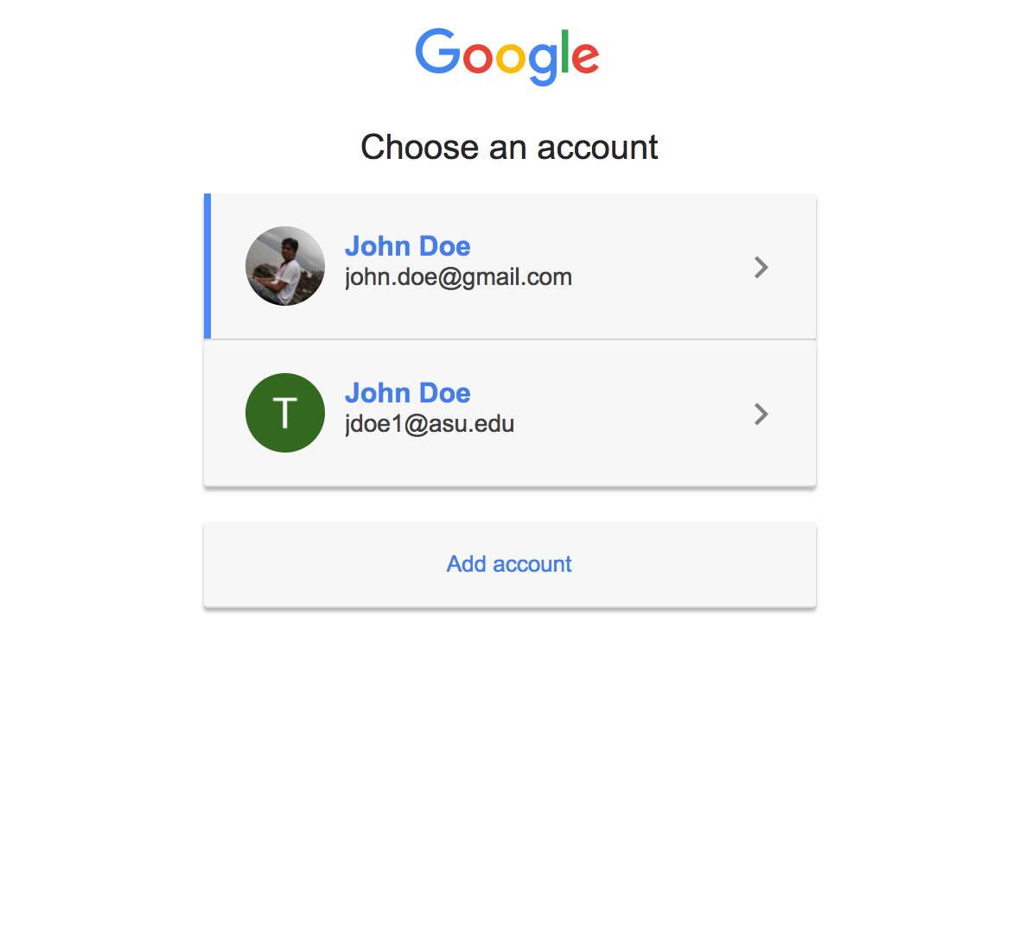
* If no error, then a pop-up from Google will be displayed, as shown in the screenshot, which will list all your current logged in accounts with Google.
* Select the appropriate ASU email address, then click “Allow”.

* If you do not select the appropriate ASU email address, you will get the following error,  
  “*The gmail id john.doe@gmail.com used for sign in with gmail is not the same as the id jdoe1@asu.edu you entered above.Please sign in again with gmail using jdoe1@asu.edu.*”
* If at any point of the workflow, you get the error “*redirect_uri_mismatch*” or “*invalid_request*”, make sure you have added the app root url in the “*Authorized Javascript origin*” section of your google project. (Read more about it here: <https://developers.google.com/identity/sign-in/web/devconsole-project>).
* If the workflow completed without errors, you will be logged in and will be able to access the admin panel.

### 3. Cookie Deletion

Once you play the game, you cannot play it again on the same browser since we’ve created a cookie that will prevent this. You will instead be led to the ‘**Thank you**’ page whenever you try to play the game.

However, to play the game again you can delete this cookie. The way we recommend you do this is by first navigating to the application and then right clicking on your Chrome browser window and selecting ‘**Inspect’**. Now click the ‘**Application’** tab and scroll down to the **‘Cookies’** option

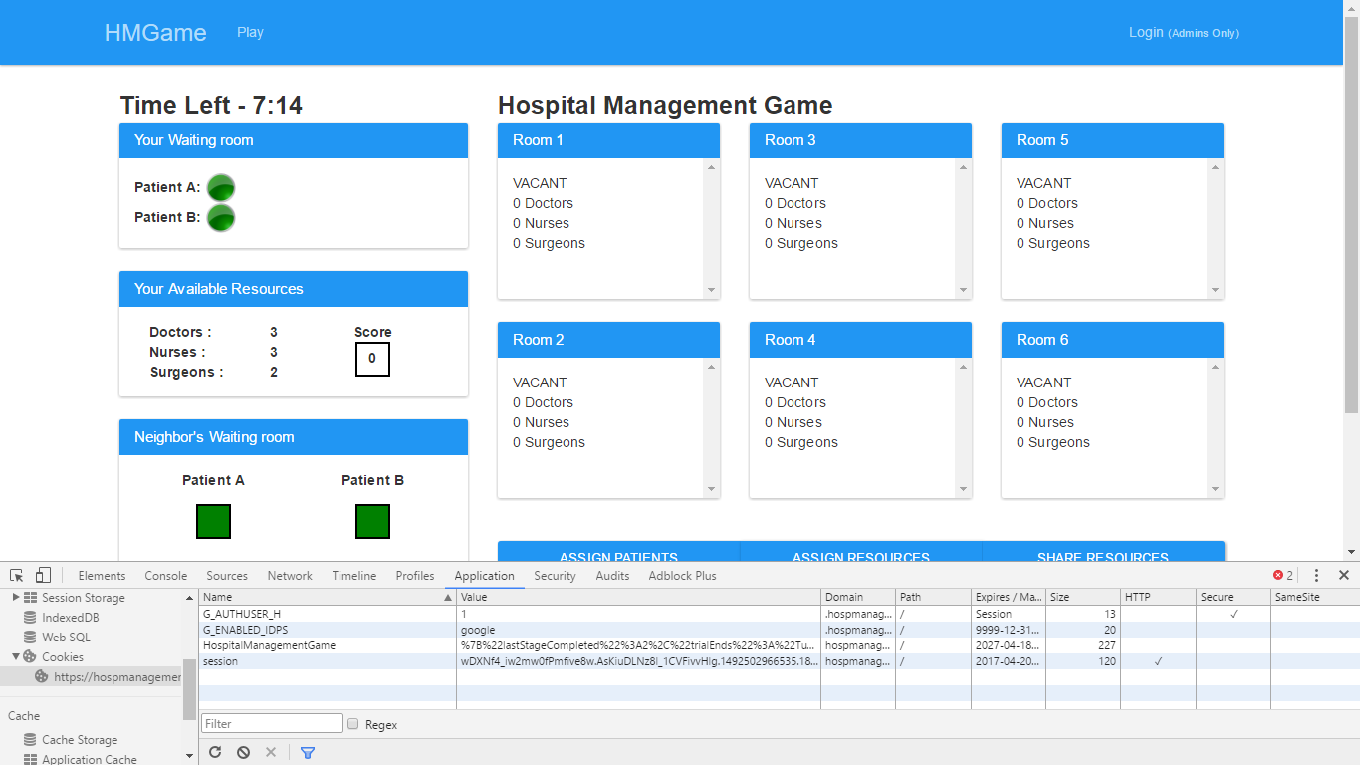

Right click and Clear the cookie which is available in the cookies section.

Now instead of refreshing the page go to the application URL again. You might also want to clear your cache if this doesn’t work.

**The other way** to do this is to delete all cookies from your browser or finding this particular cookie in the list of cookies and then deleting that.

On Mozilla, the cookie can be deleted in the following way-

In your firefox window, select the **options** from settings-

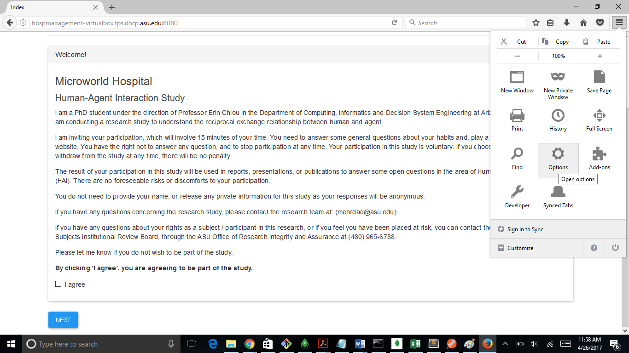

Now select the privacy tab

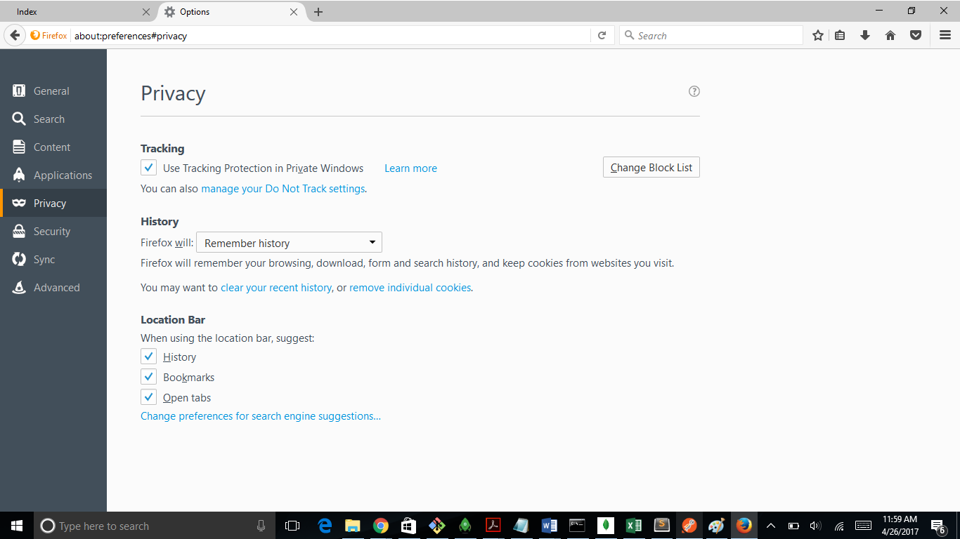

In the privacy section, click on **remove individual cookies.**

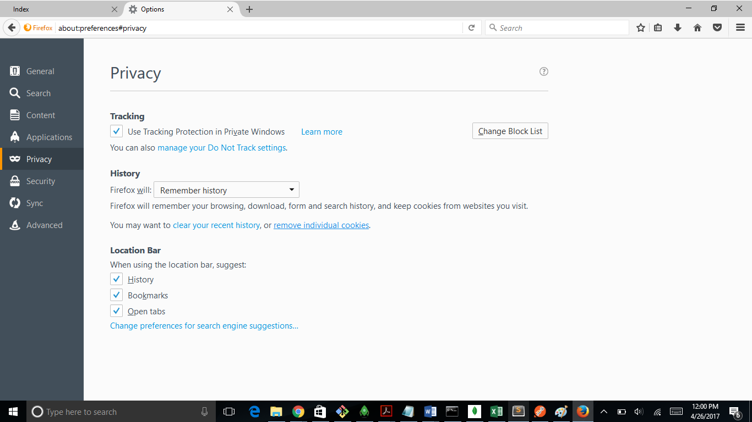

In the “remove individual cookies” section, search for the cookie name starting with “hospmanagement-virtualbox” and remove that cookie.

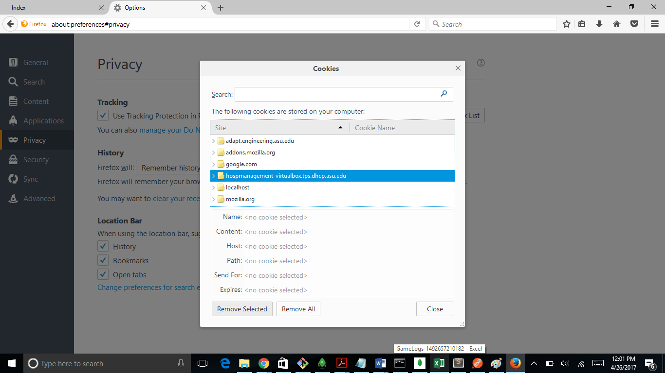

### 4. Game Configuration (and Admin Panel)

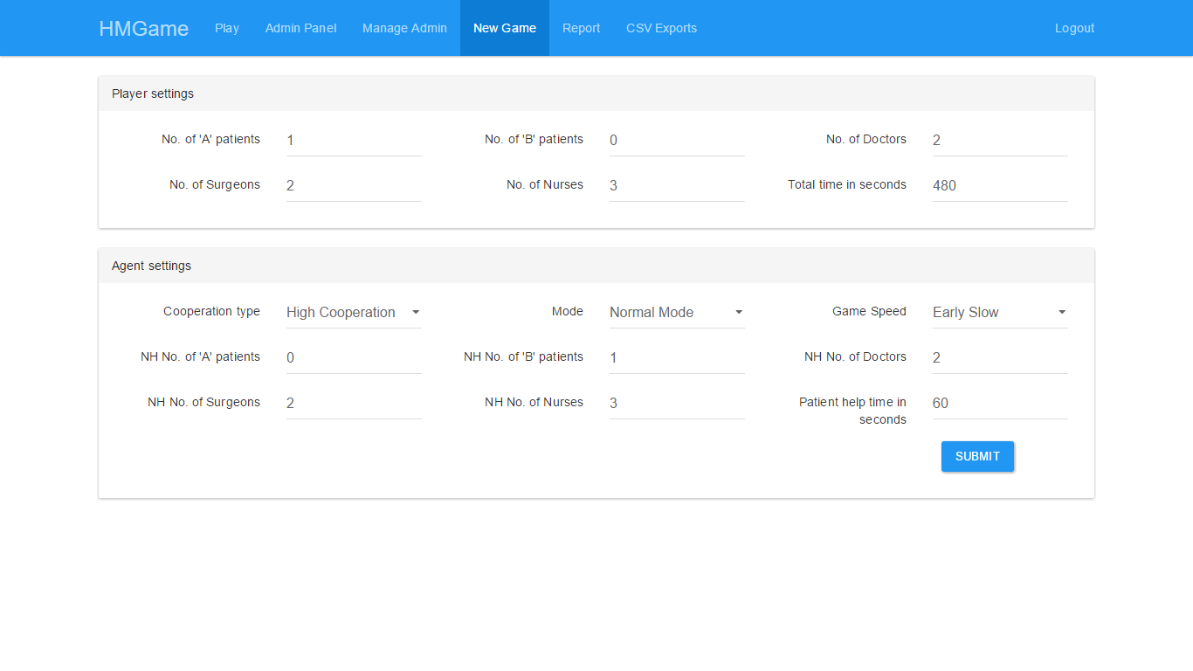

The option to create games is available to all Admins through the tab **‘New Game**’. Various game settings can be changed here. After a new game configuration is created, you’re redirected to the Admin Panel where the all game configurations appear.

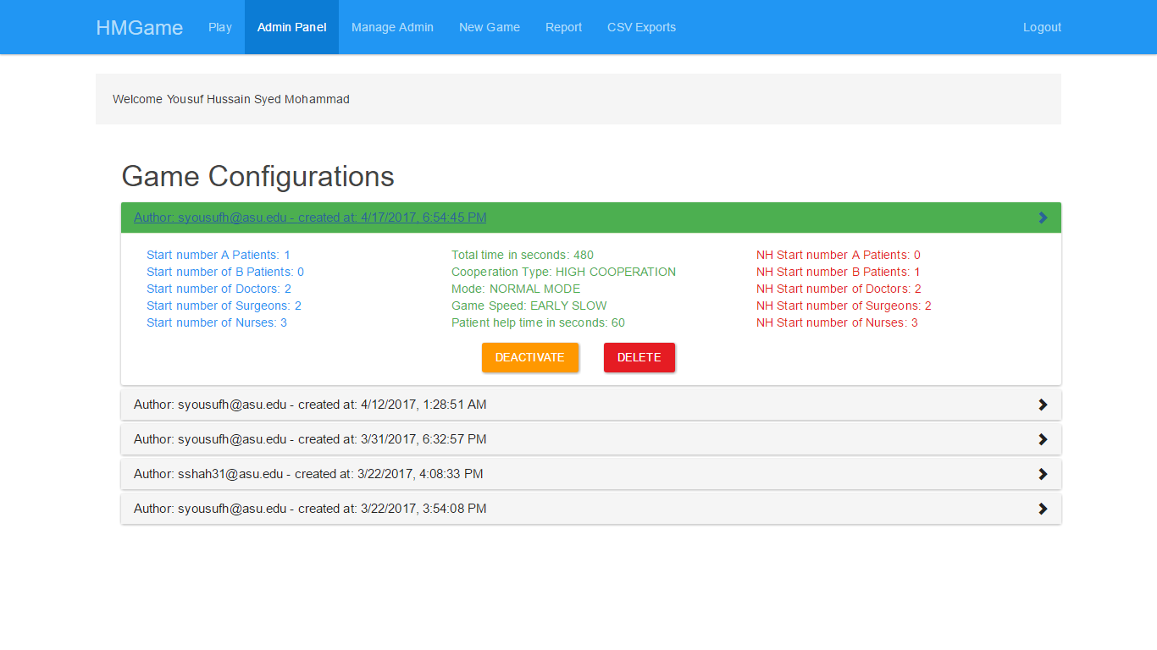

This screen is also available to all Admins and comes from the tab ‘**Admin Panel’**.

Here you can see who created a particular game configuration and at what time. It also shows individual game settings. You can Activate, Deactivate, or Delete any game configuration. **Only one configuration can be active at a time** and that configuration will be used to create the main game that users will play.

Deleted configurations cannot be recovered and game settings cannot be updated once created.

#### Shutting down the survey

To shut down the survey you can deactivate the Active configuration. Now after the user clicks ‘**I Agree’** and the Next in the home page, she will be led straight to the ‘**Thank you**’ page since no game configuration is Active.

### 

### 5. Manage Admins

This screen is only available to Super Admin and comes from the ‘**Manage Admin’** tab.

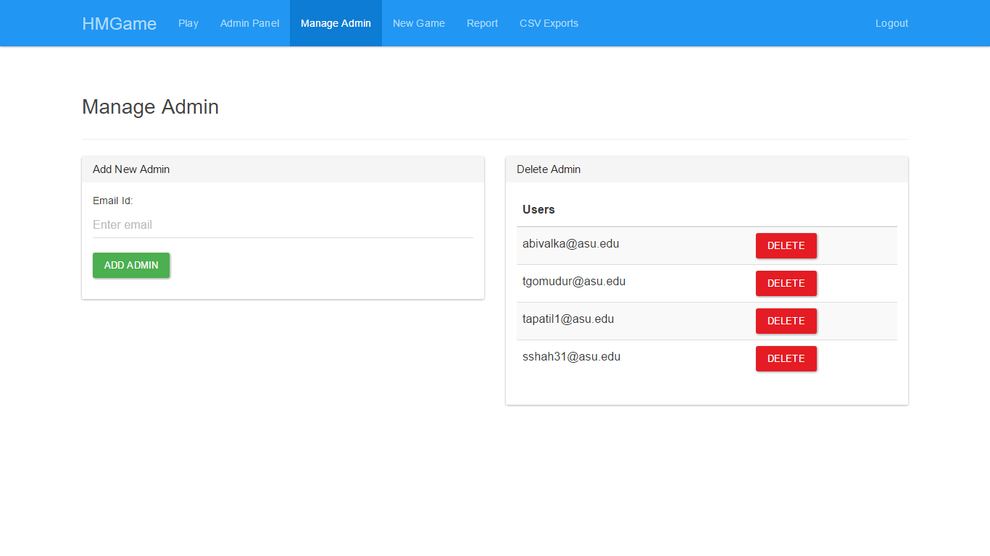

**Note: New Admins can only be created with a valid ASU ID.**

The Super Admin is not listed in the Delete Admin section because we don’t want the Super Admin user to be accidentally deleted.

### 6. Managing Super Admin

The super admin credentials can be changed only manually accessing the MongoDB database. The easiest way to do this is through MongoDB Compass application we’ve installed on the server. To access it you first need to run the mongod.exe program.

**Note: The mongod.exe program will be running if the app is running so you don’t need to run it again.**

After entering the Compass application click ‘Connect’ to connect to the database.

The DBs are in the left and our DB is called **‘Hospital’**.

The Admin information is stored in the ‘**admin**’ table/collection.

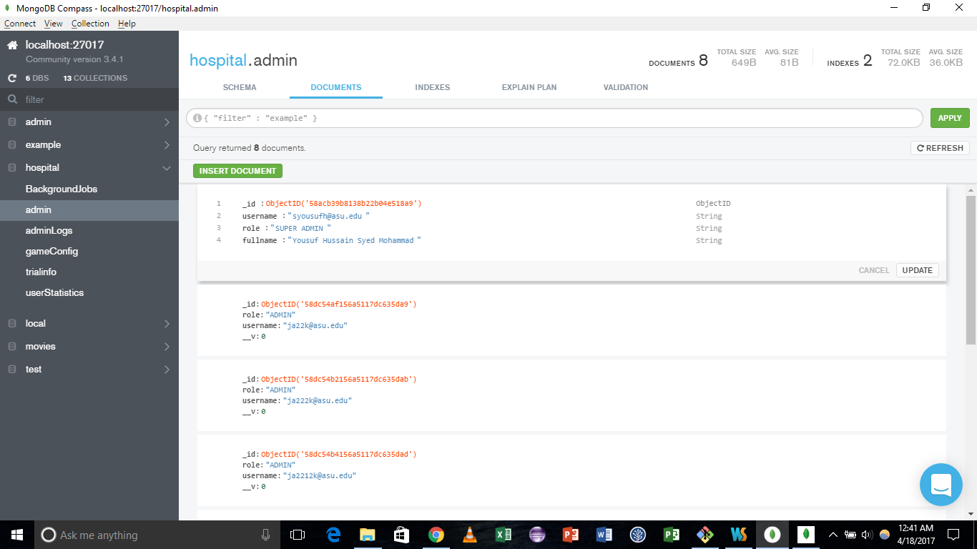

All rows/documents in the admin collection have 4 fields:

1. Auto-generated unique _id (don’t mess with this).
2. username: The ASU id of the Admin user.
3. role: Either SUPER ADMIN or ADMIN
4. fullname: This is the full name of the Admin user, we get this data from Gmail Authentication.

#### Changing the Super Admin information

To change super admin username or role you can simply edit the row/document by clicking on the ‘**Edit document’** option when you hover over the row. If changing the role make sure to make it either ADMIN or SUPER ADMIN or it will fail to be recognised by the system and cause problems.  
You can also use the ‘**Delete document**’ option to delete an admin manually. Please make sure you have only one Super Admin user.

#### Creating a new Super Admin manually

To create a new Super Admin click on the green Insert Document button. There will already be an auto-generated _id field which you shouldn’t modify.

Create an entry with key called ***role*** and add value as SUPER ADMIN

Create an entry with key called **username** and add value as the ASU ID of the person you want to anoint as Super Admin.

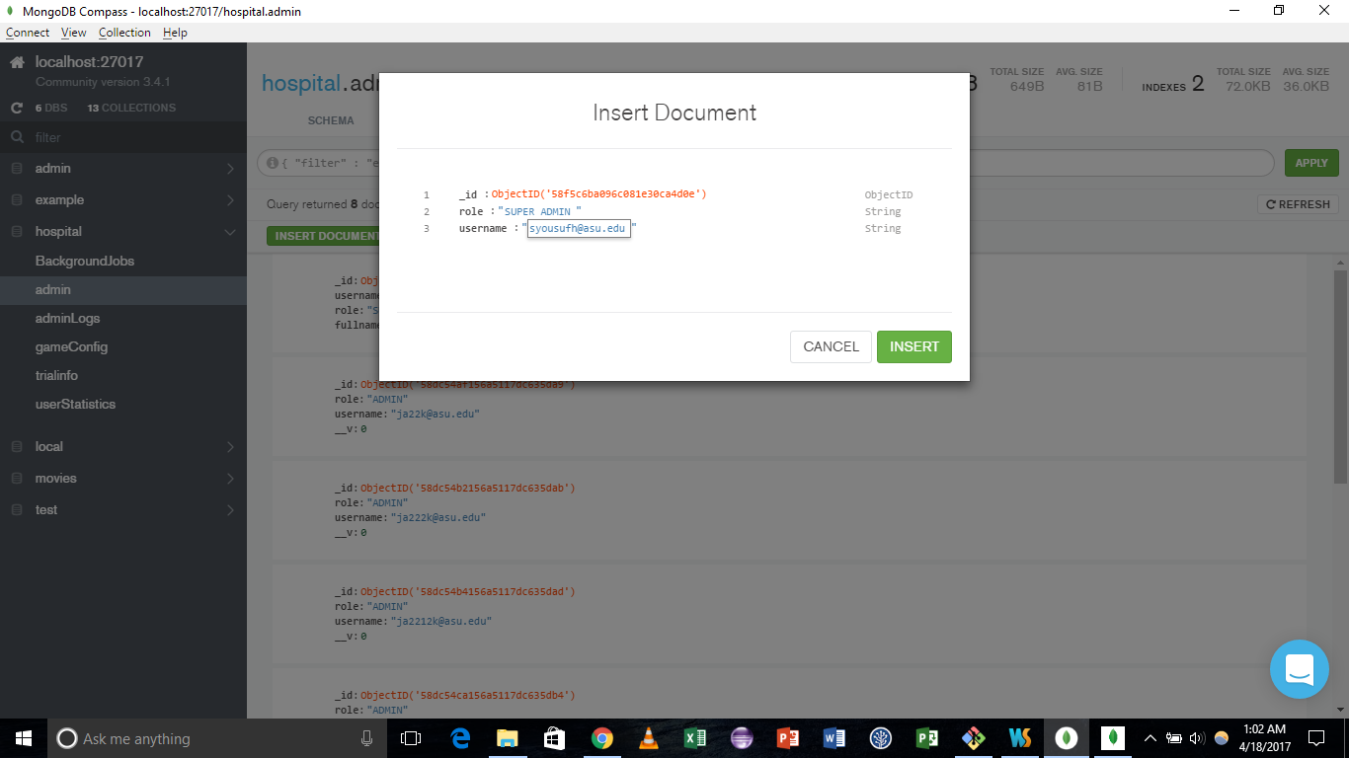

**Note:** You don’t need to create a fullname field as this will be extracted through Gmail authentication.

**Note**: Regular Admins can be created and deleted through the Manage Admin tab available to the super admin.

### 7. Reporting & Data Exports

To get a view of the Game Logs & Admin Logs collected by the app, you have to use the Reporting module and Exports module. Make sure you are logged in into the app.

1. **Reporting**

* Go to Report Tab.
* To get Game Log Report, use the “**Download Game Log**” panel.
* To get Admin Log Report (super admin only), use the “**Download Admin Log**” panel.
* Select your required FROM and TO dates and click GENERATE REPORT. If successful, you will see the following message:   
  “Your job has been queued. Please check the exports tab to view your CSV file.”

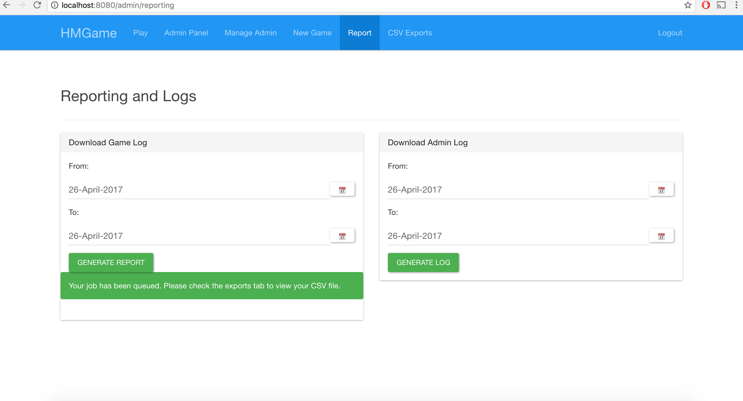

1. **Exports**

* Go to Exports tab.
* You can see only exports which you have generated.
* The exports are deleted after 10 days (you can always re-generate it, the raw data always remains).
* The exports are color coded:
  + Green (Successful): You can download the Export file.
  + Yellow (In Progress): Check back later.
  + Red (Unsuccessful): Try generating again.

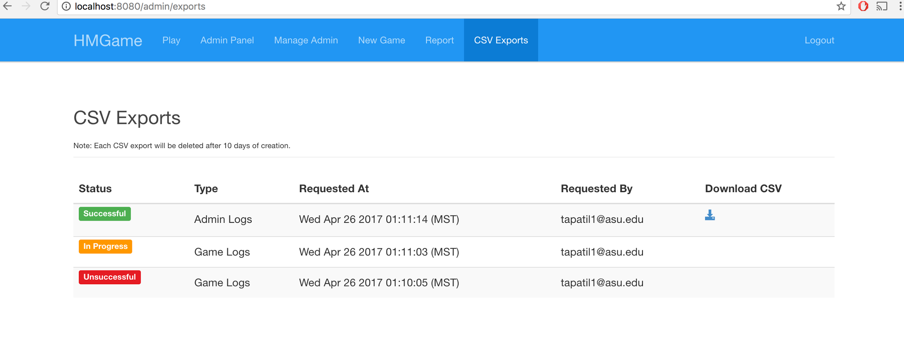

### 8. Playing the Game

For running the application, player goes through 7 steps.  
Step 1: Trial Page  
Step 2: Pre game Questionnaire page  
Step 3: Tutorial Page  
Step 4: Practice Page   
Step 5: Actual Game Page  
Step 6: Post game Questionnaire page: Trust and Task Questions  
Step 7: Thank you Page.  
At the end of all steps, the versioning of the game is explained.  
  
**Step 1: Trial Page**

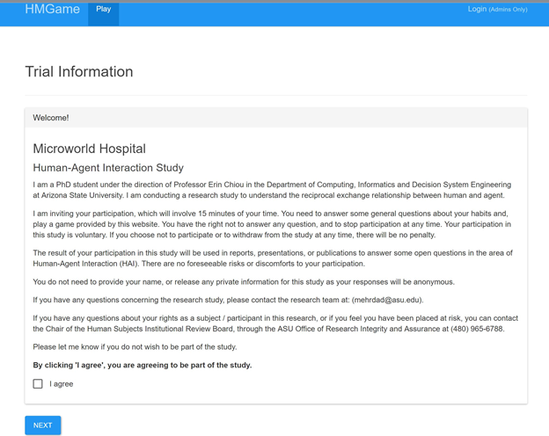

Please read the disclaimer, click on the agree checkbox and then next button to proceed further.

**Step 2: Pre game Questionnaire page**

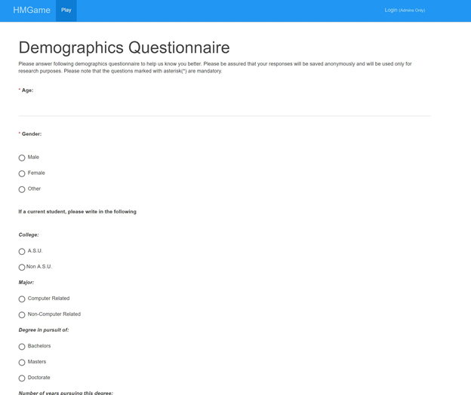

A pre game Questionnaire page comes up. Certain fields in the questionnaire are mandatory to

proceed to next step.  
  
 **Step 3: Tutorial Page**

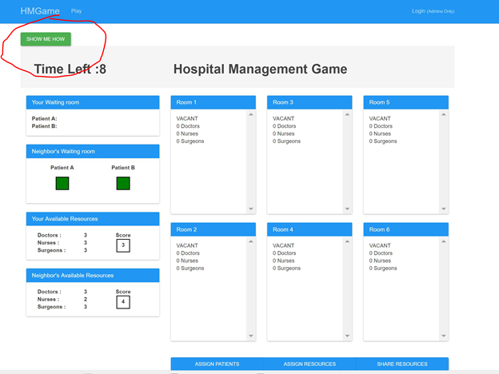  
   
By clicking on Show Me How button, you go through the tutorial that starts as seen below.  
   
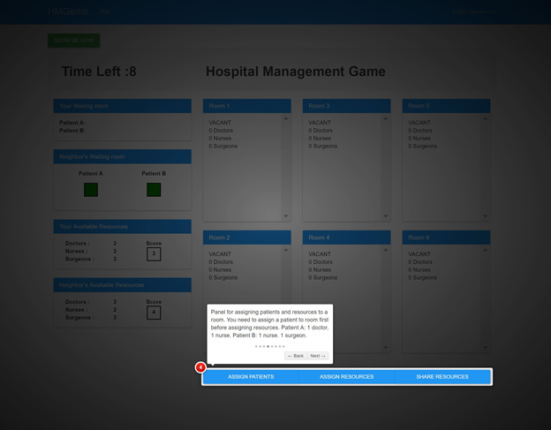

The tutorial page explains about each aspect of the game. Please read them carefully. Once done with the tutorial, you now jump to the next practice page.

**Step 4: Practice Page**

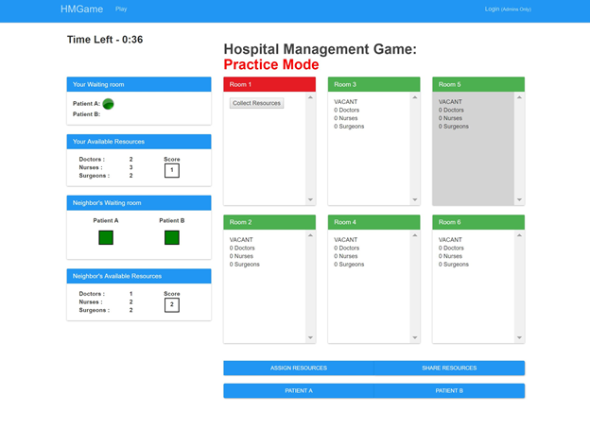  
 This is a practice mode wherein the game is for 2 minutes. User can play freely as his moves and scores are not recorded.  
  
 **Step 5: Actual Game Page**

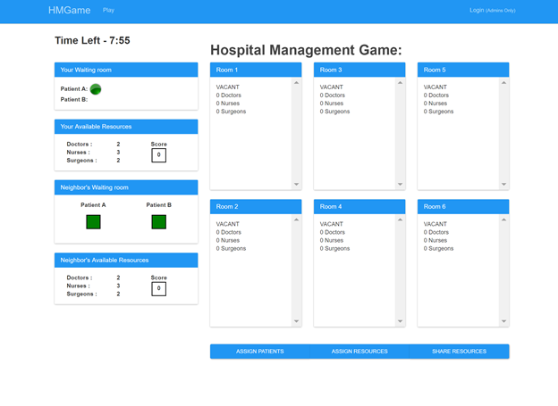  
  
   
In the actual game, you play for the specific time (Ex. 8 minutes). Once done with the game, your moves and score are recorded.

**Step 6: Post game Questionnaire: Trust and task questionnaire**

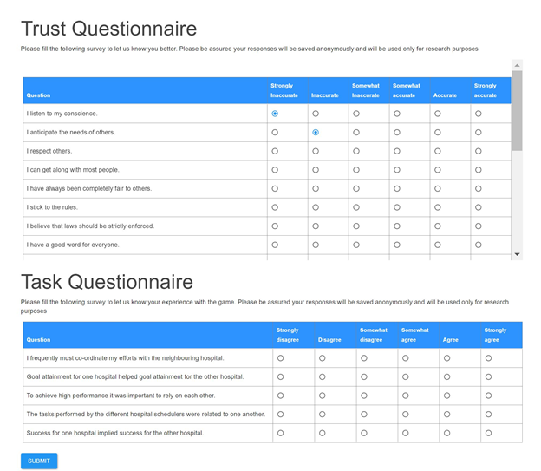  
   
The user should fill one last questionnaire. Again the user cannot skip mandatory fields. Once filled click on submit.

**Step 7: Thank you Page**

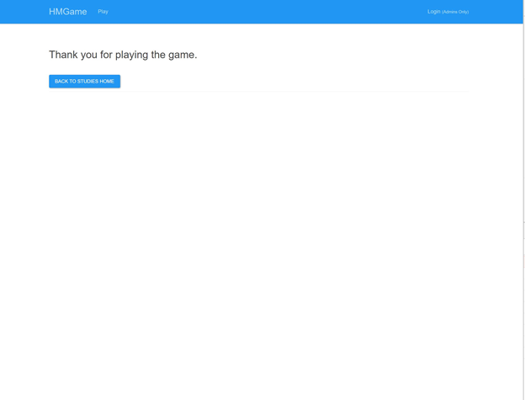  
  
  
  
  
  
  
  
  
   
You are done!. You can now get back to your studies homepage.

**Note on Versioning:**

There are two versions of the game that are built up. A brief description of each is discussed below  
User needs to specify the version in the base url (trial Page) as a query parameter  
Example: ?version=1 or ?version=2

**Version 1:**

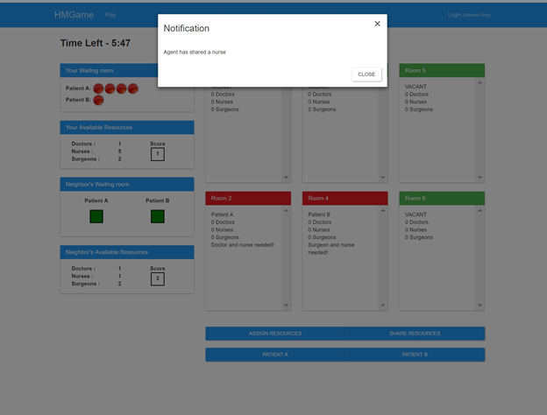

This is the default version of the game. In this version of the game, user does not have a choice whether to accept or reject the resources when given by the neighboring hospital. It just gets added to his resources pool.   
  
  
**Version2:**

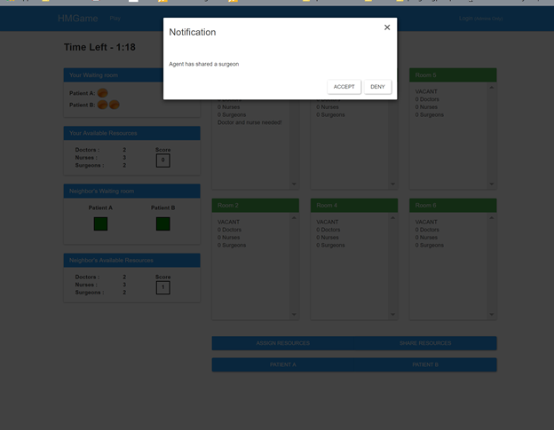

In this version of the game, user has a choice whether to accept or reject the resources when shared by the agent of the neighboring hospital.

### 9. Browser Compatibility

Desktop:

* Chrome: v57 and above
* Firefox: v53 and above
* Safari: v10 and above

Mobile:

* Chrome: v57 and above
* Firefox:
* Safari: v10 and above

10. Running the Application

Commands:

1. Open terminal
2. Run `cd HumanAgentApp/HumanAgentInteraction/MainApp`
3. Run `sudo ./restart.sh`