# Project 3

By : Yousuf Hussain - syousufh@asu.edu

Instructions:

1. Unzip the folder.
2. Double click the application file.
3. You will be presented with the following screen. The top viewport is the control panel which shows the coordinates of the car and overview viewpoint. You can navigate in the default View- Overview mode by using the direction keys.

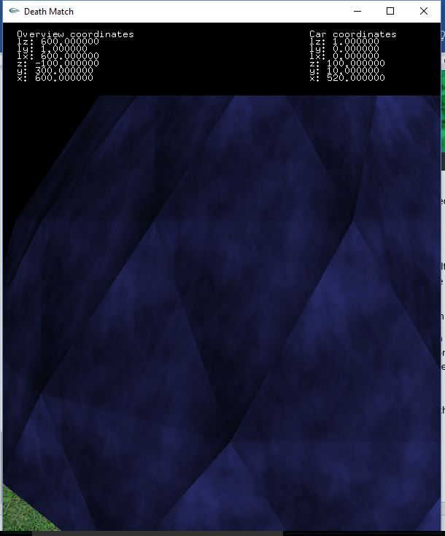  
Move the car by selecting the View- First Person from the menu. Use arrow keys to move the car. On moving the car, the timer starts.

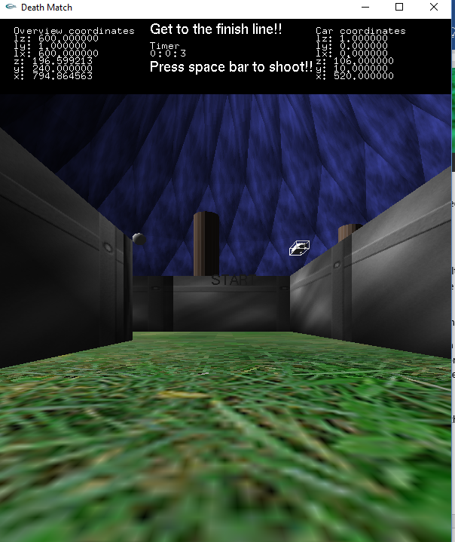

1. Right – click the mouse for menu options. You get the following screen. On clicking flat shading, the object will appear a little different.

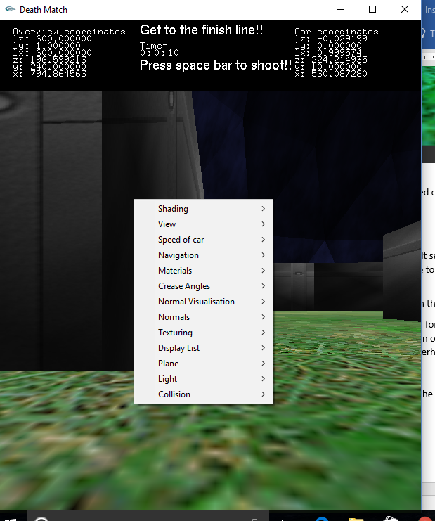

1. On clicking Navigation – Light source, and pressing left and right keys, you can see the difference in the object shading.
2. On switching on normal visualization, we get the default per vertex normals. This can be changed by the “Normals” submenu.

1. On reaching Finish the timer stops and the “FINISH!” message is rendered on the screen.
2. Other screenshots:   
   Multiscale:

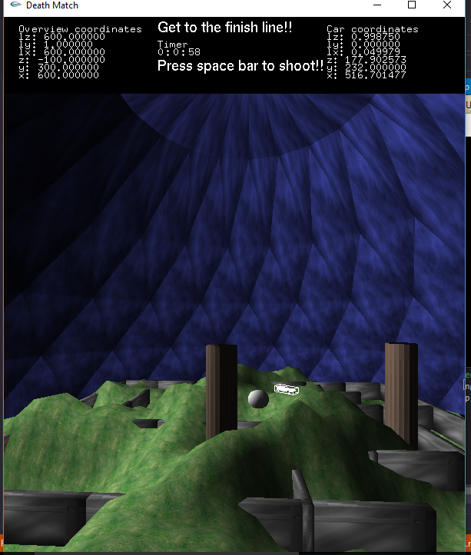

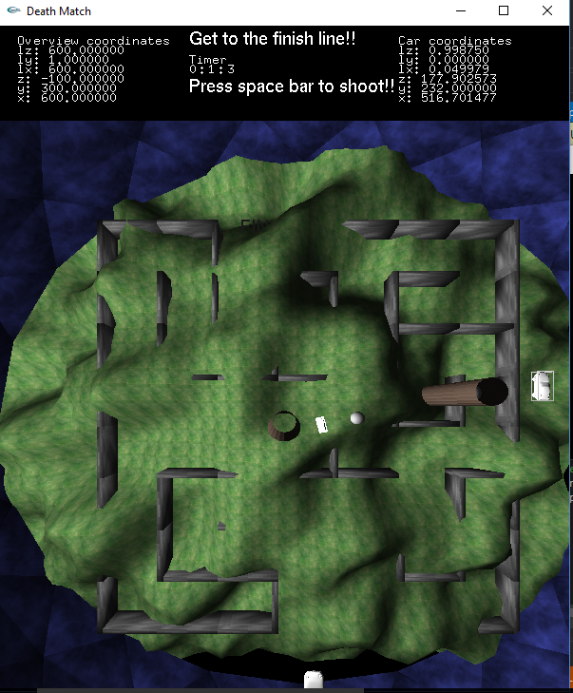

Comments:

Crease angles not implemented.

Top down view implemented.

Bounding boxes implemented.

Press space to shoot bullets!

Libraries used: Glut, Imathvec, used the mesh library and texture, bounding box code, and object loader provided by instructor.