Mohamed Abdul Prof. John Korah
CS-5990
011303422
Homework Report

1) I have followed the instructions as per the homework, and I have done the things in the following order:
- Connected to Global VPN
- SSH into the HPC cluster. Copied all the given files to the remote environment.
- Installed Miniconda, and required packages such as Matplotlib, and NetworkX.
- Created the environment under Miniconda.
- Ran the following command to switch the context to the one of the partition of HPC cluster. Before that, I changed to the directory to the file system directory or root.
  - srun -p compute --mem 100G --pty /bin/bash
  - Output as follows:
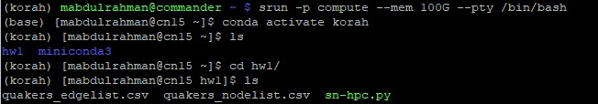Figure 1: Execution of srun scheduler to run on compute partition.
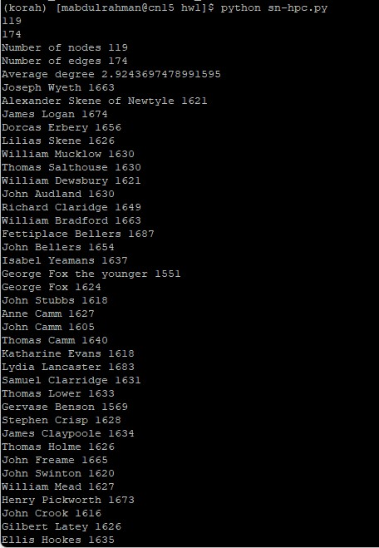Figure 2: Execution of python script

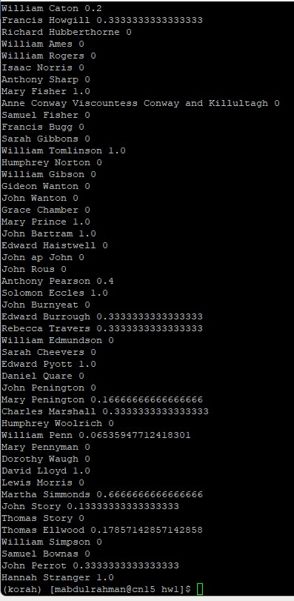

2) Installed the PyCharm as per the intruction
- Note : networkx.info() method is not available on the version I am using. Hence, I have altered the script to print the information about the graph such as number of edges, and print out the edges in the graph.
  - totalEdgesList = nx.edges(G)
print("Information about the graph")
print("Edges in the graph " , totalEdgesList) # Print information about the Graph
print("Total Number of Edges in graph", len(totalEdgesList))
  - Output as follows:
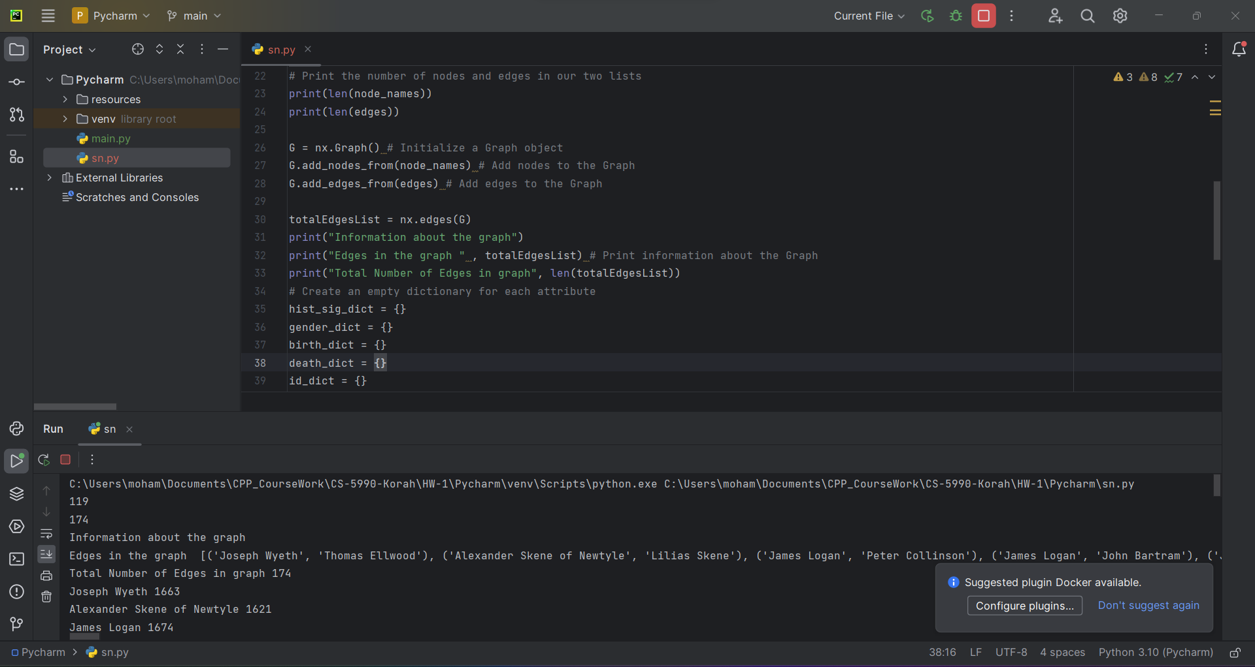
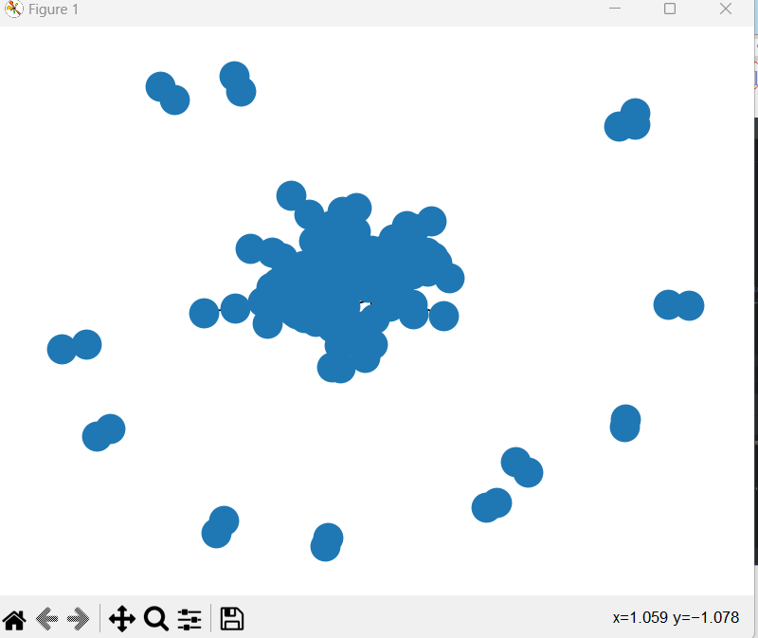
    - Text outputs:
      - C:\Users\moham\Documents\CPP_CourseWork\CS-5990-Korah\HW-1\Pycharm\venv\Scripts\python.exe C:\Users\moham\Documents\CPP_CourseWork\CS-5990-Korah\HW-1\Pycharm\sn.py
      - 119
      - 174
      - Information about the graph
      - Edges in the graph [('Joseph Wyeth', 'Thomas Ellwood'), ('Alexander Skene of Newtyle', 'Lilias Skene'), ('James Logan', 'Peter Collinson'), ('James Logan', 'John Bartram'), ('James Logan', 'William Penn'), ('James Logan', 'David Lloyd'), ('Dorcas Erbery', 'James Nayler'), ('William Mucklow', 'George Fox'), ('Thomas Salthouse', 'George Fox'), ('Thomas Salthouse', 'Margaret Fell'), ('William Dewsbury', 'Edward Burrough'), ('William Dewsbury', 'George Fox'), ('William Dewsbury', 'John Crook'), ('John Audland', 'John Camm'), ('John Audland', 'Francis Howgill'), ('John Audland', 'Edward Pyott'), ('John Audland', 'Charles Marshall'), ('John Audland', 'George Fox'), ('John Audland', 'Anne Camm'), ('Richard Claridge', 'Joseph Besse'), ('Richard Claridge', 'William Penn'), ('William Bradford', 'George Keith'), ('William Bradford', 'William Penn'), ('William Bradford', 'Tace Sowle'), ('Fettiplace Bellers', 'John Bellers'), ('Isabel Yeamans', 'William Penn'), ('George Fox the younger', 'Margaret Fell'), ('George Fox', 'George Keith'), ('George Fox', 'Francis Howgill'), ('George Fox', 'Ellis Hookes'), ('George Fox', 'William Mead'), ('George Fox', 'Elizabeth Hooten'), ('George Fox', 'Margaret Fell'), ('George Fox', 'John Crook'), ('George Fox', 'George Whitehead'), ('George Fox', 'Benjamin Furly'), ('George Fox', 'James Nayler'), ('George Fox', 'Edward Burrough'), ('George Fox', 'John Wilkinson'), ('George Fox', 'Thomas Ellwood'), ('George Fox', 'William Coddington'), ('George Fox', 'John Stubbs'), ('George Fox', 'John Perrot'), ('George Fox', 'Leonard Fell'), ('George Fox', 'William Penn'), ('John Stubbs', 'Benjamin Furly'), ('John Stubbs', 'William Caton'), ('John Stubbs', 'Samuel Fisher'), ('John Stubbs', 'John Burnyeat'), ('Anne Camm', 'Thomas Camm'), ('John Camm', 'Charles Marshall'), ('John Camm', 'Thomas Camm'), ('John Camm', 'Edward Pyott'), ('Thomas Camm', 'John Story'), ('Katharine Evans', 'Sarah Cheevers'), ('Lydia Lancaster', 'Grace Chamber'), ('Samuel Clarridge', 'Anthony Sharp'), ('Samuel Clarridge', 'James Claypoole'), ('Thomas Lower', 'Margaret Fell'), ('Gervase Benson', 'James Nayler'), ('Gervase Benson', 'Anthony Pearson'), ('Stephen Crisp', 'James Parnel'), ('Stephen Crisp', 'William Caton'), ('Stephen Crisp', 'Benjamin Furly'), ('James Claypoole', 'William Penn'), ('Thomas Holme', 'William Gibson'), ('Thomas Holme', 'Elizabeth Leavens'), ('John Freame', 'David Barclay'), ('John Swinton', 'David Barclay of Ury'), ('William Mead', 'Margaret Fell'), ('Henry Pickworth', 'Francis Bugg'), ('John Crook', 'John Perrot'), ('John Crook', 'Edward Burrough'), ('Gilbert Latey', 'Edward Burrough'), ('Gilbert Latey', 'George Whitehead'), ('Joseph Besse', 'Samuel Bownas'), ('James Nayler', 'Francis Howgill'), ('James Nayler', 'Martha Simmonds'), ('James Nayler', 'Hannah Stranger'), ('James Nayler', 'Margaret Fell'), ('James Nayler', 'Richard Farnworth'), ('James Nayler', 'George Whitehead'), ('James Nayler', 'John Perrot'), ('James Nayler', 'Robert Rich'), ('James Nayler', 'Anthony Pearson'), ('James Nayler', 'Thomas Ellwood'), ('James Nayler', 'Edward Burrough'), ('James Nayler', 'Rebecca Travers'), ('James Nayler', 'William Tomlinson'), ('George Whitehead', 'George Keith'), ('George Whitehead', 'William Rogers'), ('George Whitehead', 'Francis Bugg'), ('George Whitehead', 'Richard Hubberthorne'), ('George Whitehead', 'Alexander Parker'), ('George Whitehead', 'John Whitehead'), ('George Whitehead', 'Daniel Quare'), ('George Whitehead', 'William Penn'), ('George Whitehead', 'John Story'), ('George Whitehead', 'Rebecca Travers'), ('William Crouch', 'Francis Howgill'), ('William Crouch', 'Edward Burrough'), ('Benjamin Furly', 'George Keith'), ('Benjamin Furly', 'James Parnel'), ('Benjamin Furly', 'Franciscus Mercurius van Helmont'), ('Benjamin Furly', 'Robert Barclay'), ('Benjamin Furly', 'Alexander Parker'), ('Benjamin Furly', 'William Caton'), ('Benjamin Furly', 'William Penn'), ('Silvanus Bevan', 'Daniel Quare'), ('Robert Rich', 'William Tomlinson'), ('John Whiting', 'Christopher Taylor'), ('Christopher Taylor', 'Thomas Taylor'), ('Thomas Lawson', 'Margaret Fell'), ('Thomas Lawson', 'Alexander Parker'), ('Richard Farnworth', 'Francis Howgill'), ('Richard Farnworth', 'Richard Hubberthorne'), ('Richard Farnworth', 'John Perrot'), ('Richard Farnworth', 'Margaret Fell'), ('Richard Farnworth', 'Anthony Pearson'), ('Richard Vickris', 'George Bishop'), ('Robert Barclay', 'George Keith'), ('Robert Barclay', 'David Barclay of Ury'), ('Jane Sowle', 'Tace Sowle'), ('Tace Sowle', 'William Penn'), ('Margaret Fell', 'William Caton'), ('Margaret Fell', 'William Penn'), ('Margaret Fell', 'Alexander Parker'), ('Margaret Fell', 'Elizabeth Leavens'), ('Margaret Fell', 'Anthony Pearson'), ('Thomas Curtis', 'Anthony Sharp'), ('Thomas Curtis', 'Mary Penington'), ('Thomas Curtis', 'Thomas Ellwood'), ('Thomas Curtis', 'William Simpson'), ('Thomas Curtis', 'John Story'), ('Alice Curwen', 'Rebecca Travers'), ('Alexander Parker', 'John Wilkinson'), ('Alexander Parker', 'Sir Charles Wager'), ('John Wilkinson', 'Charles Marshall'), ('John Wilkinson', 'Solomon Eccles'), ('John Wilkinson', 'John Story'), ('Thomas Aldam', 'Anthony Pearson'), ('Sir Charles Wager', 'Lewis Morris'), ('George Keith', 'Anne Conway Viscountess Conway and Killultagh'), ('George Keith', 'Franciscus Mercurius van Helmont'), ('George Keith', 'William Penn'), ('Peter Collinson', 'John Bartram'), ('William Caton', 'William Ames'), ('Francis Howgill', 'Martha Simmonds'), ('Francis Howgill', 'Edward Burrough'), ('William Rogers', 'Thomas Ellwood'), ('Isaac Norris', 'William Penn'), ('Anthony Sharp', 'William Edmundson'), ('Mary Fisher', 'John Perrot'), ('Mary Fisher', 'Mary Prince'), ('Sarah Gibbons', 'Dorothy Waugh'), ('Humphrey Norton', 'John Rous'), ('Gideon Wanton', 'John Wanton'), ('Mary Prince', 'John Perrot'), ('Edward Haistwell', 'William Penn'), ('John ap John', 'John Burnyeat'), ('Solomon Eccles', 'John Story'), ('John Burnyeat', 'William Edmundson'), ('John Burnyeat', 'William Penn'), ('Edward Burrough', 'John Perrot'), ('Edward Burrough', 'Thomas Ellwood'), ('Rebecca Travers', 'William Penn'), ('John Penington', 'Mary Penington'), ('Mary Penington', 'William Penn'), ('Mary Penington', 'Thomas Ellwood'), ('Humphrey Woolrich', 'Mary Pennyman'), ('William Penn', 'Thomas Story'), ('William Penn', 'David Lloyd'), ('Martha Simmonds', 'Hannah Stranger'), ('John Story', 'Thomas Ellwood')]
      - Total Number of Edges in graph 174
      - Joseph Wyeth 1663
      - Alexander Skene of Newtyle 1621
      - James Logan 1674
      - Dorcas Erbery 1656
      - Lilias Skene 1626
      - William Mucklow 1630
      - Thomas Salthouse 1630
      - William Dewsbury 1621
      - John Audland 1630
      - Richard Claridge 1649
      - William Bradford 1663
      - Fettiplace Bellers 1687
      - John Bellers 1654
      - Isabel Yeamans 1637
      - George Fox the younger 1551
      - George Fox 1624
      - John Stubbs 1618
      - Anne Camm 1627
      - John Camm 1605
      - Thomas Camm 1640
      - Katharine Evans 1618
      - Lydia Lancaster 1683
      - Samuel Clarridge 1631
      - Thomas Lower 1633
      - Gervase Benson 1569
      - Stephen Crisp 1628
      - James Claypoole 1634
      - Thomas Holme 1626
      - John Freame 1665
      - John Swinton 1620
      - William Mead 1627
      - Henry Pickworth 1673
      - John Crook 1616
      - Gilbert Latey 1626
      - Ellis Hookes 1635
      - Joseph Besse 1683
      - James Nayler 1618
      - Elizabeth Hooten 1562
      - George Whitehead 1637
      - John Whitehead 1630
      - William Crouch 1628
      - Benjamin Furly 1636
      - Silvanus Bevan 1691
      - Robert Rich 1607
      - John Whiting 1656
      - Christopher Taylor 1614
      - Thomas Lawson 1630
      - Richard Farnworth 1630
      - William Coddington 1601
      - Thomas Taylor 1617
      - Richard Vickris 1590
      - Robert Barclay 1648
      - Jane Sowle 1631
      - Tace Sowle 1666
      - Leonard Fell 1624
      - Margaret Fell 1614
      - George Bishop 1558
      - Elizabeth Leavens 1555
      - Thomas Curtis 1602
      - Alice Curwen 1619
      - Alexander Parker 1628
      - John Wilkinson 1652
      - Thomas Aldam 1616
      - David Barclay of Ury 1610
      - David Barclay 1682
      - Sir Charles Wager 1666
      - George Keith 1638
      - James Parnel 1636
      - Peter Collinson 1694
      - Franciscus Mercurius van Helmont 1614
      - William Caton 1636
      - Francis Howgill 1618
      - Richard Hubberthorne 1628
      - William Ames 1552
      - William Rogers 1601
      - Isaac Norris 1671
      - Anthony Sharp 1643
      - Mary Fisher 1623
      - Anne Conway Viscountess Conway and Killultagh 1631
      - Samuel Fisher 1604
      - Francis Bugg 1640
      - Sarah Gibbons 1634
      - William Tomlinson 1650
      - Humphrey Norton 1655
      - William Gibson 1628
      - Gideon Wanton 1693
      - John Wanton 1672
      - Grace Chamber 1676
      - Mary Prince 1569
      - John Bartram 1699
      - Edward Haistwell 1658
      - John ap John 1625
      - John Rous 1585
      - Anthony Pearson 1627
      - Solomon Eccles 1617
      - John Burnyeat 1631
      - Edward Burrough 1633
      - Rebecca Travers 1609
      - William Edmundson 1627
      - Sarah Cheevers 1608
      - Edward Pyott 1560
      - Daniel Quare 1648
      - John Penington 1655
      - Mary Penington 1623
      - Charles Marshall 1637
      - Humphrey Woolrich 1633
      - William Penn 1644
      - Mary Pennyman 1630
      - Dorothy Waugh 1636
      - David Lloyd 1656
      - Lewis Morris 1671
      - Martha Simmonds 1624
      - John Story 1571
      - Thomas Story 1670
      - Thomas Ellwood 1639
      - William Simpson 1627
      - Samuel Bownas 1677
      - John Perrot 1555
      - Hannah Stranger 1656
      - Joseph Wyeth 0
      - Alexander Skene of Newtyle 0
      - James Logan 0.3333333333333333
      - Dorcas Erbery 0
      - Lilias Skene 0
      - William Mucklow 0
      - Thomas Salthouse 1.0
      - William Dewsbury 1.0
      - John Audland 0.2
      - Richard Claridge 0
      - William Bradford 0.6666666666666666
      - Fettiplace Bellers 0
      - John Bellers 0
      - Isabel Yeamans 0
      - George Fox the younger 0
      - George Fox 0.09956709956709957
      - John Stubbs 0.2
      - Anne Camm 0
      - John Camm 0.3333333333333333
      - Thomas Camm 0
      - Katharine Evans 0
      - Lydia Lancaster 0
      - Samuel Clarridge 0
      - Thomas Lower 0
      - Gervase Benson 1.0
      - Stephen Crisp 0.6666666666666666
      - James Claypoole 0
      - Thomas Holme 0
      - John Freame 0
      - John Swinton 0
      - William Mead 1.0
      - Henry Pickworth 0
      - John Crook 0.8333333333333334
      - Gilbert Latey 0
      - Ellis Hookes 0
      - Joseph Besse 0
      - James Nayler 0.15833333333333333
      - Elizabeth Hooten 0
      - George Whitehead 0.07692307692307693
      - John Whitehead 0
      - William Crouch 1.0
      - Benjamin Furly 0.2
      - Silvanus Bevan 0
      - Robert Rich 1.0
      - John Whiting 0
      - Christopher Taylor 0
      - Thomas Lawson 1.0
      - Richard Farnworth 0.3333333333333333
      - William Coddington 0
      - Thomas Taylor 0
      - Richard Vickris 0
      - Robert Barclay 0.3333333333333333
      - Jane Sowle 0
      - Tace Sowle 0.3333333333333333
      - Leonard Fell 0
      - Margaret Fell 0.10256410256410256
      - George Bishop 0
      - Elizabeth Leavens 0
      - Thomas Curtis 0.2
      - Alice Curwen 0
      - Alexander Parker 0.06666666666666667
      - John Wilkinson 0.1
      - Thomas Aldam 0
      - David Barclay of Ury 0
      - David Barclay 0
      - Sir Charles Wager 0
      - George Keith 0.2857142857142857
      - James Parnel 1.0
      - Peter Collinson 1.0
      - Franciscus Mercurius van Helmont 1.0
      - William Caton 0.2
      - Francis Howgill 0.3333333333333333
      - Richard Hubberthorne 0
      - William Ames 0
      - William Rogers 0
      - Isaac Norris 0
      - Anthony Sharp 0
      - Mary Fisher 1.0
      - Anne Conway Viscountess Conway and Killultagh 0
      - Samuel Fisher 0
      - Francis Bugg 0
      - Sarah Gibbons 0
      - William Tomlinson 1.0
      - Humphrey Norton 0
      - William Gibson 0
      - Gideon Wanton 0
      - John Wanton 0
      - Grace Chamber 0
      - Mary Prince 1.0
      - John Bartram 1.0
      - Edward Haistwell 0
      - John ap John 0
      - John Rous 0
      - Anthony Pearson 0.4
      - Solomon Eccles 1.0
      - John Burnyeat 0
      - Edward Burrough 0.3333333333333333
      - Rebecca Travers 0.3333333333333333
      - William Edmundson 0
      - Sarah Cheevers 0
      - Edward Pyott 1.0
      - Daniel Quare 0
      - John Penington 0
      - Mary Penington 0.16666666666666666
      - Charles Marshall 0.3333333333333333
      - Humphrey Woolrich 0
      - William Penn 0.06535947712418301
      - Mary Pennyman 0
      - Dorothy Waugh 0
      - David Lloyd 1.0
      - Lewis Morris 0
      - Martha Simmonds 0.6666666666666666
      - John Story 0.13333333333333333
      - Thomas Story 0
      - Thomas Ellwood 0.17857142857142858
      - William Simpson 0
      - Samuel Bownas 0
      - John Perrot 0.3333333333333333
      - Hannah Stranger 1.0

