I see lot of my colleague’s resume having only 1 page, splitting information into two columns. Is it recommended to have single page instead of 2?

Too many bold\*

Provide Git hub link if any\*

2013-2017

Move skills to the top page\*  
Awards and internal skills -> provide only those which u have command\*  
JD -> make sure skills in sync with your current\*

Samples of Resume

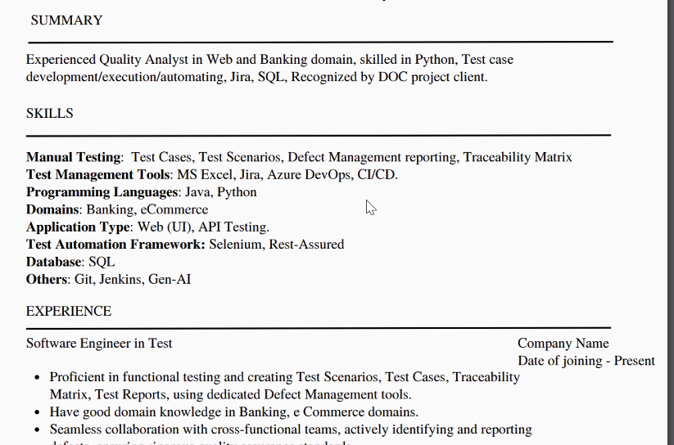

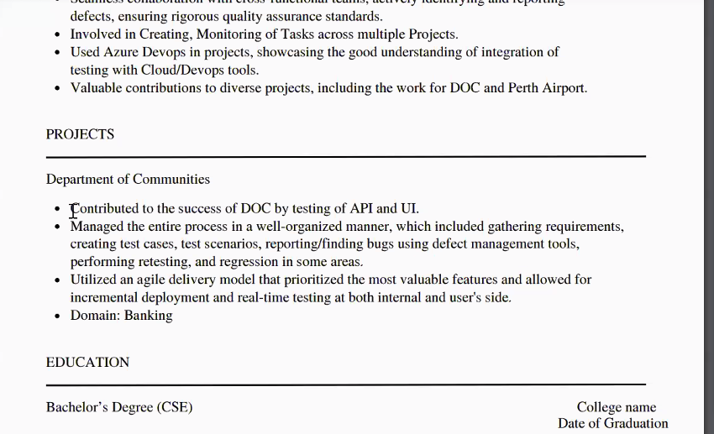

Don’t keep ‘knowledge’   
Keep minimum 2 recent projects  
ATSCore.com -> Upload your resume  
  
2

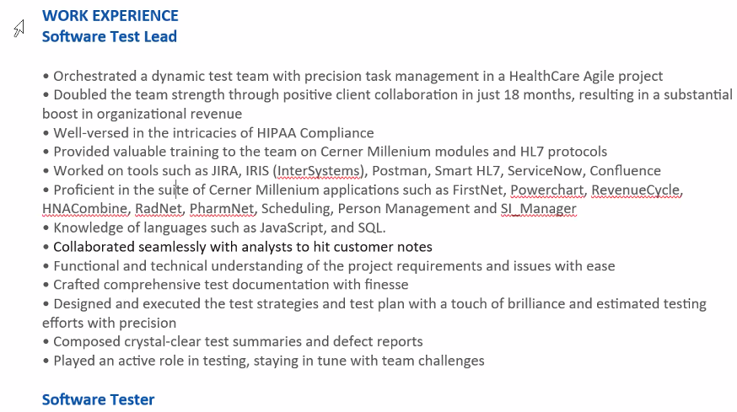

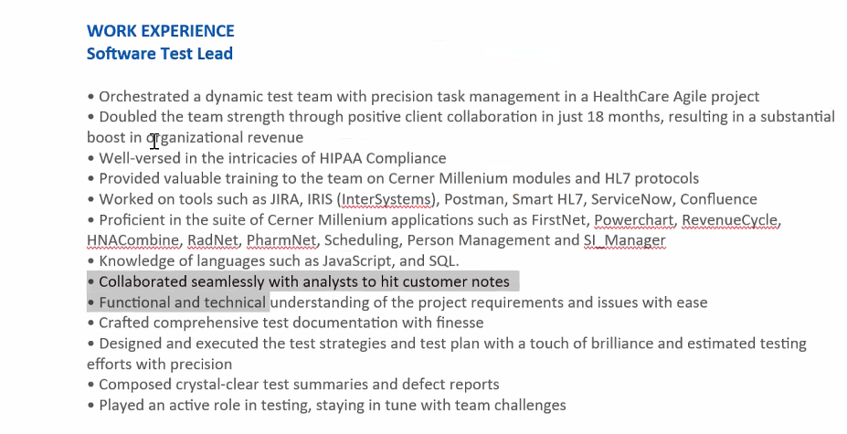

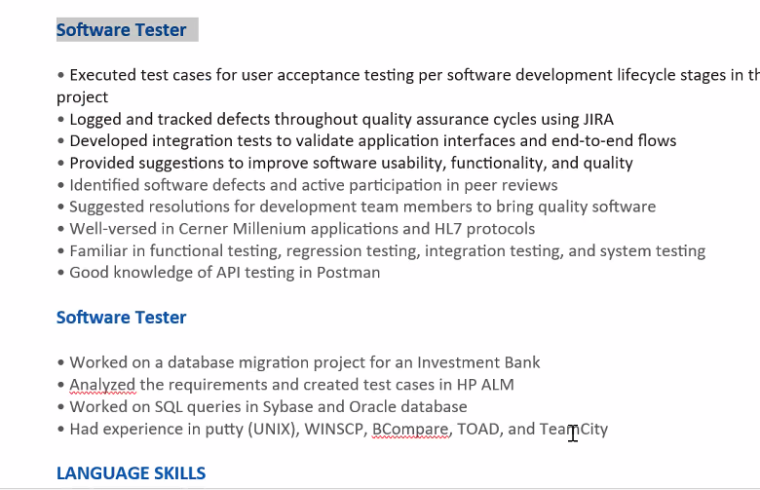

Right click>>paragraph>>increase spacing to 6 or 12 points [After] 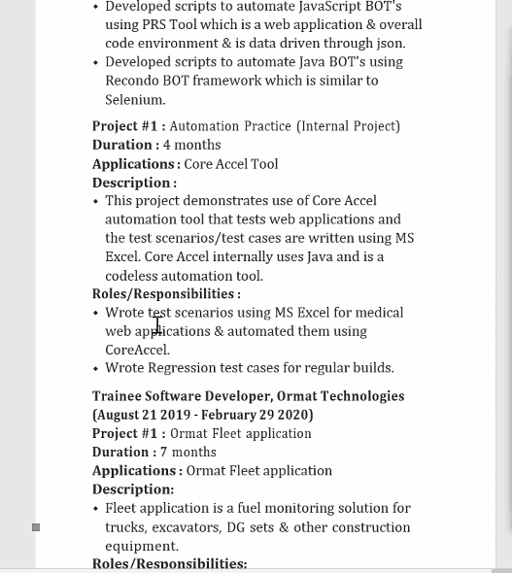

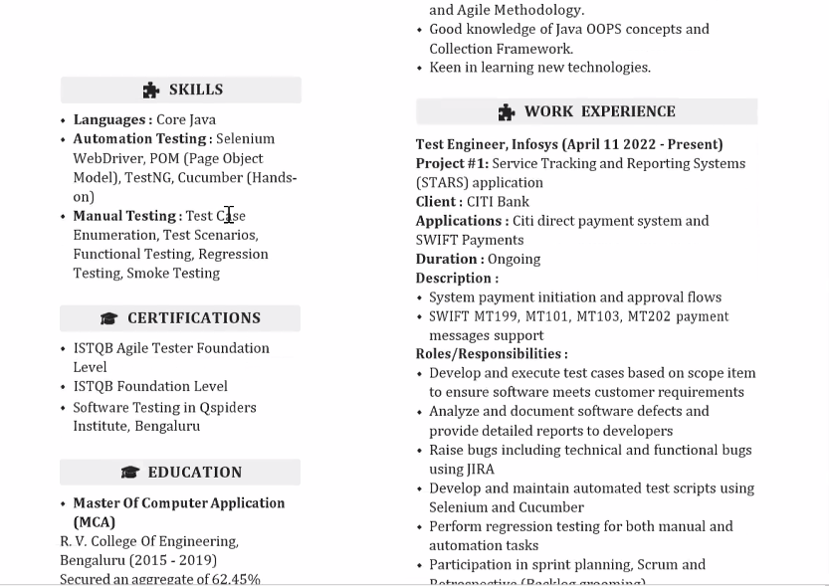

Gray and white simple clean resume

