**[Safe Ride - IOT Powered Smart Helmet]**

**Submitted**

**By**

**K.STEEV SUSHANTH (BU21EECE0100332)**

**T.S YOUSUF ALI ( BU21EECE0100155)**

**M.PRAVEEN KUMAR (BU21EECE0100379)**

**Under the Guidance of**

**(DR.SUBHASISH TIWARI, PhD)**

**(Duration: Date/Month/Year to Date/Month/Year)**



**Department of Electrical,Electronics and Communication Engineering [14 Bold]**

**GITAM School of Technology**

**GITAM**

**(DEEMED TO BE UNIVERSITY)**

**(Estd. u/s 3 of the UGC act 1956)**

**NH 207, Nagadenehalli, Doddaballapur taluk, Bengaluru-561203 Karnataka, INDIA.**

**DECLARATION**

**I/We declare that the project work contained in this report is original and it has been done by me under the guidance of my project guide.**

**Name:**

**T Syed Yousuf Ali**

**K Steev Sushanth**

**M Praveen Kumar**

**Date: Signature of the Student**

**Department of Electrical,Electronics and Communication Engineering [14 Bold]**

**GITAM School of Technology, Bengaluru-561203**



**CERTIFICATE**

**This is to certify that (T Syed Yousuf Ali, K Steev Sushanth, M Praveen Kumar) bearing (Regd. No.:BU21EECE0100155, BU21EECE0100332, BU21EECE0100379) has satisfactorily completed Mini Project Entitled in partial fulfillment of the requirements as prescribed by University for VIIIth semester, Bachelor of Technology in “Electrical, Electronics and Communication Engineering” and submitted this report during the academic year 2024-2025.**

**[Signature of the Guide] [Signature of HOD**

**Table of contents**

**Chapter 1: Introduction 1**

1.1 Overview of the problem statement 1

1.2 Objectives and goals 1

**Chapter 2 : Literature Review 2**

**Chapter 3 : Strategic Analysis and Problem Definition 3**

3.1 SWOT Analysis 3

3.2 Project Plan - GANTT Chart 3

3.3 Refinement of problem statement 3

**Chapter 4 : Methodology 4**

4.1 Description of the approach 4

4.2 Tools and techniques utilized 4

4.3 Design considerations 4

**Chapter 5 : Implementation 5**

5.1 Description of how the project was executed 5

5.2 Challenges faced and solutions implemented 5

**Chapter 6:Results 6**

6.1 outcomes 6

6.2 Interpretation of results 6

6.3 Comparison with existing literature or technologies 6

**Chapter 7: Conclusion 7**

**Chapter 8 : Future Work 8**

Here write Suggestions for further research or development Potential improvements or extensions 8

**References 9**

# Chapter 1: **Introduction**

The Smart Helmet project is designed to make riding safer by ensuring the bike starts only when the helmet is worn correctly. Using sensors, the system detects if the helmet is worn, not worn, or worn improperly, and controls the bike's ignition accordingly. We've also included fall detection, which can send alerts if an accident occurs, helping riders get help quickly. This project is practical, easy to use, and can be adapted to existing helmets and bikes, offering a simple yet effective way to improve road safety for motorcyclists.

## 1.1 **Overview of the problem statement**

Motorcycle accidents remain a significant cause of injuries and fatalities, with many riders neglecting to wear helmets, increasing the risk of serious harm. Despite helmet laws, enforcement can be difficult, and riders often ignore the importance of wearing helmets for their safety. Additionally, in the event of an accident, quick assistance is crucial, but it can be delayed without timely alerts. The Smart Helmet project addresses these issues by ensuring the bike only starts when the helmet is worn correctly and incorporating fall detection with alert notifications, providing a proactive solution for rider safety.

## 1.2 **Objectives and goals**

To develop a cost-effective IoT-based smart helmet system that prioritizes rider safety through automated features, ensuring motorcycles operate only when the rider is wearing the helmet, we aim to create a seamless, budget-friendly, and user-friendly safety solution. This system is designed to be an add-on module that can be easily integrated into existing helmets, offering a cost-efficient way to upgrade safety features without requiring a new helmet. By combining affordable technology with convenience, we promote responsible riding habits and enhance road safety standards while keeping production and installation costs low.

Ensuring everyone wears a helmet is key to protecting lives and fostering a culture of road safety and responsibility via cost effeciently

Implementing precise accident detection and rapid response to minimize injury and ensure swift assistance.

# 

# Chapter 2 : **Literature Review**

The integration of Internet of Things (IoT) technology into smart helmets has become a focal point for enhancing motorcycle safety. This review summarizes key studies that explore helmet detection and fall detection systems.

1. Smart Helmet for Motorcyclists Using IoT Technology

Park et al. (2021) examined how IoT can improve rider safety by incorporating sensors in helmets. Their system provides real-time alerts, helping riders respond to hazards quickly and reducing the likelihood of accidents.

2. IoT-Based Safety System for Helmet Detection and Fall Detection

Kumar and Rao (2020) developed an IoT system that ensures motorcycles only start when a helmet is worn. Their helmet also detects falls, sending immediate alerts to emergency services, which enhances response times and rider safety.

3. Development of a Smart Helmet System with IoT Integration for Safety Enhancement

Choi et al. (2022) created a smart helmet that detects impacts and monitors the rider’s condition continuously. Their IoT system triggers alerts for unsafe conditions, providing critical emergency notifications to nearby vehicles or riders.

4. Real-Time Fall Detection System Using Wearable IoT Devices

Lee and Ahn (2021) focused on wearable devices that detect falls using accelerometers and gyroscopes. Their system sends instant alerts in case of an accident, highlighting the importance of quick responses in emergencies.

5. Helmet Safety System with Real-Time Monitoring and Fall Detection Using IoT

Sharma and Gupta (2020) presented a smart helmet that not only checks for proper helmet use but also monitors the rider's condition during rides. In case of a fall, it automatically alerts emergency contacts, significantly improving safety.

# 

# Chapter 3 : **Strategic Analysis and Problem Definition**

The Smart Helmet project aims to enhance motorcycle safety through innovative IoT technology. Here’s a brief overview:

1. **Cost Efficiency**:

Many helmets on the market are quite expensive and often go unused. Our project focuses on providing affordable add-on solutions that enhance existing helmets, making safety features accessible to more riders.

2. **Market Need**:

Motorcycle accidents are a leading cause of injuries and fatalities, with many riders failing to wear helmets even when required by law. This highlights the pressing need for effective solutions to encourage helmet use.

3. **Technological Trends**:

With the rapid development of IoT, we can create smart helmets that monitor usage and detect falls in real time, sending alerts to improve rider safety.

4. **Competitive Landscape**:

Advanced safety features are often only found in high-cost helmets. Our project aims to make these essential features affordable for all riders, increasing overall safety.

5. **Regulatory Environment**:

As helmet laws become stricter, our project supports compliance and opens up opportunities for partnerships with safety organizations to better protect riders.

## **Problem Definition**:-

## 1. **Helmet Compliance**: Many riders don’t wear helmets properly, increasing their risk of injury. Our solution ensures that motorcycles can only start when helmets are worn correctly.

## 2. **Cost Efficiency**: Quality helmets can be prohibitively expensive, which discourages use. We offer an affordable add-on solution to enhance existing helmets.

## 3. **Delayed Emergency Response**: Quick alerts are crucial in emergencies. Our Smart Helmet detects falls and immediately notifies emergency services, ensuring a faster response.

## 3.1 **SWOT Analysis**

**STRENGTHS**

**Cost Efficient**: Ensures bike engine starts only when the helmet is worn and detects falls, potentially reducing injury and death rates The smart helmet is cost-effective, using affordable components while delivering essential safety

**Enhancded safety**:Ensures bike engine starts only when the helmet is worn and detects falls, potentially reducing injury and death rates

**Innovative Technology**: Utilizes IoT and advanced sensors, making it a cutting-edge solution in motorcycle safety.

**WEAKNESSES**

**Technical Failures**: Sensor or communication failures could lead to inaccurate helmet or fall detection, affecting performance and safety.

**Durability**: Electronic components must withstand environmental factors like moisture, temperature changes, and impacts, ensuring helmet safety.

**Regulatory Compliance**: Adapting to changing regulations requires ongoing updates, adding to costs and maintenance efforts.

**OPPORTUNITIES**

**Market Demand:** Increasing road safety awareness creates a strong market for advanced safety equipment.

**Partnerships**: Collaborations with motorcycle manufacturers or safety organizations can boost product reach and credibility.

**Technological Advancements**: Advances in IoT and sensor technology could enhance functionality and lower costs

**THREATS**

Failures: If the technology fails, it could cause customer dissatisfaction or safety risks.

Competition: New competitors may offer similar or better technologies, affecting market share.

### 3.2 **Project Plan - GANTT Chart**

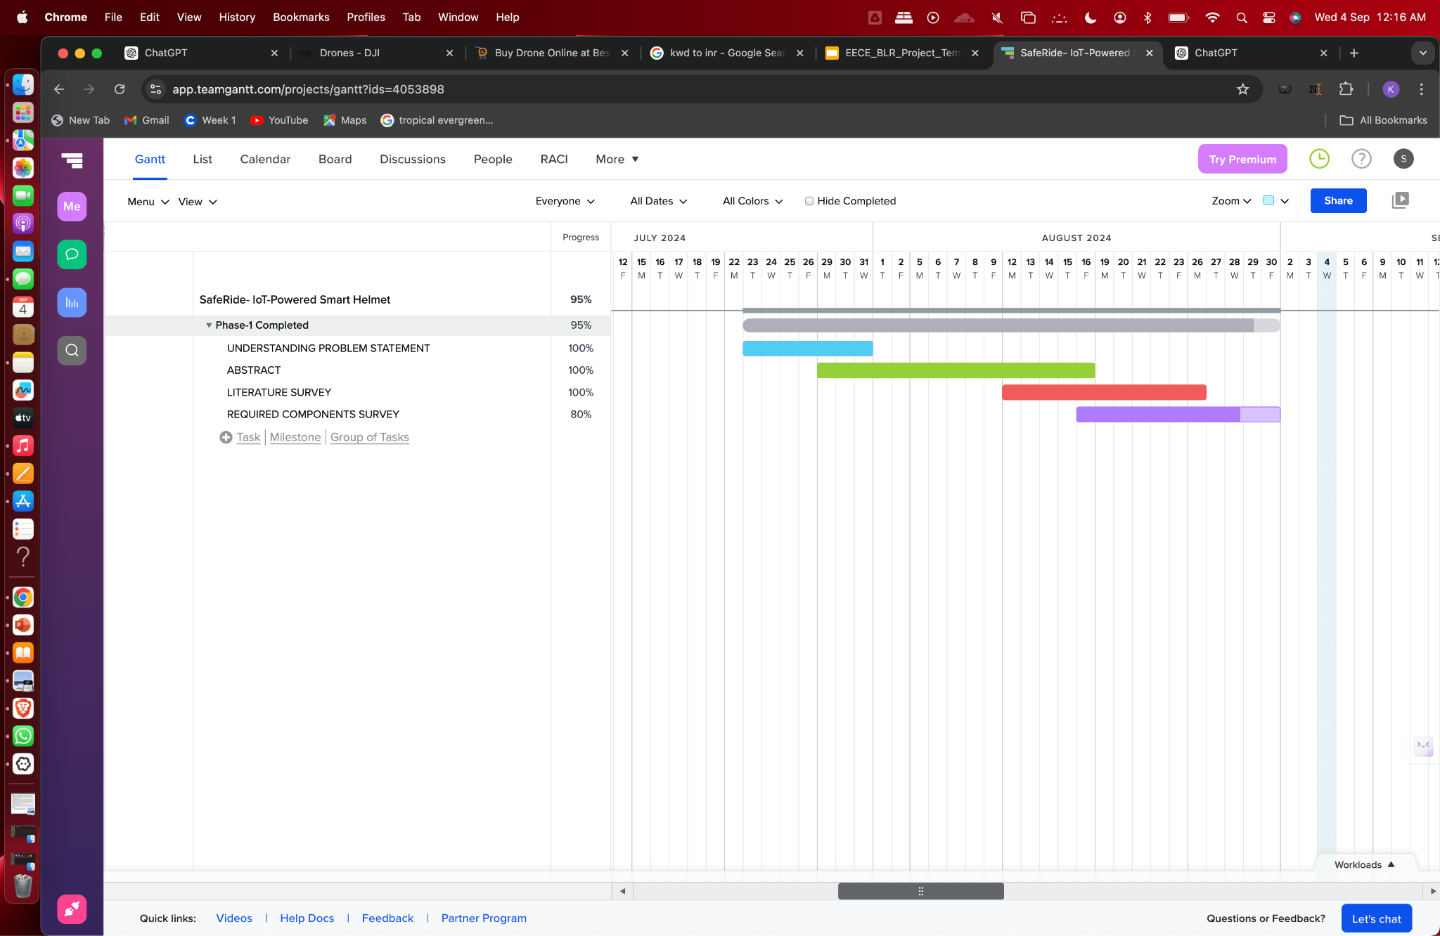

#### 

##### 

##### 3.3 **Refinement of problem statement**

The Smart Helmet project addresses the critical need for enhanced motorcycle safety by providing an affordable add-on solution for existing helmets. This system ensures that motorcycles can only start when helmets are worn correctly and detects falls to notify emergency services, significantly improving rider safety and response times in emergencies.

# Chapter 4 : **Methodology**

# 4.1 **Description of the approach**

We approached this project by integrating IoT technology with current helmets to monitor helmet usage. Using sensors, we can determine if a helmet is worn properly, and our system provides immediate alerts when it isn't, making riding safer.

### 4.2 **Tools and techniques utilized**

For our project, we used the ESP32 microcontroller to process data from proximity sensors designed to detect helmets. We incorporated LEDs to give visual alerts—green for when the helmet is worn and red for when it isn't—and a relay module to control the motorcycle's ignition.

#### 4.3 **Design considerations**

Our design prioritized reliability in various riding conditions while remaining cost-effective for users. We aimed to make the system easy to use, encouraging more riders to adopt it. Importantly, our design seamlessly integrates with existing helmets, requiring minimal changes.

# Chapter 5 : Implementation

## 5.1 **Description of how the project was executed**

We executed the project in several stages, starting with developing our prototype. We built and tested the helmet detection system using the ESP32 microcontroller and proximity sensors, continuously refining the design based on feedback to ensure it worked reliably.

### 5.2 **Challenges faced and solutions implemented**

Throughout the process, we faced challenges like achieving accurate helmet detection and ensuring the system responded quickly to alerts. We tackled these issues by carefully adjusting sensor placement and refining our programming, conducting extensive tests to improve the system's performance. Team collaboration was key to overcoming these hurdles.

# Chapter 6:Results

## 6.1 **outcomes**

Our Smart Helmet project has successfully demonstrated its ability to detect whether a helmet is worn correctly. The system triggered alerts as expected, and the relay module effectively controlled the ignition, enhancing safety.

### **6.2 Interpretation of results**

The results show that our system works reliably in various conditions, accurately detecting helmet usage. This capability highlights the potential of technology to improve rider safety on the road.

#### 6.3 **Comparison with existing literature or technologies**

When comparing our project to existing smart helmets, our solution stands out by providing an affordable option with advanced helmet detection features. Many high-end helmets offer similar functionalities, but their high prices often limit access for riders.

# Chapter 7: **Conclusion**

In conclusion, our Smart Helmet project effectively combines IoT technology with practical safety solutions for motorcyclists. By making these safety features affordable and accessible, we aim to reduce injuries and fatalities on the road. Our project addresses the critical need for helmet compliance. Moving forward, we plan to integrate additional safety features, such as fall detection and alert notifications, to further enhance rider safety.

# 

# Chapter 8 : Future Work

#### Here write Suggestions for further research or development Potential improvements or extensions

#### 

# References