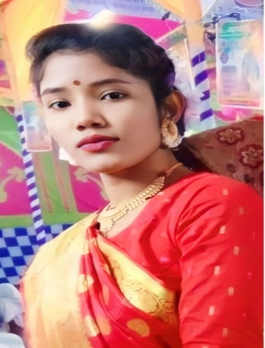

CAREER OBJECTIVE

SKILL ENHANCEMENT TRAINING

PROFESSIONAL EXPERIENCE

**1. Content Developer:** (January 01: 2019 - To be continuing)

**Description:**

* Creating content on Microsoft Excel.
* Crating content on Microsoft Word.
* Crating content on Microsoft PowerPoint.

**Department:** Branding and Marketing

**Duties/Responsibilities:**

* Coordinating team brand and communication.
* Monitor and report on effectiveness of marketing communications.
* Prepare professional branding plan and motivate branding team.
* Writing and presenting reports to senior management.

EDUCATIONAL QUALIFICATION

**Training Title : Computer Fundamental of office application**

**Duration :** 3 Month

**Time period :** December –February 2025

**Institution :** EDGE & BRUR

LANGUAGES

SKILLS

* Arts
* Poem Recitation
* Volunteer Work and Fundraising

01313-000000

tanjim.og@gmail.com

House: 10, Road-02, United Kingdom

To obtain a better position with opportunities to utilize my Practical SEO, branding & marketing and technical knowledge and experiences, skill, talent, creativity, sincerity for the better achievement of the organization.

**Lipy Rani**

Speaker phone with solid fill

**01793917005**

Email with solid fill

Lipir9155@gmail.com



Durakuti,Mogolhat,Lalmonirhat

* English
* Bangla

**LANGUAGE**

**TRAINING**

* Social work
* Travelling
* Event Management

**HOBY**

COMPUTER FUNDAMENTAL AND OFFICE IAPPLICATION

Duration: 3 month (60 Hours)

Institute: EDGE

**Higher Secondary Certificate (HSC)**

Passing Year : 2018

Result : GPA 3.50 Out of 5.00

**Secondary School Certificate (SSC)**

Board : DINAJPUR

Passing Year : 2016

Result : GPA 3.89 Out of 5.00

**Personal Information:**

Father’s Name : Monoranjon Roy

Mother’s Name : Biddashari Rani

Date of Birth : 8 October,1999

Gender : Female

Marital Status : Unmarried

Religion : Hindu

Nationality : Bangladeshi (By Birth)

Permanent Address : Village : Durakuti,

Post Office : Mogolhat

Police Station : Lalmonirhat

District : Lalmonirhat.

**Certification**

I verify that all information stated in this resume is true and complete to the best of my knowledge.

**Signature**

**Date:**