Carbon and its compounds

In-text-1

- What would be the electron dot structure of carbon dioxide which has the formula CO2?

Answer:


- What would be the electron dot structure of a molecule of Sulphur which is made up of eight atoms of Sulphur? (Hint – The eight atoms of Sulphur are joined together in the form of a ring).

Answer:
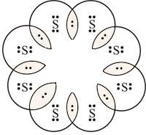

In-text-2

- How many structural isomers can you draw for pentane?

Answer:
Structural isomer of pentane are n-pentane
2-methylbutane
2, 2-dimethylpropane

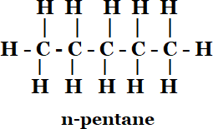
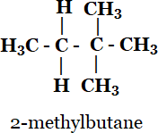
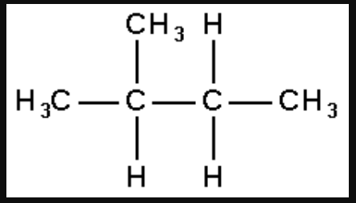

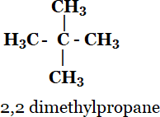

- What are the two properties of carbon which lead to the huge number of carbon compounds we see around us?

Answer:
Two properties of carbon which lead to the huge number of carbon compounds we see around us are

  - Carbon has six valence electrons which are actually a high number of valency.

  - Covalent bonding happens easily with carbon atoms and numerous others such as oxygen, chlorine, nitrogen, Sulphur, hydrogen and etc.
- What will be the formula and electron dot structure of cyclopentane?

Answer:
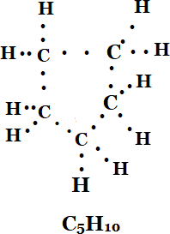
- Draw the structures for the following compounds.
- Ethanoic acid
- Bromopentane*
- Butanone
- Hexanal Answer:
i)
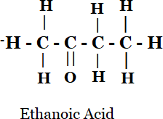

ii)

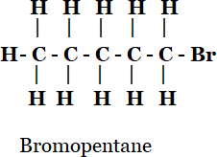

iii)
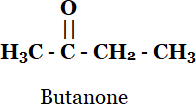

iv)
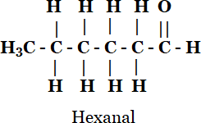

- How would you name the following compounds?

- CH3—CH2—Br

(ii)
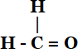

(iii)

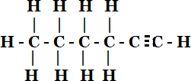

Answer:
  - Bromoethane
  - Methanal or Formaldehyde
  - Hexyne

In-text-3

- Would you be able to check if water is hard by using a detergent?

Answer: It is not possible to check if water is hard by using a detergent because detergents are salts of ammonium or sulphonates of long chain carboxylic acids. Unlike soaps they do not react with calcium and magnesium to distinguish nature of water.

- People use a variety of methods to wash clothes. Usually after adding the soap, they ‘beat’ the clothes on a stone, or beat it with a paddle, scrub with a brush or the mixture is agitated in a washing machine. Why is agitation necessary to get
clean clothes?

Answer:
Agitation is necessary to get clean clothes as agitation aid soap micelles to trap the oil, grease or any other impurities that have to be removed. When they are being beaten or agitated, the particles are removed from the clothes’ surfaces and go into the water, thus cleaning the clothes.

Exercise

- Ethane, with the molecular formula C2H6 has
  - 6 covalent bonds.
  - 7 covalent bonds.
  - 8 covalent bonds.
  - 9 covalent bonds

Answer: (b) 7 covalent bonds.

- Butanone is a four-carbon compound with the functional group
  - carboxylic acid
  - aldehyde
  - ketone
  - alcohol

Answer: Answer is option C i.e Ketone.

- While cooking, if the bottom of the vessel is getting blackened on the outside, it means that
  - the food is not cooked completely.
  - the fuel is not burning completely.
  - the fuel is wet.
  - the fuel is burning completely.

Answer: Answer is option b. While cooking, if the bottom of the vessel is getting blackened on the outside indicates that the fuel is not burning completely.

- Explain the nature of the covalent bond using the bond formation in CH3Cl

Answer: Carbon can neither lose 4 electrons nor do gain four electrons as these process make the system unstable due to requirement of extra energy. Therefore CH3Cl completes its octet configuration by sharing its 4 electrons with carbon atoms or with atoms of other
elements. Hence the bonding that exists in CH3Cl is a covalent bonding.

Here, carbon requires 4 electrons to complete its octet, while each hydrogen atom requires one electron to complete its duplet. Also, chlorine requires an electron to complete the octet.
Therefore, all of these share the electrons and as a result, carbon forms 3 bonds with hydrogen and one with chlorine.

- Draw the electron dot structures for
  - ethanoic acid
  - H2 S
  - propanone
  - F2

Answer:

a)
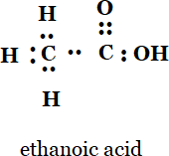
b)
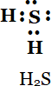
c)
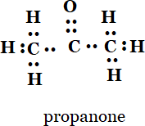

d)
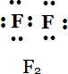

- What is a homologous series? Explain with an example.
A homologous series is a series of compounds, which has the same functional group. This also contains similar general formula and chemical properties. Since there is a change in the physical properties, we can say that there would be an increase in the molecular size and mass.

For example, methane, ethane, propane, butane, etc. are all part of the alkane homologous series. The general formula of this series is CnH2n+2. Methane CH4 Ethane CH3CH3 Propane CH3CH2CH3 Butane CH3CH2CH2CH3. It can be noticed that there is a difference of −CH2 unit between each successive compound.

- How can ethanol and ethanoic acid be differentiated on the basis of their physical and chemical properties?

Answer:

Ethanol | Ethanoic acid
Does not react with sodium hydrogen carbonate | Bubbles and fizzes with hydrogen carbonate
A good smell | Smells like vinegar
No action in litmus paper | Blue litmus paper to red
Burning taste | Sour taste

- Why does micelle formation take place when soap is added to water? Will a micelle be formed in other solvents such as ethanol also?

Answer: Micelle formation takes place because of the dirt particles in water and clean water. There are two mediums that are involved: one is pure water and the other being dirt (also called as impurities). The soap also has two mediums:

- organic tail and
- ionic head
So the organic tail mixes and dissolves with the dirt whereas the oil or grease and ionic head dissolves and mixes with the water. Therefore, when the material to be cleaned is removed from the water, the dirt is taken off by the soap molecules in the water. Hence, the soap cleans by forming closed structures by the mutual repulsion of the micelles (positively charged heads).

- Why are carbon and its compounds used as fuels for most applications?
Answer: Carbon and its compounds used as fuels for most applications for they have high calorific values and give out a lot of energy. Most of the carbon compounds give a lot of heat and light when burnt in air.

- Explain the formation of scum when hard water is treated with soap?

Answer: Scrum is produced from reaction of hard water with soap. Calcium and magnesium present in the hard water form an insoluble precipitate that stick as a white which is also called as scrum.

- What change will you observe if you test soap with litmus paper (red and blue)?

Answer: When we test soap with litmus paper color of litmus paper turns blue from red. As soap is a base it turn red litmus paper into blue.

- What is hydrogenation? What is its industrial application?

Answer: Hydrogenation is a process or a chemical reaction between hydrogen and other compounds. It is usually done in the presence of catalysts: for example nickel, palladium or platinum. Hydrogenation is used mainly to saturate organic compounds.

- Which of the following hydrocarbons undergo addition reactions: C2H6, C3H8, C3H6, C2H2 and CH4.

Answer: Unsaturated hydrocarbons undergo addition reactions. C3H6 and C2H2 are unsaturated hydrocarbons which undergo addition reactions.

- Give a test that can be used to differentiate between saturated and unsaturated hydrocarbons.

Answer:
Bromine water test - is used to differentiate between the unsaturated compounds (like alkenes and
alkynes) and the saturated compounds. For this purpose, bromine is used in the form of bromine water. A
Answer of bromine in water is called bromine water. Bromine water has a red-brown color due to the
presence of bromine in it. When bromine water is added to an unsaturated compound, then bromine gets
added to the unsaturated compound and the red-brown color of bromine water is discharged. So, if an organic
compound decolorizes bromine water, then it will be an unsaturated hydrocarbon (containing a double bond
or a triple bond), but saturated hydrocarbon (alkanes) do not decolorize bromine water.

Bromine water test is perform to differentiate between the unsaturated compounds (like alkenes and alkynes) and the saturated compounds. Bromine water is added to an un-saturated hydrocarbon red brown color of bromine Answer is discharged. Si if there is dis-coloration then the compound will be an unsaturated Hydrocarbon.

15. Explain the mechanism of the cleaning action of soaps.

Answer:
There are so many impurities and dirt mixed in water, and most of all the dirt do
not dissolve in the water. Soap molecules are a combination of salts such as sodium or
potassium. The molecules are of a long chain of carboxylic acids. So, when the carbon chain is
dissolved in oil and the ionic end is dissolved in the water, the soap starts cleansing and
trapping the dirt. When this happens, the soap molecules form structures that are called
micelles are used for capturing the oil droplets and then the other end being the ionic faces.
This will then form an emulsion in water and help in dissolving the dirt or impurities when the
clothes are washed.

The soap molecules have different properties at different ends. The first end being the
hydrophilic end which dissolves in the water and is attracted towards the water and the second
one being the hydrophobic end is dissolved in the hydrocarbons and is repulsive to water. The
hydrophobic tail aligns itself along the surface of the water because it is not soluble in the
water.

